Design and Construction Guidelines for Thermally Insulated Concrete Pavements

TPF-5(149)

MnDOT Contract No. 89261

Task 6
Construction Guidelines

Prepared by:

Jim Signore
Rita Lederle
Mary Vancura
Lev Khazanovich

May 2012

Introduction

Asphalt overlay construction on concrete pavements requires careful attention to all phases of the process to achieve acceptable performance. Appropriate construction practices must be observed during casting of the concrete slab, as well as during construction of the hot mix asphalt (HMA) overlay. Even though the Portland cement concrete (PCC) pavement will not be the final riding surface for the road, proper design and construction is important to ensure the success of the overall pavement system. The underlying PCC pavement can be either a standard PCC pavement, such as a jointed plain concrete pavement (JPCP), or a roller compacted concrete pavement (RCC). Following proper HMA mix selection, good construction practices, such as proper mixing and placement temperatures, adequate compaction, well defined quality control and quality assurance (QC/QA) procedures will help ensure the best possible overlay performance. Due to regularly spaced PCC joints below and high stresses within the HMA overlay, poor performance (reflective cracking and rutting) of the HMA overlay is not uncommon.

The performance of HMA overlays on PCC is often a compromise between strategies used to minimize reflective cracking and HMA rutting. These design strategies, which will affect construction, include selecting the mix to favor rutting or cracking performance, reducing the percentage of reflective cracks in the HMA surface, retarding the rate at which the reflective cracks appear and propagate, and enhancing the appearance of the expected cracks at the surface. Specific proprietary reflective crack control treatments, such as use of fabrics, are beyond the scope of this document. Agency policies, such as using thin HMA surfacing on PCC pavements, acknowledge the limited lifetime of the overlay, and are made for non-structural purposes, such as noise or safety.

Under this study, the research team interviewed the following experts:

Expert | Contractor | Phone Number
Dr. Shiraz Tayabji | Fugro Consultants, Inc. | 410-302-0831
Stewart Krummen | CS McCrossan | 763-315-1325/612-919-0718
Dean Allen | RL Brosamer | 925-627-1700
Dale Criswell | Teichert Construction | 916-645-4829
Chris Hundley | Tullis, Inc. | 530- 241-5105

The information gleaned from the experts during these interviews has been incorporated into the body of the document. Summaries of sample interviews are presented in Appendix A.

The following elements of HMA overlay construction on PCC pavements will be discussed: construction of standard PCC and roller compacted (RCC) pavements, HMA delivery and placement, mat compaction, joint compaction, and quality control and quality assurance (QC/QA). Numerous detailed references are cited for those wishing further information.

Construction Practices for HMA/PCC Composite Pavements

JPCP Construction
Khazanovich and Darter (2004) provided much useful information on the design of a high quality concrete pavement. To ensure a high quality HMA over PCC pavement system, it is important to begin by ensuring quality of the underlying layers. The horizontal and vertical variations in subsurface soil types, moisture contents, densities, and water table depths should be considered during the pavement design process to help ensure that the pavement structure will be supported by a uniform and consistent platform. These elements can be quantified through the implementation of proper field (subsurface investigation) and laboratory testing programs. More important, preparation of the subgrade prior to the placement of the paving layers and special subsurface conditions, such as swelling soils and frost-susceptible soils, must be identified and considered in pavement design.

It is recommended that subgrades for PCC pavement construction have a minimum CBR of 6 percent in the top 300 mm in order to provide stability and uniformity for the base paving operations. However, several European countries require a higher minimum level of subgrade support. For instance, Spain requires a minimum CBR of 10, below which the subgrade must be removed; if the CBR is between 10 and 20, a granular subbase layer is required (Darter, 1993). Similarly, Germany specifies a minimum subgrade bearing value of 45 MPa, determined using a modified plate load test (Larson et al., 1993). Austria also specified a minimum bearing value for its subgrades (35 MPa), below which soil replacement or stabilization is required (Darter, 1993). A dynamic cone penetrometer (DCP), a long, narrow device that can be driven into the subgrade to estimate the in place CBR of the soil, can also be used for construction control.

Often the native or imported embankment is unable to provide those qualities. In such cases, the following techniques can be used to improve the strength and uniformity and reduce the climatic variation of the foundation on pavement performance:

1. Stabilization of weak soils (highly plastic or compressible soils).
2. Thick granular layers.
3. Subsurface drainage systems.
4. Geotextiles.
5. Soil encapsulation.

Stabilization of the existing subgrade is one method of addressing problem soils. The following types of stabilizers are commonly used (Carpenter et al. 1992):
- Lime stabilization (soils must be reactive with lime)
- Cement stabilization
- Asphalt stabilization (granular soils only)

The type of stabilizing agent to be used is strongly dependent on the type of subgrade. Lime stabilization is appropriate for medium-, moderately fine-, and fine-grained soils with moderate to high plasticity, but most suited to soils with plasticity index (PI) greater than 10 and more than 25 percent passing No. 200 sieve. Cement stabilization is appropriate for coarse-, medium-, and fine-grained soils having low to moderately high plasticity, but moat suited to sandy soils with PI < 30, fine-grained soils with PI < 20 and LL < 40, and coarse-grained soils with PI > (20 + [50 – fines content]). Asphalt stabilization is generally suited to medium- and coarse-grained soils with low plasticity and suited to sands with less than 25 percent passing the number 200 sieve and PI < 6 or coarse grained material with less than 15 percent passing the number 200 sieve and PI < 6. Additional information on the selection and mix design of stabilizing agents are found in references (Portland Cement Association, 1995; Portland Cement Association, 1992; Asphalt Institute, 1997; Barenberg and Thompson, 1976).

Another critical consideration in the preparation of the subgrade is the potential for frost heave. Where frost heave is a problem, susceptible soils should be replaced with a nonfrost-susceptible material. Alternatively, the addition of a select nonfrost-susceptible material over the problem soil may be effective, with the result of raising the grade line above natural ground (FHWA, 2001). Many Northern European countries place thick granular layers (203 to 508 mm) between the subgrade and the base course to help control frost heave (Darter, 1993). The layer thickness required for frost protection is generally taken as one-half to three-fourths of the depth of the local frost penetration. Finally, subcutting, remixing, and recompacting suitable quality soils will increase the level of support and decrease problems due to nonuniformity of the in-place material.

In addition to frost heave, swelling (or expansive) soils represent another potential subgrade problem. These soils exhibit significant volume changes in reaction to changing moisture contents. Possible solutions for these types of soils include removal, placement of a more suitable material, compaction at water contents 1 to 2 percent above optimum, compaction to 102 percent of optimum using ASTM T-99, and lime or cement stabilization (Okamoto et al., 1991; Lehmann, 2001). More exotic treatments (such as membrane encapsulation) may be required for severe swelling soils.

After the subgrade is properly prepared, the base and subbase must be addressed. Concrete pavements use one or more base and subbase courses to fulfill a number of requirements. The base layers are placed on the finished roadbed. The two main requirements of the base for a concrete pavement are the following:

- Serve as a construction platform for the concrete slab so that the pavers will have a stable platform on which to operate to produce a smooth pavement. Smoothness of the surface requires smoothness of the sub-layers.
- Provide a uniform support for the concrete slab that will not erode and result in loss of support.

Therefore, the base must be constructed to the proper elevation along the grade, contain the specified ingredients, and the proper compaction and/or strength to achieve this high durability.
The grade has to be checked and corrected as needed prior to placement of the concrete. If the grading operations or construction traffic disturb density of the base, additional compaction is required to correct it.

Following construction of the base, paving can begin. If a slipform paving is used, it is recommended to provide a base layer 600 mm wider on each side than the traffic lanes to accommodate the slipform tracks. Special attention should be paid to preventing crushing of edge drains with the slipform paver. Edge drains can be installed beyond the edge of the base or after the traffic lanes are paved (FHWA, 2001).

Proper curing is important for pavements which will be overlain with asphalt because curing ensures adequate strength and integrity of the concrete. Contractors should consider modifying the curing regime to account for the fact that the HMA must bond to the PCC surface. An asphalt based prime coat could be applied to the wet PCC surface to ensure a good bond, but this could also interfere with the saw-cutting operation if it were not dry in time. Alternately, conventional cure compound could be used, but this may need to be removed by sandblasting in order to ensure good bond. If adequate bond is not achieved, there is a risk for early delamination of the HMA layer from the PCC. The concrete mixture must have a lower w/c ratio and sufficient cement content to provide a low abrasion surface. The entrained air content must be such that for the prevailing climate no scaling or spalling will develop due to freeze thaw.

In addition, water curing will result in a much lower built in temperature gradient during construction on sunny days which will reduce the occurrence of corner breaks and some transverse, longitudinal, and diagonal cracks. The zero-stress temperature of the PCC will also be lower resulting in less joint and crack opening.
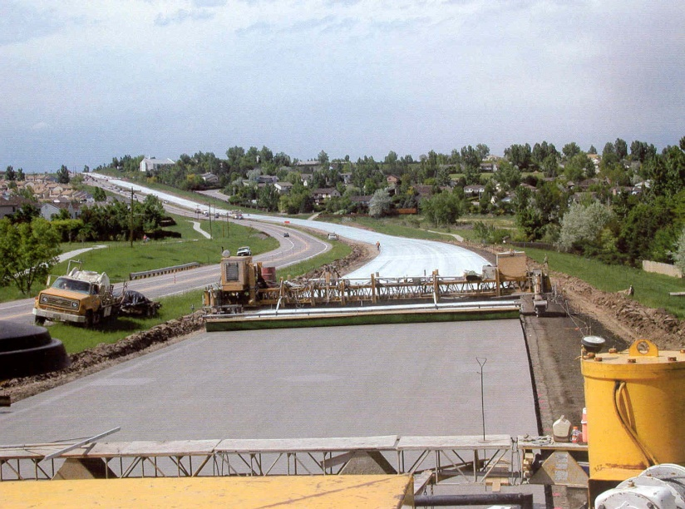

Figure 1: Curing of concrete pavements is critical; water cure eliminates built-in temperature gradients, high zero-stress temperature, and excessive shrinkage.
Conventional concrete pavements are textured to ensure a proper ride surface. In the case of concrete pavements overlain with asphalt, the wear surface will be HMA, so the texture of the PCC does not play the same role as in conventional concrete. The PCC could either be left untextured, or given a modified texture to allow for better interlock with the HMA overlay.

When transverse joint dowels do not have proper horizontal or vertical alignment the joint can lock up and the result will be random cracking near the joint. These cracks will often open up and spall and require full depth replacement of the joint and or adjacent slabs. There is much controversy over current specifications requiring certain tolerances because of lack of data to support them. There has not been the capability to measure the alignment until just recently. The MIT Scan technology has become available that makes it possible to locate dowel bars and tie bars within about 2 mm of their vertical or horizontal alignment and this technology is likely to change both specifications over the next few years (Lehmann, 2001).

When tie bars across longitudinal joints do not have adequate positioning the joint could open up over time resulting in a safety situation where motorcycle or other tires would have safety problems. Again, there is controversy over what is adequate alignment of tie bars. One criterion is that they must not be closer than 50 mm from top or bottom of the PCC slab to avoid spalling.

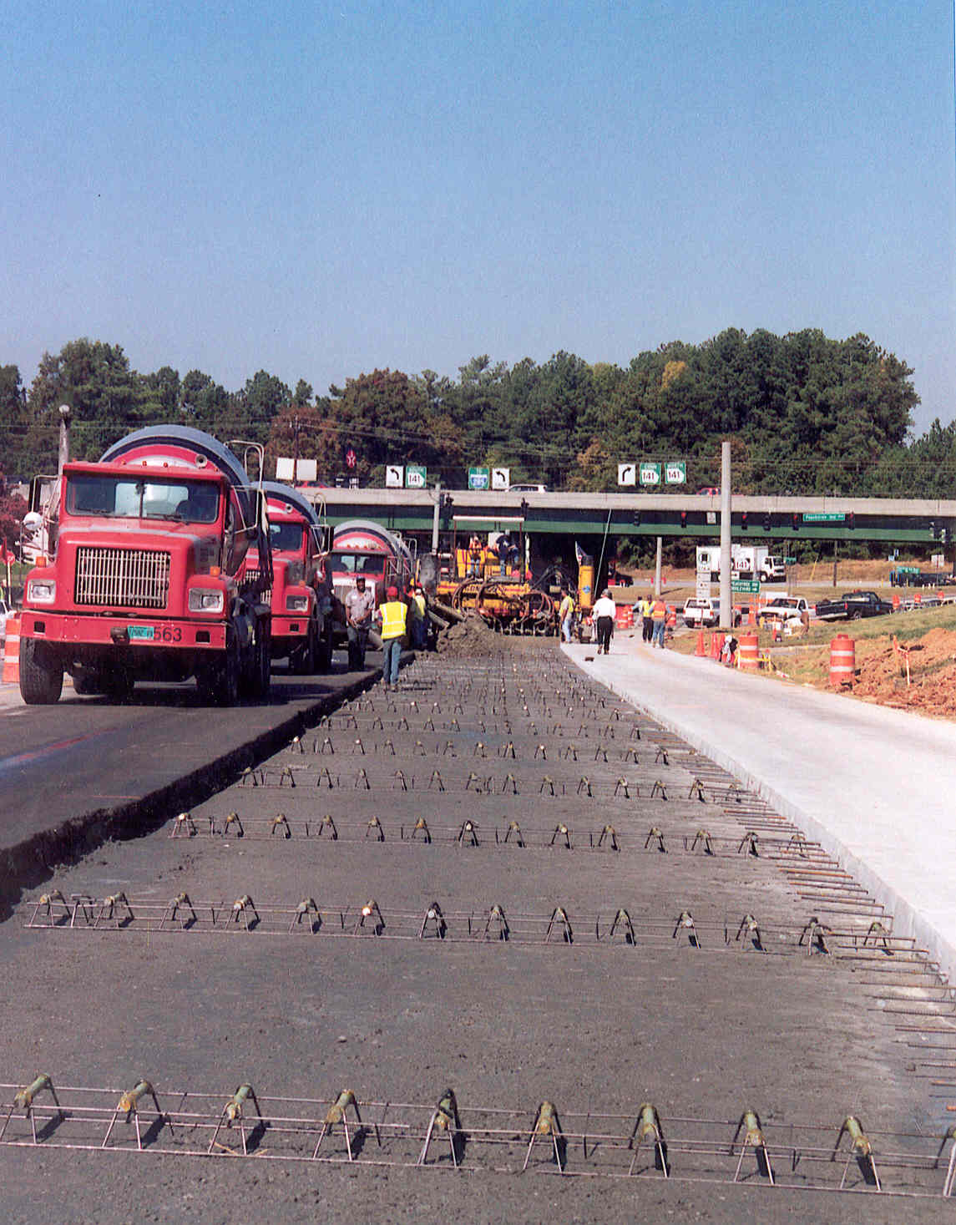
Figure 2: Dowels can be placed within acceptable tolerances, field measurement every day is critical

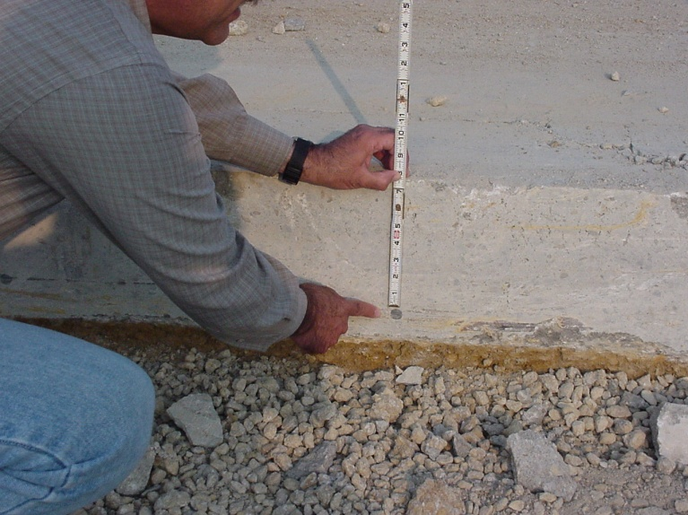
Figure 3: Tie bar placement is important and should be measured every day

The construction of the transverse joint requires that the depth of the saw-cut in a slab be deep enough to ensure the formation of the crack beneath it. However, in order to achieve maximum joint sawing production rates, it is desirable to saw to the minimum depth necessary to ensure the formation of the crack. Also, on non-doweled joints, it is desirable to limit the depth of sawing in order to provide a greater aggregate interlock load transfer.

Conventional practice has been to saw transverse joints to a depth of 25 percent of the slab thickness for transverse joints and 33 percent (or greater) for longitudinal joints. While this depth has worked well in most cases, the type of underlying base course may also have an effect on the required depth of sawing. Stabilized bases produce more friction between the slab and the base, and therefore can induce larger tensile stresses in the slab. In addition, slabs placed on permeable bases often end up slightly thicker than the design thickness due to the open texture of the base course material. Thus, to ensure the formation of the crack, the saw-cut depth of transverse joints may need to be greater for slabs placed on stabilized and permeable bases (33 percent of the slab thickness).

Another way to address the problem associated with friction caused by stabilized bases is to notch the surface of the treated base course at the prescribed transverse joint spacing to ensure the formation of the cracks at that location in the treated base. This practice is routinely conducted in Germany on their cement-treated bases. After placement of the pavement on top of the base, Germany specifies that the joints in the PCC slab be sawed to 30 percent of the slab thickness (Darter, 1993; Larson et al., 1993).

For initial saw cutting operations, most joints are sawed to a width of 3 mm prior to widening for joint reservoir. Some saw blade manufacturers now produce a blade that can produce the initial saw cut and the reservoir saw cut in a single pass.

A critical aspect of the joint sawing operations is the timing of the actual sawing of the slab. If this sawing is performed too early (i.e., before the slab has hardened sufficiently), spalling or raveling of the joint can occur. On the other hand, if the joint sawing is performed too late (after the development of internal slab stresses), uncontrolled cracking will develop. Since the occurrence of the latter is of more critical concern than the former, it is desirable to begin sawing as soon as possible, generally within 4 to 12 hours.

The far limit, or the latest time that sawing can be done to prevent the occurrence of random cracking, is dependent upon the development of restraint stresses in the slab. These restraint stresses primarily are made up of frictional restraint stresses and thermal curling stresses. During the first 24 hours of paving, the concrete slabs are very sensitive to the development of restraint stresses. Field observations and testing has shown that a primary indicator of the latest time that sawing can be performed is when the temperature of the concrete surface cools more than 8 °C. However, because of the difficulty in determining that time, and because the surface may cool off very rapidly (due to late afternoon cooling, rain shower, and so on), it is recommended that joint sawing be performed as soon as the concrete can be sawed without significant raveling of the joints. This is particularly true for slabs placed on stabilized bases, since these pavements can develop greater frictional restraint stresses. Additional time for saw cutting may be made available if paving is performed at night or very early in the morning (completing by 10 or 11 a.m.) to minimize the development of temperature gradients through the slab (Okamoto et al. 1991).

In the past, some agencies have used skip joint sawing procedures, in which only every second or third joint is initially sawed. This is usually done in an effort to keep up with the paving operation, and the skipped joints are sawed later. However, this practice can result in the development of transverse cracks at or near the joints that were skipped, particularly on slabs over stabilized bases. Also, the joints sawed first are typically wider, creating non-uniform joint movements and variable performance of joint sealants.

The need for sealing of joints in JPCP has been questioned and some highway agencies in North America have stopped sealing of these joints. When joints are not sealed, it is advantageous to cut the joint very narrow. A saw blade of 2 mm has been used in Chile to saw transverse joints with good success (e.g., low noise).

Taking care in the construction of joints will help to ensure pavement smoothness. Field studies have clearly shown that pavements that are built smoother will remain smoother over their design life and last longer than those built rougher (Smith et al. 1997). Reasons for this finding are several:

- Initial smoothness can only be achieved through quality construction of all layers from the subgrade up, uniform concrete production; accurate string line and grade control.
- Initial smoothness requires a uniformly moving construction process with no delays of concrete delivery.
- The contractor must take more care in all aspects of the construction process (steady forward motion of the paver, adequate internal vibration for proper consolidation of the concrete, timely texturing, curing, and joint sawing) to achieve a smooth pavement.

The International Roughness Index (IRI) in recent years has become the standard for expressing pavement roughness. Data from Khazanovich et al. (1997) indicate that initial IRI values less than 0.63 m/km (40 in/mi) represent good initial smoothness levels. However, the achievement of lower initial roughness levels is quite common given the recent improvements in paving technology and the more widespread use of smoothness specifications.

Smoothness specifications with strong pay incentives are strongly recommended (contractors in the US can receive up to 8 percent extra pay for many. This has led to improved paving operations and very smooth pavement surfaces to serve roadway users for many years into the future. European specifications lack of bonuses offered to contractors. Use of warranties is much more common in Europe than in the US.

The following factors govern the construction of a smooth PCC pavement (Grogg and Smith, 2001):
- PCC material and mix design. The mix design needs to be optimized to provide workability and ease of finishing without jeopardized strength. The mix produced by the contractor should be uniform and adherent to the mix design. Inconsistent mix will change the hydraulic forces of the pavement acting on the paver and alter the final pavement profile.
- Grade control. Smooth pavement cannot be constructed without a tight grade control. Grade control should be performed on all stages of the pavement construction starting from subgrade preparation and finishing when the final pavement profile is provided. The grades of stakes and string lines should be checked by surveying equipment. Two string lines should be used. It is preferably to construct the string lines of aircraft cable and space supports for them not more than 8 m apart. Special attention should be paid to areas where string lines begin and end to provide a smooth transition. The string lines should be monitored and maintained during construction. String lines might be unintentionally replaced as a result of:
  - Placing a foreign object on it
  - Workers bumping on it while crossing
  - PCC delivery operation
If such an event occurs, the string line should be re-installed using surveying equipment. Just a visual inspection might be inadequate.
- Paving speed and material delivery rate. It is crucially important to harmonize delivery of PCC with the speed of paving operations. Maintaining a constant speed of the paving train reduces changes in hydraulic forces acting on it from the plastic PCC. The number of paver’s stops during paving should be reduced to the absolutely necessary minimum. Therefore the production rate of the plastic PCC should be adequate. Shortage of the plastic concrete will cause slowing down or stoppage of the paver. Oversupply of the plastic concrete may create different degree of concrete workability. In both cases, paving and finishing processes will be jeopardized.
- PCC head in front of the paver. It is important to ensure that PCC mix is spreading uniformly across the base and avoid moving mounds of plastic PCC. A constant head should be kept above the strike-off bar to avoid changing in the hydraulic forces acting on the bottom of the paver.
- Embedded items. Dowel bars, tie bars, and reinforcing steel create challenges in producing a smooth pavement. It is important to apply an adequate pressure when the PCC is extruded from the back of the paver. Too low pressure would prevent consolidation of concrete around steel whereas too high pressure would move it downward followed by settlement or rebound of steel and resulting in dips or bumps in the pavement, respectively. It is also very important to avoid contact between the embedded steel and vibrators.
- Curing and environmental conditions (see section above).
- Equipment maintenance. It is crucial to keep equipment well-maintained and clean to minimize stoppage in paving.
- Trained workforce. All crew members should know and understand their roles in the paving process and effects their actions might have on the pavement smoothness.
- Finally, it has been found in the US over the past 20 years that incentives/disincentives to the contractor has a very major effect on achieving very smooth pavements. Up to 8 percent of the contract bid is paid to contractors who build very smooth pavements. This has revolutionized the paving operations and resulted in longer lives and more comfort to highway users.

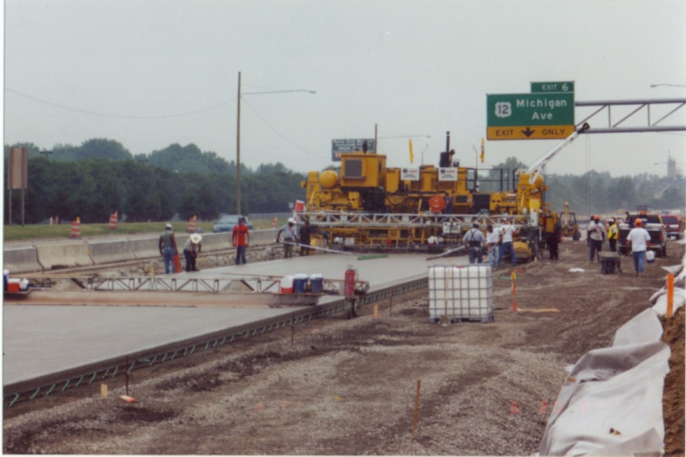
Figure 4: Quality construction is critical and contractor pay incentives are very helpful

The following table provides a useful checklist of required activities for the design and construction of a successful concrete pavement.

Table 1: Checklist of design and construction activities for concrete pavements (adapted from Grogg and Smith, 2001)
No | Item | Yes | No | NA
1 | Collect information on site conditions
1.1 | Evaluate subgrade properties
1.1.1 | Have soil samples been collected along the grade?
1.1.2 | Have soil samples been tested properly?
1.1.3 | Has the soil class been determined along the grade?
1.1.4 | Is the subgrade expansive or frost heave susceptible?
1.1.5 | Is the depth to the water table known?
1.1.6 | Will the concrete be subjected to external sulfate attack?
1.2 | Collect traffic data
1.2.1 | Has the number of heavy trucks over design life been estimated?
1.2.2 | Is the number of equivalent single axle loads known?
1.2.3 | Has the axle load spectra been measured on site?
1.2.4 | Has lane distribution of trucks been measure? Lateral offset from edge of slab?
1.3 | Collect climate information
1.3.1 | Is average annual precipitation known?
1.3.2 | What is an average number of air freeze-thaw cycles?
1.3.3 | What is an average annual air temperature?
1.3.4 | What is freezing index (estimate depth of frost)?
1.3.5 | Will be de-icing materials applied over pavement service life?
1.4 | Evaluate source of aggregates for concrete and base
1.4.1 | Do local aggregates have sufficient freeze-thaw resistance?
1.4.2 | Do local aggregates exhibit adequate wearing resistant?
1.4.3 | Is it possible to have chemical incompatibility with cement?
1.4.4 | Are the aggregates susceptible to freeze-thaw?
2 | Design PCC Mix
2.1 | Select target PCC properties
2.1.1 | What is the target PCC flexural strength?
2.1.2 | What is the target PCC modulus of elasticity?
2.1.3 | What is the coefficient of thermal expansion?
2.1.4 | What is the ultimate shrinkage?
2.2 | Select PCC mix proportion
2.2.1 | Was PCC mix design optimized considering PCC target properties, workability, and cost?
2.2.2 | Has a procedure been developed to modify the PCC mix proportion if strength, or workability are encountered?
2.2.3 | Are any cementitious replacements of cement (fly ash, slags) used?
2.2.4 | Are water-reducing admixtures required?
2.2.5 | Are air-entrained admixtures required?
2.3 | Check mix compatibility/durability
2.3.1 | Is it possible that a chemical reaction between the alkalis in Portland cement and carbonate/dolomite aggregates will take place?
2.3.2 | Is it possible that a chemical reaction between the alkalis in Portland cement and silica in aggregate (ASR) will take place?
2.3.3 | Is the mix resistant to external sources of sulfates from groundwater or deicing chemicals?
2.3.4 | Is percentage of entrained air voids sufficient for local climate?
4 | Construction
4.1 | Subgrade preparation
4.1.1 | Has a subgrade been graded for uniformity and compacted sufficiently to exhibit sufficient strength for placement of upper layers (e.g., CBR > 6 %)?
4.1.2 | Has a subgrade been trimmed to grade?
4.1.3 | Has a base layer been constructed and trimmed to grade?
4.1.4 | Has a base layer been constructed sufficiently stable?
4.1.5 | Are stable and sufficiently wide track lines provided for paver’s operation?
4.2 | Grade control
4.2.1 | Has a procedure for control of the pavement profile been developed?
4.2.2 | Has a quality control procedure for finished the finished grade of the all pavement layers (subgrade, subbase, base, and PCC) been developed?
4.2.3 | Have the design features of the roadway (grade, super-elevation, transition, railroad crossing, etc.) been accounted for in the layout and staking of the pavement?
4.3 | PCC paving
4.3.1 | Has a quality control plan for checking the consistency of designed and produced mix been developed?
4.3.2 | Has a quality control plan for checking the mix workability, segregation, or finishing problem been developed?
4.3.3 | How will the PCC mix formula be adjusted if workability of finishing problems are encountered?
4.3.4 | Will the PCC plant and delivery vehicles provide sufficient amount of concrete with required frequency?
4.3.5 | Has the paving and vibration operations adjusted to accommodate presence of dowels or steel reinforcement.
4.3.6 | Are the ranges of the environmental conditions (air temperature, humidity, wind speed) are acceptable?
4.3.7 | Is equipment cleaned of old concrete on a regular basis?
4.3.8 | Is a proper curing medium been applied to the PCC layer as soon as practical?
4.3.9 | Have been joints sawed at the right time window?
4.3.10 | Is there a plan to check the alignment of dowel bars?
4.3.11 | Is there a plan to check the alignment of the tie bars?
4.4.12 | Is there a plan to check the depth of the joint sawing and timing?
4.4 | Sub-drainage (if used)
4.4.1 | Is there a plan to video check the longitudinal and transverse pipes
4.4.2 | Are the outlets higher than the bottom of the ditch line?
4.4.3 | Are there durable outlets for the lateral drain pipes that will not clog?
4.4.4 | Is there plan to check the density of materials around the longitudinal drain pipes?
5 | Joint seals
5.1 | Installation of seals
5.1.1 | Is there a plan to check the adequacy of the joint sealants?
6 | Future preservation of pavement
6.1 | Joint seals
6.1.1 | Is there a plan for regular maintenance of joint seals?
6.1.2 | Is there a plan for spall repairs?
6.1.3 | Is there a plan for slab replacement for JPCP?
6.6.4 | Is there a plan for full-depth repair of CRCP?

RCC Construction
As an alternative to conventional concrete pavements, such as JPCP, roller compacted concrete (RCC) pavements can be used. RCC is a type of concrete with very little water in the mix. This concrete has zero slump, and therefore cannot be placed using conventional placement techniques. Because of its low water content, RCC is relatively high strength and very durable. RCC pavements do not need to be formed or finished, but as a result, they do not have a smooth surface. RCC pavements are not suited for typical highway paving applications due to low ride quality which results from this surface (Portland Cement Association, 2012). Instead, they are typically used in industrial applications, such as container terminals and ports, or for temporary road ways where quick construction and high strength are the only criteria. However, surface quality is not a problem for concrete pavements which will be overlain with HMA, because the HMA provides the smooth surface.

An additional advantage to using RCC in concrete pavements with an HMA overlay is that RCC is cast using the same equipment as HMA. This means that only one set of equipment must be mobilized to the job site for the paving operation. In a conventional asphalt overlay job, both PCC and HMA paving equipment are needed. Construction costs are also lower for RCC pavements than PCC pavements because there is no need for finishing, and joint spacing is much larger, which decreases the amount of labor needed to cut joints, and leaner mixes can be used, reducing material costs (Portland Cement Association, 2012). It is important to note that RCC cannot be used in conjunction with dowel bars, so RCC is not suitable for pavement systems where dowel bars are required. However, RCC also has much higher strengths than typical pavements, and therefore may be used in some instances without dowel bars where a conventional pavement would require them (Portland Cement Association, 2012).

The first recorded use of RCC was in Canada in the 1970’s, when logging companies needed low cost, durable platforms for storage and to unload logging trucks. In this application, RCC was found to be extremely durable despite heavy loads, a harsh climate and very little maintenance (Piggott, 1999). Since then, RCC has become common for use in industrial situations, temporary roads (particularly for the military), parking, staging areas, and low-speed roads (where the surface roughness does not pose as large of a problem) (Portland Cement Association, 2012).

RCC Pavement Design
The design of an RCC pavement is not very different from that of a conventional concrete pavement: the goal is to find the thickness required to minimize damage. For RCC pavements, the main failure mode is fatigue. Therefore, RCC pavements are designed to prevent fatigue failure by ensuring that the concrete used has a sufficiently high modulus of rupture to resist the stresses induced by the predicted loads. An analysis is conducted to determine the load cases which will produce the highest stresses and how much fatigue damage will be induced by those stresses (Luhr, 1995). The pavement thickness is selected to ensure that the pavement will have adequate strength and fatigue capacity. This thickness can be determined using either the procedure outlined by the Portland Cement Association (1987), or the computer program RCC-Pave (PCA 2002). Typical thicknesses used range from 6-15 inches (Rao et al. 2011).

RCC Mix Design
There is no one specific, accepted mix design method for RCC pavements, though several approaches exist (ex. ACI 1995, Marchand 1997). To ensure that a mix will perform as required, laboratory specimens of any potential mixes should be evaluated (Luhr, 1995). When designing an RCC mix, the main requirement is that there be a sufficient amount of paste to cover all aggregates and bond them together without voids between the aggregates. The overall water content of the mix must be low enough that the mix can support the compactor. However, there must be a sufficient amount of moisture in the mix that it can still be spread using a vibratory roller (Portland Cement Association, 2012).

Given that the aggregate is the main constituent of an RCC mix, it is important that quality aggregate and a proper gradation be used. Quality aggregates used in standard ready mix concrete are often acceptable, as long as the proper gradation can be achieved. The American Concrete Institute and the Portland Cement Association recommend that the following gradation be used. This gradation ensures that the required density will be achieved. The nominal aggregate size is limited to ¾ inch in an effort to mitigate segregation. A higher fines content is required to ensure that the mix will be stable enough to tolerate the weight of the compactor while it is still plastic. However, this can result in cost savings as it often eliminates the need for aggregate washing (Portland Cement Association, 2012).

Table 2: Recommended aggregate gradation for RCC mixes (from ACI 1995)
Sieve Size |  | Percent Passing
Inch | Millimeter | Minimum | Maximum
3/4" | 19 | 100 | 100
1/2" | 12.5 | 70 | 90
3/8” | 9.5 | 60 | 85
#4 | 4.75 | 40 | 60
#8 | 2.36 | 35 | 55
#16 | 1.18 | 20 | 40
#30 | 0.6 | 15 | 35
#50 | 0.3 | 8 | 20
#100 | 0.15 | 6 | 18
#200 | 0.075 | 2 | 8

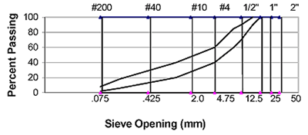
Figure 5: Recommended aggregate gradation for RCC (from ACI 1995)
Only the minimum amount of cementitious material which is necessary to ensure adequate strength should be used. This reduces the overall cost of RCC, which is often selected as a paving material due to its cost savings (Luhr, 1995).

RCC Construction
Like any concrete pavement, construction begins by preparing a proper base and subgrade. The subgrade must be graded and compacted using standard procedures for a typical pavement. A crushed stone base is then placed. Together, the base and subgrade create a stable foundation on which the RCC can be placed (Luhr, 1995).

RCC is paved in a manner similar to asphalt. All of the ingredients are mixed in a rotating mixer and loaded into a dump truck to be hauled to the site (Luhr, 1995). The dump truck is covered to reduce moisture loss, but during hot weather, additional water may need to be added to the mix to account for evaporation during transport (Portland Cement Association 2012). The dump truck empties the mix into either a conventional or high density paver (Luhr, 1995). Depending on the specification being used on a specific job, RCC must have a density that is at least 98% of optimal as measured by the modified proctor test (Portland Cement Association, 2012). Though high density pavers are capable of achieving a more compacted mix than standard pavers, they cannot meet the required density of RCC. Therefore, compaction is necessary regardless of the type of paver used.
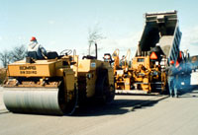

Figure 6: Typical RCC paving operation: dump truck unloads mix into an asphalt paver, a roller follows close behind to ensure adequate compaction (from Portland Cement Association, 2012).

Proper compaction of RCC is required to achieve performance in terms of strength and durability. Figure 7 shows how dramatically strength can decrease if proper compaction is not achieved. Typically, a smooth wheel, vibrating roller is used to compact the concrete, though occasionally pneumatic tire rollers are used for the final pass to provide a better finish. The rolling pattern to be used for compaction should be determined and tested before paving begins to ensure that proper densities will be achieved (Luhr, 1995).

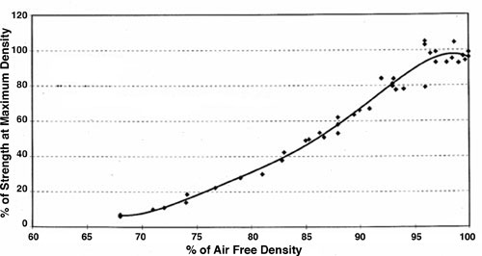
Figure 7: Relation between compaction (measured as % air free density) and strength (from Schrader, 1992).
Factors such as compaction time and technique, concrete mix properties and lift size will influence the amount of compaction which is achieved. Inadequate compaction (and therefore insufficient strength can be caused by any of the following (Portland Cement Association, 2012):
- Delaying the start of the compaction process
- Segregation of the aggregate within the mix
- Rollers which cannot provide sufficient compaction
- Lifts which are too thick
- Low moisture content of the mix
- Overcompaction due to excess rolling

If loads of adjacent materials from different trucks are placed less than an hour apart, then the joint between the material is not considered to be cold. When constructing such a joint (sometimes called a fresh joint), the material from both sides of the joint should be blended together prior to full compaction. This can be accomplished by using specific types of rolling patterns. For a cold joint, where more than one hour elapses between placement of adjacent loads of material, the set material should be cut to create a vertical surface at the edge. Grout should be applied to this face directly before the new adjacent material is placed to ensure that the set and plastic concretes form a good bond (Luhr, 1995).

As with any concrete, curing is one of the most important steps to ensure that the desired properties are achieved. If the RCC dries rather than curing, the following can occur:
- Drying shrinkage cracks on the surface
- Incomplete hydration, especially on the surface, resulting in decreased strength and durability
- Increased dust on the surface

RCC can be cured using conventional cure methods such as water cure or cure compound. Standard PCC cure compounds which follow the ASTM C 309 specification can be used on RCC, but they require an application rate which is 1.5 to 2 times greater to account for the surface texture of the RCC. For RCC, the cure compound is generally applied in two lifts, which are perpendicular to each other. Other standard cure techniques for concrete, such as covering with plastic sheeting or wet burlap can be used with RCC. However, RCC is generally used for paving large areas, where covering is not feasible (Portland Cement Association, 2012). When RCC will be used in conjunction with HMA overlays, the bituminous tack coat can be used in place of cure compound and can be applied as soon as compaction is complete (Luhr, 1995).

Less cracking is seen in RCC compared with conventional PCC because of the lack of bleed water which results from the low water/cement ratios used in RCC (Luhr 1995). In instances where cracking is not a concern, RCC is not saw cut and shrinkage cracks are allowed to form naturally; typically this results in a joint spacing of between 20-70 ft (Luhr, 1995; Portland Cement Association, 2012). This would not be desirable in a pavement which will receive an HMA overlay due to the potential for reflection cracking. Instead, joints can be saw cut to eliminate random cracks.

In RCC, joints are timed and cut using conventional techniques (Portland Cement Association, 2012), though compaction must be complete before saw cutting begins (Luhr, 1995). Saw cuts should not be deeper than ¼ of the pavement thickness. If a thin early entry saw is used, the cut should not be more than 1-1.25 inches deep. Transverse joint spacing is every 15-20 feet for pavements less than eight inches thick. For pavements more than eight inches thick, transverse joint spacing (in feet) = 3 or 4 * pavement thickness (in inches). Longitudinal joints are generally spaced closer than transverse joints in RCC because loading in the longitudinal direction causes hinge action. Longitudinal joint spacing is every 15-20 feet for pavements less than eight inches thick. For pavements more than eight inches thick, longitudinal joint spacing (in feet) = 2.5 * pavement thickness (in inches) (Portland Cement Association, 2012). It has been found that, for HMA over RCC pavements, shorter joint spacing (every 10 ft) results in less reflected cracking (Rao et al, 2011).

The HMA layer can be placed on the RCC as soon as joints have been sawn. Non-truck traffic can be allowed on the roadway as soon as it can be tolerated by the HMA layer.

HMA Overlay Construction
This section discusses HMA construction subsequent to pre-overlay repair. In-service PCC pavements will generally require pre-overlay treatment for best performance such as replacing and repairing slabs, stabilizing slabs, and preparing joints. HMA overlays constructed on newly designed and built HMA/PCC and in-service PCC pavements will generally follow comparable construction processes. However, depending on the design selection, the overlay may be conventional HMA with the goal of maximum service life, or it may be constructed as a sacrificial layer for ride and noise purposes.

The HMA overlays may be structural, consisting of dense graded or gap graded/stone matrix asphalt (SMA), or functional, consisting of open graded mixes for noise and/or splash-spray control, and may contain rubber or polymer modifiers.

HMA overlay performance can be enhanced through best practice measures throughout the construction process. These practices are aimed at maximizing cracking and rutting performance of the HMA overlay, irrespective of any crack control measures. For instance, saw and seal techniques (described at the end of this section) performed at the time of HMA overlay construction have been found in numerous studies to be one of the best performing strategies to address reflective cracking (Rao, 2011). Using these best practices, like the saw and seal technique, does not relinquish the contractor from using other best construction practices.

Pre-Overlay Treatments
Prior to placement of the HMA overlay on existing PCC pavements, rehabilitation treatments should be performed to restore a smooth profile and minimize joint movement. Examples of these treatments include joint sealing, diamond grinding, dowel bar retrofitting, slab sub-sealing and jacking, full and partial depth slab repairing, cracking and seating, and rubblizing. These specific topics are out of the scope of this section of this circular and may be found elsewhere.

Surface Preparation
The first step toward ensuring pavement performance is to provide the maximum bond between the PCC (new or existing) and the HMA overlay. Poor initial bonding or the loss of bonding between the HMA overlay and PCC pavement may result in several distresses, such as slippage cracking, as well as compaction difficulty (Leng et al., 2009, West et al., 2005). Strong interlayer bonding may be achieved through one or a combination of the following methods: 1) texturing the PCC surface to provide added bond potential, 2) cleaning the PCC surface, and 3) placing a tack coat with the proper type and quantity on the PCC surface (Leng et al. 2009).

Surface texturing can be provided by transverse or longitudinal tining or surface milling. Tining does not allow for significant connection between PCC and HMA and milling was found to provide the highest shear strength in laboratory tests (Leng et al., 2009). Subsequent to texturing and other pre-overlay repairs, clean the surface with mechanical brooms and air blowing and use water flushing where needed (MLRRB, USACE). Other studies have shown that air blasting is preferred to mechanical brooms if only one method is chosen (Leng et al. 2009).

Some agencies utilize a chip seal type SAMI alone or in combination with a leveling course for use on the PCC surface to act as a reflective crack control strategy prior to the HMA overlay. Use of a reflective crack relief interlayer mix RCRI, consisting of one inch of fine aggregate bound with a highly elastic polymer modified binder was shown to be statistically the best performer in mitigating reflective cracking, in an extensive study of composite pavement performance in New Jersey (Bennert, 2011).

Various studies have been performed looking at tack coat optimization for overlays on PCC (Al Qadi, 2008) and HMA (Mohammed, 2005). This study found that SS-1h (or SS-1hP) spread at a rate of 0.2 gal/yd² (residual) provided the greatest shear strength between layers and best overall pavement performance. Uniform coverage of the tack coat without ribbons or “zebra stripes” is critical to achieving maximum bond strength.

HMA Delivery and Placement
Guidelines for delivery, placement, and compaction of HMA overlays on either existing or new PCC vary little from sound practice recommendations for paving HMA on HMA. The goal is providing a uniform spread quantity and quality of HMA to maximize smoothness and minimize segregation during placement, prior to compaction.

Maintaining elevated mix temperatures is primary to proper placement and compaction, so the following factors should be considered when developing a delivery strategy:

- delivery haul length
- truck type
- mix type
- ambient temperature
- wind

Lower than desired temperatures make placement more difficult, and can lead to mix segregation, which has been shown to affect mix fatigue performance adversely (Khedaywi 1996). This is very important over moving PCC joints, as reflective cracking models have been developed that are based on fatigue failure modes (Wu et al 2006).

The following list highlights several best construction practices for HMA placement (MLRRB).

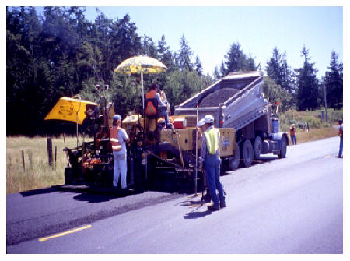
Figure 8: End dump of HMA into paver hopper (Mahoney, Pavement Interactive.com)

- The truck bed should be raised before opening the tailgate if using end-dump trucks so the mix slides against the tailgate as shown in Figure 8. This minimizes segregation.
- Let the paver move forward toward the HMA delivery truck to eliminate mat indentations. Avoid having the truck back up into the paver. The paver should stop during the exchange of material. Following emptying the HMA, the truck should drive away smoothly without jerking the paver.
- Bring the paver to paving speed as quickly as practicable to maintain constant head in front of the screed. Maintain sufficient mix in the hopper so that slat conveyors are never visible, but do not overflow the hopper. Only raise paver wings when necessary to eliminate a buildup of cold mix in the hopper corners.
- Maintain a constant head of material on the paver augers through constant speed and continuous operation. Material level should be at the same height or slightly above the auger shaft, as shown in Figure 9.

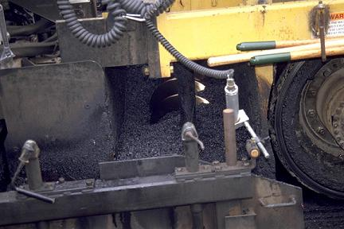
Figure 9: HMA head in auger (Mahoney, Pavement interactive.com)

A constant head at the augers results in minimal movement of the screed and helps maintain consistent mix height and mat smoothness. Variations in head affect screed movement and mat thickness, as shown in Figure 10.

Figure 10: Screed movement with material head variation

Mat Compaction
Mat compaction (density) is considered the most important factor in determining HMA performance. Compaction to six percent or less air voids increases fatigue life, reduces rutting, decreases oxidation and aging, and moisture damage (Benson and Scherocman, 2006). Lift thickness, mix properties, and environmental conditions are key factors that affect the ability of the contractor to achieve density in the HMA layer (Decker, 2006).

With HMA overlays on PCC, thin functional overlays (< 1.5 in.) may be placed as well as thicker structural overlays (> 2in.), which require greater attention during compaction, particularly in colder weather. Properties of the aggregate and asphalt binder (including use of modifiers) have an impact on the ability of the contractor to achieve density. It is well known that mixes made with coarse, angular aggregates may be more difficult to compact than mixes made with rounded materials. As a result, the coarser mixes may cool before density can be achieved (Decker, 2006).

Because it is affected by mixing temperature and delivery, the HMA mat temperature must be sufficient to obtain the required HMA density. Mat temperature are affected by numerous factors including haul time, mix type, ambient temperature, ground/PCC temperature, and wind.

When placed on PCC, HMA overlays are subject to higher levels of compressive energy due from truck traffic. The highly rigid PCC (modulus greater than 4,000,000 lb/in²) leads to the HMA layer absorbing more load energy due to higher confinement effects and lack of dissipation throughout the pavement system. Rutting levels of comparable mixes placed on PCC versus on HMA have been measured at 15 to 20 percent higher. With the increased stresses placed on HMA in composite systems, makes meeting compaction specifications even more critical than in “conventional” HMA/HMA overlays or full depth paving.

Joint Compaction
Proper HMA joint compaction is critical in composite pavements with HMA surfacing due to the high degree of PCC movement beneath the HMA. Poor compaction of longitudinal joints typically results in joints cracking, opening, and raveling of the adjacent material. Joint density is determined by three primary factors 1) density on the outside edge of the first paved lane (cold side – free edge) 2) degree of compaction of the joint which requires some overlap to ensure adequate material and 3) degree of compaction of the second paved lane (hot side) (Brown, 2006). In composite pavements, even if saw and seal will be performed, having as high density as possible in the HMA surrounding the sealed saw cut will facilitate longer life of the treatment. Figure 11 shows a typical poor performing longitudinal joint.

Figure 11: Raveled longitudinal joint (Brown, 2006)

Compaction of the free unsupported edge can be problematic. The type of roller used and its position in regard to the unsupported edge of the pavement significantly affects the amount of density that can be obtained. A pneumatic (rubber) tire roller normally cannot be used within about 150 mm (6 in.) of the unsupported edge of the lane without pushing the mix sideways due to the high pressure in the rubber tires (Benson and Scherocman 2006, Brown 2006). It is recommended that a steel wheel roller extend over the edge of the lane by approximately 6 in. as shown in Figure 12 (Benson and Scherocman 2006).

Figure 12: Proper rolling of free edge (Benson and Scherocman 2006)

The second factor for durable longitudinal joints relates to the amount of HMA placed at the interface between the two adjacent mats. Two factors are involved in this – the height of the uncompacted hot mat and the amount of overlap onto the cold mat. The height of overlap onto the cold side depends upon the thickness of the uncompacted mat on the hot side. Given that mix compacts approximately 25 percent (1/4 in. per in. thickness) the overlap needs to be high by the amount of compaction expected to occur so adequate material is present (Benson and Scherocman 2006). The amount of overlap onto the cold side (transversely) is critical. There should be no gaps by the paver and even given variability of the paver, there should always be some overlap. Augers must adequately push HMA against the free edge when placing the second lane. Any screed extensions must be assessed for sufficient material placement at the joint (Brown, 2006). The amount of transverse overlap needed is in the range of 25 mm (1 in.) to 40 mm (1½ in.) for proper longitudinal joint construction. If proper overlap is established, raking or luting the joint is not necessary (Benson and Scherocman 2006). Figure 13 shows proper overlap.

Figure 13: Proper overlap of hot mat onto cold mat (Benson and Scherocman 2006)

The final issues for constructing well performing longitudinal joints is placement of adequate material on the hot side and proper rolling of the joint. Sufficient material must be placed to allow for 20 to 25 percent compaction of the hot mat. Unfortunately, the tendency by contractors to place less material along the hot mat, to produce a smooth joint, results in too little material along the joint. Once the hot mat is compacted to the level of the cold mat, a steel wheel roller will bridge over this material and compaction will cease at the joint. A roller tire roller can be used successfully to further densify the mat in low spots (Brown 2006).
It is recommended to place either a steel wheel roller or a pneumatic tire roller, a short distance (6 in.) over the top of the joint from the hot side of the joint. For a rubber tire roller, the center of the outside tire of the roller, at the end of the roller with an even number of tires, is placed directly over the top of the longitudinal joint. Placing the roller in this position permits proper compaction of the mix at the joint as well as compaction of the mix on the hot mat (Benson and Scherocman 2006). Figure 14 shows this roller placement.

Figure 14: Rolling of hot mat for joint compaction (Benson and Scherocman 2006)

Sawing and Sealing HMA Overlays at PCC Joints
As part of the recent SHRP2 R21 project, R21 research engineers assisted the Illinois Toll-way Association in developing a specification for the sawing and sealing of joints in the AC overlay of a newly constructed PCC pavement (WSDOT 2004). This specification describes the saw cutting, cleaning, drying, and sealing of transverse joints in new AC overlay surfaces. More information on the saw and seal operations promoted by the SHRP2 R21 project can be found in Rao et al. and the SHRP2 R21 final reporting (WSDOT 2004, SHRP2 2010).

For the Illinois Toll-way AC-PCC, the joints cut for the 3-inch AC overlay were to be ½ inch wide by ⅝ inch deep. Each sawed AC overlay joint was required to be within 0.5 inches of the transverse joints in the JPCP underneath. This is shown in Figure 15 and later described in discussing the effectiveness of sawing and sealing; sawed joint locations have been shown to be critical to well-formed joints in AC-PCC.

The construction specification requires that saw joints are cut in the AC overlay no earlier than 48 hours after paving of the overlay. Saw cutting is performed as indicated above. Of particular note in the construction specifications is the requirement for the finished joint to be well-cleaned upon completion. This ensured an acceptable seal on the joint. Sealing is conducted during daylight hours and only in favorable weather.

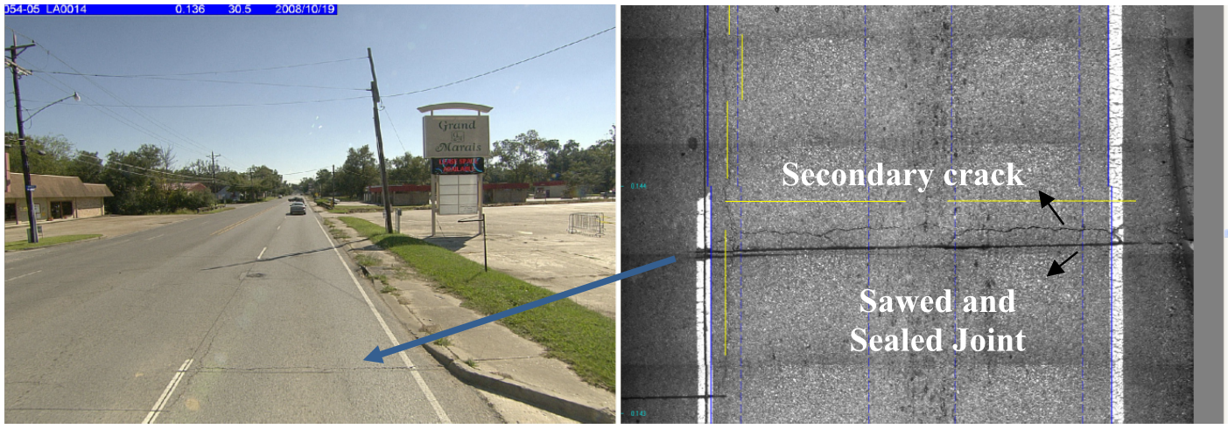
Figure 15 Illinois tollway saw and seal (Elsefi 2011)

The sealant was required to meet ASTM D-3405 with the modifications that penetration at 77 deg F be 90-150 and that the sealant pass bond testing at -20 deg F. Furthermore, the specification required that the sealant weigh between 9.0 and 9.35 lb/gal. The bond breaker tape used was required to be not more than 1/8 inch narrower than the joint saw cut.

Effectiveness of “Saw and Seal” Treatment for AC Overlays
Two recent projects have examined the effectiveness of sawing and sealing in HMA/PCC. The first was a study conducted by the Louisiana DOT to evaluate the saw and seal method in terms of pavement performance and cost (Elseifi 2011). The study involved the survey of 15 saw-and-sealed pavements throughout Louisiana over the course of six to 14 years. These saw-and-sealed pavements were compared with neighboring pavement sections that did not use sawing and sealing for the HMA overlay. The report concluded that the use of sawing and sealing extended the pavement service life by an average of four years, and was judged a cost-effective alternative for HMA overlays. Elseifi et al. also included finite element analysis of an HMA/PCC section to determine the mechanics of how saw and seal treatments minimize reflective cracking. The analysis determined that the constructed joints in the HMA allow the HMA slab to move with the underlying PCC slab as it expands and contracts.

The second study was conducted as a portion of the SHRP2 R21 Composite Pavement project; the R21 team conducted a survey of composite pavement project in the European Union (Rao et al. 2010). The SHRP2 effort included meeting with pavement experts from various countries and transportation agencies to discuss their paving techniques and experience and to survey their existing composite pavements. This survey included a number of HMA/PCC pavements that utilized the saw and seal method, which has been regularly applied to pavements in Germany since the early 1990s.

The SHRP2 team surveyed many sections featuring stone-matrix asphalt (SMA) overlays of PCC pavements along the A93 motorway, south of Munich, in 2008. For one section, illustrated in Figure 9, a 3-cm layer of SMA was placed over a 26 cm two-layer PCC pavement in 1995-1996. The SMA was a gap-graded mix with a maximum aggregate size of 8 mm. The saw and seal work showed little surface distress and looked outstanding and of very high quality. The longitudinal joints between PCC slabs had propagated up through the SMA, both between the inner/outer slabs and between inner/shoulder slabs. The only significant maintenance that had been done was to place a few patches at transverse joints where the SMA had debonded from the PCC surface and cracked. These rectangular repairs can be seen in Figure 16.

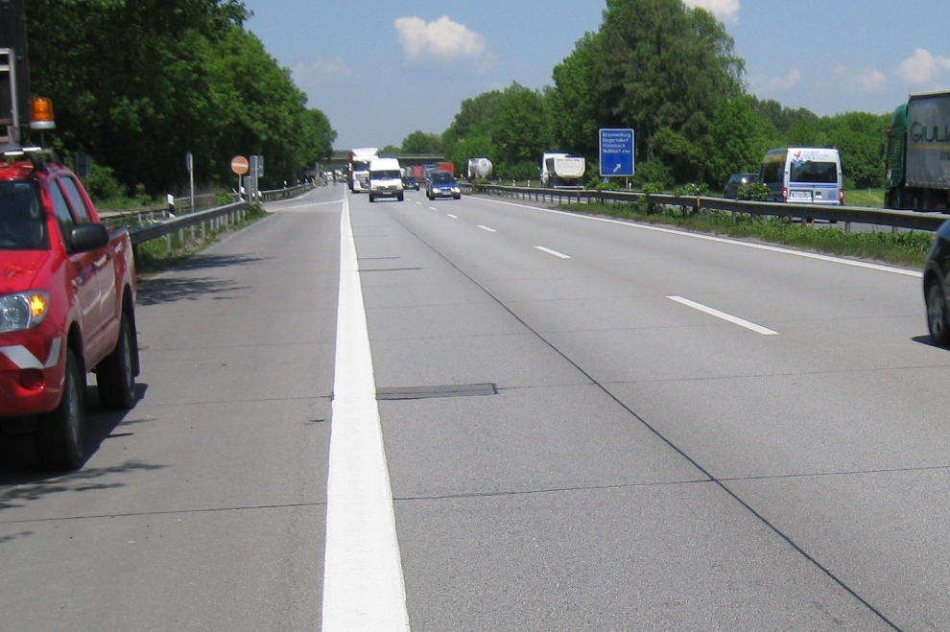
Figure 16 SMA over PCC along A93 in Germany, rectangular patch repair visible next to red traffic diversion truck (Rao SHRP 2010)

The R21 research team learned that the use of SMA over JPCP in Germany and other countries has used sawing and sealing for approximately 15 years. In the European experience, reflection cracking was found to be a problem when JPCP is used, and the JPCP joints reflected through to the surface unless the saw and sealing technique was used above transverse and longitudinal joints. Furthermore, experts in Germany claimed that the use of sawing and sealing of SMA over CRCP was effective in minimizing reflection cracking. As a result of the tour of European HMA/PCC composites, the SHRP2 R21 project recommended saw and seal to handling reflection cracking for an HMA overlay, be it SMA, Superpave, rubberized surfacing, etc. (Rao et al. 2010).

Quality Control and Quality Assurance
Quality Control and Quality Assurance (QC/QA) for HMA paving in composite pavement systems is comparable to that performed for conventional HMA full depth and overlay paving. However, with the added environmental stresses and strains and the increased traffic energy imparted to the pavement by the truck traffic, sufficient mix density, minimal segregation, and adequate joint density become even more important.

Quality assurance specifications are defined by the TRB glossary as (Burati 1995): Quality assurance specifications—Also called QA/QC specifications or QC/QA specifications. A combination of end result specifications and materials and methods specifications. The contractor is responsible for QC (process control), and the highway agency is responsible for acceptance of the product. [QA specifications typically are statistically based specifications that use methods such as random sampling and lot–by–lot testing, which let the contractor know if the operations are producing an acceptable product.] Detailed descriptions of the QC/QA process are found in (Hand and Epps 2006 and Burati 1995).

Statistically based QC/QA is used by most states to evaluate mix quality during construction. Constructed characteristics such as smoothness, binder content, in-place density, and gradation are measured and the contractor is paid for the quality provided. To quantify the measurements of these mat and mix properties, the percent within specification limits (PWL) for each parameter is commonly used. The contractor is then paid based on performance through Pay Factors and incentives and disincentives which proportion the contracted pay depending on quality. To make the process more manageable, QC/QA specifications typically utilize a composite pay factor that includes many quality measurements, and often in-place density is given the most value (Hand and Epps 2006). For composite pavements, joint saw and seal quality can be measured and rejected if quality does not meet specifications, such as joint not properly filled, sealant not bonding, and sealant contaminated (Rao SHRP II, 2011).
The main components of a QC/QA statistical system include
- acceptance sampling,
- comparison testing (f-testing (mean) and t-testing (variance)),
- quality-level analysis (PWL determination), and
- pay factor determination.

QC sampling and testing is normally the responsibility of the contractor (or the representative) and is performed randomly at a high frequency based on sublot size. Sublot size is determined from lot size (for example lot size is 5000 tons and sublot is 1000 tons).

QA sampling and testing is performed by the agency, or the contractor samples and the agency (or representative) performs the assurance tests. A view of the process is shown in Figure 17. Variability is present in all stages of this process and adds risk to the agency and contractor. The goal is to minimize this variability and balance the risk to the contractor and agency.

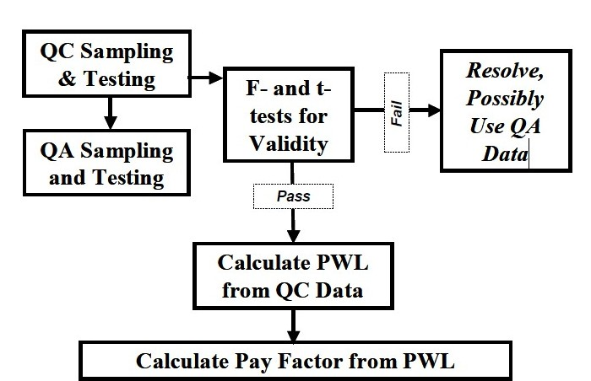

Figure 17 View of statistical QC/QA process (Hand and Epps 2006).

A key issue in QC and QA is the sampling process. This process has to be conducted properly so that the sample is representative of the placed mat. There are two phases of the sampling operation – selecting the sampling location and acquiring the material. FHWA supplement 23CFR637 recommends obtaining a sample as close to the work as possible. This means potentially sampling in the completed mat to ensure the mixture is most representative of the paved roadway. However, this disturbs the paved surface and contractors want to avoid potential penalties for smoothness (Elseifi, 2009). For example, Michigan DOT has a procedure that presents little damage to the paved surface while obtaining representative samples. Plates with affixed wires are put randomly beneath the to-be-placed lift. The material is shoveled out with a specially designed shovel from above the plates until sufficient quantities are obtained and back-fill HMA is replaced. Figure 18 and Figure 19 shows part of this process. Overall, many states successfully sample from the back of the paver and this is recommended (Elseifi, 2009).

Figure 18 Plates randomly placed under HMA mat

Figure 19 Shoveling material from above plates

For PWL determination, some specifications use just QC data, some use QA only, and others use a pooled combination of QC and QA data. Using QC data alone is recommended. Specification limits are normally selected using engineering judgment and a current limitation is the yet fully known relationship between measured quality of the pavement and long term performance of the pavement. This makes it impossible to rationally determine life cycle costs and equitably develop pay factors (Hand and Epps 2006).

Hand and Epps, 2006 recommend the following to minimize variability throughout the sampling and testing process:

- Require all laboratories conducting QC and QA testing to be AASHTO accredited;
- Require all technicians working of QC/QA projects to be certified, preferably by a national (NICET), regional (WAQTC), or state agency;
- Select sampling locations and sampling/splitting methods that result in the lowest amount of variability;
- Select test methods that result in the lowest amount of variability;
- Eliminate options within test methods to reduce between laboratory variability; and
- Use only QC rather than pooled QC and QA data.

“Each and every selection ultimately has an impact on final acceptance and payment. Therefore it is extremely important that QC/QA specifications be developed based on knowledge of all these items as well as experience with variation in each”.

REFERENCES

Al-Qadi, S. H. Carpenter, Z. Leng, H. Ozer, J. S. Trepanier, Tack Coat Optimization for HMA Overlays: Laboratory Testing, Illinois Department of Transportation, FHWA-ICT-08-023.

American Concrete Institute, “State-of-the-Art Report on Roller-Compacted Concrete
Pavements”, ACI 325.10R-95, 1995.

Asphalt Institute. A Basic Asphalt Emulsion Manual, Manual Series No. 19 (MS-19), the Asphalt Institute, Lexington, KY, 1987.

Barenberg, E. J. and M. R. Thompson, Lime-FlyAsh-Stabilized Bases and Subbases, NCHRP Synthesis of Highway Practice No. 37, Transportation Research Board, Washington, DC, 1976.

Bennert, T., Flexible Overlays for Rigid Pavements. Publication FHWA-NJ-2009-014, New Jersey Department of Transportation, 2010

Benson, J. S., J. A. Scherocman, Construction of Durable Longitudinal Joints, Transportation Research Circular, E-C105, Factors Affecting Compaction of Asphalt Pavements,
September 2006, pp 120-139.

Brown, E. R. Basics of Longitudinal Joint Compaction, Transportation Research Circular,
E-C105, Factors Affecting Compaction of Asphalt Pavements,
September 2006, pp 86-95.

Burati, J. L., R. M. Weed, C. S. Hughes, H. S. Hill, Publication FHWA-RD-02-095, Clemson University, 1995

Carpenter, S. H., M. R. Crovetti, K. L. Smith, E. H. Rmeili, and T. P. Wilson, Soil and Base Stabilization and Associated Drainage Considerations, Volume I: Pavement Design and Construction Considerations, FHWA-SA-93-004, Federal Highway Administration, Washington, DC, December 1992.

Darter, M. I., Report on the 1992 U.S. Tour of European Concrete Highways, Federal Highway Administration, FHWA-SA-93-012, Washington, DC, January 1993.

Decker, D. S., State-of-the-Practice for Cold-Weather Compaction of Hot-Mix Asphalt Pavements, Transportation Research Circular, E-C105, Factors Affecting Compaction of Asphalt Pavements, September 2006, pp 27-35.

Federal Highway Administration. Concrete Pavement Design Details and Construction Practices, NHI Course No. 131060, FHWA, 2001).

Elseifi, M. A., J. Trepanier, H. Wakefield, W. J. Pine, A. Dahhan, Hot-Mix Asphalt Sampling Techniques and Methods of Acceptance – State DOT’s Practice, Presented at 885h Annual Meeting of the Transportation Research Board,
Washington, D.C., 2009.

Elseifi, M. A, R. Bandaru, , Z. Zhang, Field Evaluation and Cost-Effectiveness of Saw and Seal Method to Control Reflection Cracking in Composite Pavements, Transportation Research Record: Journal of the Transportation Research Board, No. 1543, Transportation Research Board of the National Academies, Washington, D.C., 2011, pp. 33-42.

Grogg, M.G., and K.D. Smith. PCC Pavement Smoothness and Best Practices for Construction, Washington DC: Federal Highway Administration, 2001.

Hand, A. J. T., Epps, J. A., Fundamentals of Percent Within Limits and Quality Control–Quality
Assurance Compaction Specifications, Transportation Research Circular, E-C105, Factors Affecting Compaction of Asphalt Pavements, September 2006, pp 140-162.

Khazanovich, L., and Darter, M. Concrete Pavements for High-Volume Roads: Guidance Especially for First Time Concrete Pavement Users. 90th International Symposium on Concrete Roads. Istanbul, Turkey. April 4th, 2004.

Khazanovich, L., M. Darter, R. Bartlett, Common Characteristics of Good and Poorly Performing PCC Pavements. Washington, DC: Federal Highway Administration, 1997.

Khedaywi, T S, T. D. White, Effect of Segregation on Fatigue Performance of Asphalt Paving Mixtures, Transportation Research Record: Journal of the Transportation Research Board, No. 1543, Transportation Research Board of the National Academies, Washington, D.C., 1996, pp. 63-70.

Larson, R. M., S. Vanikar, and S. Forster, Summary Report—U.S. Tour of European Concrete Highways (U.S. TECH)—Follow-up Tour of Germany and Austria, Federal Highway Administration, FHWA-SA-93-080, Washington, DC, October 1993.

Lehmann, G., “Magnetic Tomography for Non-Destructive Testing and Process Control,” Proceedings from International Conference on Materials Testing and Research MAT 2001, ed. AMA Service GmbH, Nuremberg 2001, A.7.4, pp. 187 – 192.

Leng, Z., I. L. Al-Qadi, S. H. Carpenter, H. Ozer, Interface Bonding Between Hot-Mix Asphalt and Various Portland Cement Concrete Surfaces, Transportation Research Record: Journal of the Transportation Research Board, No. 2127, Transportation Research Board of the National Academies, Washington, D.C., 2009, pp. 20-28.

Luhr, D. Design and Construction of Roller-Compacted Concrete Pavements for Container Terminals. American Concrete Institute, Farmington Hills. 1995

Marchand, J., Gagne, R., Ouellet, E., and Lapage, S., “Mixture Proportioning of
Roller Compacted Concrete – A Review, Advance in Concrete Technology,Proceedings of the Third CANMET/ACI International Conference, SP 171,
Auckland, New Zealand, pp 457-485, 1997.

MLRRB, Minnesota Local Road Research Board, Best practices for Asphalt Paving,
http://www.lrrb.org/apg/bestpractice.htm#surface
Mohammed, L., Optimization of Tack Coat for HMA Placement, NCHRP Project 9-40, Final Report 712, Louisiana Transportation Center, Louisiana State , 2011

Okamoto, P. A., P. J. Nussbaum, K. D. Smith, M. I. Darter, T. P. Wilson, C. L. Wu, and S. D. Tayabji, Guidelines for Timing Contraction Joint Sawing and Earliest Loading for Concrete Pavements, Volume I—Final Report, FHWA-RD-91-079, Federal Highway Administration, Washington, DC, October 1991.

Piggott, R.W., “Roller Compacted Concrete Pavements – A Study of Long TermPerformance”, RP 366, Portland Cement Association, Skokie, Il., 1999.

Portland Cement Association. Roller Compacted Concrete. <http://www.cement.org/
pavements/pv_rcc.asp>. accessed May 15, 2012.

Portland Cement Association. Soil-Cement Construction Handbook, Engineering Bulletin EB003SC, Portland Cement Association, Skokie, IL, 1995.

Portland Cement Association. Soil-Cement Laboratory Handbook, Engineering Bulletin EB052SC, Portland Cement Association, Skokie, IL, 1992.

Portland Cement Association, Structural Design of Roller-Compacted Concrete for
Industrial Pavements, IS 233, Skokie, Il. 1987.

Portland Cement Association, Computer Program RCC-Pave, MC 043, Skokie, Il.,
2002.

Rao, S., Darter, M., Tompkins, D., Vancura, M., Khazanovich, L., Signore, J., Wu, R., Harvey, J., and J. Vandenbossche. SHRP2 R21 Composite Pavement Systems. Final Report. Transportation Research Board. 2011.

Schrader, E.K., “Roller-Compacted Concrete for Dams – State of the Art”, International Conference on Advances in Concrete Technology, Athens, Greece, May 1992.
Smith, K.D., M.J. Wade, D.G. Peshkin, L. Khazanovich, H.T. Yu, and M.I. Darter. (1996). Performance of Concrete Pavements, Volume II. Evaluation of In-service Concrete Pavements. FHWA-RD-95-110. Washington, DC: Federal Highway Administration.

Smith, K. L., K. D. Smith, L. D. Evans, T. E. Hoener, and M. I. Darter, “Smoothness Specifications for Pavements, Final Report, NCHRP 1-31, Transportation Research Board, Washington, D.C., 1997.

Transportation Research Board. Lime Stabilization: Reactions, Properties, Design, and Construction, Transportation Research Board, State of the Art Report 5, Washington, DC, 1987.

USACE, Hot-Mix Asphalt Paving Handbook, US Army Corps of Engineers (Document UN-13 CEMP-ET, 2000)

West, R., J. Zhang, and J. Moore, Evaluation of Bond Strength between Pavement Layers.
NCAT Report 05-08, Auburn, AL, 2005.

Wu R. J. Harvey, C. Monismith, Towards a Mechanistic Model for Reflective Cracking in Asphalt Concrete Overlays (With Discussion), Journal of the Association of Asphalt Paving Technologists, vol. 75, pp. 491-534, 2006

Appendix A

Interview with Stewart Krummen
Concrete Division Manager
C.S. McCrossan Construction, Inc
7865 Jefferson Highway
Maple Grove, Minnesota 55369

April 21, 2012

If a concrete contractor were to build identical thickness, side-by-side concrete pavements, but one of the pavements would not need to serve as a wear course (i.e. you would come back in a few weeks and overlay it with 1-2 inches of asphalt), what, operationally, could you or would you do differently? Finishing? Compaction? Paver speed and/or control? Curing? Others?
The concrete would still need to be cured.
We would not need to texture, but still need the texture/curing machine and operator to cure so really little to no savings.
The paver speed and production would be the same as it is limited on mainline paving projects by our plant productivity (simply cannot go faster than we are already without bigger plant).
If the designer was less concerned about sealing the surface, we may be able to eliminate two finishers at a cost of $1200/day or ~$0.10/sy
We would not need to have a finisher to imprint the rumble strips saving ~$0.05/sy
We would not need to seal the pavement which would save ~$1.00/sy (varies widely depending on type of sealant required from Hot Pour to Pre-Formed)
We would not need to grind for smoothness which may save $0.05-0.10/sy.
Interview with Shiraz Tayabji, Ph.D., P.E.
Senior Consultant
Fugro Consultants, Inc.
10130 Maxine Street
Ellicott City, Maryland 21042
May 3, 2012
If a concrete contractor were to build identical thickness, side-by-side concrete pavements, but one of the pavements would not need to serve as a wear course (i.e. you would come back in a few weeks and overlay it with 1-2 inches of asphalt), what, operationally, could you or would you do differently?
1. Paver speed and control?
PAVER SPEED AND CONTROL SHOULD BE SAME AS FOR CONVENTION CONCRETE. WE STILL WANT A GOOD QUALITY CONCRETE FOR THE BASE PAVEMENT.
2. Compaction?
COMPACTION SHOULD BE SAME AS FOR CONVENTION CONCRETE. WE STILL WANT A GOOD QUALITY CONCRETE FOR THE BASE PAVEMENT.
3. Finishing?
EXTRA FINISHING IS NOT REQUIRED TO GET THE PCC SURFACE TO BE VERY SMOOTH TO QUALIFY FOR PAY INCENTIVES. PAY INCENTIVE FOR SMOOTHNESS SHOULD BE BASED ON THE FINAL AC SURFACE SMOOTHNESS. HOWEVER PCC EDGES SHOULD BE MAINTAINED VERTICAL AND SLOPPY EDGES MUST NOT BE ALLOWED OR ACCEPTED.
4. Texturing?
TEXTURING SHOULD BE MODIFIED TO ALLOW FOR BETTER INTERLOCKING OF THE AC TO THE PCC SURFACE.
5. Curing?
CURING NEEDS TO BE MODIFIED. NO WAX-BASED CURING. AC NEEDS TO “BOND” TO THE AC SURFACE. SHOULD INVESTIGATE DIRECT APPLICATION OF AN AC-BASED PRIME COAT THAT CAN BE APPLIED ON WET PCC SURFACE THAT CAN EFFECTIVELY SEAL THE PCC SURFACE AND EDGES. BUT IT NEED TO BE DRY IN FEW HOURS TO ALLOW SAWING OPERATION. IF CONVENTIONAL CURING IS USED, IT MAT NEED TO BE REMOVED BY SAND-BLASTING TO ENSURE GOOD BONDING BETWEEN THE AC AND THE PCC SURFACE. OTHERWISE, THERE IS A RISK OF EARLY AC DELAMINATION.
6. Joint sawing
SHOULD FOLLW THE SAME PROCESS AS FOR CONVENTIONAL CONCRETE WITH RESPECT TO TIMING AND DEPTH OF CUT FOR BOTH LONGITUNAL AND TRANSVERSE JOINTS.
7. Others?
JOINT SAWING IN AC MUST BE DONE AS SOON AS POSSIBLE AND OVER THE PCCP JOINTS, OTHERWISE THERE IS A RISK OF REFLECTION CRACKING AT JOINT OFFSET LOCATIONS.
Furthermore, what are your thoughts regarding the use of roller-compacted concrete pavement if it would not be used as the wear coarse?
BEST COMPOSITE SYSTEM WITH RESPECT TO COST AND PERFORMANCE AND CONTRACTOR EXPEDIENCY. AC CONTRACTOR CAN PLACE RCC WITH THE EQUIPMENT HE WILL BE USING FOR THE AC PLACEMENT. HOWEVER, F/T DURABILITY OF THE RCC BELOW AC NEEDS TO BE INVESTIGATED. LESS LENGTH (TIMEWISE) OF LANE CLOSURE IF IT IS REHAB PROJECT.
NOTE: A JOINTED RCCP WILL BEHAVE SIMILARLY TO A JOINTED CONCRETE PAVEMENT, ONLY THE METHOD OF CONSTRUCTION IS DIFFERENT. HOWEVER, RCCP WOULD NOT BE A GOOD OPTION FOR HEAVT TRUCK TRAFFIC ROADWAYS IF DOWEL ARE REQUIRED AT JOINTS. WE CANNOT INSTALL DOWEL BARS IN RCCP.
1. Could the paving be done more quickly?
YES, AS THERE WOULD BE NO NEED TO WAIT FOR CONCRETE TO ATTAIN STRENGTH. THE AC LAYER CAN BE PLACED RIGHT BEHIND THE CONCRETE PLACEMENT AS SOON AS THE RCC JOINT SAWING IS DONE. THIS PRACTICE HAS BEEN USED IN EUROPE (SPAIN) AND IN CANADA. AND NON-TRUCK TRAFFIC CAN BE PUT ON THE ROADWAY AS SOON AS THE AC LAYER IS READY TO BE TRAFFICKED. SO, THE CONSTRUCTION TIME CAN BE REDUCED AND OVERALL COST WOULD BE LOWER, BY 15 to 20%, DEPENDING ON PROJECT SIZE.
2. Would it require less labor? (running the paver, finishing?)
YES, AN AC PAVER IS STILL REQUIRED PLUS COMPACTION EQUIPMENT.
3. Would the concrete cost less?
YES, DEPENDING ON AVAILABILITY OF NEARBY CONCRETE PLANTS OR CONTRACTOR SET UP PLANT.

