TRANSPORTATION POOLED FUND PROGRAM
QUARTERLY PROGRESS REPORT

Lead Agency: ---- Utah Department of Transportation ----

INSTRUCTIONS:
Project Managers and/or research project investigators should complete a quarterly progress report for each calendar quarter during which the projects are active. Please provide a project schedule status of the research activities tied to each task that is defined in the proposal; a percentage completion of each task; a concise discussion (2 or 3 sentences) of the current status, including accomplishments and problems encountered, if any. List all tasks, even if no work was done during this period.

Transportation Pooled Fund Program Project #  TPF-5(257) |  | Transportation Pooled Fund Program - Report Period:  _ Quarter 1 (January 1 – March 31)  _ Quarter 2 (April 1 – June 30)  _ Quarter 3 (July 1 – September 30)  X Quarter 4 (October 1 – December 31, 2013)

Project Title: Evaluation of Spliced Sleeve Connections for Precast RC Bridge Piers

Name of Project Manager(s):  Russ Scovil | Phone Number:  801-965-4097 |  | E-Mail  Rgscovil@utah.gov
Lead Agency Project ID:  5H06604H, UT11.502 | Other Project ID (i.e., contract #):  12-8775 |  | Project Start Date:  3/23/2012
Original Project End Date:  3/30/2013 | Current Project End Date:  6/30/2014 |  | Number of Extensions:  2

Project schedule status:

_ On schedule X_ On revised schedule _ Ahead of schedule _ Behind schedule

Overall Project Statistics:
Total Project Budget | Total Cost to Date for Project | Percentage of Work  Completed to Date
$175,848 | $143,000 | 81%

Quarterly Project Statistics:
Total Project Expenses  and Percentage This Quarter | Total Amount of Funds  Expended This Quarter | Total Percentage of  Time Used to Date
$4,000 / 2% | $4,000 | 78%

Project Description:
Sleeved connections are being considered as one of the methods for connecting precast concrete bridge elements. The purpose of this project is to perform experiments to evaluate the performance of a sleeved connection between a reinforced concrete bridge column and a bridge footing (Type I) or a reinforced concrete bridge column and a bridge bent cap (Type II) in a seismic area. This information is very valuable for construction of bridges using Accelerated Bridge Construction in areas with high seismic activity.

Progress this Quarter (includes meetings, work plan status, contract status, significant progress, etc.):

Project Progress: This quarter the project was focused on testing the two monolithic control specimens, the
column to footing connection (Figure 1) and the column to bent cap connection (Figure 2).

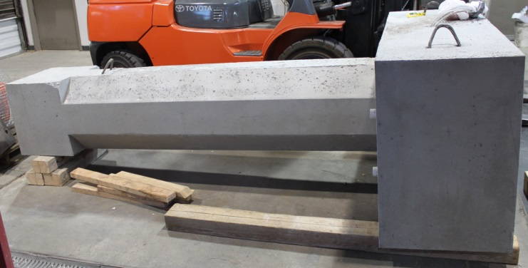
Figure 1. Column to footing monolithic connection.

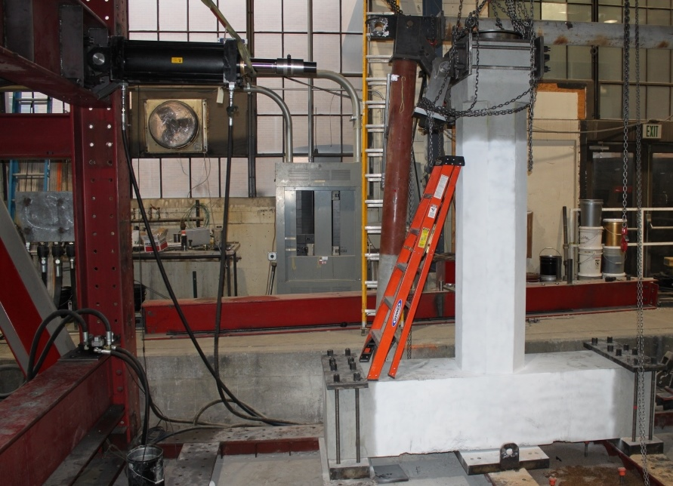
Figure 2. Column to bent cap monolithic connection placed inside the load frame.

Simulations of the predicted load and displacement that would cause failure of the monolithic control specimens showed
that the existing actuators would not have enough displacement stroke. For this reason, a new actuator was purchased
using University of Utah funds. The new actuator has a capacity of 250 kips load and 24 in. stroke and was shown
assembled in the load frame in Figures 2 and 3. However, in order for the actuator to operate there needs to be a new servovalve, as shown in Figure 4(a), and a new load cell, as shown in Figure 4(b). In addition, a new transition rod had to
be manufactured for the exact length, as shown in Figure 4(b) so that the assembly would reach the specimen.

Since these items had to be purchased or manufactured, the two monolithic tests were delayed. However, the assembly is almost complete and it is anticipated that the two monolithic specimens will be tested next quarter.

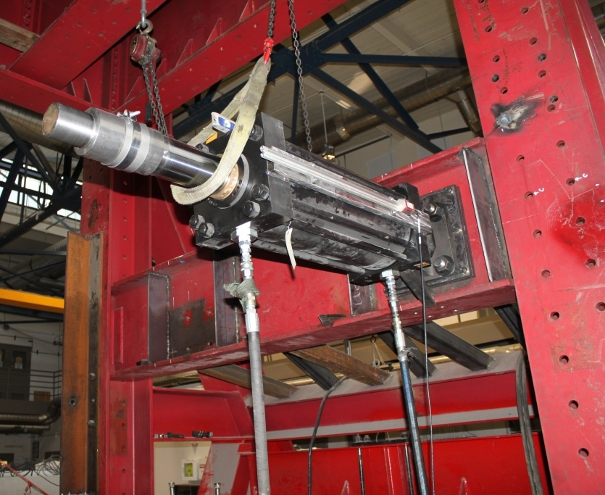
Figure 3. New actuator.

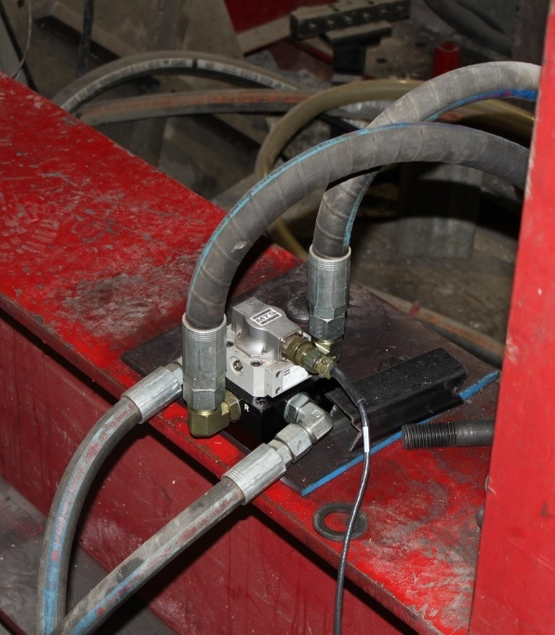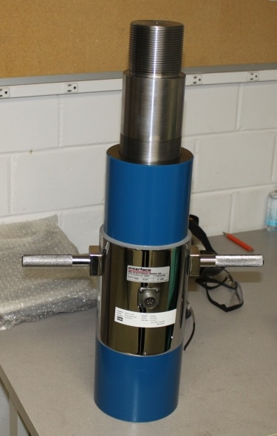
- (b)
Figure 4. Additional actuator hardware: (a) servovalve, (b) load cell and transition rod.

Project Status: The two monolithic specimens have been built and will be tested during the next quarter. The
percentage completion for each task is as follows:

Task 1: Review Existing Experimental Results for Sleeved Connections: 100% Complete
Task 2: Build Precast Columns, Footings and Cap Beams for Tests: 100% Complete
Task 3: Test Column to Footing Connections (Type I): 100% Complete
Task 4: Test Column to Cap Beam Connections (Type II): 100% Complete
Task 5: Test Column to Footing Monolithic Cast-In-Place Connection
and Column to Cap Beam Monolithic Cast-In-Place Connection: 0% Complete

Anticipated work next quarter:
It is anticipated that in Quarter 8, the two monolithic cast-in-place connections (one column to footing and one column to cap beam) will be tested. It is also anticipated that work will begin on completing the deliverables for the project.

Significant Results:
The six spliced connections have been tested and the final comparisons between the tests are currently being carried out.
With the completion of the monolithic tests next quarter, the experimental work will be complete and comparisons of the
spliced connection test results with the monolithic test results will also be carried out.
Circumstance affecting project or budget. (Please describe any challenges encountered or anticipated that
might affect the completion of the project within the time, scope and fiscal constraints set forth in the
agreement, along with recommended solutions to those problems).
With the purchase and installation of the new actuator to carry out the two monolithic tests, as described previously it is anticipated that the project will be completed on time.

Potential Implementation:
It is anticipated the Utah DOT will implement the findings of this research once it is completed in Accelerated
Bridge Construction (ABC). It is likely that the New York State Department of Transportation and the Texas Department
of Transportation will be able to implement them as well.

