International Conference on Ecology & Transportation (ICOET) Pooled Fund TPF 5-434

There have been ten biennial International Conferences on Ecology and Transportation (ICOET) since its origin in 1999. The most recent conference was held in Sacramento, California September 22-26, 2019 co-hosted by the California Department of Transportation (Cal Trans) and the California Department of Fish and Wildlife with support from the Federal Highway Administration (FHWA) and the National Center for Sustainable Transportation. The conference was organized by the Road Ecology Center at the University of California – Davis (UC Davis). The 2019 conference had 582 participants from 14 countries. There were a total of 132 presentations given and 122 posters made for the conference.

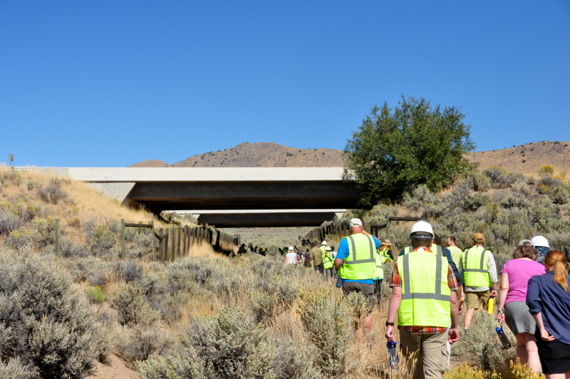

ICOET is one of the foremost multi-disciplinary bringing biologists, engineers, planners and others together to address the wide range of ecological issues related to transportation systems. Experts gathered to share the most current research information, quality applications and best management practices that can enhance the ecological sustainability of transportation systems. The folks that regularly attend ICOET represent hundreds of professionals that work for government, Tribal, academic, non-governmental and private industry from the United States and other countries.

The current ICOET pooled fund will be completed by January 30, 2020 and a new pooled fund will start solicitation for the next conference in Vermont in 2021 hosted by the Vermont Agency of Transportation (VTrans).

