Quarterly Progress Report (QPR)

Applications of Enterprise GIS in Transportation
Progress Report for Quarter 5 [October 1st 2020 – December 30th, 2020]
WSP Program Manager: Jag Mallela (jag.mallela@wsp.com)
WSP Technical Lead: Abhishek Bhargava (abhishek.bhargava@wsp.com)
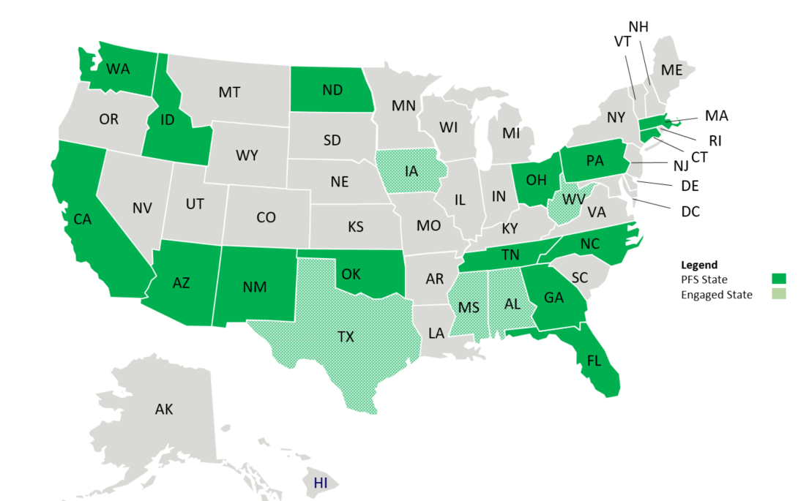
Background
The Pooled Fund Study (PFS) on Applications of Enterprise GIS in Transportation (AEGIST) was initiated by FHWA in 2018. During Phase 1 of this study a guidebook was developed for transportation agencies in the United States, with the primary objective of documenting guidance on how spatial and linear referenced data should be managed by States. Phase 2 of this PFS was initiated in October 2019. This phase will span over 5 years (October 2019 – September 2024), during which the objectives outlined below would be accomplished.
Objectives
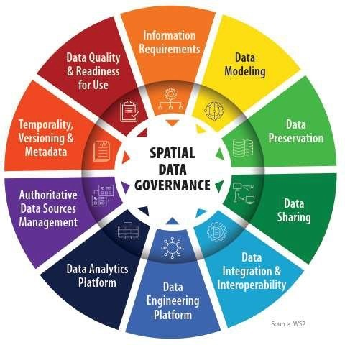
- Establish a standard for managing and governing data in spatial and linear referencing systems at transportation agencies, including but not limited to routes, intersections, interchanges, roundabouts, road segments, roadway characteristics, infrastructure assets, model inventory of roadway elements (MIRE), HPMS data items and ARNOLD road network.
- Develop guidance for States for engineering spatial transportation data and preparing it for sharing and provisioning at the enterprise level, across various business functions and stakeholders at the DOT and their Federal, State and Local partners.
- Conduct a series of webinars, workshops, peer exchange meetings and provide consulting services to the States participating in the pooled fund to develop national standards in data modeling and management; enhance existing enterprise GIS systems at these agencies.
- Update the AEGIST Guidebook that was prepared in Phase 1, by documenting best practices, patterns and similarities across agencies in managing spatial data using enterprise data systems, including but not limited to Asset Management Systems, Traffic and Safety Systems, Project Planning and Programming Systems, Design and Construction Systems, and GIS and Linear Referencing Systems (LRS).
- Collaborate with States to enhance and develop spatial data management systems, processes, platforms to establish a structured and systematic approach for management of spatial data. This would involve establishing spatial data governance systems, business rules, applications, tools and platforms for:
  - Spatial Data Modeling
  - Spatial Data Integration and Engineering
  - Spatial Data Analytics

Completion Status and Summary
Time Frame: October 1, 2019 to December 30, 2024
Total Time, months: 60
Time Expended, months: 15
Percent Calendar Time Expended: 25%
Work Accomplished This Reporting Period
Task 1: Project Management
Task Objective: Perform project management activities, which include conducting monthly status meetings, developing quarterly status reports, creating project work plan, managing project resources, schedule, deliverables and communication with all stakeholders.
Work Accomplished: Following activities were performed in the reporting period:
- Quarterly progress report development. Quarterly meeting with PFS States on Dec 18th. Topic of discussion: “Spatial Data Modeling: Business Use Patterns and Implications for Data Models”. More details on the meeting can be found here. http://gisintransportation.com/workshops-meetings/pfs-states-quarterly-meeting-4-spatial-data-modeling-business-use-patterns-and-implications-for-data-models/
- Meeting with FHWA to prioritize tasks and discuss approach for creation of work plans with States.
- Reached out to PFS States (CT, TN) to discuss timing and scope of technical services that need to be provided to the States as part of the AEGIST project. Established work plan items with CT. Setup monthly cadence for strategic work planning meeting with Tennessee.

Task 2: Technical Services
Task Objective: Provide technical services associated to PFS States by completing various agency-specific and cross-agency activities identified in the work plan.
Work Accomplished: Following activities were performed in the reporting period:
- Task 2.1:
- Analysis of routes & intersection data modeling rules and practices at Kansas DOT, Pennsylvania DOT.
- Review of the open standards (GMNS, Open Street Map and Shared Streets) for roads network modeling.
- Analysis of Statewide GIS Network models created and used in Travel Demand Modeling Systems such as Emme, TransCAD, Cube by agencies/stakeholders at Ohio DOT, Chicago and New York City. Review of practices and modeling rules for single/dual carriageways, concurrent routes, turn segments, topological connectors.
- Identifying business user requirements in following areas for modeling of road network, intersections, road segments and spatial/linearly referenced assets. Findings were presented at the AEGIST Quarterly meeting in December to all PFS States.
  - Project Planning and Programming
  - Asset Management: Bridge, Pavement, Maintenance, Asset Resilience and Risk Analysis

- Task 2.2: Guidebook v2.0: Preparation of content on modeling of Routes & Intersections at DOTs based on findings in Task 2.1.

- Task 2.ID.x: Idaho Technical Services
- Task 2.ID.2: Spatial data governance – Data Portfolio Development, Review of Data Governance Principles and Steps in Bi-weekly work sessions. HPMS Data Quality Rules development for automation of quality checks and development of quality assessment dashboards.
- Task 2.ID.3: Development of conflation tool for integrating DOT LRS and BLM, USFS datasets;

- Task 2.CA.x: Idaho Technical Services
- Task 2.CA.1: Discussions with Caltrans, CalOES and Merced County on Road Network Data Sharing, Data rules development and alignment across agencies. Documentation of data sharing plan goals and objectives, sample data sharing rules and approach to set expectations and establish next steps.

- Task 2.TN.x: Tennessee DOT Technical Services
- Task 2.TN.1: Strategic Work Planning for Data Modeling, Data Integration and Governance - Following activities were carried out to develop the strategic work plan:
  - Four work sessions to discuss goals and objective, priorities and focus areas of TDOT
  - Review of R&Hs Deployment design, including eTRIMS migration documents
  - Review of business user interview documentation to identify goals, activities and next steps discussed with users in: Project Planning and Programming, Safety, Maintenance, Structures.
  - Strategic work plan template and approach preparation for establishing the framework, approach and scope for plan development.

Task 3: Marketing and Communication
Task Objective: Webinars and Workshops will be held, and Articles will be presented in conferences and other industry forums to communicate information about the activities of the project, especially the technical work products developed as part of the project.
Work Accomplished: Following activities were performed in the reporting period:
- Deliverable 3.1.1 – Article 1
Analysis of Safety and MIRE data from CTDOT to show impact of MIRE compliance on safety analysis & develop content for article on “Utilizing HPMS & MIRE compliant safety dataset for building econometric & machine learning models for safety analysis”.
- Compilation of list of Spatial Econometric and AI/ML models that have been created to explain the impact of MIRE variables on Safety Performance. Analysis of modeling techniques and approaches.
- Development of a geoprocessing tool for associating crashes with the LRS, i.e., using the Crash Route, latitude-longitude information to locate crashes on the LRS.
- GIS-T Presentation abstract prepared and submitted. Presentation to be made on April 22nd, 2021.

- Deliverable 3.2.2 – Presentations
- Esri Roads and Highways User Group (RHUG) Presentation (October 2020): AEGIST Goals and Objectives were presented to 35+ States at the RHUG Forum. Information on Enterprise Spatial Data Modeling and Integration, Spatial Data Governance was shared. Few States (e.g.: West Virginia) expressed interest in joining the AEGIST pooled fund study after the workshop. More details about the presentation and recording can be found here: RHUG Presentation on AEGIST Vision and Goals
- AEGIST Modeling and Standards, Presentation to FHWA (December 2020): During this meeting, a presentation was made at FHWA to various stakeholders on how AEGIST is handling spatial data modeling, integration and governance. Specific emphasis was laid on alignment of AEGIST spatial data models with open standards such as those from OGC, W3C, IFC, NG911, USGS and GMNS.
- A discussion on AEGIST Goals, Objectives and Vision was held with Iowa DOT after the AEGIST presentation at the RHUG meeting in October.

- Deliverable 3.3.1 – AEGIST Webinar 1
Started planning of the webinar. Prepared goals and objectives. Reached out to States to identify presenters.
Task 5: HPMS Remodeling Support Services
Task Objective: HPMS 9.0 Remodeling Support services
Work Accomplished: Following activities were performed in the reporting period:
- Established business use cases and user requirements for roads and intersection data models
- Compared open standard data models: Open Street Maps, GMNS, NG911 to determine Routes data Model Structure and business rules that should be taken into consideration during HPMS remodeling. Specifically, requirements were established for modeling of single/dual carriageways, parent-child relationship modeling for concurrent routes and handling of HPMS data items.

Work Planned for Next Quarter: January – March 2021
Task 1: Project Management
Task Objective: Perform project management activities, which include conducting monthly status meetings, developing quarterly status reports, creating project work plan, managing project resources, schedule, deliverables and communication with all stakeholders.
Activities:
- Establishing agenda and plan for 2021 Quarterly meetings with the PFS States. Sending calendar invites to States.
- Conduct Quarterly Meeting Meeting 5 with PFS States in March 2021
- Establishing AEGIST Spatial Data Management & Governance Vision and communicating to State DOT Data Offices
- AEGIST Quarterly Report #5 publication for the period (January – March 2021)

Task 2: Technical Services
Task Objective: Provide technical services associated to PFS States by completing various agency-specific and cross-agency activities identified in the work plan.
Activities:
- Idaho:
  - Task 2.ID.2: Spatial data governance presentations, planning and envisioning for deployment at the DOT. Using Data Portfolio for Spatial Data Governance. Creating and Deploying HPMS Data Quality Rules on Idaho’s Data Engineering Platform.
  - Task 2.ID.3: Conflation of Federal Roads data with DOT LRS and County Roads data.
- California
  - Roads Data sharing business rules and agreements between Caltrans, CalOES and local agencies. Creating draft templating, reviewing rules being used for modeling across the agencies. Comparison of data modeling attributes and rules and creation of data sharing architecture.
  - Deployment of data rules at Caltrans using 1Spatial – Design and Architecture. Establishing system access and prototyping environment.
- Tennessee
  - 2.TN.1: Strategic work planning. Preparing a 5-year roadmap for spatial data integration, data modeling, management and governance at the enterprise level, with specific emphasis on how LRS-GIS systems are to be deployed and data needs to be provisioned for use across the enterprise.
- Connecticut
  - 2.CT.1: HPMS data quality rules configuration in FME.
- Pennsylvania
  - 2.PA.2: Traffic Count Site Selection Algorithm – Review of the clustering algorithm created by PennDOT Traffic group for selection of temporary traffic count sites samples.
  - 2.PA.1: Strategic plan for spatial data integration, data modeling, management and governance at the enterprise level, with specific emphasis on LRS-GIS system deployment and data modeling.

Task 3: Marketing and Communication
Task Objective: Webinars and Workshops will be held, and Articles will be presented in conferences and other industry forums to communicate information about the activities of the project, especially the technical work products developed as part of the project.
Activities:
- Presentations to non-PFS States on AEGIST activities, vision and goals
- Presentations to FHWA Division Offices, USDOT and other FHWA Stakeholders on AEGIST activities
- Webinar 1: Feb 11th 2021 – Spatial Data Governance for supporting Enterprise Business Users and Systems
- GIS-T 2021 AEGIST Workshop: Spatial Data Modeling for Roads, Intersections, Roadway Characteristics. Building Routable Network with Road Segments, Junctions and Intersections
Task 5: HPMS Remodeling Support Services
Task Objective: HPMS 9.0 Remodeling Support services
Activities: Develop HPMS 9.0 data model, with temporality and topological features and MIRE attributes.
Complete List of Base Period Deliverables
Note: Deliverables on which work is complete (in green) and work is in progress (in orange).
Task | D# | Deliverable Name | Due Date | Status
Task 1 | 1.1.0 | Kick-off Meeting | 10/30/19 | Completed.
Task 1 | 1.2.0 | Work Plan Version 1: Cross-Agency Tasks, Deliverables & Schedule | 4/30/20 | Completed. Submitted to FHWA and PFS States.
Task 1 | 1.3.1 | Quarterly Progress Report - 1 (incl. 3 monthly reports and quarterly meetings) | 12/31/19 | Completed. Submitted to FHWA. Email sent to PFS States.
Task 1 | 1.3.2 | Quarterly Progress Report - 2 (incl. 3 monthly reports and quarterly meetings) | 3/31/20 | Completed. Submitted to FHWA.  Email sent to PFS States.
Task 1 | 1.3.3 | Quarterly Progress Report - 3 (incl. 3 monthly reports and quarterly meetings) | 6/30/20 | MPR for April, May, June published.  QPR-3 (April-June) published.
Task 1 | 1.3.4 | Quarterly Progress Report - 4 (incl. 3 monthly reports and quarterly meetings) | 9/30/20 | MPR for July and August prepared. QPR-4 (this QPR Submitted)
Task 1 | 1.3.5 | Quarterly Progress Report - 5 (incl. quarterly meetings) | 12/31/20 | QPR-5 prepared. QTR Meeting (Dec 2020)
Task 1 | 1.3.6 | Quarterly Progress Report - 6 (incl. quarterly meetings) | 3/31/21 | Not Started
Task 1 | 1.3.7 | Quarterly Progress Report - 7 (incl. quarterly meetings) | 6/30/21 | Not Started
Task 2 | 2.1 | TASK 2 Technical Services (incl. Work Plan v1.1 with State Tasks) - MONTH 8 - MAY 2020 | 5/30/20 | Work Plan v1.1 has Caltrans Tasks.  May 29th PFS States Presentation.
Task 2 | 2.2 | TASK 2 Technical Services (incl. Work Plan v1.2 with State Tasks) - MONTH 9 - JUN 2020 | 6/30/20 | Work Plan v1.2 has CA, GA, ID Tasks.  June 16th PFS States Presentation.
Task 2 | 2.3 | TASK 2 Technical Services (incl. Work Plan v1.3 with State Tasks) - MONTH 10 - JUL 2020 | 7/30/20 | Work Plan v1.3 with ID Task updates. Weekly work planning with Idaho.
Task 2 | 2.4 | TASK 2 Technical Services (incl. Work Plan v1.4 with State Tasks) - MONTH 11 - AUG 2020 | 8/30/20 | Work Plan v1.4. Tasks 2.1, 2.2, 2.ID.1
Task 2 | 2.5 | TASK 2 Technical Services (incl. Work Plan v1.5 with State Tasks) - MONTH 12 - SEP 2020 | 9/30/20 | Work Plan v1.5 with ID Task updates.  Tasks 2.1, 2.2, 2.ID.2 and 2.ID.3
Task 2 | 2.6 | TASK 2 Technical Services (incl. Work Plan v1.6 with State Tasks) - MONTH 13 - OCT 2020 | 10/30/20 | Work Plan v1.6 with ID task updates.
Task 2 | 2.7 | TASK 2 Technical Services (incl. Work Plan v1.7 with State Tasks) - MONTH 14 - NOV 2020 | 11/30/20 | Work Plan v1.7 with CT and TN task updates
Task 2 | 2.8 | TASK 2 Technical Services (incl. Work Plan v1.8 with State Tasks) - MONTH 15 - DEC 2020 | 12/30/20 | Work Plan v1.8 with updates and progress report for ID, CT, TN and CA.
Task 2 | 2.9 | TASK 2 Technical Services (incl. Work Plan v1.9 with State Tasks) - MONTH 16 - JAN 2020 | 1/20/21 | Not Started
Task 2 | 2.10 | TASK 2 Technical Services (incl. Work Plan v1.92 with State Tasks) - MONTH 17 - FEB 2020 | 2/28/21 | Not Started
Task 2 | 2.11 | TASK 2 Technical Services (incl. Work Plan v1.94 with State Tasks) - MONTH 18 - MAR 2020 | 3/20/21 | Not Started
Task 2 | 2.12 | TASK 2 Technical Services (incl. Work Plan v1.98 with State Tasks) - MONTH 19 - APR 2020 | 4/30/21 | Not Started
Task 2 | 2.13 | TASK 2 Technical Services (incl. Work Plan v2.0 with State Tasks) - MONTH 20 - MAY 2021 | 5/30/21 | Not Started
Task 3 | 3.1.1 | Article 1 | 6/30/20 | Draft writeup, data analysis in progress
Task 3 | 3.2.1 | Workshop 1 - GIS-T 2021 | 4/30/21 | GIS-T-2020 replaced by GIS-T-2021.
Task 3 | 3.2.2 | Workshop or Presentations 2 | 12/30/20 | NY (Apr); TRF (Aug); KS (Jun); National Roads Symposium (Sep); Esri RHUG (Oct), AEGIST Modeling & Standards (Dec).
Task 3 | 3.2.3 | Workshop 3 | TBD | Not Started
Task 3 | 3.3.1 | Webinar 1 | 2/11/21 | Started Planning.
Task 4 | 4.1.0 | Peer-Exchange 1 - 2019 | 12/30/19 | Completed.
Task 4 | 4.2.0 | Peer-Exchange 2 - 2020 | 12/30/20 | Aug 25th-26th Peer Exchange Conducted.
Task 5 | 5.0 | HPMS 9.0 Remodeling Report/Article Database Design | 5/30/21 | In-Progress

