TRANSPORTATION POOLED FUND PROGRAM
QUARTERLY PROGRESS REPORT

Lead Agency: Utah Department of Transportation

INSTRUCTIONS:
Project Managers and/or research project investigators should complete a quarterly progress report for each calendar quarter during which the projects are active. Please provide a project schedule status of the research activities tied to each task that is defined in the proposal; a percentage completion of each task; a concise discussion (2 or 3 sentences) of the current status, including accomplishments and problems encountered, if any. List all tasks, even if no work was done during this period.

Transportation Pooled Fund Program Project #  TPF-5(244) |  | Transportation Pooled Fund Program - Report Period:  _ Quarter 1 (January 1 – March 31, 2016)  _ Quarter 2 (April 1 – June 30, 2016)  _ Quarter 3 (July 1 – September 30, 2016)  x Quarter 4 (October 1 – December 31, 2016)
Project Title:
Shaking Table Testing to Evaluate Effectiveness of Vertical Drains for Liquefaction Mitigation

Name of Project Manager(s):  David Stevens | Phone Number:  801-589-8340 |  | E-Mail  davidstevens@utah.gov
Lead Agency Project ID:  FINET 42046, ePM PIN 9933  UDOT PIC No. UT07.708 | Other Project ID (i.e., contract #):  UDOT Contract No. 138731 |  | Project Start Date:  May 1, 2013
Original Project End Date:  March 31, 2016 | Current Project End Date:  June 30, 2017 |  | Number of Extensions:  2

Project schedule status:

_ On schedule X On revised schedule _ Ahead of schedule _ Behind schedule

Overall Project Statistics:
Total Project Budget | Total Cost to Date for Project | Percentage of Work  Completed to Date
$115,000.00 | $61,500.00 | 60%

Quarterly Project Statistics:
Total Project Expenses  and Percentage This Quarter | Total Amount of Funds  Expended This Quarter | Total Percentage of  Time Used to Date
0% | $0 | 85%

Project Description:

The vision for this study is to determine the viability of large diameter (100 mm) prefabricated vertical drains for preventing liquefaction and associated settlements or lateral spreading under full-scale conditions. If viable, drainage alternatives offer substantial advantages in comparison to conventional densification approaches. In production, drains can often be installed at 25% to 40% of the cost of stone columns. In addition, the drains can be installed in about one-third to one-half of the time required for stone columns. Finally, the time and cost associated with post-treatment in-situ testing to evaluate improvement produced by densification may not be required with drains. In an era when construction budgets are becoming increasingly tight and projects are increasingly placed on fast-track schedules, innovative alternative solutions are required to deal with liquefaction hazards.

Although limited blast liquefaction testing (Rollins et al. 2003, Rollins et al. 2004), vibration testing (Chang et al. 2004) and centrifuge testing (Yang et al. 2004 ) suggest that vertical drains can be effective, no full-scale drain installation has been subjected to earthquake induced ground motions. This lack of performance data under full-scale conditions has been a major impediment to expanding the use of this technique. To remedy this problem we will conduct full-scale tests with vertical drains in liquefiable sand using the laminar shear box and high speed actuator system at NEES-Univ. at Buffalo. Tests will involve level ground conditions with two drain spacings and will be integrated with a previously funded NEESR study currently underway so that the control tests without drains will already be available. We will use the same sand installation techniques, as well as the same instrumentation plan and shaking protocols which have already been developed and proven successful. This collaborative approach will significantly reduce the cost of the study in comparison to a completely independent study. In addition, it will provide a comparison between the performance of the soil profile with drains relative to subsequent tests where piles will be involved. If full-scale tests prove the effectiveness of the drainage technique, significant time and costs savings can be achieved for both new construction and for retrofit situations.

Three objectives are outlined for this study:
1. Evaluate the ability of earthquake drains to reduce excess pore pressure and settlement for level ground conditions at progressively higher acceleration levels.
2. Define the influence of drain spacing on the effectiveness of the drains for mitigating liquefaction hazard.
3. Provide well-documented case histories which can be used to calibrate/validate numerical models for predicting the performance of vertical drains.

The scope of work consists of eight specific tasks:
1. Perform a literature review to summarize the state of the art in the area of liquefaction mitigation through drainage.
2. Conduct level ground shaking table tests with drains at 4 ft spacing.
3. Conduct level ground shaking table tests with drains at 3 ft spacing.
4. Reduce the test data, analyze, and compare with previous test on untreated sand.
5. Evaluate predictive methods by comparing measured behavior with behavior computed using computer models and simplified models.
6. Prepare a final report on effectiveness of the drain technique.
7. Disseminate the research results.
8. Hold technical advisory committee meetings.

Dr. Kyle Rollins of BYU is the Principal Investigator for this research project. The TPF-5(244) testing was performed at the SUNY-Buffalo shaking table testing facility in the summer of 2014. BYU was approved for shared-use status on the NEES-Buffalo shake table. Individual task reports will be prepared for Tasks 1 through 5 when these are completed. Up to two in-person meetings with the multi-state technical advisory committee (TAC) are planned to be held in Salt Lake City, Utah during the project. Other TAC meetings will be tele-conference or web meetings.

Progress this Quarter (includes meetings, work plan status, contract status, significant progress, etc.):

Task 1 – 100% complete.
Task 2 – 100% complete.
Task 3 – 100% complete.
Task 4 – 100% complete. Summary report was reviewed by the TAC and revised by BYU.
Task 5 – 60% complete. BYU continued evaluating predictive methods.
Task 6 – 30% complete. BYU prepared portions of the final report.
Task 7 – No work yet.
Task 8 – 40% complete.
Contract – Extended the contract end date to allow for report completion and reviews.

Anticipated work next quarter:

Task 1 – None.
Task 2 – None.
Task 3 – None.
Task 4 – Post the revised task report on the TPF website.
Task 5 – Continue with evaluating predictive methods.
Task 6 – Continue preparing portions of the final report.
Task 7 – None.
Task 8 – Plan to hold another TAC web-conference to review and discuss additional results from the study. Consider having Dr. Rollins travel to each participating state to present final results as states consider how best to implement the research results.
Contract – No adjustment planned.

Significant Results:

Refinement of Excess Pore pressure prediction

During the past quarter, additional progress has been made in modeling the measured buildup and dissipation of excess pore pressures observed in the laminar box testing. Reasonable agreement with the results from the various tests have been obtained by adjusting three parameters: the hydraulic conductivity, the modulus of compressibility, and the number of cycles to liquefaction. The hydraulic conductivity was fairly well constrained and the measured values for each test were typically employed directly. With respect to the modulus of compressibility, an average value for the entire layer was initially employed. Although this approach provided reasonable agreement with the average pore pressure response, it consistently overestimated the performance of the drains at shallow depth but underestimated the performance at greater depths. To achieve better agreement, it was necessary to reduce the compressibility with depth. Parametric studies are now being performed to evaluate this behavior in more detail. As expected the compressibility back-calculated for the sand in the laminar shear box is about five times higher than that observed in tests reported by Pestana in the FEQDrain manual because of the loose nature of the water pluviated sand in the box.

Development of G/Go Curves Considering Pore Pressure

Using displacement and acceleration data measured at each ring of the laminar shear box, the cyclic shear strain and cyclic shear stress were computed for each cycle of loading at the elevation of the pore pressure transducers for nine of the shaking tests performed. Cyclic shear stress vs. shear strain curves were then used to compute the shear modulus for each cycle and the shear modulus was normalized by the shear modulus at a strain of 0.0001 strain based on shear wave velocity tests. The G/Go data points typically lie within the strain range from 0.01% to 10%. To provide additional data points for G/Go data points at smaller strain levels, shear wave velocity measurements after a number of blast induced liquefaction tests are plotted at a strain level of 0.0001%. Data were separated into nine bins based on excess pore pressure ratio and curves were fit to the data. The curves for each range are plotted in Fig.1 in comparison with the typical range of data for sands with an R_{u}=0 developed from triaxial shear tests by Seed et al (1986). An increase in Ru clearly reduces the G/Go versus cyclic shear strain curve relative to the non-liquefied case. This set of curves could be used in modeling the behavior of sand following liquefaction.
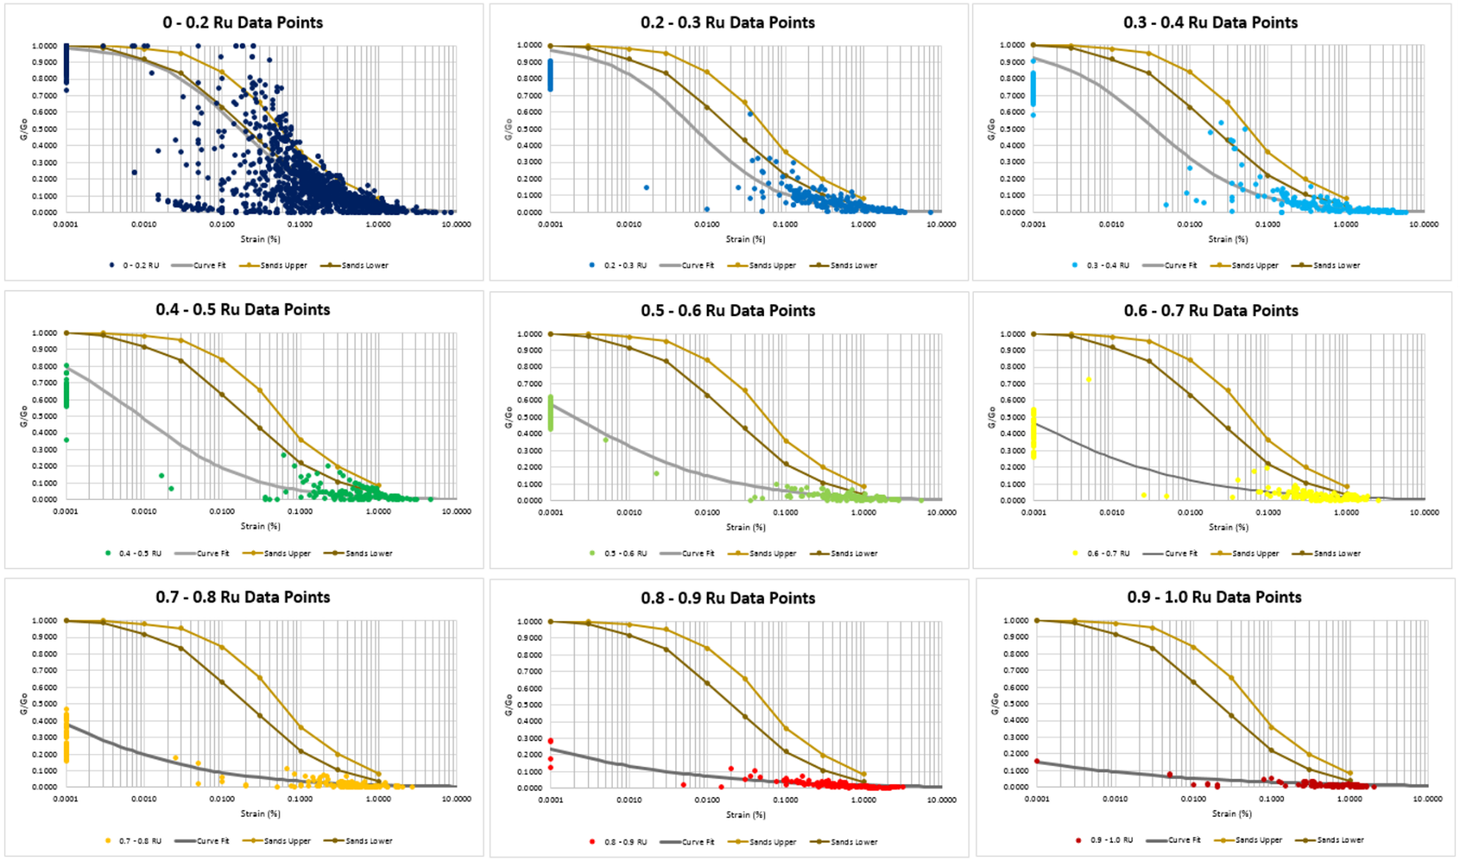

Fig. 1 G/G_{o} vs cyclic shear strain data points from laminar shear box tests with data separated into nine bins based on Ru% in comparison with curves developed from cyclic triaxial shear tests with R_{u} = 0% (Seed et al 1986). Data points for G/Go from shear wave velocity testing in blast liquefaction tests are also shown.

Circumstance affecting project or budget. (Please describe any challenges encountered or anticipated that
might affect the completion of the project within the time, scope and fiscal constraints set forth in the
agreement, along with recommended solutions to those problems).

Additional time was needed to complete reports and reviews by the TAC. Therefore the contract was amended to reflect the project ending in June 2017 instead of the original plan.

Potential Implementation:

