Specifying Low-Temperature Cracking Performance for Hot-Mix Asphalt

Tim Clyne

Introduction
Low temperature cracking is the most prevalent distress found in asphalt pavements built in cold weather climates. As the temperature drops the restrained pavement tries to shrink. The tensile stresses build up to a critical point at which a crack is formed. Thermal cracks can be initiated by a single low temperature event or by multiple warming and cooling cycles and then propagated by further low temperatures or traffic loadings.
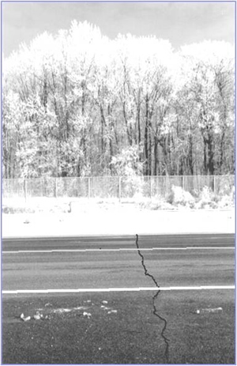
The current Superpave specification attempts to address this issue by specifying a limiting low temperature for asphalt binders. However, research has made it clear that binder testing alone is not sufficient to accurately predict low temperature cracking performance in the field; testing asphalt mixtures is necessary to obtain a reliable performance prediction. Furthermore, testing must include more sophisticated techniques based on fracture mechanics rather than the current practice of stiffness and strength testing.

To this end, a comprehensive research effort was conducted by Dr. Mihai Marasteanu at the University of Minnesota. This project is a unique partnership between the Minnesota Department of Transportation (MnDOT) and four universities: University of Minnesota, Iowa State University, University of Illinois at Urbana-Champagne, and University of Wisconsin at Madison. This project used an integrated approach of laboratory mixture fracture testing, sophisticated modeling, and field evaluation to develop a low temperature cracking specification for asphalt mixtures. This pooled fund study is the culmination of over ten years of research and will result in a tool that can be used by the seven partner State DOTs to select the optimal materials resistant to thermal cracking.

Laboratory Test Methods
While the Indirect Tensile Test for creep and strength properties (AASHTO T-322) is the current standard test method for thermal cracking performance of asphalt mixtures, researchers developed new fracture tests that are better able to distinguish good and poor performers.

The disk shaped compact tension test (DCT) was developed several years ago at the University of Illinois. It determines the fracture energy (G_{f}) of asphalt-aggregate mixtures. The test geometry is a circular specimen with a single edge notch loaded in tension. The fracture energy can be utilized as a parameter to describe the fracture resistance of asphalt concrete, with a high G_{f} value being more desirable. The DCT test has been shown to discriminate between asphalt mixtures more broadly than the indirect tensile strength parameter.
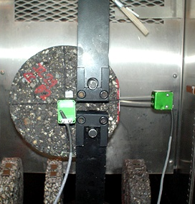
DCT test specimens can be prepared from 150-mm gyratory compacted samples or field cores. Sample preparation involves sawing and coring operations. First, a water‐cooled masonry saw is used to create flat, circular faces of a 50-mm wide specimen. A marking template is then used to indicate the location of the 1-inch loading holes to be drilled, and a water‐cooled drilling device is then used to fabricate the loading holes. Next, a masonry table saw is used to produce the final two cuts: a flattened face to facilitate the placement of the CMOD gage and a notch, which is a necessary feature of a true fracture mechanics based test. This geometry has been found to produce satisfactory results for asphalt mixtures with nominal maximum aggregates size ranging from 4.75 to 19 mm.

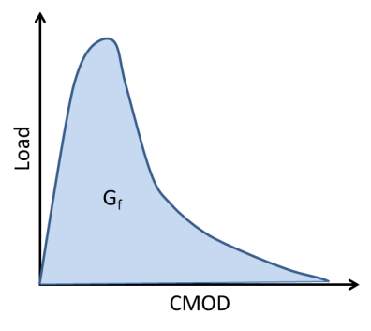
The DCT test is run in crack mouth opening displacement (CMOD) control mode at a rate of 1 mm/min. This quick loading rate essentially removes any creep behavior of the mixture during the test. Typically, specimens are completely failed in the range of 1 to 6 mm of CMOD travel after approximately 5 minutes of testing time. The test produces data similar to the plot at the left. Fracture energy is essentially the area under the Load vs. CMOD curve, and a high G_{f} indicates a greater resistance to thermal cracking.

A similar test was developed at about the same time at the University of Minnesota. The semicircular bend test (SCB) was developed several years ago based on a test method used in the Netherlands. This test has been performed on a large number of mixtures from the MnROAD research facility and other pavements around the region. It has shown to qualitatively rank good and poor performers in the field. Although this test method has been adopted by several researchers around the country, a standard test method does not exist. As part of the current pooled fund project a standard test method was proposed and submitted to AASHTO through the FHWA asphalt mixture Expert Task Group.

Since the SCB and DCT tests essentially provide the same information with slightly different geometries and loading parameters, MnDOT wanted to select a single test method to move forward with the mixture specification. After careful consideration the DCT was chosen as the test method of choice for the following reasons:
- DCT Coefficient of Variation (COV) is approximately 10%, which is significantly lower than the SCB and other mixture tests.
- DCT testing of laboratory compacted specimens more closely matched field cores taken from in-service pavements.
- The DCT has an ASTM approved test method.

Desirable Mixture Parameters
Over the course of the research, a multitude of asphalt mixtures were tested in the DCT setup. These mixtures were both prepared in the laboratory and cored from in-service pavements. By comparing and contrasting variables within similar mixture types, researchers determined that the following mixture and material parameters provide favorable resistance to low temperature cracking:
- Lower low temperature binder grade (i.e., PG xx-34 performs better than PG xx-28)
- Modified asphalt binders outperform neat binders
- Elastomeric polymers (SBS or Elvaloy) perform slightly better than polyphosphoric acid, mineral filler, and other binder modifiers
- Higher high temperature grade of binder with same low temperature grade (i.e., PG 64-34 performs better than PG 58-34)
- Hard crushed quarry rock (i.e., granite or taconite) outperforms limestone or gravel aggregates
- Lower air voids (better compaction) perform better than mixes with lower densities
- Increased binder content helps a mix resist cracking
- Lower amounts of recycled materials (RAP or shingles) help the mix to resist cracking
- Smaller nominal maximum aggregate size (4.75 mm) mixtures perform better than those with larger aggregates (12.5 mm)
- Gap graded or open graded mixtures outperform dense graded mixtures

Low Temperature Cracking Mixture Specification
The culmination of this 10+ year research program has resulted in an asphalt mixture specification for low temperature cracking. The approach is similar to the one used during the SHRP program to develop the current PG system. Researchers developed criteria for fracture energy at limiting temperature values. The criteria are based on fracture tests performed on specimens prepared from original loose mix. This approach required having both experimental fracture data as well as field performance for the same mixtures tested in the laboratory. The table below shows the proposed specification criteria at three different traffic levels, and the figure shows a portion of the data that was used to arrive at the specification limits.

 | Project Criticality / Traffic Level
 | Low  <10M ESALs | Moderate  10-30M ESALs | High  >30M ESALs
Minimum Fracture Energy (J/m²)  @ PGLT + 10⁰C | 400 | 460 | 690

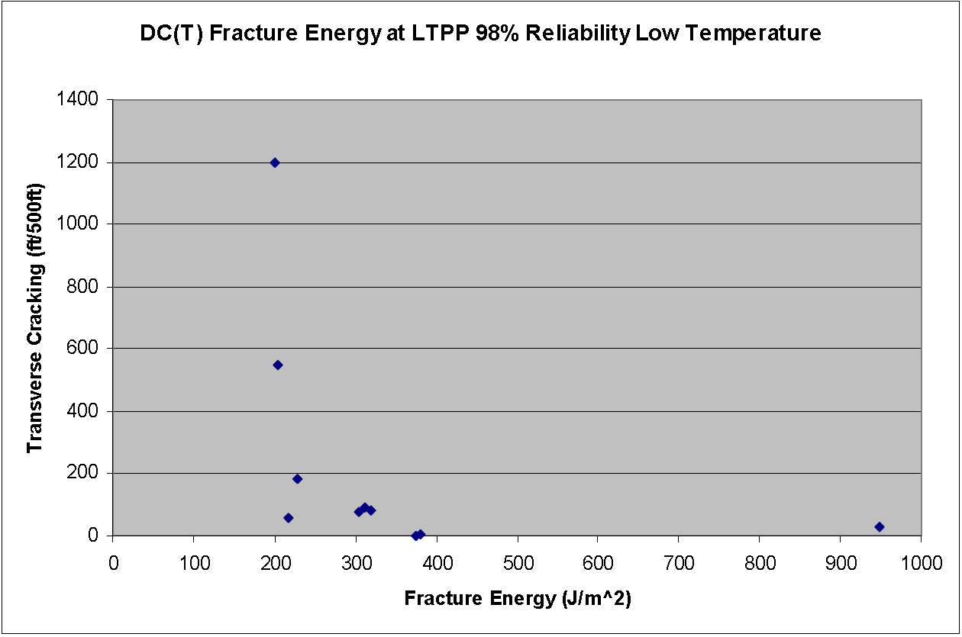

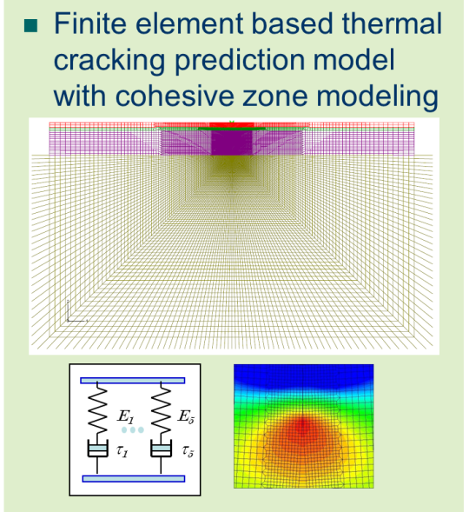
Another part of the research program was to develop an improved thermal cracking model compared to the current TC Model in the Mechanistic Empirical Pavement Design Guide. Named ILLI-TC, the model uses fracture energy and creep compliance data, along with pavement structure and climatic information, to predict thermal cracking versus time. For projects with high or moderate criticality, this program provides extra assurance that thermal cracking will be controlled, since the combined effects of mixture fracture properties, creep/relaxation behavior, thermal coefficient, and site-specific diurnal temperature cycling are considered. For high criticality projects, only negligible amounts of thermal cracking can be tolerated. Due to the characteristics of the probabilistic model that converts the single predicted thermal crack to amount of cracking, the specification of exactly zero predicted cracking is likely to be overly conservative (a very shallow predicted crack will yield a low amount of predicted cracking, but will not likely manifest itself as a visible crack in the field). Thus, a maximum predicted thermal cracking level of 4 m of cracking per 1 km of pavement (one crack per km) is specified. For projects of moderate criticality, a maximum predicted thermal cracking level of 64m/km is specified (assuming 4m wide pavement, this represents 16 cracks per km, or 1 lane-wide crack per 100 m). In addition, the use of ILLI-TC is specified as optional. For low criticality projects, the use of ILLI-TC is not required.

So What Does It Cost?
The DCT test does not yet have standard, readily available laboratory equipment. The table below shows the equipment needed to prepare samples and conduct the tests, assuming that the laboratory is already in possession of a servo-hydraulic load frame.

Item | Estimated Cost
Loading Fixtures | $3,000.00
X‐Y Tables to facilitate coring and sawing | $1,500.00
CMOD Extensometer (Epsilon) | $1,400.00
Temperature‐Chamber* | $20,000.00
Temperature modules and thermocouples | $400.00
PC for Data Acquisition | $1,000.00
Labview Based Interface Board | $700.00
Coring barrels (qty = 5) | $500.00
Labview Software for Data Acquisition | $1,500.00
Labview Programming** | $3,000.00
Dual water cooled masonry saws*** | $10,000.00
Dual saw system for flat face and notching*** | $7,000.00
* The $20,000 estimate is for a high‐power, condenser‐type cooling chamber, capable of testing down to ‐30C. A lower cooling chamber cost can result if a less stringent cooling capacity is specified, or if a liquid‐nitrogen based system is used.
** A simple Labview based data acquisition program was made available to the participating states by the research team free of charge.
*** These items are optional, but recommended for labs conducting a high volume of testing.

For a laboratory like MnDOT that has an existing load frame and much of the specimen preparation equipment, the equipment costs are in the range of $10,000. However, if a laboratory had to build the testing system from scratch it would cost about $50,000.

At least two equipment manufacturers have recently developed DCT test apparatus, the most notable being James Cox and Sons, Inc. Although exact cost estimates should be pursued by contacting the equipment manufacturers directly, it is estimated that a future, simplified DCT test based upon a screw‐type actuator system, would cost in the range of $50,000. A more elaborate DCT test device, with a universal servo hydraulic load frame capable of performing other tests, such as the simple performance test, IDT test, etc. would be expected to be in the $140,000 range. Dual‐saw sample preparation apparatus is currently being manufactured by Precision Machine Works (PMW) out of Salinas, KS.

Researchers have determined the average fabrication time per specimen to be in the 10 to 15 minute range for DCT testing, which includes the four saw cuts and two cored holes. This is based upon mass production of at least a dozen test specimens. The fabrication of fewer test specimens will naturally lead to a longer per-specimen preparation time. Therefore, combined with the testing time of approximately 10 minutes, each DCT test will take approximately 30 minutes of technician time for specimen preparation and testing when larger batches of specimens are tested. Material testing labs are currently charging in the neighborhood of $200 per test specimen (replicate) for DCT testing, and somewhat less for larger quantities of specimens ($150 per test). This is similar to the cost to perform other mixture and binder performance tests.

Implementation Plan
MnDOT is preparing to implement the low temperature cracking mixture specification on some pilot projects during the 2012 and 2013 construction seasons. They are applying for funding through a few different avenues within the Department. The plan for this implementation is to select a number of construction projects throughout the state, perform the DCT test on the mixture proposed by the contractor, and verify that it meets the newly proposed mixture specification. MnDOT would select 3-5 construction projects that include significant amounts of mainline bituminous paving. The focus will be on new construction projects (over granular base or full depth reclamation), although one or two overlay projects may be considered as well. The expected outcome of these implementation projects is that MnDOT will benefit by having superior performance of asphalt mixtures on our roadways. These mixtures will exhibit reduced cracking, which will require less time, materials, labor, and costs to maintain.

Iowa DOT is also implementing the DCT test and mixture specification in their 2012 bituminous paving specifications. If the contractor chooses to use over 25% RAP in a mix design, they must run the DCT test and prove that the mixture exhibits adequate fracture energy.

Once the DCT test and mixture specification are implemented on a more routine basis, it is expected that the methodology would extend to other types of cracking (i.e., fatigue, top-down, and reflective cracking). If a mixture performs well in a low temperature cracking environment, it is expected to perform well under other types of cracking scenarios.

Acknowledgements
The work described in this article was the result of significant efforts over the last several years by Dr. Mihai Marasteanu, Dr. Bill Buttlar, Dr. Hussain Bahia, and Dr. Chris Williams, along with many of their colleagues and graduate students. Their efforts are greatly appreciated. The research has been sponsored through the Federal Highway Administration’s Transportation Pooled Fund Program with participation from the Minnesota Local Road Research Board and Departments of Transportation from Minnesota, Connecticut, Idaho, Illinois, Iowa, Kansas, North Dakota, New York, Vermont, and Wisconsin. Their contributions are gratefully acknowledged.

Wagoner, M.P., Buttlar, W.G., and Blankenship, P. (2005). "Investigation of the Fracture Resistance of Hot-Mix Asphalt Concrete Using a Disk-shaped Compact Tension Test", Presentation at the 2005Transportation Research Board annual meeting, paper 05-2394, Washington D.C.
Li, X., Marasteanu, M.O. (2004). "Evaluation of the Low Temperature Fracture Resistance of Asphalt Mixtures Using the Semi Circular Bend Test.", Journal of the Association of Asphalt Paving Technologist, Vol. 73, 401-426.

