Development of an IOO-Industry Forum for AV Technology Knowledge Transfer
Researcher(s) | Tara Andringa
Agency | Partners for Automated Vehicle Education (PAVE)
Report Date | 6/15/2023
Project Number | 111455-B

The Problem
The AV industry is growing rapidly and, at the same time, IOOs are working to rebuild, update, and modernize transportation infrastructure to meet the needs of these new technologies. Successful AV implementation efforts will rely on collaboration and communication between parties across the AV ecosystem.

Recognizing the need for this collaboration, the Automated Vehicle Pooled Fund Study (AV PFS) commissioned the development of the IOO Strategic Roadmap for Accelerated Adoption of AVs. The roadmap identified seven program pillars, which are focus areas where IOOs can have the greatest influence in the AV ecosystem. The program pillars are: physical and digital infrastructure readiness, operations, interstate freight and multi-modal harmonization, partnerships, workforce, communications and engagement, and policy.

In conjunction with the roadmap development, the AV Pooled Fund initiated establishment of an IOO-industry forum for collaboration across the AV ecosystem. The forum, AccelerateAV.org, will facilitate idea sharing, resource use, networking, communication, and problem solving between AV stakeholders.

This project involved the planning, development and launch of this cooperative forum.

Research Approach
PAVE utilized a three-phase approach for building the forum:
- Forum Concept Development
  - Identify stakeholders for forum.
  - Survey of AV stakeholders to explore needs, concerns, and challenges.
  - Planning mission, vision, and goals of forum
  - Develop forum concept/outline.
  - Develop plan for oversight and management of forum.
  - Establish focus group for detailed feedback on forum.

- Communications Strategy Development
  - Prepare communications plan to elevate awareness of forum.
  - Design branding for forum
  - Create marketing content for forum.
  - Draft community rules, FAQs,

- Forum establishment
  - Build forum on user-friendly platform.
  - Create beta test of forum.
  - Meet with focus group for feedback on beta test.
  - Market launch of forum
  - Engage with media on forum launch.
  - Launch forum.
  - Monitor forum launch; assess launch and recommend changes as necessary.
Findings
Through a survey of stakeholders and two meetings of focus groups, the PAVE team identified the following desires and challenges for the forum:

Forum desires:
- Top pillars identified by respondents:
  - Policy (74.4%)
  - Infrastructure readiness (56.4%)
  - Partnerships (43.6%)
- Moderation is needed for forum discussions and news information.
- “Icebreaking” events may be helpful.
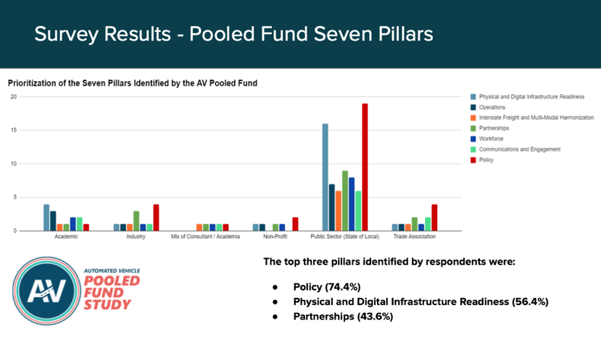
- Want ability to network and connect individually with forum users.

Recommendations
In order to optimize chances of the forum’s success, we recommend the following;

- FORUM MANAGEMENT: We recommend live forum management, including moderators, to ensure that the site is not outdated, off-topic, and that users adhere to community rules.
- FORUM OUTREACH: Earned media coverage will help encourage participation. Additionally, amplification of the forum by members of the AV Pooled Fund to their networks will help to reach broader audiences.
- USER ENGAGEMENT: Schedule opportunities for icebreaking and networking to help users form connections. When possible, public sector participants can share RFPs and other opportunities, which will encourage private sector participation.
- FORUM EVALUATION: We recommend following PAVE’s forum evaluation rubric to measure ongoing growth and success of the forum, so remediation measures can be taken as the forum evolves.

