Quarterly Progress Report (QPR)

Applications of Enterprise GIS in Transportation
Progress Report for Quarter 2 [Jan 1st 2020 – March 30th, 2020]
WSP Program Manager: Jag Mallela (jag.mallela@wsp.com)
WSP Technical Lead: Abhishek Bhargava (abhishek.bhargava@wsp.com)
Background
The Pooled Fund Study (PFS) on Applications of Enterprise GIS in Transportation (AEGIST) was initiated by FHWA in 2018. During Phase 1 of this study a guidebook was developed for transportation agencies in the United States, with the primary objective of documenting guidance on how spatial and linear referenced data should be managed by States. Phase 2 of this PFS was initiated in October 2019. This phase will span over 5 years (October 2019 – September 2024), during which the objectives outlined below would be accomplished.
Objective
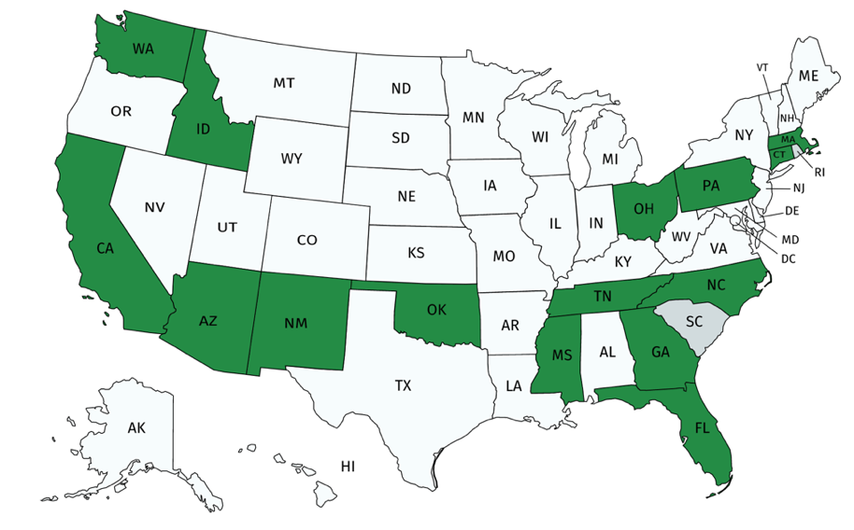
- Establish a standard for sharing and publishing highway infrastructure data between stakeholders at DOTs and their Federal, State and Local partners
- Review existing practices in spatial and linear referencing data management at State transportation agencies
- Assess the extent to which the States participating in the PFS (Figure 1) have implemented standards based spatial data management practices.
- Create/update AEGIST Guidebook based on best practices in spatial data management at State transportation agencies.
- Coordinate with the PFS States to further advance the spatial data management practices at the DOTs by implementing spatial and linear referencing data management solutions and data science platforms.
Completion Status and Summary
Time Frame: October 1, 2019 to September 30, 2024
Total Time, months: 60
Time Expended, months: 6
Percent Calendar Time Expended: 10%

Task 1: Project Management
Task Objective: Perform project management activities, which include conducting monthly status meetings, developing quarterly status reports, creating project work plan, managing project resources, schedule, deliverables and communication with all stakeholders.
Work Accomplished: Following activities were performed in the reporting period:
- Deliverable 1.2.0 – Work Plan v1.0 Preparation
  - A Technical Work Plan template was created to capture about the technical services/tasks to PFS States
  - Template was populated with cross-agency activities: Task 2.1 Model Evaluation, Task 2.2 Guidebook v2, as well as schedule, topics and plan for Webinars, Workshops and Articles in Base Period. Each State was requested to contribute 100 hours for carrying out Task 2.1 and 2.2. States were contacted and information about tasks 2.1 and 2.2 was presented so that PFS States can approve the 1600 hours between them.
  - Documented cross-agency activities (next steps) identified at peer exchange were added to template. The Work Plan template was made available on AEGIST SharePoint site so that the States can use the template for internal discussions. The template was presented to the States of Georgia, North Carolina, New Mexico, Washington and Ohio. Other PFS States will be presented this template in May-June.
  - States were informed that going forward the work plan will be updated each month as States identify technical services that are required as part of Task 2. An Agile approach will be followed to incrementally update the workplan each month based on discussions with PFS States. For e.g., v1.1 will be submitted on May 30th, v1.2 will be submitted on June 30th, and so on, until v2.0 of the workplan is submitted at the end of base period.
  - Discussions with PFS States who are part of the base period (GA, CT, ID, CA, TN) on timing and scope of technical services that need to be provided to the States as part of the AEGIST project.
  - Building catalog of technical services activities in the workplan so that the PFS States have something to look at and draw ideas from, when it comes to planning and finalizing the technical services activities
  - Added appendix to summarize how AEGIST Model helps with HPMS and MIRE data requirements modeling. Also, added appendix to complement the spatial data integration activities in the catalog of technical services.
  - Meeting with FHWA to review content in Work Plan v1.0

- Deliverable 1.3.1 & 1.3.2 Quarterly & Monthly Progress Reports
- Technical work planning discussions were held with the States of Georgia, California, Ohio, Tennessee, Idaho, Washington, North Carolina and New Mexico. These States were provided information on how (a) Cross-Agency activities and (b) State-specific activities will be defined; how Technical Service Work Plans will be created monthly, and, how services will be provided. The States were requested to identify:
  - The objectives that the State would like to accomplish with AEGIST
  - The scope/type of technical activities that the agency would like to do
  - The calendar year in which the agency would like to carry out the activity
Status of discussions with States is presented in Table below. Such discussions with the States are expected to continue until June 2020. Additional details captured in the Technical Work Plan.
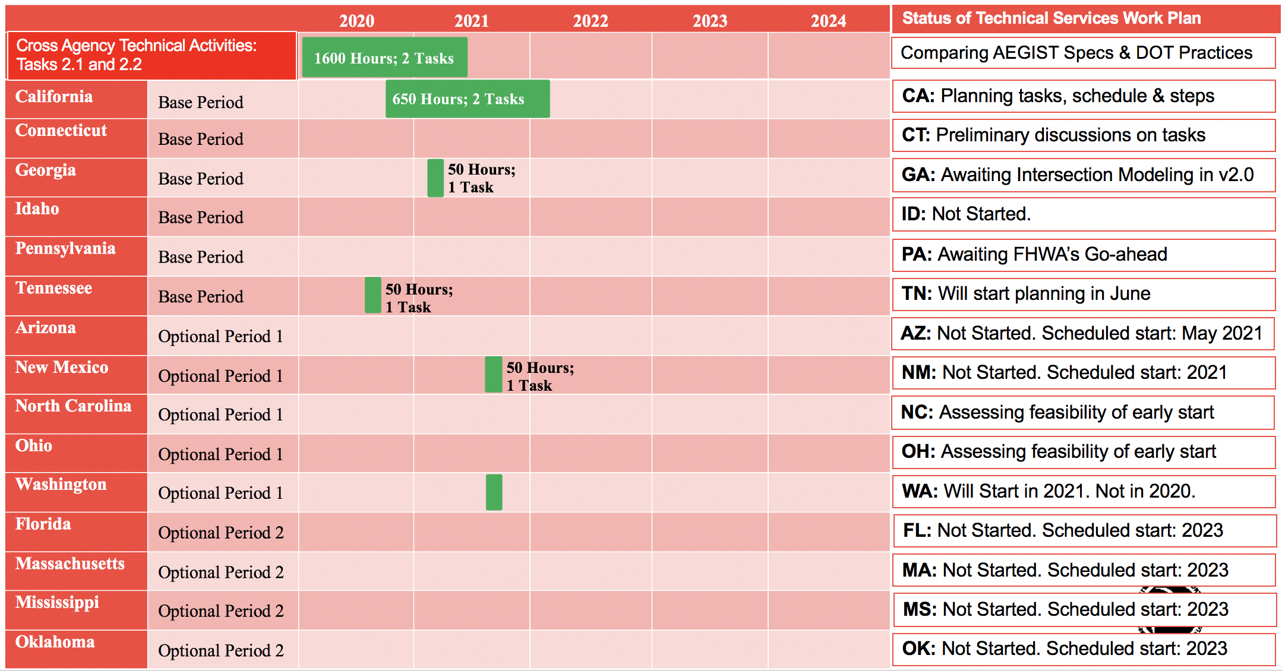
Task 2: Technical Services
Task Objective: Provide technical services associated to PFS States by completing various agency-specific and cross-agency activities identified in the work plan.
Work Accomplished: Following activities were performed in the reporting period:
- Task 2.1: Evaluation of AEGIST NRBM Model
  - Comparison of LRS models from CT, NC, AZ, CA and comparison with AEGIST modeling specifications and LRS business rules.
  - Comparison of ERD associated with the AEGIST data model was mapped to the ERD of CTDOT’s Bentley AWLRS model and NCDOTs Esri Roads & Highways ALRS model (with events)
  - AEGIST data model comparison with open standards: OGC (GDF), IFC
  - Preparation of content for documentation of Centerlines, Intersections and Routes Modeling at State DOTs in Guidebook v2.0. Assessment of:
  - “Element Types” that should be added to the AEGIST data model based on the event/inventory items information in CT, NC, AZ, CA LRS models, the HPMS & MIRE data items.
  - Object types in HPMS and MIRE data models in State DOT LRS systems, and, mapping of these object types to the object types in the AEGIST data model.
  - Validation of AEGIST data schema in Roads & Highways eGDB (Postgres) to assess how PFS States that utilize this LRS system would be able to configure the AEGIST specifications. Assessment of feasibility of agencies adopting the guidebook specifications.
  - Presentation to PFS States on March 3rd on AEGIST model, work plan and spatial data management objectives. A survey of the PFS States and FHWA was conducted. Following questions were asked and feedback received.
AEGIST Survey Comments from PFS States
- Guidebook V2 looks more organized and it seems to focus on Network and Data Modeling.
- You may also consider to have different phases to focus on different scales with topics. Network and Data Modeling seems to be very finer level compared to topics like Data Governance which seems to be too broad. I agree that combining BIM and LRS should be discussed as more application oriented. It sounds like to me that Roadway Inventory group should work with Design group to accomplish LRS + BIM with IT's support.
- For me, more engagement is necessary, otherwise, I am involved in the day to day, in office, tasks. The AEGIST quickly becomes: out of site, out of mind. Nothing extravagant is needed, perhaps an e-mail of status, current activities.
- I agree with both moving forward with a Version 2 of the Guidebook and doing an intersection comparison among several States to get a good feel for what everyone is doing.
- Abhishek is great for this task. Happy so far!
  - Do you have any concerns regarding the content presented and/or direction of AEGIST project?
- To this question, 6 people responded as “No concerns”
  - Would you like to share any thoughts, inputs, suggestions related to the direction of the AEGIST project?
– Responses to this question shown in attached table.

Task 3: Marketing and Communication
Task Objective: Webinars and Workshops will be held, and Articles will be presented in conferences and other industry forums to communicate information about the activities of the project, especially the technical work products developed as part of the project.
Work Accomplished: Following activities were performed in the reporting period:
- Deliverable 3.2.1 – Workshop/Webinar 1 GIS-T
- GIS-T workshop material was prepared in coordination with Connecticut and Arizona DOTs. Work sessions were held with these DOTs during January – March, 2020.
- In March, the GIS-T 2020 conference cancelled. Plan for replacing the workshop with a webinar in June/July was developed and discussed with partner States (Arizona and Connecticut). States proposed that the webinar is conducted after the HPMS submission is complete, i.e., sometime after June 15th, 2020. June/July are being considered for conducting a webinar.
- Deliverable 3.2.2 – Presentations
  - Presentation at the ABJ60 TRB Committee meeting to review the project goals and objectives.
  - Coordination with the States of Connecticut and Arizona to plan for the GIS-T workshop.
Task 4: Peer Exchange Meetings
Task Objective: Plan, organize and conduct 5 peer exchanges, one each year between 2019 and 2023.
Work Accomplished: Following activities were performed in the reporting period:
- Peer Exchange 2019 Follow-up: Coordination with PFS States to get 100 hours approved for conducting the guidebook update and AEGIST specifications evaluation against DOT practices as part of Task 2. These were the next steps identified at the peer exchange and added to work plan as Task 2.1 and 2.2.

Complete List of Base Period Deliverables
Note: Deliverables on which work is complete (in green) and work is in progress (in orange).
Task | D# | Deliverable Name | Target Date | Status
Task 1 | 1.1.0 | Kick-off Meeting | 10/30/19 | Completed
Task 1 | 1.2.0 | Work Plan Version 1: Cross-Agency Tasks, Deliverables & Schedule | 4/30/20 | Appendices added to complement Catalogue of technical services
Task 1 | 1.3.1 | Quarterly Progress Report - 1 (incl. 3 monthly meetings and reports) | 12/31/19 | QPRs 1 and 2 Ready.  Monthly Status reports ready
Task 1 | 1.3.2 | Quarterly Progress Report - 2 (incl. 3 monthly meetings and reports) | 3/31/20 | QPRs 1 and 2 Ready.  Monthly Status reports in-progress
Task 1 | 1.3.3 | Quarterly Progress Report - 3 (incl. 3 monthly meetings and reports) | 6/30/20 | Not Started
Task 1 | 1.3.4 | Quarterly Progress Report - 4 (incl. 3 monthly meetings and reports) | 9/30/20 | Not Started
Task 1 | 1.3.5 | Quarterly Progress Report - 5 (incl. 3 monthly meetings and reports) | 12/31/20 | Not Started
Task 1 | 1.3.6 | Quarterly Progress Report - 6 (incl. 3 monthly meetings and reports) | 3/31/21 | Not Started
Task 1 | 1.3.7 | Quarterly Progress Report - 7 (incl. 3 monthly meetings and reports) | 6/30/21 | Not Started
Task 2 | 2.1 | TASK 2 Technical Services (incl. Work Plan v1.1 with State Tasks) - MONTH 8 - MAY 2020 | 5/30/20 | Not Started
Task 2 | 2.2 | TASK 2 Technical Services (incl. Work Plan v1.2 with State Tasks) - MONTH 9 - JUN 2020 | 6/30/20 | Not Started
Task 2 | 2.3 | TASK 2 Technical Services (incl. Work Plan v1.3 with State Tasks) - MONTH 10 - JUL 2020 | 7/30/20 | Not Started
Task 2 | 2.4 | TASK 2 Technical Services (incl. Work Plan v1.4 with State Tasks) - MONTH 11 - AUG 2020 | 8/30/20 | Not Started
Task 2 | 2.5 | TASK 2 Technical Services (incl. Work Plan v1.5 with State Tasks) - MONTH 12 - SEP 2020 | 9/30/20 | Not Started
Task 2 | 2.6 | TASK 2 Technical Services (incl. Work Plan v1.6 with State Tasks) - MONTH 13 - OCT 2020 | 10/30/20 | Not Started
Task 2 | 2.7 | TASK 2 Technical Services (incl. Work Plan v1.7 with State Tasks) - MONTH 14 - NOV 2020 | 11/30/20 | Not Started
Task 2 | 2.8 | TASK 2 Technical Services (incl. Work Plan v1.8 with State Tasks) - MONTH 15 - DEC 2020 | 12/30/20 | Not Started
Task 2 | 2.9 | TASK 2 Technical Services (incl. Work Plan v1.9 with State Tasks) - MONTH 16 - JAN 2020 | 1/20/21 | Not Started
Task 2 | 2.10 | TASK 2 Technical Services (incl. Work Plan v1.92 with State Tasks) - MONTH 17 - FEB 2020 | 2/28/21 | Not Started
Task 2 | 2.11 | TASK 2 Technical Services (incl. Work Plan v1.94 with State Tasks) - MONTH 18 - MAR 2020 | 3/20/21 | Not Started
Task 2 | 2.12 | TASK 2 Technical Services (incl. Work Plan v1.98 with State Tasks) - MONTH 19 - APR 2020 | 4/30/21 | Not Started
Task 2 | 2.13 | TASK 2 Technical Services (incl. Work Plan v2.0 with State Tasks) - MONTH 20 - MAY 2021 | 5/30/21 | Not Started
Task 3 | 3.1.1 | Article 1 | 6/30/20 | Not Started
Task 3 | 3.2.1 | Workshop 1 - GIS-T 2020 | 4/30/20 | Content development in progress
Task 3 | 3.2.2 | Workshop or Presentation 2 | 10/30/20 | Not Started
Task 3 | 3.2.3 | Workshop 3 - GIS-T 2021 | 4/30/21 | Not Started
Task 3 | 3.3.1 | Webinar 1 | 8/30/20 | Not Started
Task 4 | 4.1.0 | Peer-Exchange 1 - 2019 | 12/30/19 | Follow-up with PFS States on Next Steps identified in Dec 2019
Task 4 | 4.2.0 | Peer-Exchange 2 - 2020 | 12/30/20 | Not Started

