CDOT Research Project Update
25 April 2016
Jeffrey S. Deems
National Snow and Ice Data Center, University of Colorado

Project:
Assessing Gazex Avalanche Control Effectiveness with Terrestrial Laser Scanning

Project Objective:
This project aims to use terrestrial laser scanning (TLS) technology to create snow depth maps in avalanche starting zones for an effectiveness assessment of the new Gazex systems in reducing avalanche hazard in the Loveland Pass (Seven Sisters) and Berthoud Pass (Stanley) highway corridors. Snow depth maps created prior and post Gazex activation will allow the quantification of avalanche areas and volumes, as well as the mapping of snow slabs remaining after control operations.

Research Plan and Progress:
Task 1: Conduct site assessments, study feasibility, coordinate workflow and site access details with CDOT/CAIC collaborators
Deliverable 1: Initial scan data images
Progress on Task 1:
All Task 1 elements are complete at the Loveland Pass/7 Sisters site. Loveland Pass initial scan images (Deliverable 1) are included in Appendix A in this report. Three scan locations were initially examined and used for snow-free scan acquisition, with the resulting scan data merged into a single dataset. It was determined that a single scan location would suffice for the great majority of snow-on situations. Some communication and coordination challenges remain, as individual storm and road closure events often do not follow a predictable evolution, nor are weather and access always conducive to scan acquisition.
Task 1 is not yet complete at the Berthoud Pass/Stanley Path site. Due to delays in contracting, the site assessment, feasibility, and site access components are all still in-work.

Task 2: Collect snow-free TLS scans of both sites after construction of Gazex systems.
Deliverable 2: Snow-free elevation point cloud
Deliverable 3: Snow-free bare-earth digital elevation model
Progress on Task 2:
Task 2 The snow-free scan was conducted in September 2015 at the Loveland Pass/7 Sisters site. This was accomplished on a volunteer basis prior to establishment of the contract. Production of Deliverables 2 and 3 are in work and near completion. Decision of best data product format will be determined in collaboration with CDOT and CAIC staff.
Task 2 is not yet complete at the Berthoud Pass/Stanley Path site. Due to delays in contracting, snow-free scan(s) have not yet been conducted.

Task 3: Conduct snow-on scans prior to storm events, and pre- and post-Gazex avalanche control operations
Deliverable 4: Pre-control snow depth and storm slab thickness maps
Deliverable 5: Post-control snow depth maps
Deliverable 6: Avalanche area and volume measurements
Progress on Task 3:
Strong progress has been made on Task 3 at the 7 Sisters site. To-date 5 snow-on scans have been conducted around 3 storm events, capturing pre- and post-Gazex operation on two of these dates. Evaluation and analysis of the scan data is ongoing. Production of Deliverables 4, 5, and 6 are in-work. As with Task 2, decision of best data product format to be determined in collaboration with CDOT and CAIC staff.
Task 3 is in progress at the Stanley Path site. One snow-on scan has been conducted to-date at the Berthoud Pass/Stanley Path site, on 14 April during spring snow conditions. Terrain geometry severely limits the look angles and range to target at this site, the combination of which (long range and high incidence angles) along with the low reflectivity of spring snow test the limits of the current lidar system.

Upcoming work:
Work will continue through end of 2016 snow season and until snow-free conditions predominate. Additional snow-on data sets will be collected during winter 2016/17. Work and results to-date will be presented to the avalanche community at the International Snow Science Workshop in Breckenridge, CO, October 2016.
Loveland Pass/7 Sisters:
- Finish scan data postprocessing and final product generation (summer 2016)
- Analyze results in collaboration with CDOT and CAIC staff (summer 2016)
- Additional snow-on scans (Winter 2017)
Berthoud Pass/Stanley:
- Conduct snow-free scans (summer 2016)
- Evaluate scan locations and access (summer 2016)
- Evaluate need for VZ-6000 scanner, and eye safety logistics (summer 2016)

Appendix A
Initial scan data images from Loveland Pass/7 Sisters site

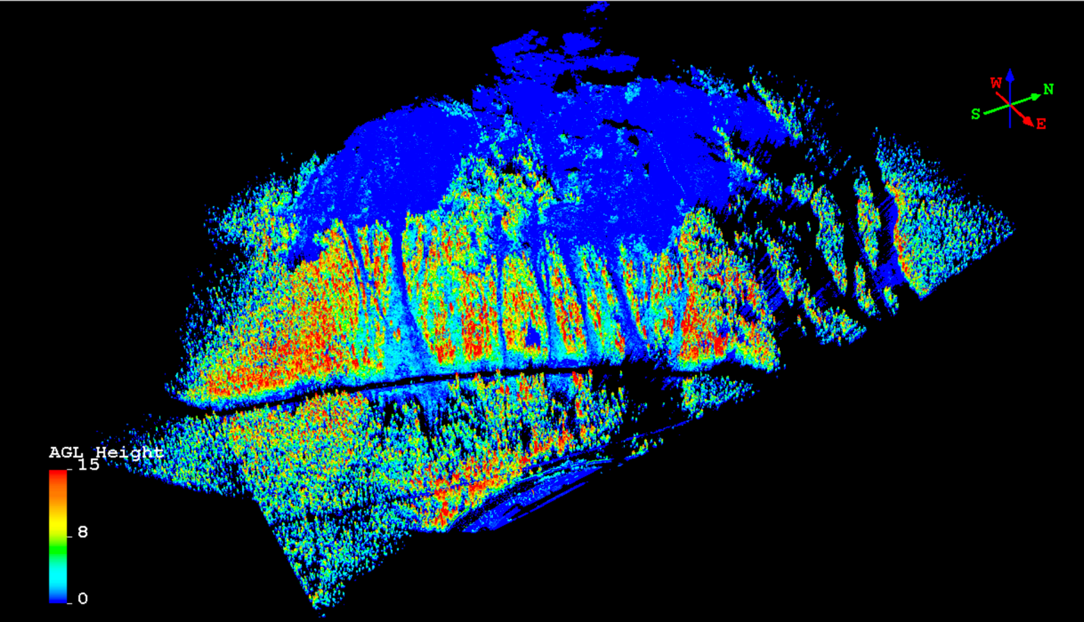
Figure A1: Image from snow-free scan of 7 Sisters paths, summer 2015. Points in image are colored by height above ground.

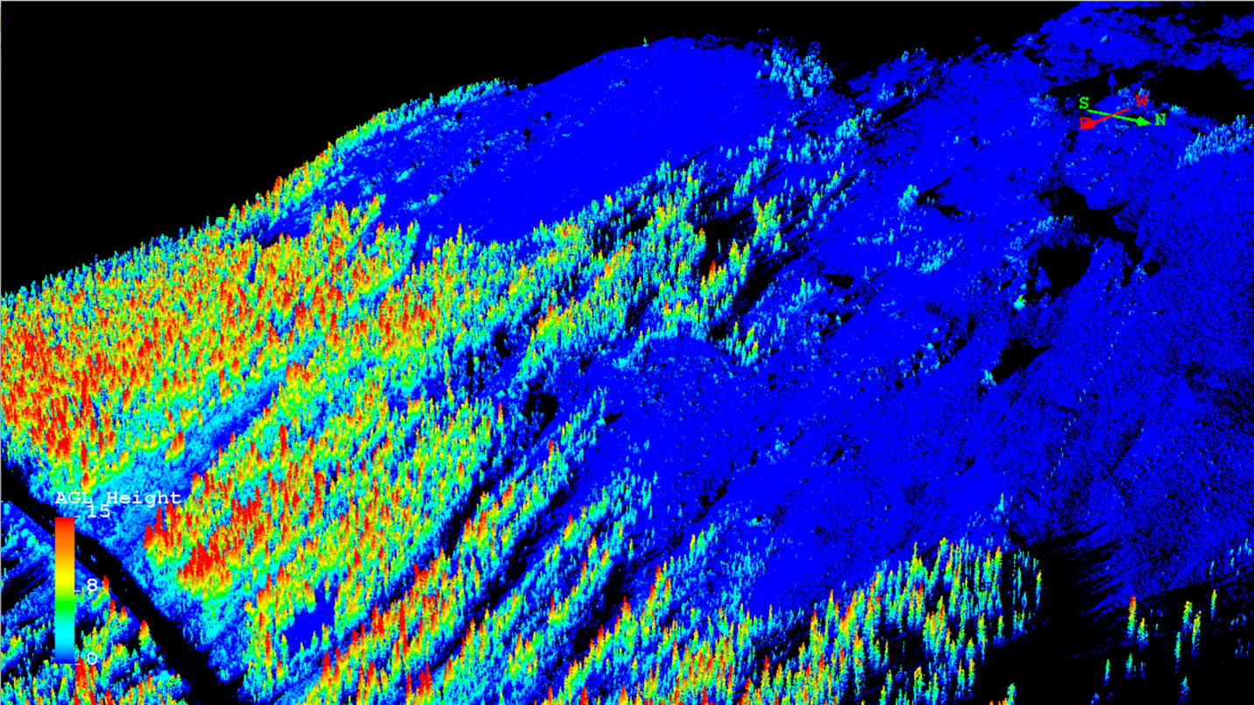
Figure A2: Oblique view of 7 Sisters snow-free scan. Point colors as in Figure A1.

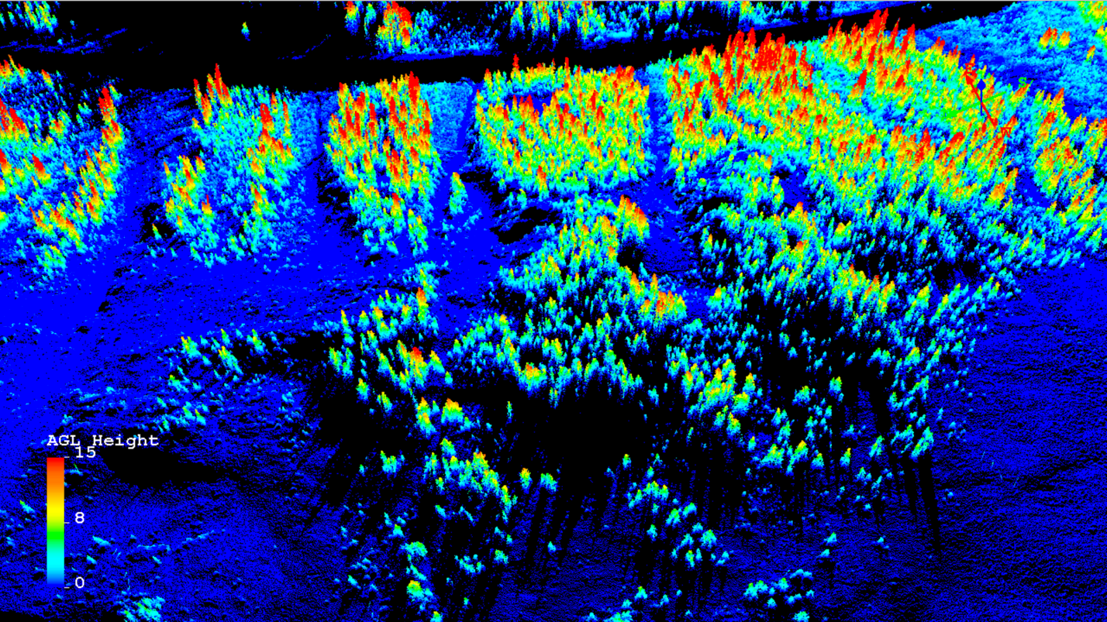
Figure A3: View of snow-free scan looking down 7 Sisters 1-4. Point colors as in Figure A1.

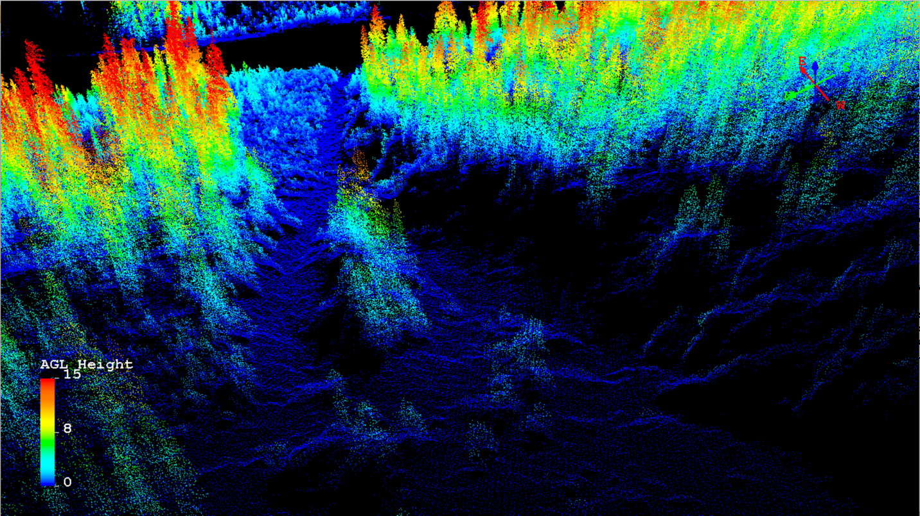
Figure A4: View of snow-free scan looking downhill within Sister #3. Point colors as in Figure A1.

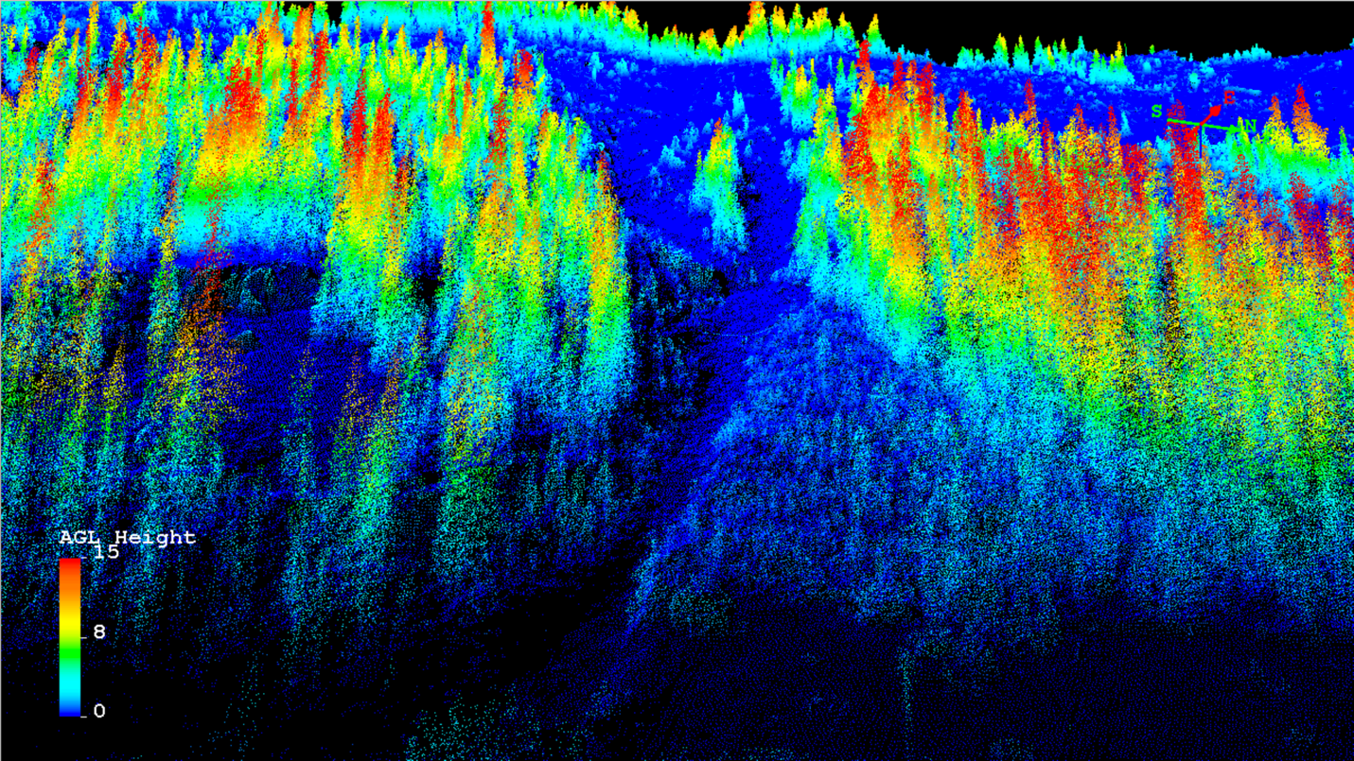
Figure A5: View of snow-free scan looking up Sister #3. Point colors as in Figure A1.

