**Investigation of Low Temperature Cracking in Asphalt Pavements**

**National Pooled Fund Study – Phase II**

**Task 6 Report**

Prepared by:

William G. Buttlar

Sofie Leon

Behzad Behnia

**University of Illinois**

Mihai Marasteanu

Ki Hoon Moon

Mugur Turos

Eyoab Zegeye Teshale

**University of Minnesota**

Eshan V. Dave

**University of Minnesota Duluth**

**May 2012**

Prepared for:

Minnesota Department of Transportation

Research Services of MS 330

395 John Ireland Boulevard

St.Paul, MN 55155

This report represents the results of research conducted by the authors and does not necessarily represent

the views or policy of the Minnesota Department of Transportation and/or the Center for Transportation Studies. This report does not contain a standard or specified technique.

# Table of contentS

1. Introduction……………………………………..………………………………..1

2. Test results……………………………………….………………………………2

Effect of aggregate size…………………………………….………………………………11

Effect of RAP…………………………………………….……………………………12

3. Field validation……………………………………………………………………13

4. Predicting Mixture creep stiffness…………………………………………19

References……………………………………………………………………………….29

# 

**LIST OF TABLES**

Table 1. Asphalt Mixtures used in Task 6……………………………………………………….1

Table 2. DC(T) fracture energy for mixtures tested at PGLT+10°C………………………..2

Table 3. DC(T) fracture energy for mixtures tested at PGLT…………………………………….3

Table 4. SCB fracture energy for mixtures tested at PGLT+10°C……………………………..4

Table 5. SCB fracture energy for mixtures tested at PGLT………………………………………5

Table 6. SCB fracture toughness for mixtures tested at PGLT+10°C……………………………6

Table 7. SCB fracture toughness for mixtures tested at PGLT…………………………………7

Table 8. Summary of results for mixtures tested at PGLT+10°C………………………………9

Table 9. Summary of results for mixtures tested at PGLT……………………………………10

Table 10. Fracture energy and field cracking for validation sections…………………………13

Table 11. Preanalyzer results and field cracking for validation sections………………………16

Table 12. Illi-TC predictions and field cracking for validation sections using calibrations from Task 4………………………………………………………………………………….17

Table 13. Summary of RTFOT binders S(60s) and m(60s) from BBR creep testing…………19

Table 14. Summary of S(60s) and S(500s) from IDT mixture testing……………………….20

Table 15. Huet model parameters for tested binders…………………………………………26

Table 16.  parameter values for mixtures for ENTPE transformation………………………..27

**LIST OF FIGURES**

Figure 1. Final validation: SCB fracture energy…………………………………………………8

Figure 2. Final validation: DC(T) fracture energy………………………………………………8

Figure 3. Final validation: SCB fracture toughness………………………………………………9

Figure 4. Ranking of mixtures tested at PGLT+10°C………………………………………10

Figure 5. Ranking of mixtures tested at PGLT………………………………………………….11

Figure 6. Example of SCB test data…………………………………………………………12

Figure 7. Example of linear extrapolation to obtain DC(T) Gf at PGLT+10 ºC (MIF\_RAP\_12.5mm)………………………………………………………………………….…14

Figure 8. Preanalyzer results for WRI1-1 section (MIF\_RAP\_12.5mm)……………………15

Figure 9. Preanalyzer results for WRI1-2 section (MIF\_12.5mm)……………………………15

Figure 10. Preanalyzer results for WRI1-3 section (Marathon\_12.5mm)……………………….15

Figure 11. Preanalyzer results for WRI1-4 section (Valero\_12.5mm)…………………………..16

Figure 12. Preanalyzer results for WRI1-5 section (Citgo\_ 12.5mm)…………………………...16

Figure 13. Thermal stresses at the end of the critical event for WRI1-4 section

(Valero\_ 12.5mm)………………………………………………………………………………..17

Figure 14. RTFOT binder S(60s) and m(60s) results from BBR creep testing………………….19

Figure 15. Results of S(60s) and S(500s) from IDT mixture creep testing………………….20

Figure 16. Semi-empirical model proposed by (Christensen et al., 2003)………………….21

Figure 17. Huet model (Huet, 1963)……………………………………………………………..22

Figure 18. Hirsch model predictions for Citgo mixtures………………………………………24

Figure 19. Hirsch model predictions for Marathon mixtures…………………………………24

Figure 20. Hirsch model predictions for MIF 12.5mm mixtures………………………………24

Figure 21. Hirsch model predictions for MIF 19.0mm mixtures……………………………25

Figure 22. Hirsch model predictions for Valero mixtures……………………………………….25

Figure 23. Huet model predictions for binders Citgo (PG 58-28) and Marathon (PG 58-28)…26

Figure 24. Huet model predictions for binders MIF (PG 58-28) and Valero (PG 58-28)……….26

Figure 25. ENTPE transformation predictions for Citgo mixtures……………………………27

Figure 26. ENTPE transformation predictions for Marathon mixtures………………………….27

Figure 27. ENTPE transformation predictions for MIF 12.5mm mixtures……………………28

Figure 28. ENTPE transformation predictions for MIF 19.0mm mixtures……………………28

Figure 29. ENTPE transformation predictions for Valero mixtures……………………………..28

# 1. Introduction

Based on the work performed in Task 3, the Disc-Shaped Compact Tension (DC(T)) was selected for further validation. Eleven mixtures used in pavement sections constructed in Olmsted County (Minnesota) during the 2006 construction season, were selected for the analysis part of the validation process, see Table 1

Table 1. Asphalt Mixtures used in Task 6

|  |  |  |  |
| --- | --- | --- | --- |
| Location | Construction date | Binder Grade | Description |
|
| Olmsted Co Rd 104 | July 2007 | PG 58-28 RAP | Warm Mix (w/RAP & antistrip) |
| Olmsted Co Rd 112 | August 2006 | PG 58-28 | WRI-Mathy Study (Citgo, 12.5 mm) |
| Olmsted Co Rd 112 | August 2006 | PG 58-28 | WRI-Mathy Study (Citgo, 19 mm) |
| Olmsted Co Rd 112 | August 2006 | PG 58-28 | WRI-Mathy Study (Marathon, 12.5 mm) |
| Olmsted Co Rd 112 | August 2006 | PG 58-28 | WRI-Mathy Study (Marathon, 19 mm) |
| Olmsted Co Rd 112 | August 2006 | PG 58-34 RAP | WRI-Mathy Study (MIF, 12.5 mm) |
| Olmsted Co Rd 112 | August 2006 | PG 58-34 | WRI-Mathy Study (MIF, 12.5 mm) |
| Olmsted Co Rd 112 | August 2006 | PG 58-34 RAP | WRI-Mathy Study (MIF, 19 mm) |
| Olmsted Co Rd 112 | August 2006 | PG 58-34 | WRI-Mathy Study (MIF, 19 mm) |
| Olmsted Co Rd 112 | August 2006 | PG 58-28 | WRI-Mathy Study (Valero, 12.5 mm) |
| Olmsted Co Rd 112 | August 2006 | PG 58-28 | WRI-Mathy Study (Valero, 19 mm) |

Three mixtures (Warm Mix, MIF 12.5 mm, and MIF 19 mm) contained RAP. Asphalt binder PG 58-28 was used in the majority of the mixtures except in the mixtures denominated MIF. For these latter mixtures, asphalt binder PG 58-34 was used. For all mixtures except Warm Mix, two different aggregate sizes, Nominal Maximum Aggregate Size (NMAS) 12.5 mm and 19 mm, were considered.

Due to difficulties in compacting 4% mixtures, only specimens with 7% air voids were prepared and tested. To make up for the reduction in testing effort, Semi-Circular Bend (SCB) specimens were also prepared and tested. Testing of the samples was performed at two different test temperatures corresponding to the asphalt binders’ PG low temperature limit (PGLT) and 10°C above the PG low temperature limit (PGLT+ 10°C).

Considering three test replicates for each test configuration and condition, a total of 132 samples were tested in this study. The SCB and DC(T) tests were conducted, respectively, at the University of Minnesota (UMN) and University of Illinois Urbana-Champaign (UIUC).

# 2. Test results

A summary of the DC(T) results is presented in Table 2 and Table 3. The GF values ranged from 174 J/m2 to 375 J/m2. The COV values were generally lower than 30%, except in two cases.

Table 2. DC(T) fracture energy for mixtures tested at PGLT+10°C

|  |  |  |  |  |  |
| --- | --- | --- | --- | --- | --- |
| **Mixture** | **Binder PG** | **Temp °C** | **Gf [J/m2]** | | |
| **Rep.** | **Mean** | **COV** |
| Warm Mix | 58-28 | -18 | 340.00 | 288.00 | 26% |
| 236.00 |
| N/A |
| Citgo\_ 12.5mm | 58-28 | -18 | 311.00 | 313.50 | 1% |
| 316.00 |
| N/A |
| Citgo\_ 19mm | 58-28 | -18 | 316.00 | 308.00 | 4% |
| 300.00 |
| N/A |
| Marathon\_12.5mm | 58-28 | -18 | 406.00 | 333.00 | 21% |
| 329.00 |
| 264.00 |
| Marathon\_ 19mm | 58-28 | -18 | 327.00 | 315.67 | 12% |
| 348.00 |
| 272.00 |
| MIF\_ RAP\_12.5mm | 58-34 | -24 | 288.00 | 297.67 | 3% |
| 299.00 |
| 306.00 |
| MIF\_12.5mm | 58-34 | -24 | 349.00 | 367.67 | 8% |
| 354.00 |
| 400.00 |
| MIF\_RAP\_19mm | 58-34 | -24 | 281.00 | 290.33 | 9% |
| 271.00 |
| 319.00 |
| MIF\_19mm | 58-34 | -24 | 358.00 | 365.67 | 2% |
| 364.00 |
| 375.00 |
| Valero\_12.5mm | 58-28 | -18 | 327.00 | 376.67 | 21% |
| 468.00 |
| 335.00 |
| Valero\_19mm | 58-28 | -18 | 261.00 | 278.00 | 25% |
| 354.00 |
| 219.00 |

Table 3. DC(T) fracture energy for mixtures tested at PGLT

|  |  |  |  |  |  |
| --- | --- | --- | --- | --- | --- |
| **Mixture** | **Binder PG** | **Temp °C** | **Gf [J/m2]** | | |
| **Rep.** | **Mean** | **COV** |
| Warm Mix | 58-28 | -28 | 208.00 | 224.50 | 10% |
| 241.00 |
| N/A |
| Citgo\_ 12.5mm | 58-28 | -28 | 238.00 | 234.33 | 2% |
| 229.00 |
| 236.00 |
| Citgo\_ 19mm | 58-28 | -28 | 152.00 | 233.33 | 39% |
| 333.00 |
| 215.00 |
| Marathon\_12.5mm | 58-28 | -28 | 240.00 | 249.00 | 24% |
| 314.00 |
| 193.00 |
| Marathon\_ 19mm | 58-28 | -28 | 237.00 | 210.00 | 11% |
| 193.00 |
| 200.00 |
| MIF\_ RAP\_12.5mm | 58-34 | -34 | 206.00 | 201.00 | 14% |
| 170.00 |
| 227.00 |
| MIF\_12.5mm | 58-34 | -34 | 262.00 | 251.67 | 9% |
| 267.00 |
| 226.00 |
| MIF\_RAP\_19mm | 58-34 | -34 | 183.00 | 178.00 | 12% |
| 154.00 |
| 197.00 |
| MIF\_19mm | 58-34 | -34 | 230.00 | 209.67 | 41% |
| 115.00 |
| 284.00 |
| Valero\_12.5mm | 58-28 | -28 | 338.00 | 284.33 | 16% |
| 253.00 |
| 262.00 |
| Valero\_19mm | 58-28 | -28 | 123.00 | 174.00 | 30% |
| 173.00 |
| 226.00 |

The SCB fracture energy (GF) results are presented in Table 4 and Table 5. The SCB fracture toughness (KIC) are reported in Table 6 and Table 7. The responses ranged approximately from 172 J/m2 to 320 J/m2 and from 0.57 MPa·m0.5 to 0.86 MPa·m0.5, respectively, for GF and KIC. The repeatability of the tests was reasonably good as indicated by the small COV values.

Table 4. SCB fracture energy for mixtures tested at PGLT+10°C

|  |  |  |  |  |  |
| --- | --- | --- | --- | --- | --- |
| **Mixture** | **Binder PG** | **Temp °C** | **Gf [J/m2]** | | |
| **Rep.** | **Mean** | **COV** |
| Warm Mix | 58-28 | -18 | 243.45 | 229.33 | 8% |
| 236.89 |
| 207.64 |
| Citgo\_ 12.5mm | 58-28 | -18 | 330.87 | 234.94 | 35% |
| 185.38 |
| 188.59 |
| Citgo\_ 19mm | 58-28 | -18 | 343.73 | 313.77 | 12% |
| 272.60 |
| 324.99 |
| Marathon\_12.5mm | 58-28 | -18 | 268.26 | 229.98 | 16% |
| 227.11 |
| 194.57 |
| Marathon\_ 19mm | 58-28 | -18 | 290.33 | 239.22 | 19% |
| 206.07 |
| 221.28 |
| MIF\_ RAP\_12.5mm | 58-34 | -24 | 240.61 | 216.76 | 13% |
| 225.06 |
| 184.62 |
| MIF\_12.5mm | 58-34 | -24 | 334.42 | 305.93 | 12% |
| 266.11 |
| 317.26 |
| MIF\_RAP\_19mm | 58-34 | -24 | 223.65 | 246.87 | 9% |
| 248.65 |
| 268.31 |
| MIF\_19mm | 58-34 | -24 | 241.65 | 257.23 | 12% |
| 292.49 |
| 237.54 |
| Valero\_12.5mm | 58-28 | -18 | 349.44 | 319.05 | 12% |
| 277.54 |
| 330.18 |
| Valero\_19mm | 58-28 | -18 | 257.68 | 288.92 | 25% |
| 370.99 |
| 238.08 |

Table 5. SCB fracture energy for mixtures tested at PGLT

|  |  |  |  |  |  |
| --- | --- | --- | --- | --- | --- |
| **Mixture** | **Binder PG** | **Temp °C** | **Gf [J/m2]** | | |
| **Rep.** | **Mean** | **COV** |
| Warm Mix | 58-28 | -28 | 186.29 | 189.28 | 6% |
| 202.73 |
| 178.82 |
| Citgo\_ 12.5mm | 58-28 | -28 | 212.77 | 208.84 | 8% |
| 190.87 |
| 222.89 |
| Citgo\_ 19mm | 58-28 | -28 | N/A | 190.35 | 35% |
| 237.72 |
| 142.97 |
| Marathon\_12.5mm | 58-28 | -28 | 197.72 | 212.57 | 11% |
| 239.82 |
| 200.16 |
| Marathon\_ 19mm | 58-28 | -28 | 201.88 | 199.33 | 2% |
| 200.59 |
| 195.51 |
| MIF\_ RAP\_12.5mm | 58-34 | -34 | N/A | 244.05 | 17% |
| 272.83 |
| 215.26 |
| MIF\_12.5mm | 58-34 | -34 | 170.98 | 189.32 | 24% |
| 240.98 |
| 156.01 |
| MIF\_RAP\_19mm | 58-34 | -34 | 164.75 | 172.73 | 9% |
| 162.00 |
| 191.44 |
| MIF\_19mm | 58-34 | -34 | N/A | 186.28 | 14% |
| 167.38 |
| 205.19 |
| Valero\_12.5mm | 58-28 | -28 | 214.08 | 184.19 | 15% |
| 176.17 |
| 162.32 |
| Valero\_19mm | 58-28 | -28 | 203.14 | 185.90 | 9% |
| 185.44 |
| 169.10 |

Table 6. SCB fracture toughness for mixtures tested at PGLT+10°C

|  |  |  |  |  |  |
| --- | --- | --- | --- | --- | --- |
| **Mixture** | **Binder PG** | **Temp °C** | **KIC [MPa\*m0.5]** | | |
| **Rep.** | **Mean** | **COV** |
| Warm Mix | 58-28 | -18 | 0.69 | 0.64 | 8% |
| 0.63 |
| 0.59 |
| Citgo\_ 12.5mm | 58-28 | -18 | 0.75 | 0.73 | 4% |
| 0.73 |
| 0.70 |
| Citgo\_ 19mm | 58-28 | -18 | 0.60 | 0.60 | 7% |
| 0.55 |
| 0.64 |
| Marathon\_12.5mm | 58-28 | -18 | 0.61 | 0.62 | 7% |
| 0.67 |
| 0.58 |
| Marathon\_ 19mm | 58-28 | -18 | 0.71 | 0.63 | 12% |
| 0.60 |
| 0.57 |
| MIF\_ RAP\_12.5mm | 58-34 | -24 | 0.76 | 0.72 | 5% |
| 0.68 |
| 0.71 |
| MIF\_12.5mm | 58-34 | -24 | 0.82 | 0.80 | 8% |
| 0.73 |
| 0.86 |
| MIF\_RAP\_19mm | 58-34 | -24 | 0.78 | 0.77 | 3% |
| 0.78 |
| 0.74 |
| MIF\_19mm | 58-34 | -24 | 0.59 | 0.65 | 14% |
| 0.76 |
| 0.61 |
| Valero\_12.5mm | 58-28 | -18 | 0.63 | 0.71 | 15% |
| 0.68 |
| 0.83 |
| Valero\_19mm | 58-28 | -18 | 0.55 | 0.57 | 10% |
| 0.63 |
| 0.53 |

Table 7. SCB fracture toughness for mixtures tested at PGLT

|  |  |  |  |  |  |
| --- | --- | --- | --- | --- | --- |
| **Mixture** | **Binder PG** | **Temp °C** | **KIC [MPa\*m0.5]** | | |
| **Rep.** | **Mean** | **COV** |
| Warm Mix | 58-28 | -28 | 0.70 | 0.72 | 14% |
| 0.64 |
| 0.83 |
| Citgo\_ 12.5mm | 58-28 | -28 | 0.81 | 0.86 | 7% |
| 0.83 |
| 0.93 |
| Citgo\_ 19mm | 58-28 | -28 | N/A | 0.71 | 1% |
| 0.71 |
| 0.71 |
| Marathon\_12.5mm | 58-28 | -28 | 0.80 | 0.71 | 12% |
| 0.68 |
| 0.64 |
| Marathon\_ 19mm | 58-28 | -28 | 0.61 | 0.64 | 8% |
| 0.70 |
| 0.62 |
| MIF\_ RAP\_12.5mm | 58-34 | -34 | N/A | 0.81 | 7% |
| 0.85 |
| 0.77 |
| MIF\_12.5mm | 58-34 | -34 | 0.78 | 0.80 | 14% |
| 0.92 |
| 0.70 |
| MIF\_RAP\_19mm | 58-34 | -34 | 0.80 | 0.78 | 5% |
| 0.73 |
| 0.81 |
| MIF\_19mm | 58-34 | -34 | N/A | 0.72 | 8% |
| 0.68 |
| 0.76 |
| Valero\_12.5mm | 58-28 | -28 | 0.69 | 0.69 | 2% |
| 0.69 |
| 0.67 |
| Valero\_19mm | 58-28 | -28 | 0.62 | 0.66 | 5% |
| 0.68 |
| 0.69 |

Both SCB and DC(T) yielded a similar range of values for GF, between approximately 170 J/m2 and 380 J/m2. The average GF values, computed from the results of three replicates, are summarized in Figure 1 and Figure 2, respectively, for the SCB and DC(T) tests. It can be observed that the fracture energy values obtained at PGLT+10˚C are always higher than those obtained at PGLT, except for SCB MIF\_RAP\_12.5. This confirms the typical behavior of asphalt mixtures: as temperature drops, the mixtures behave in an increasingly brittle manner and absorb relatively little energy prior to fracture. This important aspect, ductile-to-brittle transition, is well captured by the fracture energy parameter of both DC(T) and SCB tests.



Figure 1. Final validation: SCB fracture energy



Figure 2. Final validation: DC(T) fracture energy

The average KIC values, computed from the results of three test replicates, are summarized in Figure 3. It can be observed that generally the toughness of the material is higher at the lowest test temperature. However, two mixtures, MIF\_12.5 mm and Valero\_12.5 mm, appeared to be indifferent to change in temperature.



Figure 3. Final validation: SCB fracture toughness

Table 8 and Table 9 contain a ranking of the mixtures, from the largest response to the smallest, according to each test parameter. The mixtures with the highest response are indicated in the shaded cells. Overall, SCB and DC(T) yielded very similar fracture energy values.

Table 8. Summary of results for mixtures tested at PGLT+10°C

|  |  |  |  |  |  |  |
| --- | --- | --- | --- | --- | --- | --- |
| **Mixture** | **DC(T)** | | **SCB** | | **SCB** | |
| **rank** | **GF [J/m2]** | **rank** | **GF [J/m2]** | **rank** | **KIC [MPa·m0.5]** |
| Reinke | 10 | 288.00 | 10 | 229.33 | 7 | 0.64 |
| Citgo\_ 12.5mm | 6 | 313.50 | 8 | 234.94 | 3 | 0.73 |
| Citgo\_ 19mm | 7 | 308.00 | 2 | 313.77 | 10 | 0.60 |
| Marathon\_12.5mm | 4 | 333.00 | 9 | 229.98 | 9 | 0.62 |
| Marathon\_ 19mm | 5 | 315.67 | 7 | 239.22 | 8 | 0.63 |
| MIF\_ RAP\_12.5mm | 8 | 297.67 | 11 | 216.76 | 4 | 0.72 |
| MIF\_12.5mm | 2 | 367.67 | 3 | 305.93 | 1 | 0.80 |
| MIF\_RAP\_19mm | 9 | 290.33 | 6 | 246.87 | 2 | 0.77 |
| MIF\_19mm | 3 | 365.67 | 5 | 257.23 | 6 | 0.65 |
| Valero\_12.5mm | 1 | 376.67 | 1 | 319.05 | 5 | 0.71 |
| Valero\_19mm | 11 | 278.00 | 4 | 288.92 | 11 | 0.57 |

Table 9. Summary of results for mixtures tested at PGLT

|  |  |  |  |  |  |  |
| --- | --- | --- | --- | --- | --- | --- |
| **Mixture** | **DC(T)** | | **SCB** | | **SCB** | |
| **rank** | **GF [J/m2]** | **rank** | **GF [J/m2]** | **rank** | **KIC [MPa·m0.5]** |
| Reinke | 6 | 224.50 | 7 | 189.28 | 6 | 0.72 |
| Citgo\_ 12.5mm | 4 | 234.33 | 3 | 208.84 | 1 | 0.86 |
| Citgo\_ 19mm | 5 | 233.33 | 5 | 190.35 | 7 | 0.71 |
| Marathon\_12.5mm | 3 | 249.00 | 2 | 212.57 | 8 | 0.71 |
| Marathon\_ 19mm | 7 | 210.00 | 4 | 199.33 | 11 | 0.64 |
| MIF\_ RAP\_12.5mm | 9 | 201.00 | 1 | 244.05 | 2 | 0.81 |
| MIF\_12.5mm | 2 | 251.67 | 6 | 189.32 | 3 | 0.80 |
| MIF\_RAP\_19mm | 10 | 178.00 | 11 | 172.73 | 4 | 0.78 |
| MIF\_19mm | 8 | 209.67 | 8 | 186.28 | 5 | 0.72 |
| Valero\_12.5mm | 1 | 284.33 | 10 | 184.19 | 9 | 0.69 |
| Valero\_19mm | 11 | 174.00 | 9 | 185.90 | 10 | 0.66 |

In general, the ranking of the mixtures according to the DC(T) and SCB fracture energy were in good agreement. Figure 4 and Figure 5 include plots of mixture’s rankings according to SCB and DC(T) test parameters. At the highest test temperature, the mixtures Valero and MIF, with NMAS 12.5 mm, have the highest fracture energy values. The mixture MIF with NMAS 12.5 mm has also the highest SCB fracture toughness.



Figure 4. Ranking of mixtures tested at PGLT+10°C

At the lowest test temperature, the mixtures Marathon and Citgo, with NMAS 12.5 mm, have the highest fracture energy values (considering both SCB and DC(T) responses). The highest fracture toughness values are observed in mixtures Citgo and MIF with NMAS 12.5 mm.



Figure 5. Ranking of mixtures tested at PGLT

The effects of aggregate size and RAP on the fracture properties of the different set mixtures (see Table 1) were also analyzed.

### *Effect of aggregate size*

The effects of aggregate size on the fracture response of the material are multiple and can be observed by looking at the example provided in Figure 6.

The curves in the figure represent the average Load – Load Line Displacement (LLD) obtained from SCB testing of mixture Citgo. It can be observed that the slopes of the initial linear parts of the curves are less affected by the size of the aggregates (especially at the lowest test temperature), indicating not significant change in stiffness of the mixture. The peak loads, at both testing temperatures, have increased as the result of using smaller size of aggregates (NMAS 12.5 mm). However, the post-peak softening curves of the mixture with the smallest NMAS appear to be steeper.



Figure 6. Example of SCB test data

According to the DC(T) fracture energy results (see Table 4 and Table 5), the mixtures with smallest aggregate size (NMAS 12.5 mm) yielded always significantly higher fracture energy than the ones with large aggregates size (NMAS 19 mm).

The SCB test results showed a mixed behavior: at the lowest test temperature (PGLT) the trend observed in DC(T) fracture energy was confirmed. Whilst at the highest test temperature the contrary was observed: the mixtures with largest aggregate size (NMAS 19 mm) yielded higher fracture energy. In addition, the SCB fracture toughness was always higher for mixtures with small aggregate size (NMAS 12.5 mm) in all cases except for mixtures Marathon and MIF w/RAP tested at the highest test temperature.

### *Effect of RAP*

The effect of RAP on the fracture properties of the mixtures was investigated using the mixtures denominated MIF with PG 58-34. The DC(T) result showed that the fracture energy of the mixtures decreases significantly when RAP is used regardless of the test temperature.

The SCB fracture energy showed similar behavior to that observed for DC(T), except for one case: MIF with NMAS 12.5 mm tested at the lowest test temperature. On the contrary, the SCB fracture toughness results of mixtures containing RAP were considerably higher than that of mixtures without RAP (except MIF with NMAS 12.5 mm tested at the lowest test temperature). This indicates that adding RAP increases the strength and toughness of the material but reduces the energy required for crack propagation.

# 3. Field validation

Based upon the outcomes of the testing preliminary validation experimental plan (Task 2), the DC(T) test method was selected for evaluation in the final field validation. In this section, DC(T) fracture energy values measured on field-cored specimens are compared to the recommend fracture energy threshold for the thermal cracking specification developed in this study, which is in turn compared to measured field thermal cracking as a means to validate the recommended threshold. Instead of using the fracture energy threshold for lab-compacted mixtures as a means of comparison (460 J/m2), a fracture energy threshold of 400 J/m2 was used. This value represents the long-term fracture energy that has been associated with very low to zero thermal cracking, while the 460 J/m2 threshold is recommended to evaluate lab-compacted mix design specimens, where a higher fracture energy is required to account for the eventual drop in fracture energy that is expected to occur as a result of field aging.

As shown in Table 10, the recommended long-term fracture energy level appears to correlate well with the limited field performance data available for the Olmsted field sections investigated (5 years of performance data available at the time of this report). Although all of the field sections have experienced only minor thermal cracking to date, it is clear that the four sections with a fracture energy level below the recommended threshold have begun to exhibit thermal cracking, while the section with a fracture energy in excess of 400 J/m2 (section WRI1-2), has very minimal thermal cracking. Although the number of sections and amount of field performance data is fairly limited, the results provide an early validation of the proposed thermal cracking specification.

Table 10. Fracture energy and field cracking for validation sections

|  |  |  |  |  |
| --- | --- | --- | --- | --- |
| Pavement Section | Surface Mix | DC(T) Fracture Energy @ -18ºC (J/m2) | Meet DC(T) Fracture Energy Threshold  (> 400 J/m2) | Field Performance (Transverse cracking m/500m) |
| WRI1-1 | MIF\_ RAP\_12.5mm | 355.7 | No | 23 |
| WRI1-2 | MIF\_12.5mm | 437.3 | Yes | 2 |
| WRI1-3 | Marathon\_12.5mm | 333.0 | No | 29 |
| WRI1-4 | Valero\_12.5mm | 376.7 | No | 53 |
| WRI1-5 | Citgo\_ 12.5mm | 313.5 | No | 25 |

Please note that for some of the mixes, the fracture energies in the above table were extrapolated to -18 ºC. This was due to a lack of test results at -18 ºC for mixes produced with PG 58-34 binder. As discussed in previous sections and other task reports the recommended threshold for the DC(T) fracture energy is to be evaluated at PGLT + 10 ºC, where PGLT is the recommended 98% reliability PG low temperature grade at the location of the roadway and not the actual PGLT of virgin binder used in the manufacture of the mix. Since the Olmsted test sections are in a climate where a PG XX-28 binder is specified, the analysis above required fracture energy values to be determined at -18 C. Figure 5 demonstrates the linear extrapolation technique used. The two sections requiring extrapolation were the MIF sections (WRI1-1 and WRI1-2), which utilized a PG XX-34 base binder.

Figures 8 through 12 graphically illustrate the output from the ILLI-TC preanalyzer routine. As can be seen, only the WRI1-4 section experienced a critical tensile stress level in the five years analyzed. Since this was the worst section in terms of field cracking, this indicates that the ILLI-TC program has correctly ranked the five field sections. In addition, softening was activated along the cohesive zone fracture elements, as shown in Figure 13. However, under the current calibration parameters established in Chapter 4, zero cracking was predicted for all sections. Given the fact that the sections have only experienced low cracking to date, it can be concluded that ILLI-TC is slightly under-predicting the cracking behavior for these sections. Again, it should be noted that only a limited amount of creep compliance data was available for these sections (testing at two temperatures instead of the preferred three), so errors caused by incomplete compliance data could also have contributed to the under prediction. Given the fact that one of the five sections in the calibration data set was also under-predicted, the validation trials here may suggest that ILLI-TC should be recalibrated to produce higher levels of cracking. However, since local calibration is recommended before implementing ILLI-TC in a given region, further calibration of ILLI-TC was not pursued herein.

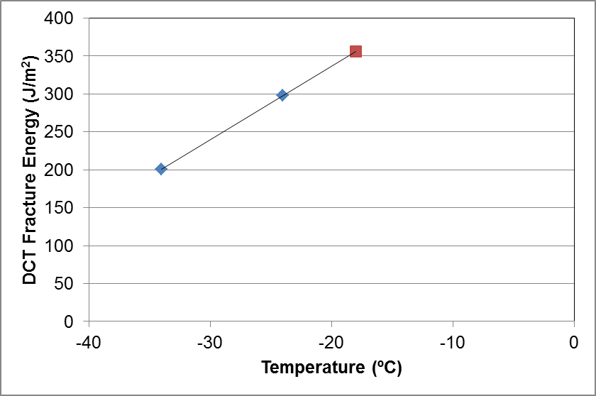

Figure 7. Example of linear extrapolation to obtain DC(T) Gf at PGLT+10 ºC (MIF\_RAP\_12.5mm)

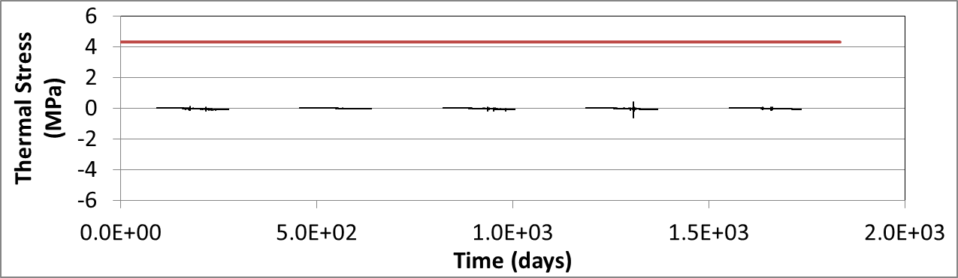

Figure 8. Preanalyzer results for WRI1-1 section (MIF\_RAP\_12.5mm)

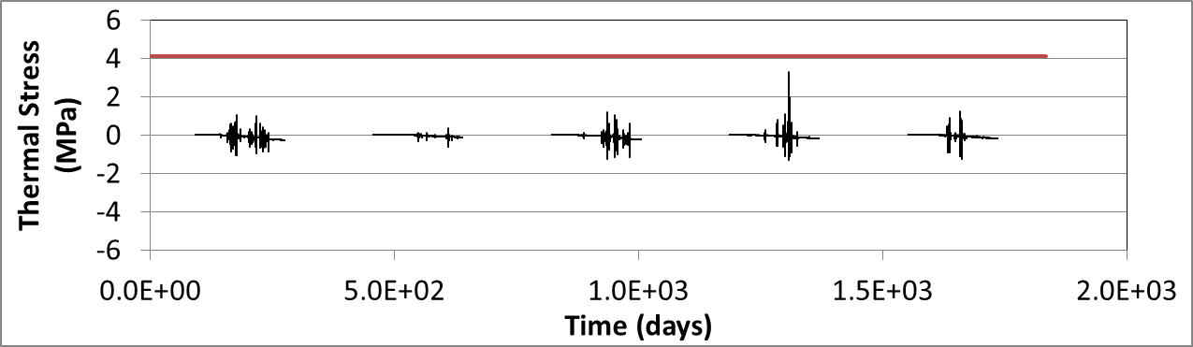

Figure 9. Preanalyzer results for WRI1-2 section (MIF\_12.5mm)

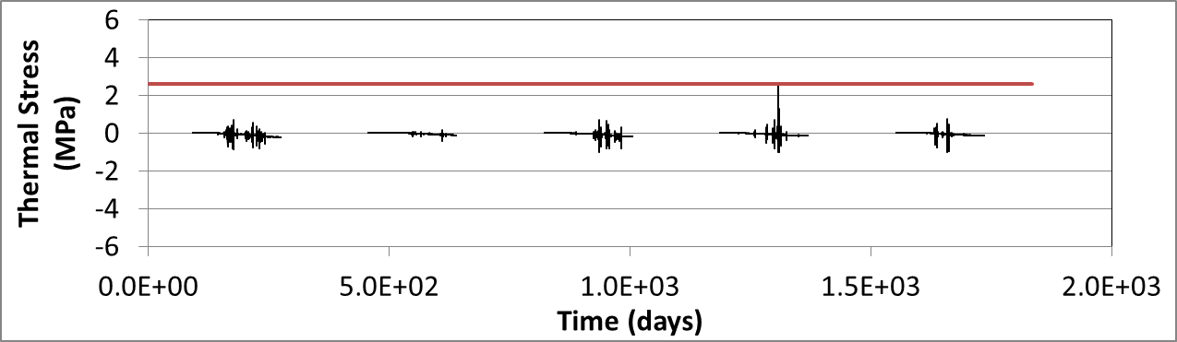

Figure 10. Preanalyzer results for WRI1-3 section (Marathon\_12.5mm)

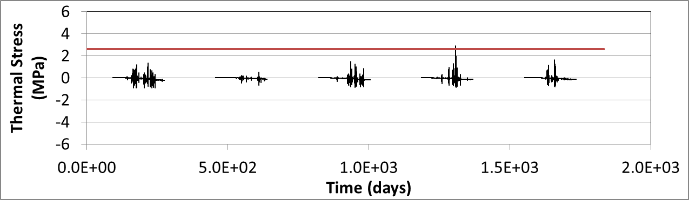

Figure 11. Preanalyzer results for WRI1-4 section (Valero\_12.5mm)

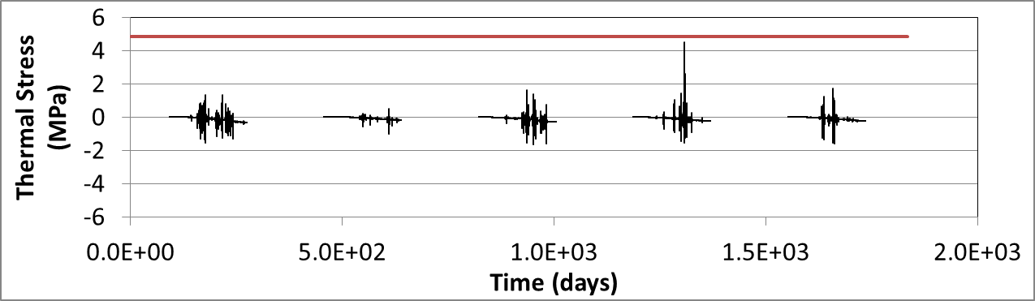

Figure 12. Preanalyzer results for WRI1-5 section (Citgo\_ 12.5mm)

Table 11. Preanalyzer results and field cracking for validation sections

|  |  |  |  |
| --- | --- | --- | --- |
| Pavement Section | Surface Mix | Number of Critical Events (Predicted by Preanalyzer) | Field Performance (Transverse cracking m/500m) |
| WRI1-1 | MIF\_ RAP\_12.5mm | 0 | 23 |
| WRI1-2 | MIF\_12.5mm | 0 | 2 |
| WRI1-3 | Marathon\_12.5mm | 0 | 29 |
| WRI1-4 | Valero\_12.5mm | 1 | 53 |
| WRI1-5 | Citgo\_ 12.5mm | 0 | 25 |

C:\Users\evdave\Documents\Research_Projects\LTC\Illi-TC_Validation\WRI1-4\Illi-TC_Runs\Out_File\WRI1-4.tif

Softening near the  
 top of pavement

Thermal Stress in Longitudinal Direction near the Crack Path (MPa), Tensile strength = 4.37 MPa

Figure 13. Thermal stresses at the end of the critical event for WRI1-4 section (Valero\_ 12.5mm)

Table 12. Illi-TC predictions and field cracking for validation sections using calibrations from Task 4

|  |  |  |  |  |
| --- | --- | --- | --- | --- |
| Pavement Section | Surface Mix | Predicted Crack Depth (mm) | Predicted Field Cracking (m/500m) | Actual Transverse Field Cracking (m/500m) |
| WRI1-1 | MIF\_ RAP\_12.5mm | 0 | 0 | 23 |
| WRI1-2 | MIF\_12.5mm | 0 | 0 | 2 |
| WRI1-3 | Marathon\_12.5mm | 0 | 0 | 29 |
| WRI1-4 | Valero\_12.5mm | 0 | 0\* | 53 |
| WRI1-5 | Citgo\_ 12.5mm | 0 | 0 | 25 |

\*softening was predicted, indicating that thermal cracking would likely results if a longer analysis period was used.

It can be concluded that the recommended long-term fracture energy level in the table-type thermal cracking specification appears to correlate well with the limited field performance data available for the Olmsted field sections investigated (5 years of performance data available at the time of this report). Although all of the field sections have experienced only minor thermal cracking to date, it is clear that the four sections with a fracture energy level below the recommended threshold have begun to exhibit thermal cracking, while the section with a fracture energy in excess of 400 J/m2 (section WRI1-2), has very minimal thermal cracking. Although the number of sections and amount of field performance data is fairly limited, the results provide an early validation of the proposed thermal cracking specification.

The ILLI-TC program was found to correctly rank the five field validation sections. In addition, softening was activated along the cohesive zone fracture elements in the section with the most field cracking (WRI1-4). However, under the current calibration parameters established in Chapter 4, zero cracking was predicted for all sections. Given the fact that the sections have only experienced a relatively low amount of cracking to date, it can be concluded that ILLI-TC is slightly underpredicting the cracking behavior for these sections. Incomplete compliance data could have contributed to the slight under prediction observed. Given the fact that one of the five sections in the calibration data set was also underpredicted, the validation trials here may suggest that ILLI-TC calibration parameters should be tuned to produce higher levels of cracking. However, since local calibration is recommended before implementing ILLI-TC in a given region, further calibration of ILLI-TC was not pursued herein.

# 4. Predicting Mixture creep stiffness from binder creep stiffness

In this section, Bending Beam Rheometer (BBR) binder creep test (AASHTO Designation: T 313-06, 2006) and Indirect Tensile (IDT) mixture creep test (AASHTO Designation: T 322-07, 2009) were performed on the materials described in Table 1 (except for the warm mix and the corresponding binder) to determine if mixture creep stiffness can be reasonably predicted from asphalt binder experimental data using two models recently published: Hirsch model and ENTPE transformation.

The four asphalt binders, Citgo (PG 58-28), Marathon (PG 58-28), MIF (PG 58-34), and Valero (PG 58-28) were short term aged (RTFOT) to match the binder condition in the loose mix used to prepare the IDT specimens. All BBR and IDT creep tests were performed at PG+10ºC. Binder creep stiffness and m-value results at 60 seconds from BBR testing are presented in Table 13 and Figure 14. Note that two replicates were tested at each testing temperature.

**Table 13. Summary of RTFOT binder S(60s) and m(60s) from BBR creep testing**

|  |  |  |  |
| --- | --- | --- | --- |
| Binder  type | Temp,  ºC | S(60s), MPa | m(60s) |
| Citgo  PG 58-28 | -18 | 171 | 0.420 |
| Marathon  PG 58-28 | -18 | 142 | 0.413 |
| MIF  PG 58-34 | -24 | 222 | 0.388 |
| Valero  PG 58-28 | -18 | 78 | 0.400 |

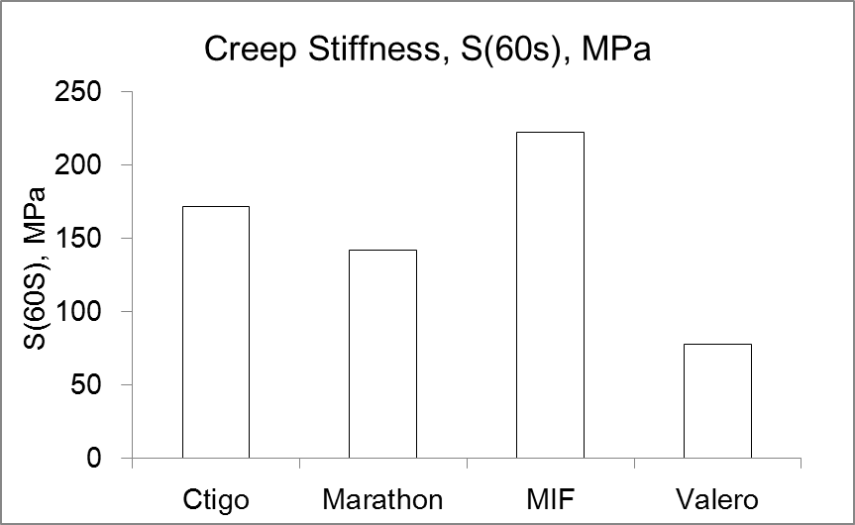 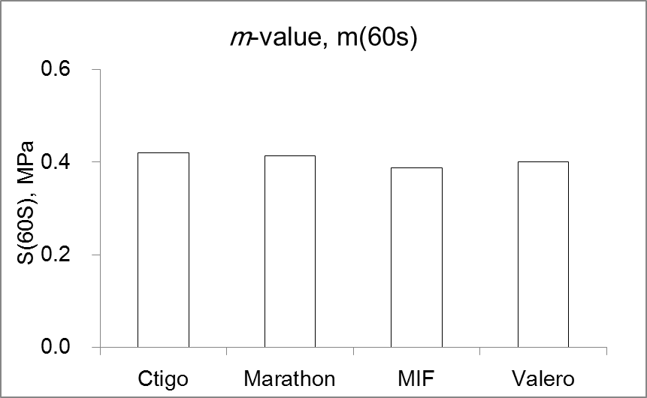

**Figure 14. RTFOT binder S(60s) and m(60s) results from BBR creep testing**

Mixture creep stiffness results at 60 and 500 seconds from IDT creep testing are presented in Table 14 and Figure 15. Three replicates were tested at each test temperature. In Figure 15, Citgo is labeled as C, Marathon as M, MIF as MI, Valero as V, and for the mixtures prepared with RAP, R is used as identifier.

**Table 14. Summary of S(60s) and S(500s) from IDT mixture creep testing**

|  |  |  |  |  |  |
| --- | --- | --- | --- | --- | --- |
| Mixture  type | Temp,  ºC | S(60s),  GPa | S(60s),  C.V.% | S(500s),  GPa | S(500s),  C.V.% |
| Citgo  12.5mm | -18 | 16.4 | 9.8 | 11.8 | 9.3 |
| Citgo  19.0mm | -18 | 13.6 | 1.2 | 8.7 | 3.8 |
| Marathon  12.5mm | -18 | 11.0 | 26.8 | 8.0 | 27.0 |
| Marathon  19.0mm | -18 | 12.8 | 21.3 | 7.7 | 19.3 |
| MIF w/R  12.5mm | -24 | 15.3 | 14.6 | 11.3 | 13.8 |
| MIF  12.5mm | -24 | 15.6 | 23.7 | 11.3 | 27.9 |
| MIF w/R  19.0mm | -24 | 15.4 | 13.2 | 11.5 | 11.4 |
| MIF  19.0mm | -24 | 15.3 | 9.5 | 11.1 | 8.6 |
| Valero  12.5mm | -18 | 9.4 | 15.1 | 6.3 | 12.9 |
| Valero  19.0mm | -18 | 6.8 | 26.5 | 3.5 | 32.3 |

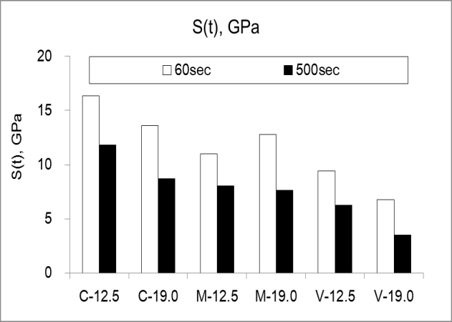 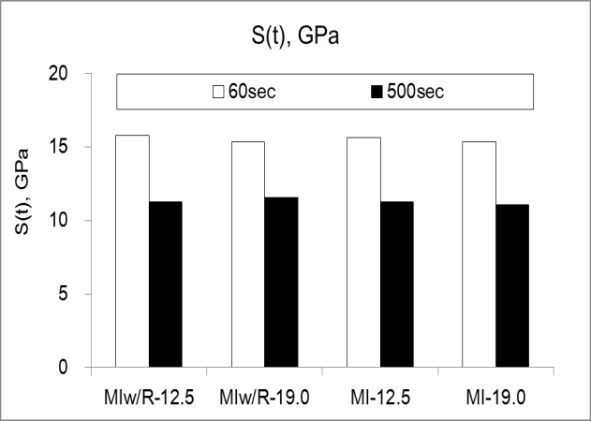

**Figure 15.** **Results of S(60s) and S(500s) from IDT mixture creep testing**

Most of the 12.5mm mixtures had higher creep stiffness values than the 19.0mm mixtures except for the mixtures prepared with Marathon binder. It was also observed that the mixtures with RAP had slightly higher stiffness values than the standard mixtures.

**Hirsch model**

A semi-empirical model, based on Hirsch model (1962) was proposed by Christensen et al. (2003) to estimate the extensional and shear dynamic modulus of asphalt mixture. The effective model was generated by combining aggregate, asphalt binder and air void in parallel and perpendicular direction as follows (see Figure 16):

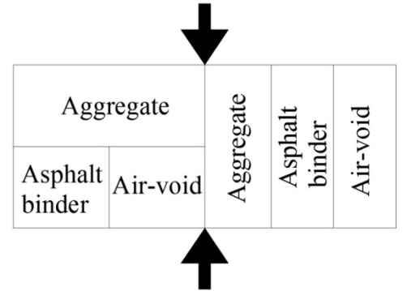

**Figure 16. Semi-empirical model proposed by (*Christensen et al., 2003)***

Based on Figure 16, the effective modulus of asphalt mixture can be expressed as follows:

[1]



where:

*Emixture* = effective modulus of the mixture,

*Eagg*, *Vagg* = modulus and volume fraction of the aggregate, respectively,

*Ebinder*, *Vbinder* = modulus and volume fraction of binder, respectively,

*Pc* = contact volume as an empirical factor defined as:

[2]



where:

*VFA* = voids filled with asphalt binder (%),

*VMA* = voids between mineral aggregate (%),

*P0, P1, P2* = fitting parameters.

Equation [1] can be changed in terms of stiffness as follows:

[3]



Based on mixture creep tests performed on small beams, Zofka et al. (2005) changed the aggregate modulus, Eagg from 4,200,000 psi (29GPa) to 2,750,000 psi (19GPa) and later on (2007) proposed a new expression for the parameter *Pc*:

[4]



where:

Ebinder = relaxation modulus of the binder, GPa,

*a* = constant equal to 1 GPa.

**Huet model and ENTPE transformation**

The Huet model is composed of two parabolic elements *J*1(*t*)=*a\*th* and *J*2(*t*)=*b\*tk* plus a spring element (stiffness *E∞*) combined in series (Figure 17) as follows:

**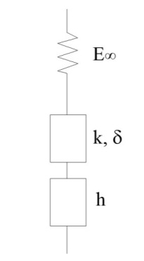**

**Figure 17. *Huet* model (*Huet*, 1963)**

The creep compliance function, D(t), in Huet model can be expressed as follows:

[5]



where:

*E∞* = glassy modulus,

*δ* = dimensionless constant,

*h*, *k* = exponents, 0 < *k* < *h* < 1,

*τ* = characteristic time varying with temperature accounting for

the Time Temperature Superposition Principle (TTSP), ,



*aT* = shift factor at temperature T,

*τ0* = characteristic time determined at reference temperature TS,

Γ = gamma function which can be expressed as follows:

[6]



[7]



*n*>0 or Real (*n*)>0,

*t* = integration variable,

*n* = argument of the gamma function.

For bituminous materials ** ≈ 2, *k* ≈ 0.3, and *h* is between 0.3 and 0.8, with lower values characteristic of aged, oxidized binders obtained by air blowing or aging during production and service life (Huet, 1999).

Based on previous work performed by Di Benedetto et al. (2004) and on Huet model, Cannone Falchetto et al. (2011) developed an expression relating asphalt mixture and asphalt binder creep stiffness:

[8]



Equation [8] can also be written for creep stiffness S(t):

[9]



An inverse relation can be easily written to obtain binder creep stiffness from mixture experimental data:

[10]



The authors found that the relationship between characteristic time of the binder, τbinder, and the corresponding characteristic time of the mixture, τmixture, developed by Di Benedetto et al. (2004) also holds at low temperature:

[11]



where:

*α* = a regression coefficient depending on mixture type and binder aging.

Equation [9] represents ENTPE (École Nationale des Travaux Publics de l’État) transformation at low temperature.

**Predicting mixture creep stiffness from binder experimental data**

The binder experimental data was used as input in the two models models to predict mixture creep stiffness and compare the results with the experimentally determined IDT creep stiffness.

**For Hirsch model**, based on preliminary trials, the original aggregate modulus Eagg = 4200000psi was used in the calculations. Using equations 3 and 4, the creep stiffness of corresponding mixtures were calculated based on asphalt binder creep stiffness. However, the predicted values correspond to creep stiffness of mixtures obtained using BBR small mixture beams. To obtain IDT creep stiffness, the equation proposed by Zofka (2005) was used:

[12]



Figures 18 to 22 contain the plots of experimental data from IDT mixture creep test and predicted creep stiffness from BBR binder creep test.

**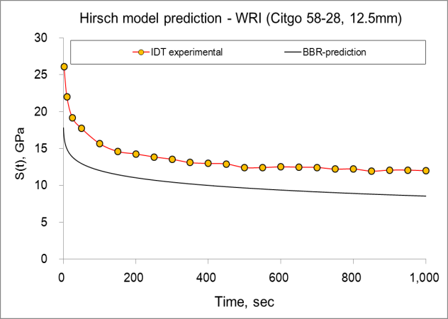 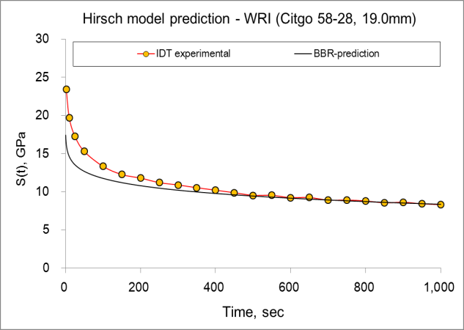**

**Figure 18. Hirsch model predictions for Citgo mixtures**

**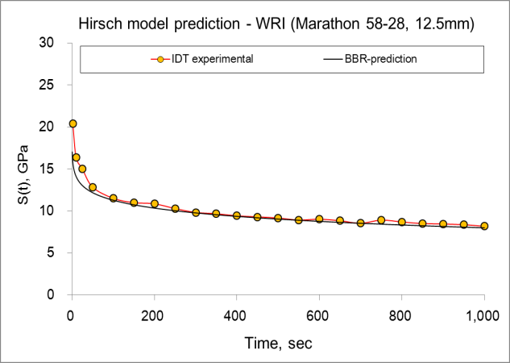 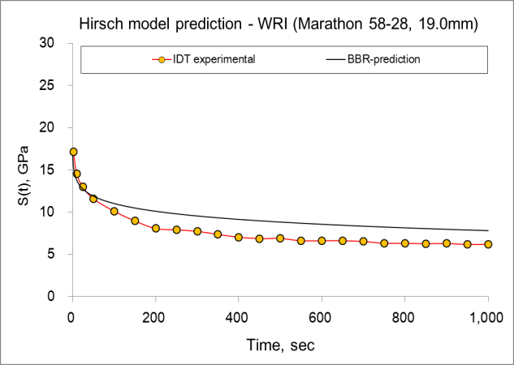**

**Figure 19. Hirsch model predictions for Marathon mixtures**

**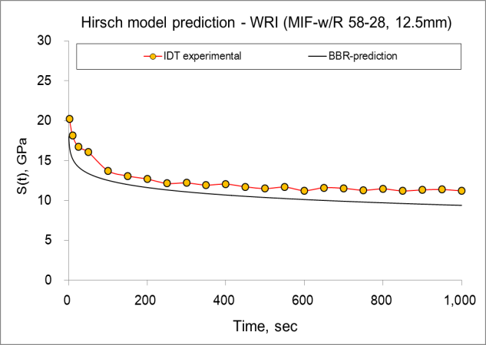 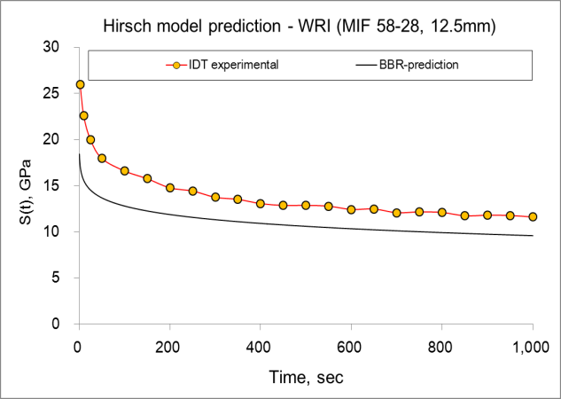**

**Figure 20. Hirsch model predictions for MIF 12.5mm mixtures**

**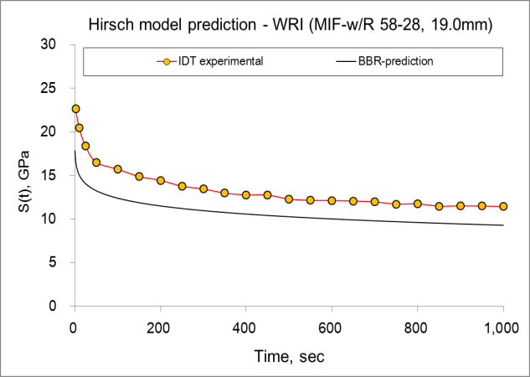 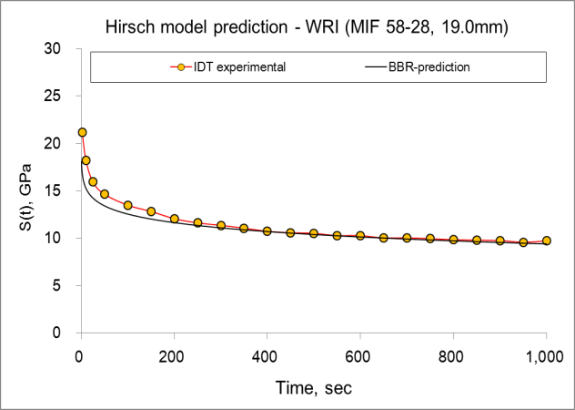**

**Figure 21. Hirsch model predictions for MIF 19.0mm mixtures**

**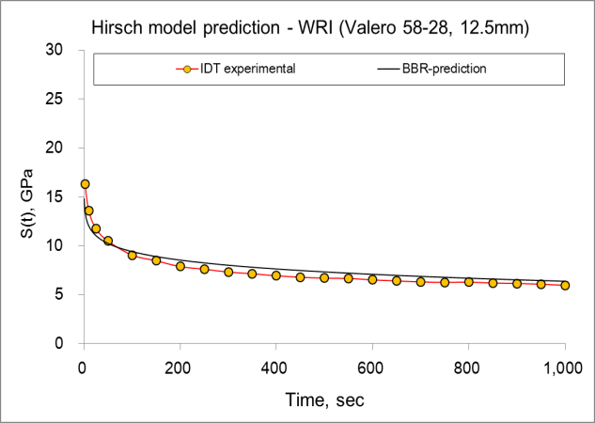 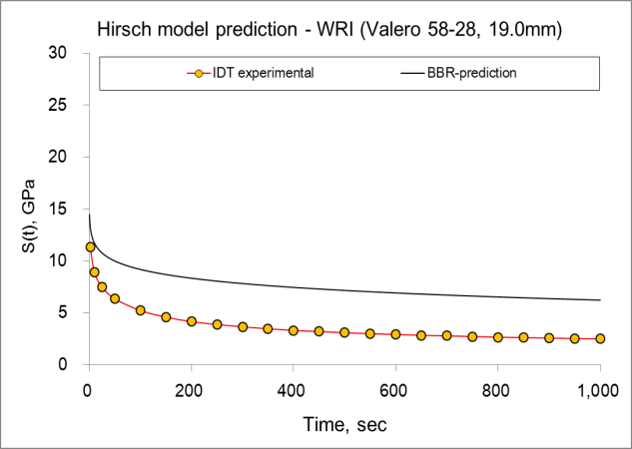**

**Figure 22. Hirsch model predictions for Valero mixtures**

It can be observed that the Hirsch model predictions are reasonable for most mixtures. However, for some mixtures, the predicted results were significantly higher (Valero 19.0mm mixture) or lower (Citgo 12.5mm mixture) compared to the experimental results.

**For ENTPE transformation**, equation 5 was first used to fit the creep compliance results of asphalt binder and five parameters were determined through minimization of sum of the distances between the experimental creep compliance results from BBR test and predicted results from Huet model fitting at 1250 time points:

[13]



Table 15 lists the computed parameters of the Huet model for four different types of asphalt binder which were tested at PG+10ºC.

**Table 15. Huet model parameters for tested binders**

|  |  |  |  |  |  |
| --- | --- | --- | --- | --- | --- |
| Binder  type | *δ* | *k* | *h* | E∞ b,  MPa | binder |
| Citgo  PG 58-28 | 1.5294 | 0.1113 | 0.5419 | 2500 | 0.9331 |
| Marathon  PG 58-28 | 2.8959 | 0.2044 | 0.5966 | 2500 | 1.5363 |
| MIF  PG 58-34 | 1.0362 | 0.1161 | 0.4912 | 2586 | 0.8779 |
| Valero  PG 58-28 | 2.4469 | 0.1069 | 0.4823 | 2500 | 0.0895 |

From the plots in Figures 23 to 24 it can be seen that Huet model fits the binder creep compliance experimental results very well.

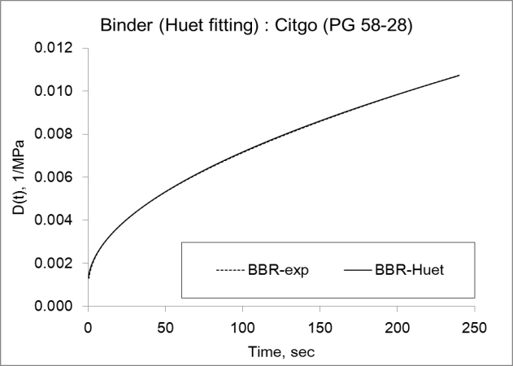 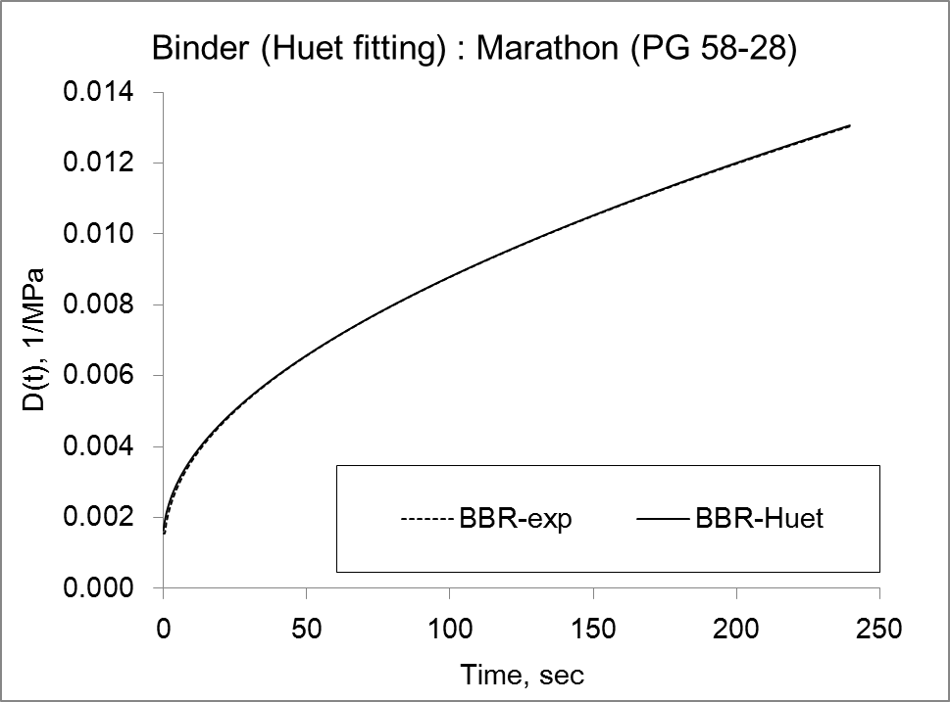

**Figure 23. Huet model predictions for binders Citgo (PG 58-28) and Marathon (PG 58-28)**

**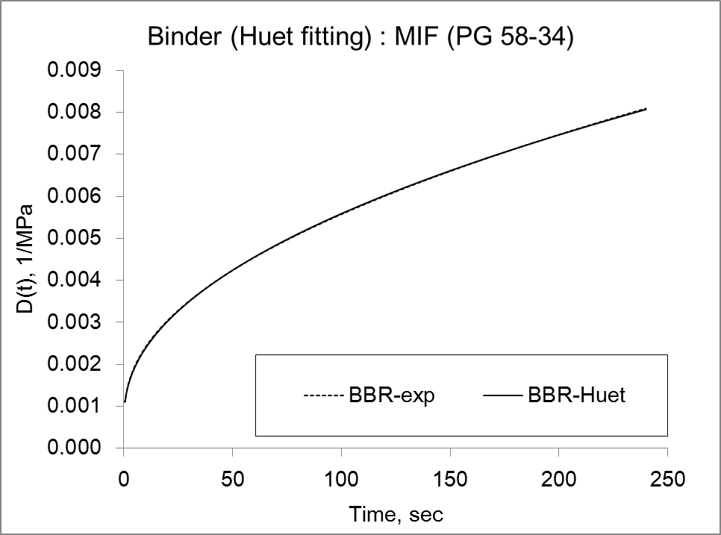 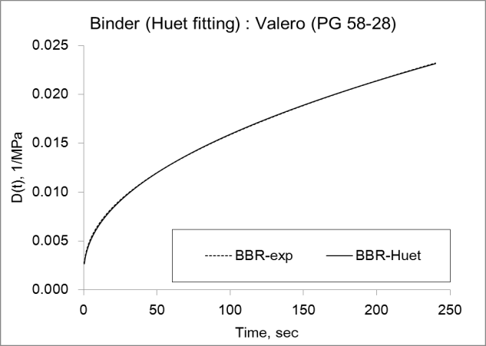**

**Figure 24. Huet model predictions for binders MIF (PG 58-28) and Valero (PG 58-28)**

Knowing that the same model parameters can be used to fit the asphalt mixture creep data, except for the characteristic time , and that the binder characteristic time and mixture characteristic time are related through parameter , the following  values were obtained and tabulated in Table 16.

**Table 16. ** parameter values for mixtures for ENTPE transformation**

|  |  |  |  |  |  |  |  |  |  |  |
| --- | --- | --- | --- | --- | --- | --- | --- | --- | --- | --- |
| Binder  type | Citgo  PG 58-28 | | Marathon  PG 58-28 | | MIF  PG 58-34 | | | | Valero  PG 58-28 | |
| NMAS,  mm | 12.5 | 19.0 | 12.5 | 19.0 | 12.5  w/R | 12.5 | 19.0  w/R | 19.0 | 12.5 | 19.0 |
| ** | 3.343 | 3.039 | 3.510 | 3.191 | 3.599 | 3.460 | 3.273 | 3.146 | 3.677 | 3.343 |

The creep stiffness of corresponding mixtures can be then easily predicted using Equation [9]. Figures 25 to 29 contain plots of predicted mixture creep stiffness using ENTPE transformation.

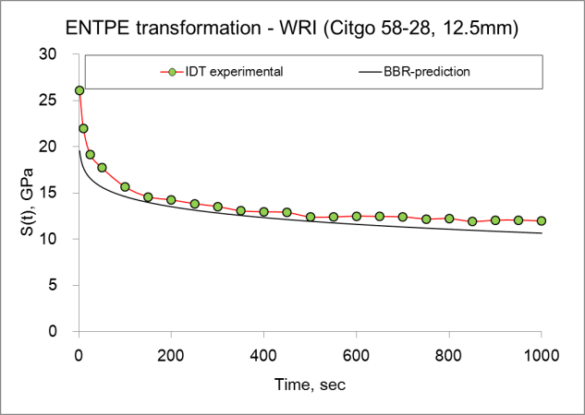 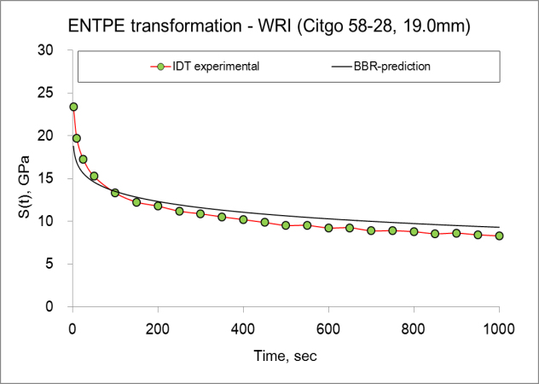

**Figure 25. ENTPE transformation predictions for Citgo mixtures**

**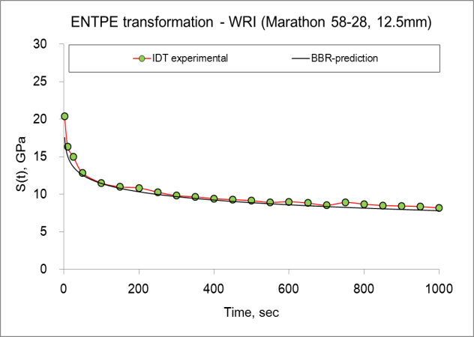 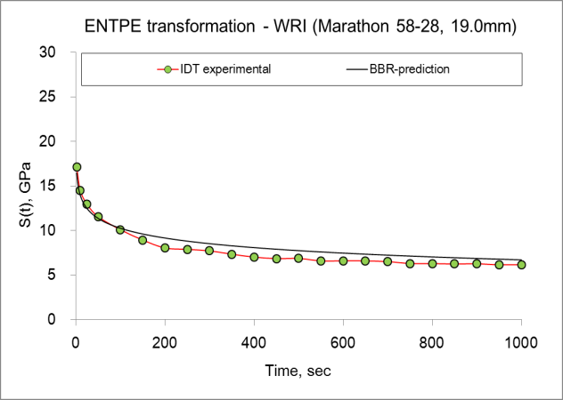**

**Figure 26. ENTPE transformation predictions for Marathon mixtures**

**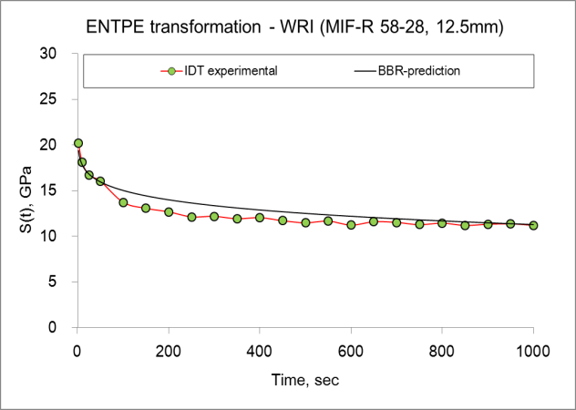 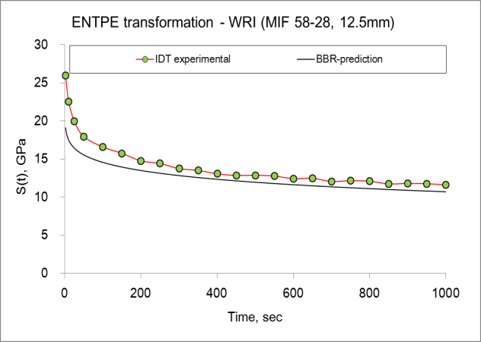**

**Figure 27. ENTPE transformation predictions for MIF 12.5mm mixtures**

**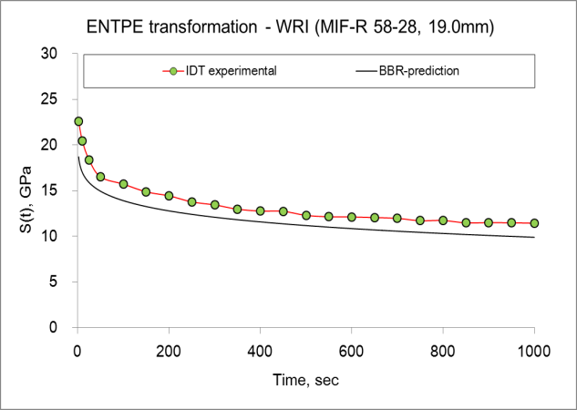 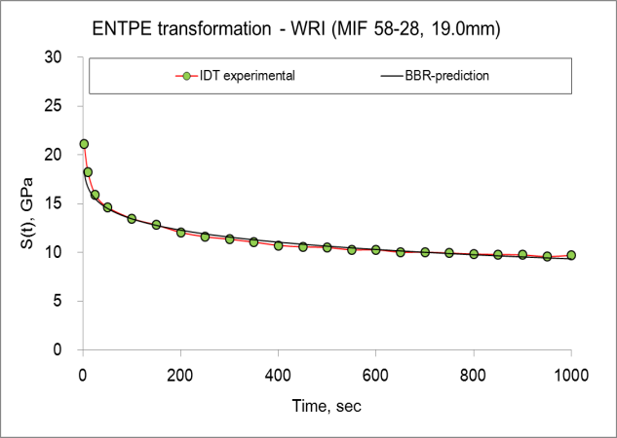**

**Figure 28. ENTPE transformation predictions for MIF 19.0mm mixtures**

**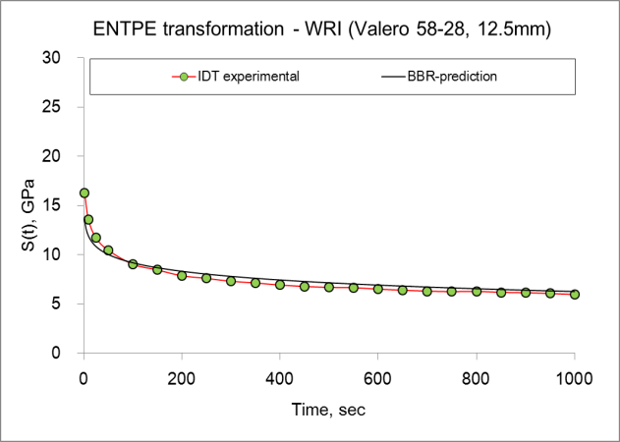 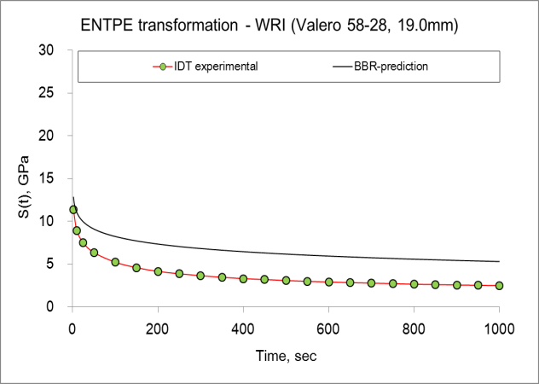**

**Figure 29. ENTPE transformation predictions for Valero mixtures**

Except for Valero 19.0mm mixture, the ENTPE transformation predicted the creep stiffness of corresponding mixtures very well. It should be mentioned that this is not unexpected since the same set of mixtures were used to obtain  parameter and to validate the model prediction.

**References**

1. American Association of State Highway and Transportation Officials (AASHTO) Standard T313-08, Standard method of test for determining the flexural creep stiffness of asphalt binder using the Bending Beam Rheometer (BBR), Standard Specifications for Transportation Materials and Methods of Sampling and Testing, 2009 Edition.
2. American Association of State Highway and Transportation Officials (AASHTO) Standard T 322-07. Determining the Creep Compliance and Strength of Hot-Mix Asphalt (HMA) Using the Indirect Tensile Test Device. Standard Specifications for Transportation and Methods of Sampling and Testing, 2009 Edition.
3. *Cannone Falchetto A., Marasteanu M. O., and Di Benedetto H.*, Analogical Based Approach to Forward and Inverse Problems for Asphalt Materials Characterization at Low Temperatures, Journal the Association of Asphalt Paving Technologists (AAPT), Vol. 80, 2011.
4. *Christensen D., Pellinen T., Bonaquist R. F.* Hirsch model for estimating the modulus of asphalt concrete, Journal of the Association of Asphalt Paving Technologists (AAPT), Vol. 72, pp. 97-121, 2003.
5. *Di Benedetto H., Olard F., Sauzéat C., Delaporte B.*, Linear viscoelastic behavior of bituminous materials: from binders to mixes, Road Material and Pavement Design, Vol. 5, Special Issue, pp.163-202, 2004.
6. *Hirsch T. J.,* Modulus of elasticity of concrete affected by elastic moduli of cement paste matrix and aggregate, Journal of the American Concrete Institute, Vol. 59(3), pp. 427-452, 1962.
7. *Huet, C.*, Coupled size and boundary-condition effects in viscoelastic heterogeneous and composite bodies, Mechanics of Materials, pp. 787-829, 1999.
8. *Marasteanu M., Velasquez R., Cannone Falchetto A., Zofka A.*, Development of a simple test to determine the low temperature creep compliance of asphalt mixture, IDEA Program Final Report NCHRP 133, Transportation Research Board of the National Academies, 2009.
9. *Zofka A., Marasteanu M., Li X., Clyne T., McGraw J.,* Simple method to obtain asphalt binders low temperature properties from asphalt mixtures properties, Journal of the Association of Asphalt Paving Technologists (AAPT), Vol. 74, pp.255-282, 2005.
10. Zofka A., Investigation of Asphalt Concrete Creep Behavior using 3-Point Bending Test, PhD thesis, University of Minnesota, Minneapolis, July 2007.