MnDOT 99007 – ***Evaluation of Guide Sign Fonts***

06/21/2013

**Project Status Update**

**Task 4: Data Analysis**

Due: June 30, 2013

* Preliminary data analysis has been completed. Initial findings are summarized below.

[Note: *Legibility index* is the distance at which the sign can be read (legibility distance) divided by the character height.]

* + Legibility index for daytime driving is significantly greater than for nighttime driving.
  + Legibility index is significantly greater for younger drivers than for older drivers.
  + For nighttime driving,
    - Font type is not significant for legibility index. However, there is an interaction effect between font type and legend type (eg, ascender, descender, neutral, number).
    - Younger drivers have a significantly greater legibility index than older drivers.
    - For older drivers, legend type has a significant effect on legibility index. Font type is not significant, although Clearview appears to perform slightly better than either Series E-Mod or Enhanced E-Mod. Specifically, descending legends in Clearview have a larger legibility index than numbers or neutral legends in any of the three fonts.

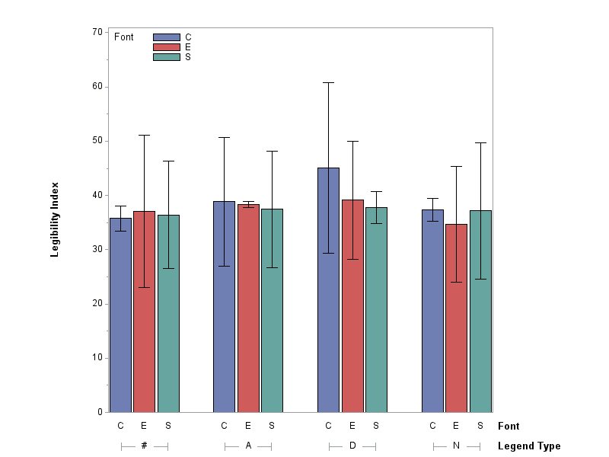

Nighttime driving – Older drivers

**Task 5: Cost Analysis**

Due: July 31, 2013

* This task is intended to determine the relative costs associated with implementing each of the fonts identified based on the relative sign sizes associated with each font.

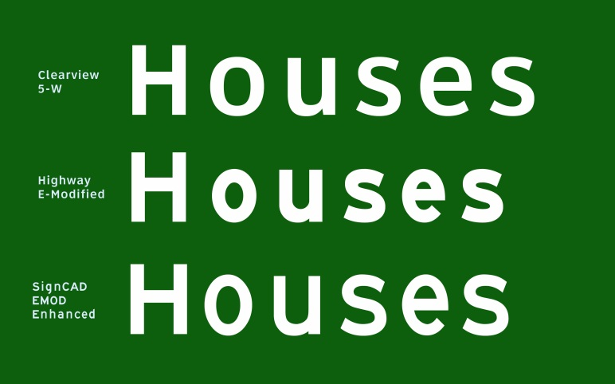

**Task 6: Draft Final Report**

Due: September 30, 2013