10th Quarterly Progress Report to the

FEDERAL HIGHWAY ADMINISTRATION

(FHWA)

On the Project

THE IMPACT OF WIDE-BASE TIRES ON PAVEMENT DAMAGE

DTFH61-11-C-00025

For the Period

July 1 to September 30, 2013

Submitted by

Illinois Center for Transportation

University of Illinois at Urbana-Champaign



**QUARTERLY PROGRESS REPORT**

**QUARTER 10**

**The Impact of Wide-Base Tires on Pavement Damage – A National Study**

1. **Work performed**

During this quarter, the following tasks have been accomplished:

* It was determined that MEPDG’s methodology for calculating loading frequency is not the most appropriate procedure. The loading waveform is being extracted from the FEM output database. The length of the finite element model was verified for appropriateness to determine the pulse time duration (Appendix A). This pulse time will be used in the master curve of each material to determine its modulus at that frequency. This is a relevant input variable for transfer functions.
* Pavement measured response data are being stored on an SQL server. The design for an online database for accessing experimental measurements was initiated.
* Field cores from the Florida and UC-Davis test sections were collected and shipped to ICT for laboratory testing. Preparation of the cores for specific testing geometries has been completed for Florida specimens and is 80% completed for UC-Davis specimens. In addition, dimensions of test specimens of field cores have been determined, and gage points needed for mounting of strain gages during testing have been installed (Appendix B).
* The load inputs were modified from contact stresses to nodal forces. Hence, the finite element models (FEM) were run using nodal forces. Progress can be seen in Appendix C

1. **Work to be accomplished next quarter**

* Laboratory characterization of materials from Florida and UC-Davis sections will be obtained and testing will be concluded.
* Loose mix collected from the Ohio plant during HMA production for test sections will be compacted to match field measured densities. Laboratory-compacted specimens will be prepared to specific testing geometries.
* The initial framework for LCA will be completed.
* The database of pavement responses from the Florida, California, and Ohio sections will continue to be added as the instrument responses are filtered and categorized.

1. **Problems encountered**

* There was significant delay in obtaining cores from UC-Davis; this resulted in some testing delays.

1. **Current and cumulative expenditures**

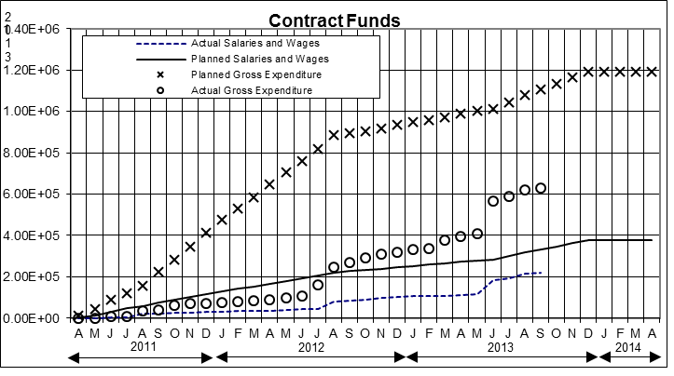

Figure 1. Project’s expenditure

1. **Planned, actual, and cumulative percentage of effort**

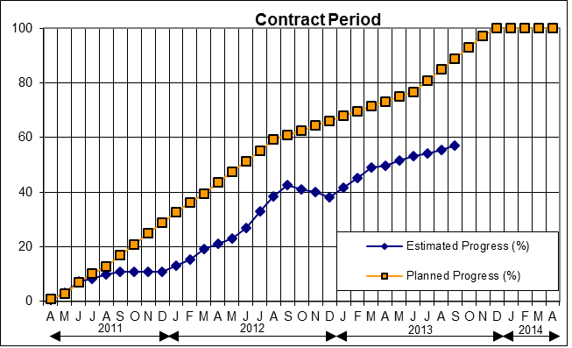

Figure 2. Project’s Progress

**APPENDIX A**

**LOADING WAVEFORM CALCULATION**

Loulizi et al. (2002) determined that the loading waveform can be estimated from the evolution of the vertical stress as the tire traverses the entire model. In addition, the authors suggested that the rising portion of the waveform up to the maximum provides sufficient information to measure the pulse duration. The time at which the normalized stress is 0.01 was defined as the start of the waveform. The pulse duration can be calculated as twice the time for the rising portion.

However, it was observed that the loading waveform does not dissipate to zero, which may be due to the boundary conditions (insufficient wheel path). The way to alleviate this issue is to increase the size of the FEM model, which will lead to a significant increase in computation time. Therefore, a case was compared with the established boundary conditions and twice the wheel path. The responses are compared for the two cases; the differences are shown in Figure A-1.

Figure A- 1. Percent difference between responses of two varying wheel paths

Further details about the loading cases and response values are provided in Tables A-1 and A-2. As shown in Table A-1, the wall clock time for computing the case that has twice the length of wheel path is fourfolds. The responses for the two cases are shown in Table A-2. Although the relative percentage difference was as high as 12.6 for the shear strain at the base layer, the absolute difference was only 1.8 με, which was deemed to be negligible. In terms of the other responses, the relative percentage difference was below 10. Therefore, the established boundary conditions were deemed to be sufficient and the maximum response values were not compromised.

Table A- 1. Duration of the loading cases

|  |  |  |  |  |
| --- | --- | --- | --- | --- |
| **Case** | **No. of Steps** | **Wheel Path Length (mm)** | **Wall Clock Time (hr)** | **End Step** |
| L4_AC412W_B150W | 17 | 1360 | 34.2 | 17 |
| L4_AC412W_B150W_2xSteps | 34 | 2380 | 96.0 | 25 |

Table A- 2. Responses of the cases compared

|  |  |  |
| --- | --- | --- |
| **Response** | **L4_AC412W_B150W** | **L4_AC412W_B150W_2xSteps** |
| e33_botAC(με) | 63.9 | 67.8 |
| e33_surfAC (με) | 101.3 | 104.4 |
| e22_sg (με) | 95 | 97.4 |
| e22_ac (με) | 57.4 | 59.9 |
| e23_ac (με) | 68 | 68.1 |
| e23_base (με) | 11.1 | 12.9 |
| e23_sg(με) | 35.9 | 38.8 |
| sig_mis (MPa) | 1.1 | 1.1 |

**APPENDIX B**

**LABORATORY SAMPLE PREPARATION**

In order to prepare test specimens from the field cores, individual materials/lifts must first be separated at the interfaces as seen in Figure B-1, and the bottom of the asphalt layer adjacent to a base course material must be cleaned or sawed to a usable state, i.e., relatively clean, smooth, flat face parallel to the opposing face of the specimen.

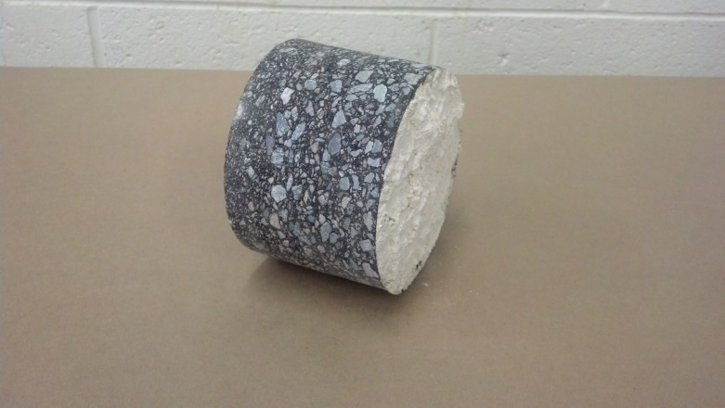 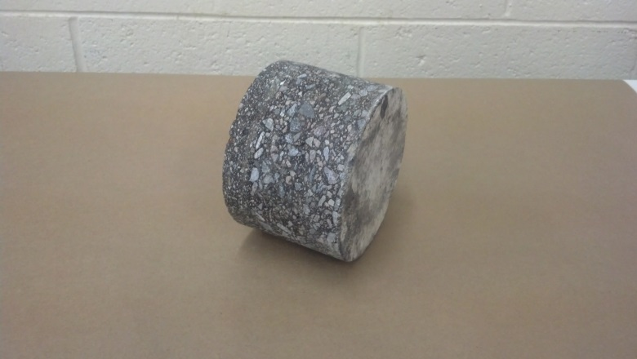 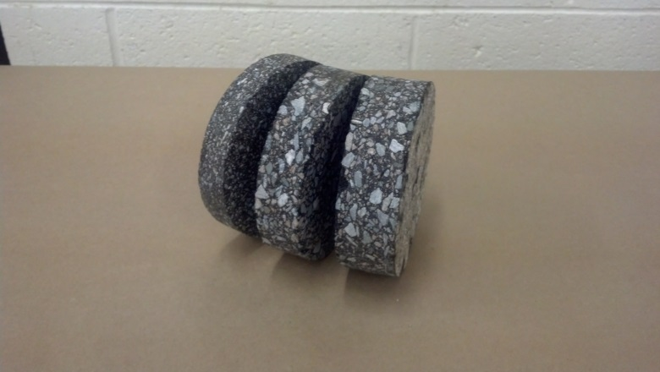

Figure B- 1. Preparation of field cores (left) by removal of partially adhered base course (center) followed by separation at layer interfaces (right)

After separation at the interface, the resultant disc-shaped specimens can be notched and/or cored to meet the test specific geometries needed such as DCT and SCB as shown in Figure B-2. It should be noted that all individual layers/lifts may not meet the minimal thickness requirements as stated in the standard, but precise specimen dimensions are measured and cross-sectional areas computed as all materials will be tested for completeness.

The minimum required dimensions are determined by the nominal maximum aggregate size which varies by material and is summarized in Table B-1. The Performance Grade (PG) of the asphalt binder for each material is also shown as this is used to specify testing temperatures for each material.

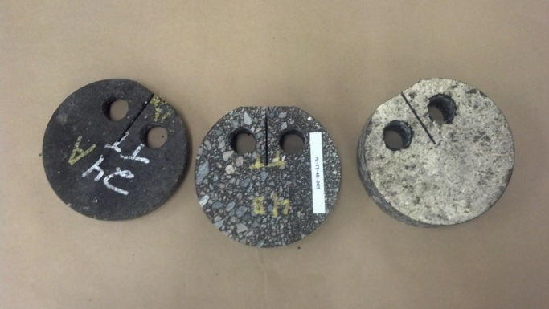 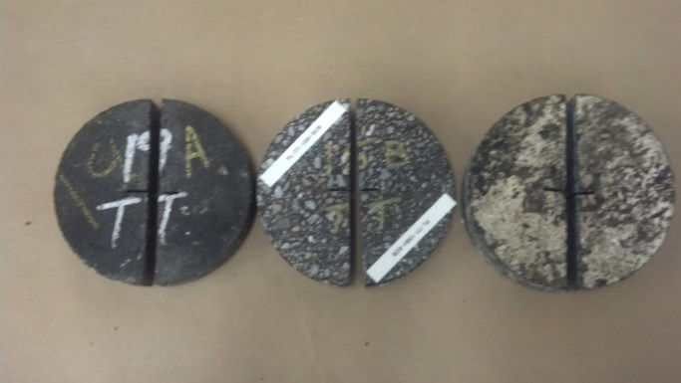

Figure B- 2. Prepared specimens of three materials/layers for DCT (left) and SCB (right)

Table B- 1. Description of FL-TT Materials/Layers

|  |  |
| --- | --- |
| Florida Test Track Materials | |
| A | 4.75 mm (PG 76-22) |
| B | 12.5 mm (PG 76-22) |
| C | 12.5 mm (PG 67-22) |

Densities of field cores were determined using both the saturated surface dry (SSD) method as well as the Corelok device to determine any variation from measurement method as well as core location. Figure B-3 to B-5 show the resulting air void percentages calculated for 24 of the cores taken from the Florida Test Track section. The blue bars show air voids as measured using the SSD method, whereas the red indicate values found using the Corelok device. The red and blue dashed (horizontal) lines indicate the average air void percentage for the 24 specimens shown as found by each method. This allows for identifying any cores that may show abnormalities or inconsistencies in volumetrics. Specimens greater than + 1% air voids from the average will not be tested as they are considered outliers based on volumetrics and are expected to produce unreliable results if included in the study.

Figure B- 3. FL-TT Material An air voids, averages of 17.7% and 17.6%

Figure B- 4. FL-TT Material B air voids, averages of 12.5% and 12.1%

Figure B- 5. FL-TT Material C air voids, averages of 10.4% and 10.3%

**APPENDIX C**

**FINITE ELEMENT MODELING**

The status of the thick and thin pavement modeling is shown in Tables C-1 and C-2. The green-highlighted cells indicate completed analysis. The first column lists the pavement structure considered and the loading cases L1 to L12.

Table C- 1. Status of thick pavement cases

|  |  |  |  |  |  |  |  |  |  |  |  |  |
| --- | --- | --- | --- | --- | --- | --- | --- | --- | --- | --- | --- | --- |
| **Thick** | **LOAD CASE** | | | | | | | | | | | |
| **WBT** | | | | | **DTA** | | | | | | |
| **L1** | **L2** | **L3** | **L4** | **L11** | **L5** | **L6** | **L7** | **L8** | **L9** | **L10** | **L12** |
| **AC125W_B150W** | 3 | 3 | 3 | 3 | 3 | 3 | 3 | 3 | 3 | 3 | 3 | 3 |
| **AC125W_B150S** |  |  |  |  |  |  |  |  |  |  |  |  |
| **AC125S_B150W** |  |  |  |  |  |  |  |  |  |  |  |  |
| **AC125S_B150S** | 3 | 3 | 3 | 3 | 3 | 3 | 3 | 3 | 3 | 3 | 3 | 3 |
| **AC125W_B600W** | 3 | 3 |  | 3 |  | 3 | 3 | 3 | 3 | 3 | 3 | 3 |
| **AC125W_B600S** |  |  |  |  |  |  |  |  |  |  |  |  |
| **AC125S_B600W** |  |  |  |  |  |  |  |  |  |  |  |  |
| **AC125S_B600S** | 3 | 3 | 3 | 3 | 3 | 3 | 3 | 3 | 3 | 3 | 3 | 3 |
| **AC412W_B150W** | 3 | 3 | 3 | 3 | 3 | 3 | 3 | 3 | 3 | 3 | 3 | 3 |
| **AC412W_B150S** |  |  |  |  |  |  |  |  |  |  |  |  |
| **AC412S_B150W** |  |  |  |  |  |  |  |  |  |  |  |  |
| **AC412S_B150S** | 3 | 3 | 3 | 3 | 3 | 3 | 3 | 3 | 3 | 3 | 3 | 3 |
| **AC412W_B600W** | 0 | 0 | 0 | 0 | 0 | 0 | 0 | 0 | 0 | 0 | 0 | 0 |
| **AC412W_B600S** | 0 | 0 | 0 | 0 | 0 | 0 | 0 | 0 | 0 | 0 | 0 | 0 |
| **AC412S_B600W** | 0 | 0 | 0 | 0 | 0 | 0 | 0 | 0 | 0 | 0 | 0 | 0 |
| **AC412S_B600S** | 0 | 0 | 0 | 0 | 0 | 0 | 0 | 0 | 0 | 0 | 0 | 0 |

Table C- 2. Status of thin pavement cases

|  |  |  |  |  |  |  |  |  |  |  |  |  |  |  |  |  |  |  |  |  |  |  |  |  |  |  |  |  |  |  |  |  |
| --- | --- | --- | --- | --- | --- | --- | --- | --- | --- | --- | --- | --- | --- | --- | --- | --- | --- | --- | --- | --- | --- | --- | --- | --- | --- | --- | --- | --- | --- | --- | --- | --- |
|  | **AC75W_B150W_SGW** | **AC75S_B150S_SGS** | **AC125W_B600W_SGW** | **AC125S_B600S_SGS** | **AC125W_B150W_SGW** | **AC125S_B150S_SGS** | **AC75W_B600W_SGW** | **AC75S_B600S_SGS** | **AC75W_B150W_SGS** | **AC75S_B150S_SGW** | **AC125W_B600W_SGS** | **AC125S_B600S_SGW** | **AC125W_B150W_SGS** | **AC125S_B150S_SGW** | **AC75W_B600W_SGS** | **AC75S_B600S_SGW** | **AC75W_B150S_SGW** | **AC75W_B150S_SGS** | **AC125W_B600S_SGW** | **AC125W_B600S_SGS** | **AC125W_B150S_SGW** | **AC125W_B150S_SGS** | **AC75W_B600S_SGW** | **AC75W_B600S_SGS** | **AC75S_B150W_SGW** | **AC75S_B150W_SGS** | **AC75S_B600W_SGW** | **AC75S_B600W_SGS** | **AC125S_B150W_SGW** | **AC125S_B150W_SGS** | **AC125S_B600W_SGW** | **AC125S_B600W_SGS** |
| **L1** | 3 | 3 | 3 | 3 | 3 | 3 | 3 | 0 | 3 | 3 | 3 | 3 | 3 | 3 | 0 | 0 | 3 | 3 | 0 | 0 |  | 0 | 0 | 0 | 0 | 0 | 0 | 0 | 0 | 0 | 0 | 0 |
| **L2** | 3 | 3 | 3 | 3 | 3 | 3 | 3 | 0 | 3 | 3 | 3 | 3 | 3 | 3 | 0 | 0 | 3 | 3 | 0 | 0 |  | 0 | 0 | 0 | 0 | 0 | 0 | 0 | 0 | 0 | 0 | 0 |
| **L3** | 3 | 3 | 3 | 3 | 3 | 3 | 3 | 0 | 3 | 3 | 0 | 0 |  |  | 0 | 0 | 3 | 3 | 0 | 0 | 0 | 0 | 0 | 0 | 0 | 0 | 0 | 0 | 0 | 0 | 0 | 0 |
| **L4** | 3 | 3 | 3 | 3 | 3 | 3 |  | 0 | 3 | 3 | 0 | 0 | 3 | 3 | 0 | 0 | 3 | 3 | 0 | 0 |  | 0 | 0 | 0 | 0 | 0 | 0 | 0 | 0 | 0 | 0 | 0 |
| **L5** | 3 | 3 | 3 | 3 | 3 | 3 |  | 0 | 3 | 3 | 0 | 0 | 0 | 0 | 0 | 0 | 3 |  | 0 | 0 | 0 | 0 | 0 | 0 | 0 | 0 | 0 | 0 | 0 | 0 | 0 | 0 |
| **L6** | 3 | 3 | 3 | 3 | 3 | 3 |  | 0 | 3 | 3 | 0 | 0 | 0 | 0 | 0 | 0 | 3 | 3 | 0 | 0 | 0 | 0 | 0 | 0 | 0 | 0 | 0 | 0 | 0 | 0 | 0 | 0 |
| **L7** | 3 | 3 | 3 | 3 | 3 | 3 | 3 | 0 | 3 | 3 | 0 | 0 | 0 | 0 | 0 | 0 | 3 | 3 | 0 | 0 | 0 | 0 | 0 | 0 | 0 | 0 | 0 | 0 | 0 | 0 | 0 | 0 |
| **L8** | 3 | 3 | 3 | 3 | 3 | 3 | 3 | 0 | 3 | 3 | 0 | 0 | 0 | 0 | 0 | 0 | 3 | 3 | 0 | 0 | 0 | 0 | 0 | 0 | 0 | 0 | 0 | 0 | 0 | 0 | 0 | 0 |
| **L9** | 3 | 3 | 3 | 3 | 3 | 3 | 3 | 0 | 3 | 3 | 0 | 0 | 0 | 0 | 0 | 0 | 3 | 3 | 0 | 0 | 0 | 0 | 0 | 0 | 0 | 0 | 0 | 0 | 0 | 0 | 0 | 0 |
| **L10** | 3 | 3 | 3 | 3 | 3 | 3 | 3 | 0 | 3 | 3 | 0 | 0 | 0 | 0 | 0 | 0 | 3 |  | 0 | 0 | 0 | 0 | 0 | 0 | 0 | 0 | 0 | 0 | 0 | 0 | 0 | 0 |
| **L11** | 3 | 3 | 3 | 3 | 3 | 3 | 3 | 0 | 3 | 3 | 0 | 0 | 3 | 3 | 0 | 0 | 3 | 3 | 0 | 0 | 0 | 0 | 0 | 0 | 0 | 0 | 0 | 0 | 0 | 0 | 0 | 0 |
| **L12** | 3 | 3 | 3 | 3 | 3 | 3 | 3 | 0 | 3 | 3 | 0 | 0 | 0 | 0 | 0 | 0 | 3 |  | 0 | 0 | 0 | 0 | 0 | 0 | 0 | 0 | 0 | 0 | 0 | 0 | 0 | 0 |