5th Quarterly Progress Report to the

FEDERAL HIGHWAY ADMINISTRATION

(FHWA)

On the Project:

THE IMPACT OF WIDE-BASE TIRES ON PAVEMENT DAMAGE

DTFH61-11-C-00025

For period

April 1st to June 30th 2012

Submitted by

Illinois Center for Transportation

University of Illinois at Urbana-Champaign



**QUARTERLY PROGRESS REPORT**

**QUARTER 4**

**The Impact of Wide-Base Tires on Pavement Damage – A National Study**

1. **Work Performed**

During this quarter, the following tasks have been accomplished:

* Three dimensional contact stresses, static footprints, and load-deflection curves were measured by the Council for Scientific and Industrial Research (CSIR) in South Africa. The measurements for the testing matrix presented in Phase I Report were received in txt format. A total of three repetitions for each combination of load and tire inflation pressure were reported.
* The 3D tire contact stresses measurements were filtered and the average of the three repetitions was calculated. In addition, the contact area was measured using AutoCAD based on static footprints also provided by CSIR. Appendix A presents a sample of the variation of the 3D contact stresses, the lengths of tire ribs, and the procedure used to determine these values.
* The LTPP Standard Release 26.0 database, from the U.S. Federal Highway Administration, was used to obtain asphalt concrete material properties. These properties will be used in the Finite Element (FE) models. Six mixes were selected to be used in modeling relatively weak and relatively strong pavement structures. Appendix B provides details on the approach used for selecting the master curve for each mix.
* Laboratory testing to characterize the tire component materials were performed by Smithers Rapra. The obtained results include frequency sweep at various values of temperature for six rubber components and tensile properties of the reinforcement.
* Pressure cells to be used for the Florida test sections were purchased and shipped to Florida DOT.
* The pavement structures to be instrumented at UC-Davis (2) were finalized. The sections have a 120-mm-thick surface layer with two percentages of reclaimed asphalt pavement (RAP) (15 and 50%). The base for both sections will be built using full-depth reclamation with no stabilizer (120-mm-thick). The sections will be constructed on top of a 400-mm of aggregate base and clay subgrade. A total of 16 strain gauges and 4 pressure cells will be installed. Details regarding pavement structure and instrumentation are given in Appendix C.
* The FE mesh for the selected pavement structures and loading conditions was defined and checked for expected pavement responses.
* Construction and testing dates were identified for the three sections to be built and instrumented in Ohio. Construction and testing will be performed between mid-August and the first week of October 2012. This timeframe may change pending the next project meeting on August 1st, 2012.

1. **Work to be accomplished next quarter**

* Finite element analysis will be performed for the load 26.7 kN and tire inflation pressure of 0.55 MPa. This will be carried out on the thin and thick pavement structures, considering various material properties, and both tire configurations.
* Contact stress measurements will be processed for the dual-tire assembly
* Construction and initial testing of the sections at UC-Davis, Florida, and Ohio are expected during the next quarter.
* Laboratory measurements of tire component materials, provided by Smithers Rapra, will be processed.

1. **Problems encountered**

No problems have been encountered in this quarter.

1. **Current and cumulative expenditures**

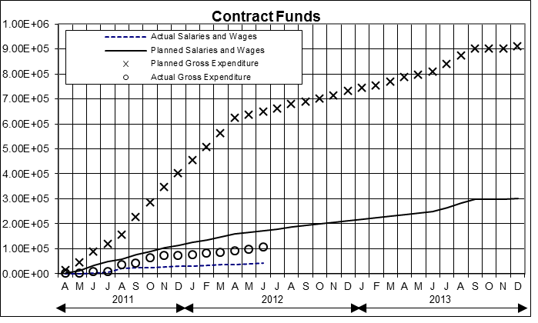



* + *Note: Subcontract expenditures have not been processed*

1. **Planned, actual, and cumulative percent of effort**

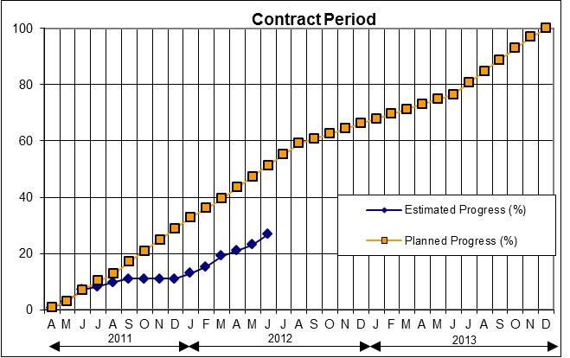

1. **APPENDIX A: PROCCESSING OF 3D CONTACT STRESS MEASUREMENTS**

The 3D contact stresses were measured by CSIR for various loads and tire inflation pressures as presented in the table below:

Table 1. Test matrix or contact stresses measurement

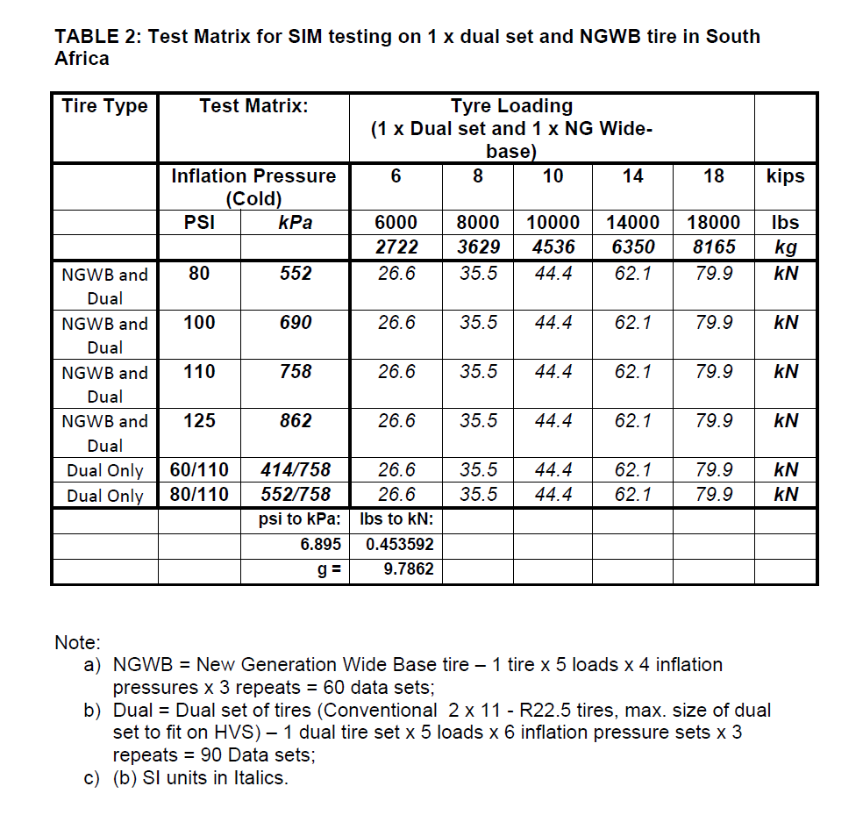

Three repetitions were performed for each entry in the test matrix and reported in txt files. The raw measurements were filtered using the moving average method with a window size of 20 measurements. This value was chosen so that a smooth variation of the data was obtained for all data sets. Once the information in each txt file was filtered, the average of the three repetitions was calculated. The variation of the vertical contact stresses was used to determine the contact length at the location of each measurement pin.

Static footprint was used to acquire the contact area. Each footprint was imported in AutoCAD and properly scaled. A polyline was drawn around each rib so that the area enclosed could be extracted. This area along with the contact length at each pin location were utilized to find the width each rib. Figure 1 shows a sample of the obtained results.

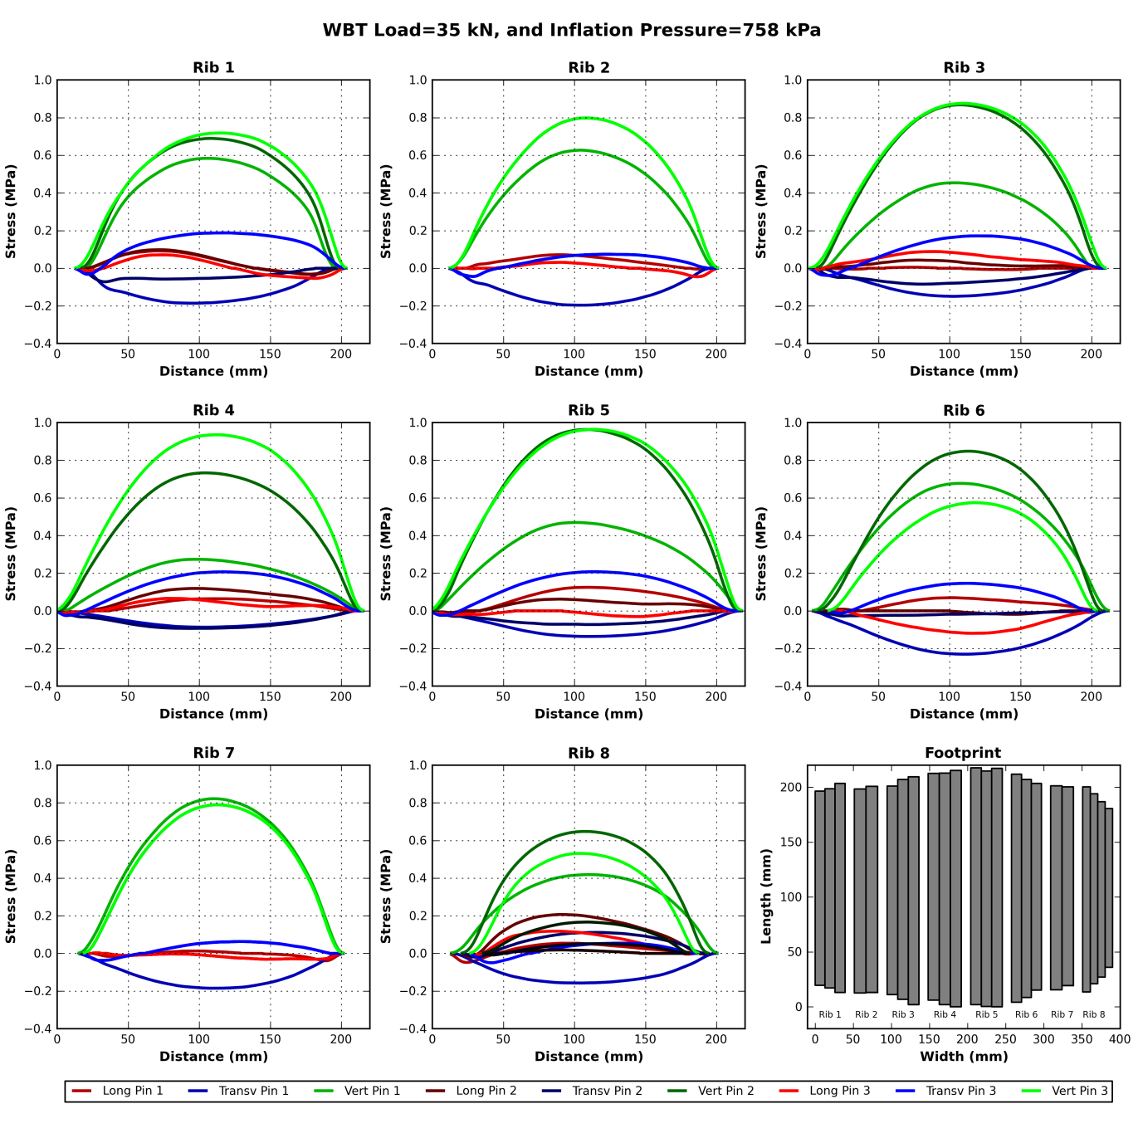

Figure 1. Variation of 3D contact stresses along the length of the tire and contact area for a load of 35 kN and tire inflation pressure of 0.758 kPa

1. **APPENDIX B: SELECTION OF AC MATERIAL PROPERTIES FOR FINITE ELEMENT ANALYSIS**

The LTPP Standard Release 26.0 database, provided by the U.S. Federal Highway Administration, allowed selecting proper material properties for the asphalt concrete (AC) layers. The utilized group of tables are ‘TST_ESTAR,’ indicating the dynamic modulus data of AC mixtures, │E*│. │E*│ is a fundamental material property that defines AC stiffness as a function of temperature and loading time. The test data collected at various temperatures can then be shifted relative to the time of loading or frequency in order to align various curves to form a single master curve. Accordingly, based on literature review, the use of a sigmoidal fitting function, used also by MEPDG, enables to solve shift factors simultaneously with the coefficients of the fitting function. It also eliminates unrealistic modulus predictions when extrapolating outside the range of data which occurs when a single polynomial model is used at high and low temperatures.

where = dynamic modulus,

= reduced angular frequency in Hertz,

= minimum modulus value,

= span of modulus values, and

= shape parameters.

Additionally, the ‘TST_ESTAR_MODULUS_COEFF’ table contains the coefficients for the time-temperature shift factor function for as indicated in the following equation:

where = AC time-temperature shift factor,

= temperature of interest,

=regression coefficients.

In order to initially filter the data provided, a ‘MASTERCURVE_QUALITY’ column is included in the ‘TST_ESTAR_MODULUS_COEFF’ table to segregate data that passes from the ones that fails. A pass is assigned if the variance is greater than 0.99 and ratio of standard error to standard deviation is less than 0.05. Further filtering of the data to appropriately choose material properties was improved through statistical analysis, wherein δ (minimum modulus value) became the controlling factor as it represents the behavior of the material under slow loading condition or high temperature.

The remaining data, approximately 1000 data sets, was then sorted in an increasing order according to the δ parameter. Moreover, using a normal distribution, three tolerance intervals were considered: 95.4, 97.5, and 99.8 percent. The chosen intervals denoted the percentage of values that lie within their respective standard deviations. The three tolerance intervals determined the minimum and maximum δ values for the wearing surface, intermediate and base layers, respectively. However, another parameter to further refine the data was the aggregate Nominal Maximum Aggregate Size (NMAS). For the wearing surface, typical NMAS of 9.5mm or 12.5mm is considered acceptable, whereas for the intermediate layer 25mm or 19.5mm was chosen, and for the binder layer 25mm or 37.5mm was selected. With the combination of the statistical tolerance level and typical layer NMAS, the data was refined to the most appropriate material properties. From the remaining data that passed these multiple criteria, graphical comparison of each master curve allows to obtain the optimum material properties for three AC layers representing the ‘weak’ and ‘strong’ sets. Additionally, data was checked for intersection and/or overlap. Six appropriate data sets were then finalized, wherein the top three master curves were chosen for the ‘strong’ set and the bottom three represented the ‘weak’ set (see Figure 2).

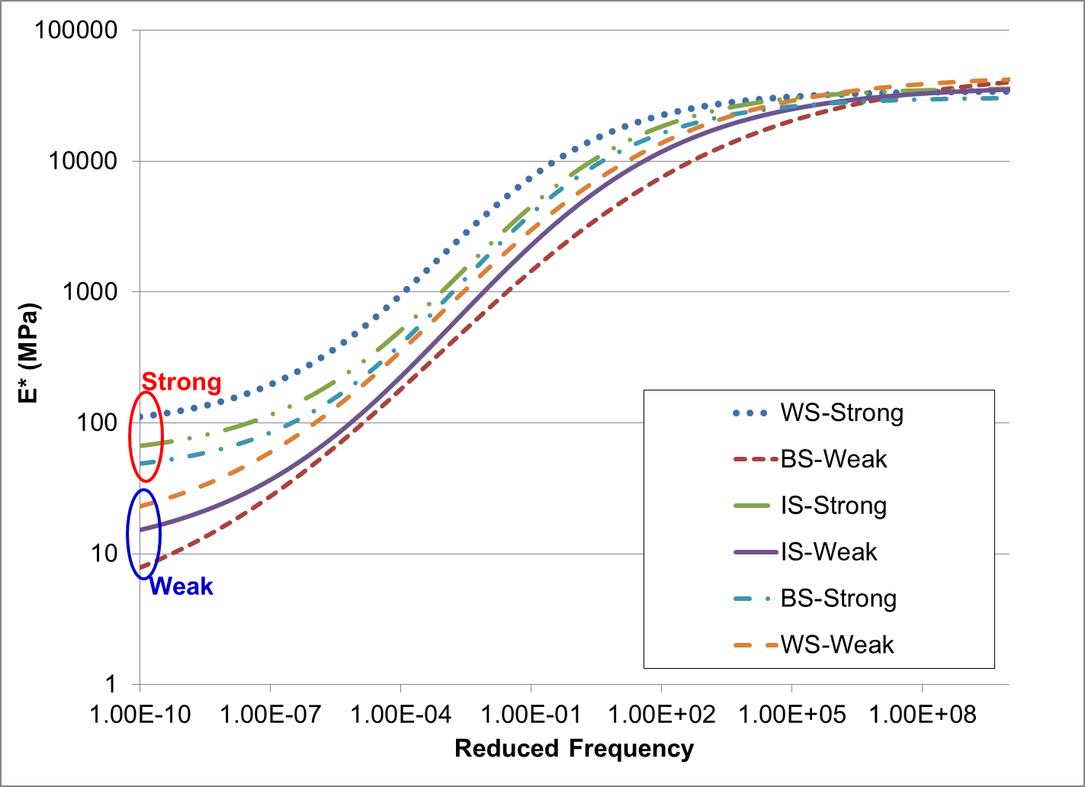

Figure : Asphalt concrete material properties for wearing surface, intermediate and base layers.

The following table indicates the sigmoidal function coefficients calculated for the final set of material properties.

Table : Sigmoidal function coefficients representing asphalt concrete material properties.

|  |  |  |  |  |  |  |  |  |
| --- | --- | --- | --- | --- | --- | --- | --- | --- |
| **Mix Type** | **Layer** | **δ** | **α** | **β** | **γ** | **α1** | **α**2 | **α3** |
| Strong | Wearing Surface | 1.9654 | 2.5711 | -1.5622 | 0.4982 | 0.0002 | -0.1053 | 6.3104 |
| Intermediate Layer | 1.7370 | 2.8245 | -1.2149 | 0.4656 | 0.0002 | -0.1053 | 6.3104 |
| Binder Layer | 1.6067 | 2.8820 | -1.2840 | 0.4812 | 0.0004 | -0.1533 | 8.6010 |
| Weak | Wearing Surface | 1.0967 | 3.5621 | -1.0530 | 0.3572 | 0.0002 | -0.1169 | 6.9827 |
| Intermediate Layer | 0.9694 | 3.6050 | -1.0560 | 0.3825 | 0.0001 | -0.0962 | 6.1900 |
| Binder Layer | 0.3505 | 4.3576 | -0.8800 | 0.2829 | 0.0009 | -0.2285 | 11.6836 |

1. **APPENDIX C: PAVEMENT STRUCTURE AND INSTRUMENTATION AT UC-DAVIS**

Figure 3 and Figure 4 presents typical pavement structures to be built in UC-Davis. Regarding this project, the following is highlighted:

* Two tests sections, about 48 m-long and about 4.0 m-wide will be built. Each section has 400 mm granular base layer on top of clayey subgrade. 120 mm of granular recycled AC layer will be placed on top of the base layer, and a 120 mm wearing surface will be then placed.
* The wearing surface of each section has 15% and 50% RAP, respectively. The base is the same for both sections: full-depth reclamation with no stabilizer (FDR-NS)
* The instrumentation includes 16 strain gauges. The strain gauges will be placed in both directions under each lift of the wearing surface (60 mm thick). They will be located at the middle of the wheel path. Each section will have 8 strain gauges: 4 under each lift of the surface layer
* Two pressure cells will be installed at the bottom of the recycled granular layer and two at the bottom of the AC wearing surface.
* In order to measure the deflection at different depths in the pavement structure, multidepth deflectometer will be used to complement the instrumentation response measurements.
* The load and tire inflation pressure that will be used during the APT is given in Table 3; the speed during testing will be 5.0 mph, applied for 100 cycles each

Table 3. Test Matrix for APT (Temperature: target temperatures are 20, 35 and 50oC; and possibly one low temperature at night)

|  |  |  |  |  |  |  |
| --- | --- | --- | --- | --- | --- | --- |
| **Tire Type** | **Inflation Pressure (psi)** | **Wheel Loading (kips)/Half Axle** | | | | |
| NG-WBT and Dual | 80 | 6 | 8 | 10 | 14 | 18 |
| NG-WBT and Dual | 100 |
| NG-WBT and Dual | 110 |
| NG-WBT and Dual | 125 |
| Dual Only | 60/110* |
| Dual Only | 80/110* |

*Indicates pressure differential in dual tires.



Figure 3. Plan and profile view of pavement structure and instrumentation for the 15%-RAP-HMA test section at UC-Davis



Figure 4. Plan and profile view of pavement structure and instrumentation for the 50%-RAP-HMA test section at UC-Davis



Figure 5. Cross section of pavement structures and instrumentation for the test section at UC-Davis (Multi-depth deflectometer not shown for clarity)