**TRANSPORTATION POOLED FUND PROGRAM**

**QUARTERLY PROGRESS REPORT**

Lead Agency (FHWA or State DOT): ____IOWA DOT _____________________________________

**INSTRUCTIONS:**

*Project Managers and/or research project investigators should complete a quarterly progress report for each calendar quarter during which the projects are active. Please provide a project schedule status of the research activities tied to each task that is defined in the proposal; a percentage completion of each task; a concise discussion (2 or 3 sentences) of the current status, including accomplishments and problems encountered, if any. List all tasks, even if no work was done during this period.*

|  |  |  |  |
| --- | --- | --- | --- |
| **Transportation Pooled Fund Program Project #**  *TPF-5(159)* | | **Transportation Pooled Fund Program - Report Period:**  Quarter 1 (January 1 – March 31, 2014)  XQuarter 2 (April 1 – June 30, 201)  Quarter 3 (July 1 – September 30, 2014)  Quarter 4 (October 4 – December 31, 2014) | |
| **Project Title:**  Technology Transfer Concrete Consortium (TTCC) | | | |
| **Project Manager: Phone: E-mail:**  Linda Narigon 239-1471 linda.narigon@dot.iowa.gov | | | |
| **Project Investigator: Phone: E-mail:**  Tom Cackler 294-3532 tcackler@iastate.edu | | | |
| **Lead Agency Project ID:**  RT 0273 | **Other Project ID (i.e., contract #):**  Addendum 315 | | **Project Start Date:**  1/27/07 |
| **Original Project End Date:** | **Contract End Date*:**  **12/31/2014** | | **Number of Extensions:**  Incremental funding, PFS |

*Administrative contract end date: 12/30/14. Project is proposed to start under a new TPF number on January 1, 2015. Currently under Solicitation Number 1363 on FHWA’s pooledfund.org website.

Project schedule status:

x On schedule □ On revised schedule □ Ahead of schedule □ Behind schedule

Overall Project Statistics:

|  |  |  |
| --- | --- | --- |
| **Total Project Budget** | **Total Cost to Date for Project** | **Total Percentage of Work**  **Completed** |
| $927,800.00 | $793,010.93 base contract +  $ 24,179.00 special studies  ---------------------------------------  =817,189.93 Total expended | 90% |

***Quarterly*** Project Statistics:

|  |  |  |
| --- | --- | --- |
| **Total Project Expenses**  **This Quarter** | **Total Amount of Funds**  **Expended This Quarter** | **Percentage of Work Completed**  **This Quarter** |
| $21,910.76 | N/A | N/A |

**Project Description:**

Increasingly, state departments of transportation (DOTs) are challenged to design and build longer life concrete pavements that result in a higher level of user satisfaction for the public. One of the strategies for achieving longer life pavements is to use innovative materials and construction optimization technologies and practices. In order to foster new technologies and practices, experts from state DOTs, Federal Highway Administration (FHWA), academia and industry must collaborate to identify and examine new concrete pavement research initiatives. The purpose of this pooled fund project is to identify, support, facilitate and fund concrete research and technology transfer initiatives.

The goal of the TTCC is to:

* Identify needed research projects
* Develop pooled fund initiatives
* Provide a forum for technology exchange between participants
* Develop and fund technology transfer materials
* Provide on-going communication of research needs faced by state agencies to the FHWA, industry, and CP Tech Center
* Provide guidance as part of the Track Team for the CP Road Map Mix Design/Analysis Track
* Provide assistance as requested by the CP Road Map Executive Committee on other select tracks

**Progress this Quarter (includes meetings, work plan status, contract status, significant progress, etc.):**

* Spring meeting was held April 22-24, 2014 in Jacksonville, Florida
* 137 attendees
* April’s agenda and minutes are attached.
* Presentations from the meeting are available at:

<http://www.cptechcenter.org/ncc/TTCC-NCCMeetings.cfm>

**Anticipated work next quarter:**

* Planning for Fall Conference for Omaha, Nebraska
* Conference will be held September 9-11, 2014

**Significant Results:**

**See** <http://www.cptechcenter.org/t2/ttcc_ncc_meeting.cfm>

**Circumstance affecting project or budget (Describe any challenges encountered or anticipated that might affect the completion of the project within the time, scope, and fiscal constraints set forth in the agreement, along with recommended solutions to those problems).**

TTCC TAC committee is listed on following page:

Reps as per TPF website are noted with *



**Agenda**

Jacksonville, FL – April 22-24, 2014

**Tuesday, April 22**

|  |  |
| --- | --- |
| 6:30 am | ***Breakfast*** *available each morning until 8:00 am (Duval Ballroom)* |
| 7:30 am | ***Registration* Moderator** - Maria Masten, MnDOT and NCC Executive Committee Chair |
| 8:00 am | Welcome and introductions – Tom Cackler, National CP Tech Center Director and  Tom Byron, Florida DOT Chief Engineer |
| 8:25 am | Comments from Butch Waidelich, FHWA Associate Administrator, Office of Infrastructure |
| 8:45 am | Open Forum   * Kansas SPS 2-lessons learned - Heather McLeod, KsDOT * Rethinking concrete delivery for increased quality – Eric Koehler, Verifi |
| 10:00 am | FHWA updates - Gina Ahlstrom - Sustainability Manual  Steve Cooper - SHRP-2 implementation update |
| 10:30 am | State Reports: developing a research database for the NCC   * Summary of survey – DOT/academic combined presentation - Tyson Rupnow, LA DOT * NCC database/research database for CP Road Map Ooverview – Peter Taylor, CP Tech |
| 11:00 am | Presentations on specific technologies/advancements  DOTs - What concrete related research have you conducted, or are conducting, that you have implemented in the last 10 years?   * MN DOT research - Tom Burnham, MN DOT * Concrete mixes – Steve Gillen, IL Tollway |
| 12:00 pm | ***Lunch*** |
| 1:00 pm | Presentations on specific technologies/advancements (continued)   * Bridge deck construction review and crack research - James Krstulovich, IL DOT * DG slurry disposal - Davis Diggs, NC DOT |
| 2:00 pm | Recommendation on AASHTO M254 on dowel bar coatings – Steve Tritsch, J C Supply and Kevin McMullen, Wisconsin Concrete Pavement Association |
| 3:00 pm | Durability/performance specifications – Peter Taylor, National CP Tech Center  Measuring the transport properties in concrete: lessons learned and their implications moving forward - Dr. Jason Weiss, Purdue University |
| 5:00 pm | Adjourn for the day/dinner on your own |

**Wednesday, April 23**

|  |  |
| --- | --- |
| 7:45 am | Cement Task Force   * Portland limestone cements – Al Innis, Holcim * Nebraska’s 2014 spec on blended cements – Lieska Halsey, Nebraska DOT * Industry perspective on Nebraska’s spec - Kameron Williams, Central Plains Cement |
| 8:30 am | Research updates   * *3rd Edition Overlay Guide*; *Synthesis, Preservation Manual & Training* - Dale Harrington,  CP Tech Center * Water permeability test - Peter Taylor, CP Tech Center * Presentation on SCOR & RAC (how to advance proposals) – Heather McLeod, KSDOT |
| 10:30 am | Research updates (continued)   * + Internal Curing: What can we learn from Disney’s inspiration? - Jason Weiss, Purdue Univ. |
| 11:30 am  11:45am | Q&A  ***Pick up box lunches and board buses*** |
| 12 noon | ***Bus departs for Gainesville Lab Technical Tour*** |

**Thursday, April 24**

|  |  |
| --- | --- |
| 8:00 am  8:30 am  9:00 am | Business meeting   * Election   + AASHTO Regions 2 and 4   + Academia   + At large * Recommendations regarding TRB research priorities – Heather McLeod, KS DOT, Tyler Ley, OK State University, and Tyson Rupnow, LA DOT * New ASR test method - Prasada Rangaraju, Clemson University |
| 10:00 am | Presentation on Miami tunnel – Steven Dusseault, Port of Miami Tunnel, Parsons Brinckerhoff |
| 10:45 am | FHWA/ACI workshop on performance engineered mixes – Tom Yu, FHWA |
| 11:05 am | Cement reciprocity agreement discussion – Maria Masten, MN DOT and John Staton, MI DOT |
| 11:45 am | ***Adjourn*** |

***Note that all presentations will be viewable online at*** [***www.cptechcenter.org***](http://www.cptechcenter.org) ***after the conference.***

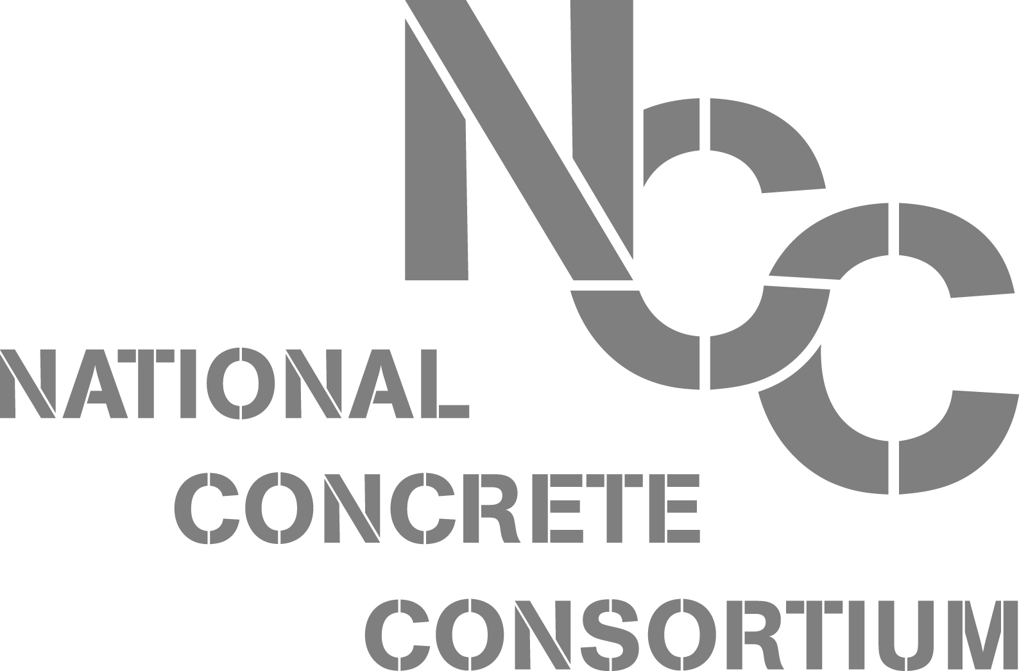

**Spring 2014 NCC Business Meeting Minutes  
April 22-24, Jacksonville, Florida**

**Election Results**

AASHTO Region 3 Special Election  
Heather McLeod (Kansas) will be unable to represent AASHTO Region 3 for the remaining year of her term as she has accepted a new position with another agency. Masten moved to approve a one-year term special election to fill the remainder of Heather McLeod’s term. Rupnow seconded.

Rupnow nominated Brett Trautman (Missouri). Schumaker seconded. McLeod nominated Tommy Nantung (Indiana). Surti seconded. A vote was taken and Nantung will represent Region 3 for McLeod’s term remainder.  
  
AASHTO Region 2  
Mack nominated Bouzid Choubane (Florida). Rupnow seconded. Nantung nominated Nilesh Surti (North Carolina). Seconded. A vote was taken and Surti will represent Region 2 for a two-year term.  
  
AASHTO Region 4  
Rupnow nominated Darin Hodges (South Dakota). Bennett seconded. McLeod nominated Wally Heyen (Nebraska). Hoops seconded. A vote was taken and Hodges will continue to represent Region 4.  
  
Academia  
Staton nominated Larry Sutter (Michigan Tech). Heyen seconded. Rupnow nominated Tyler Ley (Oklahoma State). Schumaker seconded. A vote was taken and Tyler Ley was reelected.  
  
At Large  
McMullen nominated Jim Mack (CEMEX) to continue. Seconded by Hoops. Jim Mack will continue as the at-large representative on the committee.

**Other Business**

**TRB Research Priorities**: Heather McLeod and Tyson Rupnow recommended putting forward a proposal on how cracking impacts how water and aggressive chemicals move in concrete. A rough draft has been prepared by Tyler Ley (OK State), Farshad Rajabipour (Penn State), and Jason Weiss (Purdue). It will be distributed for your comments and suggestions. The committee asks for comments on what is/isn’t applicable to your state. The project would focus on the effect on the life of the pavement, not how it happens, but what to do when it happens. This impacts every state. AFN 20, 30, and 40, all discussed cracking of concrete this year.   
  
Comments centered on whether the statement is too broad (includes pavements and bridges). It was thought that, if we split pavements from bridges, the proposal won’t make it. The RAC and SCOR members look at ranking. If high, it most likely will be funded because it will have the support of the states. It is a very big issue and will be solved in phases most likely. NACE looks at corrosion and strategies to handle.

How can we narrow the topic but include pavements and bridges?

Comments:

* Work backwards from implementation. Look at the tools needed to develop a reasonable scope.
* We need a good product/outcome—new spec or standard or guidance document.
* Focus on the implementation.
* We’re looking at a system that’s relatively small.
* Pavement needs a better corrosion model.
* Crack width part of statement?
* There is a lot of work already out on that. Look at what is already been done. Quick solutions would be useful. Solutions can be application based.

The committee appreciates the group’s input.  
  
  
**Future Meetings—Tentative Locations**

* Fall 2014 - Omaha, NE/Council Bluffs, IA (dates TBA
* Spring 2015 - Reno, NV
* Fall 2015 – exploring Wisconsin.

[**New TPF Solicitation 1363 for Technology Transfer Concrete Consortium**](http://www.pooledfund.org/Details/Solicitation/1363)

The group was reminded that the new [**TTCC Pooled Fund 1**](http://www.pooledfund.org/Details/Solicitation/1363)**363** begins in FY 2015. If your DOT hasn’t signed up yet, please talk to your coordinator, and note the new number.  
  
  
**Reciprocity Testing for Acceptance of Cement**  
  
The group discussed the history of cement reciprocity testing among the original MCC states (Midwest Concrete Consortium). There was general interest in finding out how the states currently accept cement and in possibly developing an updated agreement that the states can use. This will be a state reports topic for the fall meeting.