Quarterly Progress Report (QPR)

Applications of Enterprise GIS in Transportation
Progress Report for Quarter 1 [Oct 2019 – December 30th, 2019]
WSP Program Manager: Jag Mallela (jag.mallela@wsp.com)
WSP Technical Lead: Abhishek Bhargava (abhishek.bhargava@wsp.com)
Background
The Pooled Fund Study (PFS) on Applications of Enterprise GIS in Transportation (AEGIST) was initiated by FHWA in 2018. During Phase 1 of this study a guidebook was developed for transportation agencies in the United States, with the primary objective of documenting guidance on how spatial and linear referenced data should be managed by States. Phase 2 of this PFS was initiated in October 2019. This phase will span over 5 years (October 2019 – September 2024), during which the objectives outlined below would be accomplished.
Objective
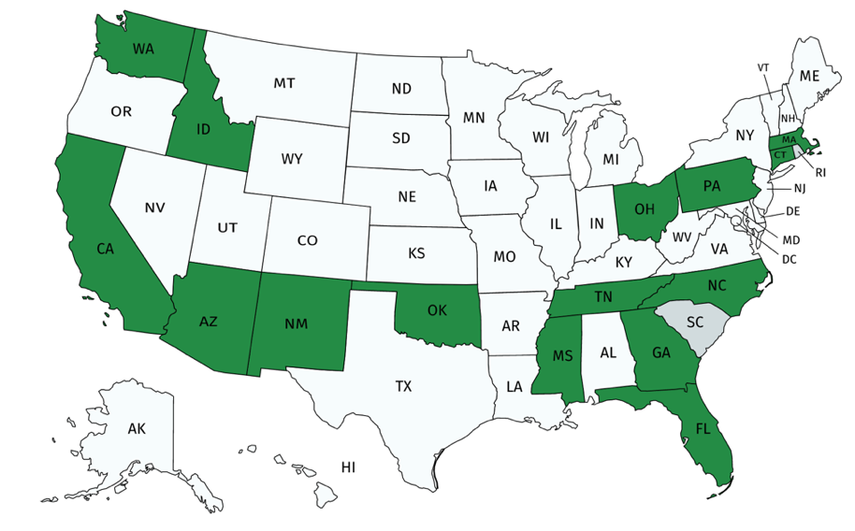
- Establish a standard for sharing and publishing highway infrastructure data between stakeholders at DOTs and their Federal, State and Local partners
- Review existing practices in spatial and linear referencing data management at State transportation agencies
- Assess the extent to which the States participating in the PFS (Figure 1) have implemented standards based spatial data management practices.
- Create/update AEGIST Guidebook based on best practices in spatial data management at State transportation agencies.
- Coordinate with the PFS States to further advance the spatial data management practices at the DOTs by implementing spatial and linear referencing data management solutions and data science platforms.
Completion Status and Summary
Time Frame: October 1, 2019 to September 30, 2024
Total Time, months: 60
Time Expended, months: 3
Percent Calendar Time Expended: 5%
Work Accomplished This Reporting Period
Task 1: Project Management
Task Objective: Perform project management activities, which include conducting monthly status meetings, developing quarterly status reports, creating project work plan, managing project resources, schedule, deliverables and communication with all stakeholders.
Work Accomplished: Following activities were performed in the reporting period:
- Deliverable 1.1 – Kickoff Meeting(s)
- Kickoff meetings held. (1) With FHWA on 10/30/2019; (2) With PFS States during week of Dec 3rd, 2019 – during Sacramento Peer Exchange;
- Planning for presentation on AEGIST to ABJ60 TRB Committee Members & Friends in Jan 2020.
- Kickoff meeting presentation decks prepared and delivered on all three occasions.
- Deliverable 1.3 - Quarterly Progress Reports, Monthly Status Meetings & Other Communications
- Multiple status meetings held with FHWA during each of the months in reporting period. Topics of discussion included: project schedule, scope, 2019 peer exchange, TRB ABJ60 committee presentation, GIS-T workshop, AEGIST Guidebook update v2.0, PFS States coordination.
Task 4: Peer Exchange Meetings
Task Objective: Plan, organize and conduct 5 peer exchanges, one each year between 2019 and 2023.
Work Accomplished: Following activities were performed in the reporting period:
- Deliverable 4.1 – Peer Exchange 2019
- Peer Exchange 1 was held in December 2019. The presentations and other peer exchange material was delivered to PFS States on 12/18. The material was also uploaded on the AEGIST SharePoint site.

Complete List of Base Period Deliverables
Note: Deliverables completed (Green); Deliverables with work is in progress (Yellow).

Task | D# | Deliverable Name | Target Date | Status
Task 1 | 1.1.0 | Kick-off Meeting | 10/30/19 | Completed.
Task 1 | 1.2.0 | Work Plan Version 1: Cross-Agency Tasks, Deliverables & Schedule | 4/30/20 | Completed. Submitted to FHWA and PFS States.
Task 1 | 1.3.1 | Quarterly Progress Report - 1 (incl. 3 monthly meetings and reports) | 12/31/19 | Completed. Submitted to FHWA. Email sent to PFS States.
Task 1 | 1.3.2 | Quarterly Progress Report - 2 (incl. 3 monthly meetings and reports) | 3/31/20 | Completed. Submitted to FHWA.  Email sent to PFS States.
Task 1 | 1.3.3 | Quarterly Progress Report - 3 (incl. 3 monthly meetings and reports) | 6/30/20 | Not Started
Task 1 | 1.3.4 | Quarterly Progress Report - 4 (incl. 3 monthly meetings and reports) | 9/30/20 | Not Started
Task 1 | 1.3.5 | Quarterly Progress Report - 5 (incl. 3 monthly meetings and reports) | 12/31/20 | Not Started
Task 1 | 1.3.6 | Quarterly Progress Report - 6 (incl. 3 monthly meetings and reports) | 3/31/21 | Not Started
Task 1 | 1.3.7 | Quarterly Progress Report - 7 (incl. 3 monthly meetings and reports) | 6/30/21 | Not Started
Task 2 | 2.1 | TASK 2 Technical Services (incl. Work Plan v1.1 with State Tasks) - MONTH 8 - MAY 2020 | 5/30/20 | Started Updating Guidebook. Draft Chapters on Centerline, Routes.
Task 2 | 2.2 | TASK 2 Technical Services (incl. Work Plan v1.2 with State Tasks) - MONTH 9 - JUN 2020 | 6/30/20 | Not Started
Task 2 | 2.3 | TASK 2 Technical Services (incl. Work Plan v1.3 with State Tasks) - MONTH 10 - JUL 2020 | 7/30/20 | Not Started
Task 2 | 2.4 | TASK 2 Technical Services (incl. Work Plan v1.4 with State Tasks) - MONTH 11 - AUG 2020 | 8/30/20 | Not Started
Task 2 | 2.5 | TASK 2 Technical Services (incl. Work Plan v1.5 with State Tasks) - MONTH 12 - SEP 2020 | 9/30/20 | Not Started
Task 2 | 2.6 | TASK 2 Technical Services (incl. Work Plan v1.6 with State Tasks) - MONTH 13 - OCT 2020 | 10/30/20 | Not Started
Task 2 | 2.7 | TASK 2 Technical Services (incl. Work Plan v1.7 with State Tasks) - MONTH 14 - NOV 2020 | 11/30/20 | Not Started
Task 2 | 2.8 | TASK 2 Technical Services (incl. Work Plan v1.8 with State Tasks) - MONTH 15 - DEC 2020 | 12/30/20 | Not Started
Task 2 | 2.9 | TASK 2 Technical Services (incl. Work Plan v1.9 with State Tasks) - MONTH 16 - JAN 2020 | 1/20/21 | Not Started
Task 2 | 2.10 | TASK 2 Technical Services (incl. Work Plan v1.92 with State Tasks) - MONTH 17 - FEB 2020 | 2/28/21 | Not Started
Task 2 | 2.11 | TASK 2 Technical Services (incl. Work Plan v1.94 with State Tasks) - MONTH 18 - MAR 2020 | 3/20/21 | Not Started
Task 2 | 2.12 | TASK 2 Technical Services (incl. Work Plan v1.98 with State Tasks) - MONTH 19 - APR 2020 | 4/30/21 | Not Started
Task 2 | 2.13 | TASK 2 Technical Services (incl. Work Plan v2.0 with State Tasks) - MONTH 20 - MAY 2021 | 5/30/21 | Not Started
Task 3 | 3.1.1 | Article 1 | 11/15/20 | Not Started
Task 3 | 3.2.1 | Workshop 1 - GIS-T 2020 | 7/15/20 | Plan to reschedule as Webinar.
Task 3 | 3.2.2 | Workshop or Presentation 2 | 1/31/21 | Not Started
Task 3 | 3.2.3 | Workshop 3 - GIS-T 2021 | 4/30/21 | Not Started
Task 3 | 3.3.1 | Webinar 1 | 11/30/20 | Not Started
Task 4 | 4.1.0 | Peer-Exchange 1 - 2019 | 12/30/19 | Completed.
Task 4 | 4.2.0 | Peer-Exchange 2 - 2020 | 10/30/20 | Not Started

