TRANSPORTATION POOLED FUND PROGRAM
QUARTERLY PROGRESS REPORT

Lead Agency: Utah Department of Transportation

INSTRUCTIONS:
Project Managers and/or research project investigators should complete a quarterly progress report for each calendar quarter during which the projects are active. Please provide a project schedule status of the research activities tied to each task that is defined in the proposal; a percentage completion of each task; a concise discussion (2 or 3 sentences) of the current status, including accomplishments and problems encountered, if any. List all tasks, even if no work was done during this period.

Transportation Pooled Fund Program Project #  TPF-5(272) |  | Transportation Pooled Fund Program - Report Period:  Quarter 1 (January 1 – March 31, 2014)  X Quarter 2 (April 1 – June 30, 2014)  _ Quarter 3 (July 1 – September 30, 2014)  _ Quarter 4 (October 1 – December 31, 2014)
Project Title:
Evaluation of Lateral Pile Resistance Near MSE Walls at a Dedicated Wall Site

Name of Project Manager(s):  Jason Richins | Phone Number:  801-360-4985 |  | E-Mail  jtrichins@utah.gov
Lead Agency Project ID:  5H07003H, 42053, ePM PIN 11075  UDOT PIC No. UT11.404 | Other Project ID (i.e., contract #):  UDOT Contract No. 148434 |  | Project Start Date:  December 2, 2013
Original Project End Date:  September 30, 2016 | Current Project End Date:  September 30, 2016 |  | Number of Extensions:

Project schedule status:

X On schedule _ On revised schedule _ Ahead of schedule _ Behind schedule

Overall Project Statistics:
Total Project Budget | Total Cost to Date for Project | Percentage of Work  Completed to Date
$204,500.00 (current contract)  $292,000.00 (total committed) | $48,800.00 | 17%

Quarterly Project Statistics:
Total Project Expenses  and Percentage This Quarter | Total Amount of Funds  Expended This Quarter | Total Percentage of  Time Used to Date
$38,800, 13% | $38,800 | 22%

Project Description:

Pile foundations for bridges with integral abutments must resist lateral loads produced by earthquakes and thermal expansion or contraction. Increasingly, right-of-way constraints are also leading to vertical mechanically stabilized earth (MSE) walls at abutment faces. Currently, there is relatively little guidance for engineers in assessing the lateral resistance of piles located close to these MSE walls. As a result, some designers assume that the soil provides no resistance whatsoever which leads to larger pile diameters and increased foundation cost. Other designers locate the abutment piles six to eight pile diameters behind a wall face to minimize the interaction and use conventional design approaches. However, this approach increases the bridge span and the cost of the bridge structure. Still other designers position the pile close to the wall face and reduce the lateral pile resistance using engineering judgment. However, the appropriate reduction factor to use as a function of pile spacing is not well defined.

Recent testing conducted by Rollins et al (2013) and Pierson et al (2008) indicate that lateral resistance decreases substantially as pile spacing from the wall decreases; however, reinforcing can reduce this effect. Rollins et al also found that p-multipliers defined as a function normalized spacing and reinforcement length seemed to provide reasonable agreement with measured pile response. Furthermore, Rollins et al found that the tensile force in the reinforcements owing to the lateral load on the pile could be estimated for design purposes using a correlation with pile load, spacing behind the wall, and distance transverse from the pile load.

Although the tests to date provide a framework for understanding the mechanisms involved and likely design approaches, the available data is too limited to make firm design recommendations. To improve our understanding of pile-MSE wall interaction, this project will involve construction of a test embankment approximately 80 ft long and 20 ft tall where it will be possible to conduct a number of lateral pile load tests on different pile types behind an MSE wall with both strip and grid type steel reinforcements. Additional contributions to the project will consist of in-kind donations from various contractors and material suppliers.

Objectives for this study include:

1. Measure reduced lateral pile resistance vs. displacement curves for circular, square, and H piles behind an MSE wall with steel strips and grid reinforcement.
2. Measure the increase and distribution of tensile force in the MSE reinforcement induced by lateral pile loading.
3. Measure effect of special pile head geometry (e.g. corrugated pipe sleeves, double plastic sheeting) on lateral pile resistance.
4. Develop design rules (e.g. p-multipliers) to account for reduced pile resistance as a function of spacing and reinforcement.
5. Develop equation to predict reinforcement force induced by pile loading.
6. Develop design equations to account for pile shape and pile head geometry.

Tasks for this study include:

1. Instrument test piles and reinforcements.
2. Drive test piles and construct MSE wall to height of 15 ft.
3. Perform lateral load tests on piles with 15 ft high MSE wall.
4. Reduce data and develop report on the testing for the 15 ft high wall.
5. Determine p-multipliers and reinforcement force equations for 15 ft high wall test results.
6. Perform lateral load tests on piles with 20 ft high MSE wall.
7. Reduce data and develop report on the testing for the 20 ft high wall. (Not funded in original contract.)
8. Determine p-multipliers and reinforcement force equations for 20 ft high wall test results. (Not funded in original contract.)
9. Develop design recommendations to account for pile sleeves and plastic sheeting effects. (Not funded in original contract.)
10. Prepare final report with recommendations based on all tests. (Not funded in original contract.)
11. Hold Technical Advisory Committee (TAC) meetings.
12. Present results of the study at AASHTO, TRB, and ASCE meetings. (Not funded in original contract.)

Dr. Kyle Rollins of BYU is the Principal Investigator for this research project. The technical advisory committee (TAC) includes representatives from UT, FL, IA, KS, MN, MT, NY, OR, and TX DOTs.

Progress this Quarter (includes meetings, work plan status, contract status, significant progress, etc.):

Task 1 – 100% complete. Piles were instrumented at BYU. MSE reinforcement grids and strips were delivered to BYU and instrumented with strain gauges in preparation for construction
Task 2 – 100% complete.
Task 3 – No work yet.
Task 4 – No work yet.
Task 5 – No work yet.
Task 6 – No work yet.
Task 7 – Not funded currently.
Task 8 – Not funded currently.
Task 9 – Not funded currently.
Task 10 – Not funded currently.
Task 11 – 10% complete. A kickoff web-conference was held in January with the TAC. Follow-up teleconferences were held in March with suppliers of the MSE wall panels and reinforcements, UDOT staff, and Dr. Rollins to discuss options for including surcharge at the top of the wall, behind the piles.
Task 12 – Not funded currently.
Contract – Additional funding transfers from state partners were received.

Anticipated work next quarter:

Task 1 – Completed
Task 2 – Completed
Task 3 – Testing for the piles at the 15 ft wall height will be performed
Task 4 – Data reduction will begin after the 15ft pile testing is completed.
Task 5 – p-multipliers will be back-calculated based on the results of the test
Task 6 – After completion of the tests at the 15 ft wall height, the MSE wall will be raised to a height of 20 ft and a second set of lateral load tests will be performed.
Task 7 – None.
Task 8 – None.
Task 9 – None.
Task 10 – None.
Task 11 – Coordinate as needed with BYU, the TAC, and wall suppliers for consensus on MSE wall design including surcharge.
Task 12 – None.
Contract – The contract will be amended to include funding recently transferred from partner states, for Tasks 7 through 10 and 12, and to address MSE wall design and construction changes. Additional funding may be sought from partner states or other sources to cover the cost of scope changes.

Significant Results:

Figs. 1-9 provide a photographic summary of the progress of the project. The tests piles shown in Fig. 1 included pipe, H and square pile sections which were instrumented with strain gauges on opposite sides of the piles and extended to a depth of 18 ft. The strain gauges were protected with angle irons prior to driving. The piles were donated by Atlas Steel and Spartan Steel. Fig. 2 shows the site after Geneva Rock equipment leveled a 200 ft length of property for the mock MSE abutment wall. The site for the test fill was also donated by Geneva Rock. Fig. 3 includes a photo showing the test piles and reaction piles being driven to a depth of 20 ft below the base of the fill prior to fill placement. The piles were driven by Deseret Deep Foundations for a $5000 mob/demob cost. The piles were driven open ended and blow counts were monitored during installation. The soil below the base of the fill appears to be sandy silt. LPILE analyses performed prior to testing indicate that the pile behavior will not be markedly affected by the presence of the lower layer of soil.
Figs 4 and 5 show the MSE reinforcements, with strain gauges attached, positioned between the test piles prior to fill placement at one level. In addition to strain gauges, PVC pipes were positioned vertically behind the MSE wall panels at 2.5 ft intervals to monitor the vertical movement of the wall panels during the lateral pile load testing. In addition, we will monitor the movement of the wall panels using a Digital Image Correlation (DIC) system. This system will give us the movement of 10 ft by 15 ft areas during each lateral load test. Figs. 6 and 7 show compaction around the test piles near the wall face with a vibratory plate compactor. Compaction was generally carried out with a roller compactor beyond 3 ft from the wall face. Density was monitored using nuclear density testing to achieve compaction to 95% of the standard Proctor maximum density. This standard could be achieved using 12-inch lifts with the roller compactor but 6-inch lifts were necessary around the piles and near the wall face. Figs. 8 and 9 show photos of the wall during construction. Fig. 9 shows the wall after reaching the 15 ft backfill height. Footings for the wall were located 2 ft below the ground surface. The wall was completed at the end of June and pile testing began on July 1, 2014. Concrete blocks will be used to simulate a weight of 5 ft of soil associated with the abutment above the MSE wall for these tests.
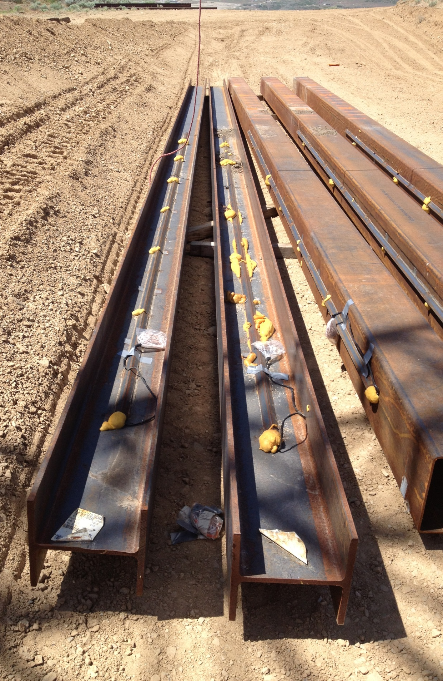
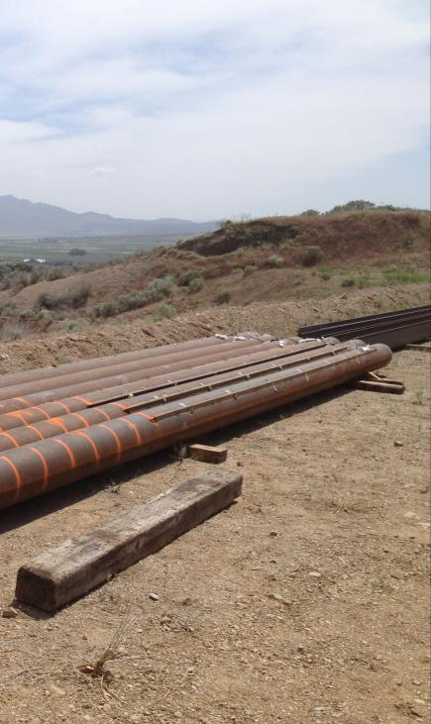

Fig. 1. Pipe, H, and Square piles instrumented with strain gauges along their lengths on opposite sides prior to driving.

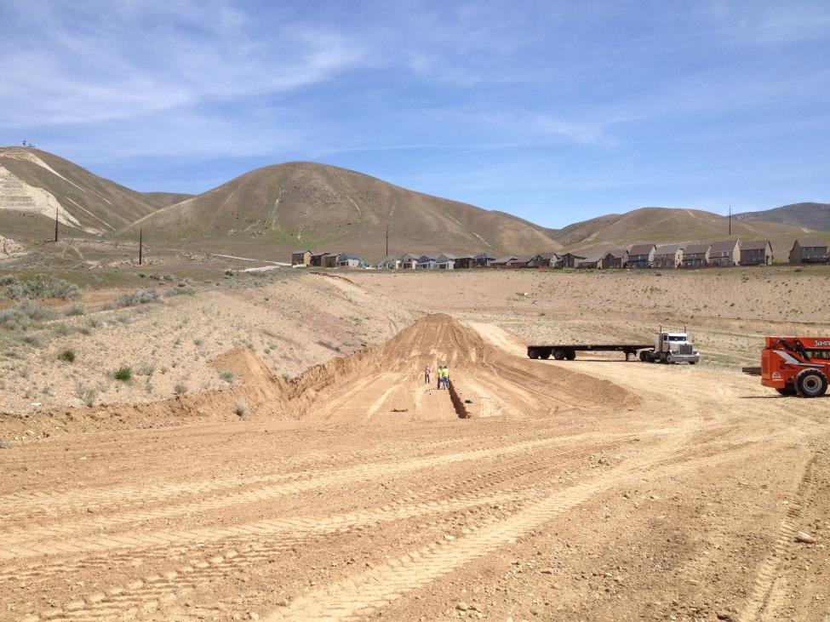
Fig. 2. Site Preparation

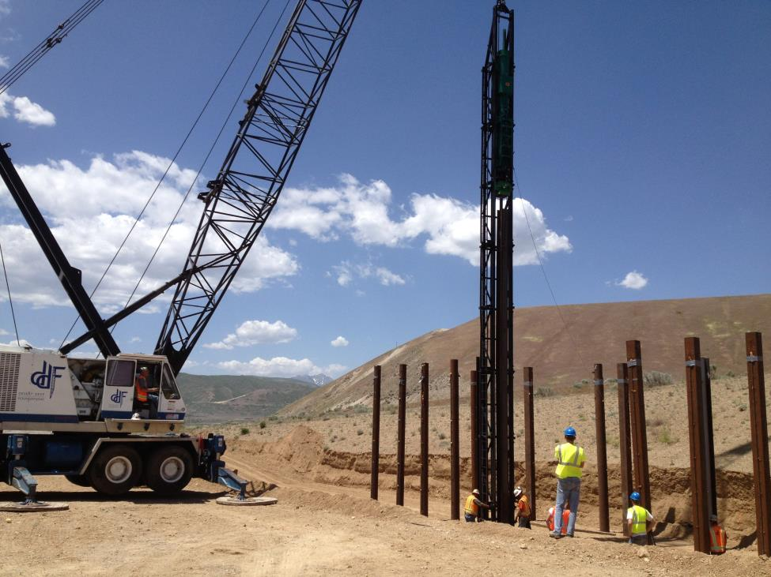
Fig. 3. Pile Driving of 16 test piles and 9 reaction piles to 20 feet into underlying soil profile.

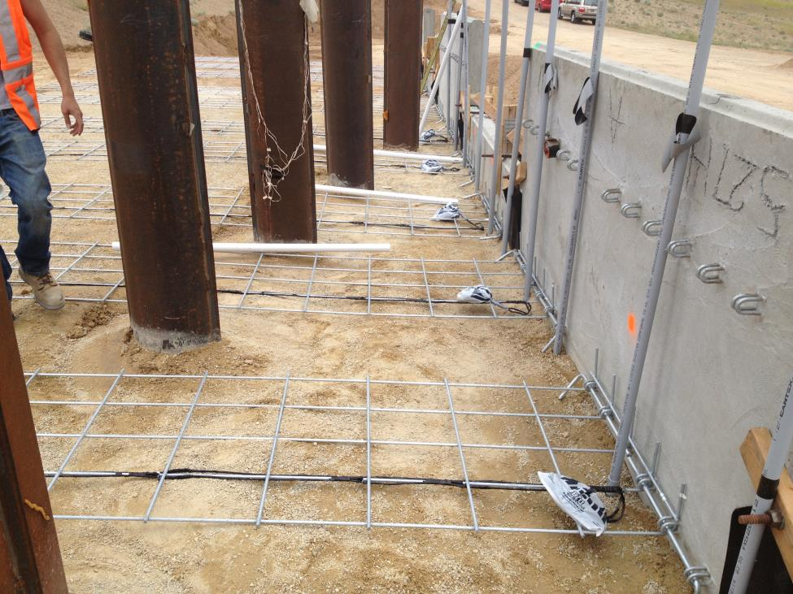
Fig. 4 Welded wire grid reinforcement between test piles at 5D, $D, 3D, and 2D behind the wall panel along with vertical PVD pipes at 2.5 ft spacings at wall face for shape arrays
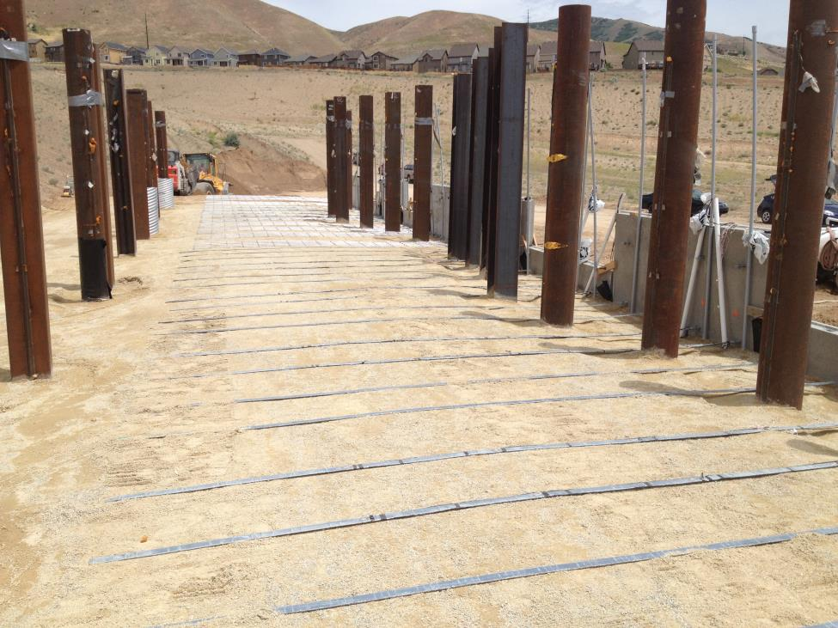
Fig. 5. Instrumented strip reinforcements in foreground and welded wire grids in the background.
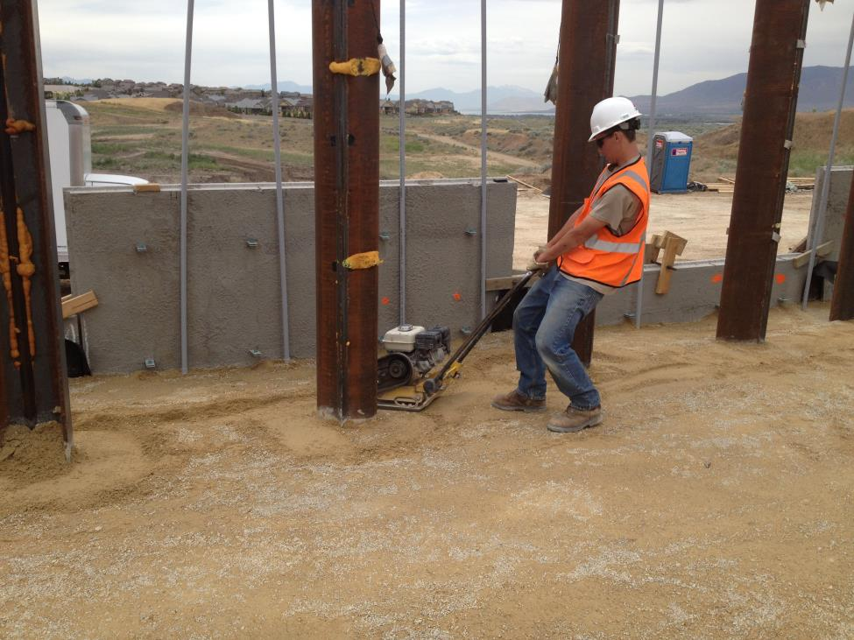
Fig. 6. Photo of compaction of backfill soil with plate compactor within 3 ft of the wall panels with 6 inch lifts. Roller compactor was used behind the 3 ft distance.

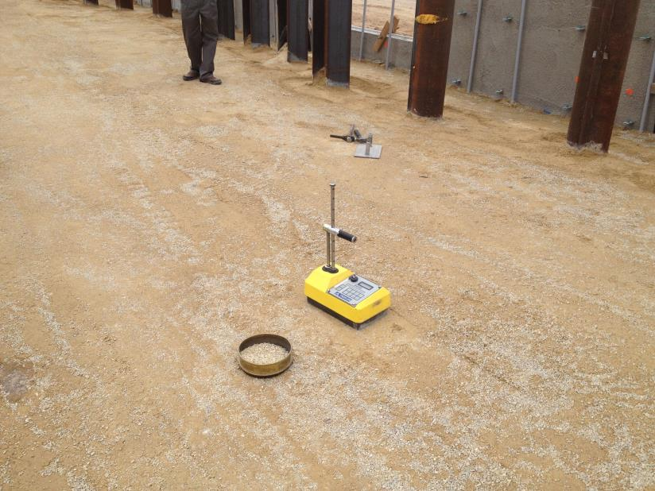
Fig. 7 Nuclear density testing to ensure compaction to 95% of standard Proctor maximum density.
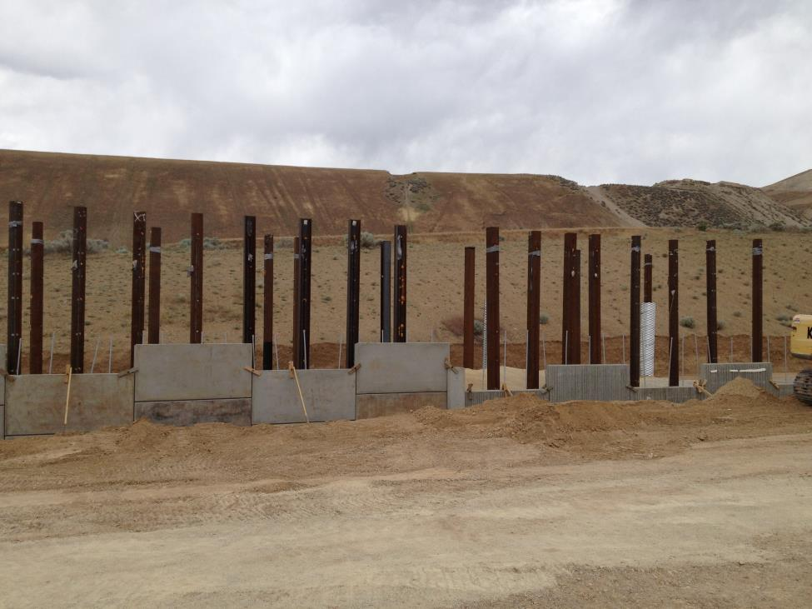
Fig. 8. Photograph of MSE wall under construction with piles in the background

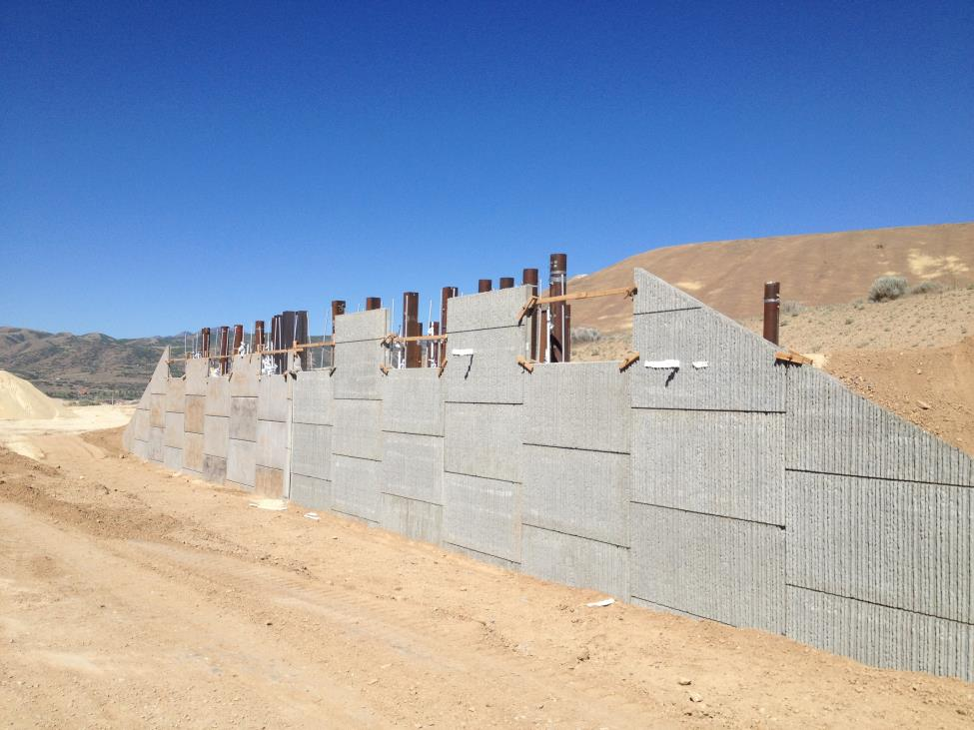
Fig. 9. Photo of MSE wall at 15 ft height prior and ready for start of pile tests.

Circumstance affecting project or budget. (Please describe any challenges encountered or anticipated that
might affect the completion of the project within the time, scope and fiscal constraints set forth in the
agreement, along with recommended solutions to those problems).

Potential Implementation:

