TRANSPORTATION POOLED FUND PROGRAM
QUARTERLY PROGRESS REPORT

Lead Agency (FHWA or State DOT): Alabama DOT

INSTRUCTIONS:
Project Managers and/or research project investigators should complete a quarterly progress report for each calendar quarter during which the projects are active. Please provide a project schedule status of the research activities tied to each task that is defined in the proposal; a percentage completion of each task; a concise discussion (2 or 3 sentences) of the current status, including accomplishments and problems encountered, if any. List all tasks, even if no work was done during this period.

Transportation Pooled Fund Program Project #  (i.e, SPR-2(XXX), SPR-3(XXX) or TPF-5(XXX)  TPF-5(228) |  | Transportation Pooled Fund Program - Report Period:  Quarter 1 (January 1 – March 31) 2012  √ Quarter 2 (April 1 – June 30)  Quarter 3 (July 1 – September 30)  Quarter 4 (October 1 – December 31)
Project Title:
Superpave Regional Center, Southeastern Region

Name of Project Manager(s):  Don Watson and Randy West | Phone Number:  (334) 844-7306 |  | E-Mail  watsode@auburn.edu
Lead Agency Project ID:  ALDOT Research Project No. 930-763P | Other Project ID (i.e., contract #):  224574 |  | Project Start Date:  April 28, 2010
Original Project End Date:  September 30, 2012 | Current Project End Date:  September 30, 2013 |  | Number of Extensions:  1

Project schedule status:
√ On schedule On revised schedule Ahead of schedule Behind schedule

Overall Project Statistics:
Total Project Budget | Total Cost to Date for Project | Percentage of Work  Completed to Date
$972,129 | $152,671 | 18

Quarterly Project Statistics:
Total Project Expenses  and Percentage This Quarter | Total Amount of Funds  Expended This Quarter | Total Percentage of  Time Used to Date
$227,044 (23.4% of budget) | $37,805 | 69

Project Description:

The Southeastern Superpave Center has been supported by state agencies through a pooled-fund project that has been largely used to provide training, verify ruggedness of equipment, check equipment calibrations, provide materials research, and aid in keeping agency personnel abreast of changes in asphalt technology. In order to continue the efforts in training, technology transfer, and implementable research, it is essential that the pooled-fund effort be continued.

NOTE: This pooled-fund project is not limited to states located in the southeast. Agencies throughout the country are invited to participate and take advantage of the research and training opportunities provided by the Southeastern Superpave Center.

OBJECTIVES

Several short-term and long-term objectives of the Southeastern Superpave Center are listed below. Several objectives deal with evaluating recently-developed performance test equipment and conducting research to address materials and tests issues. Objectives of the Center are:
- Conduct training in regard to Superpave binders, mix design, and performance testing. Provide training on special topics as requested by participating agencies at their on-site locations.
- Perform research, both cooperatively and agency-specific, sponsored by members of the pooled-fund.
- Perform precision and bias testing for asphalt-related performance test equipment.
- Conduct noise studies in an effort to develop quieter pavements.
- Perform forensic evaluations on materials or projects that have experienced premature distress.
- Prepare research articles of regional and national interest.

Progress this Quarter (includes meetings, work plan status, contract status, significant progress, etc.):

MEPDG CLIMATE DATABASE:
The verification of all 64 historic climate files is complete. A proposal for additional climate files was completed and submitted to LA DOTD for review and approval. The ISU climate team is developing the future files. The NCAT team is beginning to build the framework for the data needed for the sensitivity analysis. There will be a project review meeting with LA DOTD in the near future to discuss the types of pavement distress to be included in the analysis.

AGGREGATE FRICTION STUDY:
The NCAT lab completed all mixture blending and compacted all 24 slabs. Testing and conditioning of the fine-mixture group is 70% complete and will be completed in July. The other mixture will begin testing in late July. Preliminary results on the fine-mixture are as expected. After 40,000 cycles the mixtures with crushed gravel are retaining friction better than the control mixture with limestone. DFT(40)=0.31 for limestone and 0.34 and 0.38 respectively for higher substitutions with crushed gravel.

HIGH RAP STUDY:
Four states have sponsored a study of the use of high RAP proportions in asphalt mixtures. The RAP proportion will be varied so that the RAP binder will replace 10, 25, and 50 percent of the virgin binder. The study will evaluate whether increasing the effective binder content or using a softer grade binder will be most effective at reducing potential for cracking. All lab work has been completed and a draft report is being prepared.

DETERMINE APPROPRIATE TEMPERATURE FOR FLOW NUMBER TESTING:
Puerto Rico Highway and Transportation Authority asked for a review of LTPPBind data to determine the temperature
for flow number testing with the AMPT. Of particular interest was whether a single temperature was satisfactory for all
geographical areas or if multiple regions needed to be created with a different temperature for each region. A review of
all 34 weather stations on the island showed a significant error could be encountered by using the five closest weather
station data particularly if the elevation of those stations varies considerably as shown in Figure 1.

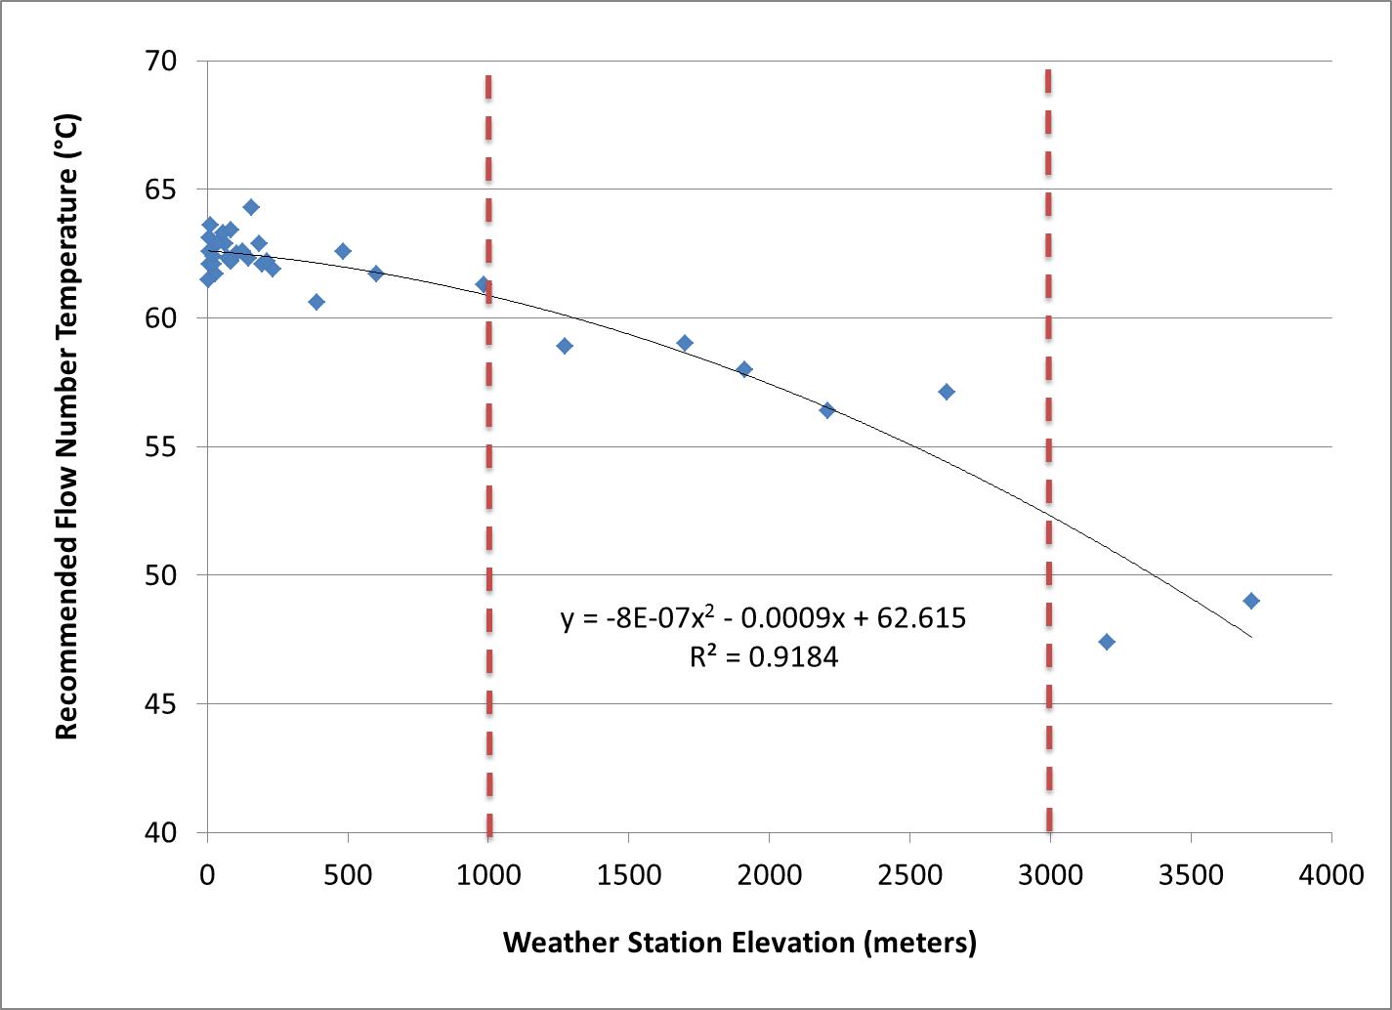
FIGURE 1: Recommended Flow Number Temperature by Weather Station Elevation.

For one project, the temperature of the five closest stations ranged from 49.0 to 62.9 degrees Celsius. This study revealed that if an agency has mountainous areas, a significant testing error could result by using an average of the five closest weather station data. The result will lead to greater rutting in the field than was predicted in the lab.
In summary, the flow number testing temperature for Puerto Rico using NCHRP 09-33 testing parameters was recommended as a function of paving site elevation. The recommendations are summarized in Table 1, below.

TABLE 1: Recommended Flow Number Testing Temperatures for Puerto Rico.
Paving Site Elevation (meters) | Flow Number Testing Temperature (°C)
0-1000 | 63.0
1000-3000 | 59.0
>3000 | 49.0

TECHNOLOGY TRANSFER/TECHNICAL MEETINGS:
Several agencies used funds this period to pay travel and registration expenses for employees to attend technical meetings such as ASTM meetings and Warm Mix Asphalt Conference.

Anticipated work next quarter:

Mix design work and laboratory performance testing will continue for the friction study. The project scope is being expanded and the work plan is being revised accordingly. The high RAP study will be completed and a draft report prepared for the sponsors. Additional Flow number testing is being conducted for Puerto Rico to compare the performance of mixtures with and without modified asphalt binders.

Significant Results:

A review of LTPPBind climate data revealed that one weather station in a mountainous area was causing the
recommended flow number test temperature to be skewed toward a lower temperature than reasonable for the
area. Using the data as typically recommended would result in asphalt mixtures passing the test criteria at
higher traffic loadings than which the mix would be able to perform.

Circumstance affecting project or budget. (Please describe any challenges encountered or anticipated that
might affect the completion of the project within the time, scope and fiscal constraints set forth in the
agreement, along with recommended solutions to those problems).

A project extension was granted this quarter to extend the pooled fund research for another year.

Potential Implementation:

The climate data being obtained will be useful for one agency by providing specific climate data that is more compre-
hensive and more accurate than the original data used in the MEPDG development.

The high RAP study will provide information to agencies that will give increased confidence for decision-making in
regard to whether increased RAP proportions can be used without fear of cracking failure.

After reviewing LTPPBind data for one agency, a more accurate temperature for conducting flow number testing has been
recommended for that geographical area.

