TRANSPORTATION POOLED FUND PROGRAM
QUARTERLY PROGRESS REPORT

Lead Agency: Utah Department of Transportation

INSTRUCTIONS:
Project Managers and/or research project investigators should complete a quarterly progress report for each calendar quarter during which the projects are active. Please provide a project schedule status of the research activities tied to each task that is defined in the proposal; a percentage completion of each task; a concise discussion (2 or 3 sentences) of the current status, including accomplishments and problems encountered, if any. List all tasks, even if no work was done during this period.

Transportation Pooled Fund Program Project #  TPF-5(272) |  | Transportation Pooled Fund Program - Report Period:  _ Quarter 1 (January 1 – March 31, 2017)  _ Quarter 2 (April 1 – June 30, 2017)  _ Quarter 3 (July 1 – September 30, 2017)  x Quarter 4 (October 1 – December 31, 2017)
Project Title:
Evaluation of Lateral Pile Resistance Near MSE Walls at a Dedicated Wall Site

Name of Project Manager(s):  David Stevens | Phone Number:  801-589-8340 |  | E-Mail  davidstevens@utah.gov
Lead Agency Project ID:  Finet 42053, ePM PIN 11075  UDOT PIC No. UT11.404 | Other Project ID (i.e., contract #):  UDOT Contract No. 148434 |  | Project Start Date:  December 2, 2013
Original Project End Date:  September 30, 2016 | Current Project End Date:  June 30, 2018 |  | Number of Extensions:  4

Project schedule status:

_ On schedule X On revised schedule _ Ahead of schedule _ Behind schedule

Overall Project Statistics:
Total Project Budget | Total Cost to Date for Project | Percentage of Work  Completed to Date
$322,000.00 (current contract)  $332,000.00 (total committed online)  $352,000.00 (total actual committed)  (Utah’s 2016 commitment of $30,000 will be moved to the new Phase 2 study) | $297,500.00 | 92%

Quarterly Project Statistics:
Total Project Expenses  and Percentage This Quarter | Total Amount of Funds  Expended This Quarter | Total Percentage of  Time Used to Date
$19,000.00  6% | $19,000.00 | 92%

Project Description:

Pile foundations for bridges with integral abutments must resist lateral loads produced by earthquakes and thermal expansion or contraction. Increasingly, right-of-way constraints are also leading to vertical mechanically stabilized earth (MSE) walls at abutment faces. Currently, there is relatively little guidance for engineers in assessing the lateral resistance of piles located close to these MSE walls. As a result, some designers assume that the soil provides no resistance whatsoever which leads to larger pile diameters and increased foundation cost. Other designers locate the abutment piles six to eight pile diameters behind a wall face to minimize the interaction and use conventional design approaches. However, this approach increases the bridge span and the cost of the bridge structure. Still other designers position the pile close to the wall face and reduce the lateral pile resistance using engineering judgment. However, the appropriate reduction factor to use as a function of pile spacing is not well defined.

Recent testing conducted by Rollins et al (2013) and Pierson et al (2008) indicate that lateral resistance decreases substantially as pile spacing from the wall decreases; however, reinforcing can reduce this effect. Rollins et al also found that p-multipliers defined as a function normalized spacing and reinforcement length seemed to provide reasonable agreement with measured pile response. Furthermore, Rollins et al found that the tensile force in the reinforcements owing to the lateral load on the pile could be estimated for design purposes using a correlation with pile load, spacing behind the wall, and distance transverse from the pile load.

Although the tests to date provide a framework for understanding the mechanisms involved and likely design approaches, the available data is too limited to make firm design recommendations. To improve our understanding of pile-MSE wall interaction, this project will involve construction of a test embankment approximately 80 ft long and 20 ft tall where it will be possible to conduct a number of lateral pile load tests on different pile types behind an MSE wall with both strip and grid type steel reinforcements. Additional contributions to the project will consist of in-kind donations from various contractors and material suppliers.

Objectives for this study include:

1. Measure reduced lateral pile resistance vs. displacement curves for circular, square, and H piles behind an MSE wall with steel strips and grid reinforcement.
2. Measure the increase and distribution of tensile force in the MSE reinforcement induced by lateral pile loading.
3. Measure effect of special pile head geometry (e.g. corrugated pipe sleeves, double plastic sheeting) on lateral pile resistance.
4. Develop design rules (e.g. p-multipliers) to account for reduced pile resistance as a function of spacing and reinforcement.
5. Develop equation to predict reinforcement force induced by pile loading.
6. Develop design equations to account for pile shape and pile head geometry.

Tasks for this study include:

1. Instrument test piles and reinforcements.
2. Drive test piles and construct MSE wall to height of 15 ft.
3. Perform lateral load tests on piles with 15 ft high MSE wall.
4. Reduce data and develop report on the testing for the 15 ft high wall.
5. Determine p-multipliers and reinforcement force equations for 15 ft high wall test results.
6. Perform lateral load tests on piles with 20 ft high MSE wall.
7. Reduce data and develop report on the testing for the 20 ft high wall.
8. Determine p-multipliers and reinforcement force equations for 20 ft high wall test results.
9. Develop design recommendations to account for pile sleeves and plastic sheeting effects.
10. Prepare final report with recommendations based on all tests.
11. Hold Technical Advisory Committee (TAC) meetings.
12. Present results of the study at AASHTO, TRB, and ASCE meetings.

Dr. Kyle Rollins of BYU is the Principal Investigator for this research project. The technical advisory committee (TAC) includes representatives from UT, FL, IA, KS, MA, MN, MT, NY, OR, TX, and WI DOTs.

Progress this Quarter (includes meetings, work plan status, contract status, significant progress, etc.):

Task 1 – 100% Complete
Task 2 – 100% Complete
Task 3 – 100% Complete
Task 4 – 100% Complete
Task 5 – 100% Complete
Task 6 – 100% Complete
Task 7 – 100% Complete
Task 8 – 100% Complete
Task 9 – 100% Complete
Task 10 – 80% Complete
Task 11 – 100% Complete
Task 12 – 100% Complete
Contract – A no-cost time extension was executed.

Anticipated work next quarter:

Task 1 – Completed
Task 2 – Completed
Task 3 – Completed
Task 4 – Completed
Task 5 – Completed
Task 6 – Completed
Task 7 – Completed
Task 8 – Completed
Task 9 – Completed
Task 10 – Revise and publish all Final Reports. Complete and share short versions of the reports with the TAC.
Task 11 – Consider holding a TAC web conference to review final results and discuss the upcoming Phase 2 pooled fund study.
Task 12 – Completed
Contract – No changes planned.

Significant Results:

During the past quarter, scope of work and budget requirements were developed for conducting follow-up (Phase 2) testing to investigate outstanding issues identified in the TAC meeting last February. These issues included: (1) Cyclic loading, (2) Fixed-head boundary condition, (3) Pile group behavior and (4) Pile diameter effects. A document summarizing the Phase 2 work and budget requirements is being sent to all pooled fund sponsors.

Work has been completed on a short summary paper describing the load test procedures and results for the lateral load testing adjacent to the MSE wall. In addition, a shorter summary paper has been prepared describing the results of the testing involving pile shape and lateral resistance. These papers have now been submitted to Utah DOT for distribution to committee members.

The equations for tensile force induced by the reinforcements have been simplified somewhat by eliminating the L/H term. This reduced the R² values somewhat but appeared to be worthwhile to make the equations more practical. The resulting equations are summarized below along with a comparison of measured and computed values.

Separate regression analyses were required for the ribbed strip and welded wire reinforcements. A total of 1,058 data observations were used in the regression analysis of the welded-wire grid reinforcements resulting in an R² value of 0.72. An R² of 0.72 indicates that the equation accounts for approximately 72 percent of the variability in the observed tensile force. The maximum induced force, ΔF(kips), in the welded-wire reinforcement produced by the lateral pile load is given by:
Where P is the pile head load (kips), T is the transverse distance from the reinforcement to the pile center, D is the outside pile diameter (same units as T), and σ_{v} is the vertical stress (psf).

A total of 942 data observations were used in the regression analysis of the ribbed strip reinforcements resulting in an R² value of 0.71. The maximum induced force, ΔF (kips), induced in a ribbed strip reinforcement due to lateral pile load is given by the equation:
where S = the distance from the back of the wall to the center of the pile (same units as D), P is in kips and σ_{v} is in psf.

A comparison between the predicted and measured maximum log of maximum tensile force plus one kip is shown in Figs. 1 and 2 for the welded-wire grid and ribbed strip reinforcements, respectively. Data on the red line indicates that the measured and predicted values are equal. Considering the complexity of the interactions involved, the agreement is reasonably good. Even in cases where reinforcement resistance is only produced by fill weight, significant variation in pullout resistance has been observed, particularly at shallow depths (Lawson et al. 2013). Dashed lines showing boundaries for plus and minus one and two standard deviations are also shown in each figure which allows a user to select a more conservative estimate of induced reinforcement force if desired.

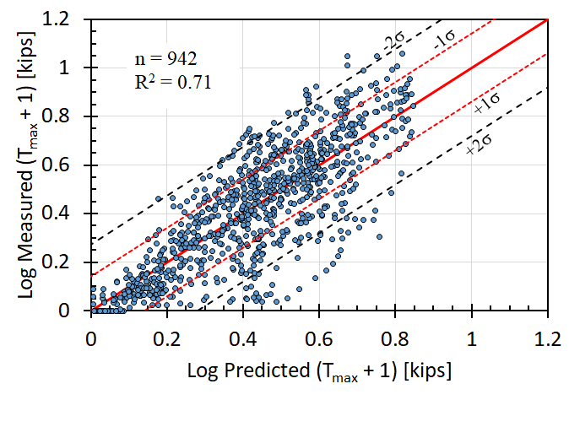
Fig. 1. Comparison of measured and predicted log of tensile force for ribbed strip reinforcements.

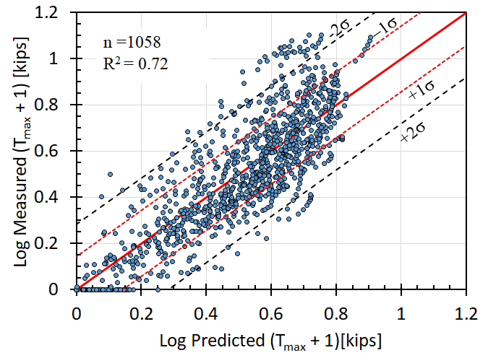
Fig. 2. Comparison of measured and predicted log of tensile force for welded-wire reinforcements.

Circumstance affecting project or budget. (Please describe any challenges encountered or anticipated that
might affect the completion of the project within the time, scope and fiscal constraints set forth in the
agreement, along with recommended solutions to those problems).

The project work tasks have nearly been completed with some time delay relative to the original time anticipated. Additional work tasks will be included in the upcoming Phase 2 pooled fund study.

Potential Implementation:

We are working with the AASHTO SCOBS T-15 committee to have the results of the study incorporated into new AASHTO codes. Shorter papers/reports have been prepared to help communicate the research results.

