TRANSPORTATION POOLED FUND PROGRAM
QUARTERLY PROGRESS REPORT

Lead Agency: ---- Utah Department of Transportation ----

INSTRUCTIONS:
Project Managers and/or research project investigators should complete a quarterly progress report for each calendar quarter during which the projects are active. Please provide a project schedule status of the research activities tied to each task that is defined in the proposal; a percentage completion of each task; a concise discussion (2 or 3 sentences) of the current status, including accomplishments and problems encountered, if any. List all tasks, even if no work was done during this period.

Transportation Pooled Fund Program Project #  (TPF-5(257) |  | Transportation Pooled Fund Program - Report Period:  _ Quarter 1 (January 1 – March 31)  _ Quarter 2 (April 1 – June 30)  X Quarter 3 (July 1 – September 30)  _ Quarter 4 (October 1 – December 31)

Project Title: Evaluation of Spliced Sleeve Connections for Precast RC Bridge Piers

Name of Project Manager(s):  Russ Scovil | Phone Number:  801-870-4665 |  | E-Mail  Rgscovil@utah.gov
Lead Agency Project ID:  5H06604H, UT11.502 | Other Project ID (i.e., contract #):  12-8775 |  | Project Start Date:  3/23/2012
Original Project End Date:  3/30/2013 | Current Project End Date:  6/30/2014 |  | Number of Extensions:  2

Project schedule status:

_ On schedule X_ On revised schedule _ Ahead of schedule _ Behind schedule

Overall Project Statistics:
Total Project Budget | Total Cost to Date for Project | Percentage of Work  Completed to Date
$175,848 | $139,000 | 79%

Quarterly Project Statistics:
Total Project Expenses  and Percentage This Quarter | Total Amount of Funds  Expended This Quarter | Total Percentage of  Time Used to Date
$20,000 / 16% | $29,000 | 67%

Project Description:
Sleeved connections are being considered as one of the methods for connecting precast concrete bridge elements. The purpose of this project is to perform experiments to evaluate the performance of a sleeved connection between a reinforced concrete bridge column and a bridge footing (Type I) or a reinforced concrete bridge column and a bridge bent cap (Type II) in a seismic area. This information is very valuable for construction of bridges using Accelerated Bridge Construction in areas with high seismic activity.

Progress this Quarter (includes meetings, work plan status, contract status, significant progress, etc.):

Project Progress: This quarter the project was focused on testing the third set of precast concrete columns, footing,
and cap beam (NMB-3 and LEN-3). NMB-3 is a connection with the modified NMB Type I connection between the
column and footing, and LEN-3 is a modified Lenton Interlock Type II connection between the column and bent cap.
Both NMB-3 and LEN-3 sleeved connections were constructed with the mechanical sleeves in the column. However,
in both cases there was an innovative detail introduced. This detail is a debonding length of the connecting bars in the
footing for the NMB splice connectors (Type I - NMB3) and a debonding length of the connecting bars in the bent cap for
the Lenton Interlock connection (Type II – LEN3).

The performance of NMB-3 is shown in Figure 1 at a displacement of 8 in., and Figure 2 shows the damage at the end of the test. The extreme bar at the east end of the column fractured in the 8 in. cycle as shown in Figure 3. The
hysteresis loops for specimen NMB-3 are shown in Figure 4.

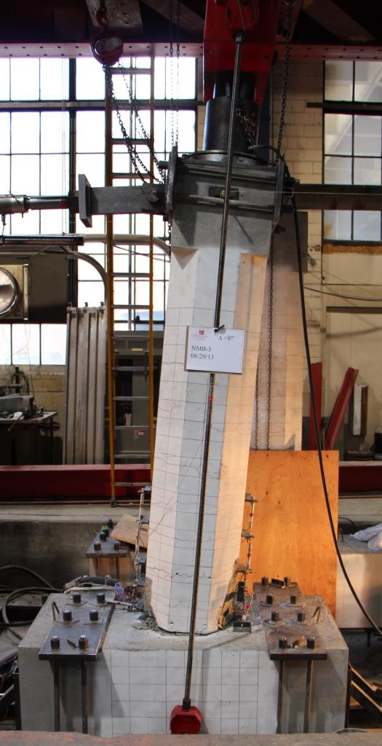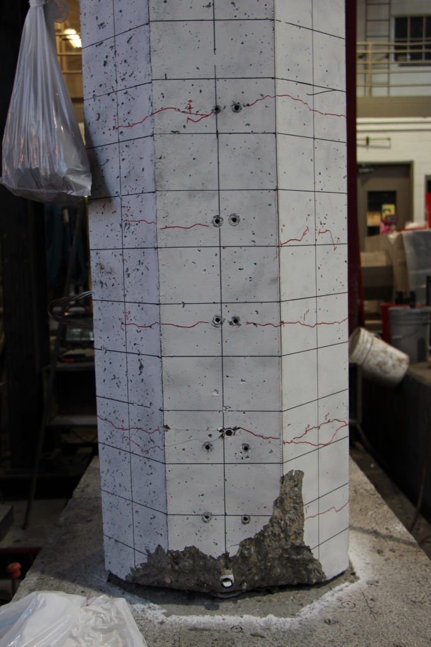

Figure 1. Specimen NMB-3 at the ultimate condition Figure 2. Damage of specimen NMB-3 at 8 in. displacement.
at 8 in. displacement.

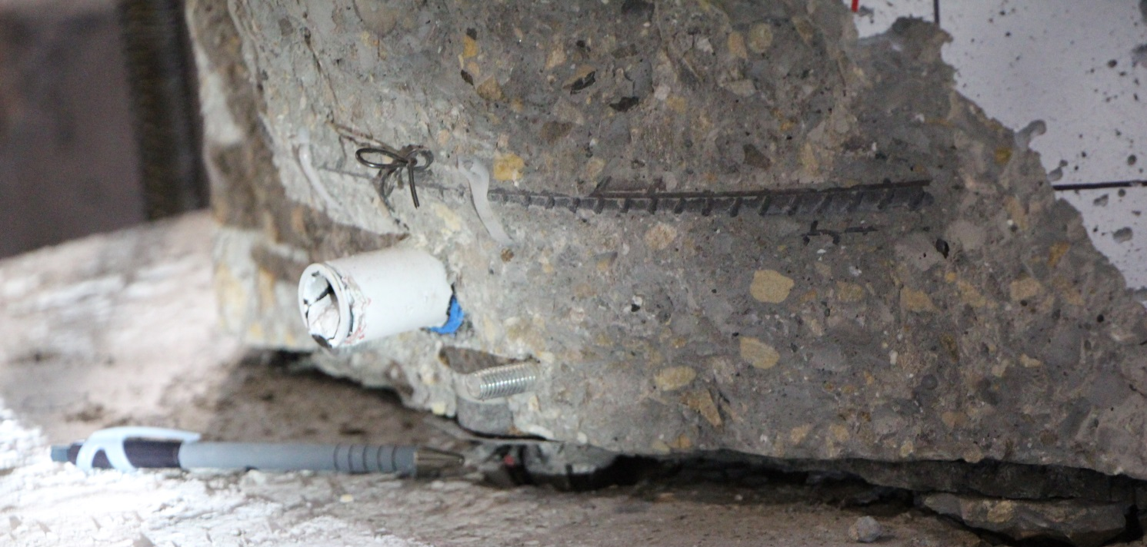

Figure 3. Fracture of extreme bar on east side of specimen NMB-3.

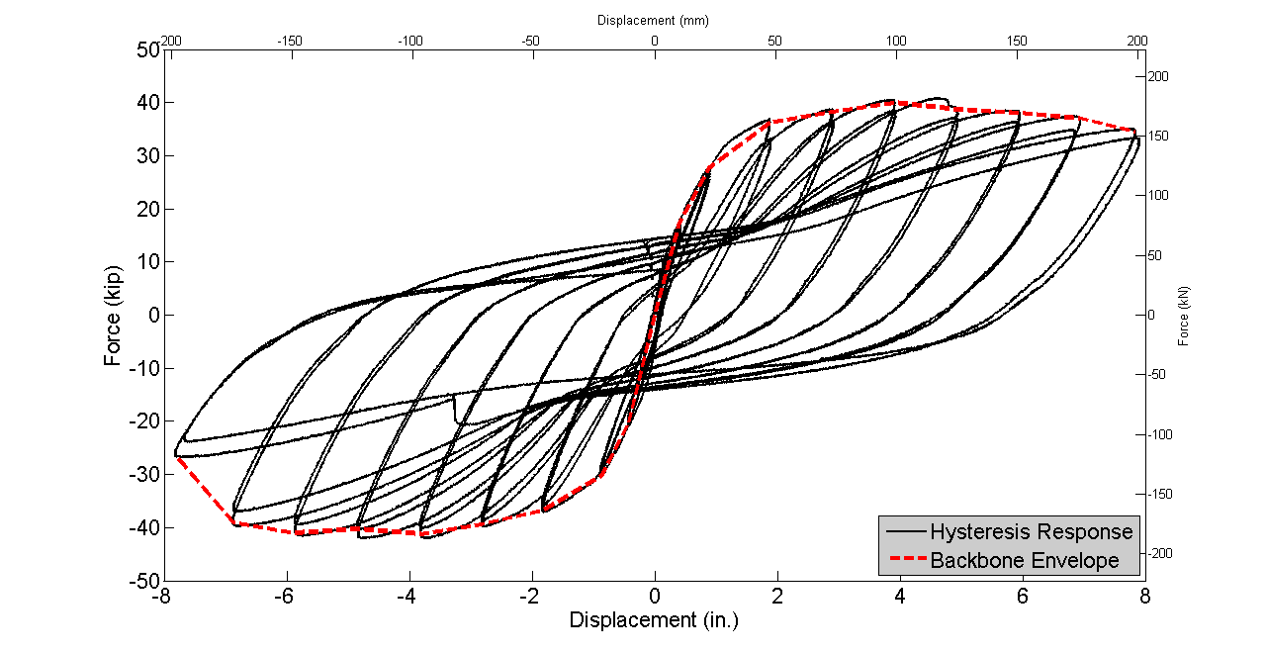
Figure 4. Hysteresis curves for specimen NMB-3.

The performance of LEN-3 is shown in Figures 5 and 6 at a displacement of 8 in.; Figure 7 shows the damage at the end
of the test. The hysteresis loops for specimen LEN-3 are shown in Figure 8. For this specimen there was no bar fracture.
Instead, the load capacity dropped because of gradual failure of the bond and pullout of the column bars as shown in
Figure 6.

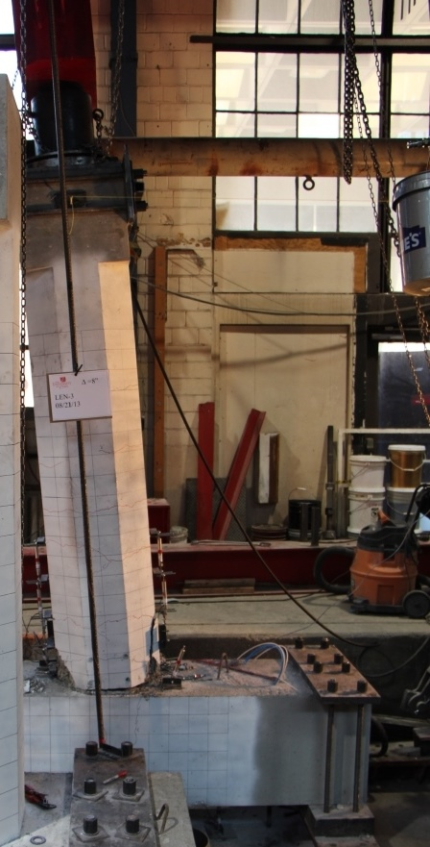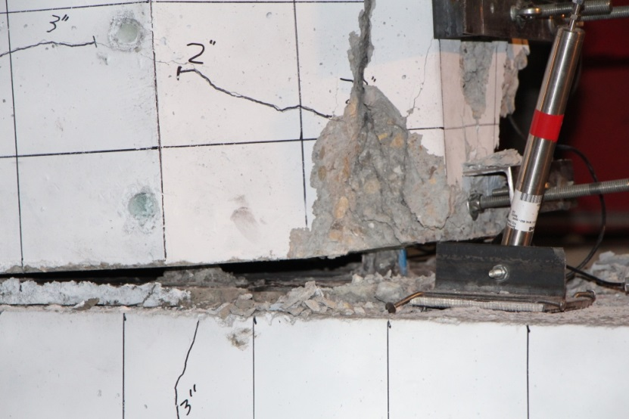

Figure 5. Specimen LEN-3 at the ultimate condition Figure 6. Damage of specimen LEN-3 at 8 in. displacement.
at 8 in. displacement.

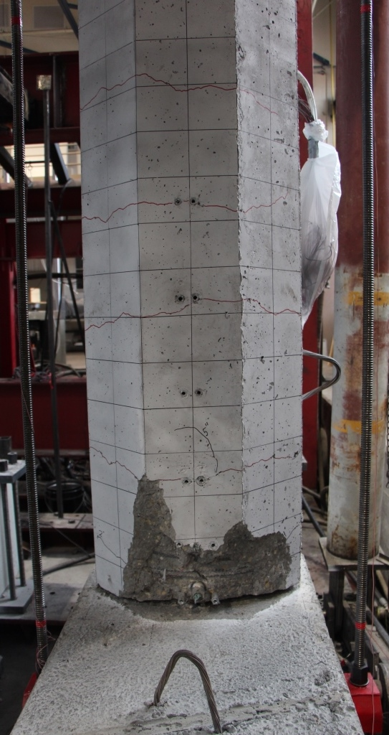

Figure 7. Damage of specimen LEN-3 at end of test.

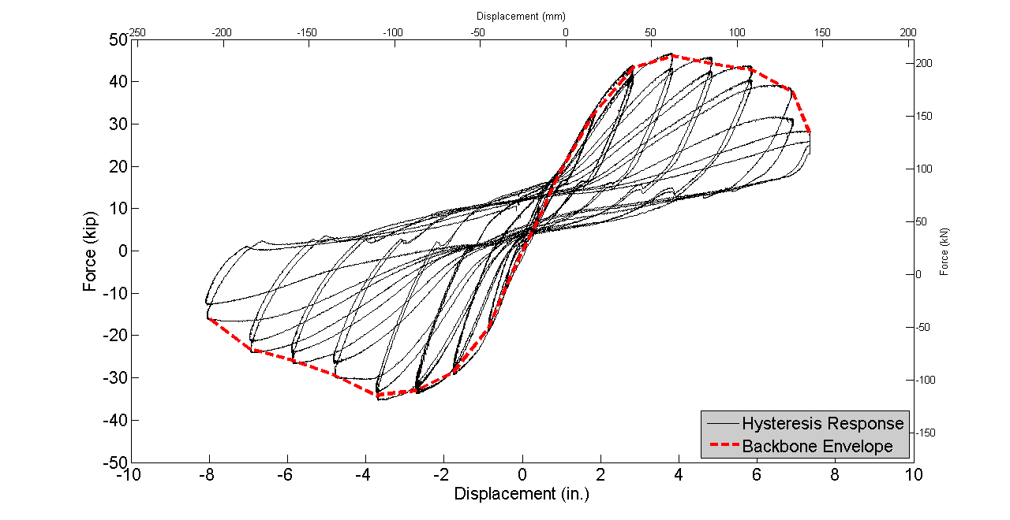
Figure 8. Hysteresis curves for specimen LEN-3.

Project Status: The six specimens built using mechanical sleeves have now been tested. The two monolithic
specimens have been built and will be tested during the next quarter. The percentage completion for each task is
as follows:

Task 1: Review Existing Experimental Results for Sleeved Connections: 100% Complete
Task 2: Build Precast Columns, Footings and Cap Beams for Tests: 100% Complete
Task 3: Test Column to Footing Connections (Type I): 100% Complete
Task 4: Test Column to Cap Beam Connections (Type II): 100% Complete
Task 5: Test Column to Footing Monolithic Cast-In-Place Connection
and Column to Cap Beam Monolithic Cast-In-Place Connection: 0% Complete

Anticipated work next quarter:
It is anticipated that in Quarter 7, the two monolithic cast-in-place connections (one column to footing and one column to cap beam) will be tested.

Significant Results:
The column to footing connection NMB-3 with splice sleeves in the column and a debonding length in the footing (Type I) performed very well up to 8% drift. The column to bent cap connection LEN-3 with Lenton Interlock connectors in the
column and a debonding length in the cap beam (Type II) performed very well up to 6% drift.

Circumstance affecting project or budget. (Please describe any challenges encountered or anticipated that
might affect the completion of the project within the time, scope and fiscal constraints set forth in the
agreement, along with recommended solutions to those problems).
None.

Potential Implementation:
It is anticipated the Utah DOT will implement the findings of this research once it is completed in Accelerated
Bridge Construction (ABC). It is likely that the New York State Department of Transportation and the Texas Department
of Transportation will be able to implement them as well.

