HOT-BCA User Guide
Prepared by:

Michael F. Lawrence
4550 Montgomery Avenue
Suite 300N
Bethesda, Maryland 20814
301-961-8835
lawrence@jfaucett.com
USER GUIDE
High-Occupancy Toll – Benefit Cost Analysis (HOT-BCA)

HOT-BCA is a spreadsheet tool that calculates the benefits and costs of various managed lane scenarios for a base and a project case. This User Guide provides an overview of the model and describes how to use it to determine the benefits and costs of your managed lane project. This User Guide is also accessible through a hyperlink on the Instructions tab of the HOT-BCA tool.

If you need technical assistance or have any questions, please contact:

Michael F. Lawrence
Jack Faucett Associates, Inc.
4550 Montgomery Avenue
Suite 300N
Bethesda, MD 20814
301-961-8835
lawrence@jfaucett.com

Devon Cartwright-Smith
Jack Faucett Associates, Inc.
4550 Montgomery Avenue
Suite 300N
Bethesda, MD 20814
301-961-8791
cartwrightsmith@jfaucett.com

Table of Contents

Table of Contents 1
1. Installation 1
2. User Interface 1
1. Home 1
2. Instructions 1
3. TOM 1
4. BCA 1
5. Benefits Summaries 1
6. Tabs used by the TOM 1
3. TOM Screens 1
Introduction 1
Navigation 1
Model Years 1
Model Year Tolling Objectives 1
Time Periods 1
Time Period Names 1
Time Period Times 1
Time Period Tolling Methods 1
Vehicle Classes 1
Vehicle Class Names 1
Passenger Car Equivalents 1
Vehicle Emissions Class 1
Value of Time 1
Managed Lane Access 1
Segment Parameter Defaults 1
Number of Segments 1
Segment Names 1
Basic Segment Data 1
Segment Lanes 1
Segment Volumes 1
Data Entry Complete 1

1. Installation

HOT-BCA is a 2007 Microsoft Excel spreadsheet file. The model was submitted to the Office of Operations for Federal Highways and can be requested from them.

The model includes a hyperlink to this User Guide. In order for the hyperlink to work, the user must have access to the Internet.

Please note that HOT-BCA is not compatible with the 1997-2003 versions of Excel due to the number of columns in some of the worksheets in the model.

This tool relies on a python script to perform many of its toll optimization calculations. In order to use this tool, the user must have version 2.7 of the programming language Python installed on his or her computer.

To install Python:
- Download and install the Python 2.7 Windows Installer, accepting the defaults.
The installer can be downloaded here: http://www.python.org/ftp/python/2.7.2/python-2.7.2.msi

- Download and install the Windows Extensions for Python 2.7 (PyWin32), accepting the defaults.
The installer can be downloaded here:
http://downloads.sourceforge.net/project/pywin32/pywin32/Build216/pywin32-216.win32-py2.7.exe

Once Python and PyWin32 are installed, double click the file, excel_tom.pyc, that came with this tool. This registers the python script with Windows so that Excel can call the script from within this tool.

2. User Interface

HOT-BCA consists of four tabs with navigational arrows that introduce the tool, provide instructions to the user, launch the Toll Optimization Model (TOM), and present the Benefit/Cost Analysis. In addition, there are four more tabs that provide itemized calculations of the benefits, determined from the parameters specified by the user and optimized in the TOM calculations. These tabs contain tables that present different breakdowns of the total benefits calculations, by vehicle class, time period, segment, and by year of operation of the new construction with present value calculation. Finally there are two additional tabs that the TOM uses to maintain user input data and output results.

1. Home
The user is presented with a welcome page upon opening HOT-BCA, which introduces the tool and provides hyperlinks to the U.S. DOT’s Federal Highway and Office of Operations websites, as well as the websites of the members of the project team. At the bottom is a navigation arrow the user may use to go to the next tab.

2. Instructions
The second tab provides instructions for the user. To run the tool, the user needs to download two files that will allow his or her windows-based computer to install the TOM’s python script and will allow Excel to interface with the script. Links to both files are provided on this tab. Once downloaded, the user is instructed to open a file that is included with the HOT-BCA tool, which registers the python script with Windows, so that Excel can find it. Below this are individual data elements about the facility that the user should have collected and have ready to enter into the TOM part of the tool. At the bottom is a navigation arrow the user may use to go to the previous or next tab.

3. TOM
The third tab provides a link to the HOT-BCA manual, which covers the information provided in this section as well as providing screen captures to familiarize the user with the key elements of the data entry aspects of the tool. In addition, the user is presented with two buttons: one to run the TOM, the other to apply default parameters, which automatically fills the data entry fields for the tool so that the user may reset the TOM to its default operating values. This latter option is not required, but is a way of assisting users by filling out some fields for them. All fields in the TOM remain editable. When the user runs the TOM, he or she is required to input the following data elements:
- Project years for which to analyze the project lifecycle (base case and project case)
- Tolling objective for each project year
- Five time periods (such as: AM peak, Midday, PM peak, Evening, Night)
- Time period start and end times
- Tolling methods for each time period (Dynamic, Static, or None)
- Vehicle class names (SOV, HOV2, HOV3, COM, MTK, HTK)
- Passenger car equivalents (PCE) for each vehicle class
- Vehicle emissions categories for each vehicle class name specified (Small Passenger Vehicle, Light Truck, Medium/Heavy Truck)
- Value of time (VOT) for each vehicle class, in $/hr
- Managed lane access rules for each vehicle class (base case, versus project case)
- Free flow speed
- Capacity for general purpose (GP) and managed lanes
- Minimum level of service for managed lanes
- Number of segments for the managed lane facility
- Segment length and direction
- Number of GP and HOT lanes per segment, per time period, for base case and project case
- Volumes for GP and HOT lanes, per segment, per time period, for base case and project case
When the user has completed the data entry in the TOM interface, he or she chooses the “finish” button in the interface, whereupon a progress bar appears on screen, indicating that the tool is processing the user’s inputs. When complete, the user is automatically brought to the fourth screen. A preview of the TOM screens is presented at the end of this guide.

4. BCA
The fourth screen presents the BCA results. The user is instructed to input a selection of additional pieces of information pertaining to their project. In particular, the user enters in:
- Analysis year
- Discount rate
- Construction cost of the project
- Annual operating cost of the facility
- Annual safety benefits in the base year and project year
- Number of weekday equivalents per year
- The average annual price per gallon of fuel in the Analysis Year
This screen presents the present value of benefits over the life of the project, the total construction costs and lifecycle operating costs. Two benefit/cost ratios are presented: one where revenue is not included in the net benefits, and one where revenue is included. The bottom of this tab provides a navigational arrow the user can use to return to the previous tab.

5. Benefits Summaries
The remaining worksheets available to the user include four tabs that present the benefits in different ways, according to the results of the TOM. The first provides the daily (weekday) benefits from travel time savings, disbenefits from tolls, revenues, VMT, and hours saved in travel, grouped by project and vehicle class. Energy savings by user class are calculated internally and are not disaggregated by user class in the TOM. The second presents the benefits from travel time savings, disbenefits from tolls, revenues, VMT, hours saved in travel, and energy savings, grouped by project and time period. The third presents the benefits from travel time savings, disbenefits from tolls, revenues, VMT, hours saved in travel, and energy savings, grouped by project and segment. The fourth page is used to calculate the present values of the benefits and costs that were derived on previous pages or input by the user, using a discount rate specified by the user and the length of the project. In addition, this tab includes an annual growth rate calculation for the price of fuel, according to the Department of Energy’s annual growth rate forecasts.

6. Tabs used by the TOM
The final two tabs are used by the TOM to output the results of the optimization procedure and summarize the operations details of the facility. These pages provide hundreds of rows of raw data, which are used by other tabs for calculations and presentation of summaries. As such, the user is not required to consult these last two tabs in order to derive the most benefit from the tool.

3. TOM Screens
The following section provides examples of the TOM screens to familiarize the user with the TOM interface and input requirements.

Introduction
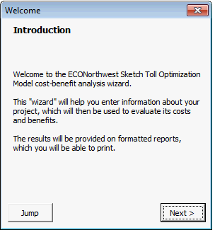

Navigation
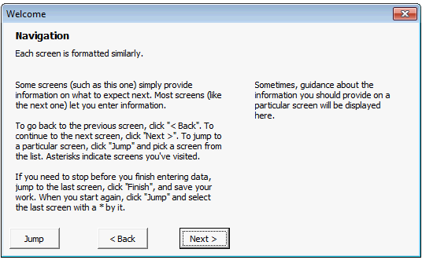

Model Years
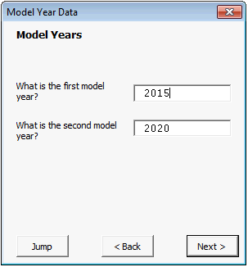

Model Year Tolling Objectives
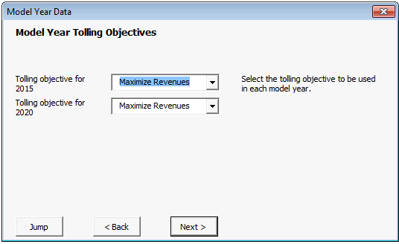

Time Periods
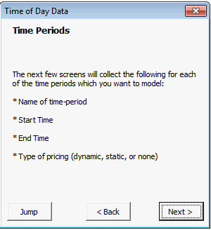

Time Period Names
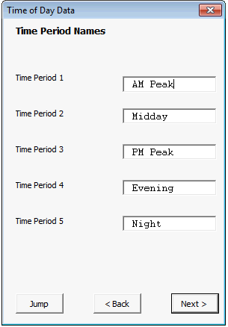

Time Period Times
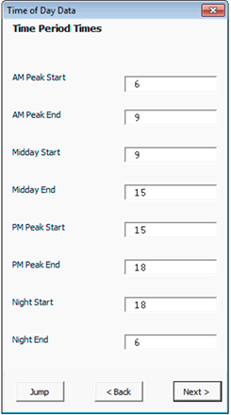

Time Period Tolling Methods
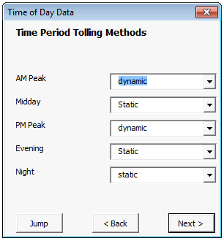

Vehicle Classes
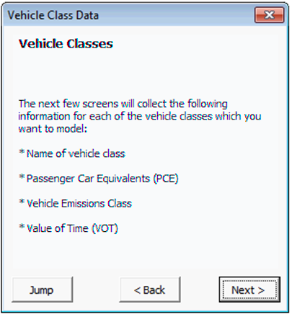

Vehicle Class Names
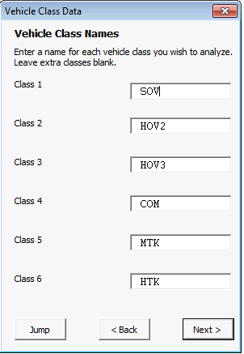

Passenger Car Equivalents
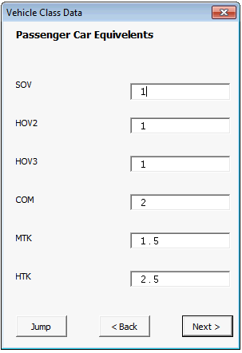

Vehicle Emissions Class
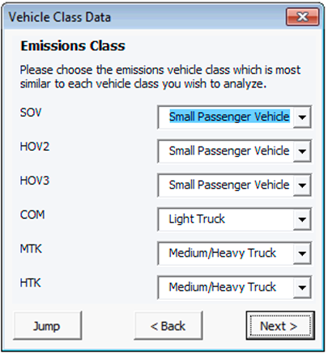

Value of Time
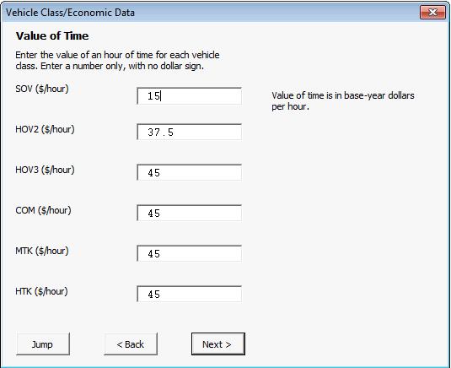

Managed Lane Access
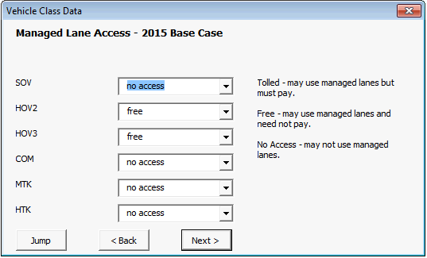

Segment Parameter Defaults
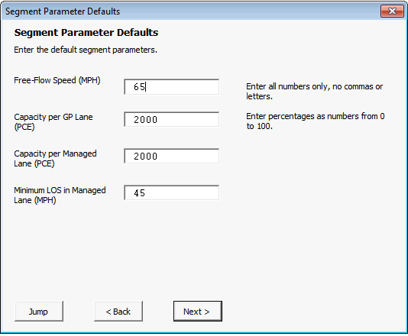

Number of Segments
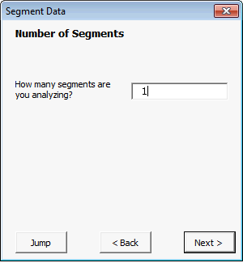

Segment Names
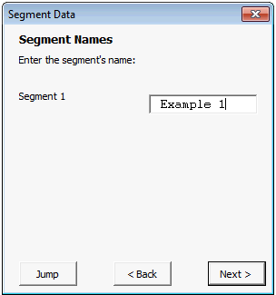

Basic Segment Data
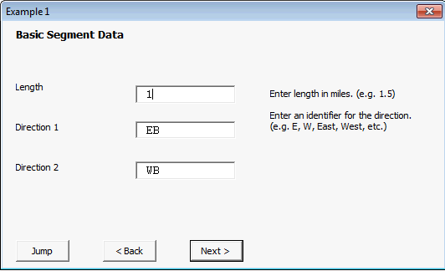

Segment Lanes
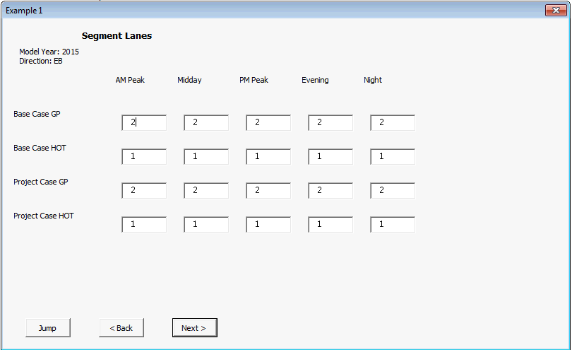

Segment Volumes
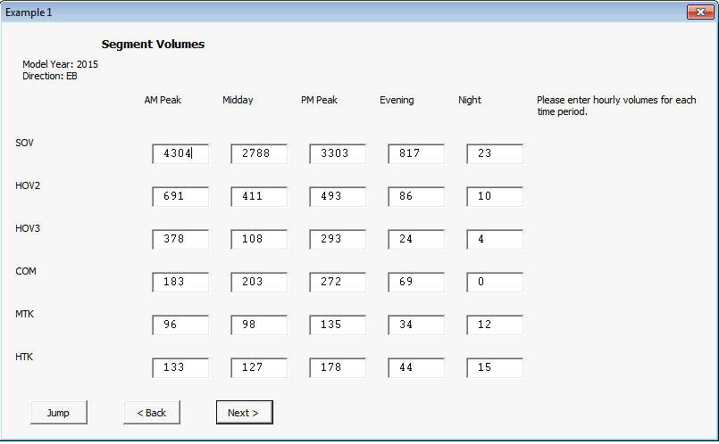

Data Entry Complete
