Investigation of Low Temperature Cracking in Asphalt Pavements
National Pooled Fund Study – Phase II
Task 4 Report
ILLI-TC: A New Thermal Cracking Model

Prepared by:

William G. Buttlar
Glaucio H. Paulino
Sofie Leon
Behzad Behnia
University of Illinois

Eshan V. Dave
University of Minnesota Duluth

May 2012

Prepared for:
Minnesota Department of Transportation
Research Services of MS 330
395 John Ireland Boulevard
St.Paul, MN 55155

This report represents the results of research conducted by the authors and does not necessarily represent
the views or policy of the Minnesota Department of Transportation and/or the Center for Transportation Studies. This report does not contain a standard or specified technique.

TABLE OF CONTENTS

TABLE OF CONTENTS 2
LIST OF TABLES 3
LIST OF FIGURES 4
1. Background 5
2. Model Components 5
2.1 Visual LTC 6
2.2 Preprocessor 2
2.3 Input File Generator 2
2.4 Preanalyzer 4
2.5 Finite Element Analysis Engine 6
2.6 Probabilistic Crack Distribution Model 11
3. Calibration of ILLI-TC Model 12
3.1 Pre-Analyzer Runs 13
3.2 Finite Element Runs 15
3.3 Model Calibration Discussion 19
4. Summary 21
References 23
Appendix A: User’s Manual for Illi-TC using Visual-LTC GUI 26

LIST OF TABLES

Table 1: Visual LTC steps 7
Table 2: Climatic locations available to user in Visual LTC 9
Table 3: Summary of pavement materials user inputs 1
Table 4: Material properties required by the analysis model 4
Table 5: Preanalyzer results (number of critical events) compared to field cracking 15
Table 5: ILLI-TC Model Calibration Results 21

LIST OF FIGURES

Figure 1: Flowchart of stand-alone low temperature cracking model, called ILLI-TC 6
Figure 2: Locations in the library of pavement temperature profiles available to the user. 10
Figure 3: Finite element model from input file generator. (a) Model geometry and boundary conditions (domain size: 0.18 m by 6 m, four asphalt layers). (b) Close-up of the mesh in vicinity of potential crack path. 3
Figure 4: Verification of preanalyzer. (a) Comparison of stresses obtained with the preanalyzer (VE1D) and the analytical solution. (b) Thermal loading. 5
Figure 5: Results from preanalyzer. (a) Surface temperatures for five-year analysis period. (b) Resulting surface stresses where four critical events were identified. 6
Figure 6: Comparisons for thermo-viscoelastic analysis conducted using recursive-incremental viscoelastic finite element formulations and commercial software ABAQUS (from Dave et al., 2010) 9
Figure 7: Bi-linear cohesive zone model 10
Figure 8: Finite element (FE) engine results of the cohesive zone model with recursive incremental viscoelastic finite element formulations. Temperature linearly decreases from 0ºC to -10ºC during 600 sec. 11
Figure 9: Pavement Surface Temperature using Default Climatic Files in ILLI-TC for MnROAD site (in the Category of Moderate Climate within the State of Minnesota). 13
Figure 10: Thermal Stress on Pavement Surface for MnROAD03 from Pre-Analyzer (Red line indicated 80% of IDT tensile strength). 13
Figure 11: Thermal Stress on Pavement Surface for MnROAD19 from Pre-Analyzer (Red line indicated 80% of IDT tensile strength). 14
Figure 12: Thermal Stress on Pavement Surface for MnROAD33 from Pre-Analyzer (Red line indicated 80% of IDT tensile strength). 14
Figure 13: Thermal Stress on pavement surface for MnROAD34 from preanalyzer (Red line indicated 80% of IDT tensile strength). 14
Figure 14: Thermal stress built-up along longitudinal direction for MnROAD19. (Tensile Strength = 4.22 MPa, Surface Temperature = -23.3ºC). 16
Figure 15: Partial depth softening damage for MnROAD19. (Tensile Strength = 4.22 MPa, Surface Temperature = -24.3ºC). 17
Figure 16: Partial crack for MnROAD19. (Tensile Strength = 4.22 MPa, Surface Temperature = -25.4ºC). 18
Figure 17: Fully-formed crack for MnROAD19. (Tensile Strength = 4.22 MPa, Surface Temperature = -29.6ºC). 19

Background
This chapter presents a new thermal cracking model developed at the University of Illinois Urbana-Champaign, called “ILLI-TC.” The predecessor to ILLI-TC is TCMODEL, which is a mechanistic-empirical thermal cracking model developed under the Strategic Highway Research Program (SHRP). ILLI-TC improves the manner in which fracture is handled in the simulation scheme, namely; in the past TCMODEL used a 1D Paris-Law phenomenological modeling approach to simulate crack propagation, while ILLI-TC uses a 2D, cohesive zone fracture modeling approach implemented within a viscoelastic finite element modeling framework. The cohesive zone approach considers both material strength and fracture energy in computing crack initiation and propagation using fundamental fracture mechanics principles, while the Paris law approach used in TCMODEL used a phenomenological power-law type model to link change in stress intensity (which was calculated in an approximate manner) to crack growth, where the Paris law parameters were empirically linked to material strength and slope of the log mixture compliance vs. log time relationship at long loading times. In summary, the new approach used in ILLI-TC has the following improvements over TCMODEL:
- A 2D model is used instead of 1D.
- The physics of cracking in a quasi-brittle, heterogeneous particulate composite are more correctly captured by using a cohesive zone approach, where softening and fracture have a distinct length scale that is captured.
- Asphalt mixtures may have unique combinations of strength and ‘ductility’ (as characterized by mixture fracture energy). For instance, some polymer-modified mixes portray moderate tensile strength and high fracture energy; some have high strength and lower fracture energy, and some have both high strength and high fracture energy. Mixtures with higher recycled material content may have high strength, but low fracture energy. ILLI-TC can capture all of these combinations in a direct manner, while TCMODEL could only capture these effects in an indirect manner.
- A user-friendly graphical interface (GUI) has been provided for ILLI-TC. The GUI program module within ILLI-TC is referred to herein as Visual-LTC.

This chapter presents the ILLI-TC model components, model verification, and model calibration results.

Model Components
The software program (ILLI-TC) provides an intuitive and user-friendly graphical user interface (GUI), as a means to perform rigorous viscoelastic finite element analysis with cohesive zone modeling. The program can be divided into the GUI and analysis modules. The overall flow of program along with various inputs and outputs is graphically illustrated in Figure 1. The code consists of four main analysis modules, which are shown in blue boxes in Figure 1: the preprocessor, the input file generator, the preanalyzer, and the finite element analysis engine. In-depth descriptions and implementation details of the GUI and analysis modules are presented in the following subsections.

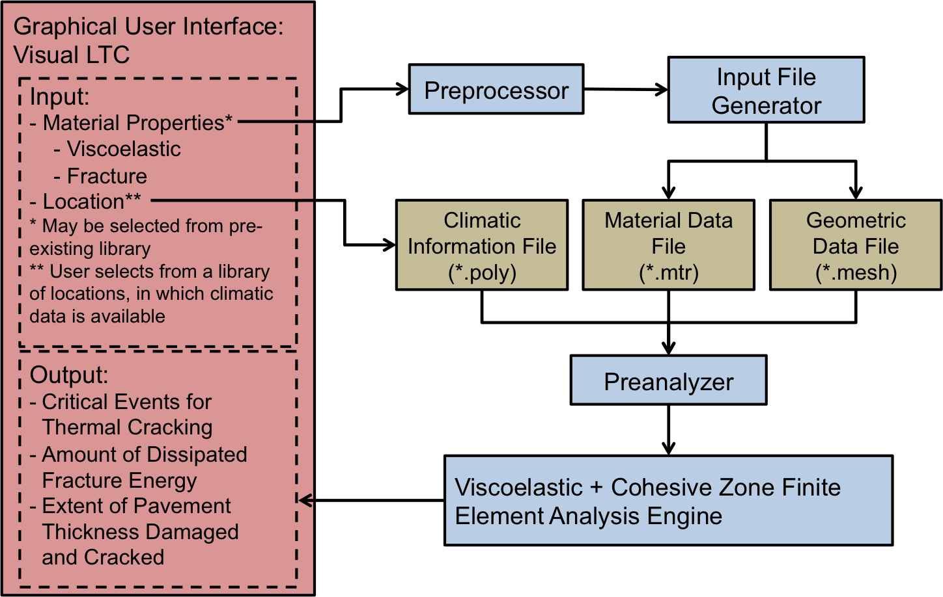
Figure 1: Flowchart of stand-alone low temperature cracking model, called ILLI-TC

Visual LTC
The GUI, called Visual LTC, collects and compiles the input conditions provided by the user, executes various analysis modules to conduct finite element analysis, and interprets and displays the results. Visual LTC was written with the object-oriented programming language C# (pronounced “see-sharp”) under Microsoft’s .NET framework, and which is intended for the development of robust, deployable software run on standard desktop or workstation personal computers.

Running Visual LTC
Visual LTC is organized into five sections: (1) Start, (2) Project Information, (3) Pavement Materials and Structure, (4) Run, (5) Results. For each section there are a number of inputs required from the user. The flow of the program is described below in the context of each of the five sections.
(1) Start: The user either opens an existing project or starts a new project. When an existing project is opened, all inputs are pre-loaded into the GUI. However, the user still has the ability to alter or change any of the inputs. In the case of a new project, the user is required to provide all required inputs.
(2) Project Information: The user inputs general information about the project, including project name, location, length of analysis, etc. The location of analysis is necessary to select the pavement temperature profiles.
(3) Pavement Materials: The user provides the pavement material properties either by selecting an asphalt concrete mix from the pre-existing library, modifying an existing mix or by creating a new mix.
(4) Run: Visual LTC executes the necessary analysis modules for pre-processing, finite element analysis and post-processing of the results. As the analysis runs, the GUI informs the user of the runtime progress by indicating which stages of the analysis are complete and which are in queue to be executed.
(5) Results: The results from the finite element analysis is converted to a user-friendly format and displayed. Three sets of outputs are provided, namely: percent of fracture energy dissipated, extent of pavement thickness damaged and extent of pavement thickness cracked (c.f., Figure 8, appearing later in this chapter). The outputs are available to users in both graphical and tabular formats and data can be exported in a convenient comma-separated value (CSV) format.

Details of the use of Visual LTC, including screen shots, and user inputs are presented in the User Manual (Appendix A).

Communication with analysis modules
Data is passed between Visual LTC and the analysis modules via input/output files. Visual LTC reads the user input then performs the series of converting data, writing files, executing programs, and reading output shown in Table 1.

Table 1: Visual LTC steps
- Read and store user input
- Extract and store climatic information for user specified analysis period
- Write input files for preprocessor
- Run preprocessor
- Read and convert preprocessor output
- Write input files for input file generator
- Run input file generator
- Run finite element analysis engine
- Read finite element analysis output
- Convert crack depth to amount of cracking
- Display results

During the analysis process, several files are written and stored in the user defined working directory. It is not necessary for the user to access the files at any point during or after analysis, however they are available for inspection by the advanced user.

User types
Visual LTC is intended for use by practitioners and researchers alike. Therefore, two user types are supported: “Standard User,” and “Advanced User.” Both user types have access to all functionality previously described. However, advanced users also have the ability to add new asphalt mixes and to modify properties of existing asphalt mixes. The standard user is the preferred default user mode for most pavement designers, since existing properties are protected from accidental user error when operating in this mode. The user can easily change from one user type to the other.

Visual LTC user inputs

The main user inputs that are required for low temperature cracking analysis are the analysis location, analysis duration and the pavement material properties. In this section, the location and duration inputs are first discussed, followed by material properties.

A series of ICM (Integrated Climatic Model) simulations were conducted to create a library of pavement temperature profiles available to the user in Visual LTC. Sets of temperature profiles were generated for one cold, one intermediate and one warm location in each state participating in the Pooled Fund Study. The locations and the lowest air temperatures as well as pavement surface temperatures are shown in Table 2. The locations are also shown on the map in Figure 2. Temperature profiles at each location were generated for the following asphalt concrete thicknesses: 3”, 4”, 5”, 6”, 7”, 8”, 9”, 10”, 12”, 14”, and 16”. A full integration of the ICM and ILLI-TC models is possible, but was beyond the scope of this study.

In Visual LTC, the user selects a location that is the most climatically similar to the analysis location. The user also provides the length of analysis and depth of pavement. Visual LTC extracts the appropriate data from the temperature profiles associated with the location and pavement thickness. This data is passed to the finite element engine where nodal temperatures are computed.

Table 2: Climatic locations available to user in Visual LTC
State | Cold Climate |  |  | Intermediate Climate |  |  | Warm Climate
State | City | Air | PG | City | Air | PG | City | Air | PG
Connecticut | Norfolk | -29.5°C | -28°C | Hartford | -26°C | -22°C | New Haven | -20.5°C | -22°C
Illinois | Elizabeth | -37°C | -34°C | Urbana | -31.5°C | -28°C | Anna | -27°C | -22°C
Iowa | Decorah | -40.5°C | -34°C | Des Moines | -32°C | -28°C | Fort Madison | -30.5°C | -28°C
New York | Massena | -39°C | -34°C | Albany | -33.5°C | -28°C | New York City | -19.5°C | -16°C
North Dakota | Westhrope | -44°C | -40°C | Bismarck | -41.5°C | -40°C | Wahpeton | -38°C | -34°C
Minnesota | International Falls | -43.5°C | -40°C | St. Cloud | -41.5°C | -34°C | Worthington | -34.5°C | -34°C
Wisconsin | Minong | -46°C | -40°C | Steven’s Point | -36.5°C | -34°C | Milwaukee | -32°C | -28°C

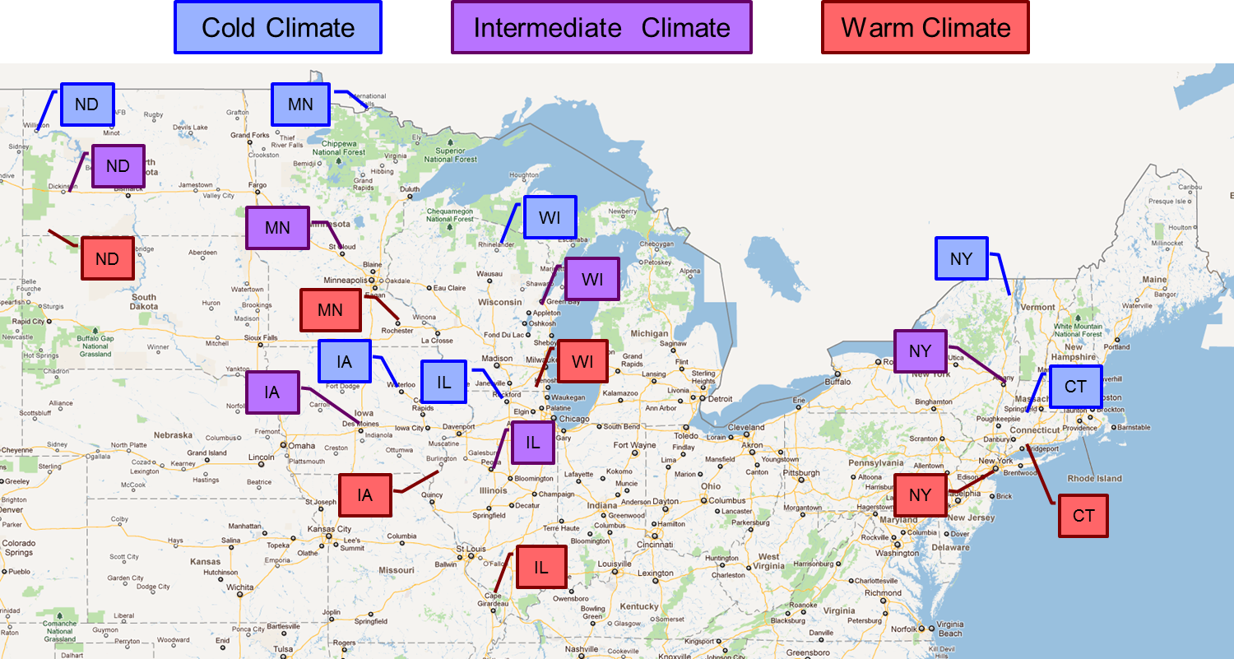
Figure 2: Locations in the library of pavement temperature profiles available to the user.
The pavement material property user inputs are summarized in Table 3 and discussed below.

Table 3: Summary of pavement materials user inputs
Property | Units | Test
Tensile strength | MPa | AASHTO T-322
Fracture energy | J/m² | ASTM D7313 ¹
Unit weight | g/cm³ | AASHTO M323
Thermal conductivity | BTU/lb-°F | No standardized test (default values provided)
Heat capacity | BTU/lb-°F | No standardized test (default values provided)
Mixture VMA ² | % | AASHTO M323
Aggregate coefficient of thermal expansion and contraction (CTEC) ² | mm/mm/°C | No standardized test
Mixture coefficient of thermal expansion and contraction (CTEC) ³ | mm/mm/°C | See Task 5 Report (by University of Wisconsin)
Creep compliance test data (100 or 1000 seconds for 3 temperatures) | 1/GPa | AASHTO T-322
Creep compliance test temperatures | °C | AASHTO T-322
¹ Fracture energy may be obtained with a different test geometry, however the model is calibrated for the ASTM D7313 test procedure
² Mixture VMA and aggregate CTEC do not need to be entered if Mixture CTEC is provided
³ Mixture CTEC will be calculated if mixture VMA and aggregate CTEC are provided

Tensile strength of asphalt concrete can be determined using the AASHTO T-322 test procedure. The fracture energy can be determined using a variety of test geometries, such as disk-shaped compact tension (DC[T]), semi-circular bend (SC[B]) and single-edge notched beam (SEN[B]) test. However, experimentally determined fracture energy is test-dependent (and specimen size dependent) and ILLI-TC has been calibrated and validated using the fracture energy obtained from the ASTM D7313 test procedure that utilizes DC[T] test geometry. According to ASTM D7313, the DC[T] test is performed at a crack mouth opening displacement (CMOD) rate of 0.0167 mm/s and at temperature of 10°C above the 98% reliability Superpave PG low temperature grade, as dictated by the project location.
The user can either directly input the coefficient of thermal expansion and contraction (CTEC) or provide asphalt mixture volumetric properties. If volumetric properties are provided, the CTEC is estimated using the approximation equation utilized by the AASHTO MEPDG software (ARA Inc., 2004). In the future, ILLI-TC can be modified to incorporate a non-linear thermal coefficient, as described in Task 5 report for this project. However, the use of a non-linear CTEC was beyond the scope of this project.
The user directly enters laboratory measured 100 or 1000 second creep test data from three temperatures following the AASHTO T-322 test procedure. This data is passed to the preprocessor, which converts the data into thermo-viscoelastic material properties in form of Prony series parameters (Generalized Maxwell model) and time temperature shift factors.

Data storage
A simple and intuitive class structure is employed to store and maintain data required for low-temperature cracking analysis, i.e. material properties, climatic data, pavement structure, and project information. The data should be easily accessible by the user and should not require installation of additional software. A working directory containing input files stores all of the data necessary for Visual LTC to conduct analysis. Furthermore, the user is not required to directly access the files, as Visual LTC creates and modifies files automatically. The project input file stores general information (i.e. project name, description, date, etc.), climatic information, and the pavement structure. Asphalt concrete input files store all material properties associated with the mix. A working directory can contain many project files, thus giving the user the option of creating a new project by modifying an existing one. Similarly, the working directory can contain as many asphalt concrete input files as necessary, which creates a library of mix designs for the analyst or designer to investigate.

Preprocessor
The main task of the preprocessor is to convert raw creep compliance test data is into thermo-viscoelastic material properties in form of Prony series parameters (Generalized Maxwell model) and time temperature shift factors. The master curve is constructed from the raw creep compliance data via Master (Buttlar et al. 1998). The Voigt-Kelvin model properties are then converted to Maxwell material model properties using TCMODEL (Lytton et al., 1993, Roque et al., 1995a, 1995b). Finally, the Maxwell model parameters are read from the TCMODEL output and passed to the input file generator.

Input File Generator
The first task of the Input File Generator is to develop a finite element mesh for the pavement geometry selected by user. The finite element mesh consists of coordinates of the nodal points, and an element connectivity table that links node numbers to their respective elements. During the first phase of low temperature pooled fund study preliminary version of mesh generator was developed (Marasteanu et al., 2007). In the present work, this mesh generation code was significantly revised and extended to develop full pavement models, perform checks for inconsistencies in the mesh, and automatically insert interfacial cohesive elements. Based on the recommendations and findings from previous studies (Paulino et al., 2006; Dave et al., 2007), the finite element domain size of 6 m was selected. The mesh generation code creates smaller elements near the potential crack path and gradually transitions them to larger size to reduce computational cost. The finite elements near the potential crack path are generated with 4 mm edge lengths, which are also based on the recommendations from previous studies (Paulino et al., 2006; Dave et al., 2007). The code generates a finite element mesh using four node quadrilateral elements (Q4) and it automatically increases the element side lengths in the longitudinal direction of pavement (x-direction) until the relative difference be the element side lengths reach 30%. At this point the mesh generator combines the smaller elements into one larger element using a three-to-one transition scheme.

Figure 3 shows a typical pavement mesh with a single asphalt concrete layer, including the three-to-one transition, which is all automatically generated by the software. The code supports multiple lifts of asphalt concrete, each with distinct material properties and thicknesses, however for the purposes of this study, the analysis was completed for a single layer only. To insert cohesive interface elements, the code traverses the mesh and generates duplicate nodes along the potential crack path. Next, cohesive zone elements are inserted and attached to the duplicate nodes. The location of cohesive elements is also illustrated in Figure 3.
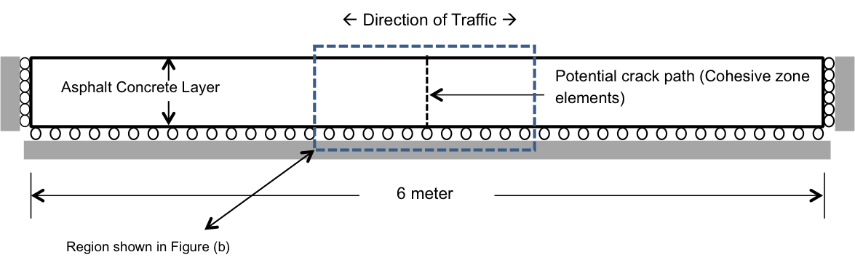
(a)
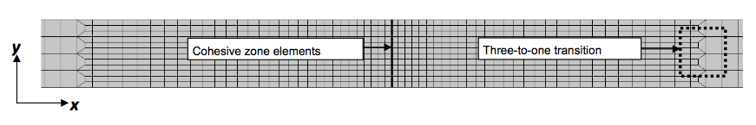
(b)
Figure 3: Finite element model from input file generator. (a) Model geometry and boundary conditions (domain size: 0.18 m by 6 m, four asphalt layers). (b) Close-up of the mesh in vicinity of potential crack path.
The second task of the Input File Generator is to create the material data file, which is primarily based on the information provided by the user. This file consists of viscoelastic (bulk) properties, the thermal expansion and contraction coefficient, and fracture properties. The list of properties utilized by the analysis code is shown in Table 4.

Table 4: Material properties required by the analysis model
- Parameters for generalized Maxwell model (spring and dashpot coefficients) and reference temperature
- Time-temperature shift factors for two temperatures other than reference temperature
- Coefficient of thermal expansion and contraction
- Fracture energy

The properties shown in Table 4 are calculated from the Visual LTC user inputs. Refer to the subsections on Visual LTC and the Preprocessor for information on the specific user inputs and calculations performed.

Preanalyzer
The preanalysis module was developed to optimize analysis times of the finite element engine. A simplified problem is solved to identify critical events that are then analyzed by the finite element analysis engine; hence only critical cooling events are analyzed with the full model. The preanalyzer modulus solves a one dimensional viscoelastic solution using thermo-viscoelastic properties of asphalt concrete and pavement surface temperatures to calculate the thermal stress on the surface of pavement. The one dimensional viscoelastic solution for thermal stress can be found in Apeagyei et al. (2008).

The results from the preanalyzer were verified with the analytical solution. The stresses obtained with the preanlayzer (VE1D) and the analytical solution is compared in Figure 4(a) for the thermal loading shown in Figure 4(b). Figure 4(a) shows the excellent agreement between the preanalyzer results and analytical solution, indicating that this portion of the ILLI-TC code has been verified.

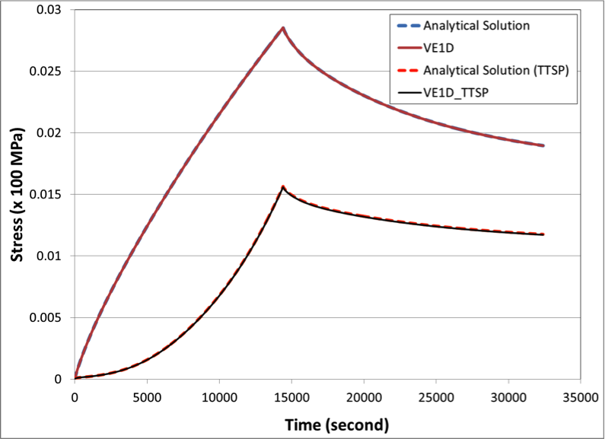 | 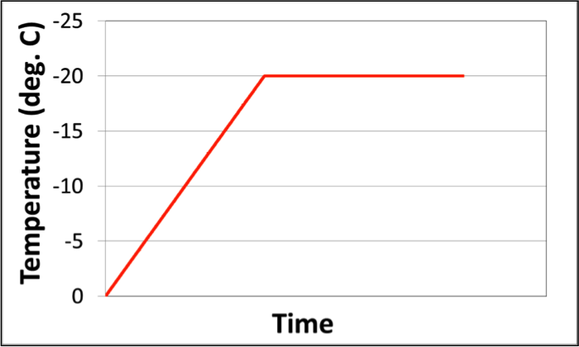
(a) | (b)
Figure 4: Verification of preanalyzer. (a) Comparison of stresses obtained with the preanalyzer (VE1D) and the analytical solution. (b) Thermal loading.

Critical events are identified when the surface stress exceeds 80% of the indirect tensile test (IDT) strength. This threshold was selected based on previous experience of researchers in determining the stress threshold corresponding to onset of damage. The full analysis with the finite element engine is performed for the 24 hours surrounding the critical event. Figure 5 shows an example of the results of the preanalyzer. The surface temperatures during the five-year analysis period are shown in Figure 5(a) and the resulting surfaces stresses are shown in Figure 5(b). Only the time duration between October 1st and March 31st are simulated. Four critical events were identified by this analysis; the full finite element simulation will be performed on these events accordingly.

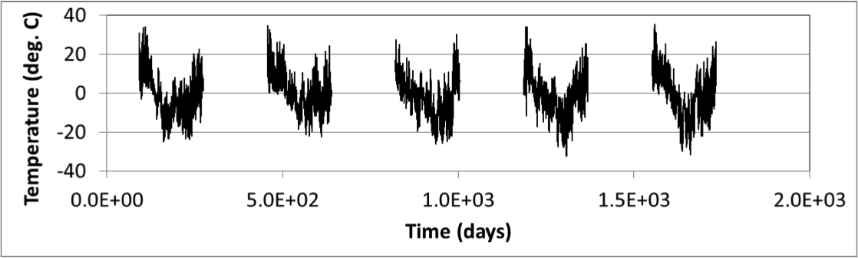
(a)
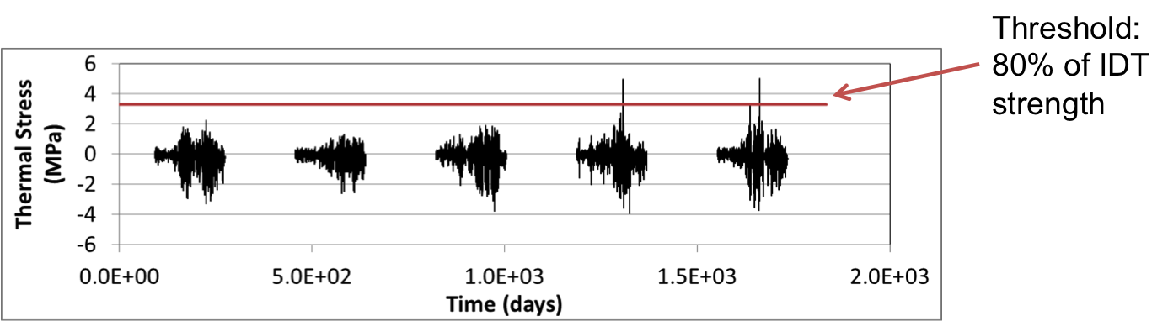
(b)
Figure 5: Results from preanalyzer. (a) Surface temperatures for five-year analysis period. (b) Resulting surface stresses where four critical events were identified.

Finite Element Analysis Engine
Finite element analysis is becoming increasingly popular in the design and analysis of pavements. For example, the current AASHTO design guide (MEPDG) utilizes finite element analysis for determination of critical pavement responses. The ability to model complex geometries and boundary conditions make finite element analysis well suited for simulation of asphalt pavements. Material behavior of asphalt concrete is time and temperature dependent with hereditary response requiring the use of thermo-viscoelastic analysis.
In order to simulate the complex mechanisms underlying the thermal cracking phenomenon, a standard “strength of materials” type analysis is insufficient, due to: 1) the highly non-linear behavior in the vicinity of the crack tip, and 2) the importance of the crack in the overall structural response (i.e., the need to model thermal crack as a moving boundary value problem). The cohesive zone model provides a computationally efficient way to predict the damage occurring in a process zone located ahead of a crack tip in a material. In the present project a finite-element analysis program is being created that utilizes both, (1) bulk viscoelastic behavior and, (2) cohesive zone model. Descriptions and formulations for each of these components are described in following sub-sections.
Viscoelastic Finite Element Analysis
General viscoelastic theory can be found in several textbooks and articles, for example, Christensen (1982). A generalized Maxwell model is utilized in this study due to its flexibility in representing a wide variety of viscoelastic materials as well as the availability of established formulations in the literature. The constitutive relationship for generalized Maxwell model can be given as,
where is stress, is strain, is reduced time and is fully relaxed modulus and is relaxation modulus for the Maxwell chains. The relaxation modulus for Maxwell units is given by,
The material parameters are spring coefficients and viscosities for the Maxwell unit. The spring coefficients and viscosities are related through relaxation times and the total number of Maxwell units in the model is given by . The effect of temperature on the material properties is accounted for through use of time-temperature superposition principle. The superposition is governed time-temperature shift factor which is a material property. The real time is related to the reduced time and temperature as,
For isotropic conditions the above shown constitutive relationships can be re-written in form of deviatoric and volumetric stress-strain relationships as,
where, are shear and bulk relaxation modulus components following the similar descriptions as shown before. The deviatoric strain components are shown by and the corresponding stress components by , these are evaluated as,
where, is Kronecker’s delta.
The time-integration approach used in this study is based on the recursive-incremental scheme developed by Yi and Hilton (1994). Similar schemes have been utilized for solving viscoelastic finite element problems by several researchers (for example, Muliana and Khan 2008). In field of asphalt concrete, Dai and You (2009) have utilized an incremental-recursive scheme for analysis of asphalt mixtures undergoing damage in lab sized specimens.
The incremental-recursive formulations (Zocher et al. 1997) rely on determination of incremental stress components in response to the strain increment given by,
where, the stiffness is given by and the viscoelastic history effect is accounted through residual stress term . Using the constitutive relationships shown in equation and recursive-incremental formulation in equation , the volumetric and deviatoric stress increments can be evaluated as,
At any reduced time the increment in reduced time and the corresponding strain rates can be approximated as,
The residual stress can be evaluated for deviatoric and volumetric components using the approximations shown in equation as,
where, symbols and represent viscoelastic (history) stress contributions at any given reduced time. These effects account for hereditary contributions should be tracked for each stress component throughout the entire range of time-steps used in a given simulation. Also notice that these terms are independent for each Maxwell unit in the material constitutive properties. The viscoelastic stress contributions are updated for each time increment. Using the approximate strain rate (equation ) and the expansion of equations and the viscoelastic stress contributions can be evaluated as,
Dave et al. (2010) conducted thermo-viscoelastic verifications to verify the accuracy of the recursive-incremental viscoelastic finite element formulations in the context of time dependent temperature conditions and temperature dependent viscoelastic properties. The boundary value problem simulated in this case is similar to the thermal stress restrained specimen test (TSRST), which is sometimes used for the evaluation of thermal cracking performance of asphalt concrete (AASHTO TP-10). In order to ensure good accuracy for thermal cooling and warming conditions, the temperature boundary conditions were chosen to impose both warming and cooling events. The results from the finite element formulations used in this study were compared with the results obtained from the commercial software ABAQUS. Figure 6 shows the variation of temperature with time as well as the corresponding thermal stresses generated in the restrained viscoelastic body. The stress response is shown for the formulations and implementation from the present study as well as those obtained using ABAQUS, showing excellent agreement. This provides verification for this portion of the ILLI-TC code.

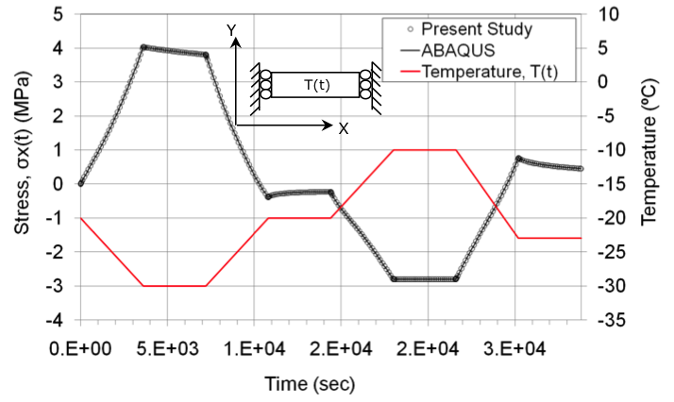
Figure 6: Comparisons for thermo-viscoelastic analysis conducted using recursive-incremental viscoelastic finite element formulations and commercial software ABAQUS (from Dave et al., 2010)

Fracture Modeling of Asphalt Concrete
Asphalt concrete is classified as a quasi-brittle material because of the large nonlinear fracture process zone resulting from crack overlapping and branching, and from the weak interface between aggregates and asphalt binder. Such nonlinear fracture process zone is approximated by the cohesive zone model (Baranblatt 1959; Dugdale 1960). The cohesive zone model has been widely utilized to investigate a range of civil engineering materials such as Portland cement concrete (Hillerborg et al. 1976), reinforced concrete (Ingraffea et al. 1984), asphalt concrete (Song et al. 2006), and fiber reinforced concrete (Park et al. 2010), etc.

In the cohesive zone model, nonlinear cohesive traction is defined as a function of separation (or crack opening width) ahead of a macroscopic crack tip. A crack is initiated when the cohesive traction reaches the cohesive strength of the material. Note that further investigation is needed for crack initiation criteria. Then, as the separation increases the cohesive traction decreases. Finally, when the separation is greater than a critical value, the material no longer has load carrying capacity and the cohesive traction is zero. In this study, the bi-linear CZM described by Song et al. (2006) is being employed. This model has been successfully employed for simulation of thermal and reflective cracking in asphalt pavements and overlays, for example by Dave et al. (2007, 2008). Additionally, an intrinsic cohesive zone modeling approach is used; hence a penalty stiffness (i.e. initial ascending slope) is introduced in the computational implementation. The initial penalty stiffness is determined on the basis of the numerical stability associated with the finite element implementation (Roesler et al. 2007).
The material parameters used in the cohesive fracture model are: material strength () and fracture energy (). Figure 7 shows schematically illustration of the bi-linear cohesive model. The horizontal axis represents the displacement-jump across the cohesive zone and vertical axis represents the traction. The area under the plot is the fracture energy () and the peak traction is limited to material strength (). The unloading and loading during the course of softening are also shown in the model. The displacement jump at the complete separation is indicated by critical displacement jump (). The bi-linear cohesive zone model was implemented in the program using a modified Newton-Raphson solution scheme.
The implementation of the cohesive zone model with recursive incremental viscoelastic finite element formulations is verified by comparing the results of the finite element analysis engine with the results of the commercial software ABAQUS. Figure 8 illustrates the stress variation with respect to time and shows excellent agreement. The stress reaches a given cohesive strength (e.g. 2MPa), and decrease to zero while temperature decreases from 0ºC to -10ºC during 600 sec. This provides verification for this portion of the ILLI-TC code.
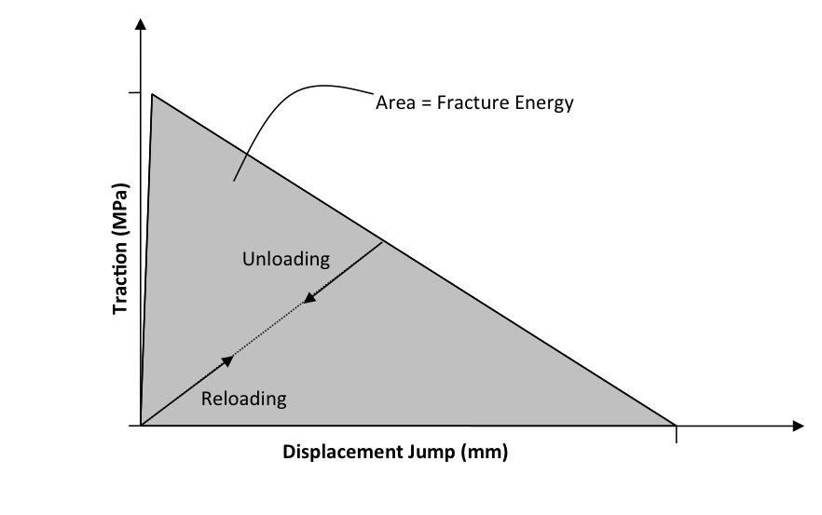
Figure 7: Bi-linear cohesive zone model

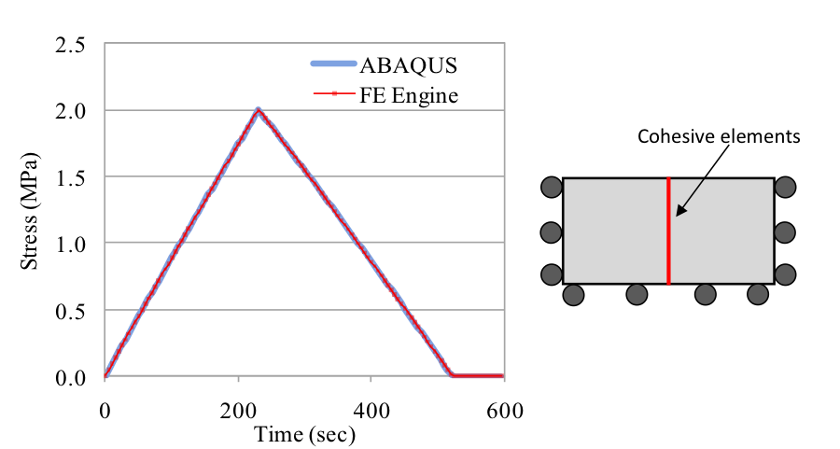
Figure 8: Finite element (FE) engine results of the cohesive zone model with recursive incremental viscoelastic finite element formulations. Temperature linearly decreases from 0ºC to -10ºC during 600 sec.

Probabilistic Crack Distribution Model
To avoid the modeling complexities and computation expense needed to simulate multiple thermal cracks, the scheme used in the original TCMODEL to translate a single thermal crack depth prediction to thermal crack density (spacing) was adopted in the current version of ILLI-TC (ILLI-TC v1.0). The modeling of multiple thermal cracks, while more exact, was not deemed as being worth the added computational expense, since the point at which crack interaction occurs is well within the range of severe cracking. Since it is unlikely that a designer would use a high cracking level as a design target, it was decided that multiple cracks would not be considered in this version of ILLI-TC. Rather, the model completes its execution once a high level of cracking reached (200 m of transverse cracking per 500 m of pavement, which corresponds to a crack spacing of 10 m).

This probabilistic crack distribution model converts the computed crack depth of a single modeled crack (viewed as a representative thermal crack, having a crack depth representing an average crack depth) to an amount of thermal cracking (crack frequency) with the following expression:

(11)

(12)

where:
C_{f} = Predicted amount of thermal cracking (m/500m) at a given simulation time
β₁ = Multiplier representing maximum thermal cracking level
N (x) = Standard normal distribution evaluated at x
σ = Standard deviation of the log of the depth of cracks in the pavement
C = Depth of crack predicted by ILLI-TC at a given simulation time
h_{ac} = Thickness of asphalt layer being simulated (generally taken as the thickness
of all asphalt layers)

Crack amount (m/500m) can be converted to thermal crack spacing by dividing predicted crack amount, Cf, by lane width (typically assumed to be 4 m), and taking the inverse of this quotient and multiplying by the unit section length (500 m). Citing the example provided earlier in this section, a crack amount of 200 m corresponds to: (1/(200/4))*500 or 10 meters. This corresponds to 1000/10 or 100 full-lane-width cracks per km, which corresponds to approximately 161 thermal cracks per mile. This corresponds to the maximum thermal cracking level predicted by ILLI-TC in the current version. Note, similar to the approach taken in the development of TCMODEL, the parameters β₁ and σ were taken as model calibration parameters. Since thermal cracks are difficult to detect until they propagate completely through the pavement, it would be extremely difficult to directly measure and assess the σ parameter. Thus, its selection as a model calibration parameter is a practical means to circumvent the need to directly measure σ.

Calibration of ILLI-TC Model
As described in the project proposal, MN/Road sections from Phase I of this pooled funds study were used to calibrate ILLI-TC, namely; sections 03, 19, 33 and 34. Details about these sections can be found in the Phase I final report (Marasteanu et al., 2007). A decision needed to be made with regards to the climatic files used in model calibration, since two approaches were possible: (1) use the actual time ranges corresponding to the field thermal cracking data for each section simulated, or; (2) use the climatic files provided in ILLI-TC. The argument for using the actual time ranges that correspond with the field data is that predicted critical cooling events would match actual critical events in the crack history data files, leading to more accurate thermal cracking predictions for model calibration. The argument for using the climatic files included in ILLI-TC is that future pavement simulations conducted using ILLI-TC would be expected to utilize these climatic files (unless the user takes the effort to modify ILLI-TC to utilize alternate climatic files, which is a cumbersome process in the current version of the software). Considering that most users will likely utilize the climatic files provided in ILLI-TC, and also considering that the model should be re-calibrated to local conditions rather than rely on the calibration provided herein, it was decided to conduct model calibration using the climatic files provided in the current version of ILLI-TC.

Pre-Analyzer Runs

Selected outputs from ILLI-TC’s preprocessor are provided in Figures 5 through 9, and summarized in Table 4. By comparing Figure 5 with Figure 6 through 9, it is clear that the days with the coldest temperatures correspond to the events with the highest surface tensile stress. Table 4 shows that 1 critical cooling event was computed for MnROAD section 03 during the simulated 5-year analysis period, while 4, 1, and 0 critical cooling events were predicted for sections 19, 33, and 34 respectively. Comparing the number of computed critical cooling events with field cracking behavior indicates the correlation between mixture viscoelastic behavior (as captured by the creep compliance master curves) and cracking behavior. The correlation between mix creep compliance and fracture behavior was also demonstrated via a statistical analysis in Phase I of this study (Marasteanu et al., 2007).

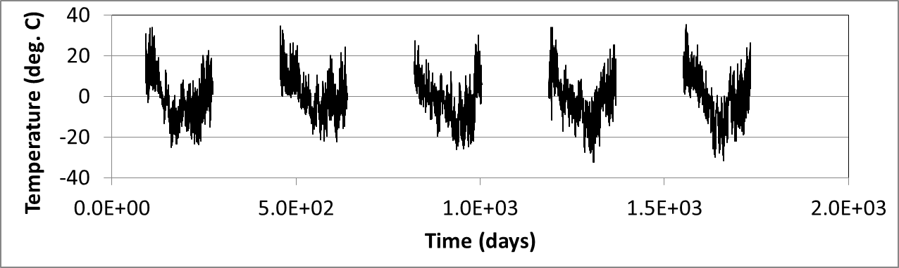
Figure 9: Pavement Surface Temperature using Default Climatic Files in ILLI-TC for MnROAD site (in the Category of Moderate Climate within the State of Minnesota).

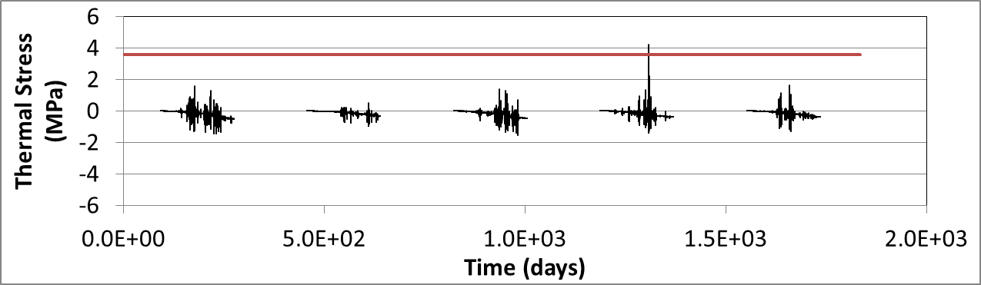
Figure 10: Thermal Stress on Pavement Surface for MnROAD03 from Pre-Analyzer (Red line indicated 80% of IDT tensile strength).

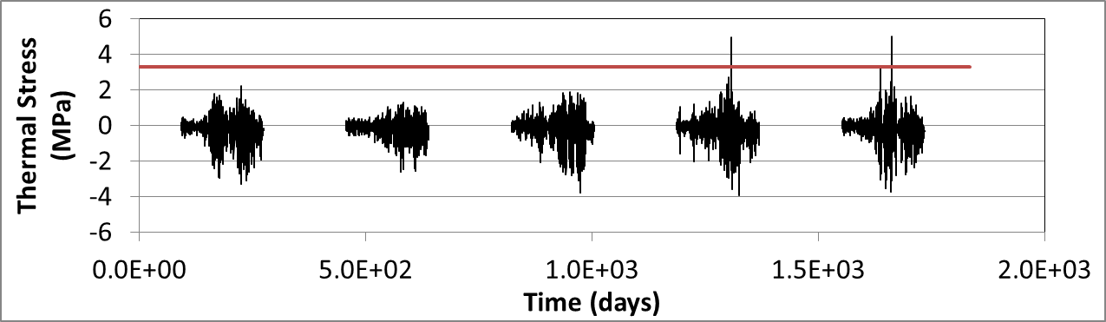
Figure 11: Thermal Stress on Pavement Surface for MnROAD19 from Pre-Analyzer (Red line indicated 80% of IDT tensile strength).

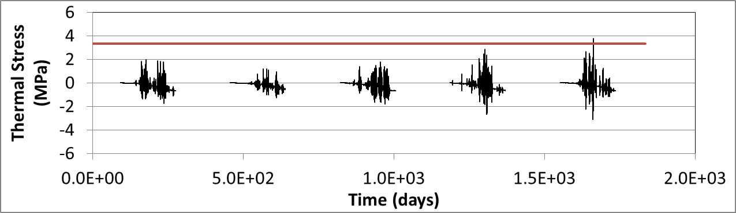
Figure 12: Thermal Stress on Pavement Surface for MnROAD33 from Pre-Analyzer (Red line indicated 80% of IDT tensile strength).

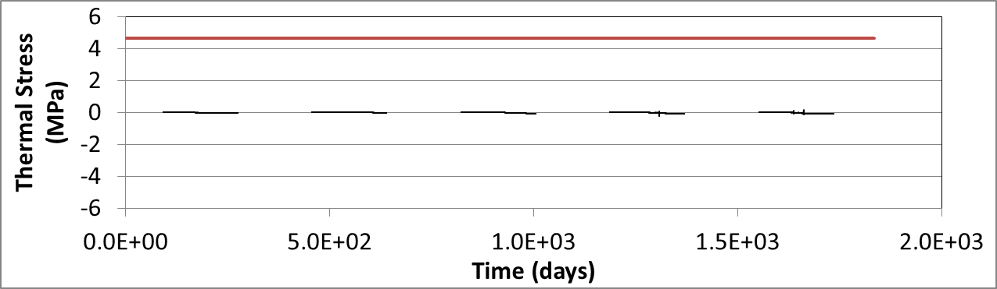
Figure 13: Thermal Stress on pavement surface for MnROAD34 from preanalyzer (Red line indicated 80% of IDT tensile strength).

Table 5: Preanalyzer results (number of critical events) compared to field cracking
MnROAD Cell | Number of Critical Events (as predicted by Pre-Analyzer) | Binder Grade | Field Cracking (m/500 m)
03 | 1 | PEN 120/150  (PG58-28) | 182
19 | 4 | AC20 (PG64-22) | 547
33 | 1 | PG 58-28 | 91
34 | 0 | PG 58-34 | 6

Finite Element Runs

Sample finite element modeling results from the calibration phase of the study for MnROAD section 19 are provided in Figures 14 through 17. The various aspects of the cohesive zone based finite element modeling approach can be seen in these stress and (exaggerated) deformed structure plots, which show the elevation view of the asphalt layers in the vicinity of the modeled crack. The progression of stress build-up, crack initiation, and crack propagation can be tracked as follows:
- Figure 14 shows high surface tensile stress (as indicated by the red color contours), and a slight disruption in the contours at the crack interface caused by the early stages of damage (post-peak softening when tensile stress exceeded material strength at the surface of the pavement) at -23.3 C surface temperature. Mild compression is still present in the lower regions of the pavement, due to time-lag effects of heat flow.
- Figure 15 shows that a thermal crack has propagated partially downward through the pavement at a temperature of -24.3 C, and that a fracture process zone of about 15% of the pavement thickness exists ahead of the current crack tip location, illustrating one of the features of the cohesive zone modeling approach (length scale of fracture is directly considered). A compression zone still exists near the bottom of the asphalt layer.
- Figure 16 shows a later stage of crack propagation, and that the fracture process zone has grown in size, and that a compression zone no longer exists (which may partially explain the expansion of the fracture process zone) at a temperature of -25.4 C.
- Figure 17 shows a fully formed crack, occurring around -29.6 C. In reality, ILLI-TC considers the pavement section as fully cracked prior to this analysis step, as described below.

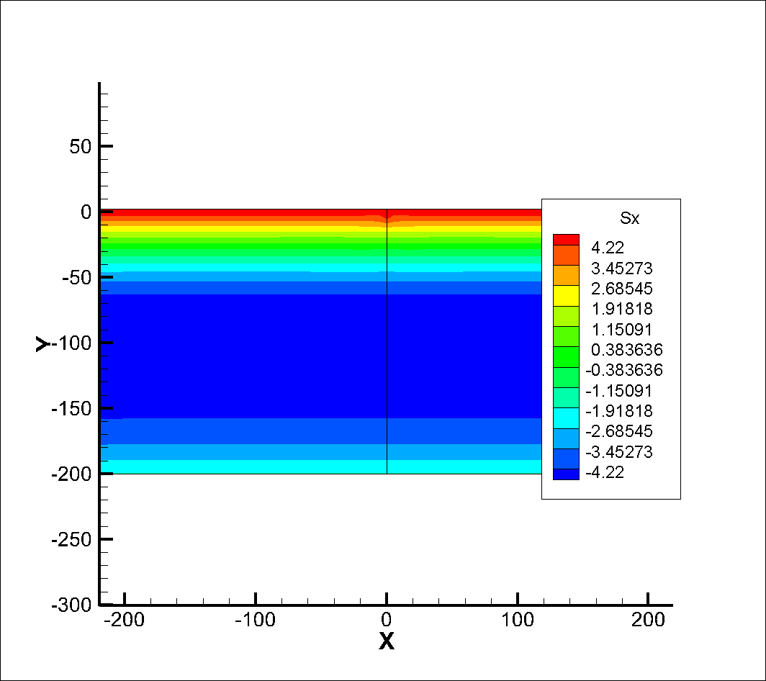
Thermal Stress in Longitudinal Direction near the Crack Path (MPa)
Figure 14: Thermal stress built-up along longitudinal direction for MnROAD19. (Tensile Strength = 4.22 MPa, Surface Temperature = -23.3ºC).
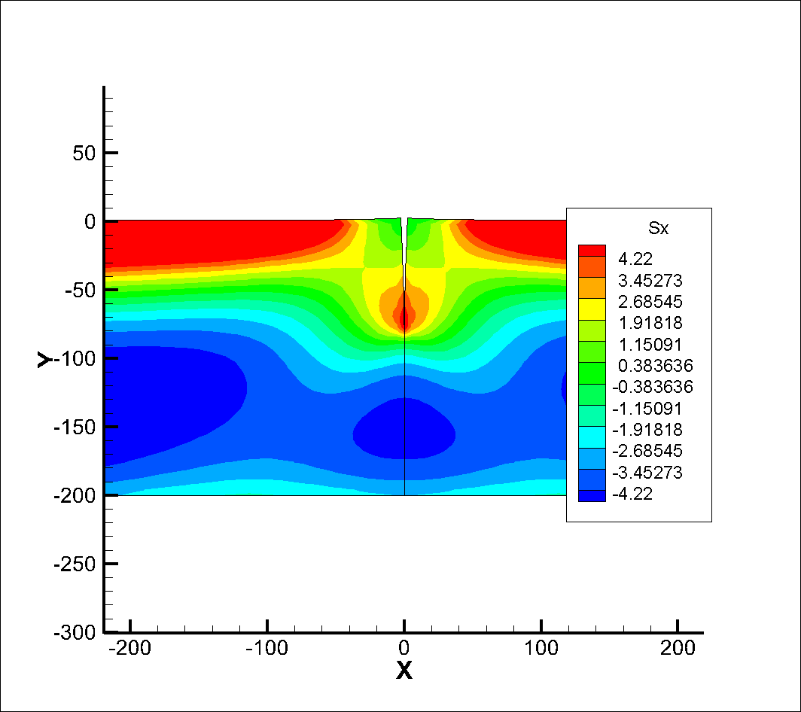
Thermal Stress in Longitudinal Direction near the Crack Path (MPa)
Figure 15: Partial depth softening damage for MnROAD19. (Tensile Strength = 4.22 MPa, Surface Temperature = -24.3ºC).
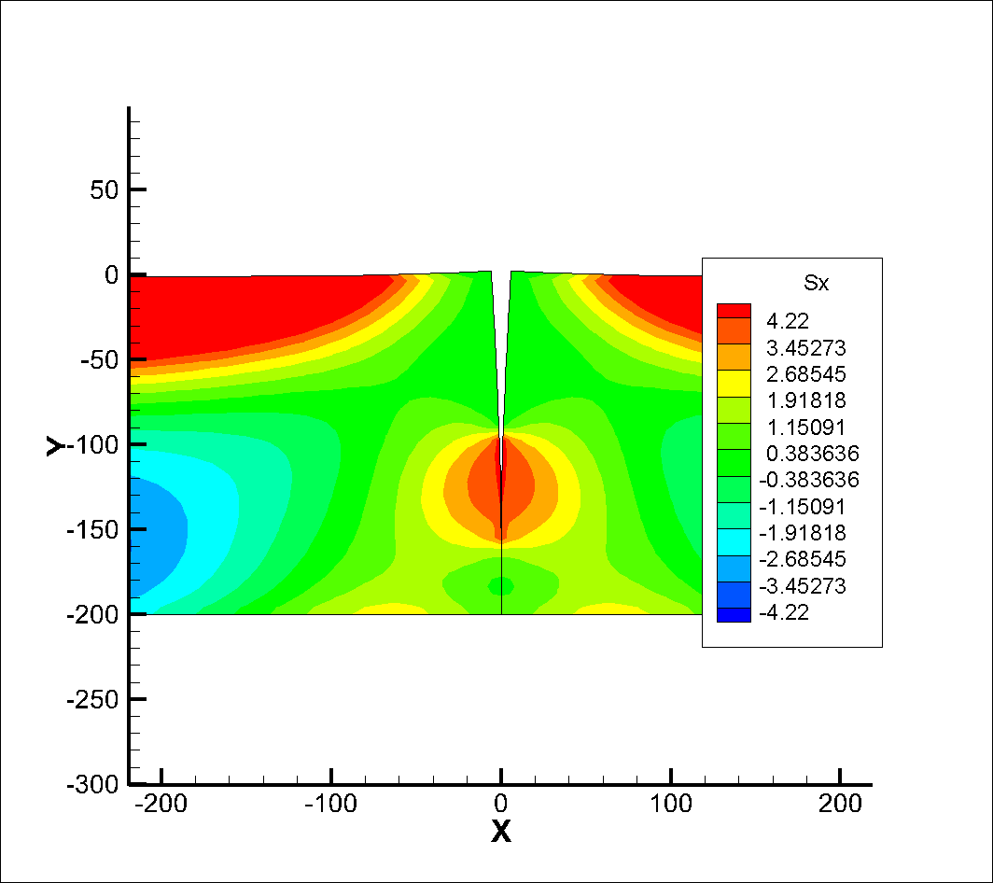
Thermal Stress in Longitudinal Direction near the Crack Path (MPa)
Figure 16: Partial crack for MnROAD19. (Tensile Strength = 4.22 MPa, Surface Temperature = -25.4ºC).
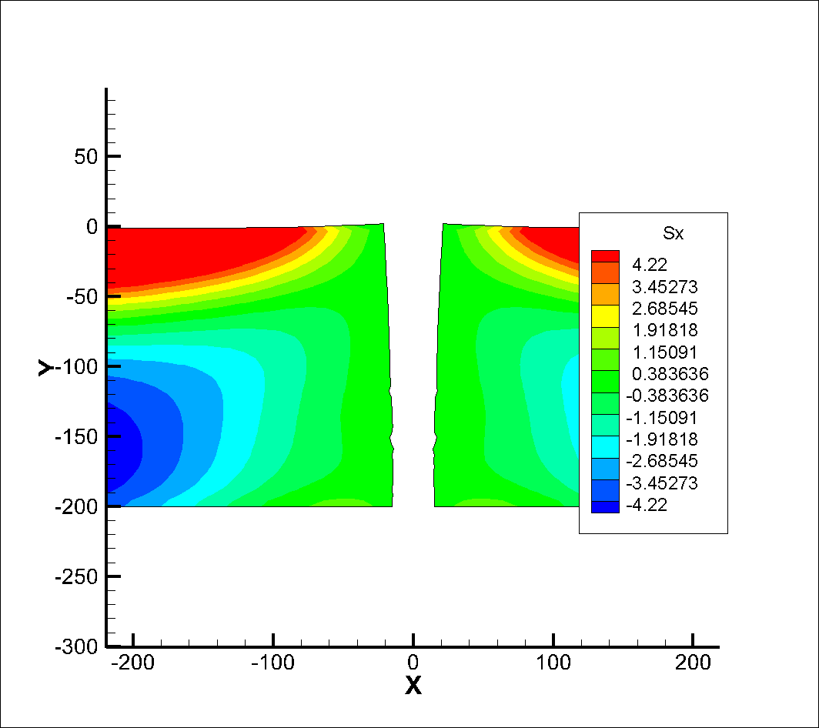
Thermal Stress in Longitudinal Direction near the Crack Path (MPa)
Figure 17: Fully-formed crack for MnROAD19. (Tensile Strength = 4.22 MPa, Surface Temperature = -29.6ºC).

Model Calibration Discussion

Model calibration in pavement studies acknowledges the significant complexities associated with pavement materials, construction, climatic effects, traffic loading and performance. Pavement performance model calibration is almost always needed as a result. In the case of thermal cracking, factors such as construction variability, inability to model aging and aging gradients with accuracy, approximate nature of tests and material models, approximate nature of climatic records and pavement temperature predictions, presence of load-associated effects and damage on pavement, etc., exist and result in the need for model calibration.
A number of factors were available to be used for model calibration, including: fracture energy multiplier, tensile strength multiplier, thermal coefficient multiplier, crack tip definition, and beta and sigma parameters from the probabilistic crack distribution model were readily available for use in model calibration. As a preliminary approach, it was decided to leave the material property factors as uncalibrated, and focus on the following three factors for model calibration: crack tip definition, beta parameter, sigma parameter. Crack tip definition refers to the fact that more than one material state can be considered as the point of crack initiation in the cohesive zone modeling technique. For instance, in Figure 7, any point along the post-peak softening curve (declining linear function in the case of the bi-linear cohesive zone model, which represents the gradual accumulation of material damage and loss of load carrying capacity across the forming crack as the material separates) could be selected as the arbitrarily chosen location of the crack tip. The point at where the softening curve reaches zero traction (the right hand limit of the plot shown in Figure 7) is arguably the point where the material no longer possesses the ability to heal. However, it can also be argued that an intermediate point along the softening curve may be a realistic choice for the crack tip, and a threshold where little to no healing may be possible. After examining the finite element results from the Mn/ROAD calibration finite element runs, it was decided that the crack tip would be defined as the point in the pavement along the line of cohesive zone elements where a softening threshold of 75% post-post peak decay of material strength (25% traction remaining) is reached. In addition, an identical beta factor (β = 400 m of cracking per 500 m of pavement section) as used in the original TCMODEL as calibrated in the MEPDG would be used. Finally, the sigma parameter in the probabilistic crack distribution model was calibrated to a value of σ = 1.1.

As per the project work plan, only MnROAD sections were used in model calibration. The results of the calibrated ILLI-TC model, using MnROAD pavement sections, is presented in Table 5. As can be seen, good modeling prediction were achieved for three out of the four sections evaluated. For instance, MnROAD section 19, which experienced very high pavement cracking due to the use of an AC-20 binder (PG 64-22) in a PG XX-34 climate, was predicted to have a maximum level of cracking. Recall that when the maximum predicted crack depth is reached (crack depth = thickness of pavement), this implies that the average crack is equal to the pavement thickness. Thus, half of the other pavement cracks will be shorter than the thickness of the pavement, and therefore, not yet counted as thermal cracks. Stated otherwise, the probabilistic crack distribution model has a maximum cracking level of 200 m of cracking per 500 m section, when β = 400.
MnROAD section 33 was found to have a cracking level of 94 m of cracking, as compared to a measured level of 91 m (this was the section that weighed heavily on the calibration of the parameter σ ), and MnROAD section 34 was found to have a cracking amount of 0 m as compared to a measured cracking level of 6 m. The only poor prediction that resulted was for MnROAD section 03, where zero cracking was predicted as compared to 182 m of measured cracking. It should be noted, however, that ILLI-TC did indicate that softening damage had begun to occur in this section (although not enough to reach the 75% softened threshold). It is also acknowledged that the time period for the ILLI-TC simulation was shorter than the period of field performance reported for Section 03. In addition, the master curve data used in the calibration was less-than-optimal, with data from only two test temperatures being available (three is preferred). Rather than add additional calibration factors to ILLI-TC, it was decided that the aforementioned calibration parameters were sufficient for the calibration of ILLI-TC. However, it is recommended that ILLI-TC be recalibrated to local conditions to arrive at better model accuracy. Model validation using an independent data set is provided through Task 6 for the project.

Table 6: ILLI-TC Model Calibration Results

MnROAD Cell | Binder Grade | Measured Field Cracking (m/500 m) | Predicted Field Cracking (using non-synchronized climate files)
03 | PEN 120/150  (PG58-28) | 182 | 0
19 | AC20 (PG64-22) | >200 (547) | >=200 (max cracking)
33 | PG 58-28 | 91 | 94
34 | PG 58-34 | 6 | 0

Summary
This chapter presented a new thermal cracking model developed at the University of Illinois Urbana-Champaign, called “ILLI-TC.” This chapter presents the ILLI-TC model components, model verification, and model calibration results. ILLI-TC improves the manner in which fracture is handled in the simulation scheme, namely; in the past TCMODEL used a 1D Paris-Law phenomenological modeling approach to simulate crack propagation, while ILLI-TC uses a 2D, cohesive zone fracture modeling approach implemented within a viscoelastic finite element modeling framework. A user-friendly graphical interface (GUI) has been provided for ILLI-TC. The GUI program module within ILLI-TC is referred to herein as Visual-LTC. A detailed account of the finite element modeling approach used herein was also provided. Intermediate results, including stress contours and deformed pavement structure were presented and discussed. A probabilistic crack distribution model, identical to the one used in the original TCMODEL program, was also presented. Model calibration strategies, including a discussion on the arbitrary selection of the definition of a crack tip in the cohesive zone modeling scheme was also presented.

As per the project work plan, only MnROAD sections were used in model calibration. MnROAD sections 19, 33, and 34 were found to have very good model predictions after model calibration. The only poor prediction that resulted was for MnROAD section 03, where zero cracking was predicted as compared to 182 m of measured cracking. It should be noted, however, that ILLI-TC did indicate that softening damage had begun to occur in this section (although not enough to reach the 75% softened threshold). It is also acknowledged that the time period for the ILLI-TC simulation was shorter than the period of field performance reported for Section 03. In addition, the master curve data used in the calibration was less-than-optimal, with data from only two test temperatures being available (three is preferred). Rather than add additional calibration factors to ILLI-TC, it was decided that the aforementioned calibration parameters were sufficient for the calibration of ILLI-TC. However, it is recommended that ILLI-TC be recalibrated to local conditions to arrive at better model accuracy. Model validation using an independent data set is provided in the Task 6 report for this project.
ILLI-TC is a modular finite element code, and can be upgraded in the future to include additional ‘physics’ which could include: multiple HMA lifts; non-linear thermal coefficient; non-linear softening curve shape for cohesive zone model; integrated ICM climatic model; a year-round modeling option, combined with a multi-processor code option to handle the extra computing requirements; aging gradient effects on bulk and fracture mixture properties, and; 3-D code to allow combined block/thermal cracking analysis to be performed. Although beyond of this study, these modeling improvements will serve to improve the accuracy and breadth of capabilities of the ILLI-TC modeling program. From a practitioner standpoint, the current ILLI-TC program has the benefit of relatively fast run times and relatively few material property testing requirement and inputs. From a research standpoint, the proposed future updates to ILLI-TC will provide more insight into the mechanisms behind thermal cracking, but will require more testing and modeling effort.

References

ARA, Inc. (2004). “Guide for Mechanistic–Empirical Design of New and Rehabilitated Pavement Structures,” National Cooperative Highway Research Program, Project 1-37A, Final Report.

A. K. Apeagyei, E. V. Dave, and W. G. Buttlar (2008). “Effect of Cooling Rate on Thermal Cracking of Asphalt Concrete Pavements,” Journal of Association of the Asphalt Paving Technologists, Volume 77, pp. 709-738.

G. I. Barenblatt (1959). “The formation of equilibrium cracks during brittle fracture: general ideas and hypotheses, axially symmetric cracks,” Applied Mathematics and Mechanics, Volume 23(3), pp. 622–636.

Buttlar, W. G., Roque, R., & Reid, B. (1998). Automated Procedure for Generation of Creep Compliance Master Curve for Asphalt Mixtures. Transportation Research Record: Journal of the Transportation Research Board, Volume 1630, pp. 28–36.

R. M. Christensen (1982). “Theory of Viscoelasticity”. Dover Publications, Inc., Mineola, NY.

Q. Dai, and Z. You (2009). “Micromechanical Finite Element Framework for Predicting Viscoelastic Properties of Heterogeneous Asphalt Mixtures,” Materials and Structures, Volume 41(6), pp. 1025-1037.

E. V. Dave, S. H. Song, W. G. Buttlar, and G. H. Paulino (2007). "Reflective and Thermal Cracking Modeling of Asphalt Concrete Overlays,” Proceedings of the International Conference on Advanced Characterization of Pavement and Soil Engineering Materials, Taylor and Francis.

E. V. Dave, A. F. Braham, W. G. Buttlar, G. H. Paulino, and A. Zofka (2008). “Integration of Laboratory Testing, Field Performance Data, and Numerical Simulations for the Study of Low-Temperature Cracking,” Proceedings of the 6th RILEM International Conference on Cracking in Pavements, Chicago, USA, Eds. Al-Qadi, Scarpas, and Loizos, CRC Press Taylor and Francis Group, New York, ISBN: 978-0-415-4757-54, pp. 369-378.

D. S. Dugdale (1960). “Yielding of steel sheets containing slits,” Journal of the Mechanics and Physics of Solids, Volume 8(2), pp. 100–104.

A. Hillerborg, M. Modeer, and P. E. Petersson (1976). “Analysis of crack formation and crack growth in concrete by means of fracture mechanics and finite elements,” Cement and Concrete Research, Volume 6(6), pp. 773–781.

A. R. Ingraffea, W. H. Gerstle, P. Gergely, V. Saouma (1984). “Fracture mechanics of bond in reinforced concrete,” Journal of Structural Engineering, Volume 110 (4), pp. 871–890.

R. L. Lytton, J. Uzan, E. G. Femando, R. Roque, D. Hiltunen, and S. M. Stoffels (1993). “Development and Validation of Performance Prediction Models and Specifications for Asphalt Binders and Paving Mixes,” Final Report, Strategic Highway Research Program, Project SHRP-A357, Washington DC.

M. Marasteanu, A. Zofka, M. Turos, X. Li, R. Velasquez, X. Li, C. Williams, J. Bausano, W. Buttlar, G. Paulino, A. Braham, E. Dave, J. Ojo, H. Bahia, A. Gallistel, and J. McGraw (2007). “Investigation of Low Temperature Cracking in Asphalt Pavements”, National Pooled Fund Study 776, Minnesota Department of Transportation, Research Services MS 330, St. Paul, MN 55155, 2007.

A. Muliana, and K. A. Khan (2008). “A Time-Integration Algorithm for Thermo-Rheologically Complex Polymers,” Computational Materials Science, Volume 41, pp. 576-589.

K. Park, G. H. Paulino, J. R. Roesler (2010). “Cohesive fracture model for functionally graded fiber reinforced concrete”, Cement and Concrete Research, Volume 40 (6), pp. 956-965.

G. H. Paulino, W. G. Buttlar, P. B. Blankenship, M. P. Wagoner, S. H. Song, and E. V. Dave (2006). “Final Report for NSF-GOALI Project - CMS:0219566,” National Science Foundation, Washington, DC, 2006.

R. Roque, D. R. Hiltunen, W. G. Buttlar. (1995a) “Thermal Cracking Performance and Design of Mixtures Using Superpave(TM),” Journal of the Association of Asphalt Paving Technologists, Volume 64, pp. 718-735.

R. Roque, D. Hiltunen, W. Buttlar, T. Farwana. (1995b) “Engineering Properties of Asphalt Mixtures and the Relationship to their Performance,” STP1265 Engineering Properties of Asphalt Mixtures and the Relationship to their Performance, ASTM International.

Roseler, J., G. H. Paulino, K. Park, C. Gaedicke. (2007). “Concrete fracture prediction using bilinear softening,” Cement and Concrete Composites, Volume 29 (4), pp. 300-312.

S. H. Song, G. H. Paulino, and W. G. Buttlar. (2006) “A Bilinear Cohesive Zone Model Tailored for Fracture of Asphalt Concrete considering Rate Effects in Bulk Materials,” Engineering Fracture Mechanics, Volume 73, Number 18, pp. 2829-2848.

S. Yi and H. H. Hilton (1994). “Dynamic Finite Element Analysis of Viscoelastic Composite Plates in the Time Domain.” International Journal of Numerical Methods in Engineering, Volume 37(12), pp. 4081-4096.

M. A. Zocher, S. E. Groves, and D. H. Allen (1997). “A Three-Dimensional Finite Element Formulation for Thermoviscoelastic Orthotropic Media.” International Journal of Numerical Methods in Engineering, Volume 40(12), pp. 2267-2288.

Appendix A: User’s Manual for Illi-TC using Visual-LTC GUI
Visual LTC User Manual

ILLI-TC is comprised of several analysis modules (preprocessor, input file generator, preanalyzer, and finite element analysis engine), which are unified through a graphical user interface (GUI), called Visual LTC. The following user manual provides detailed explanations for how to run ILLI-TC through its user interface, Visual LTC.

Download
ILLI-TC is available for download, and the contents of the program are zipped into a single folder containing the items listed in Table A1.

Table A1. Contents of zipped ILLI-TC distribution folder
VisualLTC.exe |  | Graphical user interface
analysis_modules\ |  | Folder of executable analysis modules
 | Master.exe | Constructs master curve
 | TCModel.exe | Extracts Maxwell model parameters
 | VE1D.exe | Preanalyzer
 | FEengine.exe | Finite element analysis engine
ac_mixes\ |  | Folder of existing asphalt concrete mixes
 | MnRoad33.acinp | Existing asphalt concrete mixes
 | MnRoad34.acinp | Existing asphalt concrete mixes
 | MnRoad35.acinp | Existing asphalt concrete mixes
climatic\ |  | Folder of temperature profiles
 | CT_int_3.poly | Text files of temperature profiles for intermediate, cold, and warm climates in participating states for various pavement depths
 | CT_int_4.poly
 | CT_int_5.poly
 | …
 | WI_warm_14.poly
 | WI_warm_16.poly

Setup working directory
Communication between Visual LTC and the various analysis modules is achieved through reading and writing text files stored in the working directory. The first step in running Visual LTC is to select a working directory. This directory must contain certain folder and files organized in such a way that Visual LTC can find them. The organization of the working directory is shown Table A2.

Table A2. Contents and organization of working directory (folders shown in bold)
Working Directory\
VisualLTC.exe
Existing_mix1.acinp (optional)
Existing_mix2.acinp (optional)
…
Existing_mix.acinp (optional)
analysis_modules\
Master.exe
TCModel.exe
VE1D.exe
FEengine.exe
climatic\
CT_int_3.poly
CT_int_4.poly
CT_int_5.poly
…
WI_warm_14.poly

Existing asphalt concrete files (*.acinp) may be included in the root of the home directory, although they are not required. Existing mixes present in the working directory will be available to the user. If no mixes are in the working directory root, then the user will either have to enter all of the material properties by hand, or he/she can import *.acinp files located in a different folder on his/her machine.

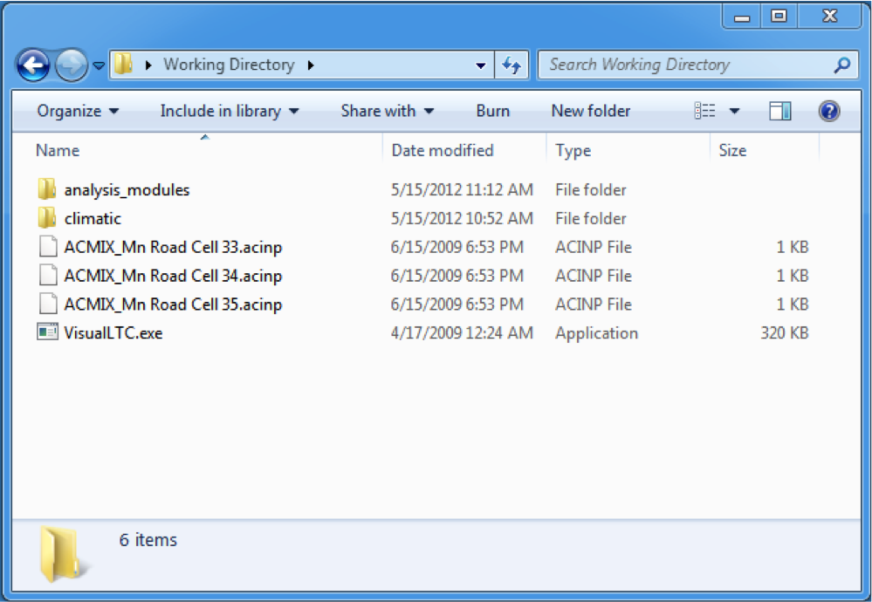
Figure A1. Screenshot of working directory with optional *.acinp files

Several files are created and moved inside the working directory during analysis. After the analysis completed, the intermediate files are stored in a directory called “intermediate_files” inside the working directory. The advanced user may access and inspect these files, however this is not necessary as they are internal to the overall analysis process.

Supported platforms
Visual LTC and the analysis modules are only supported on Windows XP and Windows 7 operating systems. Both 64 bit and 32 bit versions are available.

Use of Visual LTC

The key features of Visual LTC are described next. This section is organized as follows: first the typical usage of ILLI-TC through Visual LTC is described, additional features including saving mixes and projects, importing new mixes, and changing the user type for advanced capabilities are discussed next, finally, typical errors and warnings the user may encounter are explained.

Typical usage

The first step in Visual LTC is to create a new project or open an existing one, as shown in Figure A2. If the user chooses to create a new project, he/she will be prompted for the location of the working directory, which must be formatted properly, as discussed in the previous section and shown in Figure A1. If the user chooses to open an existing project, he/she will be prompted to select a *.prj file, which would have been saved from a previous Visual LTC run. More information on saving projects will be provided in the next section.

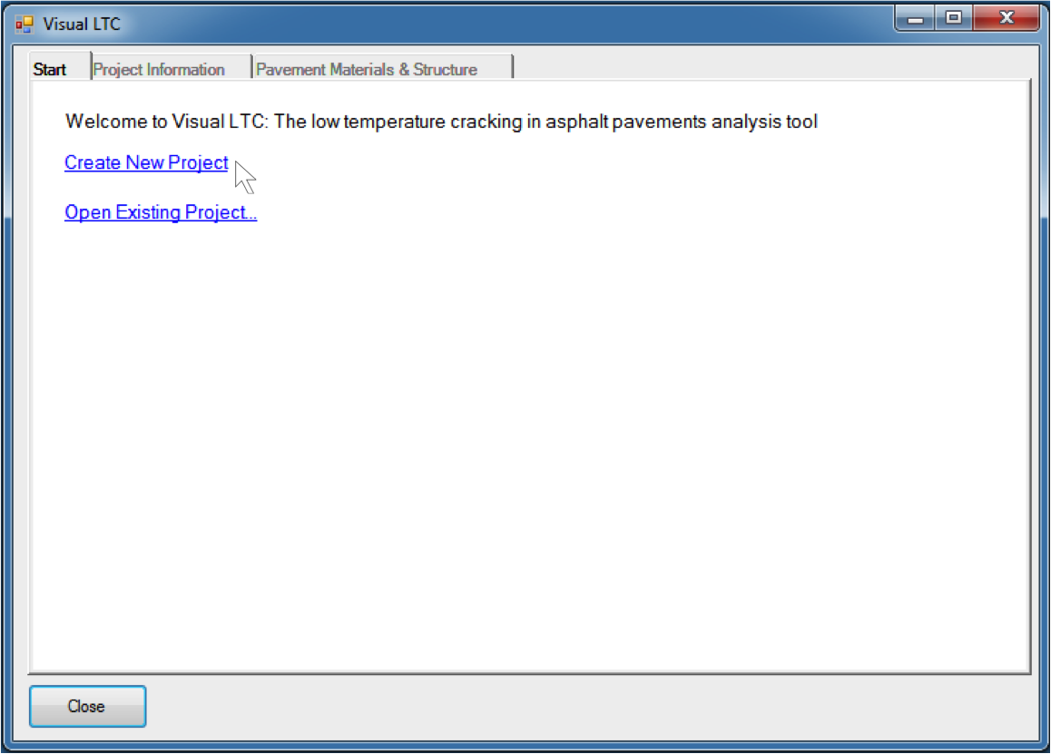
Figure A2. Start project: the user may either create and new project or open an existing project

In the following descriptions it is assumed that the user started a new project, so required fields are initially blank. If the user chose to start from an existing project, fields may be fully or partially completed. The next step is for the user to enter project information, as shown in Figure A3. The general information includes the project name, project description, analyzer, and date, all of which will be saved if the user chooses to save the project. The project location and analysis period are important pieces of information that will be fed to the finite element analysis engine. The project location is organized by state, then by zone. The locations are populated by the *.poly files in the climatic\ folder shown in Table A2. The user may plot the air temperatures of the selected location, shown in Figure A4.The analysis period can be entered either in number of years or specific dates. Hourly data for a five-year period is available for the provided locations. If the user chooses an analysis period of longer than five years the data is spliced together appropriately.

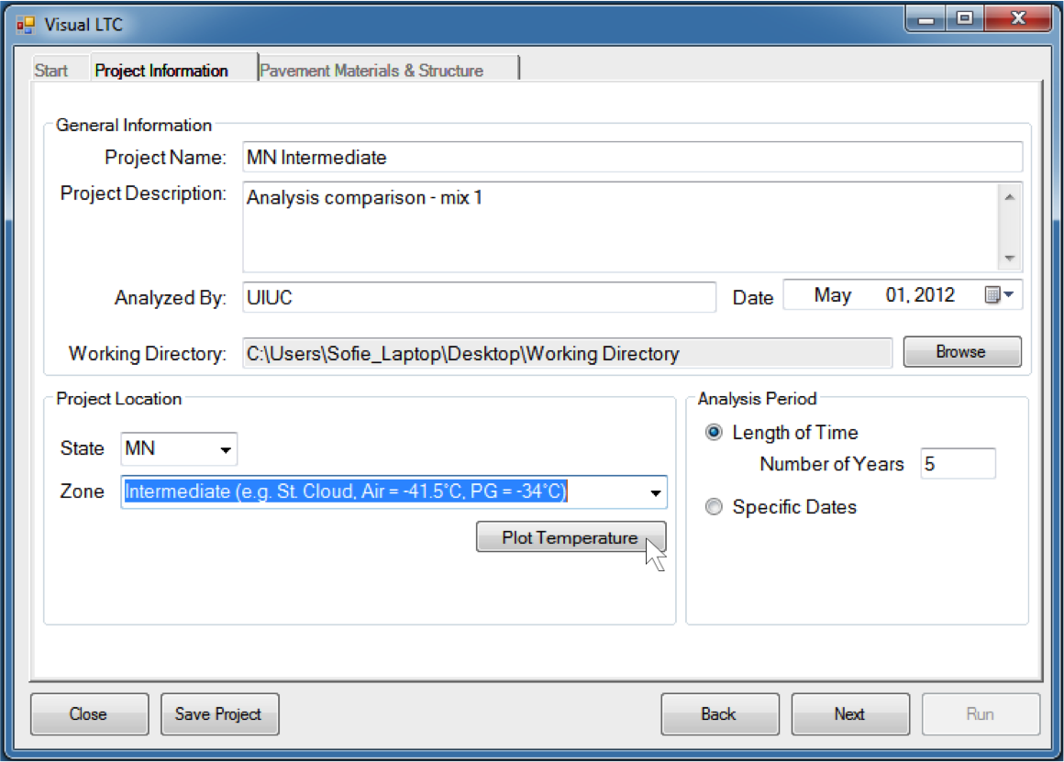
Figure A3. Project information

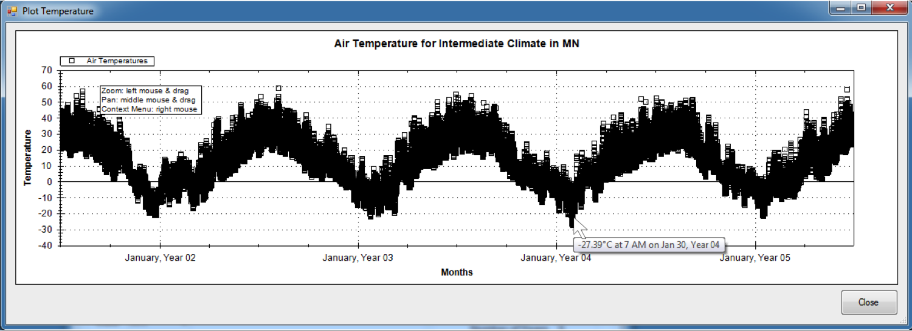
Figure A4. Plot of air temperatures

- Standard user features, reference to advanced user section
- Information shown during analysis run
- Plotted preanalyzer results
- Final result

The next set of user inputs describes the properties of the asphalt concrete layer. On the “Pavement Materials & Structure” tab, the user inserts the asphalt layer by clicking the button shown in Figure A5.

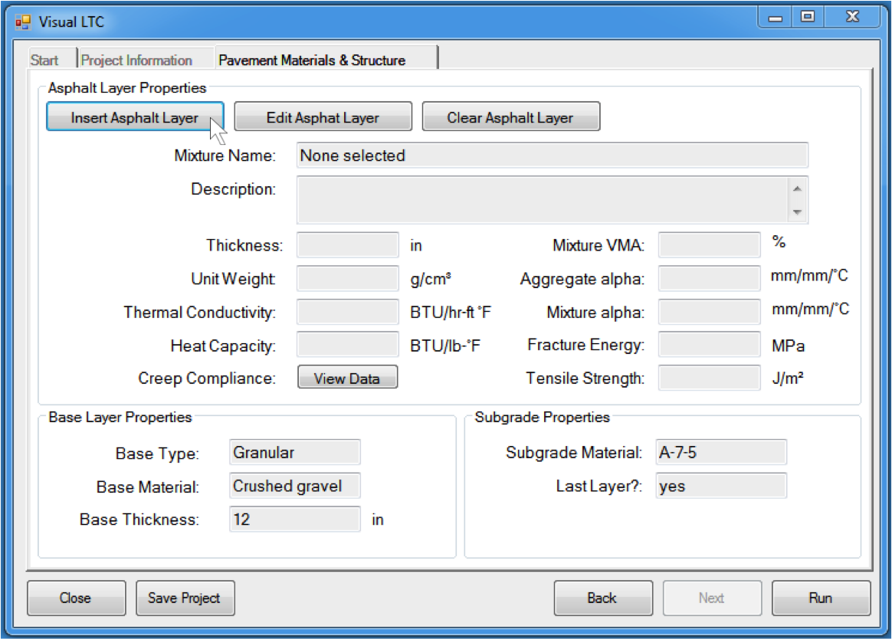
Figure A5. Pavement materials and structure: inserting the layer

One the “Add Asphalt Layer” screen the user may select from existing mixes that are present in the working directory, as shown in Figure A6, or he/she may import an mix (*.acinp file) if it is not located in the working directory. If no mixes are in the working directory the user may import a mix or add a new mix and enter the data manually. In order to create a new mix the user must select “Advanced User”. This option will be discussed in more detail in a later section.
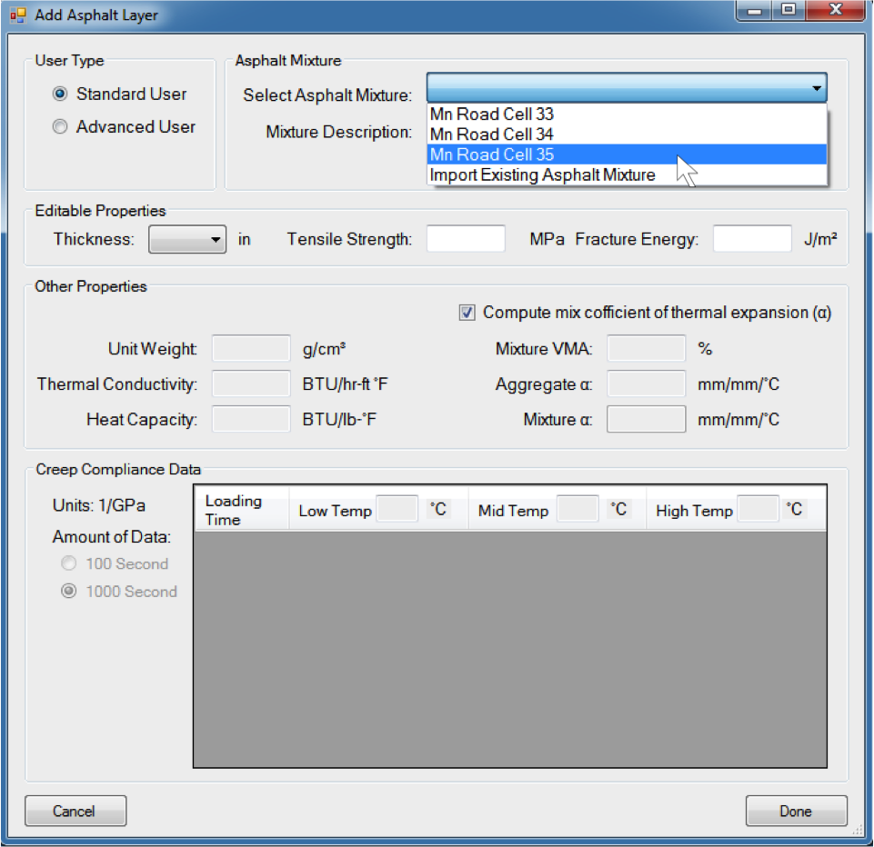
Figure A6. Add asphalt layer: selection of existing asphalt mix
When an existing mix is selected the material properties are populated. There are three editable properties available for the standard user: pavement thickness, tensile strength and fracture energy. All material properties are editable for the advanced user; see subsequent section for more information. The user selects the pavement thickness from a list of available thicknesses, as shown in Figure A7. The available thicknesses are determined by the *.poly files, because each file contains the temperature profile for a specific depth at a specific location.
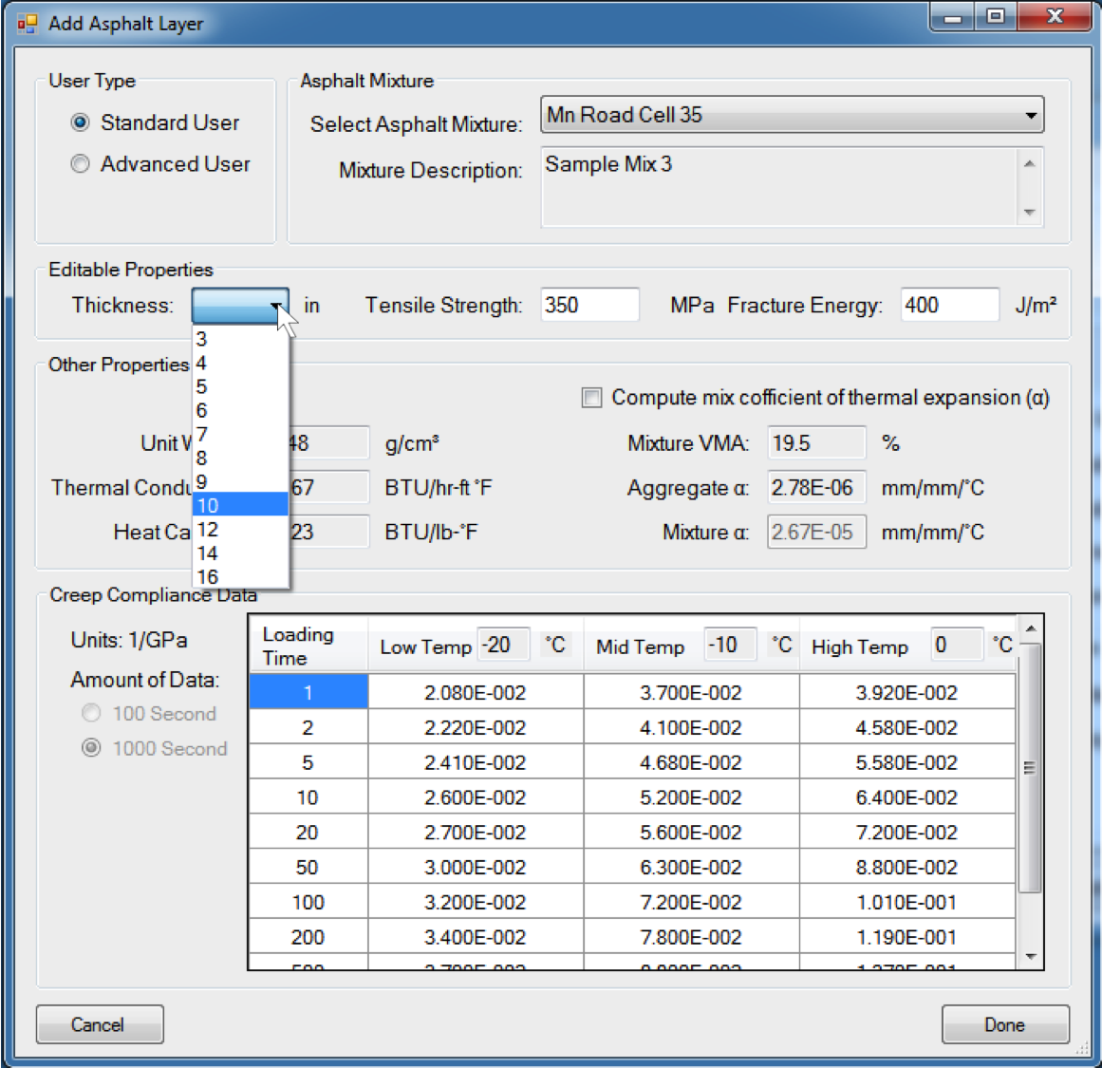
Figure A7. Add asphalt layer: selecting layer thickness

Once the asphalt properties are inserted, they summarized on the Pavement Materials & Structure page. The user can view the creep compliance data if needed, as shown in Figure A8. The user also has the option of editing or clearing the layer properties.

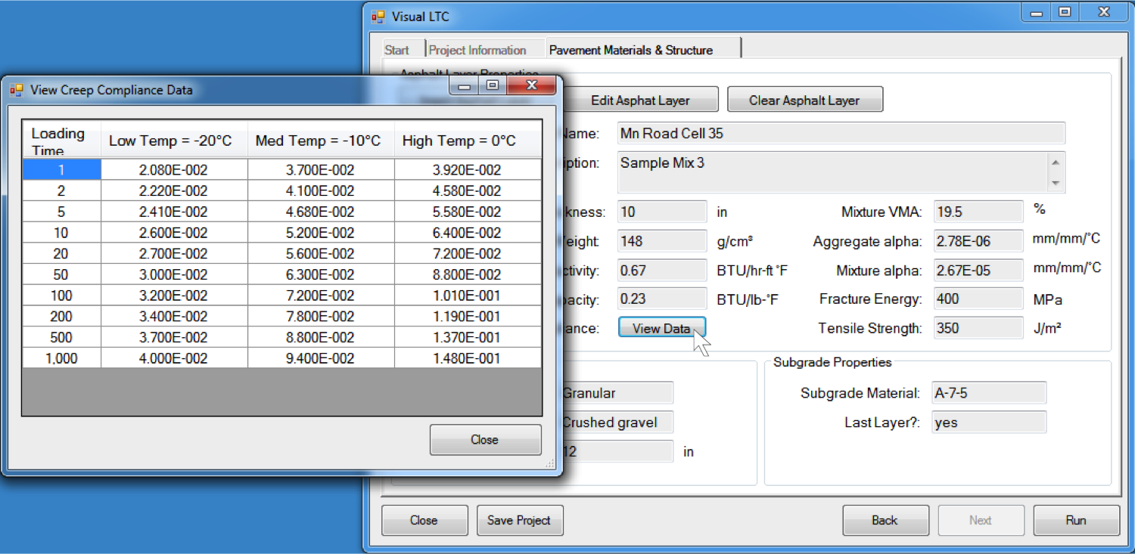
Figure A8. Summary of asphalt layer material properties

Now, the analysis is ready to be executed, and the user selected the “Run” button. The analysis modules run in the background and the user sees an update of the processes that are completed and in progress, as shown in Figure A9.

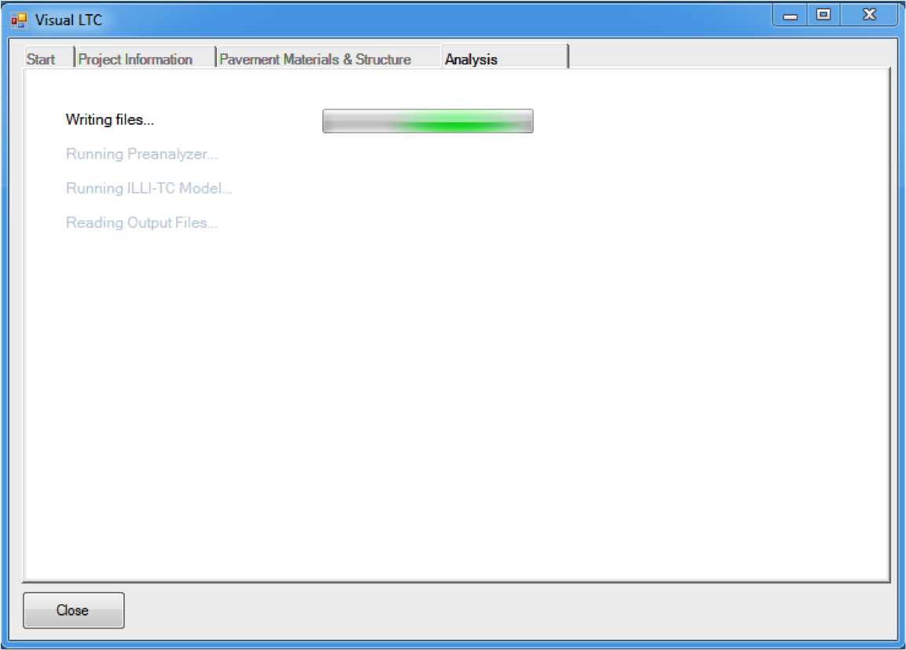
Figure A9. Analysis running

After the preanalyzer runs, the results appear on the screen for the user to view, as shown in Figure A10. The preanalyzer identifies critical events that then get analyzed by the finite element analysis engine. The user can choose to stop or continue with the analysis. If no selection is made within 30 seconds the analysis continues.

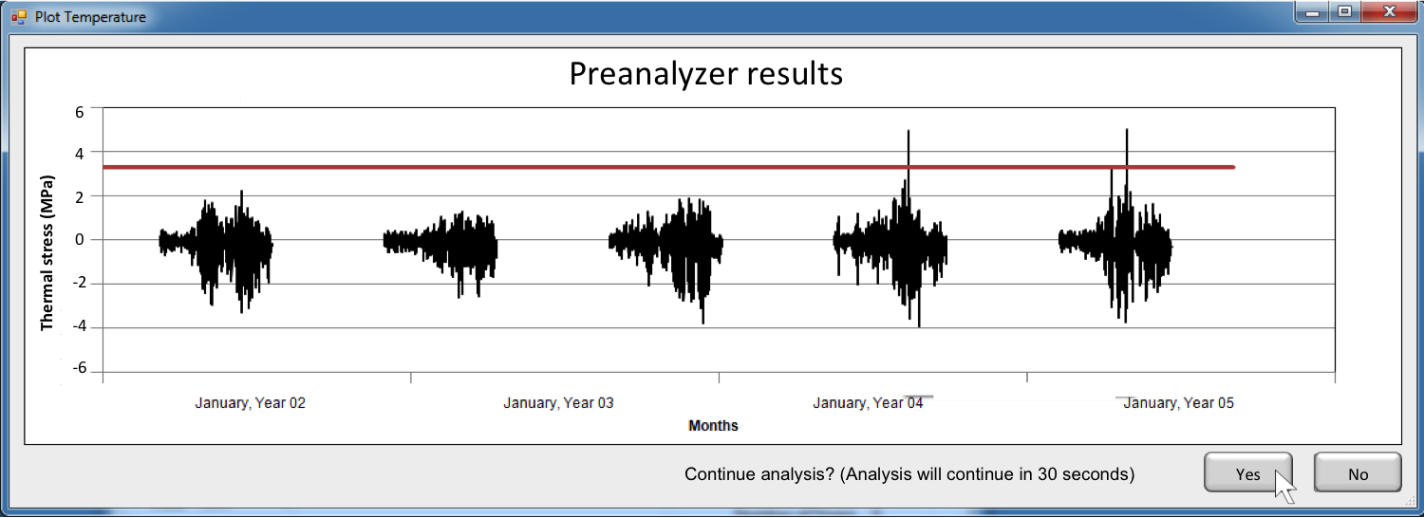
Figure A10. Preanalyzer results

The results of the full analysis are shown to the user is a simple window, containing the number of months simulated, the number of months completed, and the amount of cracking at the end of the simulation. As sample result screen is shown in Figure A11. The user has the option of saving the results to a text file.

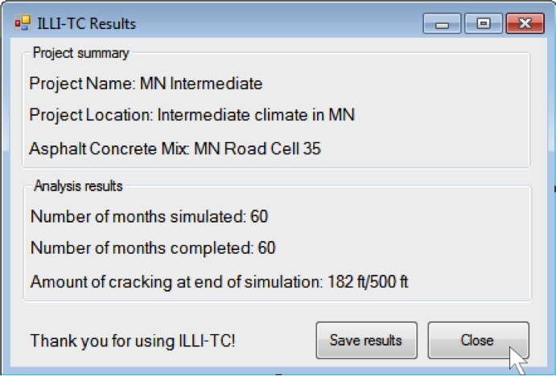
Figure A11. ILLI-TC results

Changing user type

Advanced Users have the additional capability of adding new asphalt mixes and modifying properties of existing asphalt mixes. The user can easily change from one user type to the other, and assumes the responsibility of entering consistent data. Figure A12 the option for the user to toggle between type “Standard User” and “Advanced User”. Notice that all of the material properties are editable for the advanced. If the advanced user modifies a mix, he/she will be prompted to save the mix for future Visual LTC runs. As advanced user, the “Select Asphalt Mixture” dropdown box also has the option to create a new mix. The new mix can also be saved for future runs.

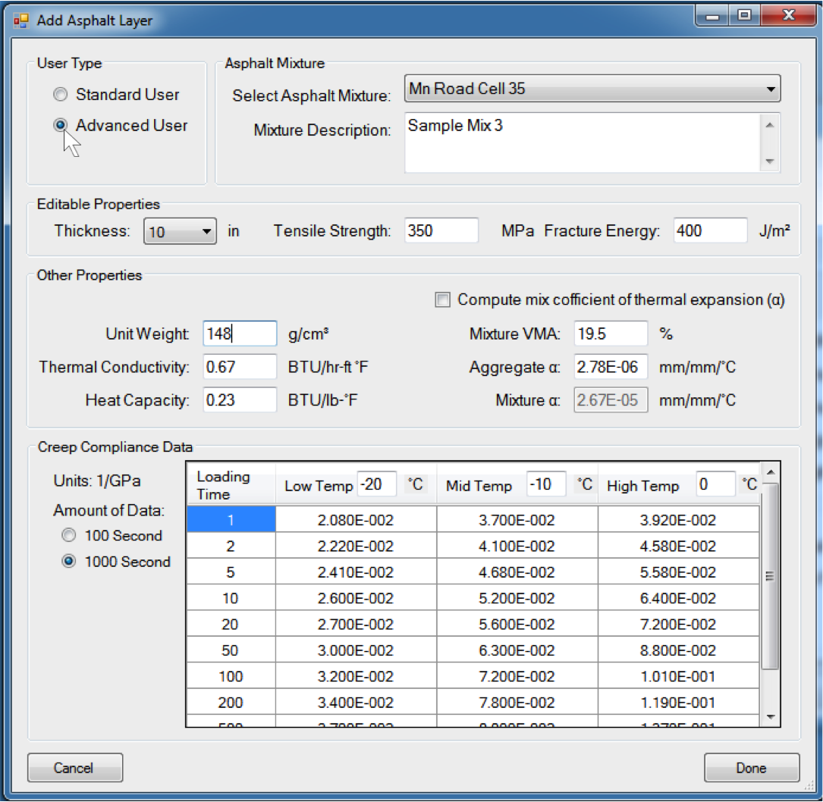
Figure A12. Advanced user type. As an advanced user, all material properties become editable and there is the option to create a new mix.

Saving Visual LTC projects and mixes

The user may save the current project, as shown in Figure A13. The project will be written to a text file with the *.prj extension. During a new Visual LTC run, the user may open this project instead of creating a new one.

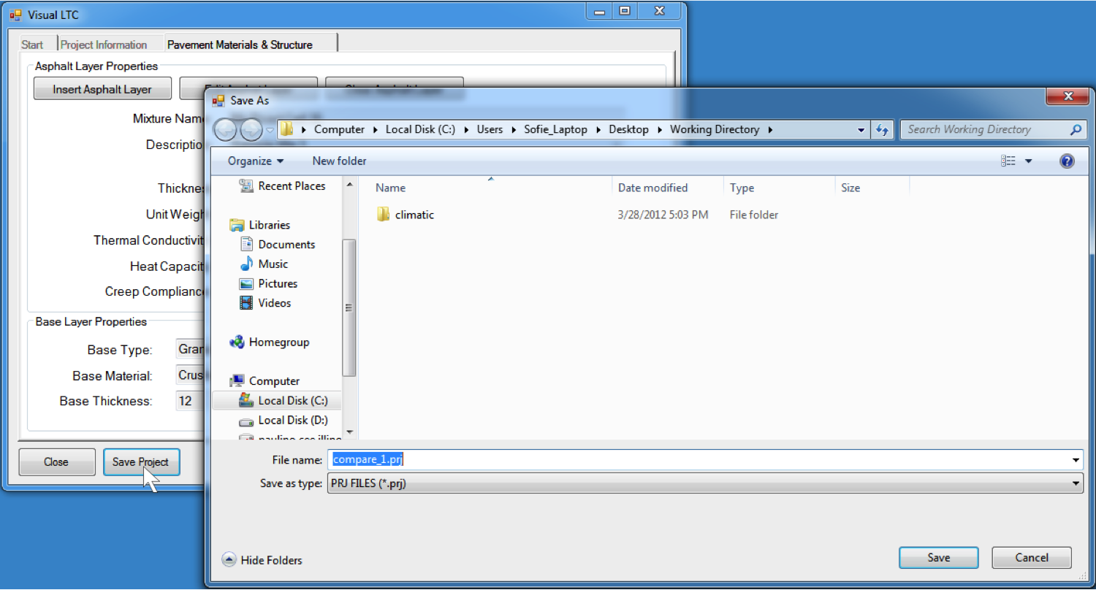
Figure A13. Save project

If the user adds a new mix or modifies an existing mix as an Advanced User (see previous section), he/she may save that mix for use in future Visual LTC runs. The use is automatically prompted to save a new or modified mix by Visual LTC. The mix is saved as a text file with the *.acinp extension.

Warnings and errors during analysis

Visual LTC is equipped with several error checks and warns the user appropriately for potential problems. Warnings may occur during analysis, in which case Visual LTC collects the information from the appropriate analysis module, reports the error to the user, and allows the user to decide how to proceed. One such example is shown in Figure A14. In this case, the Master analysis module is going to override an existing file. Visual LTC alerts the user and allows him/her to handle the problem accordingly.

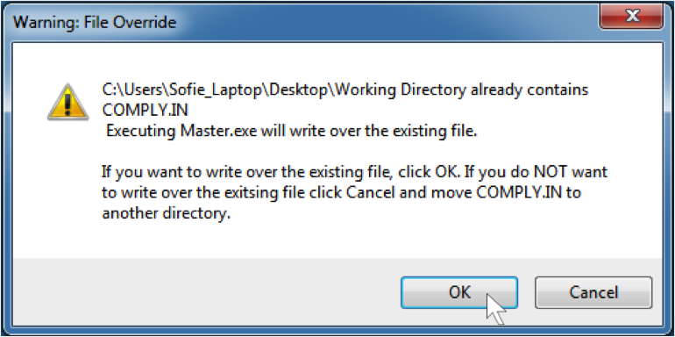
Figure A14. Typical warning screen for writing over existing files

