TRANSPORTATION POOLED FUND PROGRAM
QUARTERLY PROGRESS REPORT

Lead Agency (FHWA or State DOT): _____Minnesota Department of Transportation________

INSTRUCTIONS:
Project Managers and/or research project investigators should complete a quarterly progress report for each calendar quarter during which the projects are active. Please provide a project schedule status of the research activities tied to each task that is defined in the proposal; a percentage completion of each task; a concise discussion (2 or 3 sentences) of the current status, including accomplishments and problems encountered, if any. List all tasks, even if no work was done during this period.

Transportation Pooled Fund Program Project #  (i.e, SPR-2(XXX), SPR-3(XXX) or TPF-5(XXX)  TPF 153 |  | Transportation Pooled Fund Program - Report Period:  Quarter 1 (January 1 – March 31)  Quarter 2 (April 1 – June 30)  Quarter 3 (July 1 – September 30)  XQuarter 4 (October 1 – December 31)
Project Title:
Optimal Timing of Preventive Maintenance for Addressing Environmental Aging in HMA Pavements (MnROAD Study)

Name of Project Manager(s):  Thomas J. Wood | Phone Number:  651/366/5573 |  | E-Mail  thomas.wood@state.mn.us
Lead Agency Project ID:  95099 | Other Project ID (i.e., contract #):  95099 |  | Project Start Date:  March 31, 2010
Original Project End Date:  11/30/2013 | Current Project End Date:  11/30/2014 |  | Number of Extensions:  One

Project schedule status:
On schedule X On revised schedule □ Ahead of schedule □ Behind schedule

Overall Project Statistics:
Total Project Budget | Total Cost to Date for Project | Percentage of Work  Completed to Date
$482,205.00 | $279,208.42 | 54.9%

Quarterly Project Statistics:
Total Project Expenses  and Percentage This Quarter | Total Amount of Funds  Expended This Quarter | Total Percentage of  Time Used to Date
0% | $177,087.49 as of 10/31/13

Project Description:

The goal of this study is to determine the proper timing of preventive maintenance treatments in order to optimize life cycle costs and pavement performance. Environmental aging of the asphalt binder in the underlying pavement is not well understood, and this project will seek to better understand the aging mechanism and how it can be reduced through pavement preservation.

Progress this Quarter (includes meetings, work plan status, contract status, significant progress, etc.):

Request of one year no cost extension was submitted by Asphalt Institute and approved.
This extension will allowed the HMA on cell 24 to age another year. Cores taken and shipped for an additional round of testing from Cell 24 at MnROAD.

Mr. Andersen did a presentation at the annual MAAPT Conference December 11, 2013 on the finding. Here is one of the
Slides

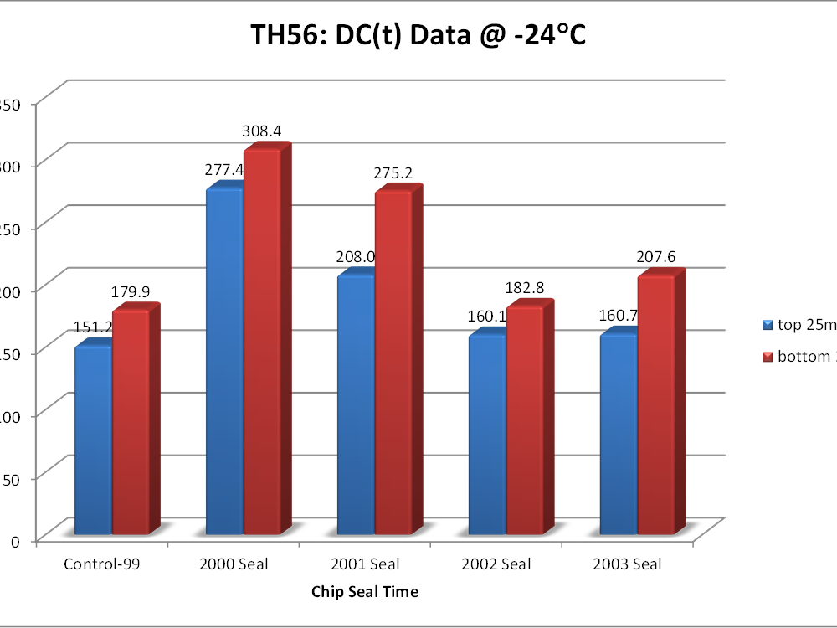

Anticipated work next quarter: Testing of cores taken 2013 working final report.

Significant Results:

The project plan has modified based on input from member states. Based on this input the Asphalt Institute (AI) is testing cores taken from test section last year and will be testing core take this year to determine the change in aging. Hopefully AI will have significant finding to report either in this quarter or early the next quarter.

Circumstance affecting project or budget. (Please describe any challenges encountered or anticipated that
might affect the completion of the project within the time, scope and fiscal constraints set forth in the
agreement, along with recommended solutions to those problems).
In order to allow Cell 24 to age one more year AI will need a one year extension at no cost to complete testing and
writing the final report including this year’s core data.

Potential Implementation:

Based on this research the States should be able to better plan when to do their pavement preventive maintenance treatment. This will allow them budget and plan to receive maximum benefit.

