12th Quarterly Progress Report to the

FEDERAL HIGHWAY ADMINISTRATION

(FHWA)

On the Project

THE IMPACT OF WIDE-BASE TIRES ON PAVEMENT DAMAGE

DTFH61-11-C-00025

For the Period

January 1 to March 31, 2014

Submitted by

Illinois Center for Transportation

University of Illinois at Urbana-Champaign



**QUARTERLY PROGRESS REPORT**

**QUARTER 12**

**The Impact of Wide-Base Tires on Pavement Damage – A National Study**

1. **Work Performed**

The following tasks were accomplished in this quarter:

* 77% and 83% of the finite element analysis of thick and thin pavements were run, respectively (see Appendix A).
* Indirect tensile creep testing for all pavement sections, including lab-compacted and field-extracted specimens, were performed per specifications under a temperature sweep condition using four replicates. The specification was extended to an additional testing temperature of 25oC to obtain material properties in accordance with the environmental conditions of FEM simulations, which will be used for validation purposes (see Appendix B).
* The disk-shaped compact tension (DCT) test was conducted on the first set of materials from UC-Davis. Cores extracted after construction were used to perform the test. Semi-circular beam (SCB) test was conducted on the Florida Test Track specimens and the results were analyzed. The specimens included three lifts of wearing surface with PG 76-22. Four replicates were tested for each lift (see Appendix C).
* Dynamic modulus test was performed on compacted samples prepared from a loose-mix collected during construction in Ohio (see Appendix D). The sample was prepared with special care to achieve an air void content of compacted specimens similar to that in the field.
* The initial version of the online user interface was completed. The user interface provides access to major databases including UIUC, Florida, UC-Davis and Ohio.

1. **Work to Be Accomplished in the Next Quarter**

* Finalize the User Interface
* Conclude laboratory testing of materials from all sections
* Complete finite element analysis of all cases
* Initiate the validation task and neural network task

1. **Problems Encountered**

* No issues were encountered in this quarter

1. **Current and Cumulative Expenditures**

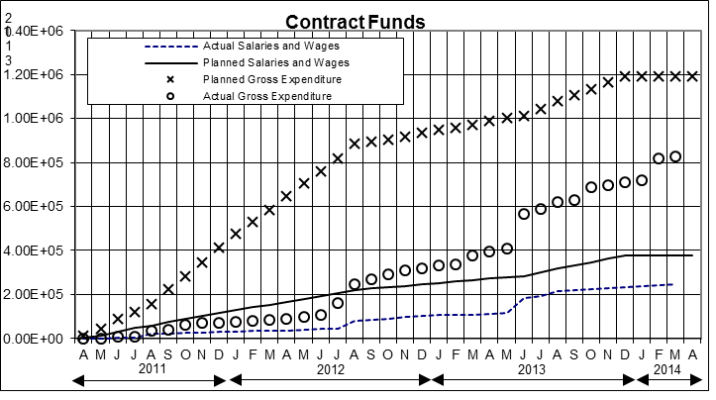

Figure . Project’s expenditure.

1. **Planned, Actual, and Cumulative Percentage of Effort**
2. 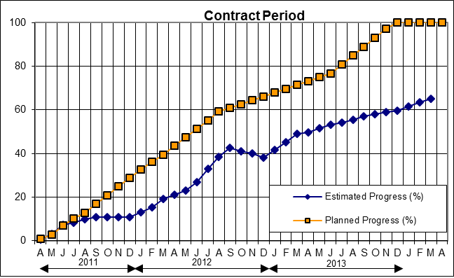

Figure . Project’s progress.

**APPENDIX A**

**FINITE ELEMENT ANALYSIS**

The status of the finite element modeling for thick and thin pavements is shown in Table A- 1 and Table A- 2, respectively. The green-highlighted cells indicate completed analyses. The first column lists the pavement structures considered for factorial 12 loading cases (L1-L12).

Table A- . Status of Thick Pavement Cases

|  |  |  |  |  |  |  |  |  |  |  |  |  |
| --- | --- | --- | --- | --- | --- | --- | --- | --- | --- | --- | --- | --- |
| **Thick** | **LOAD CASE** | | | | | | | | | | | |
| **WBT** | | | | | **DTA** | | | | | | |
| **L1** | **L2** | **L3** | **L4** | **L11** | **L5** | **L6** | **L7** | **L8** | **L9** | **L10** | **L12** |
| **AC125W_B150W** | 3 | 3 | 3 | 3 | 3 | 3 | 3 | 3 | 3 | 3 | 3 | 3 |
| **AC125W_B150S** | 3 | 3 | 3 | 3 | 3 | 3 | 3 | 3 | 3 | 3 | 3 | 3 |
| **AC125S_B150W** | 3 | 3 | 3 | 3 | 3 | 3 | 3 | 3 | 3 | 3 | 3 | 3 |
| **AC125S_B150S** | 3 | 3 | 3 | 3 | 3 | 3 | 3 | 3 | 3 | 3 | 3 | 3 |
| **AC125W_B600W** | 3 | 3 | 3 | 3 | 3 | 3 | 3 | 3 | 3 | 3 | 3 | 3 |
| **AC125W_B600S** | 3 | 3 | 3 | 3 | 3 | 3 | 3 | 3 | 3 | 3 | 3 | 3 |
| **AC125S_B600W** | 3 | 3 | 3 | 3 | 3 | 3 | 3 | 3 | 3 | 3 | 3 | 3 |
| **AC125S_B600S** | 3 | 3 | 3 | 3 | 3 | 3 | 3 | 3 | 3 | 3 | 3 | 3 |
| **AC412W_B150W** | 3 | 3 | 3 | 3 | 3 | 3 | 3 | 3 | 3 | 3 | 3 | 3 |
| **AC412W_B150S** |  |  |  |  |  |  |  |  |  |  |  |  |
| **AC412S_B150W** |  |  |  |  |  |  |  |  |  |  |  |  |
| **AC412S_B150S** | 3 | 3 | 3 | 3 | 3 | 3 | 3 | 3 | 3 | 3 | 3 | 3 |
| **AC412W_B600W** | 3 | 3 | 3 | 3 | 3 | 3 | 3 | 3 | 3 | 3 | 3 | 3 |
| **AC412W_B600S** |  |  |  |  |  |  |  |  |  |  |  |  |
| **AC412S_B600W** |  |  |  |  |  |  |  |  |  |  |  |  |
| **AC412S_B600S** | 3 | 3 | 3 | 3 | 3 | 3 | 3 | 3 | 3 | 3 | 3 | 3 |

Table A- . FEM Status for Thick Pavements



**APPENDIX B**

**CREEP COMPLIANCE DETERMINATION USING INDIRECT TENSILE TEST**

To characterize linear viscoelastic material properties of asphalt concrete (AC) layers for field test sections, the AASHTO T322-07 standard method, “Determining Creep Compliance and Strength of Hot Mix Asphalt (HMA) Using Indirect Tensile (IDT) Test Device,” is followed. The tensile creep is quantified by applying a static load at a constant magnitude along the diametral axis of the specimen. Deformations in the horizontal and vertical directions are directly measured near the center of the specimen to promote relatively constant stress fields and minimize boundary effects. These measurements are then used to determine the tensile creep compliance as a function of time. Accordingly, the applied load is carefully chosen to generate horizontal strains within the linear viscoelastic range during the entire test duration.

Generally, specimens are prepared with a height of 38 to 50 mm and a diameter of 150 ± 9 mm. Specimens collected from the Ohio test sections had a standard size similar to the specimens prepared from loose mixtures obtained during construction in September 2012. On the other hand, field cores were obtained from the test sections in California and Florida. Because of varying AC layer thicknesses, the standard test specimen height could not be followed. Therefore, the field specimens were not altered and were tested with the geometry as received.

Proper conditioning was conducted at -20, -10 and 0oC per the specification. However, in order to validate the finite element (FE) models with field data, IDT creep testing was also performed at 25oC, which corresponds to the FE model temperature field. As illustrated in Figure A- 1, a compressive load was applied to the specimen, and deformations in the horizontal and vertical directions on the two sawn, parallel faces of the specimens were measured using four extensometers. Four replicates were prepared per material for all test sections, and a temperature sweep, initiating at the lowest temperature, was applied.

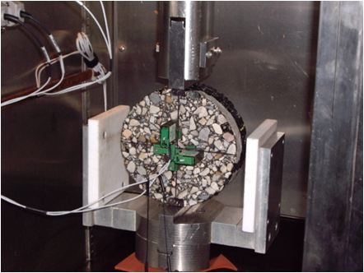

Figure A- 1. IDT test setup.

The test matrix for the IDT creep testing was completed, and a full analysis of the generated data is being completed. A sample master creep compliance curve is shown below.

Figure A- 2. Master compliance curve

**APPENDIX C**

**DISK-SHAPED COMPACT TENSION AND SEMI-CIRCULAR BEAM TEST RESULTS SAMPLE**

The following figure shows a sample of load vs CMOD results for lift B in Florida. In addition, Table C- 1 presents a summary of fracture energy results for all lifts based on SCB test.

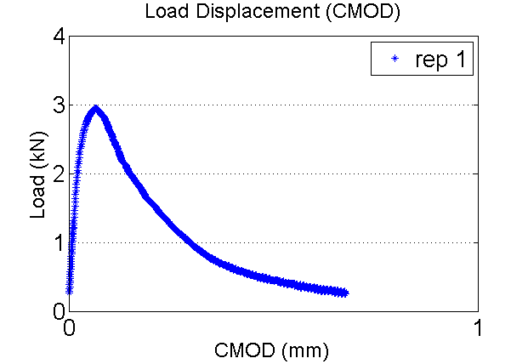

Figure C- . Sample of load vs CMOD results.

Table C- . Summary of Fracture Energy Results

|  |  |  |  |  |
| --- | --- | --- | --- | --- |
| **Lift** | **Test Temperature (C)** | **Average Ligament Length (mm)** | **Average Thickness (mm)** | **Average CMOD/ Fracture Area (N/m)** |
| 1-in 4.75mm (PG 76-22) | -12 | 58.1 | 27.4 | 565.9 |
| 1.5 -n SP12.5 (PG 76-22) | -12 | 58.8 | 34.9 | 1104.6 |
| 1.5-in SP12.5 (PG 76-22) | -12 | 58.8 | 46.4 | 804.0 |

The SCB test was also performed on UC-Davis specimens. The specimens included one lift of wearing surface with 15% RAP. Four replicates were run. Figure C- 2 and Table C- 2 show the CMOD test result and the fracture energy, respectively.

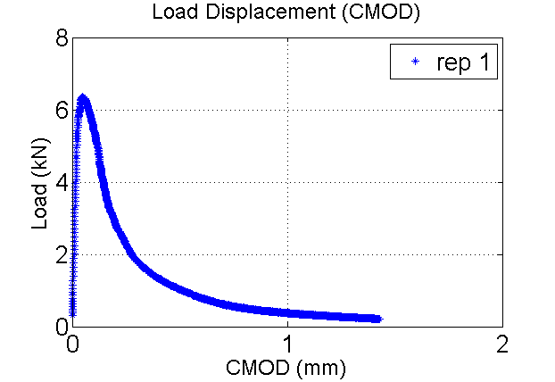

Figure C- . Sample of SCB results for UC-Davis.

Table C- . Fracture Energy Results

|  |  |  |  |  |
| --- | --- | --- | --- | --- |
| **Lift** | **Test Temperature (C)** | **Average Ligament Length (mm)** | **Average Thickness (mm)** | **Average CMOD/ Fracture Area (N/m)** |
| 60 mm HMA, 15% RAP | -6 | 59.1 | 51.1 | 788.8 |

**APPENDIX D**

**DYNAMIC MODULUS TEST RESULTS**

The dynamic modulus test was performed on compacted samples prepared from loose-mix collected during the construction of the instrumented pavement sections in Delaware, Ohio. Four specimens were tested for each of the four materials following AASHTO TP 62 Dynamic Modulus Test. Figure D- 1 presents the obtained master curve for the materials used during construction in Ohio.

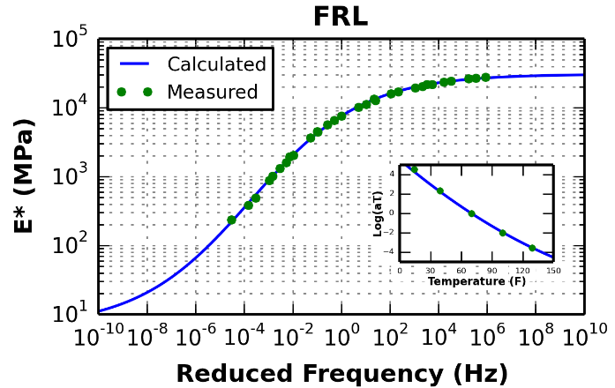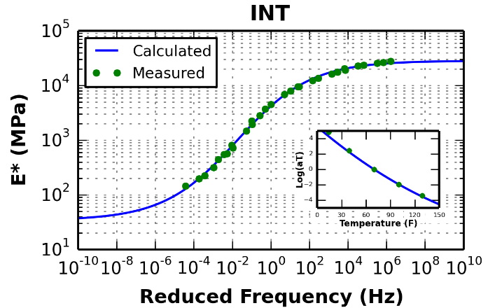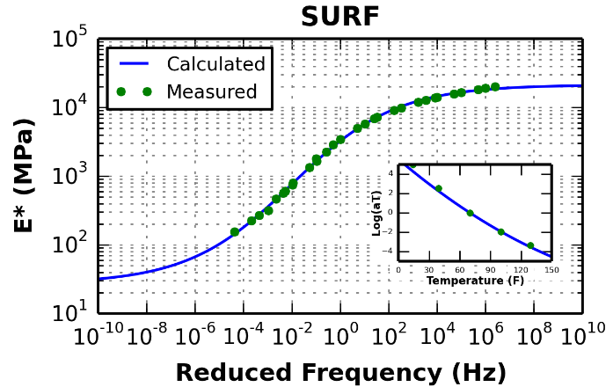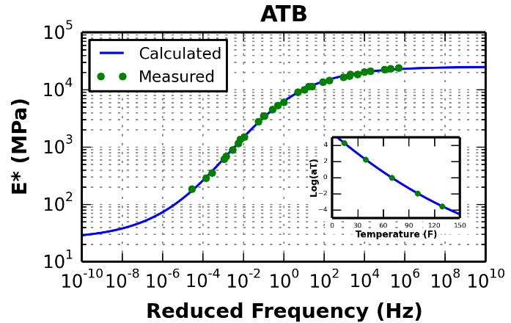

Figure D- . Dynamic modulus master curve for Ohio materials.