TRANSPORTATION POOLED FUND PROGRAM
QUARTERLY PROGRESS REPORT

Lead Agency: ---- Utah Department of Transportation ----

INSTRUCTIONS:
Project Managers and/or research project investigators should complete a quarterly progress report for each calendar quarter during which the projects are active. Please provide a project schedule status of the research activities tied to each task that is defined in the proposal; a percentage completion of each task; a concise discussion (2 or 3 sentences) of the current status, including accomplishments and problems encountered, if any. List all tasks, even if no work was done during this period.

Transportation Pooled Fund Program Project #  (TPF-5(257) |  | Transportation Pooled Fund Program - Report Period:  _ Quarter 1 (January 1 – March 31)  _X Quarter 2 (April 1 – June 30)  _ Quarter 3 (July 1 – September 30)  _Quarter 4 (October 1 – December 31)

Project Title: Evaluation of Spliced Sleeve Connections for Precast RC Bridge Piers

Name of Project Manager(s):  Russ Scovil | Phone Number:  801.965.4097 office  801.870.4665 cell |  | E-Mail  Rgscovil@utah.gov
Lead Agency Project ID:  5H06604H, UT11.502 | Other Project ID (i.e., contract #):  12-8775 |  | Project Start Date:  3/23/2012
Original Project End Date:  3/30/2013 | Current Project End Date:  3/30/2013 |  | Number of Extensions:  1

Project schedule status:

_ On schedule X_ On revised schedule _ Ahead of schedule _ Behind schedule

Overall Project Statistics:
Total Project Budget | Total Cost to Date for Project | Percentage of Work  Completed to Date
$175,848.00 | $37,800.00 | 21%

Quarterly Project Statistics:
Total Project Expenses  and Percentage This Quarter | Total Amount of Funds  Expended This Quarter | Total Percentage of  Time Used to Date
$20,216.00, 11% | $20,216.00 | 20%

Project Description:

The splice sleeve connection is being considered as the method of choice for connecting precast concrete bridge elements. The purpose of this project is to perform experiments to evaluate the performance of the splice sleeve connection between a reinforced concrete square bridge column and a bridge footing (Type I) or a reinforced concrete square bridge column and a bridge cap beam (Type II) in a seismic setting. This information is very valuable for construction of bridges using Accelerated Bridge Construction in areas with seismic activity.

The present proposal aims at performing cyclic tests to verify the capacity of the splice sleeve connection in seismic regions for connecting precast elements such as footings and columns or columns and cap beams.
The splice sleeve connection is being considered as the method of choice for connecting precast concrete bridge elements. The purpose of this proposal is to perform experiments to evaluate the performance of the splice sleeve connection between a reinforced concrete square bridge column and a bridge footing (Type I) or a reinforced concrete square bridge column and a bridge cap beam (Type II) in a seismic setting. This information is very valuable for construction of bridges using Accelerated Bridge Construction in areas with seismic activity.

Progress this Quarter (includes meetings, work plan status, contract status, significant progress, etc.):

This quarter the project was focused on building the precast concrete column and footing for the NMB splice connection (Type I), as well as the precast concrete column and bent cap for the Lenton Interlock connection (Type II). The steel has been delivered for six specimens (two NMB specimens and two Lenton Interlock specimens as well as two controls). The plan is to carry out these six tests and depending on the results, construct and test two more specimens. The steel cages for the NMB splice connection and footing have been built. In addition, strain gauge instrumentation for the NMB splice connection specimens has been applied, as well as threaded rods for the displacement transducers.

Figure 1 shows a picture of the column with the NMB splice sleeve connectors, and Figure 2 shows the corresponding footing. We are currently building the column for the Lenton Interlock connection, as shown in Figure 3. In addition, the actuator for applying the axial load in the columns has been serviced and calibrated.

Moreover, the data acquisition system has been upgraded to handle 40 electrical strain gauges and 24 displacement transducers.

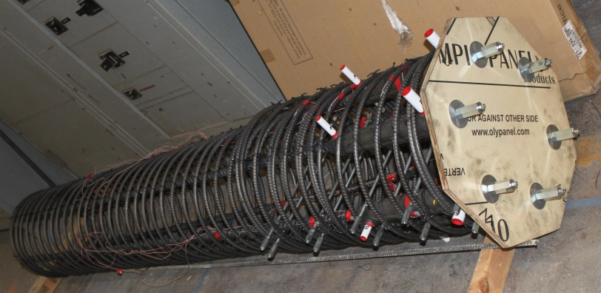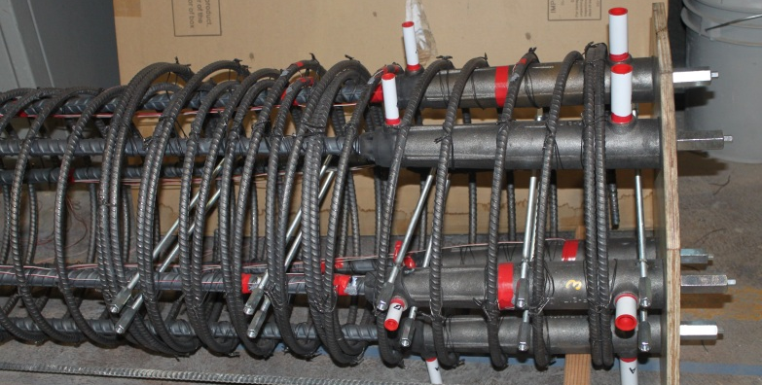

Figure 1. Column reinforcement with six NMB splice sleeve connectors.

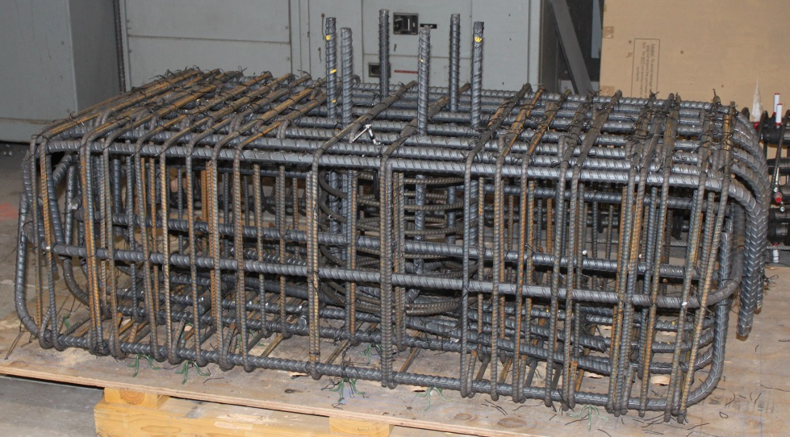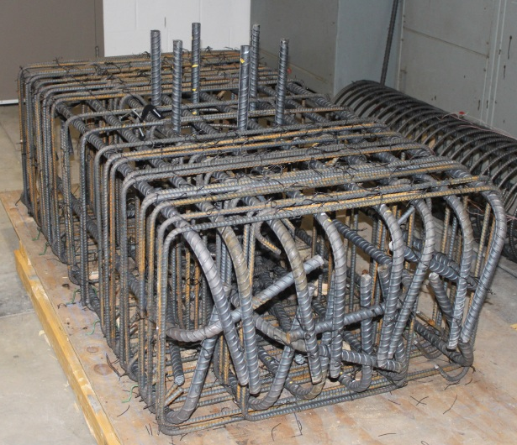

Figure 2. Footing reinforcement for six NMB splice sleeve connectors.

Figure 3. Column reinforcement with six Lenton Interlock connectors.

Anticipated work next quarter:

It is anticipated that in Quarter 3, the precast concrete column, footing, and cap beam will be built. It is also anticipated that the setup for the lateral load tests of the subassemblies will be in place. We are expecting that the first two tests will be carried out during October 2012.

Significant Results:

There are no results to report at the present time.

Circumstance affecting project or budget. (Please describe any challenges encountered or anticipated that
might affect the completion of the project within the time, scope and fiscal constraints set forth in the
agreement, along with recommended solutions to those problems).

None.

Potential Implementation:

It is anticipated the Utah DOT will implement the findings of this research once it is completed in Accelerated
Bridge Construction (ABC). It is likely that the New York State Department of Transportation and the Texas Department of Transportation will be able to implement them too.

