TRANSPORTATION POOLED FUND PROGRAM
QUARTERLY PROGRESS REPORT

Lead Agency: Utah Department of Transportation

INSTRUCTIONS:
Project Managers and/or research project investigators should complete a quarterly progress report for each calendar quarter during which the projects are active. Please provide a project schedule status of the research activities tied to each task that is defined in the proposal; a percentage completion of each task; a concise discussion (2 or 3 sentences) of the current status, including accomplishments and problems encountered, if any. List all tasks, even if no work was done during this period.

Transportation Pooled Fund Program Project #  TPF-5(244) |  | Transportation Pooled Fund Program - Report Period:  _ Quarter 1 (January 1 – March 31, 2015)  x Quarter 2 (April 1 – June 30, 2015)  _ Quarter 3 (July 1 – September 30, 2015)  _ Quarter 4 (October 1 – December 31, 2015)
Project Title:
Shaking Table Testing to Evaluate Effectiveness of Vertical Drains for Liquefaction Mitigation

Name of Project Manager(s):  David Stevens | Phone Number:  801-589-8340 |  | E-Mail  davidstevens@utah.gov
Lead Agency Project ID:  FINET 42046, ePM PIN 9933  UDOT PIC No. UT07.708 | Other Project ID (i.e., contract #):  UDOT Contract No. 138731 |  | Project Start Date:  May 1, 2013
Original Project End Date:  March 31, 2016 | Current Project End Date:  March 31, 2016 |  | Number of Extensions:

Project schedule status:

_ On schedule X On revised schedule _ Ahead of schedule _ Behind schedule

Overall Project Statistics:
Total Project Budget | Total Cost to Date for Project | Percentage of Work  Completed to Date
$115,000.00 | $23,250.00 | 40%

Quarterly Project Statistics:
Total Project Expenses  and Percentage This Quarter | Total Amount of Funds  Expended This Quarter | Total Percentage of  Time Used to Date
0% | $0 | 70%

Project Description:

The vision for this study is to determine the viability of large diameter (100 mm) prefabricated vertical drains for preventing liquefaction and associated settlements or lateral spreading under full-scale conditions. If viable, drainage alternatives offer substantial advantages in comparison to conventional densification approaches. In production, drains can often be installed at 25% to 40% of the cost of stone columns. In addition, the drains can be installed in about one-third to one-half of the time required for stone columns. Finally, the time and cost associated with post-treatment in-situ testing to evaluate improvement produced by densification may not be required with drains. In an era when construction budgets are becoming increasingly tight and projects are increasingly placed on fast-track schedules, innovative alternative solutions are required to deal with liquefaction hazards.

Although limited blast liquefaction testing (Rollins et al. 2003, Rollins et al. 2004), vibration testing (Chang et al. 2004) and centrifuge testing (Yang et al. 2004 ) suggest that vertical drains can be effective, no full-scale drain installation has been subjected to earthquake induced ground motions. This lack of performance data under full-scale conditions has been a major impediment to expanding the use of this technique. To remedy this problem we will conduct full-scale tests with vertical drains in liquefiable sand using the laminar shear box and high speed actuator system at NEES-Univ. at Buffalo. Tests will involve level ground conditions with two drain spacings and will be integrated with a previously funded NEESR study currently underway so that the control tests without drains will already be available. We will use the same sand installation techniques, as well as the same instrumentation plan and shaking protocols which have already been developed and proven successful. This collaborative approach will significantly reduce the cost of the study in comparison to a completely independent study. In addition, it will provide a comparison between the performance of the soil profile with drains relative to subsequent tests where piles will be involved. If full-scale tests prove the effectiveness of the drainage technique, significant time and costs savings can be achieved for both new construction and for retrofit situations.

Three objectives are outlined for this study:
1. Evaluate the ability of earthquake drains to reduce excess pore pressure and settlement for level ground conditions at progressively higher acceleration levels.
2. Define the influence of drain spacing on the effectiveness of the drains for mitigating liquefaction hazard.
3. Provide well-documented case histories which can be used to calibrate/validate numerical models for predicting the performance of vertical drains.

The scope of work consists of eight specific tasks:
1. Perform a literature review to summarize the state of the art in the area of liquefaction mitigation through drainage.
2. Conduct level ground shaking table tests with drains at 4 ft spacing.
3. Conduct level ground shaking table tests with drains at 3 ft spacing.
4. Reduce the test data, analyze, and compare with previous test on untreated sand.
5. Evaluate predictive methods by comparing measured behavior with behavior computed using computer models and simplified models.
6. Prepare a final report on effectiveness of the drain technique.
7. Disseminate the research results.
8. Hold technical advisory committee meetings.

Dr. Kyle Rollins of BYU is the Principal Investigator for this research project. The TPF-5(244) testing was performed at the SUNY-Buffalo shaking table testing facility in the summer of 2014. BYU was approved for shared-use status on the NEES-Buffalo shake table. Individual task reports will be prepared for Tasks 1 through 5 when these are completed. Up to two in-person meetings with the multi-state technical advisory committee (TAC) are planned to be held in Salt Lake City, Utah during the project. Other TAC meetings will be tele-conference or web meetings.

Progress this Quarter (includes meetings, work plan status, contract status, significant progress, etc.):

Task 1 – 100% complete.
Task 2 – 100% complete. The summary report for the task testing was shared with the TAC for their review.
Task 3 – 100% complete. The summary report for the task testing was shared with the TAC for their review.
Task 4 – 70% complete. BYU continued the test data reduction and analysis.
Task 5 – 20% complete. BYU continued evaluating predictive methods.
Task 6 – No work yet.
Task 7 – No work yet.
Task 8 – 30% complete. A web-conference TAC meeting was held on May 26. Kyle Rollins provided recent results from comparison and analysis of the shaking table test data. The group also discussed next steps.

Anticipated work next quarter:

Task 1 – None.
Task 2 – None.
Task 3 – None.
Task 4 – Continue with test data reduction and analysis. Prepare summary reports for this task.
Task 5 – Continue with evaluating predictive methods.
Task 6 – None.
Task 7 – None.
Task 8 – Plan to hold another TAC web-conference to review and discuss additional results from the study.

Significant Results:

During this quarter we have focused on preparing a summary report describing the test results from the laminar shear box testing (Task 4). Preliminary reports on the basic results were provided to the TAC members. In addition to the plots shown in the preliminary report, we have been developing plots of volumetric strain vs. depth from each test (0.05g, 0.10g, and 0.20g) for each of the three rounds of testing. Volumetric strain was calculated using settlement data obtained from the Sondex profilometers. Data was collected at intervals of approximately 2 feet. Strain was calculated at each Sondex measurement by taking half of the strain between that point and the one above it and half of the strain from between the same point and the point below it. Because the length and width of the box at all points remains the same, this strain is equal to the volumetric strain. Figure 1 through Figure 3 show the volumetric strain profiles for each round of testing. The strain calculated from both Sondex profilometers is included. Results from the Sondex profilometer located in the center of the box is shown on the left, while results from the profilometer located on the East end is shown on the right. Unfortunately, similar measurements were not made for the tests without drains so comparisons can’t be made.

The volumetric strain profiles tell us that the strain is apparently not uniform with depth as might have been anticipated. In general, strain tends to be greater near the surface for the tests at lower acceleration levels but increases at greater depths as the acceleration increases. Of course, strain in subsequent tests is likely affected by settlement from the previous tests which leads to a denser soil. In general the strain level decreases with each round of testing as the sand densifies. Some additional effort at smoothing the results may be necessary to account for aberrations in the measurements which may lead to some negative strain values.

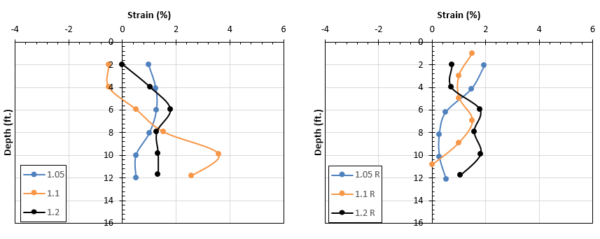
Figure 1. Profiles of volumetric strain versus depth using Sondex measurements for round 1
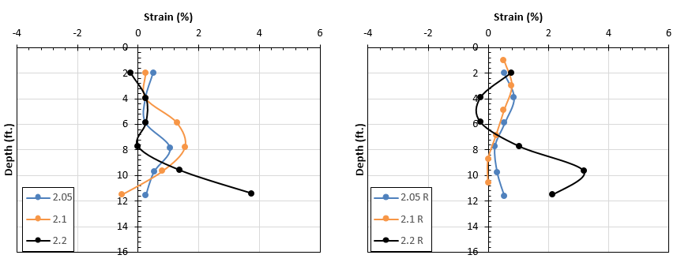
Figure 2. Profiles of volumetric strain versus depth using Sondex measurements for round 2
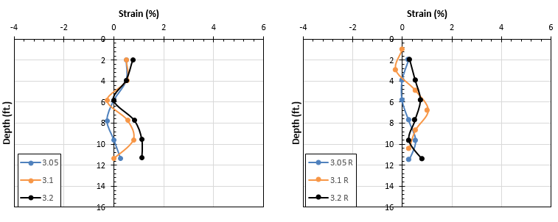
Figure 3. Profiles of volumetric strain versus depth using Sondex measurements for round 3

Circumstance affecting project or budget. (Please describe any challenges encountered or anticipated that
might affect the completion of the project within the time, scope and fiscal constraints set forth in the
agreement, along with recommended solutions to those problems).

Some testing tasks and associated analysis have taken longer to complete than originally planned. However, it is anticipated that the project tasks and deliverables will be completed within the original contract period.

Potential Implementation:

