Click here to enter Program or Project Title
Progress Report – Click here to enter a date.

Title: Assessment and Repair of Prestressed Bridge Girders Subjected to Over-height Truck Impacts Pooled Fund Project

Project Number: TR202011

Principal Investigator (PI): Mohamed ElGawady PhD (PI)
Co-PI(s): William Schonberg PhD, PE (Co-PI)

Award date: | 1/1/2021
Scheduled completion date: | 12/31/2023 | % of project completed to date: | 40%
Total budget: | $755,000 | % of budget expended to date: | 40%
Draft report due: | 9/30/2023 | Final report due: | 12/1/2023

Provide a short description of the work currently underway.
Use additional notes section if you need to provide more information.
Task 2. Experimental testing of bridge girders subjected to lateral impacts: All parts of the test setup arrived to the lab after several delays. The test setup is almost ready and the remaining part will be finalized this week. The last part is to bend the rail. Bending the rail during the last three weeks was quite challenging. A new high-power electrical saw was acquired and the trials for bending the rail were successful.
Fig. 1: (a) The test setup, and (b) bending the rail

The impact cart is being finalized as shown in Figures 2 through 4.
Fig. 2: An overview of the impact cart
Fig. 3: Preparing the impact cart axles
Fig. 4: Preparing the impact cart side and front beams

The data acquisition system is prepared to acquire the dynamic measurements. Strain gauges for the full-scale testing of the beams are prepared as well as shown in Figure 5.
Fig. 5: Preparing the impact cart axles

Provide a short description of the noteworthy activities/accomplishments during this reporting period.
Use additional notes section if you need to provide more information.
Task 2. Experimental testing of bridge girders subjected to lateral impacts: Several delays occurred due to the current supply chain issues. However, all pieces arrived and the test setup will be completed this week. The test setup is shown in Figure 6.
Fig. 6: Test setup
Task 5: Develop finite element models for the beams. Finite element (FE) models of the bridge and girders continued. Calibration at a single beam level was carried out as summarized at the end of this report.
A parametric study matrix was prepared to investigate the response of full-scale prestressed bridges under OHTI considering a wide range of parameters. Table 1 shows the simulation parameters. Two impactor types will be used in this study; the FHWA class 9 (Five axle tractor-semitrailer), and a rigid solid body representing the possible hit by any equipment loaded to the truck. Figure 7 shows the truck details and the truck FE model. Figure 8 shows preliminary results of the impact simulation. It can be seen that the impact force exerts two displacement components (vertical and horizontal). More details and model enhancement are underway.
Table 1: Impact simulation parameters
Parameter | Value
Impactor Type | FHWA class 9 (The five axles semi-trailer), Rigid impactor
Impactor Speed | 25 mph, 40 mph, 60 mph, and 70 mph
Impactor Weight | Empty truck, fully-loaded truck,  rigid mass (70,000 pounds – 100,000 pounds)
Clearance | Hit at the bottom flange, web, or the whole girder
Impact Location | Mid-span and quarter spans
Bridge Skew angle | 0$°$, 15$°$, 30$°, 45°, and 60°$
Girder Section | Using IOWA standard girders
Number of girders | 3, 4, and 5
Girders’ spacing | (6 ft., 10 ft, and 15 ft.)
Lateral bracing | No diaphragms, RC, Steel, X-Bracing with and without struts, K-Bracing, Bridge Deck Rigidity.

b) Truck Details
a) Truck FE model

Figure 7: The FHWA class 9 truck
Vertical displacement
Horizontal displacement
Figure 8: Impact simulation preliminary results

In reinforced concrete structures under severe dynamic loading, as impact and blast, both concrete and reinforcing bars are subjected to high strain-rates in the order of 10 s⁻¹ to 1000 s⁻¹. At these high strain rates, the apparent strength of these materials can increase significantly, by more than 50 percent for the reinforcing steel, by more than 100 percent for concrete in compression, and by more than 600 percent for concrete in tension. The dynamic tensile behavior of concrete and reinforcing bars was the subject of many research studies. However, while there is a considerable increase in prestressed concrete applications, the behavior of slow relaxation strands under high strain rate has been not considered yet. It is really important to investigate its behavior to be able to numerically simulate prestressed concrete under high strain rates.
The Split Hopkinson Tensile Test was used to find the dynamic increase factors of low-relaxation Grade 270 strands. The sample geometry used is shown in Figure 9. The geometry was based on ASTM E8, and the overall diameter of the samples was kept as the diameter of strand (approximately 4.3 mm). Testing was conducted using an REL split Hopkinson pressure bar system at room temperature. Tensile tests were conducted at strain rates of approximately 400/s, 800/s, and 1500/s. Figure 10 shows a schematic diagram of the test setup. Test results are shown in Figure 11. The results are still being analyzed to determine the exact DIF for the different strain rates.

Figure 9: Tensile sample geometry from ASTM E8

Figure 10: SHTP test setup

Figure 11: SHTP test results

Identify issues or problems that need to be addressed.
Use additional notes section if you need to provide more information.
We finally received the rails and other parts of the test setup except the wheels for the cart. All precast plants are too busy to cast the beams. However, we should start receiving the girders in two months. Another ongoing issue is to bring in the last graduate student as he is international student and has issues with his visa.

Provides dates for when the next progress report or presentation due:
9/30/2022

Several beams were used for model a
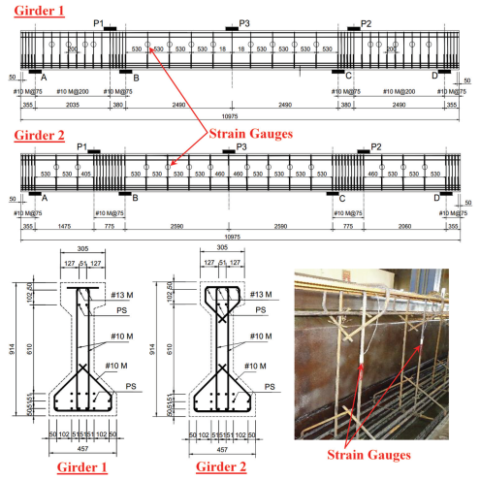
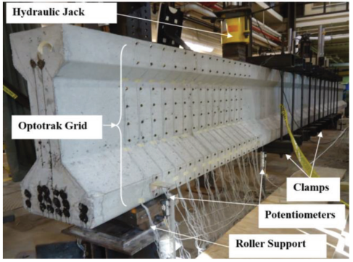
Figure 12: Test configurations of AASHTO type II girder under static loading ( Chehab et al 2018)
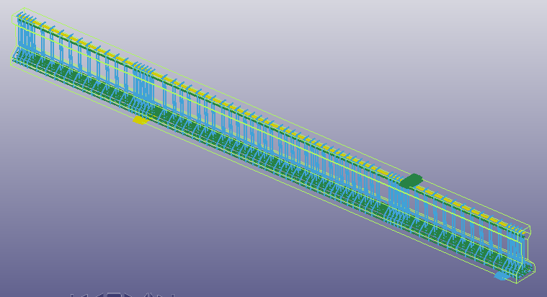 | 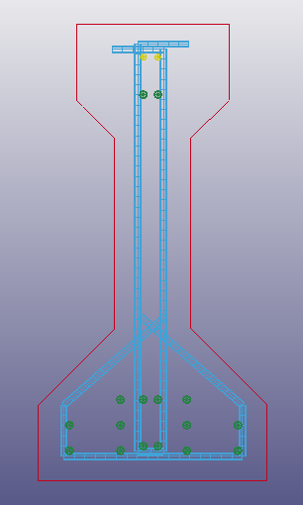
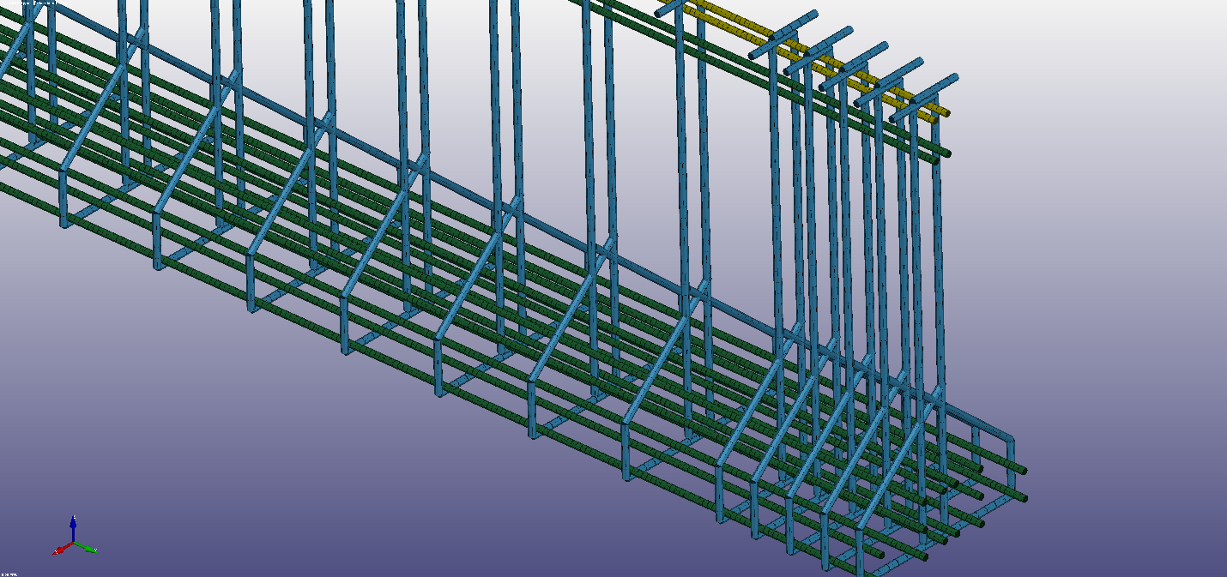
Figure 13: FE model of AASHTO type II girder ( Girder 1, Test No 2 )

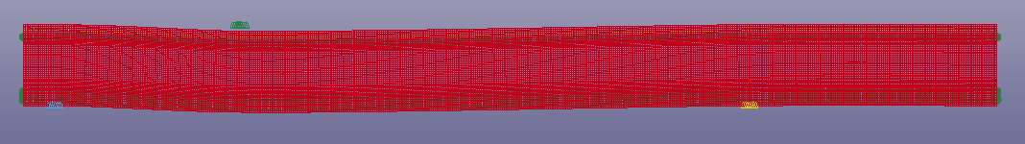
Figure 14: Deformed shape of the girder
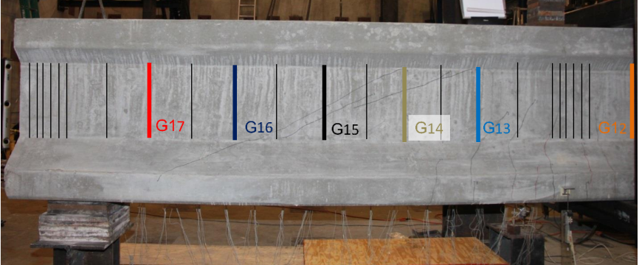 | 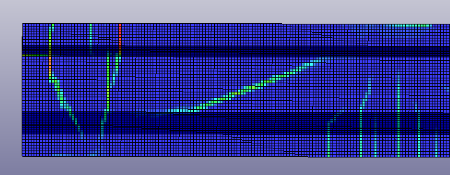
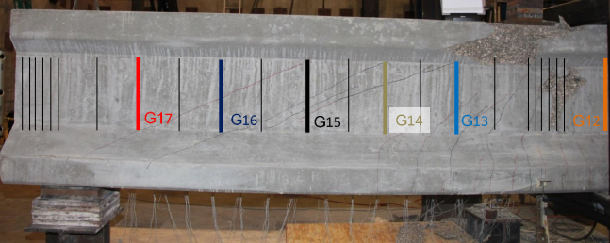 | 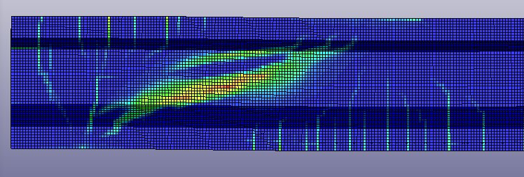
Figure 15: (A) Girder1 Test 2 at first cracking and the corresponding FE results; (B) Girder1 Test 2 at failure and the corresponding FE results

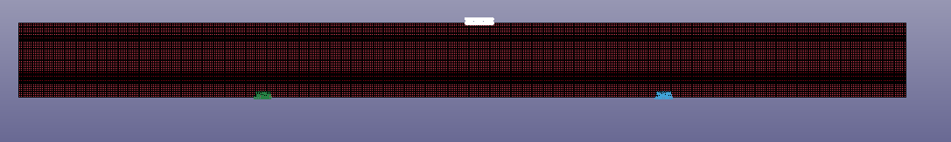
Figure 16: FE model of Girder 1 - Test No 3
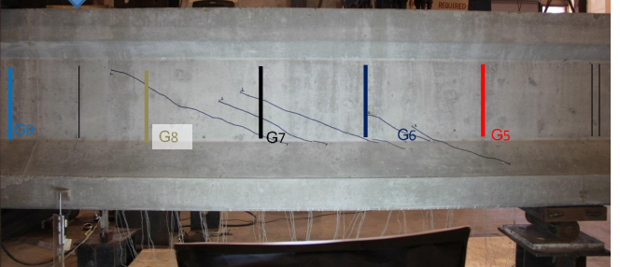 | 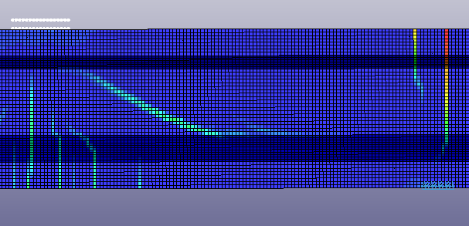
(A)
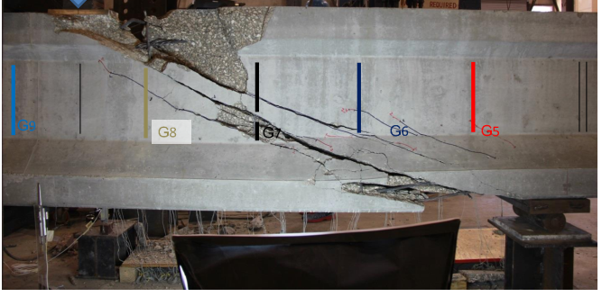 | 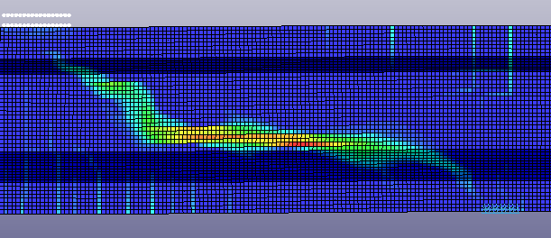
(B)
Figure 17: (A) Tested girder at first crack, (B) Tested girder at failure , and the corresponding crack pattern by FE model

(A)
AASHTO Nominal bending moment = 1705 KN.m
(B)
Figure 18: (A) Shear force and deflection curve by test results and FE model; (B) FE Model bending moment vs deflection at the loading plate

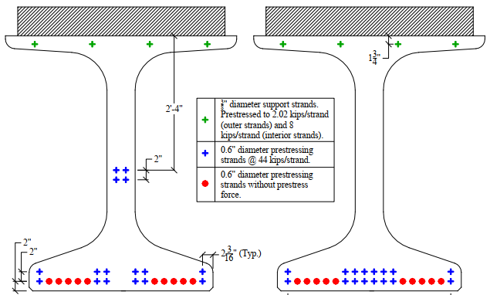
Figure 19: Model calibration using NU girder

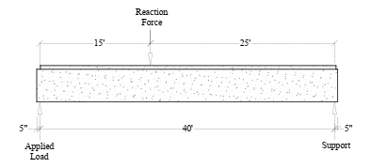 | 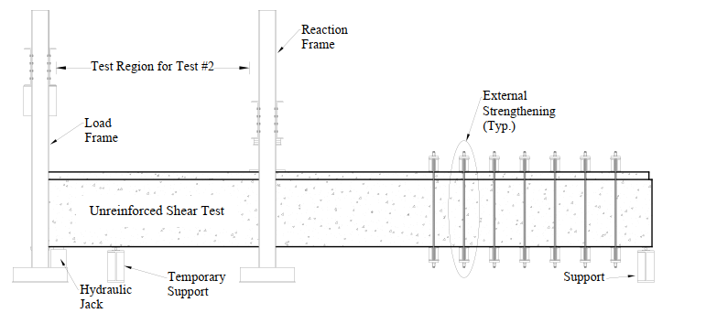
Figure 19: Experimental test setup configuration

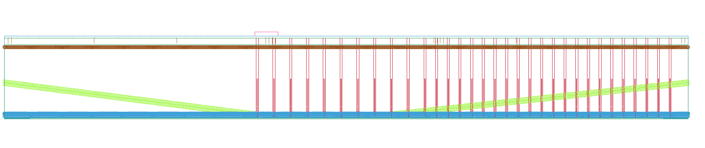
Figure 20: FE model
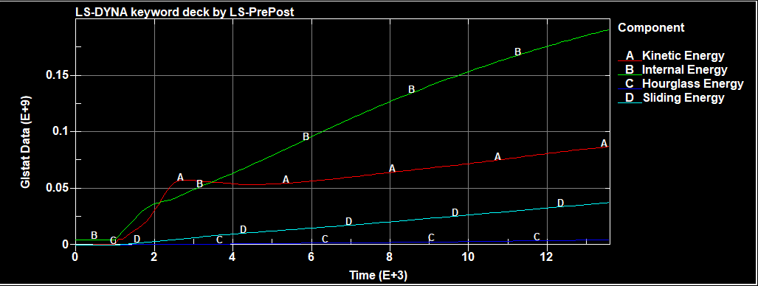
Figure 20: FE model energy plot
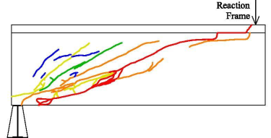
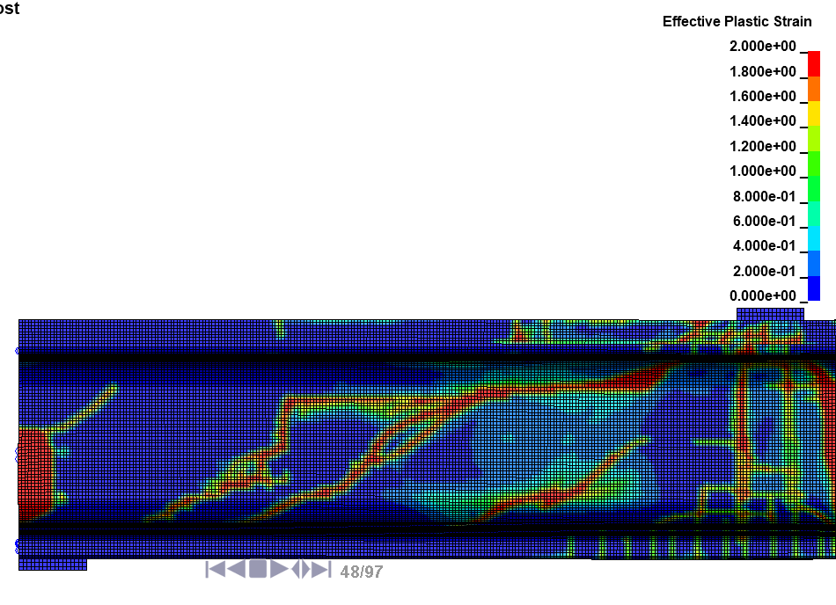
Figure 21: Experimental cracking diagram vs FE crack propagation pattern

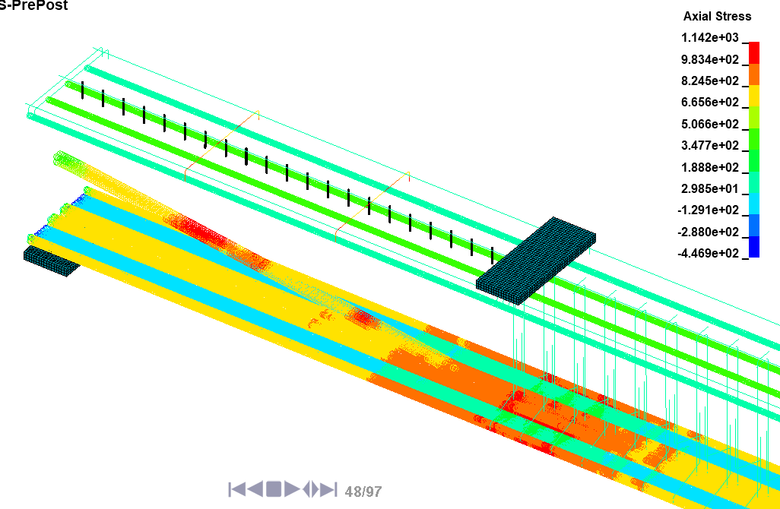
Figure 22: Axial stress of the prestressing strands

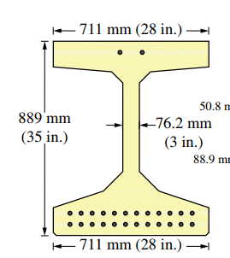 | 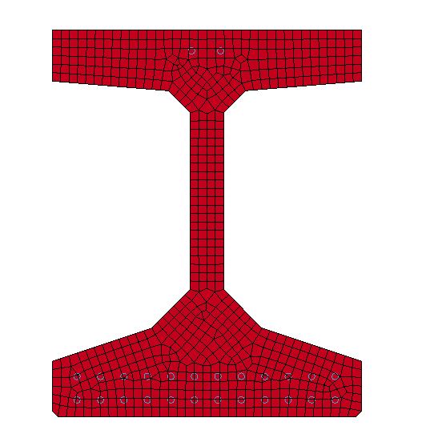
Figure 23: Model calibration using HP1- test bulb-tee girder
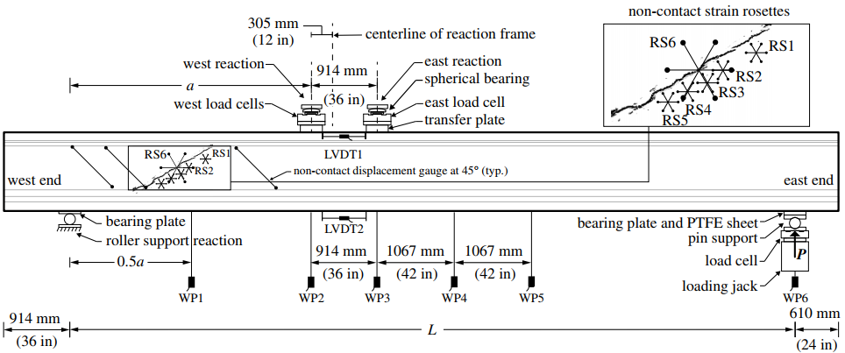
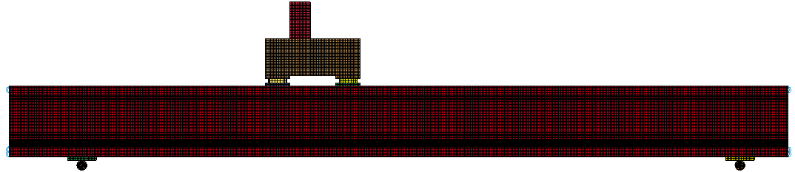
Figure 24: The test-setup configuration
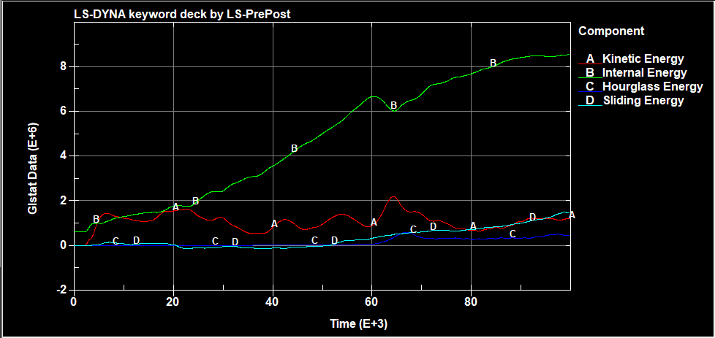
Figure 25: FE energy plots

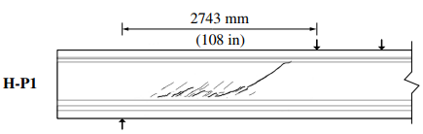
Figure 26: Crack patterns of FE and experimental testing
References
Chehab, Alaa I., Christopher D. Eamon, Gustavo J. Parra-Montesinos, and Thai X. Dam. "Shear testing and modeling of AASHTO type II prestressed concrete bridge girders." ACI Structural Journal 115, no. 3 (2018): 801-811.
Griffin, Alexander Michael. "Shear behavior of high strength self-consolidating concrete in NU bridge girders." (2014).
El-Helou, Rafic G., and Benjamin A. Graybeal. "Shear Behavior of Ultrahigh-Performance Concrete Pretensioned Bridge Girders." Journal of Structural Engineering 148, no. 4 (2022): 04022017.

