TRANSPORTATION POOLED FUND PROGRAM
QUARTERLY PROGRESS REPORT

Lead Agency: Utah Department of Transportation

INSTRUCTIONS:
Project Managers and/or research project investigators should complete a quarterly progress report for each calendar quarter during which the projects are active. Please provide a project schedule status of the research activities tied to each task that is defined in the proposal; a percentage completion of each task; a concise discussion (2 or 3 sentences) of the current status, including accomplishments and problems encountered, if any. List all tasks, even if no work was done during this period.

Transportation Pooled Fund Program Project #  TPF-5(264) |  | Transportation Pooled Fund Program - Report Period:  x Quarter 1 (January 1 – March 31, 2015)  _ Quarter 2 (April 1 – June 30, 2015)  _ Quarter 3 (July 1 – September 30, 2015)  _ Quarter 4 (October 1 – December 31, 2015)
Project Title:
Passive Force-Displacement Relationships for Skewed Abutments

Name of Project Manager(s):  David Stevens | Phone Number:  801-589-8340 |  | E-Mail  davidstevens@utah.gov
Lead Agency Project ID:  FINET 42051, ePM PIN 10903  UDOT PIC No. UT11.406 | Other Project ID (i.e., contract #):  UDOT Contract No. 138123 |  | Project Start Date:  August 13, 2012
Original Project End Date:  September 30, 2014 | Current Project End Date:  December 15, 2015 |  | Number of Extensions:  2

Project schedule status:

_ On schedule X On revised schedule _ Ahead of schedule _ Behind schedule

Overall Project Statistics:
Total Project Budget | Total Cost to Date for Project | Percentage of Work  Completed to Date
$270,000.00 | $139,200.00 | 65%

Quarterly Project Statistics:
Total Project Expenses  and Percentage This Quarter | Total Amount of Funds  Expended This Quarter | Total Percentage of  Time Used to Date
0% | $0 | 80%

Project Description:

At present, about 40% of the 600,000 bridges in the FHWA database are constructed at a skew angle (Silas Nichols, Personal Communication). There is considerable uncertainty about the passive force on skewed abutments where the passive force develops at an angle relative to the longitudinal axis of the bridge structure. Although current design codes (AASHTO 2011) consider that the ultimate passive force will be the same for a skewed abutment as for a non-skewed abutment, numerical analyses performed by Shamsabadi et al. (2006) indicate that the passive force will decrease substantially as the skew angle increases. Reduced passive force on skewed abutments would be particularly important for bridges subject to seismic forces or integral abutments subject to thermal expansion. Unfortunately, there have not been any physical test results for skewed abutments reported in the literature which could guide engineers in making appropriate adjustments for skewed conditions. Nevertheless, some field evidence has clearly shown poorer performance of skewed abutments during seismic events and distress to skewed abutments due to thermal expansion (Shamsabadi et al. 2006, Steinberg and Sargand 2010).

This study builds on previous pooled fund testing conducted by Rollins and his students at BYU to evaluate passive force-deflection relationships for non-skewed abutments (TPF-5(122), Dynamic Passive Pressure on Abutments and Pile Caps, Rollins et al, 2010). The test facilities can readily be modified to allow for the test program with relatively small additional costs because of the test fixtures (reaction shafts, reaction walls, and pile supported cap) which are already constructed at the site. Results from this study can be compared with previous testing to assess overall performance.

Four objectives are outlined for this new study:
- Determine static passive force-displacement curves for skewed abutments with and without wingwalls from large scale tests.
- Provide comparisons of behavior of skewed abutments with that of normal abutments.
- Evaluate the effect of wingwalls on skewed abutment response.
- Develop design procedures for calculating passive force-displacement curves for skewed abutments.

The scope of work consists of twelve specific tasks, including new tasks 7 through 12:
- Literature Review and Collection of Existing Test Data
- Perform Laboratory Passive Force-Deflection Tests on 2 ft High Wall with Skew Angles of 0º, 15º, 30º, and 45º
- Perform Field Passive Force-Deflection Tests on 5.5 ft High Wall with Skew Angles of 0º, 15º, and 30º and Transverse Wingwalls
- Perform Field Passive Force-Deflection Tests on 5.5 ft High Abutment with Skew angles of 0º, 15º, 30º and MSE Wingwalls
- Calibrate Computer Model and Conduct Parametric Studies
- Preparation of Final Report
- Perform Additional Field Passive Force-Deflection Tests on 5.5 ft High Abutment with a Skew Angle of 45º with and without MSE Wingwalls
- Perform Field Passive Force-Deflection Tests on 3.0 ft High Unconfined Backfill with Skew Angles of 0º and 30º
- Perform Field Passive Force-Deflection Tests on 5.5 ft High Pile Cap with Concrete Wingwalls and Skew Angles of 0º and 45º
- Perform Field Passive Force-Deflection Tests on 3.5 ft High Unconfined Gravel Backfill with Skew Angles of 0º and 30º
- Perform Field Passive Force-Deflection Tests on 3.5 ft High GRS Gravel Backfill with Skew Angles of 0º and 30º
- Present the Results of the Study at TRB and AASHTO Meetings

Dr. Kyle Rollins of BYU is the Principal Investigator for this research project. Individual task reports will be prepared for Tasks 1 through 5 and 7 through 11 when these are completed. Up to two in-person meetings with the multi-state technical advisory committee (TAC) are planned to be held in Salt Lake City, Utah during the project. Other TAC meetings will be tele-conference or web meetings.

Progress this Quarter (includes meetings, work plan status, contract status, significant progress, etc.):

Task 1 – 100% complete.
Task 2 – 100% complete.
Task 3 – 100% complete.
Task 4 – 100% complete.
Task 5 – 80% complete. BYU continued data analysis and worked on task report.
Task 6 – 30% complete. BYU combined portions of other task reports for the Final Report.
Task 7 – 80% complete. BYU continued data analysis and worked on task report.
Task 8 – 80% complete. BYU continued data analysis and worked on task report.
Task 9 – 80% complete. BYU continued data analysis and worked on task report.
Task 10 – 80% complete. BYU continued data analysis and worked on task reports.
Task 11 – 80% complete. BYU continued data analysis and worked on task reports.
Task 12 – 60% complete.
TAC Meetings – None held this quarter.
Contract – No adjustments this quarter.

Anticipated work next quarter:

Task 1 – None.
Task 2 – None.
Task 3 – None.
Task 4 – None.
Task 5 – Work will continue on the task report.
Task 6 – Combine portions of other task reports for the Final Report.
Task 7 – Complete the full task report (the revised Tasks 3 and 4 reports).
Task 8 – Complete the full task report.
Task 9 – Complete the full task report.
Task 10 – Complete the full task report.
Task 11 – Complete the full task report.
Task 12 – Prepare for upcoming AASHTO SCOBS meetings, with TAC input, to encourage implementation of research results.
TAC Meetings – We will hold a TAC web conference to discuss completed task reports during this quarter. Discussion may also include a related new field testing task to potentially add to the research contract.
Contract – None.

Significant Results:

Efforts this past quarter have involved merging task reports to prepare a final draft report on all the second phase tasks. In addition, we have been making comparisons between measured and computed passive force-deflection curves using various approaches for the field tests involving gravel backfill and GRS backfill. This quarterly report will highlight some of this work. Because of the large particle size of the gravel backfill, in-situ direct shear tests were performed on this material during the field testing phase. A photograph of the 18 inch square shear box, which was hand-trimmed into the compacted fill is shown in Figure 1. Weights were stacked on top of the soil in the box to obtain confining pressures appropriate for the conditions. Based on the field tests, the measured friction angle was 45.8º and the cohesion was 40 psf for the gravel backfill. This is 4º to 5º higher than the friction angle of the sand backfill used in previous field tests.

Figure 2 provides a plot showing the computed passive force-deflection curve for the gravel backfill test in comparison with the measured curve. The computed curve was obtained using the computer model PYCAP developed by Mokwa and Duncan (2001) and employs the log-spiral method for computing the ultimate passive resistance along with a hyperbolic curve to model the force-deflection curve. The agreement with the measured curve is very good. For this model we used a friction angle of 45.8º and a cohesion of 40 psf as measured by the in-situ direct shear test along with a wall friction angle of 28.9º which is equal to 63% of the soil friction angle. This ratio of δ/φ is typical of what has been used for previous tests involving sand backfill acting against the back of the concrete test wall. The value of wall deflection required to achieve ultimate resistance was taken as 7.3% of the wall height which is higher than the value of 3% to 5% typically employed for tests with sand backfill. A deflection of 6% was used by Rollins et al in analyzing the passive force development of a gravel backfill; however, this was attributed to the presence of a lower-strength clay layer under the backfill. In this case, the weaker clay layer at this site is 3 ft below the base of the granular layer, but could be having some influence on the response at these higher force levels.

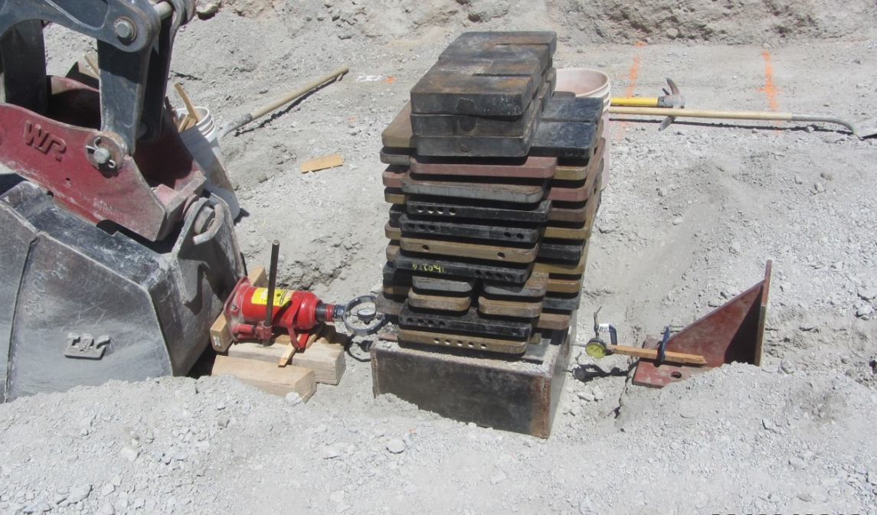

Figure 1. Photo of in-situ direct shear test on gravel backfill.

Figure 2. Comparison of measured passive force-deflection curve for the test with gravel backfill relative to curve computed with the computer model PYCAP which employs the log-spiral method with a hyperbolic curve shape.

Figure 3 provides a plot showing the computed passive force-deflection curves for the GRS backfill test in comparison with the measured curve. Because the same gravel backfill was used in the GRS backfill as was used in the gravel only test in Figure 2, the same soil parameters were initially employed to compute the passive force-deflection curve. However, this approach produced a force-deflection curve which overestimated the passive force relative to the measured curve as shown in Figure 3. Given the fact that the geotextile layers intersect the log-spiral failure surface, we might have expected the computed curves based on the gravel backfill only case would have underpredicted the measured GRS resistance. The discrepancy appears to be associated with the lower interface friction that develops between the concrete wall and the geotextile sheets which wrap around the backfill at each one foot interval. Laboratory interface friction tests have indicated that the interface friction between the geotextile and the backfill is between 45% and 57% of the friction angle of the gravel and that the interface friction develops gradually after reaching an initial “peak” where the slope in shear strength changes. To achieve agreement with the measured curve, a wall friction angle equal to 26.1º or 56% of the gravel friction angle was employed. In addition, the deflection required to achieve the ultimate resistance was taken as 8.5% of the wall height which is about twice what is typically assumed for granular backfill. This higher displacement to reach ultimate resistance appears to be consistent with the larger displacement necessary to develop ultimate interface friction from the laboratory test. Using these parameters, however, reasonably good agreement is obtained with the measured curve.

Figure 3. Comparison of measured passive force-deflection curve for the test with the GRS backfill relative to curve computed with the computer model PYCAP which employs the log-spiral method with a hyperbolic curve shape.

In the next quarter comparisons between measured curves will also be made using the computer program ABUT, and procedures recommended by AASHTO and Caltrans.

Circumstance affecting project or budget. (Please describe any challenges encountered or anticipated that
might affect the completion of the project within the time, scope and fiscal constraints set forth in the
agreement, along with recommended solutions to those problems).

Some of the analysis in the newer tasks has taken longer than originally planned. When the newer field testing tasks were added to the contract, the contract end date was not extended. The contract was subsequently amended to reflect a revised schedule to complete all tasks and deliverables by the end of 2015.

Potential Implementation:

UDOT is considering early adoption of the skew reduction factor for passive force based on the laboratory and field test results, but no final decision has been made at this point. In June 2013 and June 2014, Dr. Rollins presented the results of the research to date to technical committees at the AASHTO Subcommittee on Bridges and Structures Annual Meetings in Oregon and Ohio on behalf of the project TAC. This interaction is intended by the TAC and Dr. Rollins to prepare the way for design code revisions once the research is completed. Caltrans is also promoting use of the research results in their design methods.

