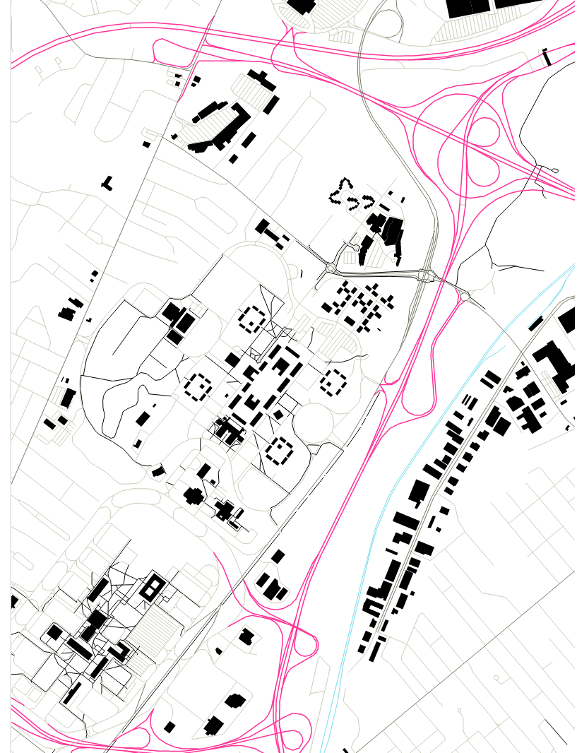
Catherine T. Lawson, Ph.D.
Chair, Geography and Planning Department
Director, Lewis Mumford Center
AS 218 1400 Washington
Albany, New York 12222
(518) 442-4775
lawsonc@albany.edu
  - WEB-BASED TRAFFIC DATA VISUALIZATION AND ANALYSIS TOOLS
  - Contract: DTFH6114P00028
  - TA Panel Forum Summary Report
  - Draft Version 1.0
  - By
  - Albany Visualization And Informatics Lab (AVAIL)
  - Lewis Mumford Center, University at Albany, SUNY
  - March 20, 2014

Contents
1. Forum Report. 3
1.1 Forum Objectives 3
1.2 Forum Accomplishments 3
1.3 Next Steps 4
Appendix A: Agenda 5

Forum Report.
On March 6, 2014 the Technical Advisory (TA) panel met with the State University of New York at Albany Visualization and Informatics Lab (AVAIL) project team to discuss and agree on project goals.

1.1 Forum Objectives
The purpose of the TA Panel Kickoff Meeting was to review the Statement of Work with all members of the project, to discuss priorities and areas of particular interest for TA Panel as well as to provide the first formalized opportunity for TA Panel and Project Team to address questions and comments about the project.

1.2 Forum Accomplishments
The two-hour long forum was a successful execution of its objectives. The SUNY AVAIL Project Team led a guided discussion of each point of the project Statement of Work, for an agenda with an itemized Statement of Work, see Appendix A. The TA Panel provided guidance, clarification and specific objectives of many of these items, leading to a greater understanding of project goals.

The Kick-Off forum established a precedent for open and continuous conversation between all parties involved in the Web-Based Traffic Data Visualization and Analysis Tools project.

Some key points taken from this forum are as follows.

- All parties wish to duplicate other projects as little as possible.
  - This project will focus on creating additional value from existing data.
- This project will be GIS agnostic, we will not require use of specific GIS programs.
- The Web-Based visualization tools will be built as follows;
  - Each state involved will have their own “instance” of the tools, that will show them data specific to their state and any regulatory or administrative considerations will be localized.
  - Additionally all participating states will have access to an “instance” that uses a nationwide data set.
- TA Panel expressed interest in the following areas of data exploration, however these are not to be considered final or exhaustive. Additional areas of development will continue as outlined in the statement of work.
  - Oversize/Overweight enforcement.
  - Historic/Seasonal trend analysis.
  - Load Spectra
    - Axle and Truck level.
  - Truck VMT.
  - Bridge Weight Analysis.

1.3 Next Steps
- The project team will follow up individually with TA Panel members and their teams to discuss;
  - Data Availability.
  - Data Transfer.
  - Project goals specific to their departments.
  - Any questions or comments.
- A web-based forum will be established by the AVAIL project team, and secure access provided to the TA Panel and Project team where questions, comments, bugs, ideas, etc. can be shared in a collaborative manner.
- Project team will begin to evaluate existing software.
- Project team will begin to develop system requirements.
- Project team will begin to collect data.

Appendix A: Agenda
  - WEB-BASED TRAFFIC DATA VISUALIZATION AND ANALYSIS TOOLS
  - TA Panel Kickoff Meeting
Date: 03/06/2014
Time: 11:00am – 1:00pm EST
Location: Web Teleconference.

Teleconference Details:
Meeting Hyperlink: https://global.gotomeeting.com/meeting/join/225735773

Audio:
Participants can use their computer's microphone and speakers (VoIP) or telephone.
- Phone Number: +1 (630) 869-1013
- Access Code: 225-735-773
- Audio PIN: Shown after joining the session

Video:
- In lieu of a face-to-face meeting, the SUNY Albany Visualization and Informatics Lab (AVAIL) will join the meeting “in person” using built-in meeting video. Participants are not required to use video conferencing

Attendees:
Federal Highway Administration:
- Tianjia Tang | Chief, Highway System Performance Division | Chief, Travel Monitoring and Travel Surveys
- David L. Jones Sr | Transportation Specialist | Travel Monitoring and Travel Surveys
- Adella Santos | NHTS Program Manager | Survey Method and NHTS
- Justin Clarke | HPMS / Data Analysis

TA Panel:
- Andrew O'Neill | Transportation Planning Supervisor | PA Department of Transportation | Bureau of Planning and Research
- Bradley J. Overturf | Transportation Supervising Planner | Connecticut Department of Transportation
- Lindsey M. Pflum, PE | Office of Technical Services | Ohio Department of Transportation
- Kent L. Taylor | State Traffic Survey Engineer | Traffic Survey Group - NCDOT
- Lawrence J. Whiteside, PMP | Supervisor, Travel Information Unit, Data Collection and Analysis Section Asset Management Division | Michigan Department Of Transportation

SUNY Albany AVAIL:
- Dr. Catherine Lawson | Principal Investigator
- Alex Muro | Lead Programmer
- Matt Wolkoff | Project Manager
Also Attending
- Anne-Marie McDonnell | Connecticut Department of Transportation

Purpose: During this kick-off meeting, the FHWA and TA members will review roles, and responsibilities of personnel involved, reach agreement on common issues, resolve and identify potential problems, and clarify understandings of the technical aspects of the contract.

Methodology: AVAIL proposes an itemized review of the project scope of work (shown below), identifying key areas of focus. AVAIL seeks ideas and feedback from TA and FHWA members on each point with the goal of establishing a clear and concise course of action for the project.

- Introductions.
- Project Overview.
- Planned approach.
- Task Overview: Within 1 week of contract award, the contractor personnel shall participate in an initial teleconference kick-off meeting with the FHWA Office of Highway Policy Information technical staff, FHWA PC and Travel Monitoring and Surveys Chief where the draft management and work plan on project goals and expectations will be discussed.
  - The contractor shall deliver a meeting memorandum outlining issues discussed and complete a final management and work plan within 5 business days of the kick-off meeting.
- Task 2 -- Arrange In-Person TA Meeting
  - The contractor shall arrange all meeting details including agenda, meeting materials, meeting facilities, and all costs associated with non-Federal employee TA member travel (Federal Government Travel Per Diem). The TA panel members shall meet in person two times and be kept informed of progress through three web meetings and phone conferences. The Technical Advisory panel members will stay in place throughout the contract and serve in a reviewing and advisory capacity.
  - During this kick-off meeting, the FHWA and TA members will review roles, and responsibilities of personnel involved, reach agreement on common issues, resolve and identify potential problems, and clarify understandings of the technical aspects of the contract.
- Task 3 -- Evaluate Functionality Characteristics of Existing Legacy Systems to Determine Suitability for an Improved System
  - Subtask 3.1: The contractor shall identify functionality characteristics and strengths and weaknesses of current systems such as GIS systems, TMAS, VTRIS, HPMS applications, the Mechanistic Empirical Pavement Design Guide (AASHTOWare ME), SAS, or other applicable traffic monitoring / analysis systems.
  - Subtask 3.2: The contractor shall explore new data storage and software options that will maximize performance in a web-based environment allowing multiple users to simultaneously conduct complex traffic data analyses.
  - The contractor shall identify new functional needs other than the above Subtask 3.1 and Subtask 3.2.

- Task 4 -- Develop System Requirements
  - Accommodation of various data formats including but not limited to linear referenced data (LRS) TMG weight, class, volume, and speed, AASHTOWare ME standard traffic input tables, bridge, weather and speed probe.
  - Data validation process using various quality control techniques including but not limited to TMAS, Long-Term Pavement Performance, and VTRIS.
  - Diverse data queries for specific analysis including but not limited to w-tables, truck weight roadway groups and load spectra.
  - Export function for data in formats including but not limited to standard software; (i.e. Microsoft Excel, DBF, CSV, TMG, GIS / SHP, LRS, ESRI, Google).
  - Data analysis process using proven statistical methods including but not limited to cluster analysis,
  - Data linking capability for all roadway attributes and bridges of national significance and capability to associate corresponding data with HPMS LRS, TMAS, VTRIS W-Tables, National Highway System, National Highway Planning Network , land use, weather and current related developmental impacts.
  - Graphical display features for all traffic and related attributes using standard universal GIS mapping formats and specifications. (e.g. shapefile or geodatabase for ArcMap) with the appropriate data, data categories, symbology, line weights, colors, etc. to produce a specific graphical representation.
  - Recognition of legacy data output for upload into the study product, with option to export results into existing systems.

- The contractor shall develop tools that display / report:
  - Highway specific estimates of truck volumes and loadings by time of day, day of week, week of year and year to year.
  - Monthly truck class adjustment factors.
  - Heavy vehicle travel monthly trends.
  - Axle loading trends.
  - Highway ton-miles of freight moved each month.
  - Flow maps linking all roadways seamlessly locally, regionally and nationally.
  - Truck weight road groups locally, regionally and nationally.
  - Load spectra by standard truck class and axle group type.
  - AASHTOWare ME (MEPDG) inputs for project specific design requirements. Develop a process to synthesize raw data from existing traffic data collecting stations to match traffic stream parameters (e.g. average annual daily truck traffic, vehicle truck class distribution, monthly truck class adjustment factors) particular to the project location.
  - Loading trends for bridge stress.
  - Speed trends.
  - Size & Weight and Enforcement
- Clarification of issues or concerns
- Next Steps

