TRANSPORTATION POOLED FUND PROGRAM
QUARTERLY PROGRESS REPORT

Lead Agency (FHWA or State DOT): _FHWA______________________________________

INSTRUCTIONS:
Project Managers and/or research project investigators should complete a quarterly progress report for each calendar quarter during which the projects are active. Please provide a project schedule status of the research activities tied to each task that is defined in the proposal; a percentage completion of each task; a concise discussion (2 or 3 sentences) of the current status, including accomplishments and problems encountered, if any. List all tasks, even if no work was done during this period.

Transportation Pooled Fund Program Project #  (i.e, SPR-2(XXX), SPR-3(XXX) or TPF-5(XXX)  TPF-5(279) |  | Transportation Pooled Fund Program - Report Period:  □Quarter 1 (January 1 – March 31)  Quarter 2 (April 1 – June 30)  □Quarter 3 (July 1 – September 30)  □Quarter 4 (October 1 – December 31)
Project Title:
High Performance Computational Fluid Dynamics (CFD) Modeling Services for Highway Hydraulics

Name of Project Manager(s):  Kornel Kerenyi | Phone Number:  (202) 493-3142 |  | E-Mail  kornel.kerenyi@fhwa.dot.gov
Lead Agency Project ID: | Other Project ID (i.e., contract #): |  | Project Start Date:
Original Project End Date: | Current Project End Date: |  | Number of Extensions:

Project schedule status:
On schedule □ On revised schedule □ Ahead of schedule □ Behind schedule

Overall Project Statistics:
Total Project Budget | Total Cost to Date for Project | Percentage of Work  Completed to Date

Quarterly Project Statistics:
Total Project Expenses  and Percentage This Quarter | Total Amount of Funds  Expended This Quarter | Total Percentage of  Time Used to Date

Project Description:

The Federal Highway Administration established an Inter-Agency Agreement (IAA) with the Department of Energy’s (DOE) Argonne National Laboratory (ANL) Transportation Analysis Research Computing Center (TRACC) to get access and support for High Performance Computational Fluid Dynamics (CFD) modeling for highway hydraulics research conducted at the Turner-Fairbank Highway Research Center (TFHRC) Hydraulics Laboratory. TRACC was established in October 2006 to serve as a high-performance computing center for use by U.S. Department of Transportation (USDOT) research teams, including those from Argonne and their university partners. The objective of this cooperative project is to:

- Provide research and analysis for a variety of highway hydraulics projects managed or coordinated by State DOTs.
- Provide and maintain a high performance Computational Fluid Dynamics (CFD) computing environment for application to highway hydraulics infrastructure and related projects
- Support and seek to broaden the use of CFD among State Department of Transportation employees.

The work includes:

- Computational Mechanics Research on a Variety of Projects: The TRACC scientific staff in the computational mechanics focus area will perform research, analysis, and parametric computations as required for projects managed or coordinated by State DOTs.
- Computational Mechanics Research Support: The TRACC support team consisting of highly qualified engineers in the CFD focus areas will provide guidance to users of CFD software on an as needed or periodic basis determined by the State DOTs.
- Computing Support: The TRACC team will use the TRACC clusters for work done on projects; The TRACC system administrator will maintain the clusters and work closely with the Argonne system administrator’s community; The TRACC system administrator will also install the latest versions of the STAR-CCM+ CFD software and other software that may be required for accomplishing projects.

Progress this Quarter (includes meetings, work plan status, contract status, significant progress, etc.):

1: Computational Mechanics Research on a Variety of Projects
1.1: Computational Analysis of Water Film Thickness on Modern Road Geometry During Rain Events for Assessing Hydroplaning Risk
An analysis showed that it is essential to consider the roughness of the surface when modeling water film thickness on pavements. It is proposed to approximate the pavement surface with a model of a bed of spherical particles with diameter equal to the average aggregate size. The thickness of the porous region is equal to the mean depth of the pavement macro texture. The bottom surface of the domain is a no-slip wall boundary, and therefore the surface is not pervious. This approach does not make it possible to model the details of the flow around and over the asperities in the surface, but gives an area-averaged character of the flow which proved to represent the water film thickness with good accuracy.
TXD
Figure 1. Example of a surface profile and its representation with a porous medium
A sketch of a rough surface and a corresponding CFD two-region model is presented in Figure 1. The bottom region is a porous media region, and the region on top is a fluid region and an internal interface is created between them. An analysis of results obtained with the use of CFD models: with a rough pavement surface modeled as a porous region, as well as modeled as a smooth surface was performed, thus making it possible to establish what is the range of texture depths in which assuming a smooth surface in the CFD model is reasonable. A series of CFD simulations were developed with varying cross slopes, widths, texture depths, and rain intensities. Figure 2 shows an example of the water depth across a four-lane road (48 feet wide) computed as a rough and a smooth surface, calculated from Gallaway’s et al. equation [1], and measured in an experiment for a two-lane road [1]. The CFD rough surface model gives a good approximation of the experiment. The smooth surface model underpredicts the depth by 1mm at the shoulder, as compared to the rough surface model. Also, the smooth surface model is not able to represent the water film thickness in the crown vicinity, where the water level is negative.

Figure 2. Water film thickness on a 4-lane surface with texture depth 0.9mm, cross slope 2%, rain intensity 6.05in/hr

[1] Gallaway B., Schiller R., Rose J., The Effects of Rainfall Intensity, Pavement Cross Slope, Surface Texture, and Drainage Length on Pavement Water Depths, Texas Transportation Institute Research Report 138-5, 1971

1.2: Hydraulic study of a SCDOT catch basin CB25
A new type of a catch basin with an inlet grate, Type 25 (CB25), to use as drainage on South Carolina’s freeways was designed by the South Carolina Department of Transportation engineers. Computational fluid dynamics (CFD) modeling was chosen to establish the hydraulic capacity of the grate. Three-dimensional computational fluid dynamic simulations were developed by scientists at Argonne’s Transportation Research and Analysis Computing Center with the use of high-performance cluster computing.

The fraction of flow over the grate entering from the upstream end (front flow) and from the side of the grate (side flow), as well as bypassing the grate, was analyzed in the study. In the majority of the considered cases, part of the flow was not captured by the grate. In the case of a spread narrower than the grate width, all of the flow goes through the front of the grate. When the spread exceeds the grate width, part of the flow enters through the side of the grate, and/or bypasses the inlet. Also, the front efficiency decreases with increasing longitudinal slope of the roadway. The side flow reaches higher values for the lowest longitudinal slopes at high flow rates. Figure 2 shows streamlines of water velocity for five different longitudinal slopes, for a roadway with a 4-foot shoulder, when spread of the oncoming flow is equal 6 feet, roadway has a cross-slope of 2%, and the shoulder cross-slope equals 4%.The streamlines marked in yellow cross a vertical surface in front of the grate, and streamlines marked in green cross a vertical surface on the side of the grate. Also, the spread is marked with a red line. The figure illustrates that the front of the grate intercepts only the shoulder flow and the side of the grate intercepts mostly the shoulder flow.
(a) | 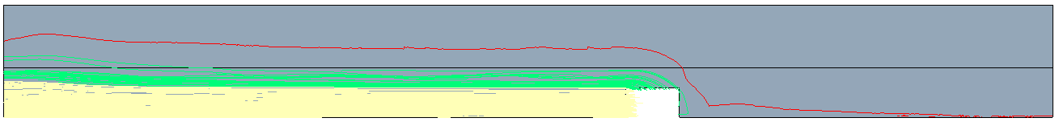
(b) | 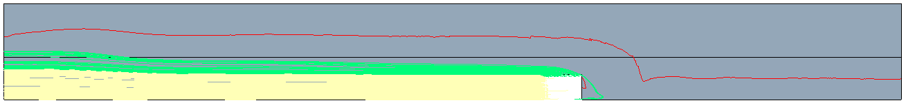
(c) | 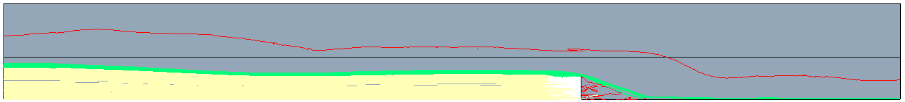
(d) | 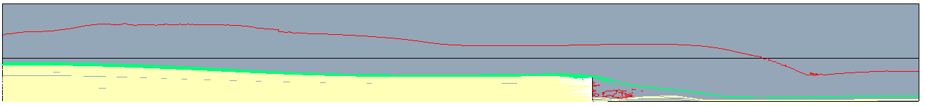
(e) | 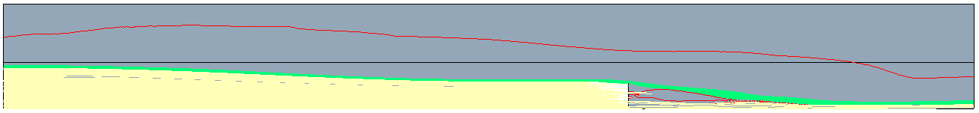
Figure 2. Streamlines of water velocity crossing surfaces: on the grate front (yellow) and grate side (green). The red line marks the extent of the water surface on the road. In each case the flow spread is 6 feet, on a road with a 4 foot shoulder, and varying longitudinal slope (a) 0.3%, (b) 1%, (c) 3%, (d) 5%, (e) 7%

The primary goal of the present research was to establish the grate efficiency, which is the percentage of the flow captured by the grate to the total flow on the roadway. The results of the CFD simulations were combined in an ANL technical report in the form of tables and plots for the considered geometries of the roadway with varying shoulder width: (a) flow rate through the grate vs. longitudinal slope for various spread widths, (b) flow rate through the grate vs. flow spread for the considered longitudinal slopes, and (c) hydraulic efficiency of the grate vs. flow spread for the set of longitudinal slopes. Figure 3 presents an example column plot for a road with a 4-foot shoulder.

Figure 2. Hydraulic efficiency of the grate vs. spread for a road with a 4-foot shoulder

2: Computational Mechanics Research Support

Argonne Transportation Research and Analysis Computing Center (TRACC) computational mechanics staff ran nationwide videoconferences every other Thursday that were open to state Department of Transportation staff and university researchers supported by the Federal Highway Administration or state DOTs. The videoconferences provide a venue to discuss approaches and issues related to hydraulics modeling projects. Topics during this reporting period included, but were not limited to:
- river bank erosion rate prediction
- approaches to modeling and mitigating hydroplaning risk

3: Computing Support

Routine cluster maintenance including software and hardware upgrades, security patching against cyber threats, and development of custom tools to increase users' productivity. Currently working on upgrading the TRACC clusters to support the latest scientific and engineering software utilizing industry's best practice guidelines in Open Source software and virtualization.
Anticipated work next quarter:

1: Computational Mechanics Research on a Variety of Projects

- development of a new methodology for river bed scour
- hydraulic analysis of a catch basin
- analysis of flow in a flow accelerator

2: Computational Mechanics Research Support

This work will continue.

Task 3: Computing Support

This work will continue.

Circumstance affecting project or budget. (Please describe any challenges encountered or anticipated that
might affect the completion of the project within the time, scope and fiscal constraints set forth in the
agreement, along with recommended solutions to those problems).

None.

