TRANSPORTATION POOLED FUND PROGRAM
QUARTERLY PROGRESS REPORT

Lead Agency (FHWA or State DOT): _FHWA______________________________________

INSTRUCTIONS:
Project Managers and/or research project investigators should complete a quarterly progress report for each calendar quarter during which the projects are active. Please provide a project schedule status of the research activities tied to each task that is defined in the proposal; a percentage completion of each task; a concise discussion (2 or 3 sentences) of the current status, including accomplishments and problems encountered, if any. List all tasks, even if no work was done during this period.

Transportation Pooled Fund Program Project #  (i.e, SPR-2(XXX), SPR-3(XXX) or TPF-5(XXX)  TPF-5(279) |  | Transportation Pooled Fund Program - Report Period:  □Quarter 1 (January 1 – March 31)  □Quarter 2 (April 1 – June 30)  Quarter 3 (July 1 – September 30)  □Quarter 4 (October 1 – December 31)
Project Title:
High Performance Computational Fluid Dynamics (CFD) Modeling Services for Highway Hydraulics

Name of Project Manager(s):  Kornel Kerenyi | Phone Number:  (202) 493-3142 |  | E-Mail  kornel.kerenyi@fhwa.dot.gov
Lead Agency Project ID: | Other Project ID (i.e., contract #): |  | Project Start Date:
Original Project End Date: | Current Project End Date: |  | Number of Extensions:

Project schedule status:
On schedule □ On revised schedule □ Ahead of schedule □ Behind schedule

Overall Project Statistics:
Total Project Budget | Total Cost to Date for Project | Percentage of Work  Completed to Date

Quarterly Project Statistics:
Total Project Expenses  and Percentage This Quarter | Total Amount of Funds  Expended This Quarter | Total Percentage of  Time Used to Date

Project Description:

The Federal Highway Administration established an Inter-Agency Agreement (IAA) with the Department of Energy’s (DOE) Argonne National Laboratory (ANL) Transportation Analysis Research Computing Center (TRACC) to get access and support for High Performance Computational Fluid Dynamics (CFD) modeling for highway hydraulics research conducted at the Turner-Fairbank Highway Research Center (TFHRC) Hydraulics Laboratory. TRACC was established in October 2006 to serve as a high-performance computing center for use by U.S. Department of Transportation (USDOT) research teams, including those from Argonne and their university partners. The objective of this cooperative project is to:

- Provide research and analysis for a variety of highway hydraulics projects managed or coordinated by State DOTs.
- Provide and maintain a high performance Computational Fluid Dynamics (CFD) computing environment for application to highway hydraulics infrastructure and related projects
- Support and seek to broaden the use of CFD among State Department of Transportation employees.

The work includes:

- Computational Mechanics Research on a Variety of Projects: The TRACC scientific staff in the computational mechanics focus area will perform research, analysis, and parametric computations as required for projects managed or coordinated by State DOTs.
- Computational Mechanics Research Support: The TRACC support team consisting of highly qualified engineers in the CFD focus areas will provide guidance to users of CFD software on an as needed or periodic basis determined by the State DOTs.
- Computing Support: The TRACC team will use the TRACC clusters for work done on projects; The TRACC system administrator will maintain the clusters and work closely with the Argonne system administrator’s community; The TRACC system administrator will also install the latest versions of the STAR-CCM+ CFD software and other software that may be required for accomplishing projects.

Progress this Quarter (includes meetings, work plan status, contract status, significant progress, etc.):

1: Computational Mechanics Research on a Variety of Projects
1.1: Rockery Design Guidelines for River and Coastal Environments
Gravity dry-stack rockeries are gaining in popularity as retaining structures in a river environment in locations such as narrow mountain canyons. So far no engineering analysis procedures have been available for evaluating the hydraulic stability of such structures when exposed to the various forces acting upon them. Gravity force, lateral earth pressure, buoyancy, hydrodynamic forces and contact/friction forces are the main forces acting on the rocks in a dry-stack rockery in a river environment. While most of these forces can be determined with well-known geotechnical engineering methods, the estimation of hydrodynamic forces can only be performed in scaled laboratory tests or by using advanced, three-dimensional numerical methods. The CFD analysis covers topics such as: resolve all forces acting upon a dry-stack rockery when constructed to function as a river bank protection; conduct a parametric study to identify the geotechnical and hydraulic factors that govern the stability of rockeries and test them over a large range of values to demonstrate robustness of the numerical analysis; identify the potential failure modes of rockeries in the river environment; develop practical, dimensionless equations that will allow rockeries to be designed and/or evaluated for any given set of geotechnical and hydraulic site conditions.

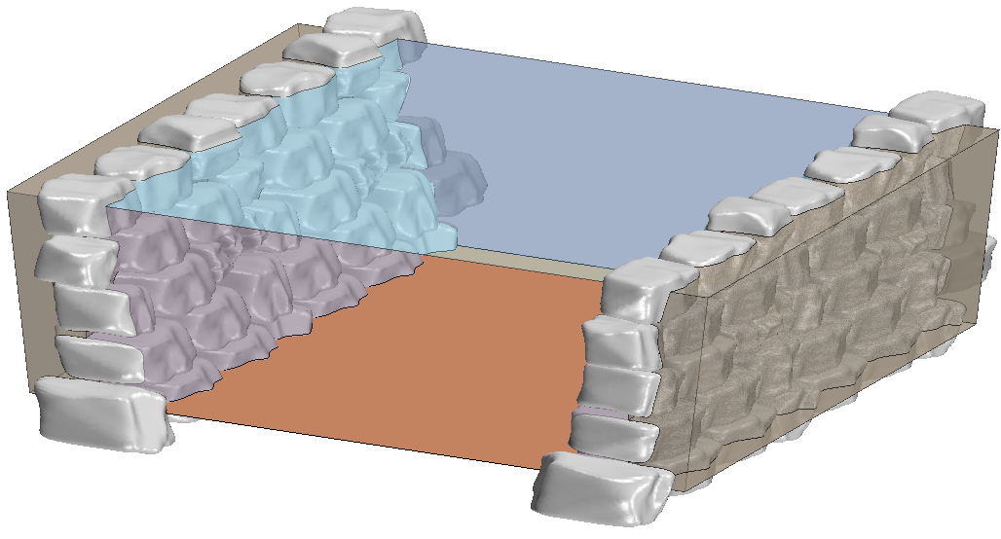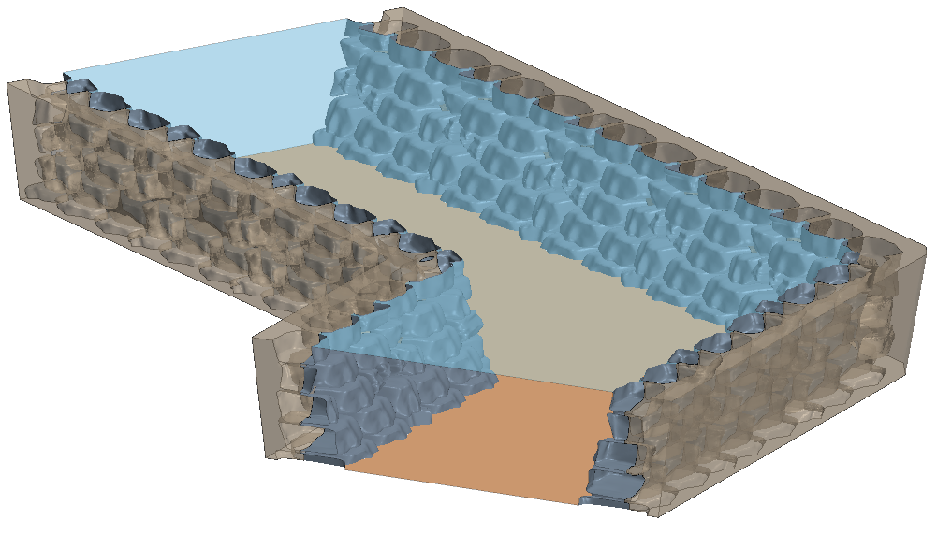
Figure 1. Two types of computational domains, for straight channels and channels with sharp bends, used to analyze the driving hydrodynamic forces acting on rockeries.

In addition to an analysis of straight channels, a set of models was built that take into account the influence of sharp bends on the flow. Four values of the channel bend angle were considered, ranging from 0 degrees to 60 degrees. It was found that the relationship between the forces acting on a selected cluster of rocks vs. the angle is approximately linear.
Moreover, a non-dimensional chart was developed for the considered test cases of straight channels, that could serve as a design tool for engineers. It presents a dependency of a lateral force coefficient, C_{lat}, on the geometry of the channel and rockery, and would allow back calculation of the hydrodynamic forces, F_{HD}.

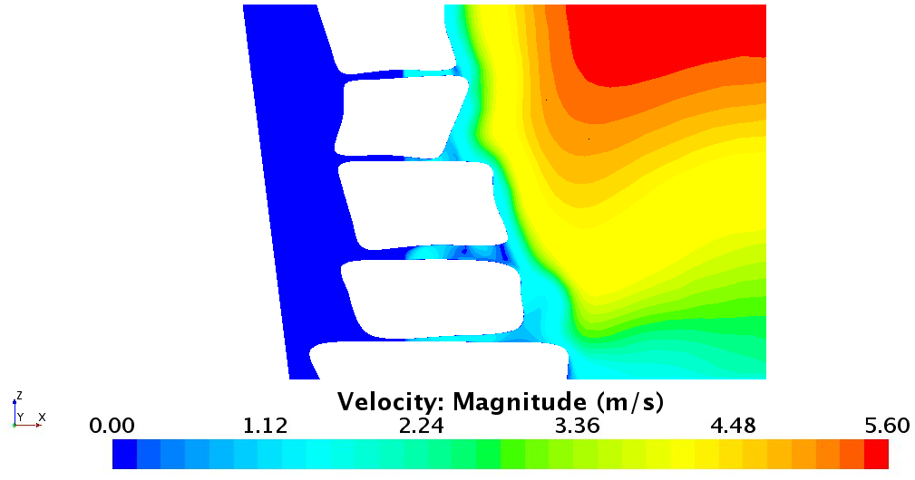
C
d
$$C_{r}$$
h
$$F_{HD}$$
H
Z
W/2
8.7
0.033
$$F_{HD}=KC_{lat}ρv^{2}h/2$$
Figure 2. The wo types of computational domains, for straight channels and channels with sharp bends, used to analyze the driving hydrodynamic forces acting on rockeries.

1.2: 3D CFD local scour calculation methodology
Scour is the erosion of a stream-bed due to hydrodynamic forces. Local scour occurs around objects
in the path of flow, such as bridge piers and abutments. In order to predict local scour, a new scour modeling technique has been developed by the computational mechanics team at Argonne’s Transportation Research and Analysis Computing Center. The approach uses commercial Computational Fluid Dynamics (CFD) software to compute sediment transport and an in-house Python code to compute displacements of the bed and sand slides.
A multiphase Eulerian hydrodynamic model is used to solve for the flow field using Reynolds Averaged Navier-Stokes (RANS) equations with the high Reynolds number k– epsilon turbulence model. The hydrodynamic model also solves for sediment transport (bed load and suspended sediment transport) and computes sediment entrainment and deposition rates. The Python code computes bed displacements from the entrainment and deposition rate distribution and morphs the bed. A sand slide model for non-cohesive sediment is also included in the Python program to keep scour holes from becoming too steep. Simulations were performed for different flow conditions and for mean sediment diameters from 0.25 mm to 4mm. The model agrees reasonably well with limited experimental data for equilibrium scour shape and size.

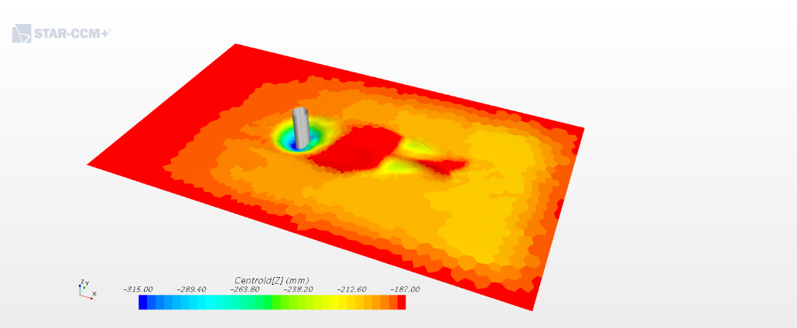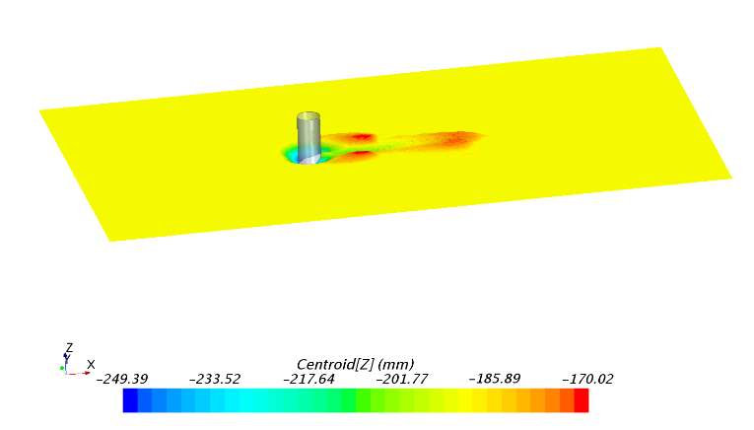
flow
Figure 3. Local scour around a circular pier. Experimental result on the left and computational model on the right.

2: Computational Mechanics Research Support

Argonne Transportation Research and Analysis Computing Center (TRACC) computational mechanics staff ran nationwide videoconferences every other Thursday that were open to state Department of Transportation staff and university researchers supported by the Federal Highway Administration or state DOTs. The videoconferences provide a venue to discuss approaches and issues related to hydraulics modeling projects. Topics during this reporting period included, but were not limited to:
- new methodologies of scour modeling
- recommendations for rockery analysis and design
- approaches to modeling and mitigating hydroplaning risk

3: Computing Support

Routine cluster maintenance including software and hardware upgrades, security patching against cyber threats, and development of custom tools to increase users' productivity. Currently working on upgrading existing TRACC cluster to support the latest scientific and engineering software utilizing industry's best practice guidelines in Open Source software and virtualization.
Anticipated work next quarter:

1: Computational Mechanics Research on a Variety of Projects

- modeling permeable pavements
- hydraulic analysis of a catch basin
- development of a new methodology for river bed scour

2: Computational Mechanics Research Support

This work will continue.

Task 3: Computing Support

This work will continue.

Circumstance affecting project or budget. (Please describe any challenges encountered or anticipated that
might affect the completion of the project within the time, scope and fiscal constraints set forth in the
agreement, along with recommended solutions to those problems).

None.

