Solicitation Number: TBA
Status: Solicitation posted
Title: Regional and National Implementation and Coordination of ME Design
Sponsoring Agency: Federal Highway Administration
Sponsor Solicitation Contact: Leslie Wright (Leslie.Wright@dot.gov)
Phone: 202-493-3460
Fax: 202-493-3170
Technical Contact: Chris Wagner (christopher.wagner@dot.gov) Others??
Phone: 404-562-3693
Fax: 404-562-3700
Lead Agency Contact: Chris Wagner (Christopher.wagner@dot.gov)
Phone: 404-562-3693
Fax: 404-562-3700
Lead Agency: Federal Highway Administration
Partners: AASHTO Ware (Vicki Schofield), AASHTO JTCoP ( Judy Corley-Lay), FHWA, Canada (Marta Juhasz), 30 State DOT, Suggest participating agencies other than DOT, should we allow consultants to contribute?
Date Posted: TBD
Solicitation Expires: 12/30/2014
Commitment Start Year: 2014
Commitment End Year: 2017
Duration: 36 months (3 years initially with potential extension)
100% SP&R Approval: Pending Approval
Commitments Required: $225,000 – this is the minimum needed to hold 5 meetings and hire a contractor to plan/facilitate (4 regional +1 National) 2 persons per meeting
Commitments Received: $25,000 – From FHWA, AASHTO Ware - $25,000 (Suggested)
Background:
The Mechanistic Empirical Pavement Design Guide (MEPDG) was developed under the National Cooperative Highway Research Program (NCHRP) project 1-37A with an objective to provide the highway community with a state-of-the-practice tool for the design for new and rehabilitated pavement structures. This substantial effort produced a mechanistic-empirical (M-E) pavement design guide that includes a Guide for M-E design and analysis, companion AASHTO software with documentation and a user manual. The MEPDG Manual of Practice was prepared under NCHRP Project 1-40B, which became the American Association of State Highway and Transportation Officials’ balloted and approved design procedure for the MEPDG.
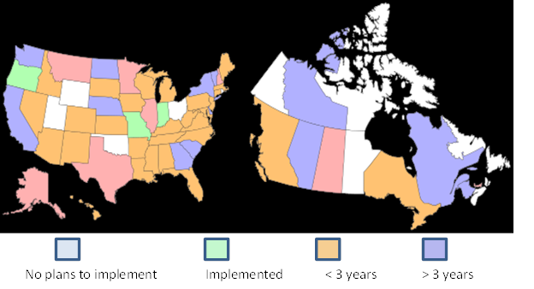
Development of the MEPDG is only the first phase. The next phase is implementation—adoption and use of that design procedure by the AASHTO member states and Canadian providences that have supported MEPDG development. Currently, State highway agencies are at various phases of the implementation effort. Based on a recent synthesis conducted by the National Cooperative Highway Research Board (NCHRP), three states have implemented the MEPDG and 30 additional states and several Canadian provinces plan to implement within 5 years.¹
Figure 1: Implementation Status for US and Canada

Regional and National coordination between agency representatives will be critical in the next 5 years in reducing the duplication of efforts and help highway agencies adopt this new design procedure. A recent survey conducted by AASHTO revealed that 42 out of 51 agencies (83%) support the creation of a regional peer exchanges and a National Users group.²
This pooled fund study will serve to meet the need for forums to discuss ME Design implementation efforts and will also coordinate implementation efforts on a regional and National level. These activities will aid in ME Design adoption.

Objectives:
The purposes of these peer exchanges and users group meetings are to (1) share information between agencies on the use of AASHTO Pavement ME design software, (2) identify issues at the local/regional level with regard to implementation, (3) identify needs or areas that still need to be researched relative to the MEPDG, and (4) organize implementation efforts on a regional and National basis. Support the State DOT and Canadian province implementation of ME Design.

Scope of Work: This pooled fund will include the following tasks:
- Conduct 4 regional peer exchanges in each of the 4 AASHTO regions
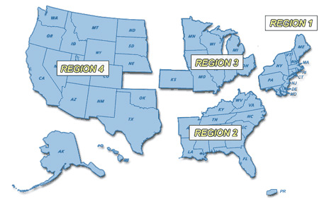
Figure 2: AASHTO regions

- Conduct 1 National AASHTO Users Group exchange
- Provide funding for travel for 2 representative from each participating agency to the regional and National meeting
- Provide contract support for meeting logistics and documentation of outcomes
- Develop regionally and Nationally significant products that aid ME implementation

Comments: Minimum commitment per state is $10,000 per year for 3 years.

References:
- Implementation of the AASHTO Mechanistic-Empirical Pavement Design Guide (MEPDG) and Software. NCHRP Synthesis Topic 44-06. 2014.
- AASHTOWare Pavement ME Design Customer Survey. August 2013. http://www.me-design.com/MEDesign/Index.html

