Quarterly Progress Report (QPR)

Applications of Enterprise GIS in Transportation
Progress Report for Quarter 7 [April 1st 2021 – June 30th, 2021]
WSP Program Manager: Jag Mallela (jag.mallela@wsp.com)
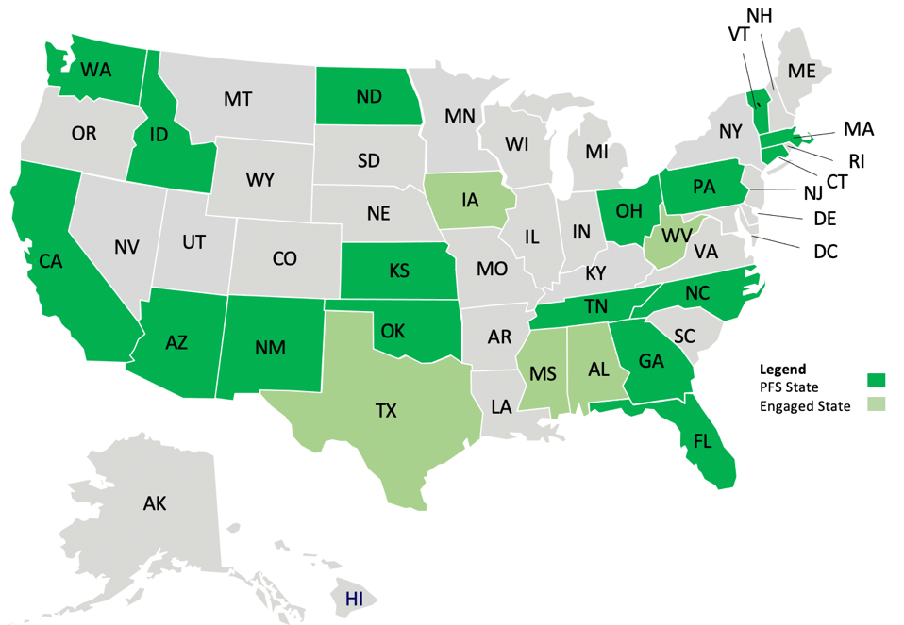
WSP Technical Lead: Abhishek Bhargava (abhishek.bhargava@wsp.com)
Background
The Pooled Fund Study (PFS) on Applications of Enterprise GIS in Transportation (AEGIST) was initiated by FHWA in 2018. During Phase 1 of this study a guidebook was developed for transportation agencies in the United States, with the primary objective of documenting guidance on how spatial and linear referenced data should be managed by States. Phase 2 of this PFS was initiated in October 2019. This phase will span over 5 years (October 2019 – September 2024), during which the objectives outlined below would be accomplished.
Objectives
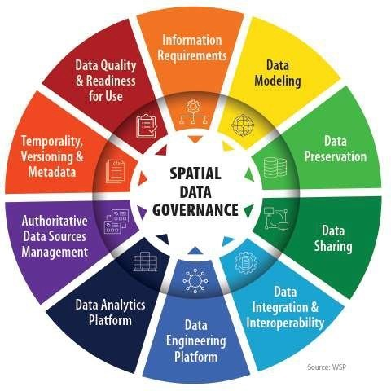
- Establish a standard for managing and governing data in spatial and linear referencing systems at transportation agencies, including but not limited to routes, intersections, interchanges, roundabouts, road segments, roadway characteristics, infrastructure assets, model inventory of roadway elements (MIRE), HPMS data items and ARNOLD road network.
- Develop guidance for States for modeling spatial transportation data, especially linear referencing system (LRS) data. Importing, exporting & conflating road network and roadway characteristics data across DOT LRS and Federal, State and Local data systems.
- Conduct a series of webinars, workshops, peer exchange meetings and provide consulting services to the States participating in the pooled fund to develop national standards in data modeling and management; enhance existing enterprise GIS systems at these agencies.
- Update the AEGIST Guidebook that was prepared in Phase 1, by documenting best practices, patterns and similarities across agencies in managing spatial data using enterprise data systems, including but not limited to Asset Management Systems, Traffic and Safety Systems, Project Planning and Programming Systems, Design and Construction Systems, and GIS and Linear Referencing Systems (LRS).
- Collaborate with States to enhance and develop spatial data management systems, processes, platforms to establish a structured and systematic approach for management of spatial data. This would involve establishing spatial data governance systems, business rules, applications, tools and platforms for:
  - Spatial Data Modeling
  - Spatial Data Integration and Engineering
  - Spatial Data Analytics
Completion Status and Summary
Time Frame: October 1, 2019 to September 30, 2024
Total Time, months: 60
Time Expended, months: 21
Percent Calendar Time Expended: 33%
Work Accomplished This Reporting Period: May – July, 2021

Task 1: Project Management
Task Objective: Perform project management activities, which include conducting monthly status meetings, developing quarterly status reports, creating project work plan, managing project resources, schedule, deliverables and communication with all stakeholders.
Activities:
- Conducted Quarterly Meeting 6 with PFS States in July 2021
- Prepared and delivered AEGIST Quarterly Report #6 along with invoice for the period (May – July, 2021). Both Base Period and Performance Period 1 activities with 11 PFS States are reported.
- Coordinate with following PFS States to determine kickoff date and technical services activities scope for AEGIST performance period 1: North Carolina, Washington, Kansas, New Mexico, Florida.
- Prepare and review agenda for PFS States Quarterly Meetings #7 and #8 in October and December 2021. Publish agenda, presenters and details at https://gisintransportation.com/.
- Initiated AEGIST Performance Period 1, which will span July 2021 – Feb 2022; and coordinated with PFS States in Performance Period 1 to plan AEGIST Technical services activities. The States include: North Carolina, New Mexico, Florida, Kansas and Washington.

Task 2: Technical Services
Task Objective: Provide technical services associated to PFS States by completing various agency-specific and cross-agency activities identified in the work plan.
Activities: Following technical services activities were carried out for each of the listed States in Base Period.
- Idaho:
  - Task 2.ID.2: Spatial data governance activities continued
    - Data Portfolio (Catalog) deployed on AirTable cloud platform. Data Engineering and Governance Dashboard created and delivered for ITD Web Applications.
    - Continued HPMS Data Quality Rules configuration in FME/Python Geoprocessing Tool (ArcGIS).
    - Presentation of data governance deliverables at AEGIST Quarterly Meeting 6 on July 22nd
  - Task 2.ID.3: Conflation of Federal Roads data with DOT LRS and County Roads data. – Analyzed results from the conflation geoprocessing tool to determine improvement opportunities.
- California
  - Task 2.CA.1: Statewide Roads data modeling and data exchange architecture: Developed draft report for roads data modeling architecture and applications technical architecture and review content in the report with Caltrans, CalOES and Merced.
- Tennessee
  - Task 2.TN.1: Strategic work plan for GIS-LRS, Maintenance, Safety, Planning, Structures Groups. Coordinated with the DOT to determine next steps on the strategic plan that was delivered in the previous quarter.
  - Task 2.TN.2: Identified potential technical services activities from the “Strategic Roadmap” that can be performed, including (a) Development of Data workflows (b) Data Catalog and Data Dictionary development for MIRE-HPMS Items and (c) Prioritization Framework for Planning Projects. Next steps on these activities to be determined by TDOT.
- Connecticut
  - Task 2.CT.1: HPMS data quality rules were configured in FME (Feature Manipulation Engine). The FME workspace file was delivered to Connecticut.
  - Task 2.CT.2: Continued development of the GIS Tool for extracting and transforming Connecticut DOTs Roads, Intersection data into AEGIST recommended road network publication data model (with topology, routability and temporality rules). This AEGIST road network data model was developed based on open standards from FHWA (AROLD, HPMS, MIRE), Open Geospatial Consortium (OGC).
- Pennsylvania
  - Task 2.PA.1: Prepared AEGIST Technical services work plan document.
  - Task 2.PA.7: Speed Limit Data Extraction from the Permits PDFs using AI/ML techniques – Received and reviewed the PDF Permit files from Pennsylvania.
  - Task 2.PA.10: Roads Data Modeling – NG911, PennDOT RMS & National Road Network - Developed agenda for workshop with stakeholders on alignment of roads data modeling practices.
  - Task 2.PA.11: LRS Systems Demonstration – Discussed goals and approach for presentation of LRS systems to assist with RMS rewrite.
- Ohio
  - Task 2.OH.2: Continued development of strategic roadmap for GIS/LRS activities on (a) HPMS-ARNOLD-MIRE data modeling and preparation and (b) LRS-GIS Database administration.
- North Carolina
  - Initiated Performance Period 1 technical services. Conducted kickoff meeting
  - Identified two tasks related to “Intersection Data Modeling Pilot” and “Intersection Data Model Maintenance”. Finalized scope of these tasks and documented in AEGIST Technical Services Document
- New Mexico
  - Initiated Performance Period 1 technical services. Conducted kickoff meeting
  - Identified task on “Intersection Data Modeling Pilot”. Finalized scope of these tasks and documented in AEGIST Technical Services Document
- Florida
  - Initiated Performance Period 1 technical services.
  - Identified tasks on “Dual Carriageway Modeling” and “Intersection Data Modeling Pilot”. Finalized scope of these tasks and documented in AEGIST Technical Services Document
- Kansas
  - Initiated Performance Period 1 technical services. Conducted kickoff meeting & monthly sprint meetings.
  - Identified task on “Intersection Data Modeling Pilot” and “Lidar Data integration and management in GIS/LRS”. Finalized scope of these tasks and documented in AEGIST Technical Services Document
- Washington
  - Initiated discussion on potential AEGIST technical services activities that can be taken on in Performance Period 1.

Task 3: Marketing and Communication
Task Objective: Webinars and Workshops will be held, and Articles will be presented in conferences and other industry forums to communicate information about the activities of the project, especially the technical work products developed as part of the project.
Activities:
- Task 3.1.x – AEGIST Articles
  - Task 3.1.1 - Article 1: Updated content for Article 1 on “Road Network Publication Data Model with Topology, Temporality, Routable Network Rules” based on the content in AEGIST Interim Report created as part of Task 5. Coordinating with FHWA, California, Pennsylvania to determine how to determine if NG911 road centerline and street name alias data entities can be included in the road network data model.
  - Task 3.1.2 - Article 2: Updated content for AEGIST Article 2 on “Enterprise GIS Application for Spatial Safety Performance Functions Calibration and HSM-based Safety Analysis”
  - Task 3.1.3 - Article 3: Evaluated scope, objectives and value of the content created for AEGIST Article 3 on “Enterprise GIS Application to Identify Optimal Location of Traffic Monitoring Sites based on Enterprise Needs”. Review of the need and value of this article under progress.
  - Task 3.1.4 - Article 4: Updated content for AEGIST Article 4 on “Enterprise GIS Application for Modeling and Conflating Federal Lands Management Agency, DOT LRS and Local Agency Roads data”
  - Task 3.1.5 - Article 5: Identified the need to create an AEGIST Article 5 on “LRS Data and Database Administration Maturity Model”. Developed an outline for the Article and a Structure for the Maturity Model.
- Task 3.2.x – AEGIST Workshops & Presentations
  - Task 3.2.4: AEGIST Presentations (2021)
    - Presented at the NaTMEC Conference on June 23rd, 2021, on Traffic Counts Site Selection and associated data management. Conducted a follow-up meeting with New Hampshire (one of the participating States in the conference) to discuss the needs and follow-up questions of the DOT. Coordinated with Stuart Thompson and Gordon Thompson
    - Prepared for August 31st presentation to FHWA’s National Road Network (NRN) Panel on AEGIST PFS State Activities in 11 States, during the Base Period and Performance Period 1. Discussion on AEGIST recommendations for HPMS 9.0 Data Modeling and National Road Network Data Model
Task 5: HPMS Remodeling Support Services
Task Objective: HPMS 9.0 Remodeling Support services
Activities:
- Presented the findings from the AEGIST Interim report (with HPMS data model) at the AEGIST Quarterly Meeting 6, on July 22nd, 2021
- Discussed the proposed AEGIST data model for HPMS 9.0 remodeling with FHWA. Specifically, this discussion focused on engineering of Inventory Routes, Junctions and Intersection Points, from the ARNOLD Routes with z-values. Also discussed the modeling of Intersection points and Intersection legs, specifically the HPMS and MIRE attributes. For Inventory Routes, it was confirmed with FHWA and PFS States, that the routes do not have to break at county boundaries. It is up to the States to make that decision. Prepared a matrix to compare model features across AEGIST, HPMS 9.0 and National Road Network Data Models; and, aligned the temporality and topology related modeling specifications.
- Opened review of the proposed road network publication data model to all PFS States. Setup review deadline of September 2nd, 2021.
Work Planned for Next Reporting Period: Aug – Sep 2021

Task 1: Project Management
Task Objective: Perform project management activities, which include conducting monthly status meetings, developing quarterly status reports, creating project work plan, managing project resources, schedule, deliverables and communication with all stakeholders.
Activities:
- Prepare and Deliver AEGIST Quarterly Report #7 for the period (Aug –September 2021) for Base Period and Performance Period 1
- Prepare for PFS States Quarterly Meetings #7 on October 21st. Publish agenda, presenters and details at https://gisintransportation.com/. Tentative agenda/theme: Spatial Data Analytics.

Task 2: Technical Services
Task Objective: Provide technical services associated to PFS States by completing various agency-specific and cross-agency activities identified in the work plan.
Activities:
- Idaho:
  - Task 2.ID.2: Continue work on Spatial Data Governance and HPMS Data Quality; and,
  - Task 2.ID.3: Continue testing and improvements to Roads Data Conflation tool.
  - Prepare with ITD for Data Summit being held at Idaho in October 2021, focusing on data engineering platform governance and data engineering platform tools/applications.
- California
  - Task 2.CA.1: Coordiante with Caltrans, CalOES and Merced County on State Roads Data Modeling and Data Exchange Architecture. Review/Update Document.
  - Task 2.CA.2: Prepare plan for pilot with Caltrans, CalOES and Merced County on use of ArcGIS Hub for Roads data editing and exchange;
- Tennessee
  - 2.TN.1: Discuss Strategic Work Plan with Division Directors. Identify activities in the plan that will be taken on for further work in AEGIST.
- Pennsylvania
  - Provide technical services related to:
    - Task 2.PA.1: AEGIST work planning
    - Task 2.PA.11: LRS Systems Demonstration
    - Task 2.PA.10: Roads Data Modeling – NG911, PennDOT RMS & National Road Network
- Ohio
  - Task 2.OH.2: Continue development of LRS data and database administration roadmap.
- North Carolina
  - Task 2.NC.2: Spatial Data Governance - Develop Scope and conduct work session on requirements.
- New Mexico
  - Task 2.NM.1: Intersection Data Modeling Pilot: Identify locations for pilot and review NMDOT datasets.
- Florida
  - Task 2.FL.1: Discuss technical approach for Intersection Data Modeling Pilot and review Florida data for arcs, routes, nodes and topology rules.
- Kansas
  - Task 2.KS.1: Intersection data model development – Schema alignment Lidar Intersection data with KDOT Intersection Manager Schema
- Washington
  - Follow-up to determine next steps on AEGIST Technical Services.

Task 3: Marketing and Communication
Task Objective: Webinars and Workshops will be held, and Articles will be presented in conferences and other industry forums to communicate information about the activities of the project, especially the technical work products developed as part of the project.
Activities:
- Task 3.2.x – AEGIST Workshops & Presentations
  - Task 3.2.4: Prepare and deliver presentations for
    - Deliver presentation on August 31st to FHWA’s National Road Network (NRN) Panel on AEGIST PFS State Activities in 11 States, during the Base Period and Performance Period 1.
- Task 3.3.1: AEGIST Webinars - Webinar 2 preparation and delivery on Aug 12th, 2021.
  - Prepare and Start Planning meetings for the AEGIST Webinar in November. Focus of this webinar will be on AEGIST PFS State Activities during the Base Period and Performance Period 1.
Task 5: HPMS Remodeling Support Services
Task Objective: HPMS 9.0 Remodeling Support services
Activities: Coordinate with FHWA to determine next steps for review and updates to report. Align with Task 3.1.1.

Complete List of AEGIST Deliverables
Note: Deliverables on which work is complete (in green) and work is in progress (in light yellow).
Task | D# | Deliverable Name | Due Date | Status
Task 1 | 1.1.0 | Kick-off Meeting | 10/30/19 | Completed.
Task 1 | 1.2.0 | Work Plan Version 1: Cross-Agency Tasks, Deliverables & Schedule | 4/30/20 | Completed. Submitted to FHWA and PFS States.
Task 1 | 1.3.1 | Quarterly Progress Report - 1 (incl. 3 monthly reports and quarterly meetings) | 12/31/19 | Completed. Submitted to FHWA. Email sent to PFS States.
Task 1 | 1.3.2 | Quarterly Progress Report - 2 (incl. 3 monthly reports and quarterly meetings) | 3/31/20 | Completed. Submitted to FHWA.  Email sent to PFS States.
Task 1 | 1.3.3 | Quarterly Progress Report - 3 (incl. 3 monthly reports and quarterly meetings) | 6/30/20 | MPR for April, May, June published.  QPR-3 (April-June) published.
Task 1 | 1.3.4 | Quarterly Progress Report - 4 (incl. 3 monthly reports and quarterly meetings) | 9/30/20 | MPR for July and August prepared. QPR-4 Prepared.
Task 1 | 1.3.5 | Quarterly Progress Report - 5 (incl. quarterly meetings) | 12/31/20 | QPR-5 prepared. QTR Meeting (Dec 2020)
Task 1 | 1.3.6 | Progress Report 6: Jan-Apr 2021 (incl. quarterly meet) | 4/31/21 | QPR-6 prepared. QTR Meeting (Mar 2021)
Task 1 | 1.3.7 | Progress Report 7: May-Aug 2021 (incl. quarterly meet) | 8/30/21 | Not Started
Task 2 | 2.1 | TASK 2 Base Period Technical Services (incl. Work Plan v1.1 with State Tasks) - MONTH 8 - MAY 2020 | 5/30/20 | Work Plan v1.1 has Caltrans Tasks.  May 29th PFS States Presentation.
Task 2 | 2.2 | TASK 2 Base Period Technical Services (incl. Work Plan v1.2 with State Tasks) - MONTH 9 - JUN 2020 | 6/30/20 | Work Plan v1.2 has CA, GA, ID Tasks.  June 16th PFS States Presentation.
Task 2 | 2.3 | TASK 2 Base Period Technical Services (incl. Work Plan v1.3 with State Tasks) - MONTH 10 - JUL 2020 | 7/30/20 | Work Plan v1.3 with ID Task updates. Weekly work planning with Idaho.
Task 2 | 2.4 | TASK 2 Base Period Technical Services (incl. Work Plan v1.4 with State Tasks) - MONTH 11 - AUG 2020 | 8/30/20 | Work Plan v1.4. Tasks 2.1, 2.2, 2.ID.1
Task 2 | 2.5 | TASK 2 Base Period Technical Services (incl. Work Plan v1.5 with State Tasks) - MONTH 12 - SEP 2020 | 9/30/20 | Work Plan v1.5 with ID Task updates.  Tasks 2.1, 2.2, 2.ID.2 and 2.ID.3
Task 2 | 2.6 | TASK 2 Base Period Technical Services - MONTH 13 - OCT 2020 | 10/30/20 | Work plan activities at ID, TN, CA and Tasks 2.1 and 2.2.
Task 2 | 2.7 | TASK 2 Base Period Technical Services - MONTH 14 - NOV 2020 | 11/30/20 | Work plan activities at ID, TN, CA and Tasks 2.1 and 2.2.
Task 2 | 2.8 | TASK 2 Base Period Technical Services (incl. Work Plan v1.6 with State Tasks) - MONTH 15 - DEC 2020 | 12/30/20 | Work Plan v1.6 with updates for ID, CT, TN and CA. Continued Tasks 2.1 and 2.2
Task 2 | 2.9 | TASK 2 Base Period Technical Services - MONTH 16 - JAN 2021 | 1/20/21 | Technical Services to ID, TN, CA, PA, CT, OH and Cross-agency Tasks 2.1 & 2.2.
Task 2 | 2.10 | TASK 2 Base Period Technical Services - MONTH 17 - FEB 2021 | 2/28/21 | Technical Services to ID, TN, CA, PA, CT, OH and Cross-agency Tasks 2.1 & 2.2.
Task 2 | 2.11 | TASK 2 Base Period Technical Services - MONTH 18 - MAR 2021 | 3/20/21 | Technical Services to ID, TN, CA, PA, CT, OH and Cross-agency Tasks 2.1 & 2.2.
Task 2 | 2.12 | TASK 2 Base Period Technical Services - MONTH 19 - APR 2021 | 4/30/21 | Technical Services to ID, TN, CA, PA, CT, OH and Cross-agency Tasks 2.1 & 2.2.
Task 2 | 2.13 | TASK 2 Base Period Technical Services - MONTH 20 - MAY 2021 | 5/30/21 | Technical services to 11 States and for Cross-agency Tasks 2.1 & 2.2.
Task 2 | 2.14 | TASK 2 Base Period Technical Services - MONTH 21 - JUN 2021 | 6/30/21 | Technical services to 11 States and for Cross-agency Tasks 2.1 & 2.2.
Task 2 | 2.15 | TASK 2 Base Period Technical Services - MONTH 22 - JUL 2021 | 7/30/21 | Technical services to 11 States and for Cross-agency Tasks 2.1 & 2.2.
Task 2 | 2.16 | TASK 2 Base Period Technical Services - MONTH 23 - AUG 2021 | 8/30/21 | Not Started
Task 2 | 2.17 | TASK 2 Base Period Technical Services - MONTH 24 - SEP 2021 | 9/30/21 | Not Started
Task 2 | 2.18 | TASK 2 Base Period Technical Services - MONTH 25 - OCT 2021 | 10/30/21 | Not Started
Task 2 | 2.19 | TASK 2 Base Period Technical Services - MONTH 26 - NOV 2021 | 11/30/21 | Not Started
Task 2 | 2.20 | TASK 2 Base Period Technical Services - MONTH 27 - DEC 2021 | 12/30/21 | Not Started
Task 2 | 2.21 | TASK 2 Base Period Technical Services - MONTH 28 - JAN2022 | 1/30/22 | Not Started
Task 2 | 2.22 | TASK 2 Base Period Technical Services - MONTH 29 - FEB 2022 | 2/30/22 | Not Started
Task 2 | 2.23 | TASK 2 Base Period Technical Services - MONTH 30 - MAR 2022 | 3/30/22 | Not Started
Task 2 | 2.24 | TASK 2 Base Period Technical Services - MONTH 31 - APR 2022 | 4/30/22 | Not Started
Task 2 | 2.25 | TASK 2 Base Period Technical Services - MONTH 32 - MAY 2022 | 5/30/22 | Not Started
Task 3 | 3.1.1 | Article 1: Road Network Publication Data Model with Topology, Temporality, Routable Network Rules | 5/30/21 | Delivered content of the article as part of Task 5 Report on Road network publication data model. FHWA and following PFS States reviewing: DC, ID, NC, OH.
Task 3 | 3.1.2 | Article 2: Enterprise GIS Application for Spatial Safety Performance Functions Calibration and HSM-based Safety Analysis | 5/30/22 | Connecticut, North Carolina, Kansas and California Safety datasets being engineered and evaluated for analysis. First milestone/ presentation made at GIS-T 2021 on spatial analysis techniques. Second milestone or presentation to be made in July 2021, at the PFS States Quarterly meeting
Task 3 | 3.1.3 | Article 3: Enterprise GIS Application to Identify Optimal Location of Traffic Monitoring Sites based on Enterprise Needs | 12/30/22 | California and Connecticut data being reviewed for application development
Task 3 | 3.1.4 | Article 4: Enterprise GIS Application for Modeling and Conflating Federal Lands Management Agency, DOT LRS and Local Agency Roads data | 12/30/23 | AEGIST Technical Services being delivered to ITD, Caltrans, CalOES and Merced being leveraged for development of this article and for communicating the need for synchronization of roads data modeling practices at DOT and local agencies.
Task 3 | 3.1.5 | Article 5: Preparing routable network from LRS routes and MIRE-HPMS-ARNOLD data items for Travel Demand Modeling | 9/30/24 | Coordinating with Travel Demand Modeling groups at DOTs and Routing experts in the industry to build routable network from LRS by factoring in specifications from OSM, GMNS, SharedStreets, etc.
Task 3 | 3.2.1 | Workshop 1 - GIS-T 2021 | 4/30/21 | GIS-T Workshop 2021 Delivered
Task 3 | 3.2.2 | AEGIST Presentations (2020) | 12/30/20 | Following Presentations Delivered:  NY (Apr); TRF (Aug); KS (Jun); National Roads Symposium (Sep); Esri RHUG (Oct), AEGIST Modeling & Standards (Dec).
Task 3 | 3.2.3 | Workshop 3 – TRB 2022 | 1/30/21 | Planning Started
Task 3 | 3.2.4 | AEGIST Presentations (2021) |  | USDOT Presentation on April 2nd.  Presentations to new PFS States: WV, DC  Provided AEGIST Overview to Colorado. Presentation at NaTMEC on Jun 23rd.
Task 3 | 3.3.1 | Webinar 1: Data Governance | 2/11/21 | Webinar delivered on Feb 11th, 2021
Task 3 | 3.3.2 | Webinar 2: Spatial Data Integration & Engineering | 8/12/21 | Planning Started
Task 4 | 4.1.0 | Peer-Exchange 1 - 2019 | 12/30/19 | Completed.
Task 4 | 4.2.0 | Peer-Exchange 2 - 2020 | 12/30/20 | Aug 25th-26th Peer Exchange Conducted.
Task 4 | 4.3.0 | Peer-Exchange 3 – 2021 | TBD | Not Started. Likely to be moved to 2022.
Task 5 | 5.0 | HPMS 9.0 Remodeling Report/Article Database Design | 5/30/21 | Delivered report on Road Network Publication Data Model for FHWA and PFS States Review. Developed draft ERDs to depict conceptual/local data model entities and relationships.

