TRANSPORTATION POOLED FUND PROGRAM
QUARTERLY PROGRESS REPORT

Date: October 26 2012 (last revision)

Lead Agency (FHWA or State DOT): Michigan DOT

INSTRUCTIONS:
Project Managers and/or research project investigators should complete a quarterly progress report for each calendar quarter during which the projects are active. Please provide a project schedule status of the research activities tied to each task that is defined in the proposal; a percentage completion of each task; a concise discussion (2 or 3 sentences) of the current status, including accomplishments and problems encountered, if any. List all tasks, even if no work was done during this period.

Transportation Pooled Fund Program Project #  TPF-5(254) |  | Transportation Pooled Fund Program - Report Period:  □Quarter 1 (January 1 – March 31)  □Quarter 2 (April 1 – June 30)  □Quarter 3 (July 1 – September 30)  □Quarter 4 (October 1 – December 31)
Project Title:
Bulb-T Beam As Alternate ABC to Side-by-Side Box Beam.

Name of Project Manager(s):  David Juntunen, P.E./  Matthew Chynoweth, P.E | Phone Number:  517-335-2993  517-322-3322 |  | E-Mail  juntunend@michigan.gov  ChynowethM@michigan.gov
Lead Agency Project ID:  MDOT Job No. 114419; OR11-010 | Other Project ID (i.e., contract #):  2010-0293 |  | Project Start Date:  September 19, 2011
Original Project End Date:  September 30, 2014 | Current Project End Date:  September 30, 2014 |  | Number of Extensions:  None.

Project schedule status:
□On schedule □On revised schedule □Ahead of schedule □Behind schedule

Overall Project Statistics:
Total Project Budget | Total Cost to Date for Project | Percentage of Work  Completed to Date
$349,000. | $126,114. | 30%

Quarterly Project Statistics:
Total Project Expenses  and Percentage This Quarter | Total Amount of Funds  Expended This Quarter | Total Percentage of  Time Used to Date
$126,114. (36%) | $24,477. | 30%

Project Description:

To analyze and evaluate the decked bulb-T beam (or decked I- beam) as a viable replacement for the side-by-side box-beam bridge.
The project description uses the term bulb- T beam as a general description of an I- beam shape, with a wide top flange that can
serve as a deck surface. For this type of beam to be a viable replacement to a box beam, it must have a very robust cross-section
designed to have a shallow depth-to-span ratio; which makes it very different than the standard AASHTO section used by some states.
The use of a bulb- T beam cross section would eliminate inherent problems associated with the ability to inspect and repair box-beam
type structures. The Bulb-T beam cross-section will provide enough space at the section bottom for ease of periodical inspections and
maintenance of critical elements; such as beam web and the suffit of the bridge deck slab.

Scope of Work:
The purpose of this proposed study is to collaborate and share common interests with State DOTs in the Midwest area, and other research stakeholders, regarding alternative/innovative solution(s)to environmental and structural challenges in building and maintaining a sustainable transportation infrastructure. In correlation with analyzing the bulb T beam this study includes comparing alternative non corrosive materials, including, but not limited to carbon fiber, stainless steel and stainless clad reinforcement materials. The study analysis and evaluation will include the evaluation of top flange connection details including the use of ultra high performance concrete (UHPC) to fill the joint between the adjacent decked bulb t beams (as used in New York).
The goal is to have a bridge structure with a service life exceeding 100 years, and have rapid construction applicability.

Progress this Quarter (includes meetings, work plan status, contract status, significant progress, etc.):

Project On Time:

The project is on schedule:

Task 1 is 100% completed.
Task 2 is approximately 67% completed.
Task 3 is approximately 40% completed.

This quarter period the PI continued work on the Experimental Investigation (EI); ~40% complete, and the Numerical
Simulation (NS); ~67% complete, portions of the research plan.

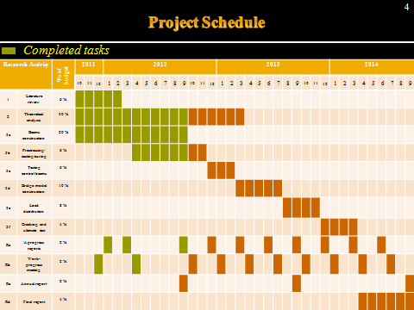

Percent Completions By Category:

By Time- approximately 30% completed.

By Work- approximately 30% completed.

By Budget- approximately 36% completed.

Project Within Budget:
Project expenditures to date- $126,114.
Planned budget for FY 2012- $115,281.
The third 2012 TAC Meeting is scheduled for October 2, 2012. The meeting facilitation will use an Adobe Connect
Webinar feature with the partner state representatives participating from a remote location. Audio will be via conference call.

The principal investigator’s presentation will include two power point presentations plus four media (video) productions of the project’s research activities performed at the LTU Center for Innovative Materials Research (CIMR). The planned meeting will be
approximately 2-1/2 hours in length.

Anticipated work next quarter:

The theoretical analysis will continue through March 2013.

Pre-stressing casting/curing will continue through November 2012.

Testing of the control beams is planned for February/March 2013.

The next planned TAC Meeting will occur mid/late March 2013.

Lead agency will initiate activity to publish a project update fact sheet. The update fact sheet will provide a summary of
research activities performed during the first year of the project and will be used to solicit interest from other states to
join the pooled fund.

Results This Period:

The theoretical analysis and pre-stressing casting/curing activities continue.

Construction of the decked bulb t control beams continue. Four beams were constructed at the LTU laboratory this period.

Circumstance affecting project or budget. (Please describe any challenges encountered or anticipated that
might affect the completion of the project within the time, scope and fiscal constraints set forth in the
agreement, along with recommended solutions to those problems).

Potential Implementation:

