TRANSPORTATION POOLED FUND PROGRAM
QUARTERLY PROGRESS REPORT

Lead Agency (FHWA or State DOT): _FHWA______________________________________

INSTRUCTIONS:
Project Managers and/or research project investigators should complete a quarterly progress report for each calendar quarter during which the projects are active. Please provide a project schedule status of the research activities tied to each task that is defined in the proposal; a percentage completion of each task; a concise discussion (2 or 3 sentences) of the current status, including accomplishments and problems encountered, if any. List all tasks, even if no work was done during this period.

Transportation Pooled Fund Program Project #  (i.e, SPR-2(XXX), SPR-3(XXX) or TPF-5(XXX)  TPF-5(279) |  | Transportation Pooled Fund Program - Report Period:  □Quarter 1 (January 1 – March 31)  □Quarter 2 (April 1 – June 30)  □Quarter 3 (July 1 – September 30)  Quarter 4 (October 1 – December 31)
Project Title:
High Performance Computational Fluid Dynamics (CFD) Modeling Services for Highway Hydraulics

Name of Project Manager(s):  Kornel Kerenyi | Phone Number:  (202) 493-3142 |  | E-Mail  kornel.kerenyi@fhwa.dot.gov
Lead Agency Project ID: | Other Project ID (i.e., contract #): |  | Project Start Date:
Original Project End Date: | Current Project End Date: |  | Number of Extensions:

Project schedule status:
On schedule □ On revised schedule □ Ahead of schedule □ Behind schedule

Overall Project Statistics:
Total Project Budget | Total Cost to Date for Project | Percentage of Work  Completed to Date

Quarterly Project Statistics:
Total Project Expenses  and Percentage This Quarter | Total Amount of Funds  Expended This Quarter | Total Percentage of  Time Used to Date

Project Description:

The Federal Highway Administration established an Inter-Agency Agreement (IAA) with the Department of Energy’s (DOE) Argonne National Laboratory (ANL) Transportation Analysis Research Computing Center (TRACC) to get access and support for High Performance Computational Fluid Dynamics (CFD) modeling for highway hydraulics research conducted at the Turner-Fairbank Highway Research Center (TFHRC) Hydraulics Laboratory. TRACC was established in October 2006 to serve as a high-performance computing center for use by U.S. Department of Transportation (USDOT) research teams, including those from Argonne and their university partners. The objective of this cooperative project is to:

- Provide research and analysis for a variety of highway hydraulics projects managed or coordinated by State DOTs.
- Provide and maintain a high performance Computational Fluid Dynamics (CFD) computing environment for application to highway hydraulics infrastructure and related projects
- Support and seek to broaden the use of CFD among State Department of Transportation employees.

The work includes:

- Computational Mechanics Research on a Variety of Projects: The TRACC scientific staff in the computational mechanics focus area will perform research, analysis, and parametric computations as required for projects managed or coordinated by State DOTs.
- Computational Mechanics Research Support: The TRACC support team consisting of highly qualified engineers in the CFD focus areas will provide guidance to users of CFD software on an as needed or periodic basis determined by the State DOTs.
- Computing Support: The TRACC team will use the TRACC clusters for work done on projects; The TRACC system administrator will maintain the clusters and work closely with the Argonne system administrator’s community; The TRACC system administrator will also install the latest versions of the STAR-CCM+ CFD software and other software that may be required for accomplishing projects.

Progress this Quarter (includes meetings, work plan status, contract status, significant progress, etc.):

1: Computational Mechanics Research on a Variety of Projects
1.1: Hydroplaning water film thickness modeling on rough and permeable surfaces
There is an increased interest in using permeable pavements instead, or as addition to, conventional non-porous surfaces. The top surface of a permeable pavement can be either porous as to allow the fluids to flow through it, or it can be built of nonporous elements with gaps in between them. Examples of porous paving materials are: porous asphalt, pervious concrete, open graded friction courses, etc. Permeable pavements manage runoff from paved surfaces, make it possible for water to reach underlying soils or drain it to the sides of the road, and therefore reduce downstream flooding and reduce road side and stream bank erosion.
The researchers at Argonne’s Transportation Research and Analysis Computing Center were asked to come up with possible approaches to model these type of structures. There are a number of approaches to model porous phases, from very simple to more complex ones. The top of a porous surface may be approximated with a wall boundary condition with assigned porosity characteristics; the porous layer is represented by a volume with assigned porosity and permeability characteristics; the geometry of separate grains forming the porous layer is included in the computational domain. The last approach is the most complex, but also the most accurate. It resolves the flow around particles and therefore it has the least reliance on physics models. A methodology was developed to build irregular porous layers made of grains of different sizes and shapes.

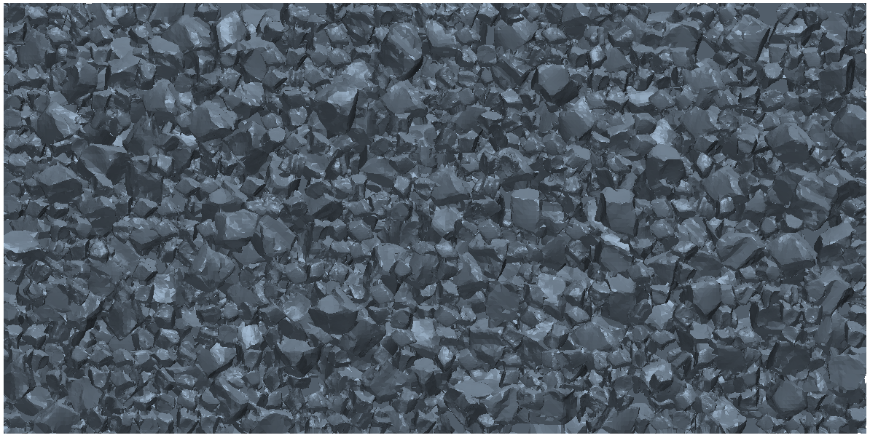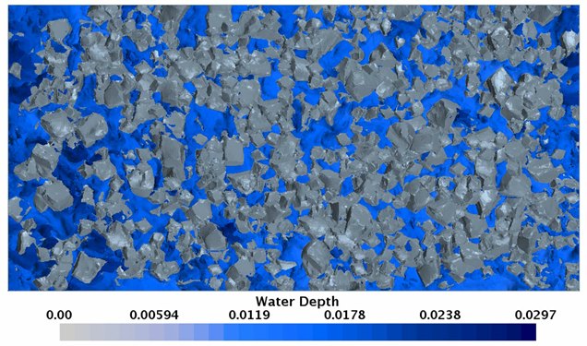
Figure 1. Top view of the geometry of a developed rough and porous layer (left), and a top view of an example water flow through the porous layer (right).

The approach can also be used to analyze flow on rough and non-porous pavements, if there is a necessity of representing a road surface more accurately.

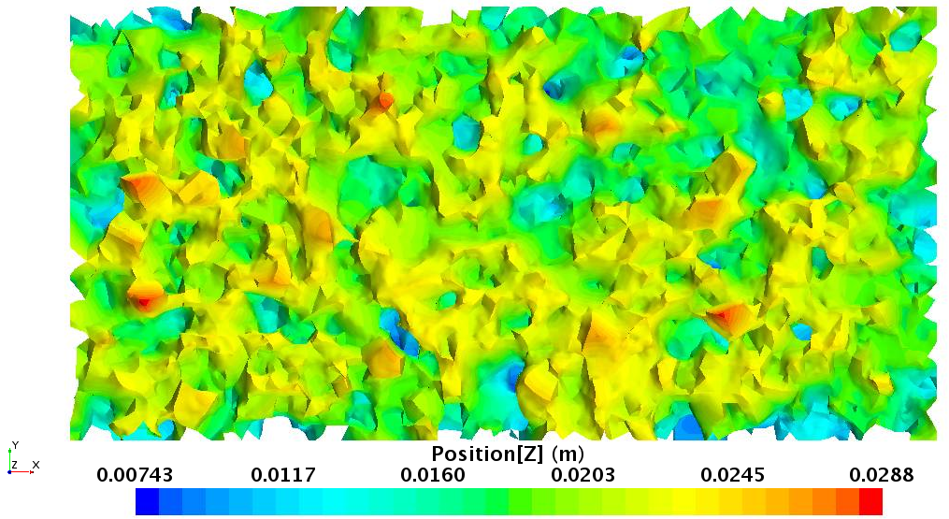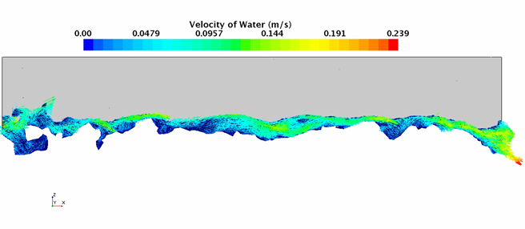

Figure 2. Top view of the geometry of a developed rough layer (left), and a cross section of the domain showing velocity of water (right).

1.2: Hydraulic study of a SCDOT catch basin CB25
The engineers at South Carolina DOT, SCDOT, designed a new type of a catch basin with a grate, Type 25 (CB25), to use as drainage on South Carolina’s freeways. As CB25 is a relatively new design, there is a need to perform a hydraulic study and assess the hydraulic performance of the new design. The researchers at Argonne TRACC were asked to perform CFD analysis that will yield the following results: (a) efficiency curves as function of the spread or volume flow rate, the longitudinal slope, and the shoulder width, (b) the flow spread along the roadway in the vicinity the catch basin inlet, and (c) drainage area curves used for designing the spacing between drains.
A report will be provided to SCDOT, which will include information about the methods of development of the efficiency and drainage area curves, and also instructions on how to use them in the design process. This will allow SCDOT to modify and create new design information due to changes in roadway and hydraulic design requirements.
The test case matrix includes simulations for: 4 shoulder widths, 5 or more longitudinal slopes, and initially 5 spread width values for each case set. Total number of cases is equal to 100. First few cases from the matrix were modelled and the efficiency of the grate was established for those conditions.

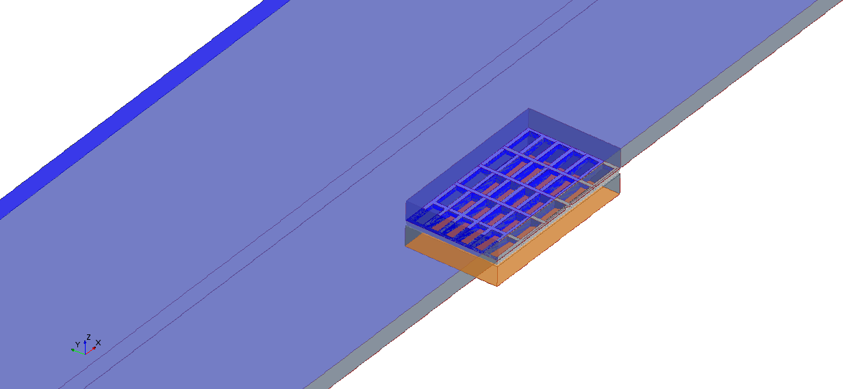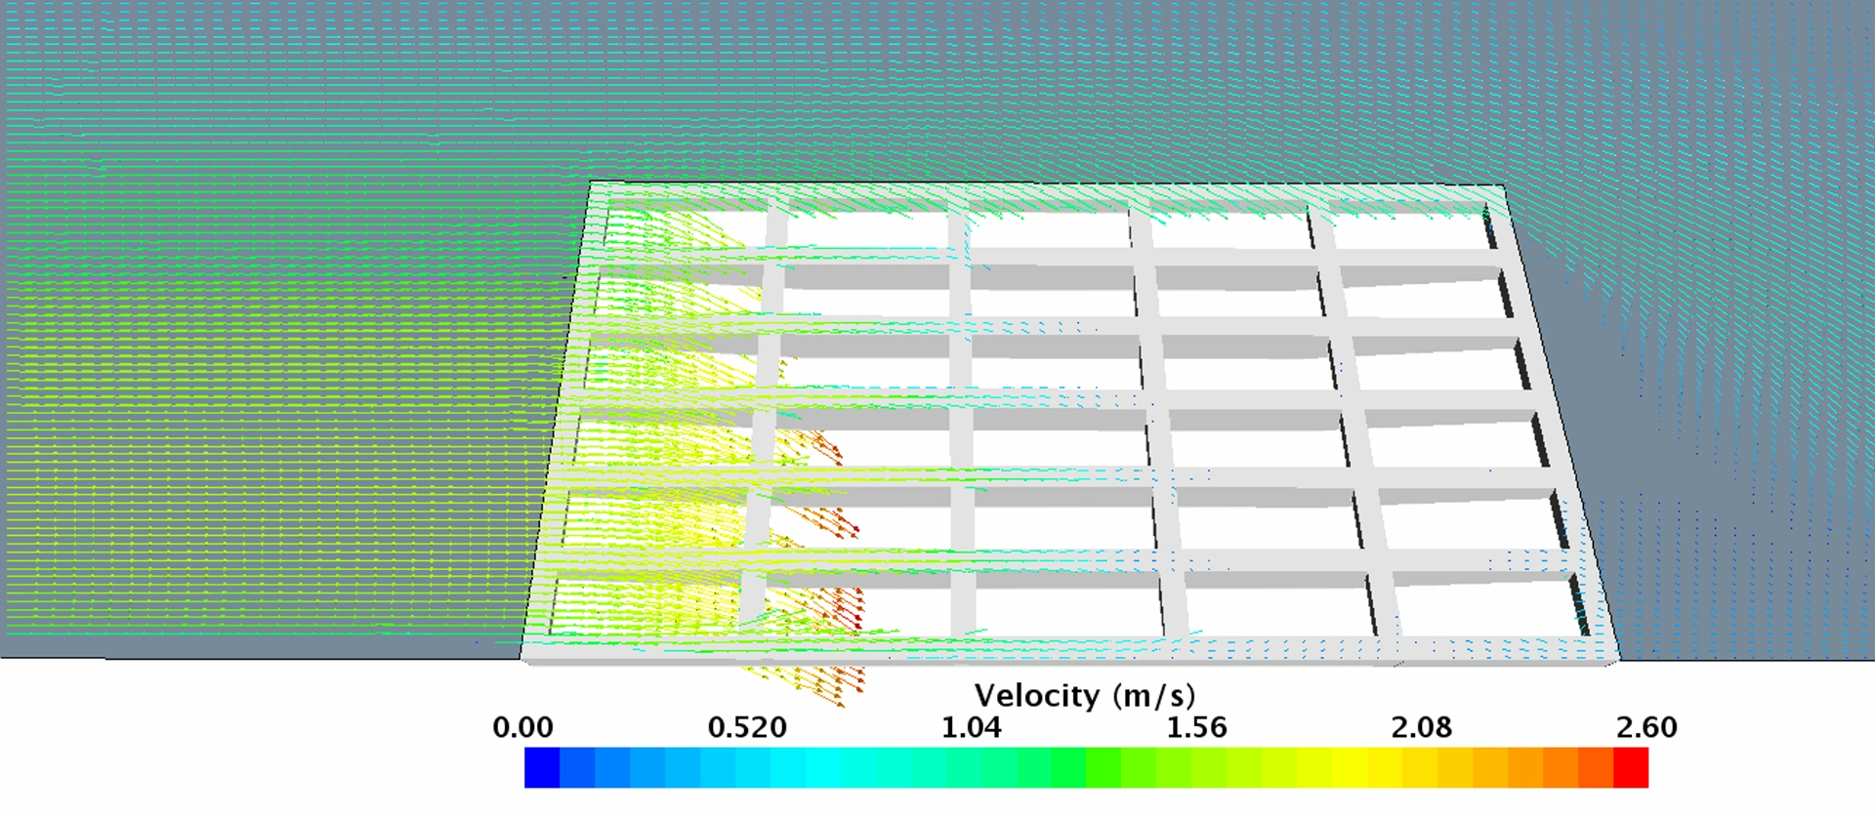
Figure 3. Geometry of the domain in the vicinity of the grate (left), and an example water outflow through the grate (right).

2: Computational Mechanics Research Support

Argonne Transportation Research and Analysis Computing Center (TRACC) computational mechanics staff ran nationwide videoconferences every other Thursday that were open to state Department of Transportation staff and university researchers supported by the Federal Highway Administration or state DOTs. The videoconferences provide a venue to discuss approaches and issues related to hydraulics modeling projects. Topics during this reporting period included, but were not limited to:
- new methodologies of scour modeling
- recommendations for rockery analysis and design
- approaches to modeling and mitigating hydroplaning risk

3: Computing Support

Routine cluster maintenance including software and hardware upgrades, security patching against cyber threats, and development of custom tools to increase users' productivity. Currently working on upgrading existing TRACC cluster to support the latest scientific and engineering software utilizing industry's best practice guidelines in Open Source software and virtualization.
Anticipated work next quarter:

1: Computational Mechanics Research on a Variety of Projects

- development of a new methodology for river bed scour
- modeling permeable pavements
- hydraulic analysis of a catch basin
- analysis of hydrodynamic forces acting on rockeries in river environment

2: Computational Mechanics Research Support

This work will continue.

Task 3: Computing Support

This work will continue.

Circumstance affecting project or budget. (Please describe any challenges encountered or anticipated that
might affect the completion of the project within the time, scope and fiscal constraints set forth in the
agreement, along with recommended solutions to those problems).

None.

