Click here to enter Program or Project Title
Progress Report – Click here to enter a date.

Title: Assessment and Repair of Prestressed Bridge Girders Subjected to Over-height Truck Impacts Pooled Fund Project

Project Number: TR202011

Principal Investigator (PI): Mohamed ElGawady PhD (PI)
Co-PI(s): William Schonberg PhD, PE (Co-PI)

Award date: | 1/1/2021
Scheduled completion date: | 12/31/2023 | % of project completed to date: | 81%
Total budget: | $805,000 | % of budget expended to date: | 72%
Draft report due: | 9/30/2023 | Final report due: | 12/1/2023

Provide a short description of the work currently underway.
Use additional notes section if you need to provide more information.

Task 2. Experimental testing of bridge girders subjected to lateral impacts:
- 2nd girder is being prepared for testing and will be ready for testing in two weeks after modifying the test setup to revise the boundary conditions.
- A second set of beams (five girders) is placed at Core slab (see pictures 1 through )

Provide a short description of the noteworthy activities/accomplishments during this reporting period.
Use additional notes section if you need to provide more information.

Task 5: Repair Evaluation:
- Preparing the flexural testing of the 1st repaired beam. Fig. 2 through 5 show the repaired beam and main results.

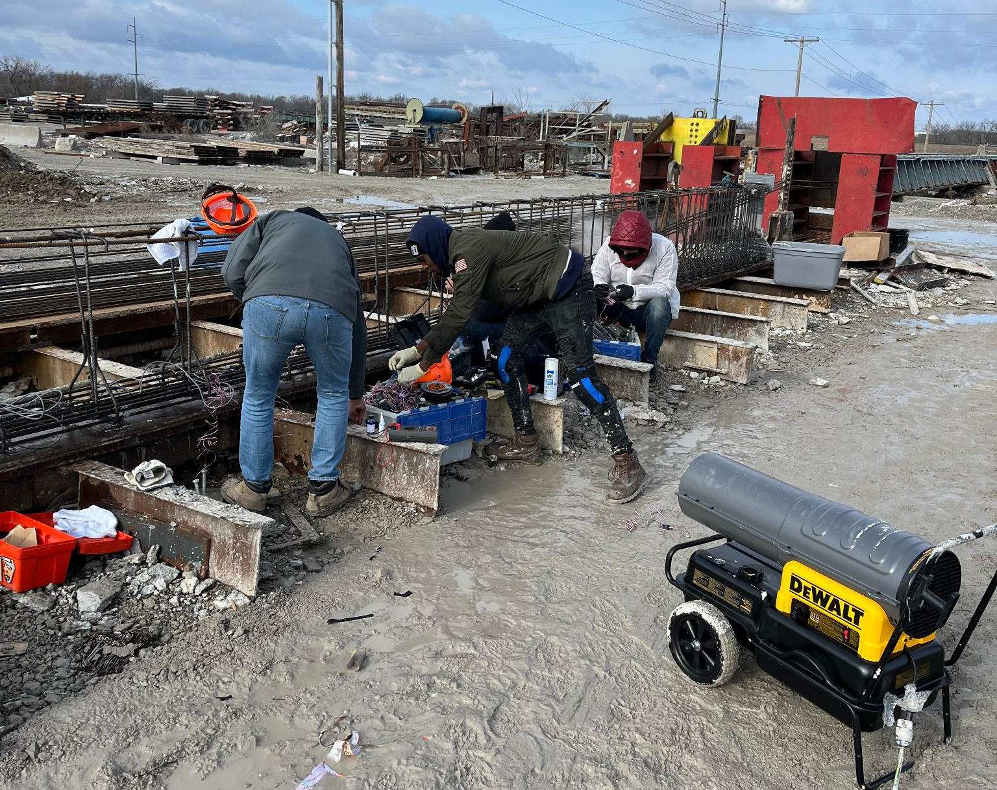
(a)
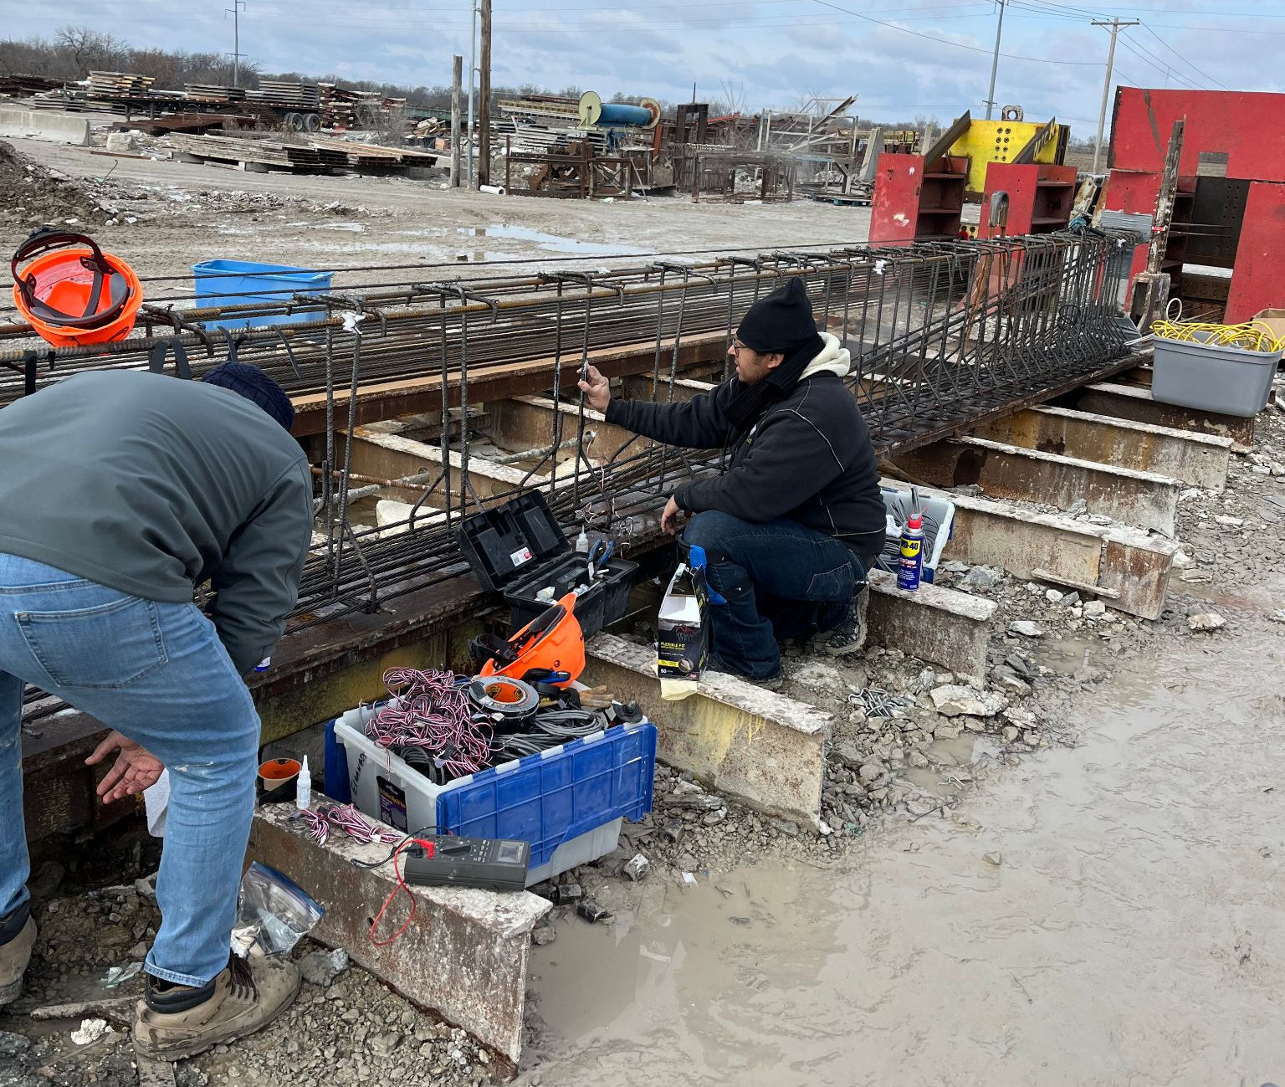
(b)
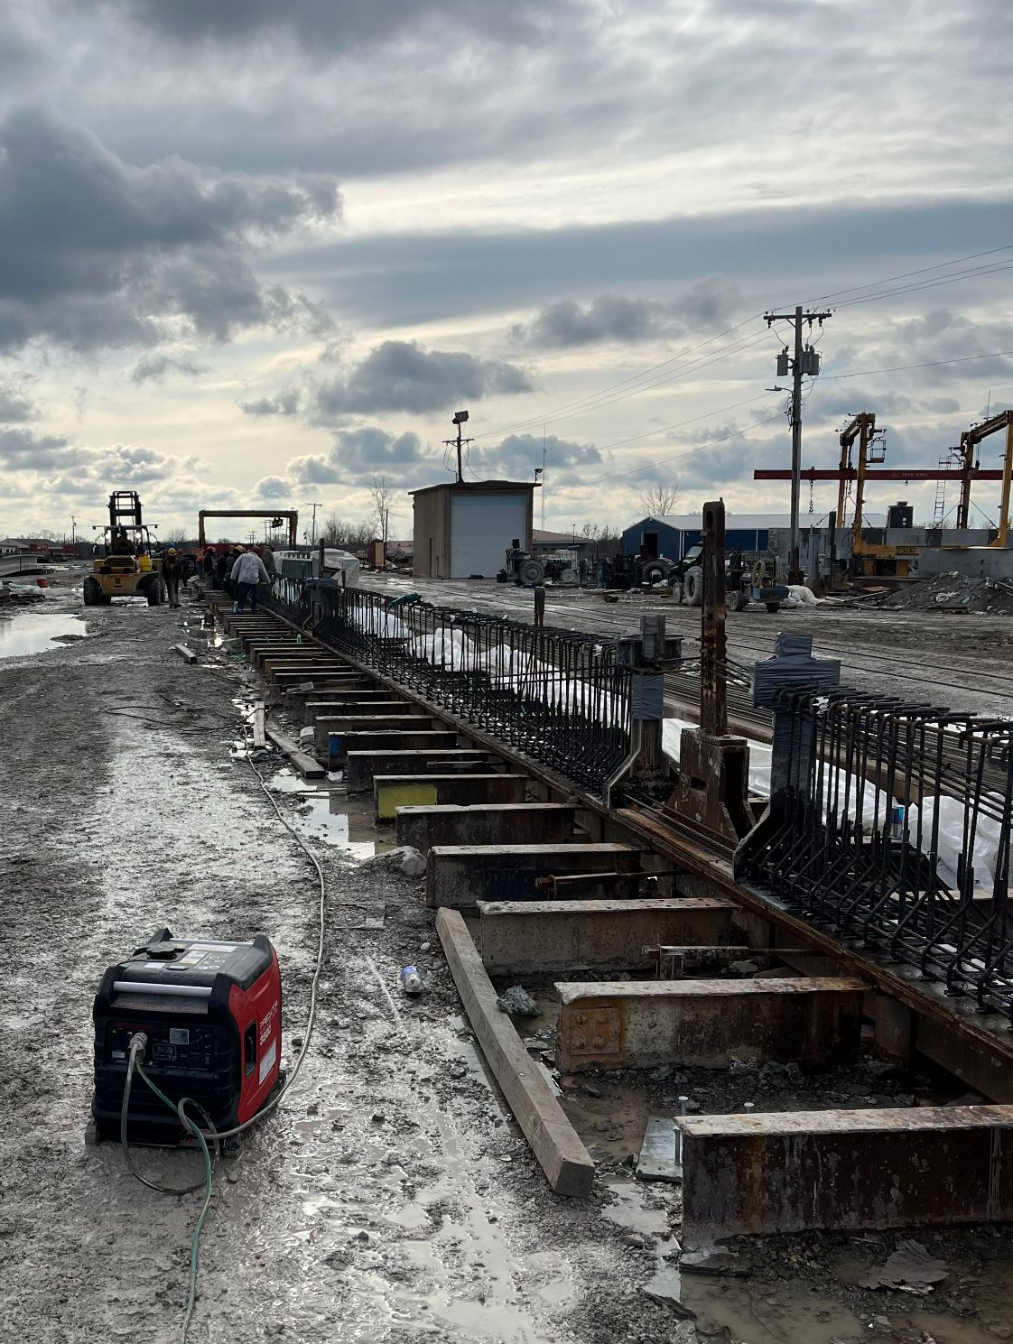
(c)
Fig. 1: Placing strain gauges on steel cages for the second set of girders.

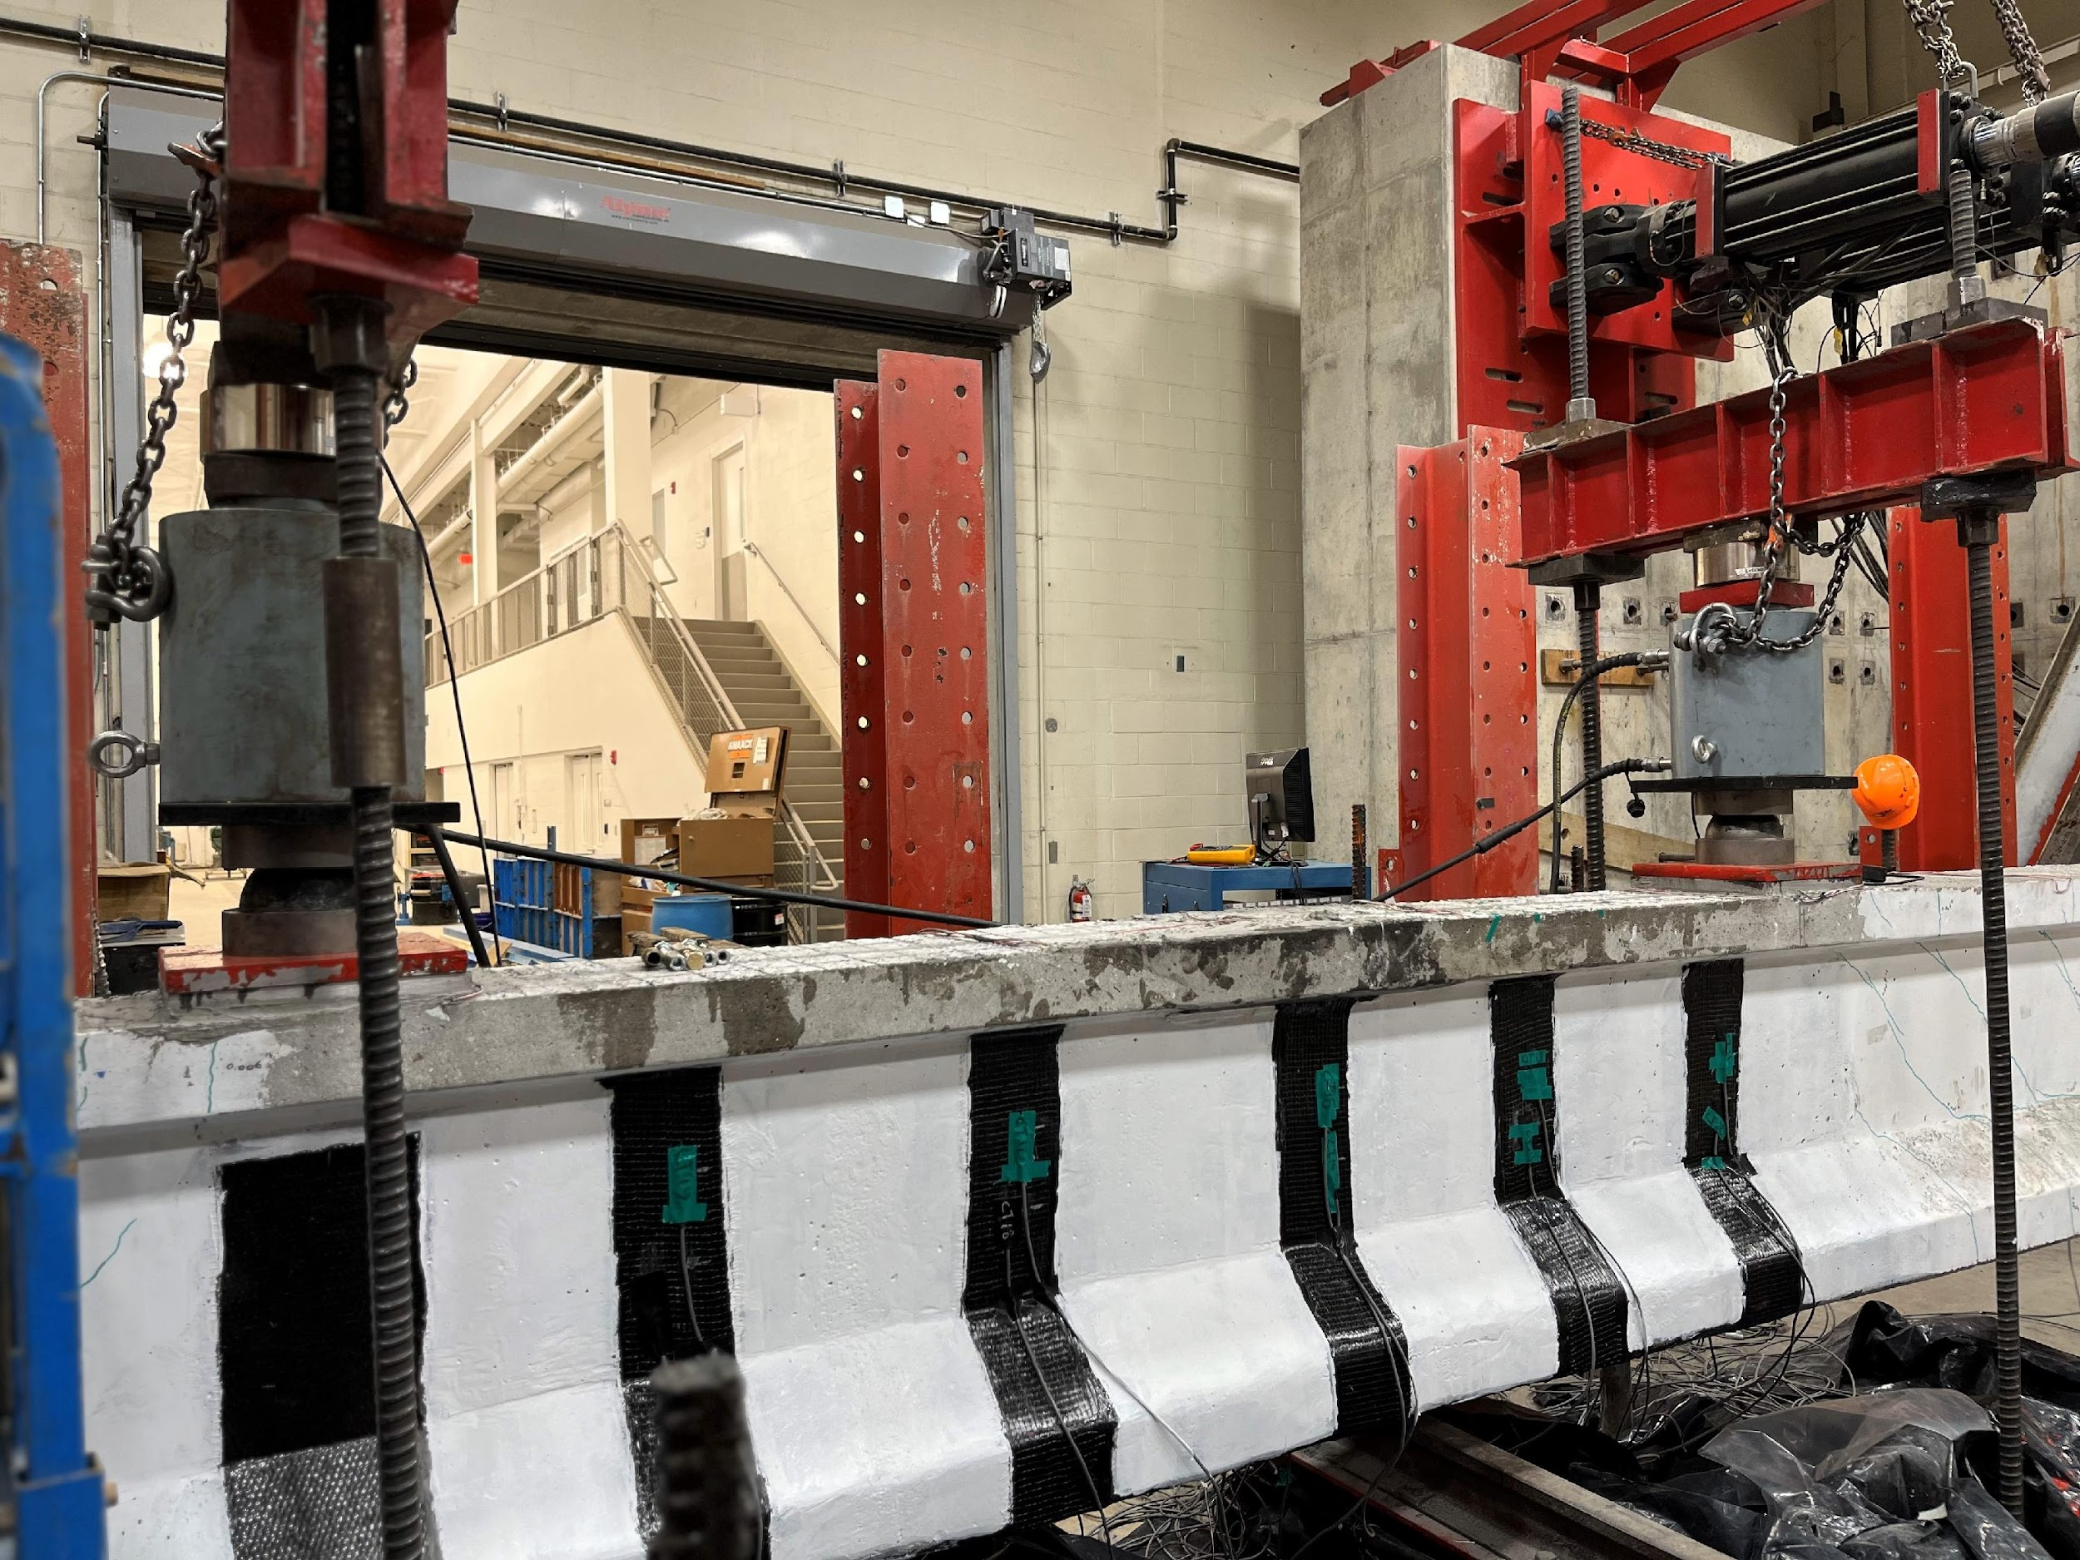 | 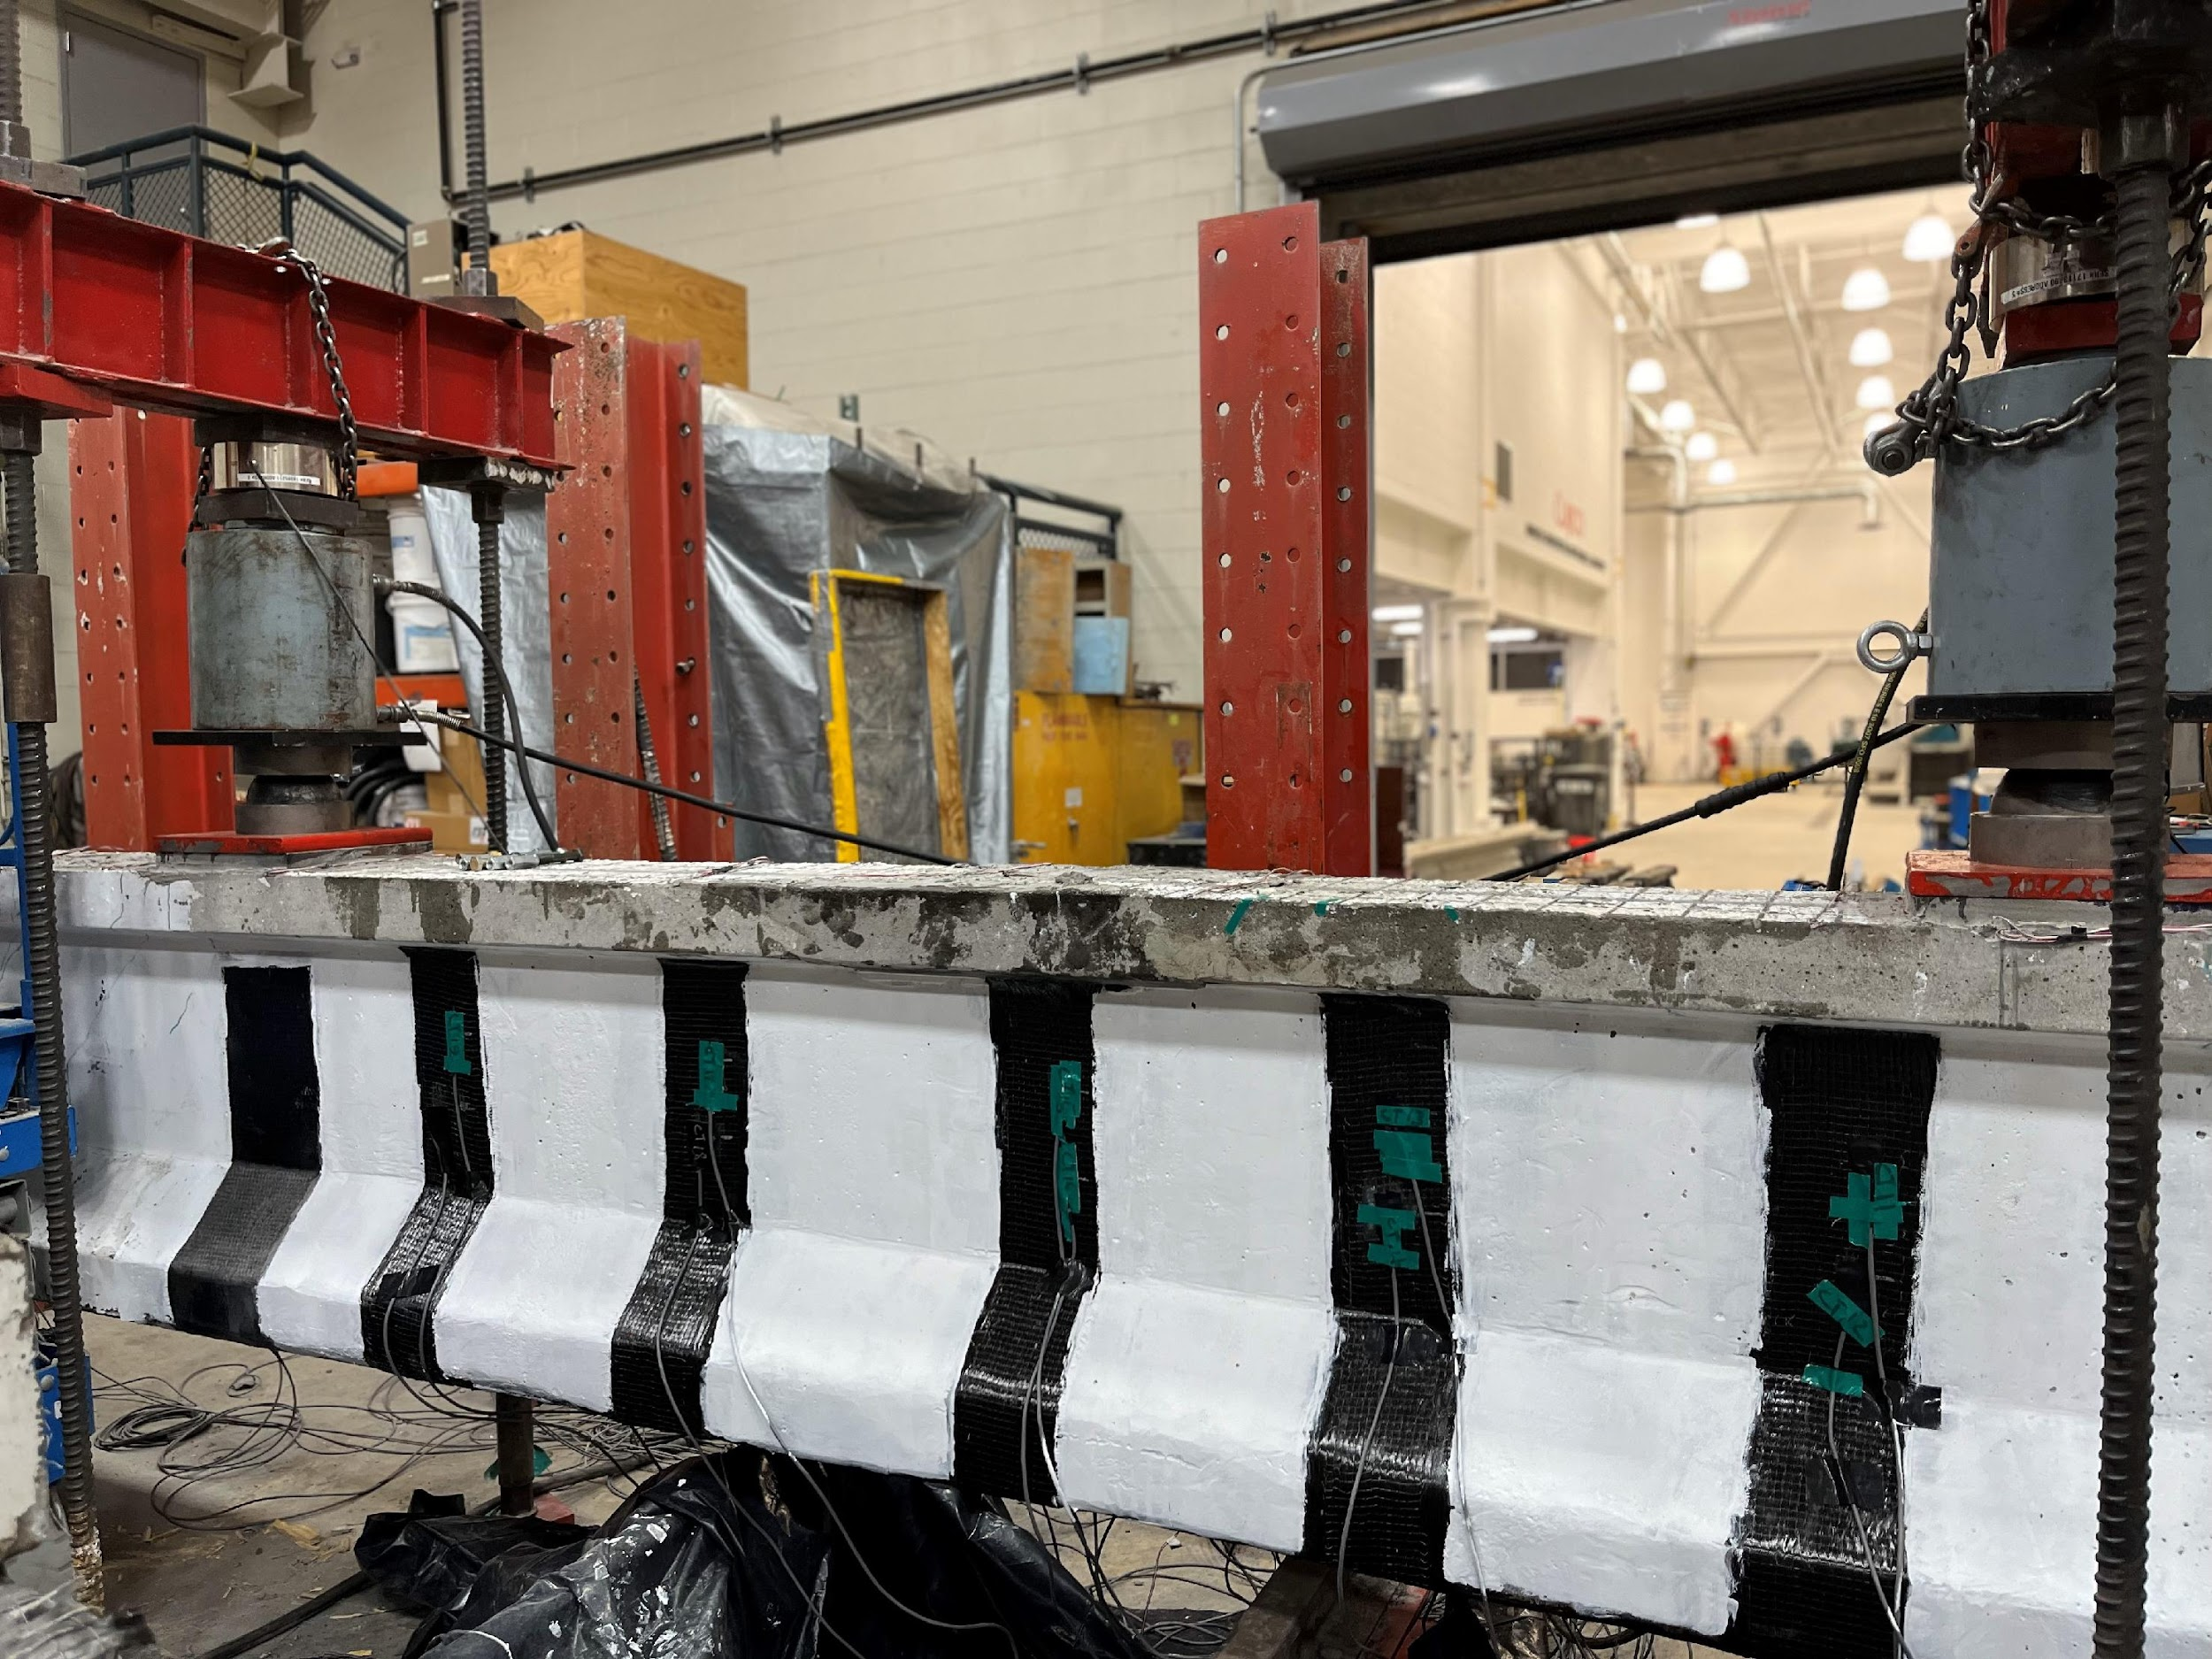
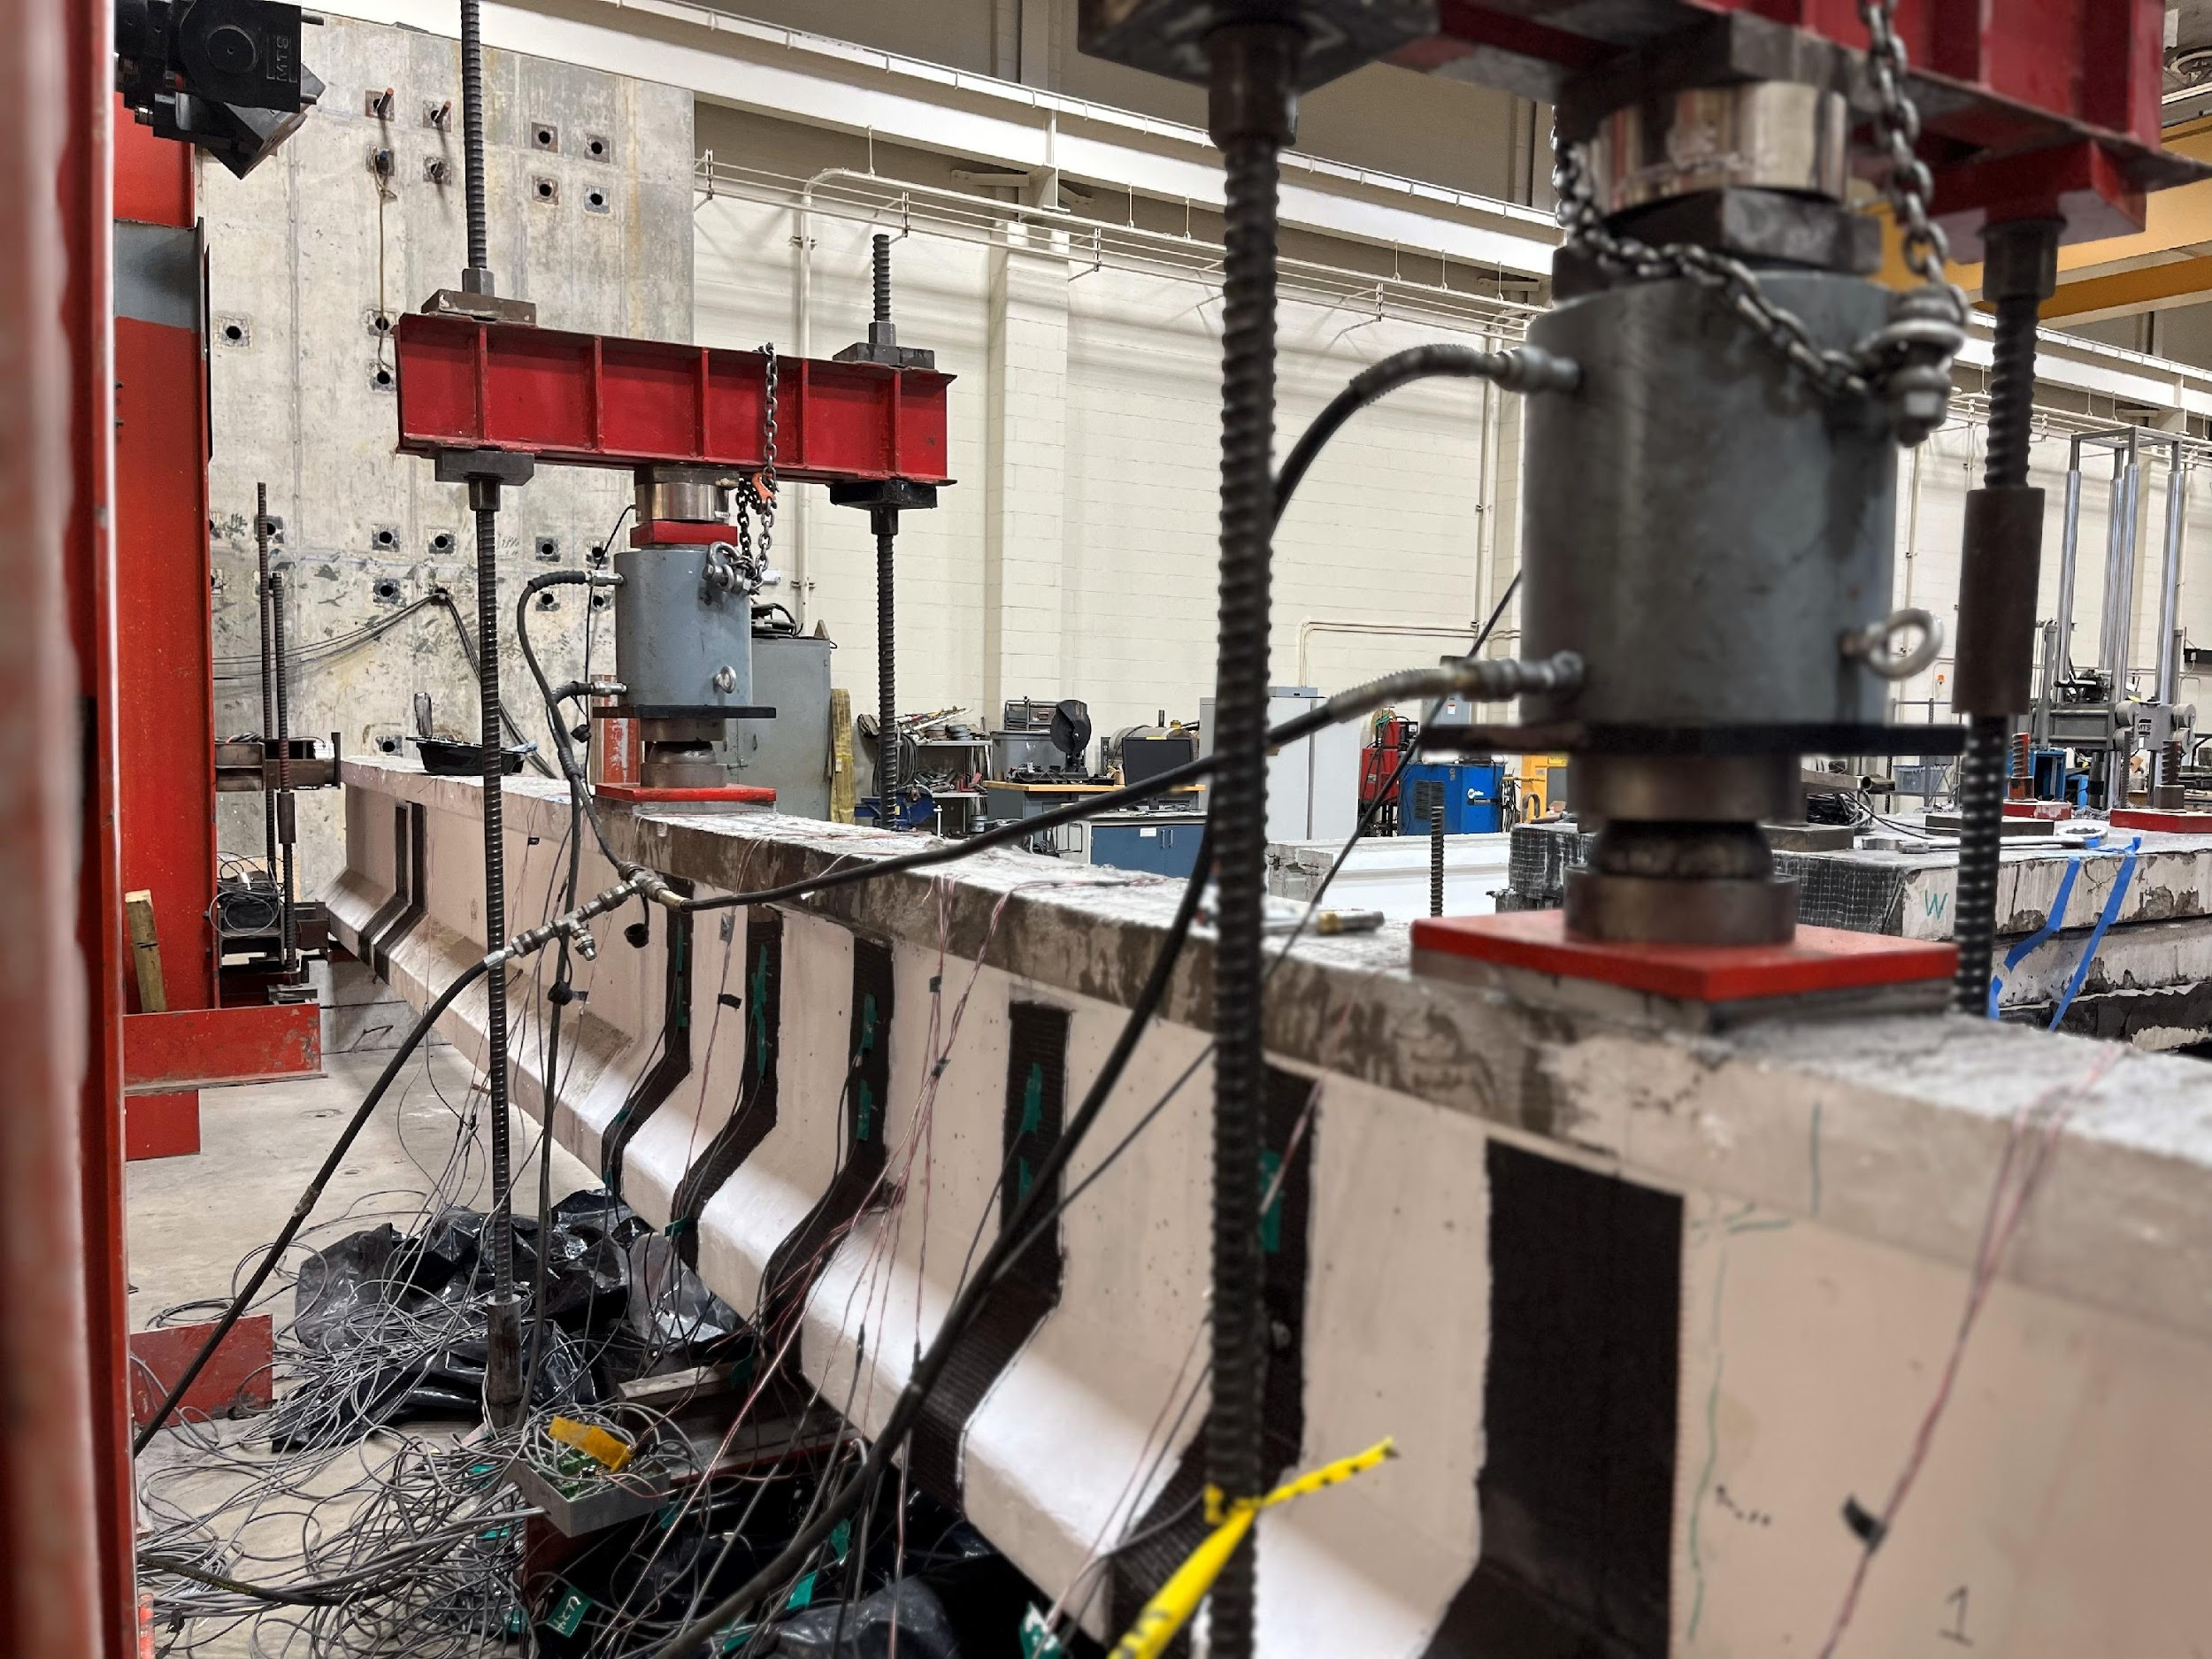 | 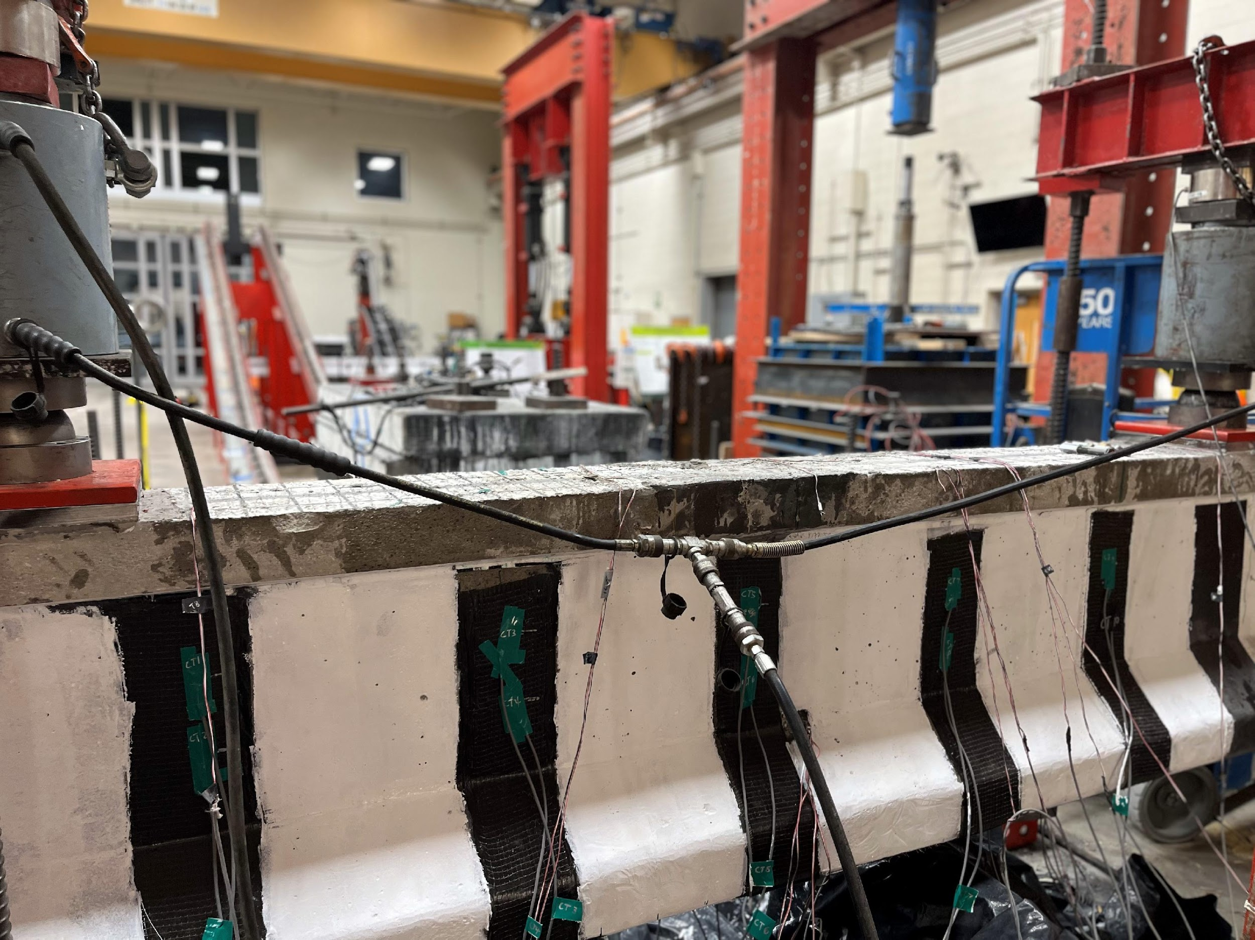
Fig. 2: Repaired beam 1 ready for testing (a) Front view of repaired girder, and (b) Rear view of the repaired girder with flexural test setup

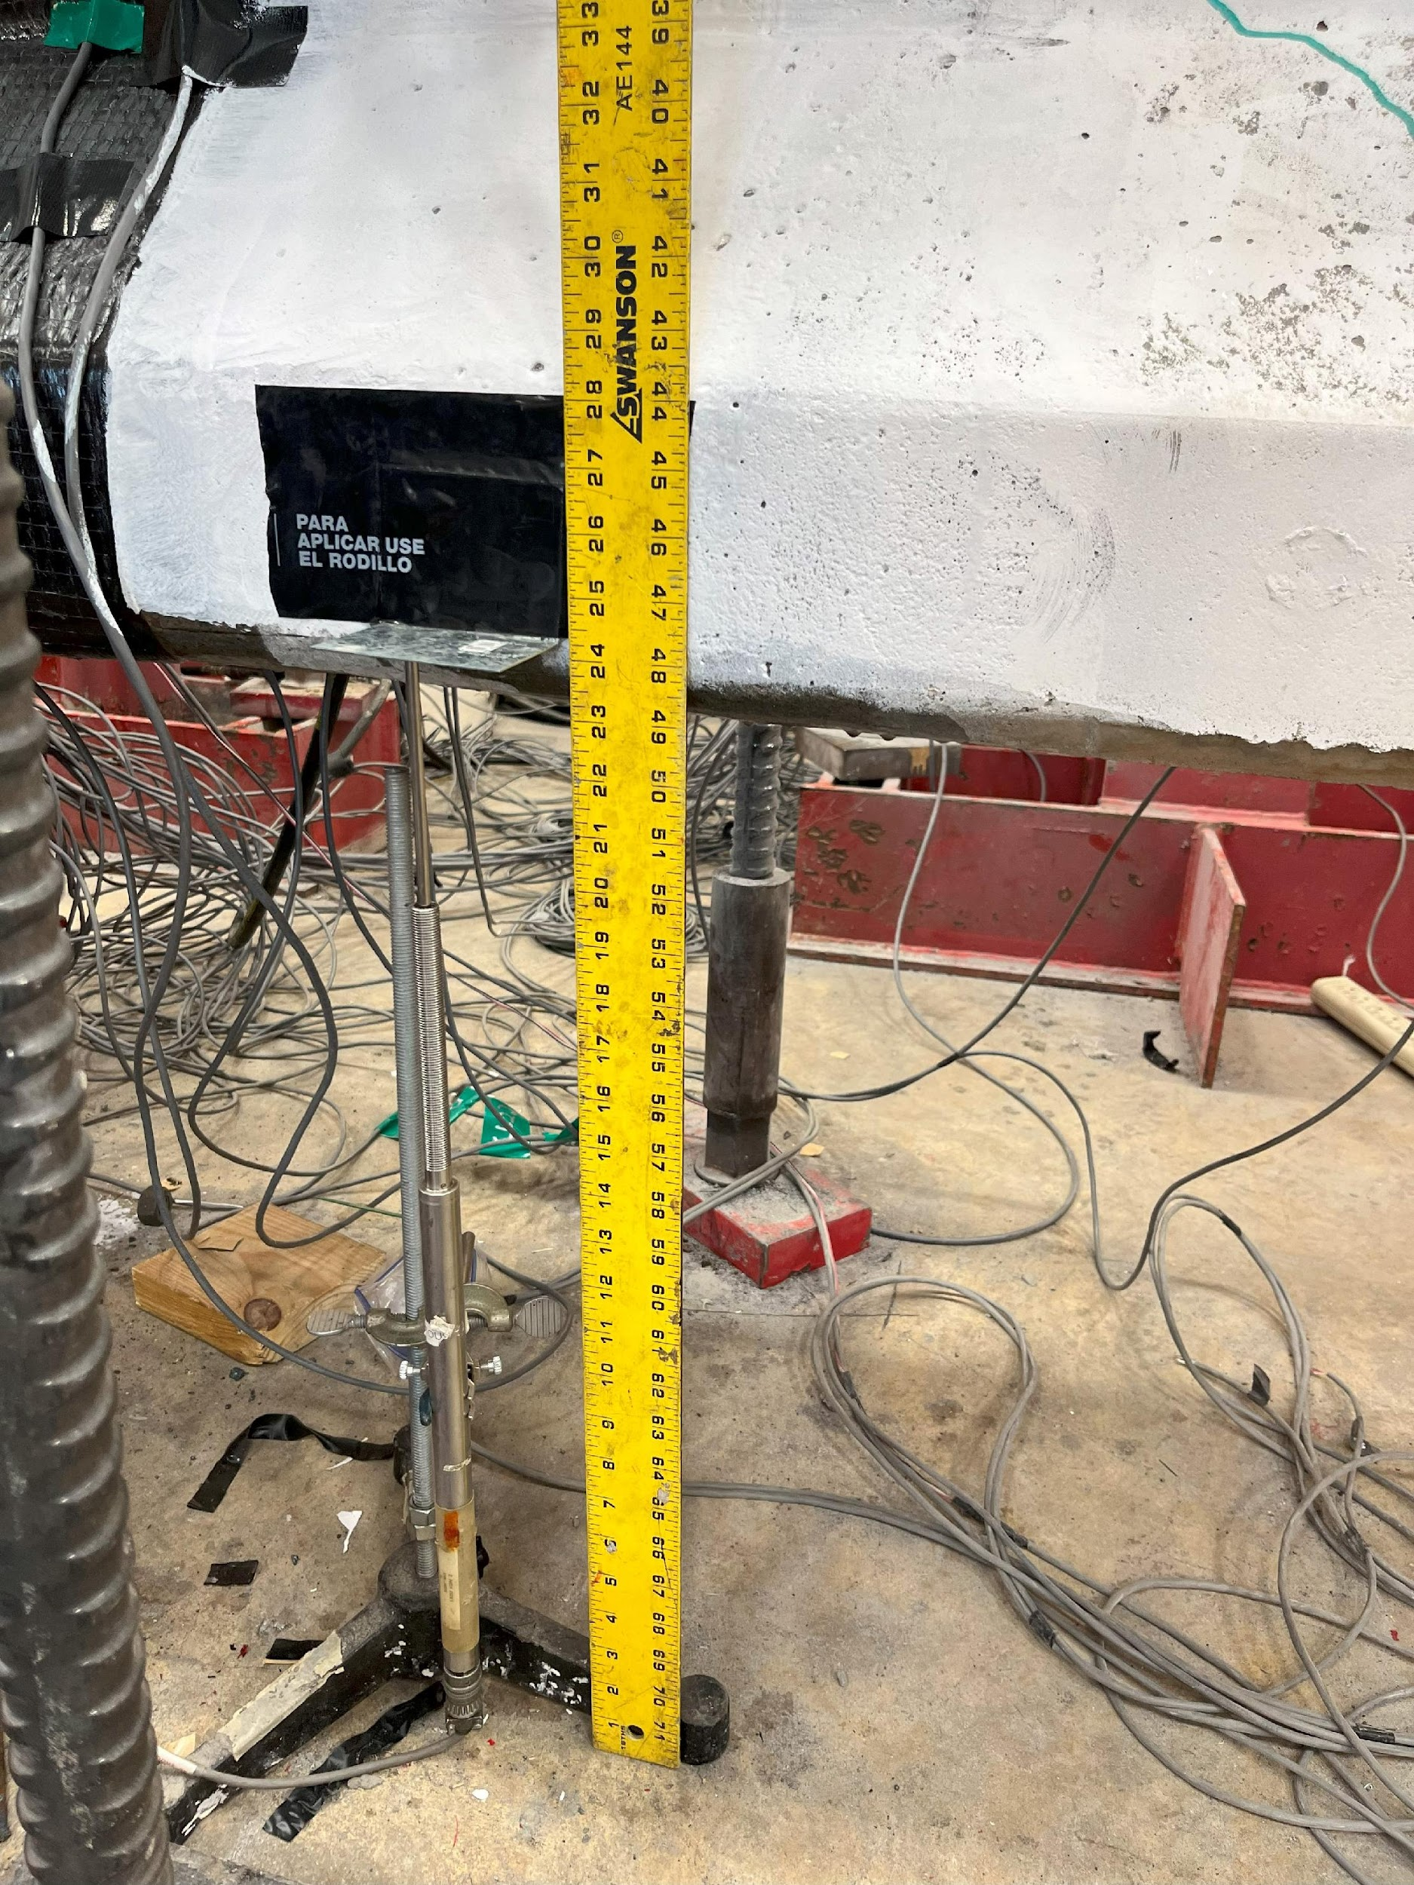
Fig. 3: Measuring the beam deflection at mid-span using LVDT

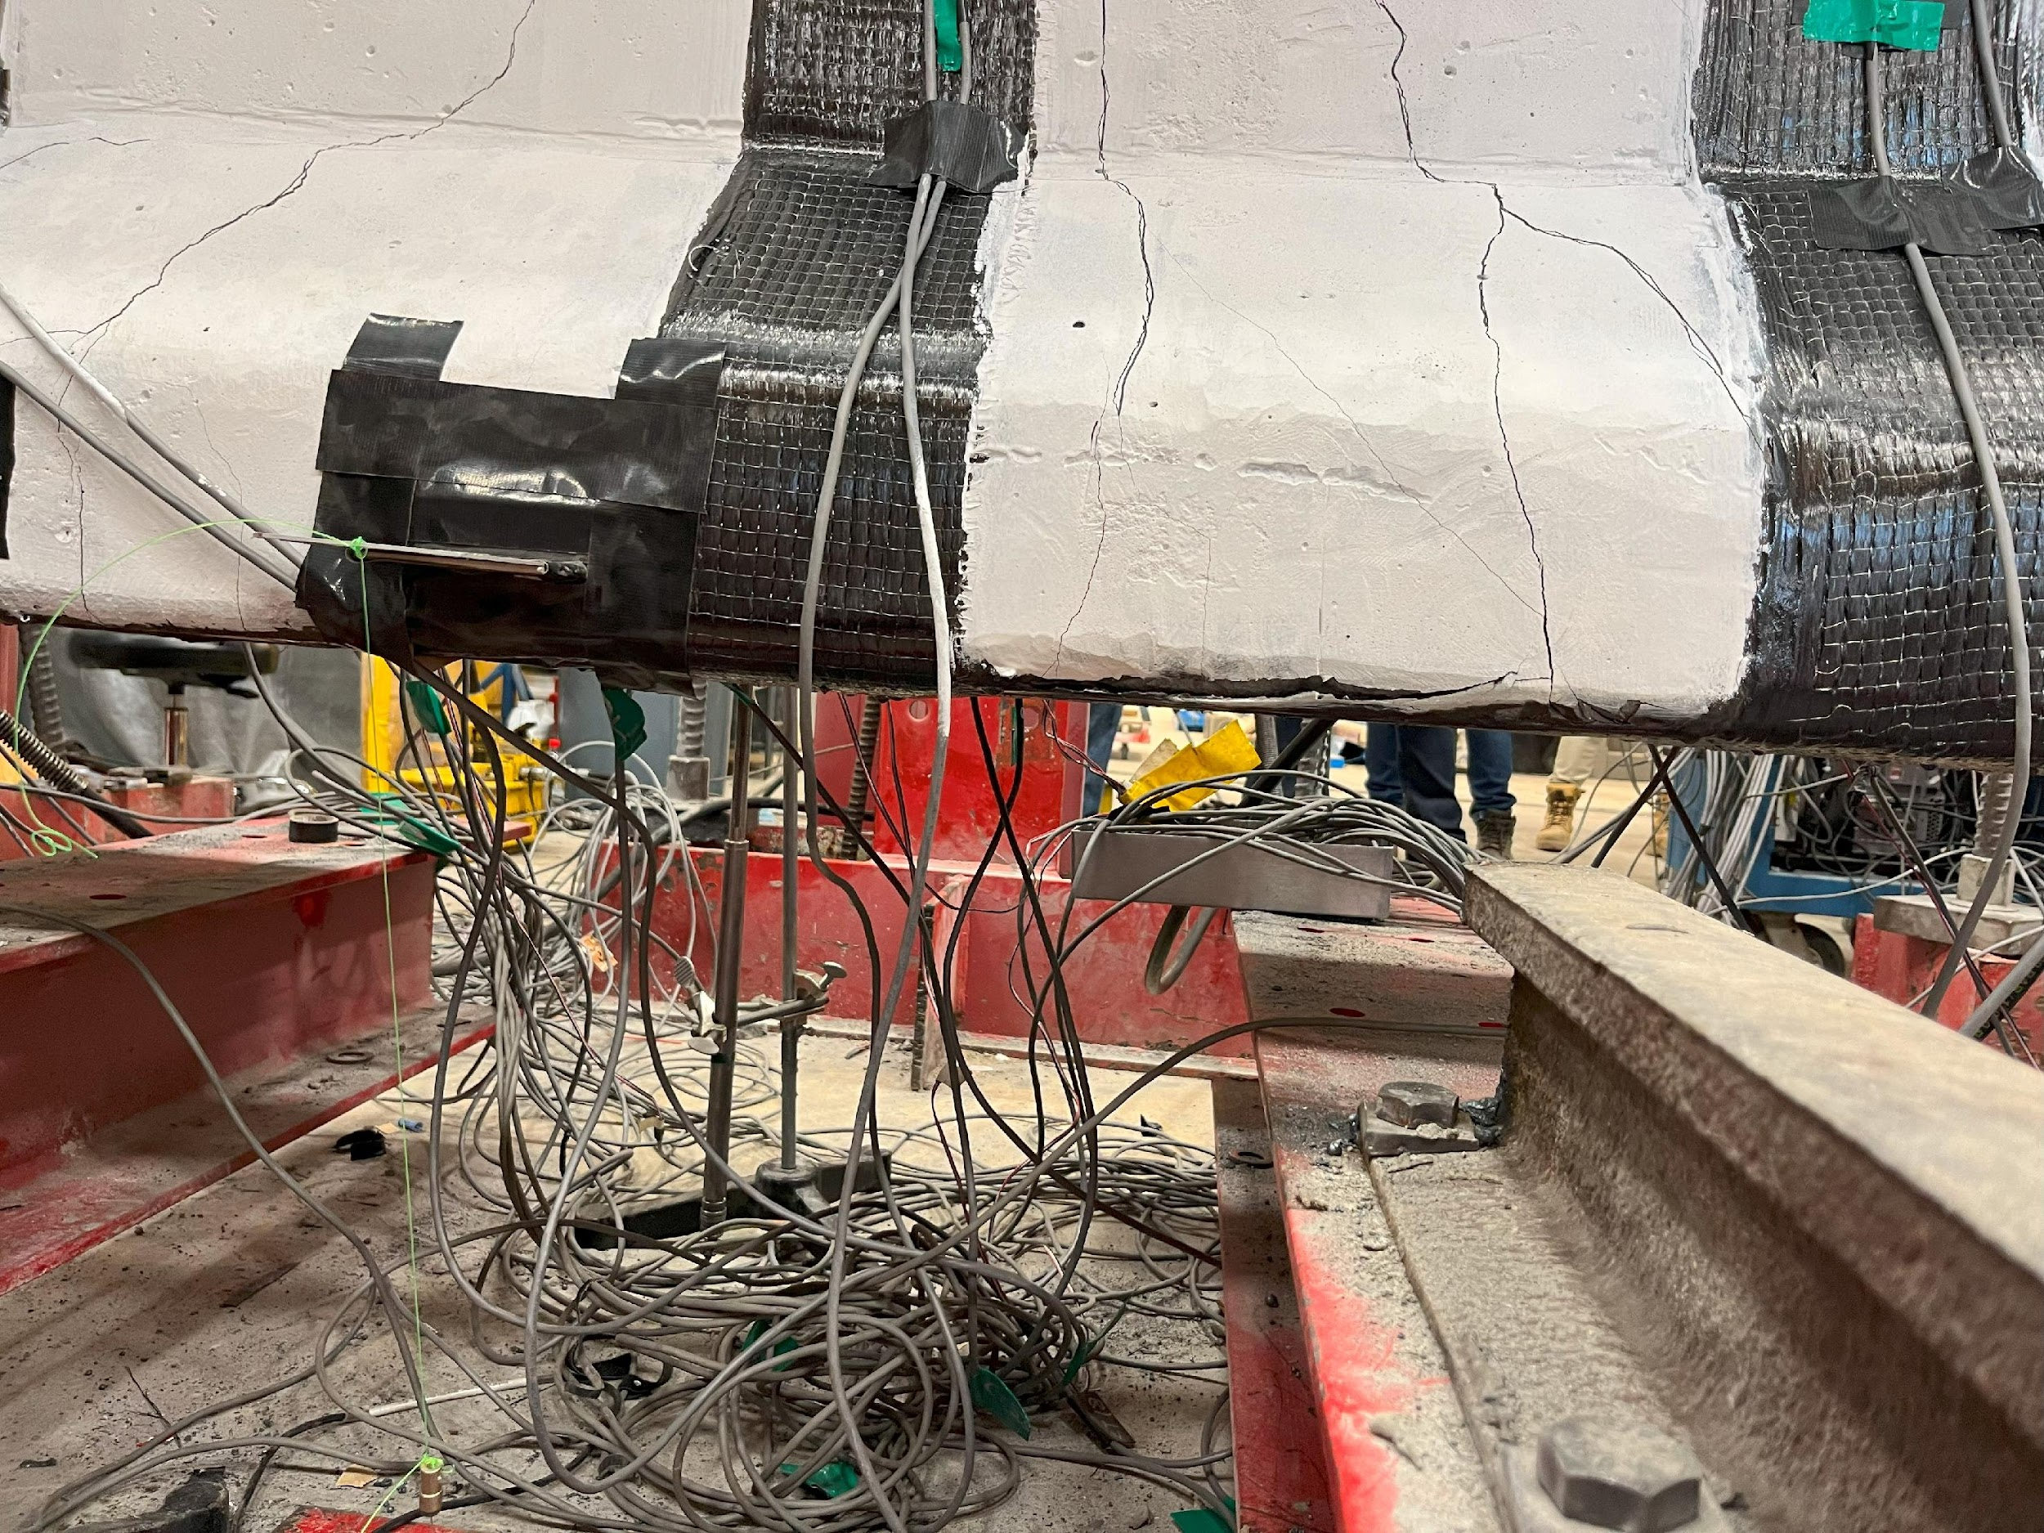 | 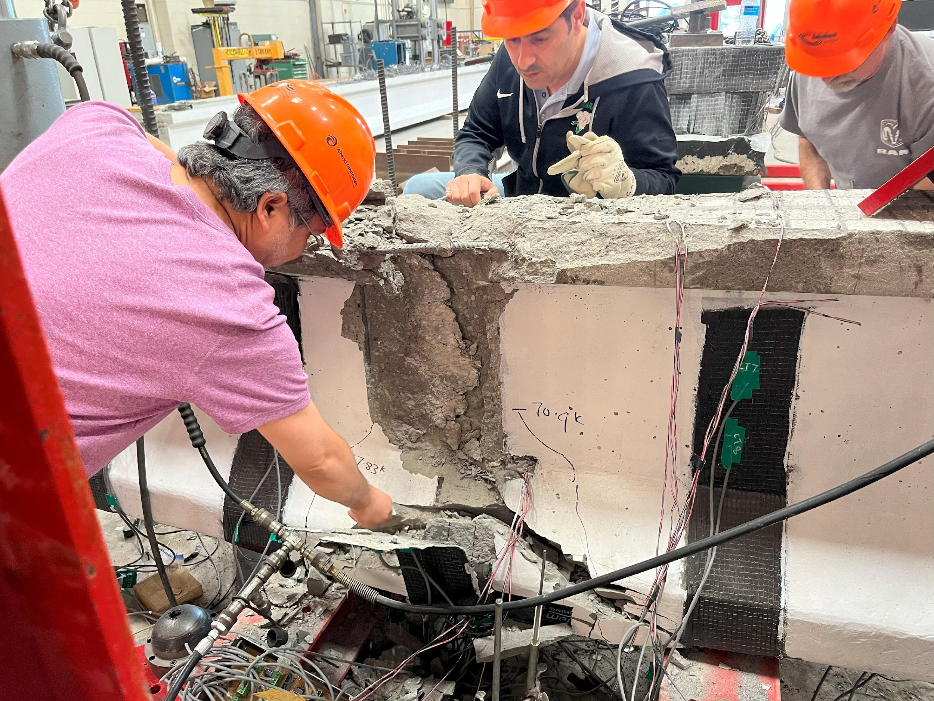
(a) | (b)
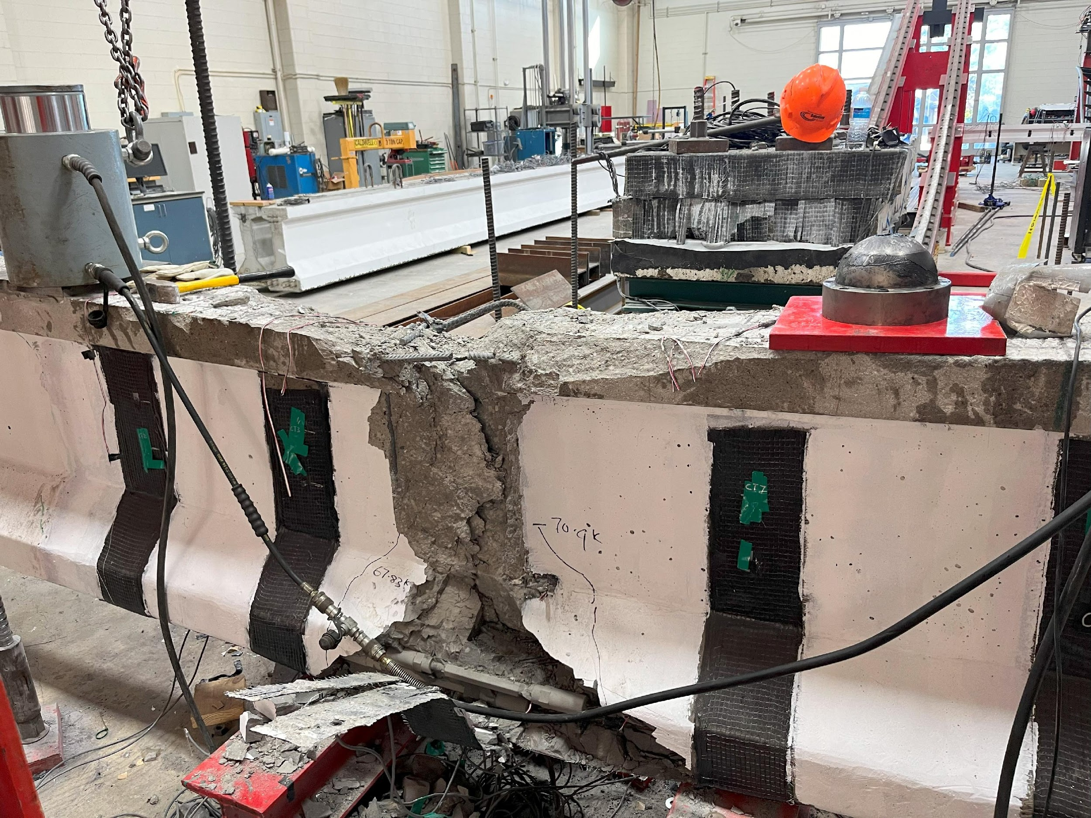 | 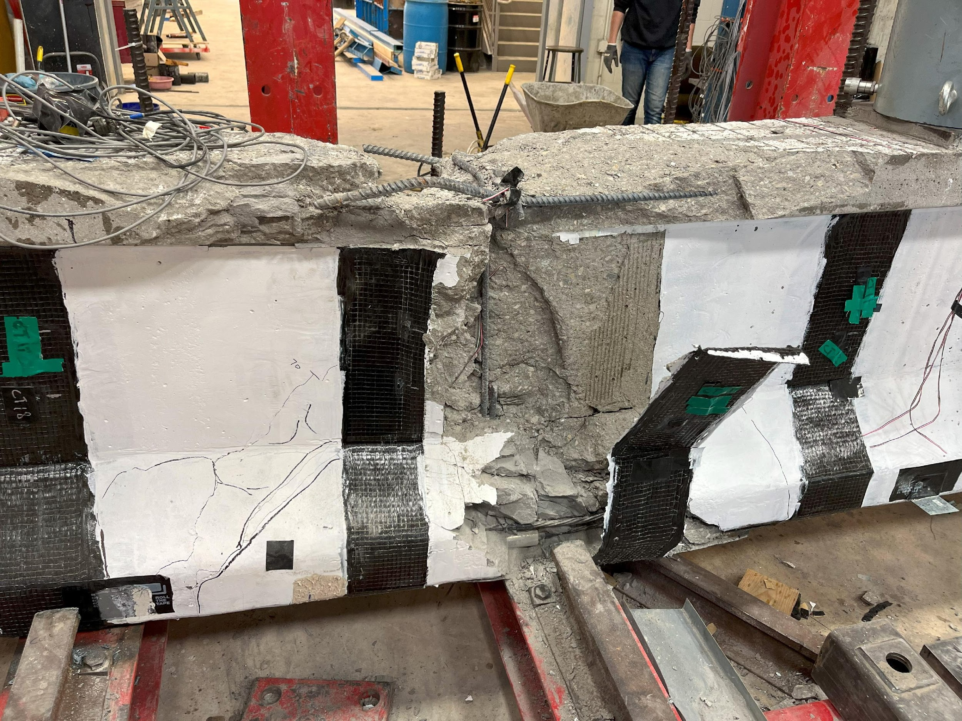
(c)
Fig. 4: Damage of the strengthened beam (a) Flexure-shear crack at 70 kips, (b) Debonding of Transverse CFRP, and (c) Rear view of damaged beam

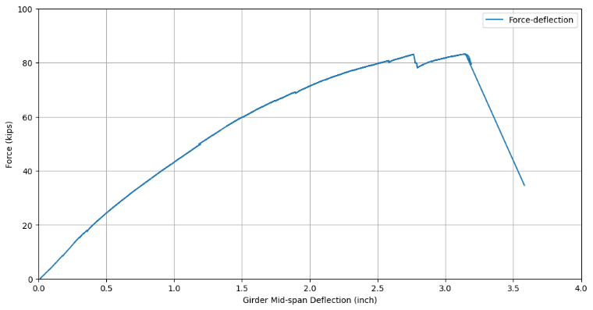 | 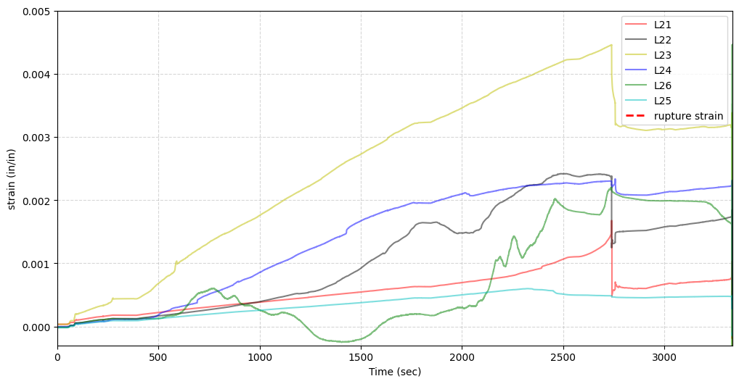
(a) | (b)
Fig. 5: Test results (a) Load - deflection curve at midspan of girder, and (b) Longitudinal FRP strains

