TRANSPORTATION POOLED FUND PROGRAM
QUARTERLY PROGRESS REPORT

Lead Agency (FHWA or State DOT): Oklahoma Department of Transportation

INSTRUCTIONS:
Project Managers and/or research project investigators should complete a quarterly progress report for each calendar quarter during which the projects are active. Please provide a project schedule status of the research activities tied to each task that is defined in the proposal; a percentage completion of each task; a concise discussion (2 or 3 sentences) of the current status, including accomplishments and problems encountered, if any. List all tasks, even if no work was done during this period.

Transportation Pooled Fund Program Project #  TPF-5(297) |  | Transportation Pooled Fund Program - Report Period:  O Quarter 1 (January 1 – March 31)  O Quarter 2 (April 1 – June 30)  X Quarter 3 (July 1 – September 30)  O Quarter 4 (October 1 – December 31)
Project Title:
Improving Specifications to Resist Frost Damage in Modern Concrete Mixtures

Name of Project Manager(s):  Tyler Ley | Phone Number:  405-744-5257 |  | E-Mail  Tyler.ley@okstate.edu
Lead Agency Project ID:  TPF-TPF5(297)RS / JOB PIECE 30802(04) | Other Project ID (i.e., contract #):  AA-5-52974 |  | Project Start Date:  March 10, 2014
Original Project End Date:  February 28, 2017 | Current Project End Date: |  | Number of Extensions:

Project schedule status:
On schedule □ On revised schedule □ Ahead of schedule X Behind schedule

Overall Project Statistics:
Total Project Budget | Total Cost to Date for Project | Percentage of Work  Completed to Date
$572,500 | $60,000 | 14%

Quarterly Project Statistics:
Total Project Expenses  and Percentage This Quarter | Total Amount of Funds  Expended This Quarter | Total Percentage of  Time Used to Date
$31,000 (52%) | $31,000 | 16%

Project Description:

Concrete can be damaged when it is 1) sufficiently wet (has a high degree of saturation) and 2) exposed temperature cycles that enable freezing and thawing. The damage that occurs due to freezing and thawing can lead to premature deterioration, costly repairs, and premature replacement of concrete infrastructure elements. Current specifications for frost durability are largely based on work completed in the 1950s, and while this work included many landmark discoveries (Kleiger 1952, 1954) it may not be completely representative of materials used in modern concrete mixtures. Further, the majority of current frost damage studies investigate freezing and thawing in water. While it is known that the presence of salts alters the freezing behavior, little research on frost damage is performed on air entrained concrete in salt water other than scaling studies. While the use of water greatly simplifies the system, it is not the most representative of what occurs on America’s bridges and highways. Results from recent studies suggest that there are several ways in which frost damage can be reduced through new tests and improve specifications that can lead to extended service life of concrete infrastructure.

The goal of the research is to produce improved specifications, and test methods; while, improving the understanding of the underlying mechanisms of frost damage. Specifically, this work will seek to develop new test procedures that may be faster and/or more reliable than the existing methods. The objectives of this project are:

• Determine the necessary properties of the air-void system to provide satisfactory frost durability in laboratory testing of laboratory and field concretes with different combinations of admixtures, cements, and mixing temperatures in salt environments
• Determine the accuracy of a simple field test method that measures air void system quality with field and laboratory concrete
• Determine the critical combinations of absorption and the critical degree of saturation on the frost durability in accelerated laboratory testing in the presence of deicer salts
• Establish new test methods and specifications for fresh and hardened concrete to determine frost durability and field performance

In addition a streaming lecture series over freeze that durability will be generated as part of this work.

Progress this Quarter (includes meetings, work plan status, contract status, significant progress, etc.):

Task 1: Literature Review and Development of the Testing Matrix (OSU and Purdue)

In this task the research teams will review the existing literature and determine a testing matrix to cover the necessary variables. Work is needed to understand how cements of different alkali content, different mixing temperatures, and types of mixing impact the air entrainment system and subsequently the frost durability of concrete. These variables can lead to changes in AEA effectiveness and their impact needs to be quantified with ASTM C 666 testing. As part of this task we will work with our project oversight committee to establish a set of materials and a testing matrix that can be used for the entire study. The decisions used in developing this test matrix will be made based on literature review, previous research by the PIs and the needs identified by the study advisory discussions.

The initial testing matrix will focus on more closely understanding the impact of different air void systems on the freeze thaw durability of concrete has been developed and was shared with the research oversight committee in the first conference call. The team will first look at mixtures for bridge decks and then work towards mixtures that are more appropriate for pavements. Here is an overview of the mixtures:

Limestone aggregate and natural sand from Oklahoma will be used for these mixtures. Both aggregates have been shown great freeze thaw field performance in the laboratory and the field. A mixture with 20% class C fly ash will be investigated with 6.5 sacks of total cementitious content and a w/cm of 0.45. A wood rosin AEA will be used to produce mixtures with different spacing factors and air content. Next, a mixture with 0.40 w/cm will be investigated with the same AEA. After that mixtures with high range water reducers will be investigated with 0.40 and 0.35 w/cm. A few mixtures will different high range water reducer dosages will be investigated. After this point the team will start to think about investigating a subset of pavement mixtures.

Review of the literature is still ongoing to help guide the research.

50% complete

Task 2: Sample Preparation (OSU and Purdue)

A number of the mixtures suggested in task 1 have been completed at OSU and have been shipped to Purdue for testing. This is a great accomplishment for the first quarter of the project. A few mixtures will be investigated with with different superplasticizers and then the team will start investigating mixtures that are aimed at concrete pavements.

15% complete

Task 3: Validation of the Super Air Meter (OSU)

In this task the Super Air Meter (SAM) will be evaluated in laboratory and field mixtures. The laboratory mixtures to be investigated include: aggregate with high aggregate correction factor, light weight aggregate, hot weather concrete, cold weather concrete, and any other items that the research oversight committee feels is important. In addition a number of mixtures will be investigated in the field. This will be done by visiting local ready mix and central mix batch plants to take samples.

A number of laboratory mixtures have been completed and the results are being complied. The data shows that the SAM does a good job of predicting the spacing factor for the majority of the mixtures investigated. The SAM limit of 0.20 psi has shown a conservative correlation to a spacing factor of 0.008” over 90% of the time. For all of these mixtures at least two different SAMs are being investigated in order to collect the precision and bias information needed for the AASHTO test method. Work will be done to look at different dosages of high range water reducer and the impact on the air content, SAM number, and spacing factor relationship. Work is continuing to be completed to investigate the variability in the test method.

In addition the research team has evaluated over 60 different field concrete mixtures. For all of these mixtures we have used two SAMs to evaluate each mixture. We plan to continue to add to our measured data.

In addition commercial versions of the SAM have been provided to the following partners for their usage: Purdue, Iowa, Nebraska, Kansas, North Dakota, Illinois, Oklahoma, Pennsylvania, Minnesota, Oklahoma, and Wisconsin. The following partners already have a meter: Iowa State and Michigan. By allowing all of these groups to simultaneously collect data this will allow a thorough investigation of the meter. OSU is offering to do the hardened air void analysis for the states that cannot complete it.

Materials have already been provided by Colorado and Minnesota DOT. These samples are being investigated.

20% complete

Task 4: Creation of an AASHTO Test Method and Specification for the SAM (OSU)
A presentation was made to the AASHTO Materials subcommittee. The presentation was well received and we have been invited to submit a draft of the test for the summer meeting. The draft test method has been prepared with the help of Larry Sutter and has been submitted. PI Ley traveled to the SOM meeting and gave an update on the pooled fund. The SOM reported that the test method should become a preliminary standard at the fall meeting.

35% complete

Task 5: Use of X-Ray Tomography of Air Voids and Frost Damage (OSU)

Researchers at OSU have developed nondestructive techniques to examine microscopic air voids in fresh and hardened concrete by using a X-ray micro computed tomography (mCT) scanner. This is a powerful technique that allows measurements to be made not previously possible. The research team has developed techniques to image water movements and have access to a freezing stage. By combining this information about the void distribution, the moisture content and distribution, and then being able to image the damage that occurs from freezing is a powerful tool. These observations can lead to ground breaking insights into the mechanisms of frost damage and how it can be avoided.

Work has focused on perfecting imaging water movement with mCT. The results look very promising and the method should be complete soon.

Progress 5%

Task 6: ASTM C 666 (OSU)

The primary test method used to investigate the frost durability of the concrete will be the ASTM C666 test. This test is the most widely recognized test to investigate the rapid deterioration from freezing and thawing. As many mixtures will be investigated with this test as possible. For some mixtures a modified version will be used where the samples are soaked in salt solutions during freezing and thawing. As part of this task the specimen absorption and desorption of the samples will be investigated using a modified form of ASTM C1585. The impact of wetting and drying will also be investigated. While the team realizes that the ASTM C666 is a well-respected test they feel that the three months required to complete the test is too long. The research team plans on using this information to help find a shorter test with the same rigor.

A new chamber will be purchased in the next quarter from the funding provided by the RMC Foundation and OSU. This will help speed the testing in the project. Testing has already begun for several of the samples prepared in Task 2. We should begin having results next quarter.

Progress 5%

Task 7: Absorption and Desorption (Purdue)

During this task the research team will perform desorption/sorption analysis on the mixtures prepared in Task 2. To obtain the sorption-desorption isotherms, dynamic vapor sorption (DVS) will be performed on 50 to 70 mg mortar samples at a constant temperature (23.0 ± 0.1°C). The relative humidity will be increased 10% RH increments while recording the mass. With this technique a RH between 0% and 98% can be generated. In addition, a series of experiments will be performed to determine the absorption and drying behavior of these materials. For the sorption tests 100 mm diameter samples will be used that are 50 mm in thickness. These samples will be conditioned in 50% and 80% RH environments while their mass is recorded until the samples approach equilibrium. The samples will then be placed in fluid according to a modified version of ASTM C 1585 to determine the degree of saturation over time. In addition, the complete degree of saturation will be determined using vacuum saturation.

The sampling and testing protocols have been developed (as illustrated in Figure 1). The sorption samples have been cut from the first batch of cylinders sent to Purdue and are in week 5 of conditioning at 50% and 80% relative humidity (Figure 2a). Physical dynamic vapor sorption testing has not started. Upon receipt of additional cylinders, this process will be repeated. It is essential that the conditioning of the sample starts early due to the time required for the samples to condition to come to equilibrium. This information will be extremely useful to determine the S_{n} value of sorption and the slope of the secondary sorption curve which is essential for prediction of long term performance.

Progress 10%

Task 8: Degree of Saturation and Damage Development (Purdue)

Samples prepared in Task 2 will be saturated to different degrees of saturation and the freeze-thaw tests will be performed with the samples in a sealed condition. Freeze-thaw tests will be performed on samples with 50 mm thickness, 68mm diameter using a new Longitudinal Gaurded Comparitive Calorimeter (LGCC) setup with acoustic emissions sensing to detect damage. Results from this test will be used to identify the critical degree of saturation with the express purpose of relating the critical degree of saturation to the quality of the entrained air system (for example the spacing factor). Information from this test will be used in conjunction with the results from Task 7 to determine if the air void system alters the time required to reach a critical degree of saturation (which is hypothesized with a worse SAM number corresponding to a lower S _{CRIT}). A series of 3 cylinders will be used to determine the resistivity over time of samples submerged in pore solution to prevent leaching. Additional resistivity tests will be performed at various ages and degrees of saturation on samples from a variety of tests.

The testing protocols have been developed (See Figure 1). Degree of saturation cylinders have been conditioned and cut, and vacuum saturation will begin shortly. Freeze-Thaw samples have been cut and cored and are in the final stages of preparation for the LGCC (Figure 2b). The LGCC setup with acoustic emissions capabilities for freeze-thaw testing of these samples is in the final stages of construction. Resistivity samples will remain sealed until testing begins. Upon receipt of additional cylinders, this process will be repeated. A spreadsheet is being developed to predict the effects of degree of hydration, air, and water-cement ratio.
Progress 10%

Task 9: Rate of Damage Analysis (Purdue)

This task will combine acoustic emission data and X-ray mCT to detect cracking and also image the location. This will be done in samples with different quality of air void systems and with different paste quality and saturation level.

No progress has been made to date as research has focused on launching Tasks 7 and 8 however as those tasks are progressing; however this will become a primary focus during the next quarter.

Progress 0%

Task 10: Technology Transfer (OSU and Purdue)

A portion of this project will be dedicated to development of a strong educational technology transfer program. The PI’s propose the development of a short course that utilizes streaming video (and could be placed on a DVD for widespread dissemination). No progress has been made on this task. This will be completed late in the project so that the latest findings can be shared with the audience.

Progress 0%

Task 11: Final Report (OSU and Purdue)

This task will be completed in the final quarter of the project.

Progress 0%

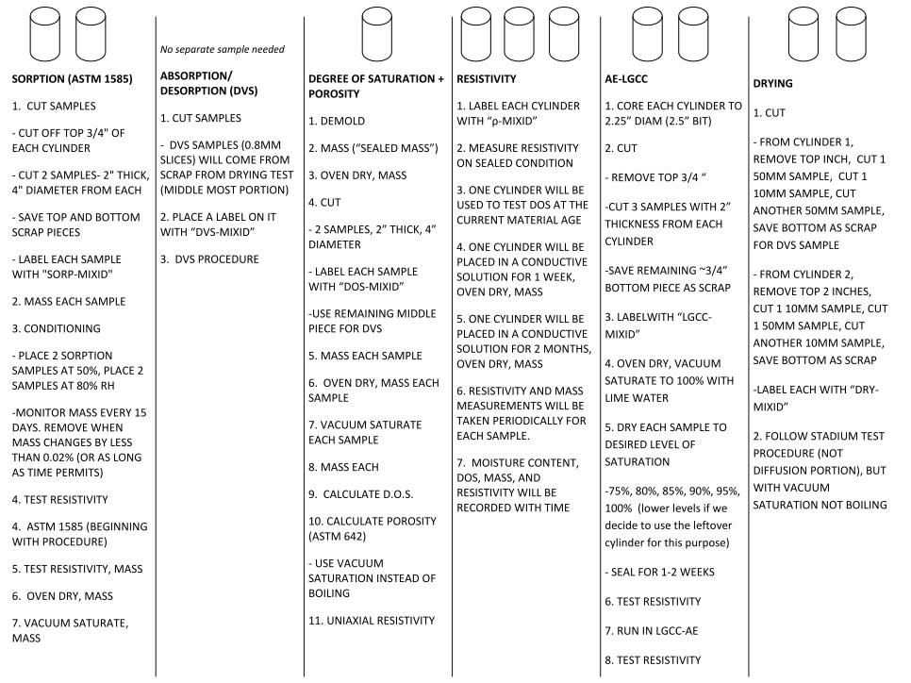
Figure 1: Sample cutting, conditioning, and testing plan for each series of mixtures

(a) | (b) | (c)

Figure 2: Current Testing States (a) Sorption samples conditioning at 50% relative humidity (b) Sample labeling convention on a cut and cored LGCC sample (c) Sample organization in preparation for testing

Anticipated work next quarter:

The teams will continue preparing concrete mixtures to be investigated with the SAM and processing the materials produced previously.

The team also plans to begin examining the rate of looking the absorption and desorption, rate of damage, and degree of saturation level on the damage with the concrete provided by OSU.

Significant Results:

There has been no significant results yet. This is expected as the project is still in the first year.

A presentation on the progress of the project was given at the NCC meeting in Omaha, NE. Many of the sponsoring states were at the meeting and were able to be updated on the progress. In addition, webinars were given by Dr. Ley to the ACPA and their members and also to Missouri Science and Technology. This has been good exposure for the research.

Circumstance affecting project or budget. (Please describe any challenges encountered or anticipated that
might affect the completion of the project within the time, scope and fiscal constraints set forth in the
agreement, along with recommended solutions to those problems).

There was some delay getting the contracts signed. This has delayed the start of the project some but the research team is doing their best to make up for this. A contract extension will likely be necessary.

Other than this issue the project is on time and on scope.

Potential Implementation:

A preliminary test method for the Super Air Meter has been presented to the AASHTO SOM. There was discussions at the AASHTO SOM meeting in Minneapolis and it appears that the test method will be approved in the fall and become available. This is a great accomplishment for the project in the first quarter. Work will continue on the project to develop the precision and bias statement.

