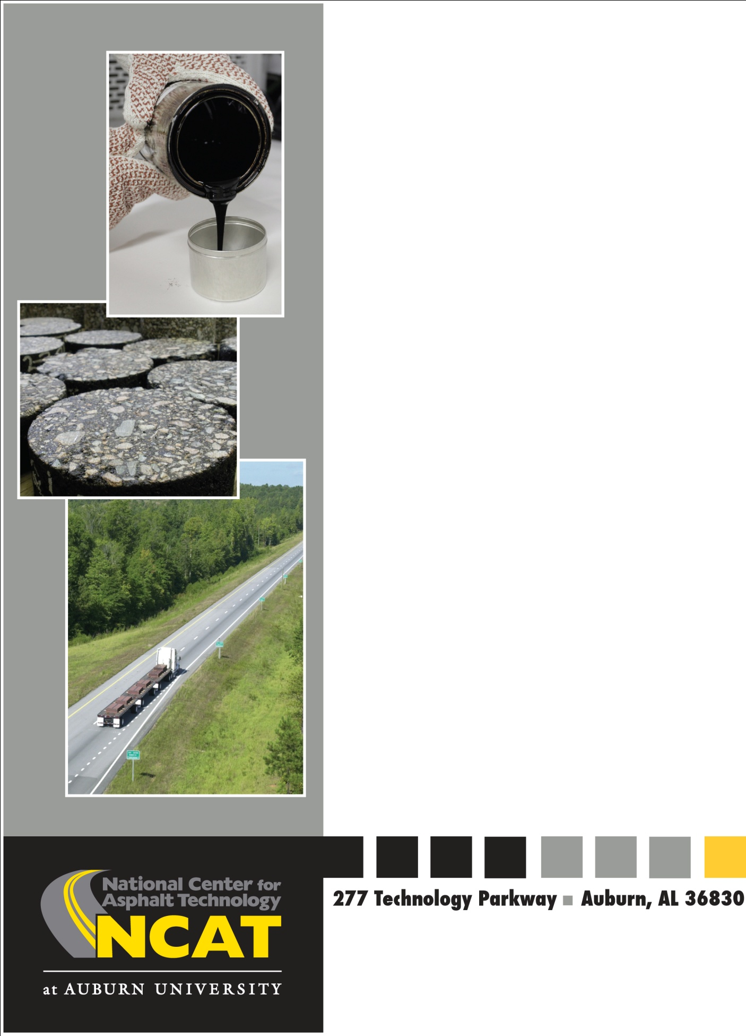
NCAT Report No…

Alternative methods for increasing the durability of RAP mixtures

By
J. Richard Willis, Ph.D.
Pamela Turner
Grant Julian
Nam Tran, Ph.D., P.E.
Flavio de Goes Padula, Ph.D.
National Center for Asphalt Technology
277 Technology Parkway
Auburn, AL 36830
E-mail: willi59@auburn.edu
Phone: 334-844-7301

April, 2013

April 2013

Alternative methods for increasing the durability of RAP mixtures

By

J. Richard Willis, Ph.D.
Pamela Turner
Grant Julian
Nam Tran, Ph.D., P.E.
Flavio de Goes Padula, Ph.D.

National Center for Asphalt Technology
Auburn University, Auburn, Alabama

April 2013

Disclaimer

The contents of this report reflect the views of the authors who are responsible for the facts and accuracy of the data presented herein. The contents do not necessarily reflect the official views or policies of the sponsored agency or the National Center for Asphalt Technology, or Auburn University. This report does not constitute a standard, specification, or regulation. Comments contained in this report related to specific testing equipment and materials should not be considered an endorsement of any commercial product or service; no such endorsement is intended or implied.

TABLE OF CONTENTS

TABLE OF CONTENTS iv
CHAPTER 1 INTRODUCTION 1
1.1 Background 1
1.2 Objective 2
1.3 Scope of Work 2
1.4 Organization of this Report 2
CHAPTER 2 LABORATORY TESTING PLAN AND METHODOLOGY 4
2.1 Testing Plan 4
2.2 RAP Characterization 4
2.3 Mix Designs 4
2.4 Linear Amplitude Sweep 5
2.5 Energy Ratio Testing 7
2.6 Overlay Tester 8
2.7 Asphalt Pavement Analyzer 10
CHAPTER 3 LABORATORY TEST RESULTS 12
3.1 RAP Characterization 12
3.2 Mixture Designs 13
3.3 Linear Amplitude Sweep Test Results 15
3.4 Energy Ratio Test Results 18
3.4.1 Fracture Energy 18
3.4.2 Energy Ratio 20
3.5 Overlay Tester Results 24
3.6 Asphalt Pavement Analyzer Results 27
3.7 Summary 30
3.7.1 10 Percent RAP Mixtures 30
3.7.2 25 Percent RAP Mixtures 31
3.7.3 50 Percent RAP Mixtures 31
CHAPTER 4 CONCLUSIONS AND RECOMMENDATIONS 33
4.1 Conclusions 33
4.2 Recommendations 33
REFERENCES 34
APPENDIX A AGGREGATE PROPERTIES 35
APPENDIX B OVERLAY TESTER RESULTS 37
APPENDIX C ASPHALT PAVEMENT ANALYZER RESULTS 38

CHAPTER 1 INTRODUCTION

1.1 Background

It is commonly accepted that using reclaimed asphalt pavement (RAP) in asphalt mixtures can provide economic savings to contractors and state agencies by reducing the demand of both the virgin binder and aggregates in asphalt mixtures. However, state highway agencies commonly limit the RAP contents allowed in its mixtures due to the lack of long-term performance data despite the fact that each year 20 million tons of RAP are used for purposes other than in asphalt pavements (1).

Recent increases in oil costs have caused escalations in both the cost of virgin asphalt binder and energy. This cost increase can be offset by using more RAP in asphalt mixtures. Recent reports have suggested that materials costs can be decreased by 20 to 35 percent (2) by using 25 to 50 percent RAP in asphalt mixtures. Although RAP may be used for the construction of a granular base course (e.g., Full Depth Reclamation), or shoulder material, the greatest economic and environmental benefits can be realized when RAP is used to replace virgin binder and aggregates in the production of hot-mix asphalt (HMA) mixture.

Recycled asphalt mixture may use RAP from a range of sources, but three important concepts should be followed in their use (3, 4):
a) The aggregate in the RAP should meet the same requirements as required for virgin aggregates.
b) Control the moisture content in RAP stockpiles at acceptable levels
c) The recycled asphalt mixture should meet the same specification requirements as that required for virgin mixture.

Most highway agencies have decades of experience with HMA containing low to moderate percentages of RAP (i.e., below 25% by weight of aggregate). One reason states are reluctant to increase RAP contents is the general perception that RAP mixtures may be more susceptible to various modes of cracking (i.e. fatigue, thermal, reflection). This is due to the fact that the RAP binder is aged, stiffer and less strain tolerant than a virgin binder. As the RAP proportion increases there is the potential for an increase in mixture stiffness and decrease in resistance to cracking resulting in earlier performance problems and increased rehabilitation costs. The goal of numerous research efforts is to increase the RAP percentage without sacrificing performance.

Before specifying high RAP percentages, agencies want assurance that high RAP mixes will provide satisfactory field performance. If high RAP mixtures cannot perform as well as virgin mixtures or even low content RAP mixtures, recommendations for improving the durability of these mixtures are necessary.

One suggested method of increasing the durability of high RAP mixtures is to adjust the grade of the virgin binder. Current recommendations provided by AASHTO M323 are based on levels of RAP percentages (Table 1). Each level represents a RAP percentage by weight of the aggregate. When between 15 and 25 percent RAP is used in an asphalt mixture, current guidance suggests that mix designers should reduce both the high and low critical temperatures by one performance grade. When more than 25 percent RAP is in the mixture, blending charts should be used to determine the appropriate virgin binder grade; however, many state agencies want to minimize the use of solvents required for extracting and recovering the RAP binder. Additionally, some state agencies do not want to change the grade of binder more than one or two grades since incomplete mixing may result in soft areas in the pavement instigating early distresses (5).

Table 1 Binder Selection Guidelines for RAP mixtures according to AASHTO M323
Recommended Virgin Asphalt Binder Grade | RAP Percent
No change in binder selection | <15
Select virgin binder one grade softer than normal (e.g., select a PG 58-28 if PG 64-22 would normally be used) | 15-25
Follow recommendations from blending charts | >25

Recent research has also suggested that the performance of RAP mixtures might be related to volume of the virgin binder in the mixture rather than the performance grade of the virgin binder (2). Other work from the 2009 Test Track has shown that incorporating WMA in high RAP mixtures can increase mixture durability (6).

1.2 Objective

This research plan was developed to assess whether increasing volume of effective virgin binder, using a softer binder, or using a warm-mix asphalt (WMA) technology aided in improving the durability of mixtures containing high percentages of RAP. The objective of this research was to quantify how increasing the volume of virgin binder or decreasing the performance grade of virgin asphalt binders affects the durability of RAP mixtures. In addition to changing the grade of the virgin binder, Evotherm 3G™ was added to the control RAP mixtures to assess how using this WMA technology affected the mixture’s durability and rutting performance.

1.3 Scope of Work

To complete this objective, 10, 25 and 50 percent RAP mixtures at optimum asphalt content were designed using a standard PG 67-22 virgin asphalt binder. These mixtures were tested to evaluate the top-down (surface cracking) and reflection cracking susceptibility using the energy ratio (ER) and overlay tester (OT) methodologies. These tests were also conducted on the RAP mixtures with 0.25% and 0.50% higher asphalt contents and at the optimum asphalt content using a PG 58-28 virgin binder rather than the PG 67-22 virgin binder. In addition to the previously described mixtures, samples using a PG 67-22 binder at the optimum asphalt content were made incorporating Evotherm 3G to assess how WMA affects mixture durability. Additionally, the linear amplitude sweep (LAS) methodology was used to assess the fatigue properties of the blended RAP and virgin binders.

1.4 Organization of this Report

This report is divided into four chapters. Chapter 2 provides the laboratory testing plan and methodologies used to perform the research while Chapter 3 provides the results of the aforementioned tests. Chapter 4 presents the final conclusions and recommendations based on the results of this study.

CHAPTER 2 LABORATORY TESTING PLAN AND METHODOLOGY

This chapter describes testing used to assess the impact increasing the asphalt content or reducing the asphalt binder performance grade has on the cracking resistance of RAP mixtures.

2.1 Testing Plan

Multiple laboratory tests were conducted to quantify how increasing the volume of effective virgin binder or decreasing the performance grade of the virgin asphalt binder affected the durability of RAP mixtures. The linear amplitude sweep (LAS) was utilized to characterize the fatigue properties of the blended RAP and virgin binder while the overlay tester (OT) was conducted to assess the resistance to reflection cracking of the RAP mixtures.
The energy ratio testing procedure was used to evaluate each mixture’s resistance to surface cracking. Finally, the rutting resistance of the most durable mixtures was assessed using the asphalt pavement analyzer (APA) to ensure that increasing mixture durability did not cause the asphalt mixture to become susceptible to rutting.

2.2 RAP Characterization

When RAP is used in an asphalt mixture design, it must first be characterized. The RAP aggregate from each source was recovered using the ignition method following AASHTO T308-10. The asphalt content of the RAP was then determined using this test procedure. The gradation of the RAP aggregate was also determined using AASHTO T30-10. The bulk specific gravity of the RAP aggregate was quantified on the material recovered from the ignition test using AASHTO T84 and T85. In addition to the specific gravities, the consensus aggregate properties of the RAP stockpile were determined.

The RAP binder was extracted using ASTM D2171, Test Methods for Quantitative Extraction of Bitumen from Bituminous Paving Mixtures Method A with trichloroethylene (TCE) as the solvent. Once extracted, ASTM D5404, Practice for Recovery of Asphalt from Solution Using the Rotary Evaporator was used to remove the solvent from the asphalt binder. The recovered asphalt binder was then tested to determine its Performance Grade (PG) binder properties using AASHTO M320.

2.3 Mix Designs

Mix designs were conducted for the virgin, 25% and 50% RAP mixtures in accordance with AASHTO M323-07, Standard Specification for Superpave Volumetric Mix Design, and AASHTO R35-04, Standard Practice for Superpave Volumetric Design for Hot-Mix Asphalt, except the virgin asphalt binder grade was not changed for the mixes with RAP. The optimum binder contents were determined corresponding to 4 percent air voids. Each mix was designed using a 12.5 mm nominal maximum aggregate size (NMAS), and the gradations consisted of three aggregate stockpiles and a locally available RAP stockpile. Two different stockpiles of granite were used, #89’s and #7’s. The granite was obtained from Vulcan Materials Barin Quarry in Columbus, Georgia. The natural sand was from Martin-Marietta Sand and Gravel in Shorter, Alabama, while the RAP was sampled from East Alabama Paving in Opelika, Alabama. For the 10 and 25 percent designs, the stockpile was left unfractionated; however, to achieve acceptable volumetrics, the RAP stockpile was fractionated over the #4 sieve for the 50 percent design.

A PG 67-22 virgin binder was the normal base binder used in the mixture design. The softer binder used in this study was a PG 58-28 binder which was a reduction in both the high and low temperature grades of the virgin binder. Evotherm 3G was added to the asphalt binder during mixing at a prescribed rate of 0.53% by weight of the asphalt binder. These binders were mixed in the laboratory with the previously determined blend of aggregates and RAP. All the samples were short-term aged in the oven at a temperature of 135°C for two hours before compaction. The design pills were compacted to an N_{des} level of 60 gyrations and a target height of 115 ±5 mm.

The loose mixes and compacted specimens were cooled down in the laboratory. Then, the bulk specific gravity of the compacted specimens was determined according to AASHTO T166, and the maximum theoretical specific gravity of the loose mix was determined in accordance with AASHTO T209. The specific gravity information was used to determine the volumetric properties of the mixes that are presented later in this report.

Moisture susceptibility testing was performed in accordance with AASHTO T 283.

2.4 Linear Amplitude Sweep

The Linear Amplitude Sweep Test (LAS) is an accelerated binder fatigue test that has been proposed to replace the current Dynamic Shear Rheometer (DSR) intermediate temperature G*sinδ parameter. The G*sinδ parameter is based on the assumption that asphalt binders in pavements function in the linear-viscoelastic range and are, therefore, insensitive to strain levels. These assumptions have long been challenged especially as modified asphalts have been shown to exhibit increased fatigue resistance and non-linear strain response. The LAS test was developed in response to the need for a fatigue test that could account for actual damage resistance as well as pavement structure and traffic loading. The LAS procedure uses cyclic loading with increasing load amplitude to accelerate damage. The end result is a prediction of binder fatigue life as a function of strain magnitude.

A blend of extracted RAP and virgin binders were tested using LAS methodology. The RAP binder was extracted using ASTM D2171, Test Methods for Quantitative Extraction of Bitumen from Bituminous Paving Mixtures Method A with trichloroethylene (TCE) as the solvent. Once extracted, ASTM D5404, Practice for Recovery of Asphalt from Solution Using the Rotary Evaporator was used to remove the solvent from the asphalt binder. The extracted RAP binder was then blended with the virgin binder source in proportion to the amount of reclaimed binder in each of the mixture designs.

This testing methodology was used to assess how the RAP binder affected the fatigue properties of the virgin binder. The nature of mixing the RAP and virgin binders assumes complete mixing of the virgin and RAP binders which may not actually occur during production. Complete documentation of the testing procedure used to conduct the LAS testing procedure has been documented elsewhere (2)

The binder fatigue performance parameter (N_{f}) is the end result of the testing method. N_{f} can be changed during the testing procedure by adjusting the strain values to account for difference in pavement structure. Higher strain values correspond to thinner pavements or heavier traffic loading while lower strain magnitudes correspond to thicker pavements or lighter traffic loads. An example of the data is shown in Figures 1 and 2 (7).

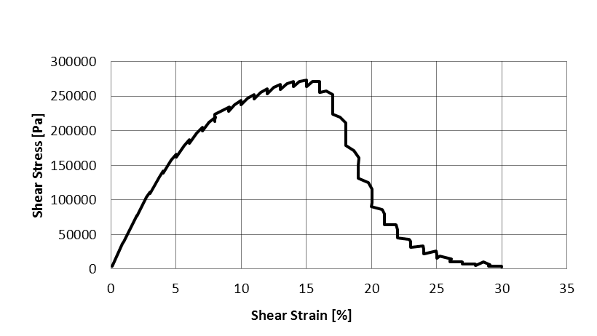

FIGURE 1 Plot of shear stress versus shear strain.

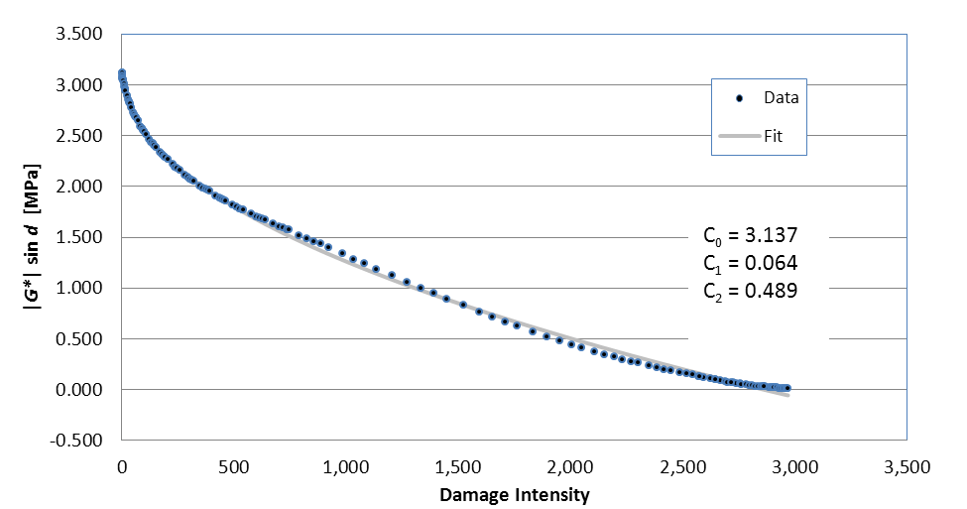

FIGURE 2 Damage intensity plot.

2.5 Energy Ratio Testing

The energy ratio test procedure was developed to assess an asphalt mixture’s resistance to top-down or surface cracking (8). This testing procedure has been used in past research cycles at the NCAT Test Track as a predictor of whether or not a mixture would be susceptible to top-down cracking (9). The energy ratio is determined using a combination of three tests: resilient modulus, creep compliance, and indirect tensile strength. These tests are described in greater detail below. These tests were performed at 10°C using an MTS® testing device. The tests were conducted on three specimens 150 mm diameter by approximately 38 mm thick, cut from gyratory compacted samples (Figure 3). The target air voids for the cut specimens was 7 ± 0.5 percent.

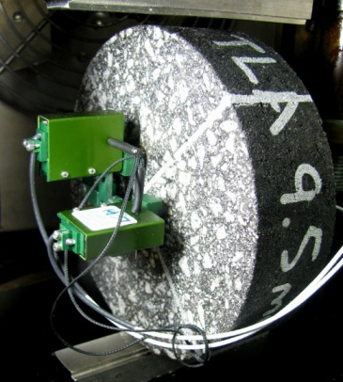
FIGURE 3 Energy ratio test specimen setup.

Detailed testing procedures and data interpretation methods for the three testing protocols are described elsewhere (8, 9, 10). The results from these tests are then used to evaluate each mixture’s surface cracking resistance using Equation 1. Data analysis was performed using a software package developed at the University of Florida. The details of the software operation are documented elsewhere (10). A higher energy ratio provides more resistance to surface cracking. Table 2 lists the recommended thresholds for the energy ratio as a function of rate of traffic.

$ER=\frac{{DSCE}_{f}\left[7.294×{10}^{-5}×σ^{-3.1}\left(6.36-S_{t}\right)+2.46×{10}^{-8}\right]}{m^{2.98}D_{1}}$ (Equation 1)

Where: σ = tensile stress at the bottom of the asphalt layer, 150 psi
M_{r} = resilient modulus
D₁, m = power function parameters
S_{t} = tensile strength
DSCE_{f} = dissipated stress creep energy at failure
ER = energy ratio

TABLE 2 Recommended Energy Ratio Criteria (10)

Traffic: (ESALs/yr ) | Minimum Energy Ratio
< 250,000 | 1
< 500,000 | 1.3
< 1,000,000 | 1.95

2.6 Overlay Tester

The overlay tests were performed in accordance with TxDOT 248-F (Figure 4). The procedure states that a 150 mm diameter Superpave gyratory sample should be compacted to a height of 115 ± 5 mm. Upon achieving the desired height, the specimens were trimmed to the following dimensions: 150 mm long by 75 mm wide by 38 mm tall (Figure 5). Three replicates with air voids between 6 and 8 percent after trimming were tested.

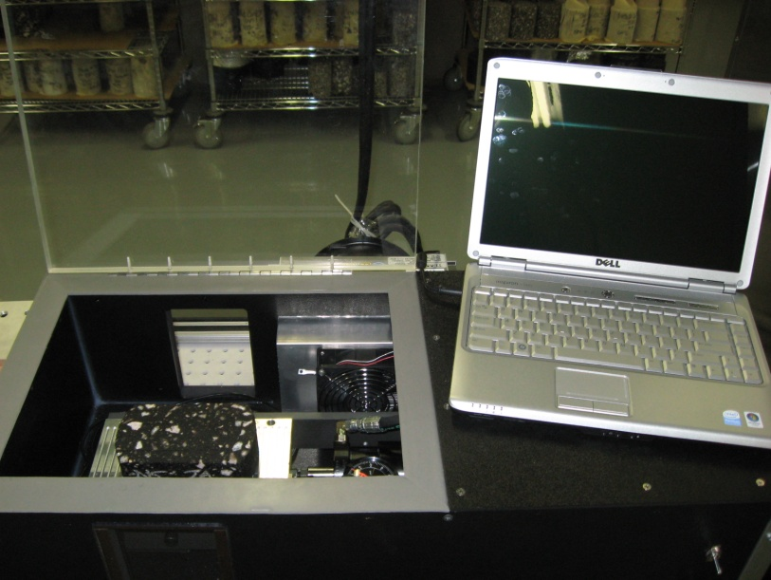

FIGURE 4 Overlay tester.

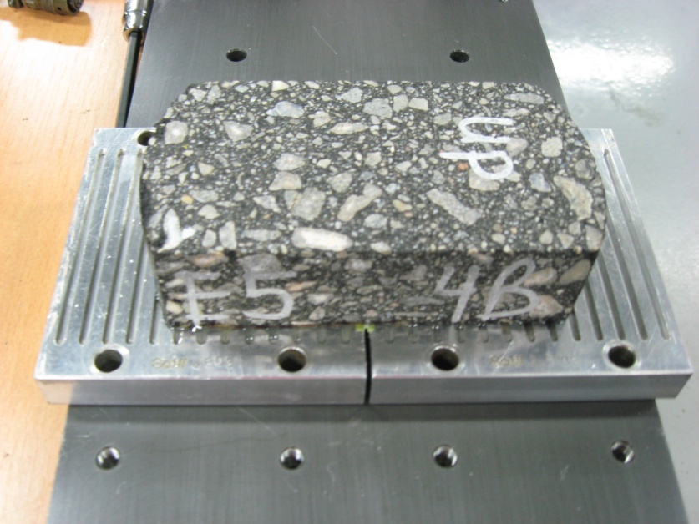

FIGURE 5 Overlay tester specimen.

The samples were tested at 25°C in controlled displacement mode. Loading occurs when a movable steel plate attached to the asphalt specimen slides away from the other plate (Figure 6). Loading occurs at a rate of one cycle every 10 seconds with a sawtooth waveform (Figure 7). The maximum load the specimen resists in controlled displacement mode is recorded for each cycle. The test continues until the sample fails. Failure is defined as 93% reduction in load magnitude from the first cycle (11).

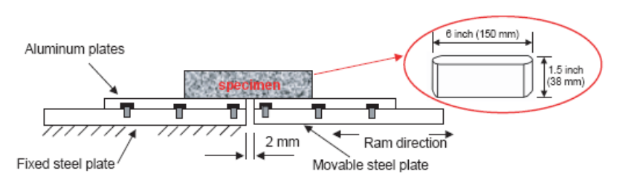
FIGURE 6 Overlay tester specimen (11).

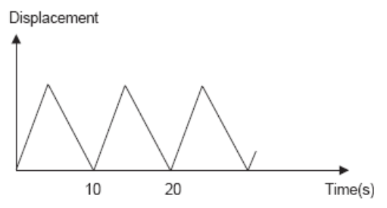
FIGURE 7 Loading form of the overlay tester (11).

TxDOT 248-F specifies a maximum opening displacement of 0.025 inches, which is equal to about 32% strain on the specimen. However, past research has shown that using this crack opening displacement can instantaneously fail RAP mixtures (12). Therefore, to get reliable and usable data, it was determined that the crack opening displacement needed to be reduced. Previous research had shown that an opening displacement of 0.017 inches is still a harsh condition for testing high RAP mixtures (12); however, if the crack opening were too small, a low RAP mixture might not fail.

Two previous studies at NCAT have used 0.013 inches as displacements for high RAP mixtures. While this displacement is not based on scientific theory, it provides a more appropriate displacement while still being able to achieve failure within the confines of the software (2).

2.7 Asphalt Pavement Analyzer

The rutting susceptibility of asphalt mixtures is commonly assessed using the Asphalt Pavement Analyzer (APA) (Figure 8). While the objective of this research was to determine how increasing the volume of effective binder or reducing the asphalt binder performance grade affected the mixture durability, one does not want to sacrifice rutting resistance for mixture durability. Therefore, the mixtures were also assessed for rutting susceptibility using AASHTO TP 63-09.

Tests were conducted at 64°C. Manual depth readings were taken at two locations on each sample after 25 loading cycles and at the conclusion of testing to determine the sample rut depth.

Past research at NCAT suggests that mixtures with less than 5.5 mm of rutting in the APA should be able to withstand 5 million equivalent single axle loads (ESALs) without rutting more than 9.5 mm (13).

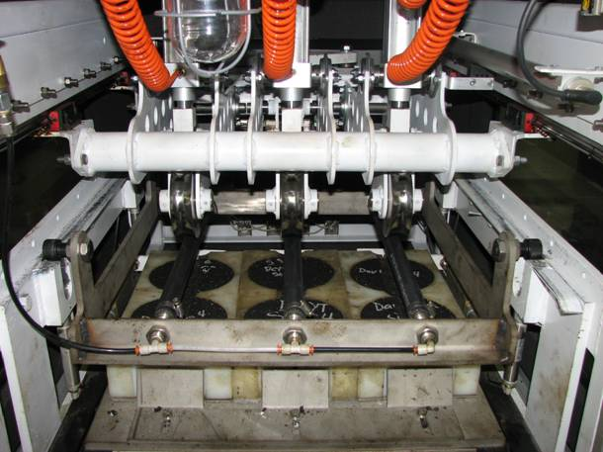
FIGURE 8 Asphalt Pavement Analyzer.

CHAPTER 3 LABORATORY TEST RESULTS

This chapter describes the RAP characterization process and mix design iterations used in the laboratory testing described in Chapter 2. The objective of this work was to quantify the effect of either using a softer asphalt binder or increasing the amount of effective virgin asphalt in RAP mixtures.

3.1 RAP Characterization

The RAP binder was extracted using ASTM D2171, Test Methods for Quantitative Extraction of Bitumen from Bituminous Paving Mixtures Method A with trichloroethylene (TCE) as the solvent. Once extracted, ASTM D5404, Practice for Recovery of Asphalt from Solution Using the Rotary Evaporator was used to remove the solvent from the asphalt binder. The recovered asphalt binder was then tested to determine its Performance Grade (PG) binder properties using AASHTO M320. The recovered RAP binder properties are shown in Table 3.

TABLE 3 RAP Binder Performance Grades
Binder | T_{crit, high} | T_{crit, int} | T_{crit, low} | PG Grade
RAP | 99.1 | 33.1 | -9.2 | 94 -4

The asphalt content, gradation and bulk specific gravity of the RAP aggregate were also determined. Table 4 shows the asphalt content and specific gravities of the RAP material.

TABLE 4 RAP Properties
Aggregate | Asphalt Content, % | G_{sb} | G_{sa}
RAP | 5.33 | 2.708 | 2.744
Fine RAP | 5.91 | 2.674 | 2.704
Coarse RAP | 3.24 | 2.636 | 2.711

3.2 Mixture Designs

The gradations of the individual stockpiles, the gradation of the total blend, and the percentages of each stockpile used in the final blends are shown in Appendix A with the aggregate specific gravities, absorptions, and consensus properties (crushed face count, uncompacted voids in fine aggregate, sand equivalency, and flat and elongated particle percentages) for each of the four stockpiles. The weighted average of each of the four consensus properties fell within the specification for an acceptable mix design set forth in AASHTO M 323-07.

Two virgin binders were used in this study with the aggregate gradations described in Section 3.2. The first binder was a PG 64-22 (or PG 67-22). The second binder was chosen to be one grade softer for both the high and low critical temperature (i.e. PG 58-28). Both of these binders were tested and graded according to AASHTO M320. The test results are given in Table 5.

TABLE 5 Virgin Binder Performance Grades
Binder | T_{crit, high} | T_{crit, int} | T_{crit, low} | PG Grade
67-22 | 67.0 | 23.9 | -23.2 | 67-22
58-28 | 60.3 | 15.5 | -31.7 | 58-28

A summary of the volumetric properties of the three mixtures for the 10, 25, and 50 percent RAP designs is given in Tables 6-8. According to AASHTO M323, the minimum voids in mineral aggregate (VMA) requirement for a 12.5 mm mixture is 14.0 percent. The voids filled with asphalt (VFA) requirement is 65-75 for high traffic mixtures, and the dust to asphalt ratio should be between 0.6 and 1.2. All three mixtures meet these standards at the optimum asphalt contents.

TABLE 6 10% RAP Mix Design Properties
Property | 10% RAP
Mix Version | Opt. | Opt. +0.25% | Opt. + 0.5%
AC, % | 5.10 | 5.35 | 5.60
AC_{RAP}, % | 0.53 | 0.53 | 0.53
AC_{Virgin}, % | 4.57 | 4.82 | 5.07
RAP Binder/Total Binder, % | 10.39 | 9.91 | 5.07
Air Voids, % | 4.0 | 3.4 | 2.4
VMA, % | 14.0 | 13.60 | 13.50
VFA, % | 69.8 | 76.1 | 82.3
Effective AC, % | 4.22 | 4.47 | 4.72
Dust/Asphalt Ratio | 0.98 | 0.93 | 0.87

TABLE 7 25% RAP Mix Design Properties

Property | 25% RAP
Mix Version | Opt. | Opt. + 0.25% | Opt. + 0.5%
AC, % | 5.05 | 5.30 | 5.55
AC_{RAP}, % | 1.33 | 1.33 | 1.33
AC_{Virgin}, % | 3.72 | 3.97 | 4.22
RAP Binder/Total Binder, % | 26.34 | 25.09 | 23.96
Air Voids, % | 4.0 | 3.4 | 2.5
VMA, % | 14.1 | 14.05 | 14.1
VFA, % | 70.7 | 76.1 | 81.6
Effective AC, % | 4.33 | 4.57 | 4.83
Dust/Asphalt | 0.97 | 0.91 | 0.85

TABLE 8 50% RAP Mix Design Properties

Property | 50% RAP
Mix Version | Opt. | Opt. + 0.25% | Opt. + 0.5%
AC, % | 5.25 | 5.50 | 5.75
AC_{RAP}, % | 2.02 | 2.02 | 2.02
AC_{Virgin}, % | 3.23 | 3.48 | 3.73
RAP Binder/Total Binder, % | 38.48 | 36.73 | 35.13
Air Voids, % | 4.0 | 3.5 | 2.7
VMA, % | 14.1 | 13.75 | 13.85
VFA, % | 71.0 | 75.5 | 80.7
Effective AC, % | 4.30 | 4.56 | 4.82
Dust/Asphalt | 0.86 | 0.82 | 0.77

Moisture susceptibility testing was performed on the three completed mix designs in accordance with AASHTO T 283. Table 9 gives a summary of the TSR results for the three mixtures. AASHTO M323 requires mixtures to have a tensile-strength ratio of at least 0.80. All three mixtures met this requirement using 0.5% LOF anti-strip by weight of the virgin binder.

TABLE 9 Moisture Susceptibility Results

Mixture | Average Conditioned Strength, psi | Average Unconditioned Strength, psi | TSR
10% RAP | 109.2 | 121.2 | 0.90
25% RAP | 125.8 | 131.6 | 0.96
50% RAP | 120.0 | 129.6 | 0.93

3.3 Linear Amplitude Sweep Test Results

Blends of the virgin and extracted RAP binders were created corresponding to the amounts of each binder in the 10, 25 and 50% RAP mixture designs. The blends with the PG 67-22 virgin binder were then adjusted to correspond to an increase in the effective virgin binder content by 0.25 and 0.5%. The increase in virgin binder should theoretically increase the fatigue life of the binder. Asphalt pavements with higher asphalt contents tend to have better fatigue life due to the increased asphalt binder film thickness surrounding the aggregate particles. The reduction in overall binder stiffness due to the increased virgin binder and filling in the voids between the coated particles should also improve the binder fatigue life.

Table 10 shows the N_{f} values for each design iterative at strain levels of 2.5 and 5.0 percent. The results shown are the average of two test results. Test results for replicate samples did not vary by more than 15 percent. Figures 9-11 compare the results graphically by RAP content.

TABLE 10 LAS Test Results

Binder | % RAP | Binder Content | N_{f} @ 2.5% Strain |  | N_{f} @ 5.0% Strain
 |  |  | Sample 1 | Sample 2 | Sample 1 | Sample 2
PG 67-22 | 0 | Opt. | 341,645 | 350,787 | 13,915 | 14,338
PG 67-22 | 10 | Opt. | 75,912 | 60,050 | 2,955 | 2,408
PG 67-22 | 10 | Opt. + 0.25% | 75,787 | 75,336 | 3,068 | 3,025
PG 67-22 | 10 | Opt. + 0.50% | 69,932 | 67,700 | 2,794 | 2,677
PG 67-22 | 10 | Opt. + WMA | 69,832 | 68,971 | 2,809 | 2,779
PG 58-28 | 10 | Opt. | 902,641 | 1,042,011 | 31,500 | 36,467
PG 67-22 | 25 | Opt. | 75,537 | 71,527 | 2,133 | 1,920
PG 67-22 | 25 | Opt. + 0.25% | 77,893 | 72,583 | 2,290 | 2,102
PG 67-22 | 25 | Opt. + 0.50% | 76,117 | 84,728 | 2,189 | 2,411
PG 67-22 | 25 | Opt. + WMA | 89,083 | 80,283 | 2,560 | 2,297
PG 58-28 | 25 | Opt. | 505,112 | 507,174 | 14,700 | 14,639
PG 67-22 | 50 | Opt. | 87,633 | 81,079 | 1,915 | 1,818
PG 67-22 | 50 | Opt. + 0.25% | 106,472 | 100,815 | 2,401 | 2,259
PG 67-22 | 50 | Opt. + 0.50% | 81,150 | 77,131 | 1,915 | 1,818
PG 67-22 | 50 | Opt. + WMA | 104,701 | 119,680 | 2,318 | 2,643
PG 58-28 | 50 | Opt. | 292,480 | 362,514 | 7,303 | 9,062

It can be seen that the LAS testing protocol is capable of capturing the expected trend in binder fatigue life relative to strain magnitude. As the strain on the asphalt binder decreases, the number of cycles required to fail the binder increases showing better fatigue performance.

The test results also show that blending RAP binder with the PG 67-22 virgin asphalt binder reduces expected fatigue performance of the blends. For the 10 percent RAP mixture, these reductions were approximately 80 percent at both strain levels. The 25 percent RAP mixture at optimum asphalt saw a 78 percent reduction in fatigue life at 2.5 percent strain and an 86 percent reduction at 5.0 percent strain. For the 50 percent RAP mixture, the reductions were 75 and 87 percent for the 2.5 and 5.0 percent strain loadings respectively.

While the 25 percent RAP binder test results follow the expected trends, deviations from expectations occurred in the 10 and 50 percent binder blends. The test results shown in Table 9 don’t always follow the expected trends. For example, the 10 percent RAP mix design increased its binder fatigue life by adding an additional 0.25 percent virgin asphalt to the binder blend; however, using an additional 0.5 percent virgin asphalt added no additional fatigue life to the optimum blend. This same trend was noticed with the 50 percent RAP binder blends; however, it should be noted that the 50 percent RAP binder blends had longer fatigue lives than the 10 percent RAP binder blends.

Overall, the PG 58-28 virgin-RAP binder blends had longer fatigue lives than the PG 67-22 virgin-RAP binder blends. The reduction of fatigue life caused by increasing the RAP content from 25 to 50 percent is more noticeable for the PG 58-28 binder blends. The reduced sensitivity of the PG 67-22 binder to the addition of RAP when compared to the PG 58-28 binder is most likely due to the increased intermediate temperature stiffness. The PG 58-28 binder is still fairly soft at intermediate temperatures as evidenced by its true grade intermediate temperature, 15.5°C. The PG 67-22 binder is stiffer with an intermediate true grade temperature of 23.9°C. The addition of the RAP binder would not have as great an effect on the intermediate temperature properties of the PG 67-22 binder as it would on the PG 58-28 binder.

One also notices that using a WMA additive to increase the fatigue life of the binder blends had more of an effect at higher RAP contents. At 10 percent RAP, the WMA additive had little to no effect on the predicted fatigue life. When 25 percent RAP was used, a 15 percent increase in fatigue life was seen at low strains and 20 percent increase was seen at the higher strain level. This increase in fatigue life was even more pronounced for the 50 percent RAP mixtures as the WMA increased fatigue lives by approximately 32 percent at both strain levels.

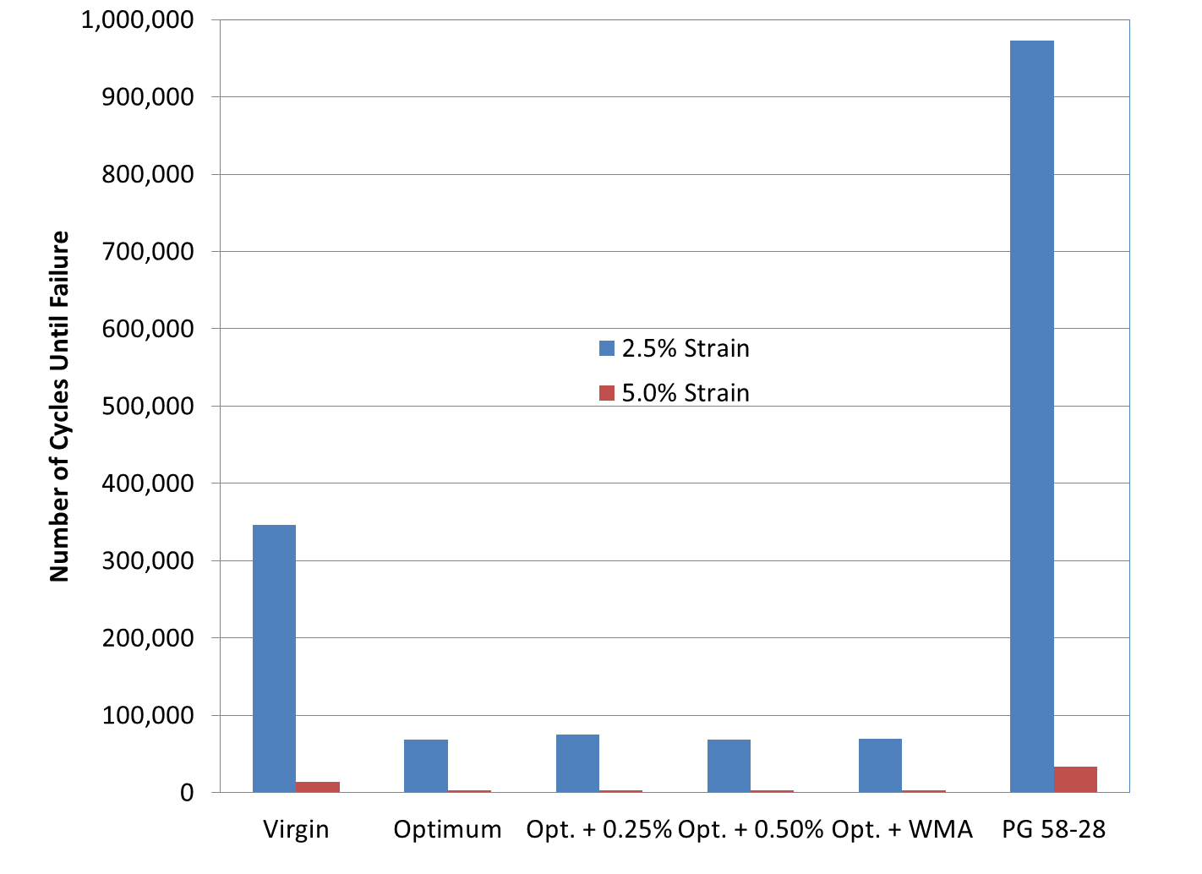
FIGURE 9 LAS Results for 10 Percent RAP Mixtures.

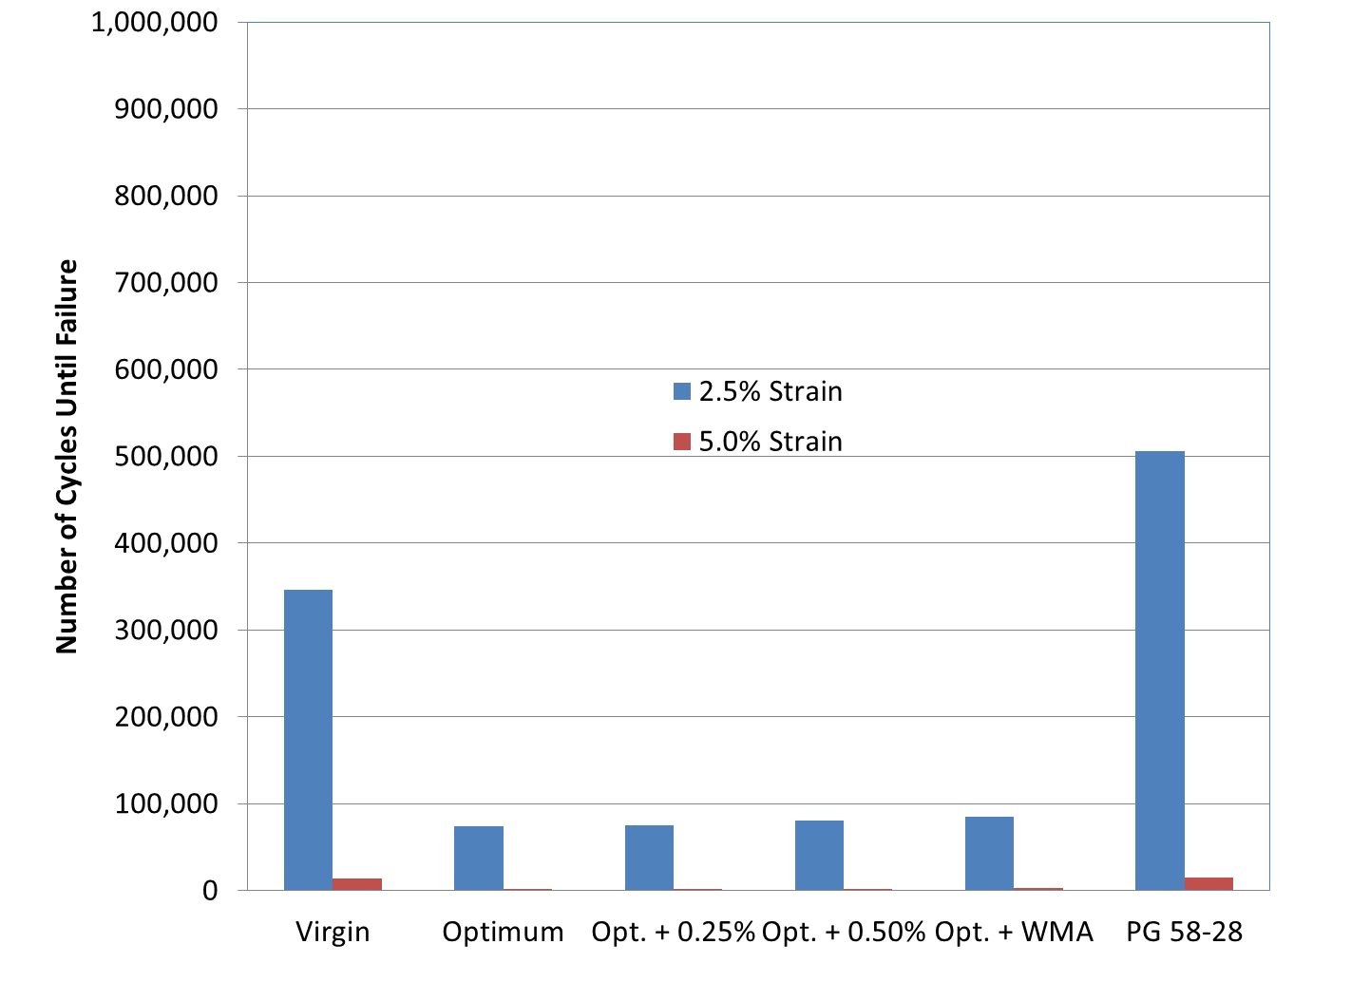
FIGURE 10 LAS Results for 25 Percent RAP Mixtures.

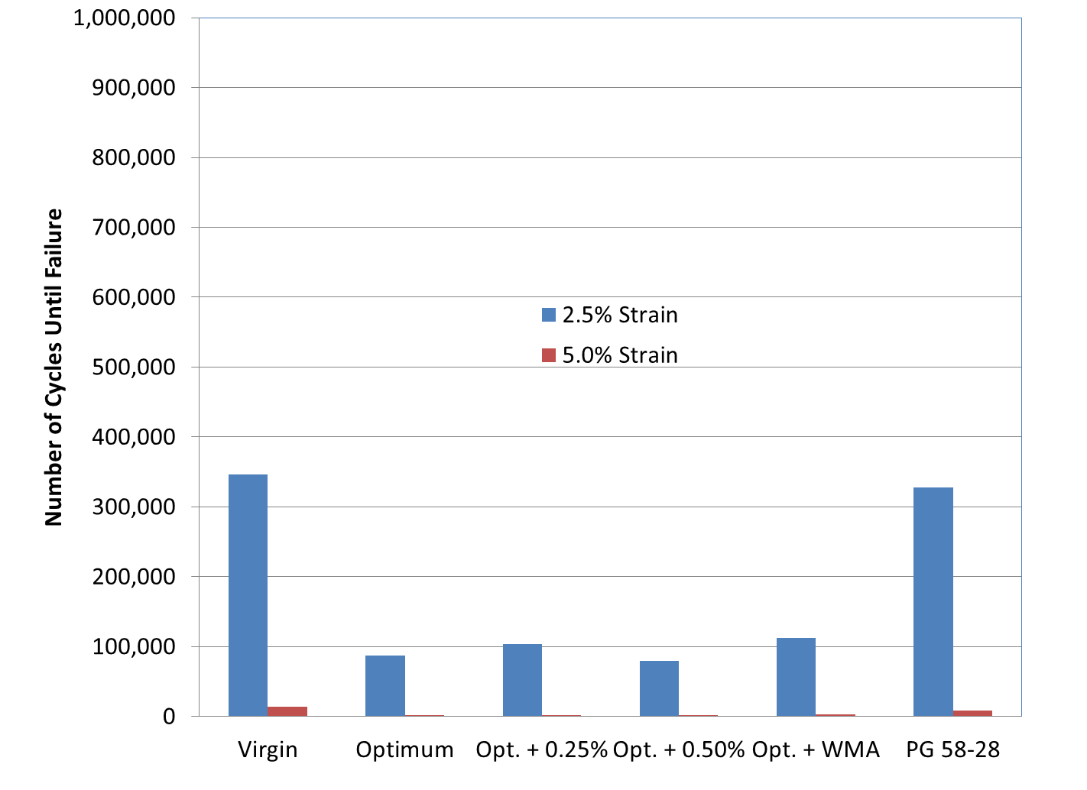
FIGURE 11 LAS Results for 50 Percent RAP Mixtures.

Overall, using the softer binder had the greatest impact on blended binder fatigue life. The use of WMA additives shows the greatest affect when they are used in conjunction with high RAP mixtures.

3.4 Energy Ratio Test Results

3.4.1 Fracture Energy

As part of the energy ratio test procedure, the fracture energy (FE) of each mixture was determined. The FEs for the RAP mixtures are shown in Figures 12-14. The FE of mixtures has been linked to fatigue performance at WesTrack (14); however, there are no generally accepted criteria for minimum FE requirements.

The results show that using the PG 58-28 improves the FE for both the 10 and 50 percent RAP mixtures when compared to the 10 and 50 percent RAP mix designs with PG 67-22 binder at the optimum asphalt content. Using a softer binder increased the FE of the 10 percent RAP mixture by approximately 300 percent while using a softer binder for the 50 percent RAP mixture increased the fracture energy of the mixture by 100 percent. There was a slight reduction in the FE of the 25 percent RAP mixture when using the softer binder.

Increasing the effective volume of the virgin binder increased the FE of the 10 percent RAP mixtures as did using WMA additives. While using an additional quarter percent virgin binder increased the FE of the 10 percent RAP mixture by only 30 percent, using an additional half percent virgin binder increased the FE by 160 percent. A 140 percent increase was seen with the WMA additive.

For the 25 percent RAP mixtures, using WMA, increased virgin binder content, or a softer binder did not positively affect the mixture’s FE.

The FE of the 50 percent RAP mixture at the optimum asphalt content with the PG 67-22 binder had the lowest FE of all the mixtures tested. While increasing the effective virgin binder content did not improve the FE of the 25 percent RAP mixtures, increasing the virgin binder content by 0.25 percent improved the FE by 71percent. Further increasing the amount of virgin asphalt in the mixture by 0.5 percent only improved the FE by another 40 percent. A 100 percent increase in FE was measured when using the WMA additive.

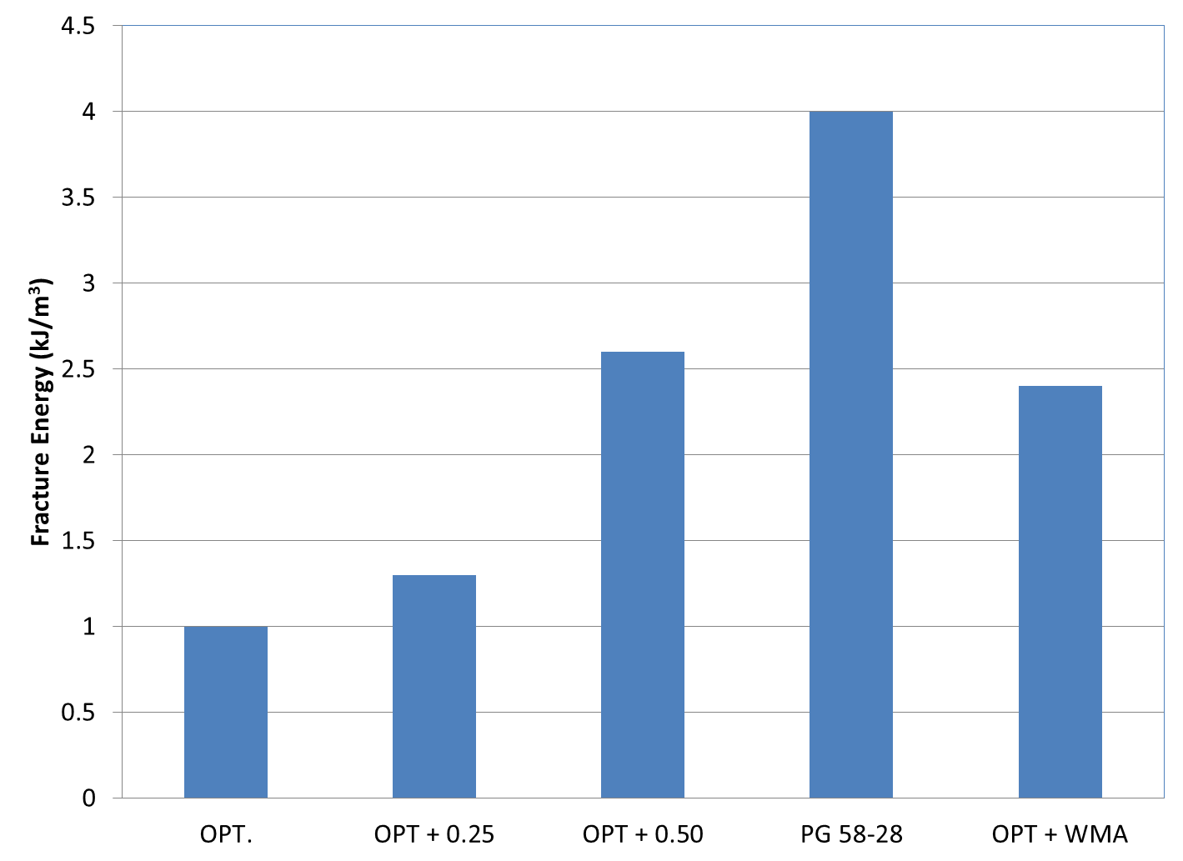
FIGURE 12 Fracture Energy Results for 10 Percent RAP Mixtures.

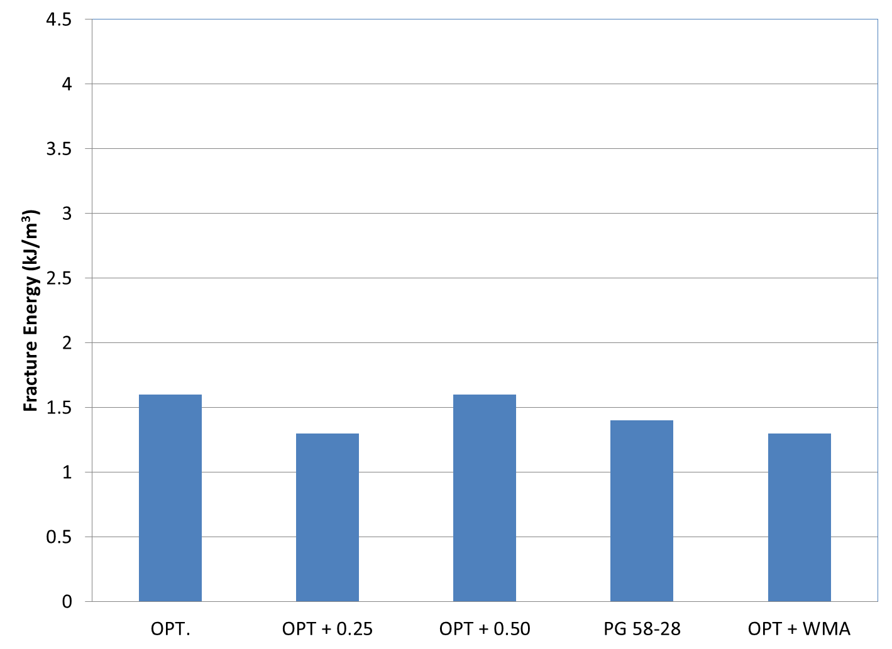
FIGURE 13 Fracture Energy Results for 25 Percent RAP Mixtures.

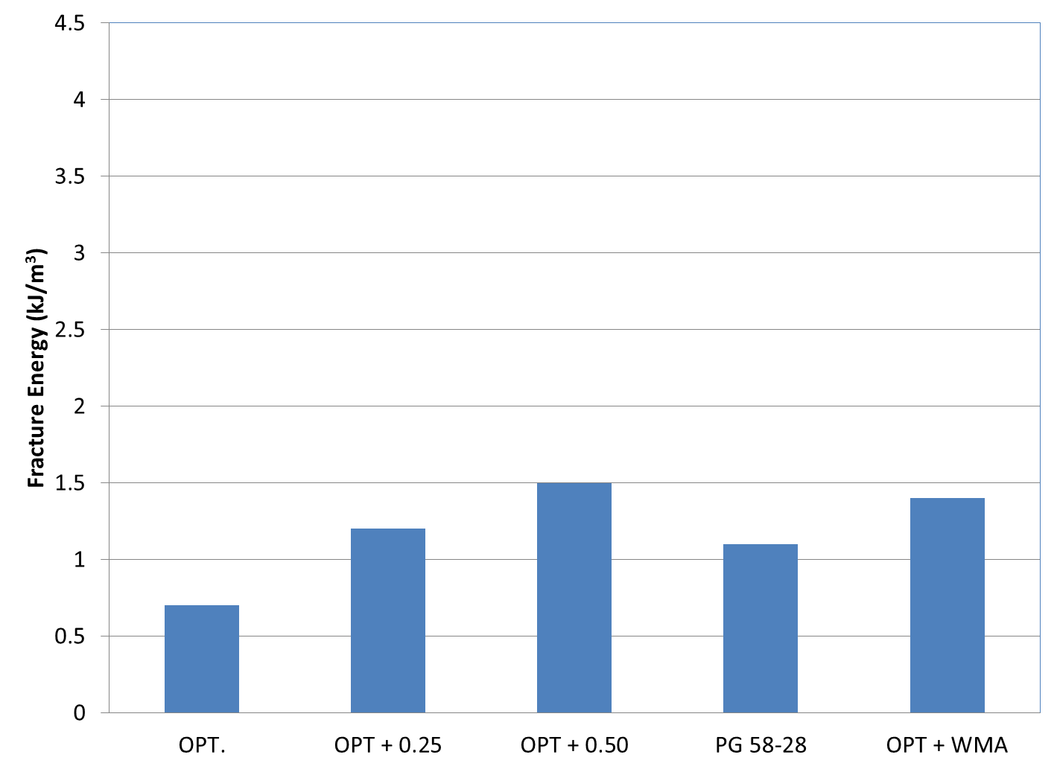
FIGURE 14 Fracture Energy Results for 50 Percent RAP Mixtures.

The results of these tests were mixed in that the FE of both the 10 and 50 percent RAP mixtures were able to be positively affected by using WMA additives, softer binders, or additional virgin asphalt. However, the 25 percent RAP mixture with the optimum asphalt content using the standard binder had the greatest fracture energy of the 25 percent RAP mixtures.

3.4.2 Energy Ratio

The energy ratio was developed to assess an asphalt mixture’s susceptibility to surface cracking using a combination of indirect tension tests described in Section 2.5. Each mixture described in Section 3.2 was evaluated using the energy ratio methodology. The individual components used to calculate the energy ratio is provided in Tables 11-13 while Figures 15-17 graphically compare the energy ratios of the 25 and 50 percent RAP mixtures.

Of the five 10 percent RAP mixtures, the mixture with the lowest ER was the mixture using the PG 67-22 binder at the optimum asphalt content. Increasing the virgin binder content by 0.25 percent only slightly improved (11 percent) the mixture performance; however, using 0.5 percent additional binder almost doubled the ER of the control mixture. The mix with the best performance was the 10 percent RAP mixture using the WMA additive; however, using 0.5 percent additional binder, WMA or a softer binder all increased the allowable traffic the mixture could withstand without surface cracking.

TABLE 11 Energy Ratio Test Results for 10 Percent RAP Mixtures

 | PG 67-22 @ Opt. | PG 67-22 @ Opt. + 0.25% | PG 67-22 @ Opt. + 0.5% | PG 58-28 @ Opt. | PG 67-22w/ WMA
m-value | 0.4162 | 0.4537 | 0.4447 | 0.4695 | 0.3904
FE (kJ/m³) | 1.0 | 1.3 | 2.6 | 4.0 | 2.4
DSCE_{HMA} (kJ/m³) | 0.821 | 1.123 | 2.366 | 3.747 | 2.192
DSCE_{MIN} (kJ/m³) | 0.5962 | 0.7463 | 0.9324 | 1.6910 | 0.6901
ER | 1.38 | 1.50 | 2.53 | 2.21 | 3.17
Rate of Creep Compliance (s/GPa x 10⁻⁹) | 2.888 | 3.958 | 4.712 | 9.261 | 3.134
Allowable Traffic (ESALs/year) | <500,000 | <500,000 | <1,000,000 | <1,000,000 | <1,000,000

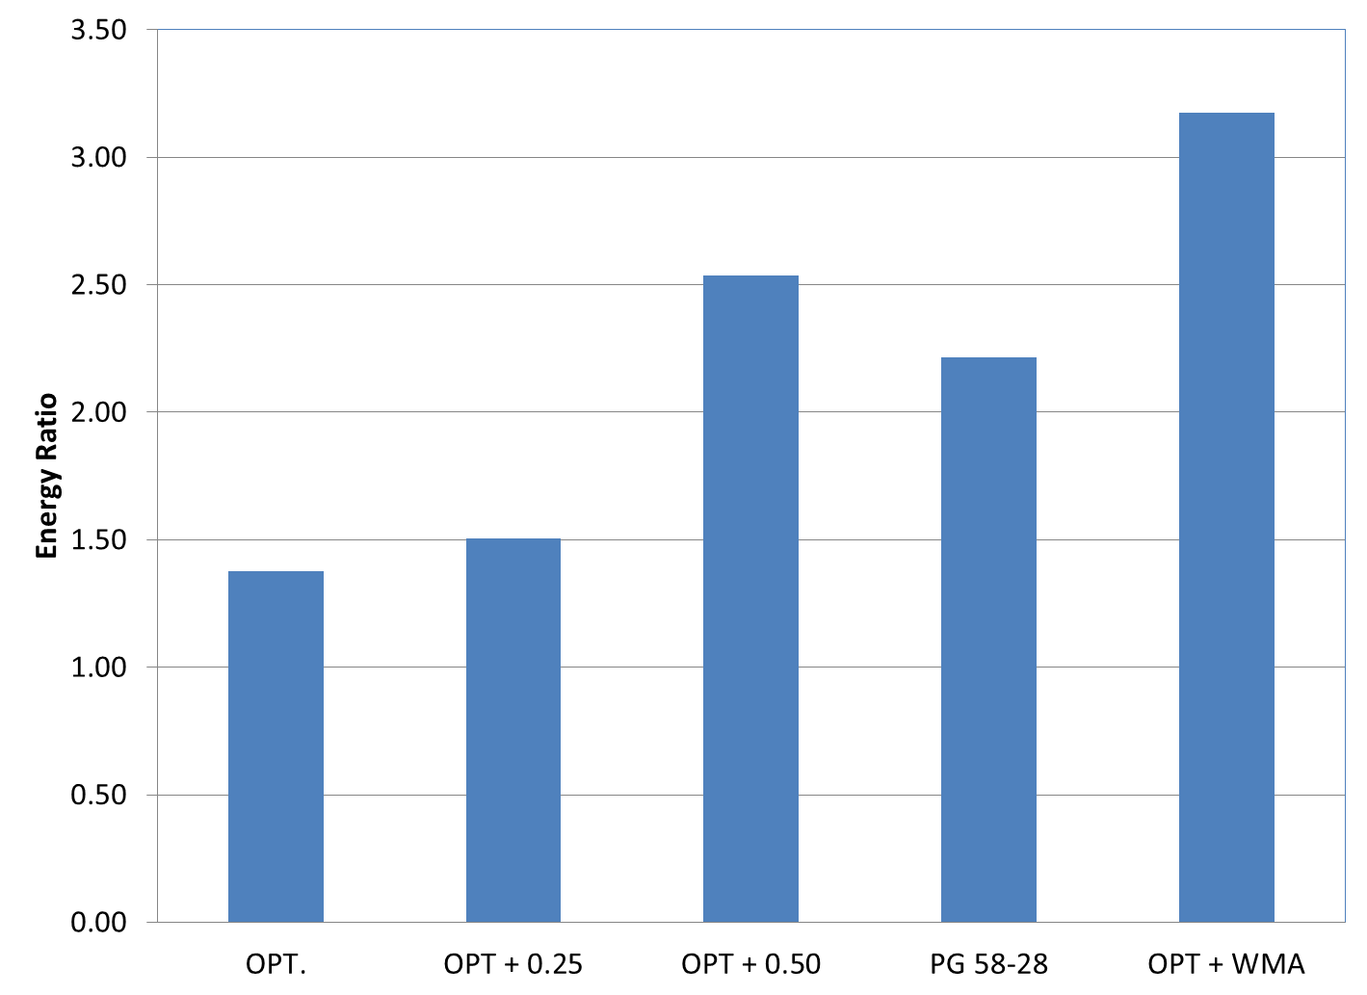
FIGURE 15 Energy ratio results for 10 percent RAP mixtures.

All five 25 percent RAP mixtures had ER values great enough to withstand less than 1,000,000 ESALs of traffic per year. However, the mixture which had the greatest numerical ER was the PG 67-22 mixture at the optimum asphalt content. Past research has shown two of the biggest contributors to determining the ER are FE and rate of creep compliance. If the FE is small, then the ER will be small. Conversely, if the rate of creep compliance is small, then then ER will be large. The 25 percent RAP mixture that had the highest ER also had the highest FE and a smaller rate of creep compliance. Thus, this accounted for the higher ER when compared to some of the other mixtures.

TABLE 12 Energy Ratio Test Results for 25 Percent RAP Mixtures

 | PG 67-22 @ Opt. | PG 67-22 @ Opt. + 0.25% | PG 67-22 @ Opt. + 0.5% | PG 58-28 @ Opt. | PG 67-22w/ WMA
m-value | 0.381 | 0.368 | 0.372 | 0.383 | 0.343
FE (kJ/m³) | 1.6 | 1.3 | 1.6 | 1.4 | 1.3
DSCE_{HMA} (kJ/m³) | 1.368 | 1.073 | 1.381 | 1.188 | 1.103
DSCE_{MIN} (kJ/m³) | 0.3861 | 0.3864 | 0.4806 | 0.5489 | 0.4198
ER | 3.54 | 2.78 | 2.87 | 2.16 | 2.62
Rate of Creep Compliance (s/GPa x 10⁻⁹) | 1.645 | 1.679 | 2.092 | 2.456 | 1.381
Allowable Traffic (ESALs/year) | <1,000,000 | <1,000,000 | <1,000,000 | <1,000,000 | <1,000,000

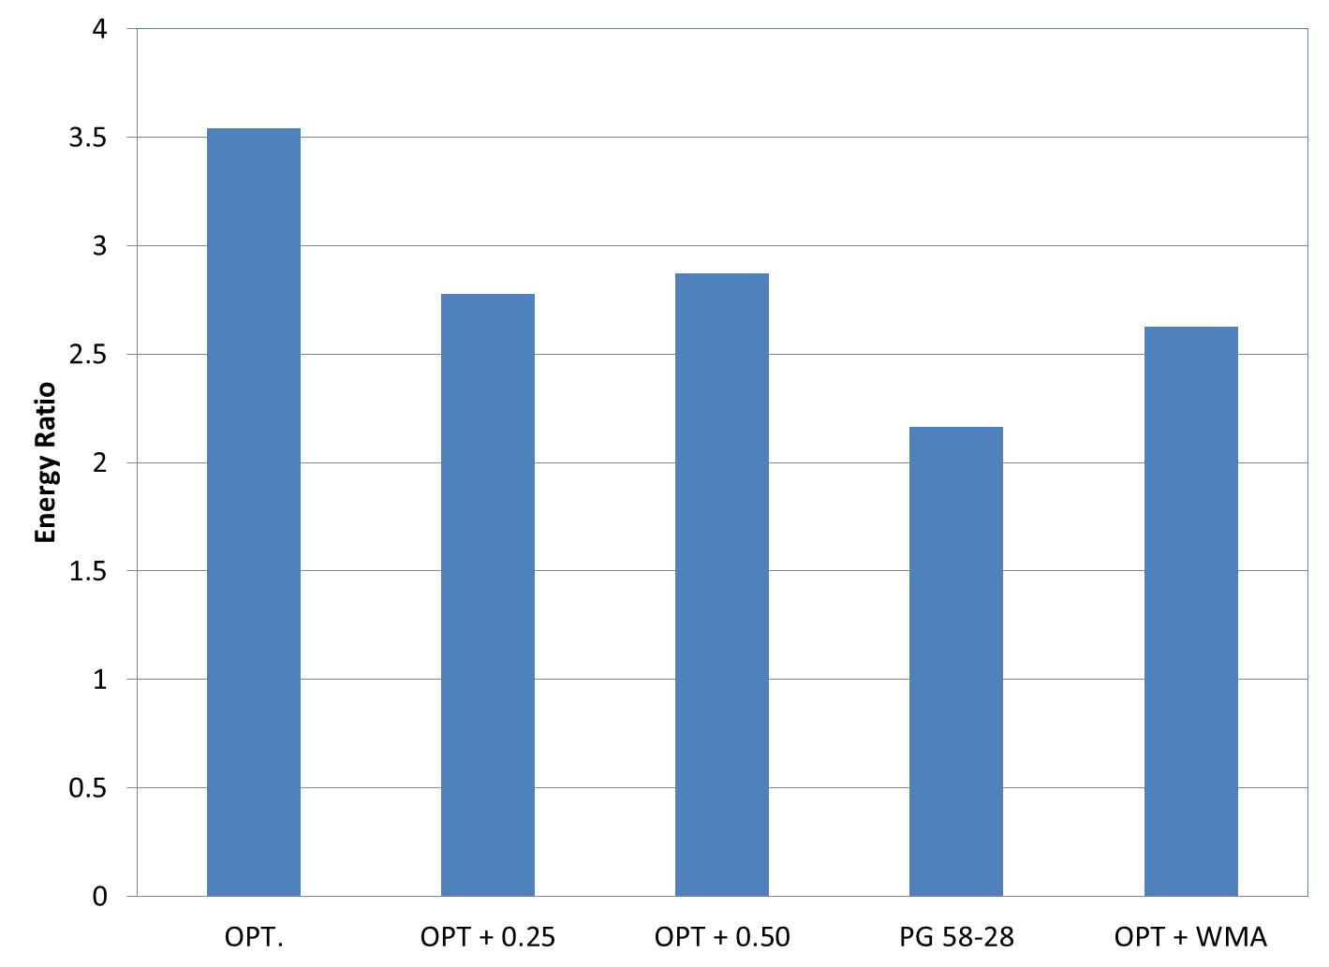
FIGURE 16 Energy ratio results for 25 percent RAP mixtures.

The 50% RAP mixtures somewhat followed the expected trend. Adding virgin binder increased the ER of the mixtures at both the quarter and half percent level by one traffic level for the quarter percent and two traffic levels for the half percent virgin binder increase. Using the softer grade of asphalt only increased the mixture’s resistance to surface cracking by one traffic level. The method of increasing mixture durability that had the greatest influence on the ER results was using 50 percent RAP at the standard binder grade with the WMA additive. In this case, the mixture was able to resist less than 1,000,000 ESALs of traffic per year and showed a 100% increase in the ER compared to the 50 percent RAP control mixture.

TABLE 13 Energy Ratio Test Results for 50 Percent RAP Mixtures

 | PG 67-22 @ Opt. | PG 67-22 @ Opt. + 0.25% | PG 67-22 @ Opt. + 0.5% | PG 58-28 @ Opt. | PG 67-22w/ WMA
m-value | 0.3866 | 0.3876 | 0.3925 | 0.4123 | 0.3598
FE (kJ/m³) | 0.7 | 1.2 | 1.5 | 1.1 | 1.4
DSCE_{HMA} (kJ/m³) | 0.567 | 0.977 | 1.321 | 0.937 | 1.193
DSCE_{MIN} (kJ/m³) | 0.411 | 0.527 | 0.584 | 0.542 | 0.442
ER | 1.38 | 1.85 | 2.26 | 1.73 | 2.70
Rate of Creep Compliance (s/GPa x 10⁻⁹) | 1.91 | 2.38 | 2.72 | 2.62 | 1.91
Allowable Traffic (ESALs/year) | <250,000 | <500,000 | <1,000,000 | <500,000 | <1,000,000

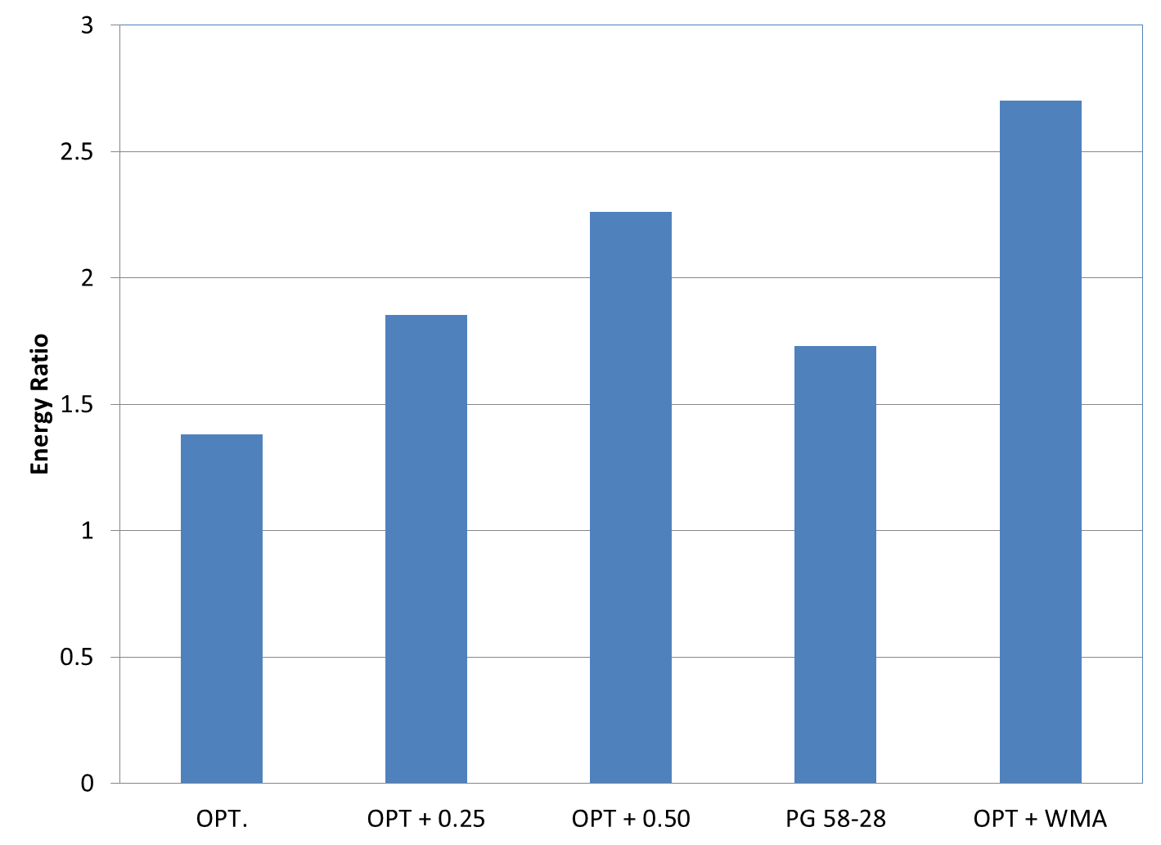
FIGURE 17 Energy ratio results for 50 percent RAP mixtures.

3.5 Overlay Tester Results

The Overlay Tester (OT) was used to assess the resistance to reflection cracking for all nine mixtures in this study. Each mixture was tested in the Overlay Tester at 25°C using a maximum opening displacement of 0.013 inches as previously reported. The OT results are shown in Figures 18-20.

While the purpose of this study was to determine the optimal way to improve the durability of RAP mixtures, the test results reiterate the harsh conditions of the OT as indicated in section 2.6. The 10 percent RAP mixture lasted 813 cycles before the stiffness dropped by 93 percent; however, the 25 percent RAP mixture only lasted 108 cycles. The 50 percent RAP mixture at the optimum asphalt content had an average life of 183 cycles before it achieved failure. Thus, increasing the RAP content beyond 10 percent drastically decreased the cycles to failure in this extremely high strain test. These results are consistent with other research using the overlay tester to evaluate mixes containing recycled binders (2, 11, 12).

The General Linear Model (α = 0.05) was used to assess differences in OT results for the five 10 percent RAP mixtures. According to this statistical analysis (Table 14), there are no statistical differences between any of the variables. This statistical finding is probably due to the high variability of the data. While there we no statistical differences, changing the binder grade, volume or using WMA increased the cycles until failure by at least 65 percent. The two mixtures which performed the best were the PG 58-28 mixture at optimum content and the PG 67-22 mixture using an additional quarter percent binder.

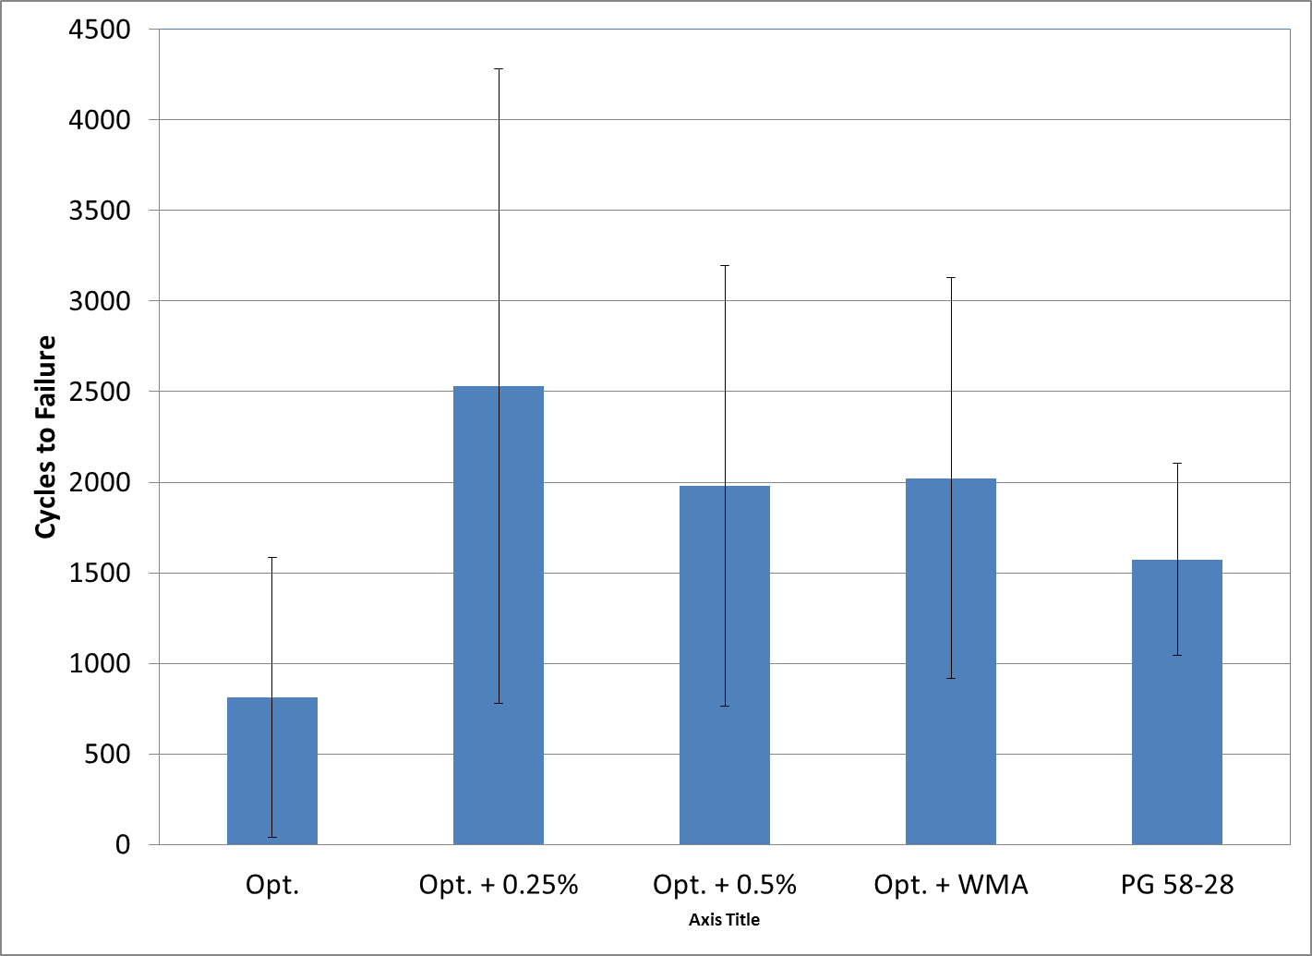
FIGURE 18 10 Percent RAP overlay tester results.

TABLE 14 10 Percent RAP OT Statistical Groupings

Mixture | Mean, Cycles to Failure | Grouping
PG 67-22 @ Opt. | 813 | A
PG 67-22 @ Opt. + 0.25% | 2529 | A
PG 67-22 @ Opt. + 0.50% | 1468 | A
PG 67-22 + WMA | 1574 | A
PG 58-28 @ Opt. | 2023 | A

The General Linear Model (α = 0.05) was also used to assess differences in OT results for the five 25 percent RAP mixtures. According to this statistical analysis (Table 15), there are no statistical differences between any of the variables. This statistical finding is again probably due to the high variability of the data. While there we no statistical differences, changing the binder grade, volume or using WMA increased the cycles until failure by at least 78 percent. The mixture which incorporated WMA with the RAP and the mixture which used a softer binder had the highest numerical cycles until failure.

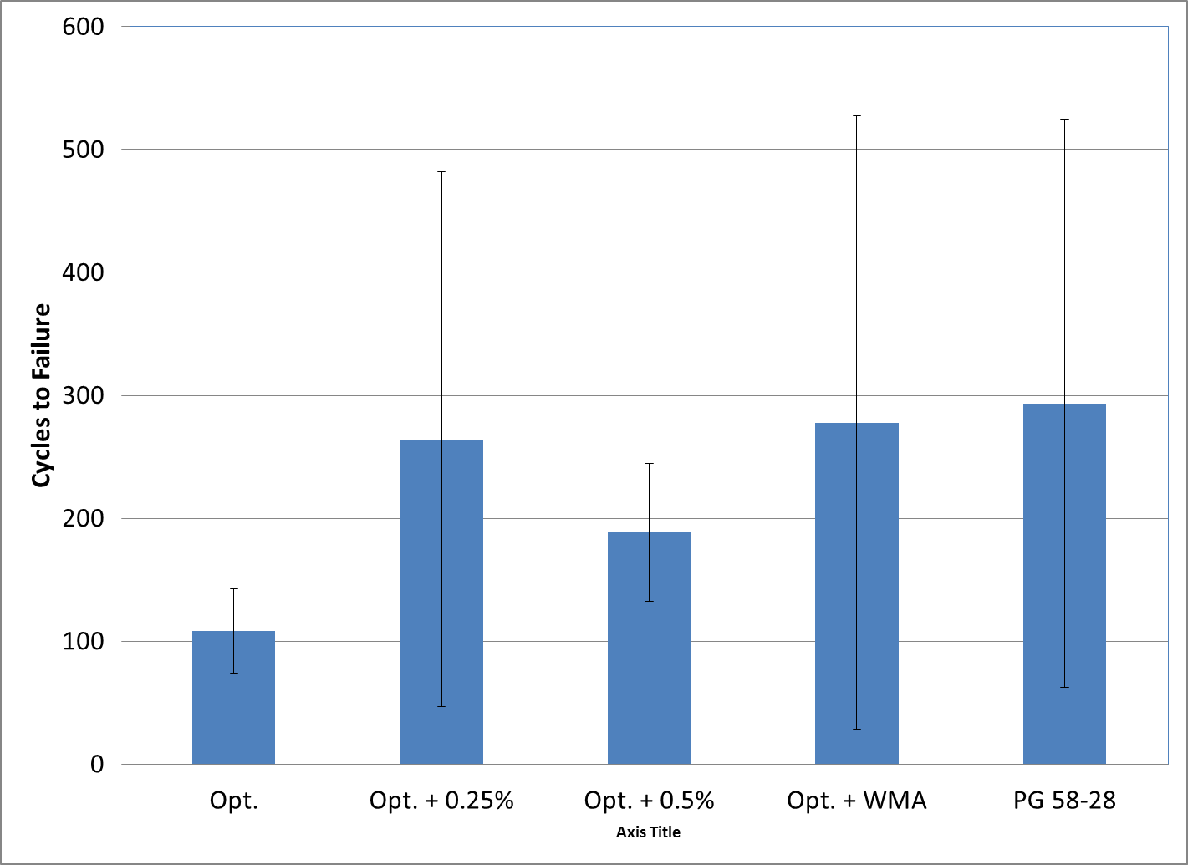
FIGURE 19 25 Percent RAP overlay tester results.

TABLE 15 25 Percent RAP OT Statistical Groupings

Mixture | Mean, Cycles to Failure | Grouping
PG 67-22 @ Opt. | 108 | A
PG 67-22 @ Opt. + 0.25% | 264 | A
PG 67-22 @ Opt. + 0.50% | 189 | A
PG 67-22 + WMA | 294 | A
PG 58-28 @ Opt. | 278 | A

The General Linear Model (α = 0.05) was also used to assess differences in OT results for the five 50 percent RAP mixtures. According to this statistical analysis and due to high testing variability (Table 16), there are no statistical differences between any of the variables. Using a softer binder with 50 percent RAP increased the mixture performance by 326 percent. Incorporating WMA in the mixture had minimal effect on the mixture performance.

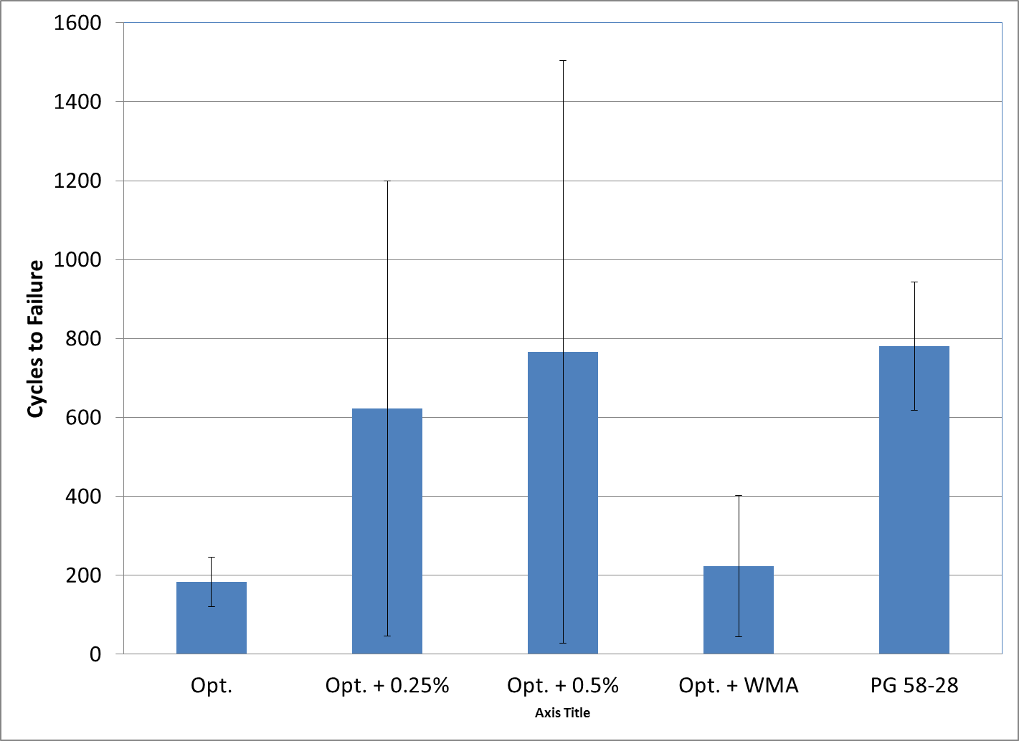
FIGURE 20 50 Percent RAP overlay tester results.

TABLE 16 50 Percent RAP OT Statistical Groupings

Mixture | Mean, Cycles to Failure | Grouping
PG 67-22 @ Opt. | 183 | A
PG 67-22 @ Opt. + 0.25% | 622 | A
PG 67-22 @ Opt. + 0.50% | 766 | A
PG 67-22 + WMA | 223 | A
PG 58-28 @ Opt. | 780 | A

3.6 Asphalt Pavement Analyzer Results

The APA was used to assess the rutting potential of all nine mixtures in this study. Each mixture was tested in the APA at 64°C using a maximum load and pressure of 100 lbs and 100 psi, respectively. The results for the RAP mixtures are shown in Figures 21-23.

The GLM (α = 0.05) was used to statistically compare the rutting of the of the five 10 percent RAP mixtures (Table 17). Statistically speaking, the mixture with the most rutting was the 10 percent RAP mixture with the PG 58-28 binder at the optimum asphalt content. All of the mixtures which used additional asphalt content or WMA were statistically equivalent to the 10 percent RAP mixture at the optimum asphalt content; therefore, they did not negatively influence the rutting performance of the mixtures.

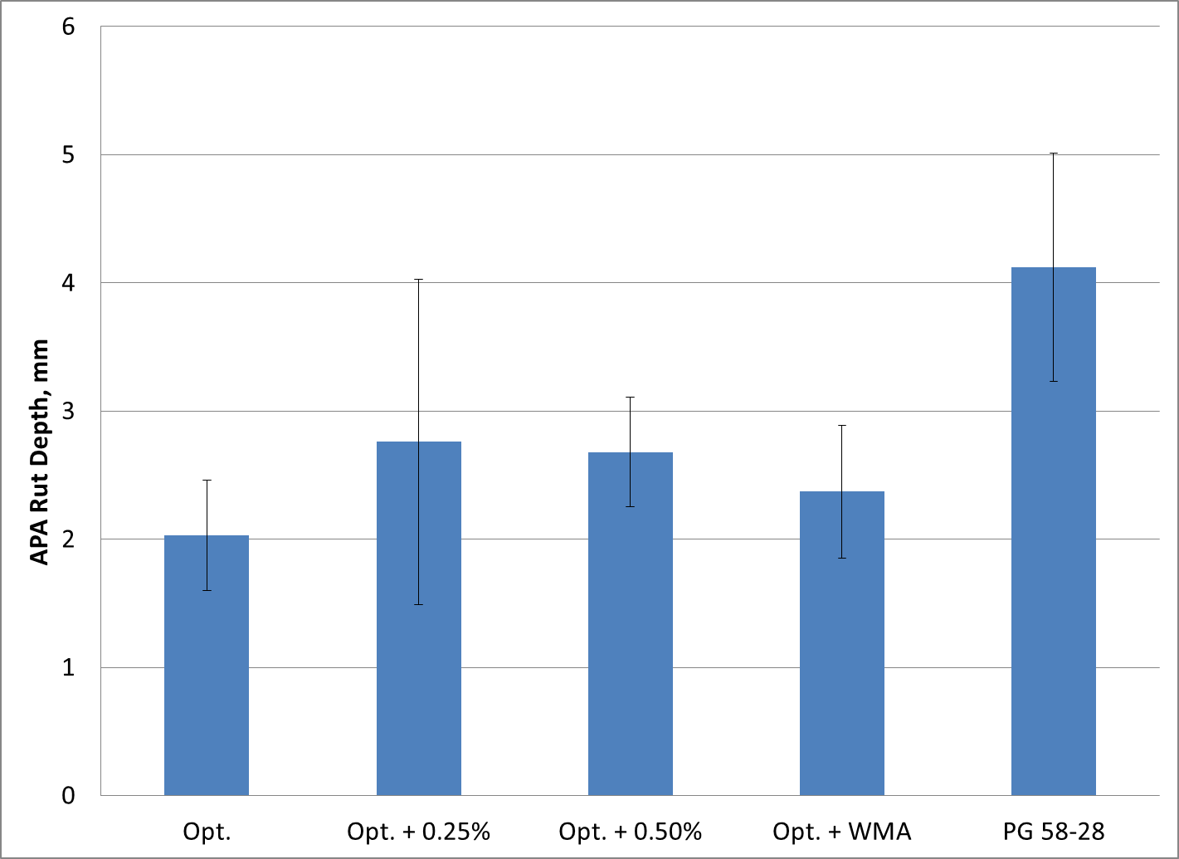
FIGURE 21 10 percent RAP APA test results.

TABLE 17 10% RAP Mixture APA GLM Groupings

Mixture | Mean Rut Depth, mm | Group
PG 67-22 @ Opt. | 2.03 | B
PG 67-22 @ Opt. + 0.25% | 2.76 | B
PG 67-22 @ Opt. + 0.5% | 2.68 | B
PG 67-22 + WMA | 2.37 | B
PG 58-28 @ Opt. | 4.12 | A

The GLM (α = 0.05) was also used to statistically compare the rutting of the of the five 25 percent RAP mixtures (Table 18). Three mixtures were grouped into one classification with the greatest rutting susceptibility. These three mixtures were the 25 percent RAP mixture with the softer binder, at the optimum asphalt content, and using an additional quarter percent binder. While the mixture with the PG 67-22 binder at optimum asphalt content was statistically equivalent to the worst performing rutting mixtures, it was also statistically equivalent to the best performing mixtures in terms of rutting (PG 67-22 at optimum + 0.5% and the mixture using WMA additives). It should be noted that based on these test results and a maximum allowable rut depth of 5.5 mm, none of these mixtures are considered susceptible to rutting.

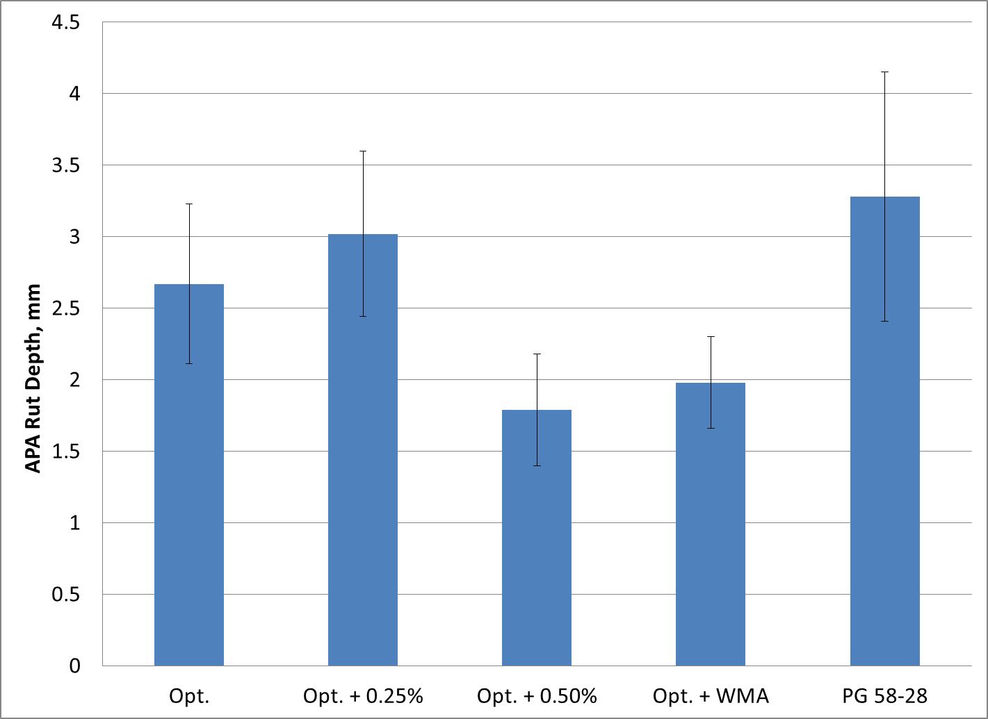
FIGURE 22 25 percent RAP APA test results.

TABLE 18 25% RAP Mixture APA GLM Groupings

Mixture | Mean Rut Depth, mm | Group
PG 67-22 @ Opt. | 2.67 | A B
PG 67-22 @ Opt. + 0.25% | 3.02 | A
PG 67-22 @ Opt. + 0.5% | 1.79 | B
PG 67-22 + WMA | 1.98 | B
PG 58-28 @ Opt. | 3.28 | A

The GLM (α = 0.05) was also used to statistically compare the rutting of the of the five 50 percent RAP mixtures (Table 19). Two sets of test results were statistically grouped together. Statistically speaking, the mixture which had the least amount of rutting was the 50% RAP mixture at optimum + 0.25% asphalt. All of the other four mixtures were statistically equivalent. Again, these results indicate that none of the mixture would be considered susceptible to rutting.

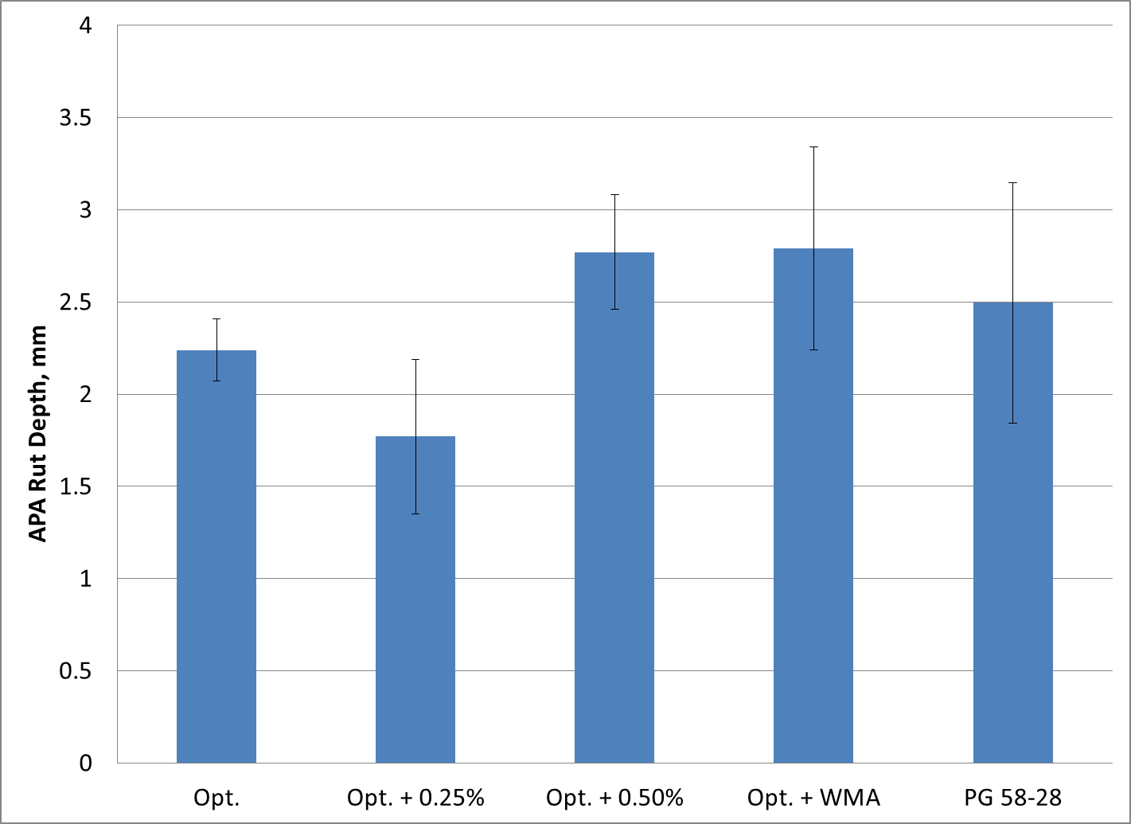
FIGURE 26 50 percent RAP APA test results.

TABLE 19 50% RAP Mixture APA GLM Groupings

Mixture | Mean Rut Depth, mm | Group
PG 67-22 @ Opt. | 2.24 | A B
PG 67-22 @ Opt. + 0.25% | 1.77 | B
PG 67-22 @ Opt. + 0.5% | 2.77 | A
PG 67-22 + WMA | 2.79 | A
PG 58-28 @ Opt. | 2.50 | A B

3.7 Summary

The following sections present a summary of the test results for three different RAP content mixtures.

3.7.1 10 Percent RAP Mixtures

Linear amplitude sweep test results on the blend of RAP and virgin binders suggest that the most effective way of increasing the fatigue resistance was to use a softer asphalt binder. Increasing the effective virgin asphalt content and using WMA only slightly changed the fatigue life of the blended binders.

The FE of the mixtures was most affected by using a softer binder. Both using an additional half percent asphalt and WMA additives had the second greatest effect on improving the FE test results. Energy ratio test results indicate that the three mixtures with the highest FE also had the highest ER ratio. All three of these mixtures would be considered resistant to top-down cracking in Southeastern states for traffic levels less than 1,000,000 ESALs.

Although increasing the amount of virgin binder in the mixture did not statistically improve the performance of the 10 percent RAP mixtures in the Overlay Tester, the results of this test did show a substantial numerical improvement in cracking resistance. The most effective way of increasing the OT cycles to failure was to use an additional quarter percent of asphalt.

APA test results indicate that a softer binder grade might increase the rutting susceptibility of the RAP mixtures. Therefore, one should ensure that the mixture is resistant to rutting before placing the mixture on a roadway.

Thus, the 10 percent RAP mixtures which are expected to have the best performance in terms of both cracking and rutting are the RAP mixture with an additional 0.5% asphalt or WMA additives. These mixtures improved both the FE and ER of the mixtures without increasing the rutting susceptibility of the RAP mixture at the optimum asphalt content.

3.7.2 25 Percent RAP Mixtures

Linear amplitude sweep test results on the blend of RAP and virgin binders suggest that the most effective way of increasing the fatigue resistance was to use a softer asphalt binder. Increasing the effective virgin asphalt content and using WMA again only slightly changed the fatigue life of the blended binders.

The FE of the mixtures was really not affected by changing the binder content, grade, or using a WMA; however, the ER of the mixture was reduced by changing the binder content, grade, or using a WMA. While this reduction was evident, all of the mixtures were still able to withstand the most stringent loading case based on current recommendations.

Although increasing the amount of virgin binder in the mixture did not statistically improve the performance of the 25 percent RAP mixtures in the Overlay Tester, the results of this test did show a substantial numerical improvement in cracking resistance. The most effective way of increasing the OT cycles to failure was to use an additional quarter percent of asphalt, use WMA, or soften the binder grade.

APA test results show that using softer binders, WMA additives and increased binder volume did not negatively affect the rutting susceptibility of the mixtures.

Thus, the 25 percent RAP mixtures which are expected to have the best performance in terms of both cracking and rutting are the RAP mixture with the WMA and the softer binder grade. This is based on increasing the reflective cracking resistance of the mixture in the OT. The mixtures increased OT performance without decreasing the rutting or cracking resistance below commonly assumed thresholds.

3.7.3 50 Percent RAP Mixtures

Using a softer grade of asphalt increased the fatigue life of the virgin-RAP binder blend on the LAS test. Increasing the effective virgin asphalt content did not increase the binder fatigue life. In contrast, the fracture energy of the mixture increased when using either a softer grade of asphalt, WMA additive or increased effective virgin asphalt content. Using 0.5 percent additional asphalt in the mixture provided the greatest benefit to FE. While the additional virgin binder content showed the greatest improvement to FE, using the WMA had the greatest impact on ER. The mixtures using a half percent additional virgin binder or WMA were the only two to meet the criterion for the most rigorous trafficking. The other mixtures would be appropriate for lower volume roads.

The OT cycles to failure were not statistically improved for the 50 percent RAP mixtures by using any of the theorized methods. Numerically, the mixture using a PG 58-28 binder at optimum had a fatigue life approximately three times that of the PG 67-22 mixture at optimum asphalt content. The additional half percent virgin asphalt also showed increased performance; however, these test results were highly variable.

All five mixtures should be resistant to rutting in the APA.

The best performing mixture using 50 percent RAP was the mix which used the 0.5% virgin asphalt above optimum. This mixture had increased fracture energy and ER compared to the 50 percent RAP mixture at the optimum asphalt content. Additionally, while there was not a statistical difference in the OT results, the mixture using the softer binder had a fatigue life more than three times that of the mix at the optimum asphalt content using the standard binder.

CHAPTER 4 CONCLUSIONS AND RECOMMENDATIONS

This chapter describes the conclusions and recommendations based on the previously detailed research methodology and results.

4.1 Conclusions

The following conclusions can be drawn based on the experimental plan and results. These conclusions are based on laboratory data using some tests DOTs do not commonly use and have not been thoroughly validated in the field. Field verification is critical of any laboratory finding before implementation becomes widespread.
- Using a softer binder had the greatest impact on improving the fatigue life of all the RAP binder blends based on the LAS binder fatigue test.
- Increasing the effective virgin binder content did not have much effect on the LAS test results.
- Using a softer binder grade, additional virgin asphalt, and WMA technologies improved the FE of both 10 and 50 percent RAP mixtures; however, no increase in FE was noticed for the 25 percent RAP mixtures.
- The ER decreased when using the softer virgin asphalt or increasing the effective virgin asphalt content of a mixture for the 25 percent RAP mixtures. For the 10 and 50 percent RAP mixtures, using a half percent additional asphalt or WMA showed the greatest increase in ER.
- OT test results were not statistically affected by the addition of virgin binder, WMA technologies, or using a softer binder at any RAP content. However, additional asphalt and WMA technologies made the greatest numerical increase in cycles to failure for 10 percent RAP and additional virgin asphalt or softer binders increased the cycles to failure the most for the 50 percent RAP mixtures. No real increase was seen for the 25 percent RAP mixtures.
- Using a softer binder at low RAP contents increased the rutting in the asphalt mixtures.

4.2 Recommendations

Based on this limited study, technical and cost effective options for enhancing the durability of high RAP mixtures appear viable. Further work is needed to validate these solutions in the field. When using less than 25 percent RAP, using an additional 0.5 percent virgin asphalt or incorporating a WMA technology in the RAP mixture should provide the additional durability. At 25 percent RAP, a softer binder or WMA technologies should be used to increase the mixture durability. Finally, an additional 0.5% or a softer binder should be allowed to increase the mixture durability. When using alternative technologies to increase mixture durability, one must ensure the mixture will not become susceptible to rutting. These options should be validated in the field and further analyzed on a regional basis. The authors also understand that using a different WMA additive or foaming technology may change the performance of the mixtures. Finally, State Agencies and Contractors should conduct cost analyses to determine if adding additional binder, a softer binder, or using a WMA technology would provide the most cost-effective solution when similar results are seen options.

REFERENCES
- Asphaltwa – Accessed on April, 20th, 2010. (http://www.asphaltwa.com/wapa_web/modules/02_pavement_types/02_recycled_hma.htm).
- Willis, J.R., P. Turner, G. Julian, A. Taylor, N. Tran, F. Padula. Effects of Changing Virgin Binder Grade and Content on RAP Mixture Properties,” NCAT Report 12-03, National Center for Asphalt Technology, 2012.
- Page, G.C. and K.H. Murphy, “Hot-Mix Recycling Saves Florida DOT $38 Million,” Asphalt, Vol. 1, No. 1, Spring 1987.
- Copeland, Audrey. Reclaimed Asphalt Pavement in Asphalt Mixtures: State of the Practice, FHWA-HRT-11-021, Federal Highway Administration, McClean, VA, April 2011.
- American Association of State Highway and Transportation Officials. “AASHTO M 323: Standard Specification for Superpave Volumetric Mix Design,” Standard Specifications for Transportation Materials and Methods for Sampling and Testing, 30th Edition, AASHTO, Washington, DC.
- West, R., D. Timm, R. Willis, B. Powell, N. Tran, D. Watson, M. Sakhaeifar, R. Brown, M. Robbins, A. Vargas-Nordcbeck, F. Villacorta, X. Guo, and J. Neslson. Phase IV NCAT Pavement Test Track Findings, NCAT Report 12-10, National Center for Asphalt Technology, 2012.
- Johnson, C.M. and H.U. Bahia, “Evaluation of an Accelerated Procedure for Fatigue Characterization of Asphalt Binders,” Submitted for publication in Road Materials and Pavement Design, 2010.
- Roque, R., B. Birgisson, C. Drakos, and B. Dietrich. Development and Field Evaluation of Energy-Based Criteria for Top-down Cracking Performance of Hot Mix Asphalt. Journal of the Association of Asphalt Paving Technologists, Vol. 73, 2004, pp. 229-260.
- Timm, D.H., G. Sholar, J. Kim, and J.R. Willis. “Forensic Investigation and Validation of Energy Ratio Concept,” Transportation Research Record: Journal of the Transportation Research Board, No. 2127, pp. 43-51, 2009.
- Roque, R., W.G. Buttlar, B.E. Ruth, M. Tia, S.W. Dickison and B. Reid. Evaluation of SHRP Indirect Tension Tester to Mitigate Cracking in Asphalt Concrete Pavements and Overlays. Final Report, FDOT B-9885, University of Florida, Gainesville, FL, 1997.
- Zhou, F., S. Hu, D. Chen, and T. Scullion. Overlay Tester: Simple Performance Test for Fatigue Cracking, Transportation Research Record: Journal of the Transportation Research Board, No. 2001, pp. 1-8, 2007.
- Willis, J.R., A.J. Taylor, and N. Tran, “Evaluation of Influential Parameters on Overlay Tester Results,” (Presented), American Society of Civil Engineers Engineering Mechanics Institute Conference, Boston, MA, June 2-4, 2011.
- Tran, N., R.C. West, R.B. Powell, and A.N. Kvasnak, Evaluation of AASHTO Rut Test Procedure Using the Asphalt Pavement Analyzer, Journal of the Association of Asphalt Paving Technologists, Vol. 78, 2009, pp. 1-24.
- Kim, Y.R., J. Daniel, and H. Wen. Fatigue Performance Evaluation of WesTrack Asphalt Mixtures Using Viscoelastic Continuum Damage Approach, North Carolina Department of Transportation, 2002.

APPENDIX A AGGREGATE PROPERTIES

TABLE A.1 Aggregate Gradations for 10% RAP Mixture
Sieve  Size  (mm) | Sieve  Size (Inches) | Percent Passing
 |  | Columbus  Granite  7’s | Columbus  Granite  89’s | EAP  Limestone 8910’s | Shorter Natural Sand | Unprocessed RAP | Total Blend
19.0 | 3/4" | 100.0 | 100.0 | 100.0 | 100.0 | 100.0 | 100.0
12.5 | 1/2" | 95.2 | 100.0 | 100.0 | 100.0 | 100.0 | 98.5
9.5 | 3/8" | 51.8 | 99.5 | 99.5 | 100.0 | 99.2 | 84.3
4.75 | # 4 | 7.4 | 31.9 | 99.4 | 99.5 | 83.1 | 47.4
2.36 | # 8 | 1.8 | 4.9 | 90.0 | 89.3 | 64.3 | 32.7
1.18 | # 16 | 1.1 | 2.6 | 65.4 | 70.0 | 49.5 | 24.4
0.600 | # 30 | 1.0 | 2.0 | 47.8 | 38.7 | 34.9 | 16.0
0.300 | # 50 | 0.9 | 1.6 | 36.1 | 14.0 | 22.4 | 9.7
0.150 | #100 | 0.8 | 1.2 | 27.5 | 4.4 | 14.9 | 6.3
0.075 | #200 | 0.6 | 0.8 | 20.2 | 0.8 | 9.5 | 4.1
Cold Feed (%) |  | 32 | 31 | 13 | 14 | 10 | --

TABLE A.2 Aggregate Gradations for 25 Percent RAP Mixture
Sieve  Size  (mm) | Sieve  Size (Inches) | Percent Passing
 |  | Columbus  Granite  7’s | Columbus  Granite  89’s | Columbus  Granite M10’s | Shorter Natural Sand | Unprocessed RAP | Total Blend
19.0 | 3/4" | 100.0 | 100.0 | 100.0 | 100.0 | 100.0 | 100.0
12.5 | 1/2" | 95.2 | 100.0 | 100.0 | 100.0 | 100.0 | 98.5
9.5 | 3/8" | 51.8 | 99.5 | 100.0 | 100.0 | 99.2 | 84.7
4.75 | # 4 | 7.4 | 31.9 | 99.3 | 99.5 | 83.1 | 50.6
2.36 | # 8 | 1.8 | 4.9 | 88.6 | 89.3 | 64.3 | 35.6
1.18 | # 16 | 1.1 | 2.6 | 70.5 | 70.0 | 49.5 | 27.4
0.600 | # 30 | 1.0 | 2.0 | 53.5 | 38.7 | 34.9 | 18.7
0.300 | # 50 | 0.9 | 1.6 | 36.8 | 14.0 | 22.4 | 11.4
0.150 | #100 | 0.8 | 1.2 | 23.0 | 4.4 | 14.9 | 7.0
0.075 | #200 | 0.6 | 0.8 | 13.2 | 0.8 | 9.5 | 4.1
Cold Feed (%) |  | 31 | 24 | 10 | 10 | 25 | --

TABLE A.3 Aggregate Gradations for 50 Percent RAP Mixture
Sieve  Size  (mm) | Sieve  Size (Inches) | Percent Passing
 |  | Columbus  Granite  7’s | Columbus  Granite  89’s | Shorter Natural Sand | Coarse (+#4s) RAP | Fine  (-#4s) RAP | Total Blend
19.0 | 3/4" | 100.0 | 100.0 | 100.0 | 100.0 | 100.0 | 100.0
12.5 | 1/2" | 95.2 | 100.0 | 100.0 | 99.7 | 100.0 | 98.5
9.5 | 3/8" | 51.8 | 99.5 | 100.0 | 97.3 | 100.0 | 84.6
4.75 | # 4 | 7.4 | 31.9 | 99.5 | 41.0 | 100.0 | 44.7
2.36 | # 8 | 1.8 | 4.9 | 89.3 | 23.7 | 79.3 | 30.2
1.18 | # 16 | 1.1 | 2.6 | 70.0 | 19.4 | 58.3 | 23.1
0.600 | # 30 | 1.0 | 2.0 | 38.7 | 15.4 | 41.2 | 15.9
0.300 | # 50 | 0.9 | 1.6 | 14.0 | 10.7 | 24.6 | 9.3
0.150 | #100 | 0.8 | 1.2 | 4.4 | 7.5 | 16.0 | 5.8
0.075 | #200 | 0.6 | 0.8 | 0.8 | 5.1 | 10.6 | 3.7
Cold Feed (%) |  | 30 | 10 | 10 | 35 | 15 | --

TABLE A.4 Consensus Aggregate Properties
Consensus Property | Columbus  Granite  7’s | Columbus  Granite  89’s | EAP  Limestone 8910’s | Columbus  Granite M10’s | Shorter Natural Sand | Unprocessed RAP | Coarse (+#4s) RAP | Fine  (-#4s) RAP
Bulk Specific Gravity (Gsb) | 2.661 | 2.610 | 2.819 | 2.707 | 2.614 | 2.708 | 2.636 | 2.674
Absorption (%) | 0.9 | 1.5 | 0.5 | 0.3 | 0.2 | 0.5 | 1.1 | 0.4
Crushed Faces (%) | 100 | 100 | N/A | N/A | N/A | N/A | 97.2 | N/A
Uncompacted Void Content | N/A | N/A | 48.4 | 50.2 | 45.8 | 46.6 | N/A | 45.8
Sand Equivalence | N/A | N/A | 78 | 72 | 81 | 89 | N/A | 86
Flat and Elongated Particles (%) ** | 0 | 0 | N/A | N/A | N/A | NA | 0 | N/A
** - Weighted Average Based on Gradation (5:1)

APPENDIX B OVERLAY TESTER RESULTS

TABLE B.1 Overlay Tester Results
RAP Content | Binder Content | Binder Grade | Cycles Until Failure
 |  |  | 1 | 2 | 3 | 4 | Average | StDev
10 | Opt | 67-22 | 221 | 433 | 657 |  | 437 | 218
 | Opt + 0.25% | 67-22 | 4201 | 2176 | 3516 |  | 3298 | 1030
 | Opt + 0.50% | 67-22 | 786 | 1259 | 2360 |  | 1980 | 1218
 | Opt + WMA | 67-22 | 1249 | 2279 | 1092 | 1676 | 1574 | 531
 | Opt | 58-28 | 3461 | 2084 | 1756 |  | 2023 | 1105
25 | Opt | 67-22 | 104 | 151 | 67 | 111 | 108 | 34
 | Opt + 0.25% | 67-22 | 101 | 394 | 502 | 60 | 264 | 217
 | Opt + 0.50% | 67-22 | 245 | 114 | 181 | 214 | 189 | 56
 | Opt + WMA | 67-22 | 622 | 263 | 203 |  | 294 | 231
 | Opt | 58-28 | 312 | 138 | 614 |  | 278 | 250
50 | Opt | 67-22 | 244 | 186 | 120 |  | 183 | 62
 | Opt + 0.25% | 67-22 | 155 | 787 | 179 | 1368 | 622 | 577
 | Opt + 0.50% | 67-22 | 216 | 382 | 621 | 1846 | 766 | 739
 | Opt + WMA | 67-22 | 289 | 438 | 30 | 136 | 233 | 178
 | Opt | 58-28 | 950 | 765 | 626 |  | 780 | 163

APPENDIX C ASPHALT PAVEMENT ANALYZER RESULTS

TABLE C.1 APA Results
%RAP | Binder Content | Binder Grade | Rut Depth, mm
 |  |  | 1 | 2 | 3 | 4 | 5 | 6 | Average | COV, %
10 | Opt | 67-22 | 1.41 | 1.79 | 2.43 | 1.79 | 2.38 | 2.40 | 2.04 | 0.43
 | Opt + 0.25% | 67-22 | 1.26 | 2.81 | 3.12 | 1.32 | 4.46 | 3.58 | 2.76 | 1.27
 | Opt + 0.50% | 67-22 | 1.97 | 2.47 | 2.78 | 3.17 | 2.64 | 3.05 | 2.68 | 0.43
 | Opt + WMA | 67-22 | 1.74 | 2.44 | 2.36 | 2.84 | 1.80 | 3.02 | 2.37 | 0.52
 | Opt | 58-28 | 5.28 | 3.68 | 4.76 | 2.76 | 4.43 | 3.80 | 4.12 | 0.89
25 | Opt | 67-22 | 3.00 | 2.03 | 2.72 | 2.17 | 3.57 | 2.55 | 2.67 | 0.56
 | Opt + 0.25% | 67-22 | 2.21 | 2.71 | 3.02 | 2.81 | 3.82 | 3.52 | 3.02 | 0.58
 | Opt + 0.50% | 67-22 | 1.36 | 1.77 | 2.41 | 1.39 | 1.85 | 1.93 | 1.79 | 0.39
 | Opt + WMA | 67-22 | 1.77 | 1.57 | 2.19 | 1.86 | 1.98 | 2.48 | 1.98 | 0.32
 | Opt | 58-28 | 2.43 | 2.79 | 3.32 | 3.03 | 4.95 | 3.18 | 3.28 | 0.87
50 | Opt | 67-22 | 2.24 | 1.97 | 2.19 | 2.26 | 2.35 | 2.46 | 2.25 | 0.17
 | Opt + 0.25% | 67-22 | 1.65 | 1.43 | 1.38 | 1.57 | 2.16 | 2.42 | 1.77 | 0.42
 | Opt + 0.50% | 67-22 | 2.92 | 2.29 | 3.14 | 2.97 | 2.52 | 2.76 | 2.77 | 0.31
 | Opt + WMA | 67-22 | 2.05 | 1.72 | 2.87 | 2.02 | 2.97 | 3.34 | 2.50 | 0.65
 | Opt | 58-28 | 2.34 | 2.32 | 3.02 | 2.25 | 3.48 | 3.31 | 2.79 | 0.55

