TRANSPORTATION POOLED FUND PROGRAM
QUARTERLY PROGRESS REPORT

Lead Agency: Utah Department of Transportation

INSTRUCTIONS:
Project Managers and/or research project investigators should complete a quarterly progress report for each calendar quarter during which the projects are active. Please provide a project schedule status of the research activities tied to each task that is defined in the proposal; a percentage completion of each task; a concise discussion (2 or 3 sentences) of the current status, including accomplishments and problems encountered, if any. List all tasks, even if no work was done during this period.

Transportation Pooled Fund Program Project #  TPF-5(244) |  | Transportation Pooled Fund Program - Report Period:  _ Quarter 1 (January 1 – March 31, 2015)  _ Quarter 2 (April 1 – June 30, 2015)  x Quarter 3 (July 1 – September 30, 2015)  _ Quarter 4 (October 1 – December 31, 2015)
Project Title:
Shaking Table Testing to Evaluate Effectiveness of Vertical Drains for Liquefaction Mitigation

Name of Project Manager(s):  David Stevens | Phone Number:  801-589-8340 |  | E-Mail  davidstevens@utah.gov
Lead Agency Project ID:  FINET 42046, ePM PIN 9933  UDOT PIC No. UT07.708 | Other Project ID (i.e., contract #):  UDOT Contract No. 138731 |  | Project Start Date:  May 1, 2013
Original Project End Date:  March 31, 2016 | Current Project End Date:  March 31, 2016 |  | Number of Extensions:

Project schedule status:

_ On schedule X On revised schedule _ Ahead of schedule _ Behind schedule

Overall Project Statistics:
Total Project Budget | Total Cost to Date for Project | Percentage of Work  Completed to Date
$115,000.00 | $40,000.00 | 45%

Quarterly Project Statistics:
Total Project Expenses  and Percentage This Quarter | Total Amount of Funds  Expended This Quarter | Total Percentage of  Time Used to Date
15% | $16,750 | 80%

Project Description:

The vision for this study is to determine the viability of large diameter (100 mm) prefabricated vertical drains for preventing liquefaction and associated settlements or lateral spreading under full-scale conditions. If viable, drainage alternatives offer substantial advantages in comparison to conventional densification approaches. In production, drains can often be installed at 25% to 40% of the cost of stone columns. In addition, the drains can be installed in about one-third to one-half of the time required for stone columns. Finally, the time and cost associated with post-treatment in-situ testing to evaluate improvement produced by densification may not be required with drains. In an era when construction budgets are becoming increasingly tight and projects are increasingly placed on fast-track schedules, innovative alternative solutions are required to deal with liquefaction hazards.

Although limited blast liquefaction testing (Rollins et al. 2003, Rollins et al. 2004), vibration testing (Chang et al. 2004) and centrifuge testing (Yang et al. 2004 ) suggest that vertical drains can be effective, no full-scale drain installation has been subjected to earthquake induced ground motions. This lack of performance data under full-scale conditions has been a major impediment to expanding the use of this technique. To remedy this problem we will conduct full-scale tests with vertical drains in liquefiable sand using the laminar shear box and high speed actuator system at NEES-Univ. at Buffalo. Tests will involve level ground conditions with two drain spacings and will be integrated with a previously funded NEESR study currently underway so that the control tests without drains will already be available. We will use the same sand installation techniques, as well as the same instrumentation plan and shaking protocols which have already been developed and proven successful. This collaborative approach will significantly reduce the cost of the study in comparison to a completely independent study. In addition, it will provide a comparison between the performance of the soil profile with drains relative to subsequent tests where piles will be involved. If full-scale tests prove the effectiveness of the drainage technique, significant time and costs savings can be achieved for both new construction and for retrofit situations.

Three objectives are outlined for this study:
1. Evaluate the ability of earthquake drains to reduce excess pore pressure and settlement for level ground conditions at progressively higher acceleration levels.
2. Define the influence of drain spacing on the effectiveness of the drains for mitigating liquefaction hazard.
3. Provide well-documented case histories which can be used to calibrate/validate numerical models for predicting the performance of vertical drains.

The scope of work consists of eight specific tasks:
1. Perform a literature review to summarize the state of the art in the area of liquefaction mitigation through drainage.
2. Conduct level ground shaking table tests with drains at 4 ft spacing.
3. Conduct level ground shaking table tests with drains at 3 ft spacing.
4. Reduce the test data, analyze, and compare with previous test on untreated sand.
5. Evaluate predictive methods by comparing measured behavior with behavior computed using computer models and simplified models.
6. Prepare a final report on effectiveness of the drain technique.
7. Disseminate the research results.
8. Hold technical advisory committee meetings.

Dr. Kyle Rollins of BYU is the Principal Investigator for this research project. The TPF-5(244) testing was performed at the SUNY-Buffalo shaking table testing facility in the summer of 2014. BYU was approved for shared-use status on the NEES-Buffalo shake table. Individual task reports will be prepared for Tasks 1 through 5 when these are completed. Up to two in-person meetings with the multi-state technical advisory committee (TAC) are planned to be held in Salt Lake City, Utah during the project. Other TAC meetings will be tele-conference or web meetings.

Progress this Quarter (includes meetings, work plan status, contract status, significant progress, etc.):

Task 1 – 100% complete.
Task 2 – 100% complete.
Task 3 – 100% complete.
Task 4 – 80% complete. BYU continued the test data reduction and analysis.
Task 5 – 30% complete. BYU continued evaluating predictive methods.
Task 6 – No work yet.
Task 7 – No work yet.
Task 8 – 30% complete.

Anticipated work next quarter:

Task 1 – None.
Task 2 – None.
Task 3 – None.
Task 4 – Continue with test data reduction and analysis. Prepare summary reports for this task.
Task 5 – Continue with evaluating predictive methods.
Task 6 – None.
Task 7 – None.
Task 8 – Plan to hold another TAC web-conference to review and discuss additional results from the study.

Significant Results:

As indicated previously, surface settlement was measured using string pots connected to plates sitting on the surface of the sand at three locations. Surface settlement versus time plots are presented in Figs. 1, 2, and 3 for the three rounds of testing with drains at 4 ft spacing. The settlement plots are in groups of three for each round. The left plot represents the settlement from the 0.05 g test, the center plot is the 0.1 g test, and the right plot is the 0.2 g test. Beneath each settlement plot are two plots of excess pore pressure ratio versus time. The upper plot is for a transducer located near the surface, and the lower plot is for a transducer near the bottom of the liquefied layer. Settlement increases with increasing acceleration, which is to be expected, as more energy is being introduced into the soil. In addition, settlement decreases with each progressive round of testing. Each round of testing has densified the sand from the settlement of the previous rounds, also evidenced by the increased cone tip resistance in the CPT soundings. The settlement from the final round is much less than the settlement from the first round, and even the second round.

Most of the settlement occurs during application of the 15 cycles of shaking (0 to 7.5 seconds), and the remainder occurs mainly within the next 15 seconds as pore pressures dissipate. Very little settlement occurs after r_{u} goes below 0.5. The later tests have a very flat curve after the shaking is finished because the time for r_{u} to go below 0.5 is very small. For example, in Fig. 1, about 0.5 inch (20%) of the 2.5 inches of total settlement occurred after the shaking had stopped for the 0.2g test for round 1, whereas in Fig. 3, only about 0.1 inch (10%) of the 1.0 inch of total settlement or less occurs after the shaking has stopped in the 0.2g test for round 3. The time for r_{u} to reach 0.5 again after shaking stopped in Fig. 3 for the 0.2g test is about 7 seconds. In Fig. 1, it takes at least 14 seconds for r_{u} to reach 0.5 again in the 0.2g test. As the sand gets denser the permeability of the sand decreases which would tend to decrease the effectiveness of the drains in dissipating pore pressure. However, the rate of settlement is inversely proportional to the coefficient of compressibility of the sand. As the compressibility decreases due to the densification of the sand, the rate of dissipation actually increases. It appears that the decrease in compressibility overcomes the reduction in permeability to make the drains more effective as the density of the sand increases. Additional effort is underway to quantify the rate of dissipation at the end of shaking and to compare it with the rate of dissipation observed in tests without drains in place. We are working with Prof. Thevanayangam at SUNY-Buffalo to obtain this information.
Work is continuing on the final report on the shaking table testing. A draft report has been completed and is in the second round of review. We hope to have this completed by the end of the next quarter.

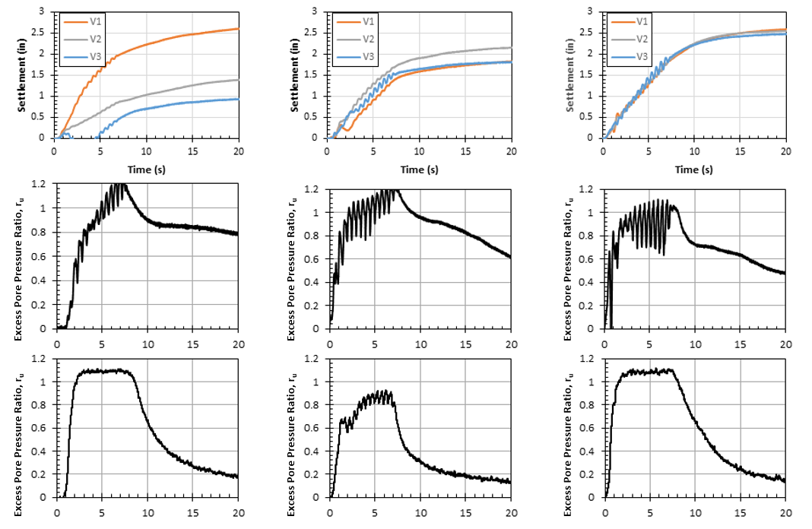
Fig. 1 Surface settlement versus time paired with excess pore pressure ratio (PPR) versus time for the first round test, left a_{max}=0.05 g, middle a_{max}=0.10 g, right a_{max}=0.20 g

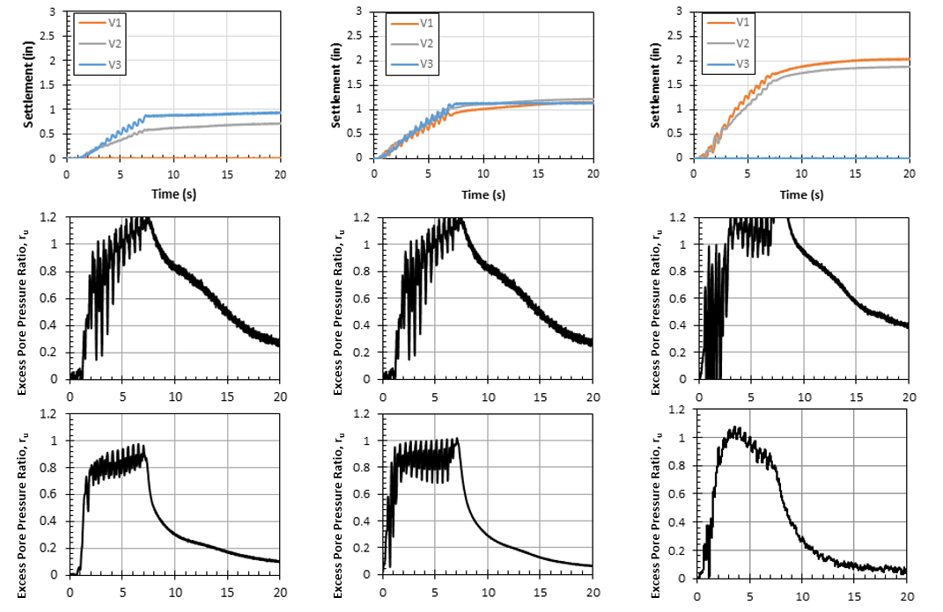
Fig. 2 Surface settlement versus time paired with excess pore pressure ratio (PPR) versus time for the second round test, left a_{max}=0.05 g, middle a_{max}=0.10 g, right a_{max}=0.20 g

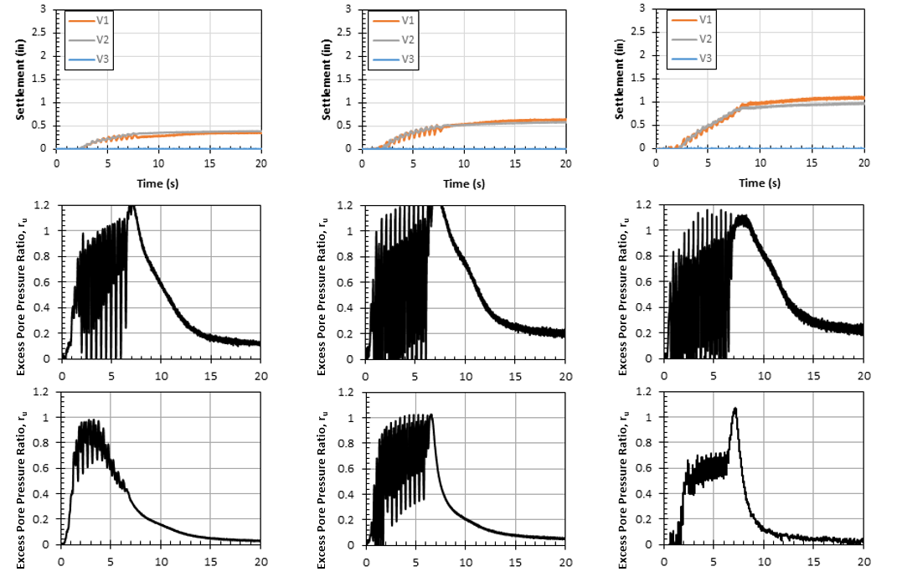
Fig. 3 Surface settlement versus time paired with excess pore pressure ratio (PPR) versus time for the third round test, left a_{max}=0.05 g, middle a_{max}=0.10 g, right a_{max}=0.20 g

Circumstance affecting project or budget. (Please describe any challenges encountered or anticipated that
might affect the completion of the project within the time, scope and fiscal constraints set forth in the
agreement, along with recommended solutions to those problems).

Some testing tasks and associated analysis have taken longer to complete than originally planned. However, it is anticipated that the project tasks and deliverables will be completed within the original contract period.

Potential Implementation:

