Click here to enter Program or Project Title
Progress Report – Click here to enter a date.

Title: Assessment and Repair of Prestressed Bridge Girders Subjected to Over-height Truck Impacts Pooled Fund Project

Project Number: TR202011

Principal Investigator (PI): Mohamed ElGawady PhD (PI)
Co-PI(s): William Schonberg PhD, PE (Co-PI)

Award date: | 1/1/2021
Scheduled completion date: | 12/31/2023 | % of project completed to date: | 25%
Total budget: | $755,000 | % of budget expended to date: | 17%
Draft report due: | 3/31/2021 | Final report due: | 12/1/2023

Provide a short description of the work currently underway.
Use additional notes section if you need to provide more information.

Task 2. Experimental testing of bridge girders subjected to lateral impacts: The review of the design of the test setup is completed. Acquiring and manufacturing of the test setup has been completed. Delivery of the different pieces started.

Provide a short description of the noteworthy activities/accomplishments during this reporting period.
Use additional notes section if you need to provide more information.
The following are different images presenting the design and physical setup

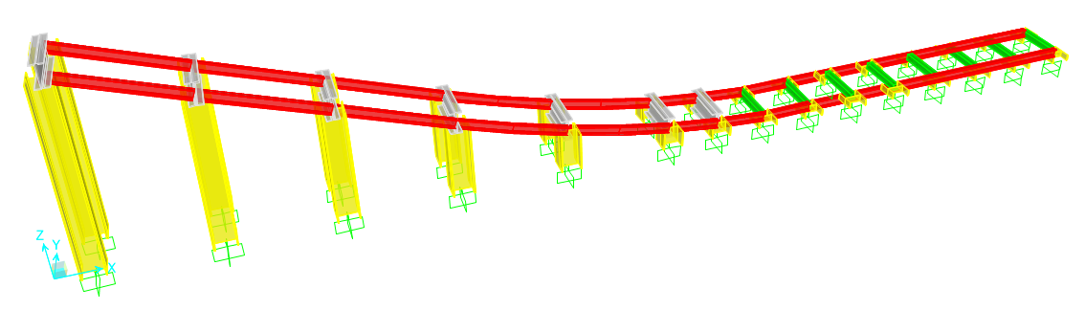
Figure 1: 3D Model of the track system in Sap2000
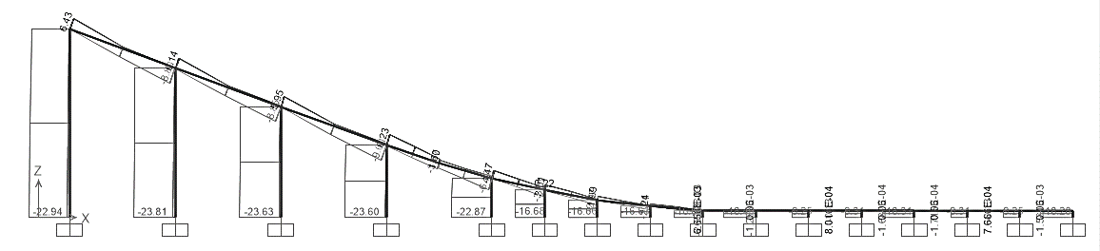
Figure 2: Track system maximum axial forces
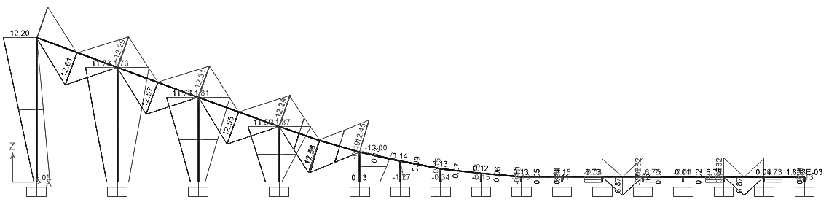
Figure 3: Track system maximin bending moments

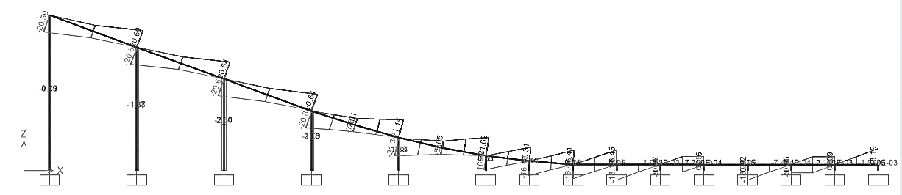
Figure 4: Track system maximin frame shear forces

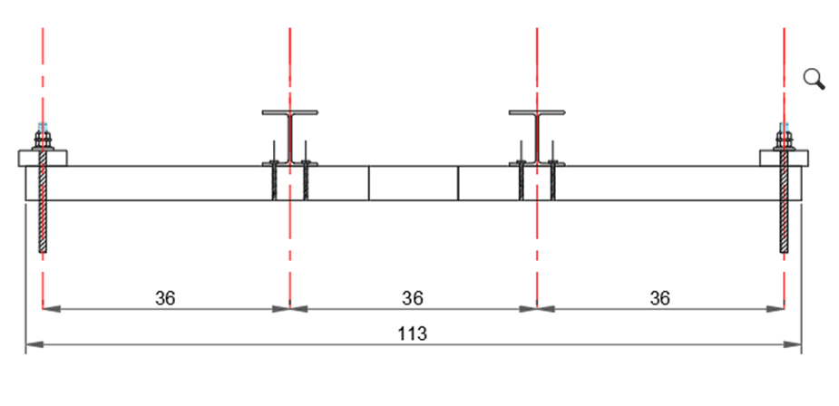
Figure 5: HSS sections to carry out the rail
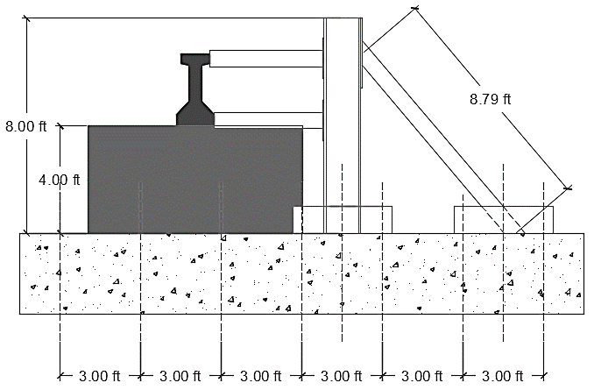
Figure 6: Geometric design of the lateral support (side view)

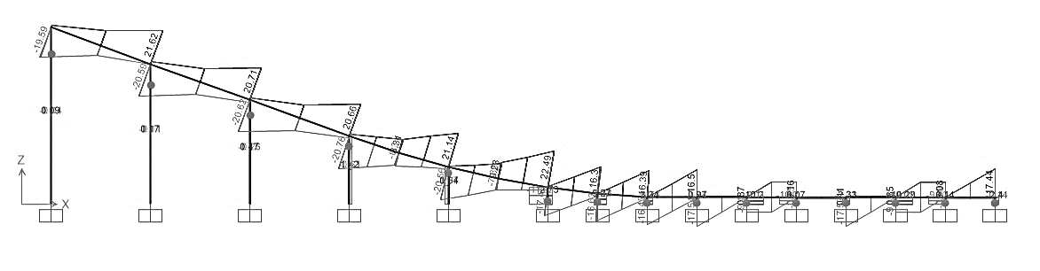
Figure 7: Shear force diagram of the beams due to ultimate load combination

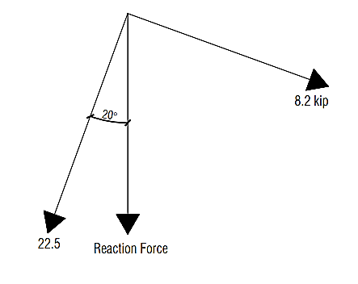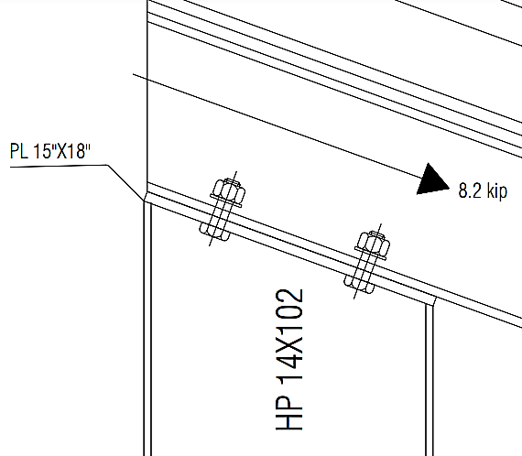
Figure 8: Maximum shear force acting on the connection

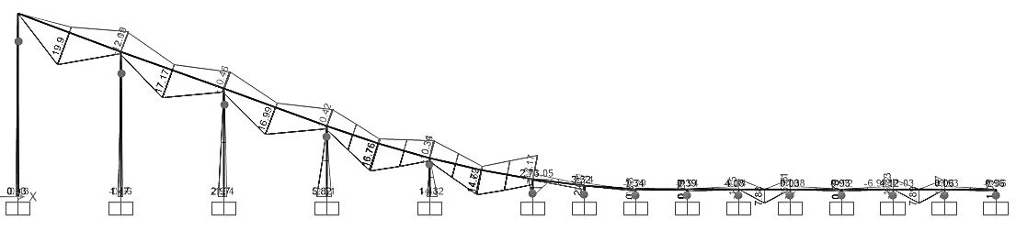
Figure 9: Bending moment diagram of the beams due to ultimate load combination

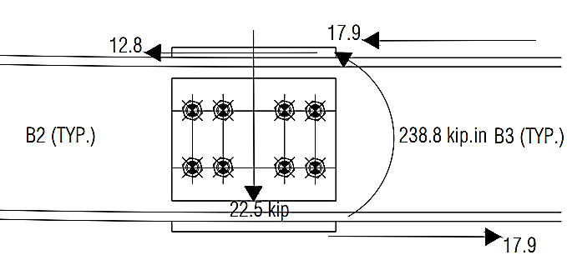
Figure 10: Straining actions acting on the splice

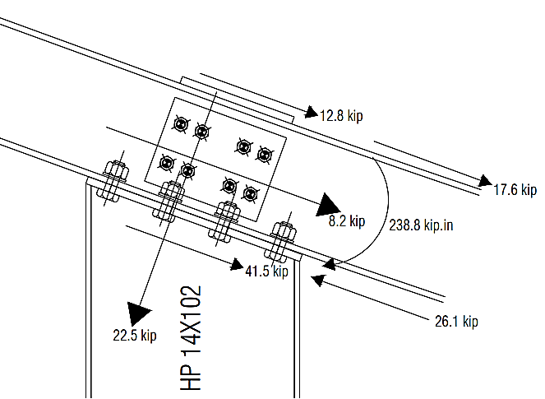
Figure 11: Straining actions on the connection
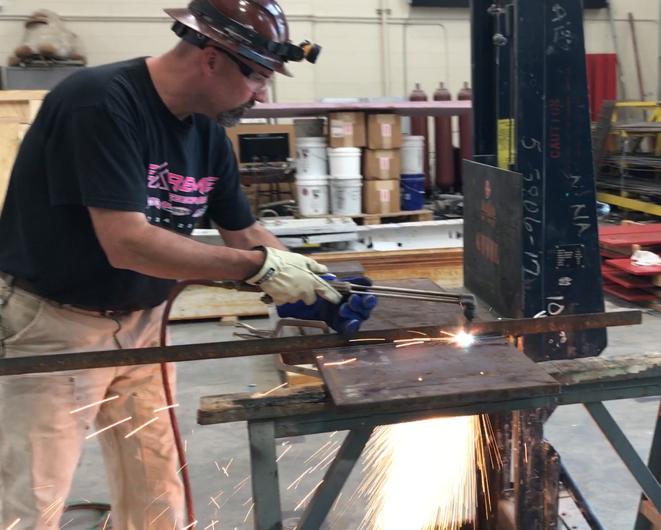
Figure 11: Steel plates preparation

 | 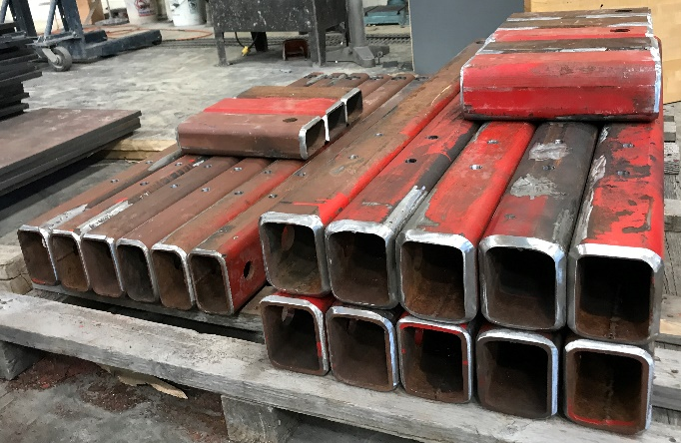
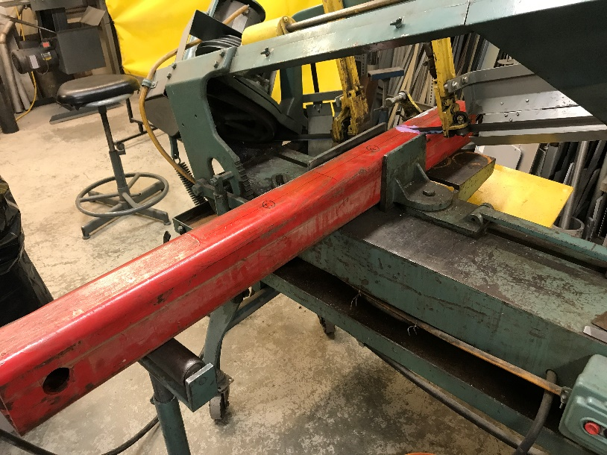 | 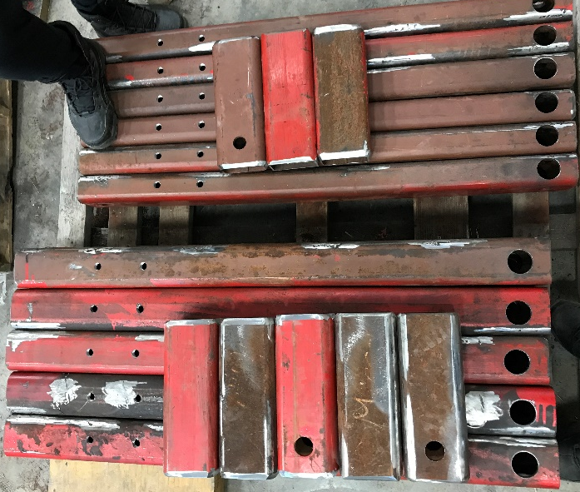
Figure 11: Preparing the HSS beams

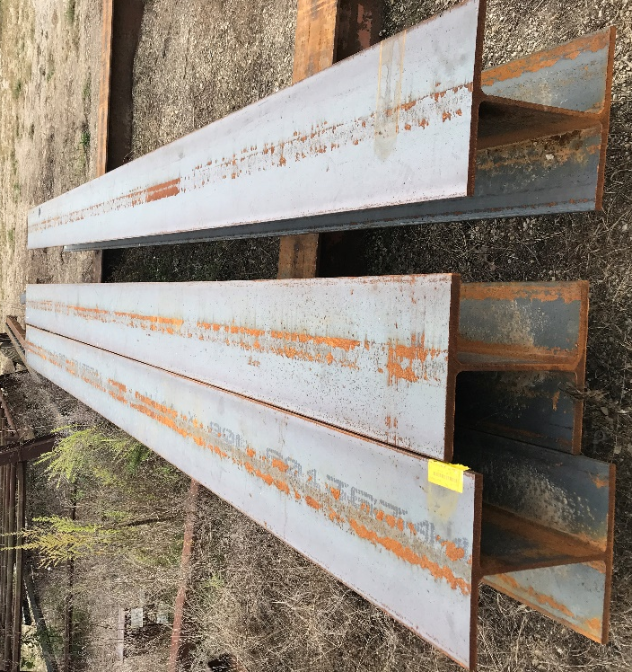 | 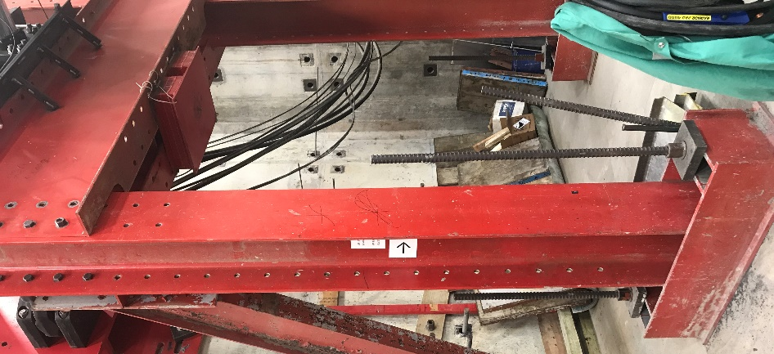
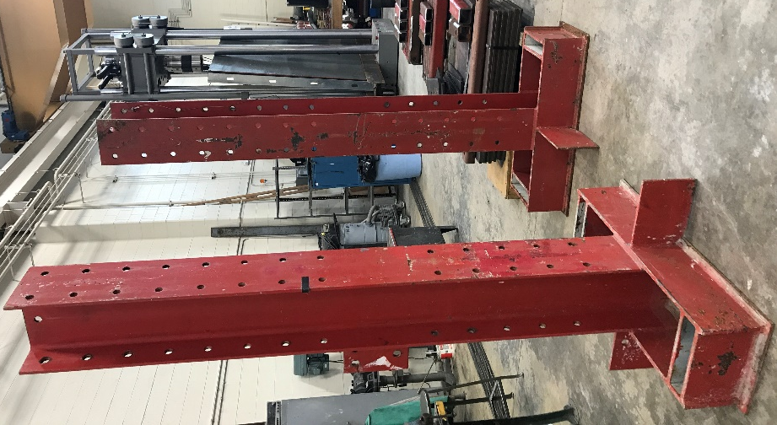 | 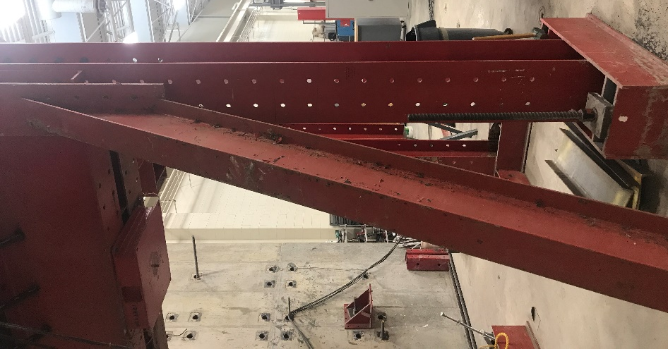
Figure 12: Vertical elements

Figure 13: Vertical elements

Identify issues or problems that need to be addressed.

Three graduate students arrived late for this project due to COVID-19 and visa issues (US embassies halt the visa section for the major part of the year). A fourth student will join us o January 2022.

Use additional notes section if you need to provide more information.

Provides dates for when the next progress report or presentation

