TRANSPORTATION POOLED FUND PROGRAM
QUARTERLY PROGRESS REPORT

Lead Agency: ---- Utah Department of Transportation ----

INSTRUCTIONS:
Project Managers and/or research project investigators should complete a quarterly progress report for each calendar quarter during which the projects are active. Please provide a project schedule status of the research activities tied to each task that is defined in the proposal; a percentage completion of each task; a concise discussion (2 or 3 sentences) of the current status, including accomplishments and problems encountered, if any. List all tasks, even if no work was done during this period.

Transportation Pooled Fund Program Project #  TPF-5(257) |  | Transportation Pooled Fund Program - Report Period:  x Quarter 1 (January 1 – March 31, 2014)  _ Quarter 2 (April 1 – June 30)  _ Quarter 3 (July 1 – September 30)  _ Quarter 4 (October 1 – December 31)

Project Title: Evaluation of Spliced Sleeve Connections for Precast RC Bridge Piers

Name of Project Manager(s):  Russ Scovil | Phone Number:  801-965-4097 |  | E-Mail  Rgscovil@utah.gov
Lead Agency Project ID:  5H06604H, UT11.502 | Other Project ID (i.e., contract #):  12-8775 |  | Project Start Date:  3/23/2012
Original Project End Date:  3/30/2013 | Current Project End Date:  6/30/2014 |  | Number of Extensions:  2

Project schedule status:

_ On schedule X On revised schedule _ Ahead of schedule _ Behind schedule

Overall Project Statistics:
Total Project Budget | Total Cost to Date for Project | Percentage of Work  Completed to Date
$175,848 | $158,000 | 90%

Quarterly Project Statistics:
Total Project Expenses  and Percentage This Quarter | Total Amount of Funds  Expended This Quarter | Total Percentage of  Time Used to Date
$15,000 / 8% | $15,000 | 89%

Project Description:
Sleeved connections are being considered as one of the methods for connecting precast concrete bridge elements. The purpose of this project is to perform experiments to evaluate the performance of a sleeved connection between a reinforced concrete bridge column and a bridge footing (Type I) or a reinforced concrete bridge column and a bridge bent cap (Type II) in a seismic area. This information is very valuable for construction of bridges using Accelerated Bridge Construction in areas with high seismic activity.

Progress this Quarter (includes meetings, work plan status, contract status, significant progress, etc.):

Project Progress: This quarter the project was focused on testing the two monolithic control specimens, the
column to footing connection and the column to bent cap connection. Figure 1 shows the reinforcement details of the
monolithic column to footing connection, Figure 2 shows the hysteretic performance, and Figure 3 shows the condition
at a 9% drift which was the maximum it achieved; Figure 4 shows fracture of the two longitudinal bars on the east and
west face. The performance is very good.
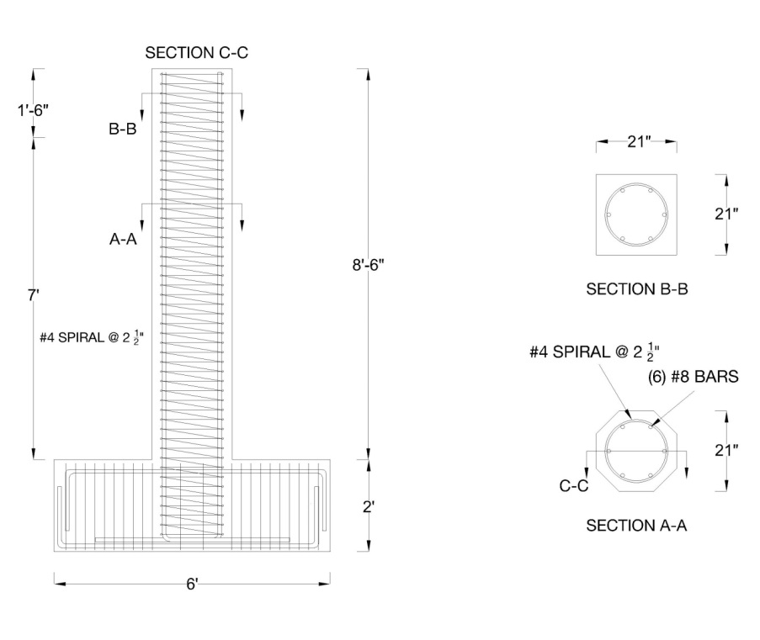
Figure 1. Column to footing monolithic connection.

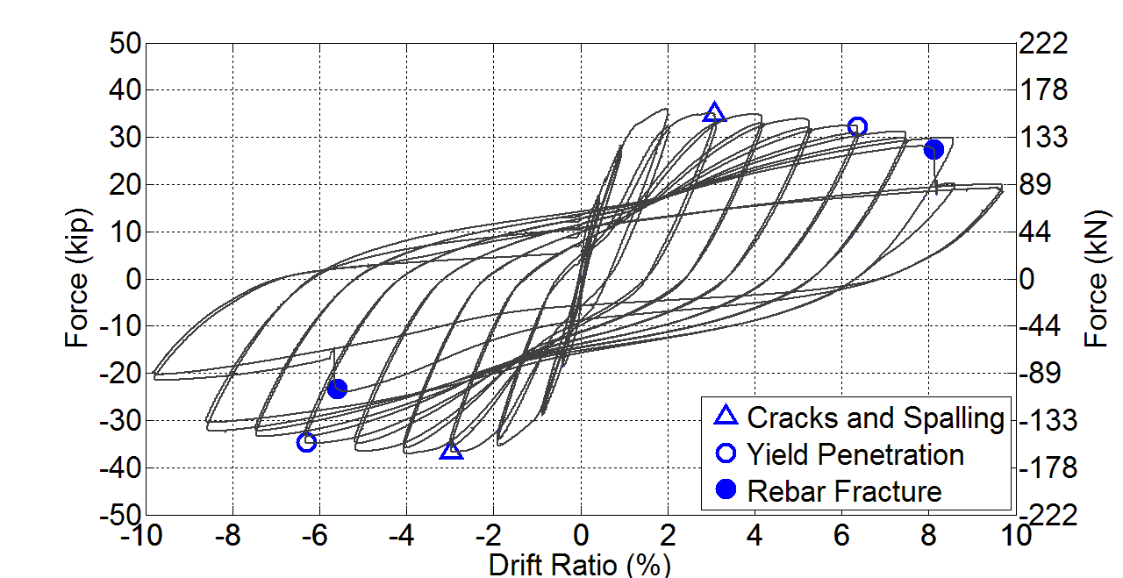

Figure 2. Hysteretic performance of column to footing monolithic connection.

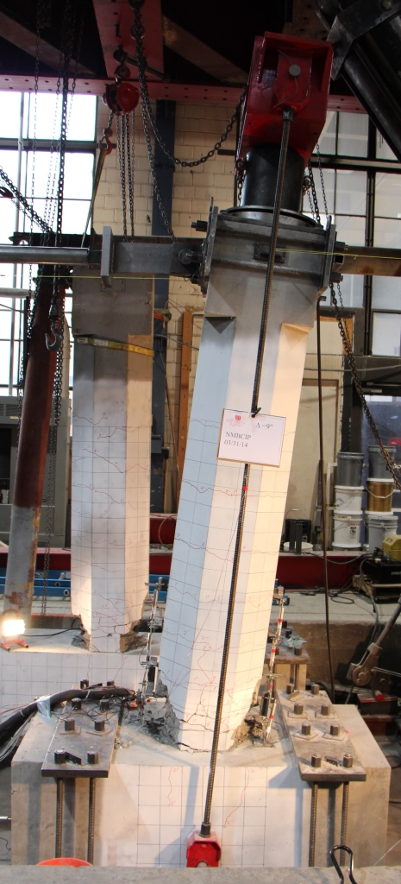

Figure 3. Column to footing monolithic connection at 9% drift ratio.

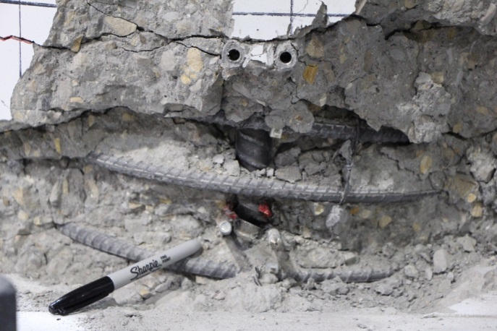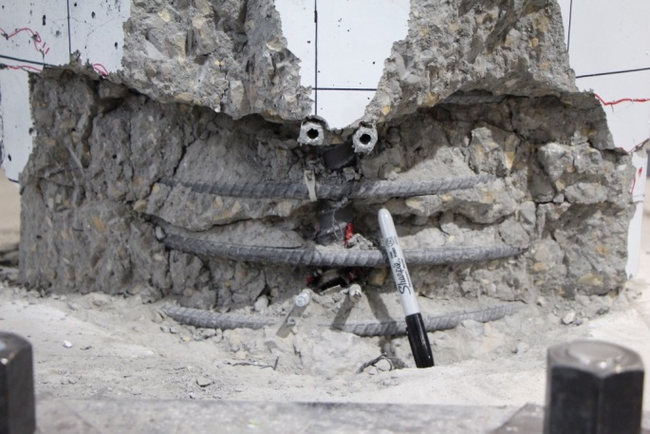
- (b)

Figure 4. Fracture of column longitudinal bars at 9% drift ratio for column to footing monolithic connection:
(a) west bar; (b) east bar.

Figure 5 shows the reinforcement details of the monolithic column to bent cap connection, Figure 6 shows the hysteretic performance, and Figure 7 shows the condition at a 10% drift which was the maximum it achieved; Figure 8 shows
fracture of the two longitudinal bars on the east and west face. The performance is very good.

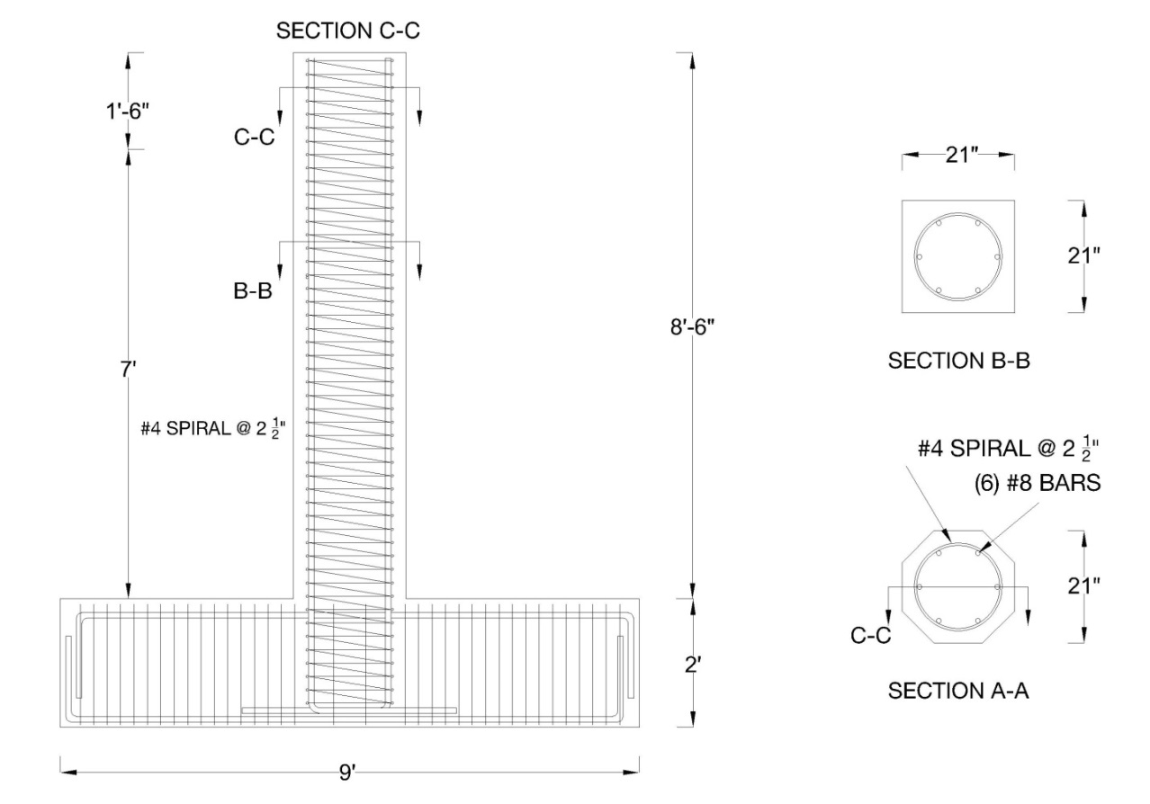
Figure 5. Column to bent cap monolithic connection.

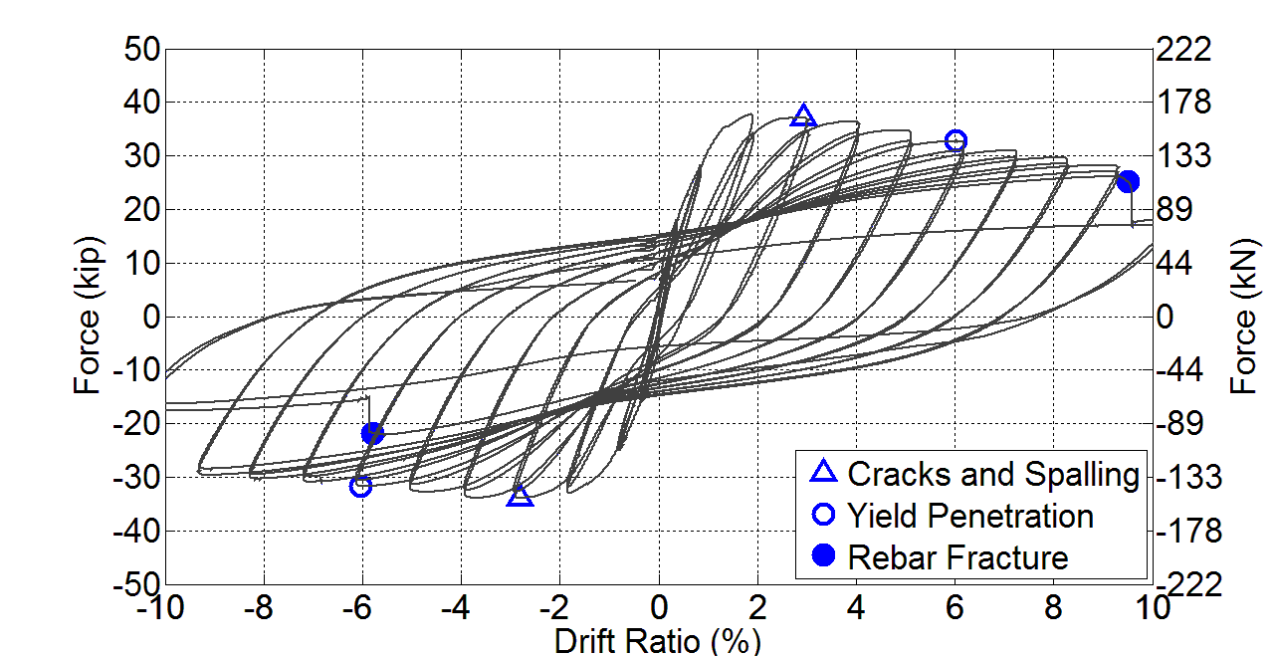

Figure 6. Hysteretic performance of column to bent cap monolithic connection.

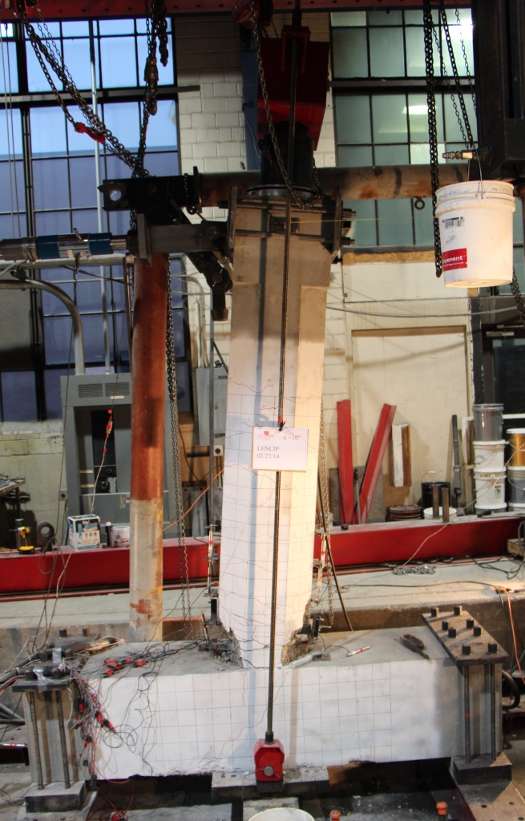

Figure 7. Column to bent cap monolithic connection at 10% drift ratio.

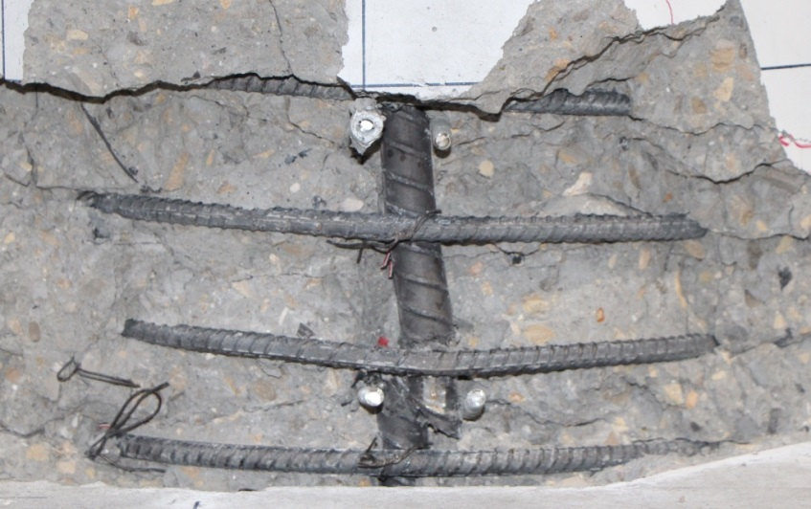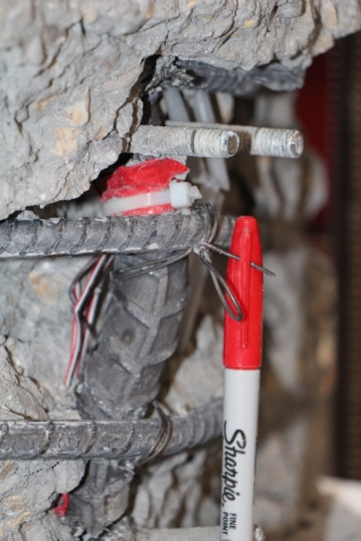
(a) (b)
Figure 8. Fracture of column longitudinal bars at 10% drift ratio for column to bent cap monolithic connection:
(a) west bar; (b) east bar.

Project Status: The two monolithic specimens have been tested and the final report will be completed next quarter.
The percentage completion for each task is as follows:

Task 1: Review Existing Experimental Results for Sleeved Connections: 100% Complete
Task 2: Build Precast Columns, Footings and Cap Beams for Tests: 100% Complete
Task 3: Test Column to Footing Connections (Type I): 100% Complete
Task 4: Test Column to Cap Beam Connections (Type II): 100% Complete
Task 5: Test Column to Footing Monolithic Cast-In-Place Connection
and Column to Cap Beam Monolithic Cast-In-Place Connection: 100% Complete

Anticipated work next quarter:

It is anticipated that in Quarter 9, the final report will be written. It is also anticipated that the deliverables of the project will be completed.

Significant Results:

The six spliced and two monolithic connections have been tested, the experimental work is complete, and final
comparisons between the monolithic and spliced specimens are currently being carried out.

Circumstance affecting project or budget. (Please describe any challenges encountered or anticipated that
might affect the completion of the project within the time, scope and fiscal constraints set forth in the
agreement, along with recommended solutions to those problems).

The project is currently on time and it is anticipated that it will be completed by the end date.

Potential Implementation:

It is anticipated the Utah DOT will implement the findings of this research once it is completed in Accelerated
Bridge Construction (ABC). It is likely that the New York State Department of Transportation and the Texas Department
of Transportation will be able to implement them as well.

