Development of an IOO-Industry
Forum for AV Technology Knowledge Transfer
Ohio Led Pooled Fund

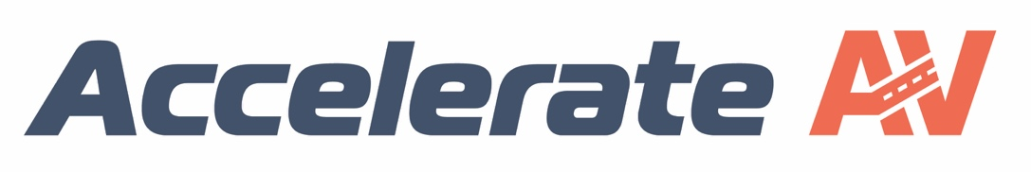

Prepared by:
Tara Andringa

Prepared for:
The Ohio Department of Transportation,
Office of Statewide Planning & Research

Project ID Number: 111455

June 15, 2023

Final Report

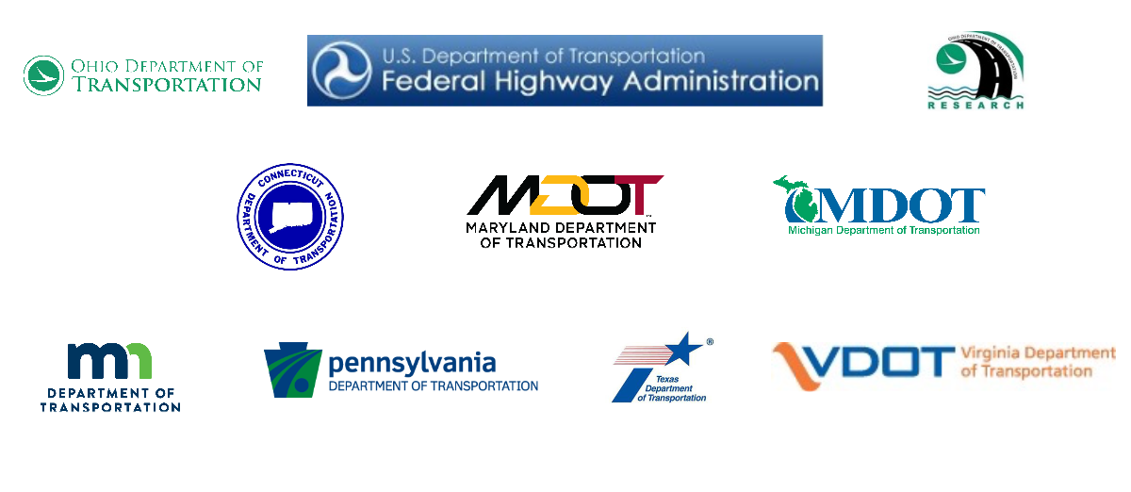

Technical Report Documentation Page

1. Report No. | 2. Government Accession No. |  |  |  | 3. Recipient's Catalog No.
4. Title and Subtitle |  |  |  |  | 5. Report Date
Development of an IOO-Industry Forum for AV Technology Transfer |  |  |  |  | June 15, 2023
 |  |  |  |  | 6. Performing Organization Code
7. Author(s) |  |  |  |  | 8. Performing Organization Report No.
Tara Andringa
Executive Director
Partners for Automated Vehicle Education (PAVE)
9. Performing Organization Name and Address |  |  |  |  | 10. Work Unit No. (TRAIS)
Partners for Automated Vehicle Education
6841 Elm Street, Box 189
McLean, VA 22101
 |  |  |  |  | 11. Contract or Grant No.
 |  |  |  |  | PID: 111455
12. Sponsoring Agency Name and Address |  |  |  |  | 13. Type of Report and Period Covered
Ohio Department of Transportation  1980 West Broad Street  Columbus, Ohio 43223 |  |  |  |  | June 2022 – June 2023
 |  |  |  |  | 14. Sponsoring Agency Code
15. Supplementary Notes
n/a
16. Abstract
The goal of this effort is to establish a forum in which industry, government, and other AV stakeholders can collaborate, to their mutual benefit. The forum will allow industry players to provide input and share perspectives with AV Pooled Fund members so that all stakeholders can align their approaches and needs – and do so in a way that respects the proprietary needs of all parties. The industry input will assist IOOs in acquiring essential information for their long-term strategic planning and operations, and it will facilitate future coordination and interoperability between states. PAVE will build on its record of AV leadership to help build a strategy that ensures that the forum becomes the “go-to” spot for AV collaboration.

17. Keywords |  |  |  |  | 18. Distribution Statement
AV Pooled Fund, IOO-Industry Forum, AccelerateAV.org, Automated Vehicles, Automated Vehicle Forum, AV Forum |  |  |  |  | No restrictions. This document is available to the public through the National Technical Information Service, Springfield, Virginia 22161
19. Security Classification (of this report) |  | 20. Security Classification (of this page) |  | 21. No. of Pages |  | 22. Price
Unclassified |  | Unclassified |  | 40
Form DOT F 1700.7 (8-72) |  |  | Reproduction of completed pages authorized

TABLE OF CONTENTS

TABLE OF CONTENTS 3
Credits and Acknowledgments Page 4
Problem Statement 5
Research Background 6
Research Approach 8
Research Findings and Conclusions 10
Recommendations for Implementation 11
Appendix 1: Stakeholder Survey 13
Appendix 2: Key Survey Findings 18
Appendix 3: Focus Group Feedback 22
Appendix 4: Communications Plan 24

Credits and Acknowledgments Page

Prepared in cooperation with the Ohio Department of Transportation
and the U.S. Department of Transportation, Federal Highway Administration

The contents of this report reflect the views of the author(s) who is (are) responsible for the facts and the accuracy of the data presented herein. The contents do not necessarily reflect the official views or policies of the Ohio Department of Transportation or the Federal Highway Administration. This report does not constitute a standard, specification, or regulation.

We have received incredible support and guidance from members of the Technical Advisory Committee and ODOT staff, including the following individuals. Their regular calls and emails, as well as their thoughtful feedback, have been critical to the project’s progress and success.

Nick Hegemier | Ohio DOT/DriveOhio
Jill Martindale | ODOT/Research
Carole Delion | Maryland DOT
Pete Calcaterra | Connecticut DOT
Cory Johnson | Minnesota DOT
Elise Feldpausch | Michigan DOT
Kevin Tobias | Pennsylvania DOT
Zeke Reyna | Texas DOT
Noah Goodall | Virginia DOT

Additionally, Robin Piazza and Michelle Kowalski from Ohio’s Walder Studio have worked tirelessly on the design of the forum and materials. We are incredibly grateful for their support.

Problem Statement

Automated vehicle technologies offer great promise to society, but at the same time, these new technologies create unprecedented challenges for our transportation system. Numerous stakeholders across the public and private sectors play critical roles in the development of an organized, efficient, and sustainable transportation system for highly automated vehicles, but the creation of such a system will require open communication and effective collaboration between diverse parties.

The Automated Vehicle Pooled Fund Study, led by the Ohio Department of Transportation (ODOT), wisely called for the creation of an IOO-Industry Forum to facilitate this collaboration. The forum will help to provide state DOTs with information needed to make well-informed planning and infrastructure decisions and allow the AV industry to provide input while protecting proprietary information.

Partners for Automated Vehicle Education (PAVE) is a 501(c)(3) nonprofit coalition whose mission is to educate the public about automated vehicle technologies. Our members span the broad AV ecosystem, including OEMs, start-ups, suppliers, insurers, consumer advocates, transportation groups (SAE, GHSA, etc.), and other nonprofits (National Safety Council, National Council on Aging, National Federation of the Blind, MADD, etc.). We also maintain advisory councils of public sector entities (including six of the AV Pooled Fund members) and the leading academics in the AV space. Our work aligns perfectly with the heart of the forum concept: we excel at aligning AV groups to collaborate and spur progress.

As an educational nonprofit, PAVE has a deep understanding the AV ecosystem; develops clear messaging involving these complicated technologies; convenes diverse AV stakeholders in a united mission; and communicates with wide-ranging audiences.

PAVE is leveraging its existing AV stakeholder relationships to help ensure success in the forum’s creation. PAVE’s private sector members include most of the major players in the AV industry, and the coalition has a proven adeptness at respecting the legal and proprietary needs of industry players while successfully serving as a convener and finding common ground among players. Within PAVE’s Public Sector Advisory Council, the coalition has demonstrated the ability to listen to the needs of these partners and help facilitate productive conversations.

Additionally, PAVE has tapped its broad knowledge and experience with stakeholders in the AV ecosystem to determine the needs and priorities of an online forum; to design a forum that meets the expectations of prospective users; to draft a communications plan that will announce the forum’s existence, encourage usage, and generate media attention; and monitor the forum’s launch and growth to ensure its continued success.

Research Background

The goal of this effort was to establish a forum in which industry, government, and other AV stakeholders can collaborate, to their mutual benefit. The forum will allow industry players to provide input and share perspectives with AV Pooled Fund members so that all stakeholders can align their approaches and needs – and do so in a way that respects the proprietary needs of all parties. The industry input will assist IOOs in acquiring essential information for their long-term strategic planning and operations, and it will facilitate future coordination and interoperability between states.

In undertaking this project, we reviewed past research that has examined the potential impacts of autonomous vehicles on road infrastructure as society works to prepare for future technologies. Past research into AVs and infrastructure has included Caltrans Automated Vehicle Industry Survey of Transportation Infrastructure Needs^{[1]} and an examination of international perspectives on a future for AV infrastructure by future users, urban planners and developers^{[2]}. In addition to research of this manner - which surveys a broad stakeholder environment on multiple topics - there has also been targeted research into specific applications and development of plans for infrastructure and communication with Infrastructure Owner Operators (IOOs). One example is the FHWA’s investigation of key human factors safety issues related to infrastructure, which included a workshop for stakeholders across state DOTs, universities, national organizations, and vehicle manufacturers to discuss projects relevant to AVs and infrastructure^{[3]}. The outcome of this research was the development of a list of prioritized research topics, as well as a list of efforts taking place across other states that the stakeholders believe need discussion and consideration going forward. Many of these prioritized research topics would be included in the IOO-Industry forum, which would provide a space for continued conversation and idea sharing.

By building upon previous work such as the FHWA workshop to identify priorities, the proposed forum project would provide a unique space for key stakeholders to collaborate on the important topics that research and stakeholders have identified for consideration by IOOs and industry. The forum would provide outlets for discussions and lesson-sharing such as those in the research projects conducted by Caltrans^{[4]} and Stromberg et al^{[5]} ; it would provide a venue to expand on issues such as those raised in the FHWA workshop^{[6]} on human factors safety issues; and it would allow for exploration of other research topics, such as guidelines for applying the Transportation Systems Management and Operations (TSMO) Capability Maturity Model (CMM) to describe IOO operational maturity and assist with the development of action plans to support effective and efficient implementation of Connected Vehicle program capabilities^{[7]}.

By enabling IOO and industry partners across states to come together in a collaborative manner, this forum will help to build on other research, external projects, and disparate guidelines from across the AV ecosystem in a convenient and accessible space.

^{[1]} Chan & Wang (2021). Caltrans Autonomous Vehicles Industry Survey of Transportation Infrastructure Needs. https://dot.ca.gov/-/media/dot-media/programs/research-innovation-system-information/documents/final-reports/ca21-3605-finalreport-a11y.pdf
^{[2]} Stromberg et al (2021). A future without drivers? Comparing users’, urban planners’ and developers’ assumptions, hopes, and concerns about autonomous vehicles. https://doi.org/10.1186/s12544-021-00503-4
^{[3]} Roldan et al (2020). Investigating Key Automated-Vehicle Human Factors Safety Issues Related to Infrastructure: Summary of Stakeholder Workshop. https://www.fhwa.dot.gov/publications/research/safety/20058/20058.pdf
^{[4]} Chan & Wang (2021). Caltrans Autonomous Vehicles Industry Survey of Transportation Infrastructure Needs. https://dot.ca.gov/-/media/dot-media/programs/research-innovation-system-information/documents/final-reports/ca21-3605-finalreport-a11y.pdf
^{[5]} Stromberg et al (2021). A future without drivers? Comparing users’, urban planners’ and developers’ assumptions, hopes, and concerns about autonomous vehicles. https://doi.org/10.1186/s12544-021-00503-4
^{[6]} Roldan et al (2020). Investigating Key Automated-Vehicle Human Factors Safety Issues Related to Infrastructure: Summary of Stakeholder Workshop. https://www.fhwa.dot.gov/publications/research/safety/20058/20058.pdf
^{[7]} Gettman et al (2017). Guidelines for Applying the Capability Maturity Model Analysis to Connected and Automated Vehicle Deployment. https://rosap.ntl.bts.gov/view/dot/34398

Research Approach

We used a three-phase project approach: 1) Forum concept development, 2) Communications strategy development, and 3) Forum establishment.

Phase 1: Forum Concept Development
Upon the commencement of this contract, our first task was to survey stakeholders to ensure that the forum planning is responsive to the needs and requirement of prospective users.
The contract team built a list of 958 stakeholders across the AV ecosystem, including public sector entities, industry partners, and other stakeholder groups. We identified contacts and emails for each stakeholder organization.
Next, we developed an online survey instrument to send to the list of stakeholders. The survey asked about what elements should be included in an IOO-Industry forum; what functionality would make the user inclined or disinclined to use a forum; whether the individual uses existing platforms and what the pros and cons are; and what design elements would make the forum most appealing. (See Appendix 1, Stakeholder Survey)
We sent the survey to the list of stakeholders, and then after receiving responses, we compiled the data and shared it with the TAC. (See Appendix 2, Key Survey Findings)
Following the survey, we reviewed software platforms to determine which program would best fit the needs identified by the survey respondents. We provided demonstrations of several platforms to the TAC and decided on the Hivebrite platform.
In subsequent months, we convened focus groups to gather more in-depth information about user needs. In December, we met with the focus group to gather detailed information regarding forum topics and organization (See Appendix 3, Focus Group Feedback). We reconvened the group in February to request feedback on the beta site.

Phase 2: Communications Strategy Development
We drafted a robust communications plan that is designed to elevate awareness of the forum and establish the forum as the go-to hub of collaboration for industry, government, and other AV stakeholders. The communications plan calls for extensive outreach with AV stakeholder organizations, engagement with reporters and media outlets, and branding that unifies the messaging for the forum. (See Appendix 4, Communications Plan)
We decided upon a name and URL for the site with input from the TAC (AccelerateAV.org) and we purchased the URL, as well as the URL AccelerateAV.com, which redirects to the primary site. We created an initial landing site where prospective users can sign up to stay informed of site progress and the eventual launch.
We worked with the TAC and web designers to make organizational decisions about the forum; developed logo and branding guidelines and revised them based on feedback from the TAC; and executed the communications plan, including sharing news of the forum at industry conferences. We created marketing materials for stakeholders to share upon the forum launch.

Phase 3: Forum establishment
Using the Hivebrite platform, our web development team built a beta version of the forum site. The site allows users to create profiles, find other users, participate in groups and discussions, share news, files and events, and explore resources.
We sent invitations for the beta site both to the TAC and to the focus group, and we met with both groups to solicit feedback. We edited the beta site based on the feedback and launched the final forum on June 15, 2023.

Research Findings and Conclusions

The survey of AV stakeholders provided useful data to help inform development of the forum. We will provide a summary below, but additional details can be found in Appendix 2: Key Survey Findings.
We sent the survey to over 900 contacts and received over 40 written responses in addition to some verbal feedback. Of those, 17 respondents said they would be willing to participate in focus groups in the upcoming months to provide additional input, as necessary, during forum development.
Of the respondents, 53% were from public sector entities, 14.6% represented academia; 12.2% represented industry, and 9.8% represent industry groups.
We asked respondents how they would prioritize the AV Pooled Fund Pillars (Physical and digital infrastructure readiness; Operations; Interstate freight and multi-modal harmonization; Partnerships; Workforce; Communications and engagement; and Policy).
Public Sector respondents ranked Policy their top priority, followed by Physical and Digital Infrastructure readiness, and then Partnerships.
Academic respondents ranked Physical and Digital Infrastructure Readiness their top priority.
Industry respondents ranked Policy as their top priority, followed by Partnerships.
Additionally, the survey found that respondents’ priorities for the site include accessing subject matter experts, sharing documents, accessing officials, and networking with other stakeholders. They reported that concerns with similar sites include difficulty finding information, content becoming out-of-date, and information being too dense/heavy.
Respondents desire security measures including two-factor authentication and secure file storage.
Based on this research, we are building a framework for the forum with topic-based pages that users can join; building a robust networking platform; designing forum moderation to ensure that the dialogue is relevant and up to date; and ensuring secure log-in and file transfer.

Recommendations for Implementation

Based on data collected by the survey and focus groups, we recommended the following for the forum platform, its organization, its management, and outreach. We have shared these recommendations with the TAC. Our recommendations and findings follow:
- PLATFORM: We recommended a clean, user-friendly software platform. We heard repeatedly from users that they have stopped using other sites because they find it difficult to find information, the sites are confusing, the information is too dense, etc. We reviewed many platforms and recommended the Hivebrite platform because it has broad functionality; is clear and user-friendly; and offers exceptional technical support if users have questions. Its organization is similar to many social media platforms that users may already be familiar with, so this will likely accelerate comfort of the site for many users.

- TOPICS: We recommend organizing conversations on the platform around the topics prioritized by users in the survey. These topic pages will be easy to find, and the organization will ensure that conversations remain focused. For example, a “trucking and freight” page may allow users with those interests to find other stakeholders wishing to engage on those topics, and it would allow users not interested in this area to focus attention elsewhere. Based on extensive feedback and conversation, the initial forum topics are: Communications and messaging, Interstate freight and trucking, Operations, Physical and digital infrastructure, Partnerships, Policy, Safety, Education, Licensing/registration, Private vehicles, Commercial vehicles, MaaS, and Workforce.

As the site progresses, we will continue to fine-tune the topic areas, but this organizational approach will help to ensure that users can find content that is relevant to their interests and to network with other users with similar interests. Users can suggest new forum topics, or administrators can create new topics as we see conversations focused on particular issues. We will regularly evaluate the forum topics and propose changes and additions.

Finally, we recommended including a place for IOOs to provide links to RFPs. Focus group users suggested this would incentivize industry participants to visit the site regularly.

- GROUPS: The platform also also allows users to join groups based on their role in the ecosystem (public sector, academia, industry, nonprofit, etc). Feedback from respondents suggested that users would appreciate the opportunity to collaborate with other users who may share common challenges and can accordingly share ideas and approaches.

- SITE MANAGEMENT AND USER ROLES: We recommend live forum management of the site to ensure that users abide by the community guidelines. Focus group members reported that other sites become outdated, conversations go off-topic, etc. By having a live forum moderator, we can ensure that users adhere to the community rules, that posts are relevant, and that information is timely and up to date.

Users need to be approved to join the site. Administrators review each request and confirm that the user is part of the AV ecosystem prior to approval. Once in the site, users can apply to be part of individual groups (public sector, etc.). Additionally, users can apply to serve as moderators for conversations or groups. All requests will be thoroughly vetted by administrators.

Finally, if users are found to violate the community rules, administrators can give them a warning or remove them from the site. The user can appeal that decision, which will then go to the AV Pooled Fund for consideration. The AVPF’s ruling will be final.

- OUTREACH: We recommend targeted outreach for recruiting users for the forum. The majority of survey respondents were public sector officials, which suggests that these users understand the importance of the forum. The smaller number of industry respondents, however, suggests that we need to actively engage these users to ensure they are aware of the forum and that the content is helpful and relevant to their work. Without industry participation, the public sector will not receive the information it needs to do its job. We prepared specific targeted content in the communications plan to reach industry players and encourage participation by these critical stakeholders.

All these recommendations were implemented within the original contract term. PAVE is building an evaluation rubric for the forum, which will provide metrics to measure forum success. This evaluation program will both measure whether the forum is meeting its targets and, moreover, suggest remediation measures that can be taken to adapt the forum as the nascent AV ecosystem evolves.

Appendix 1: Stakeholder Survey

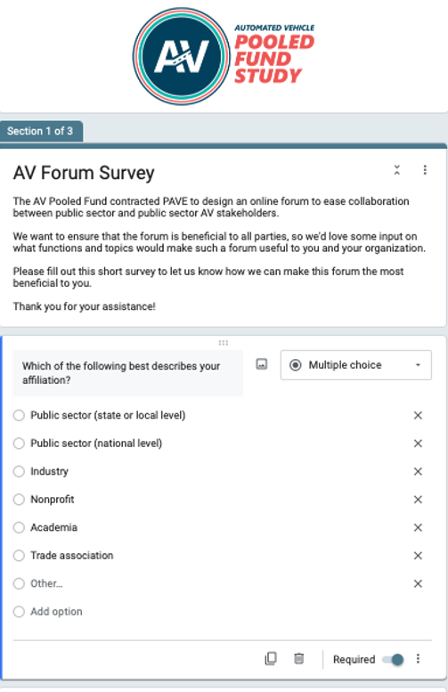

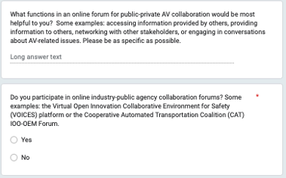
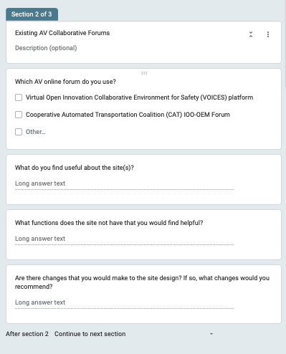

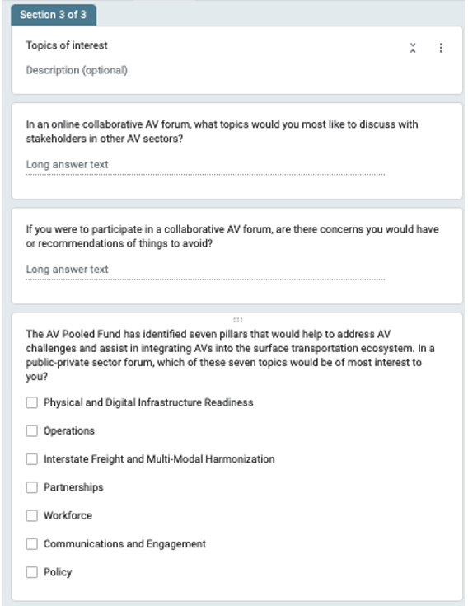
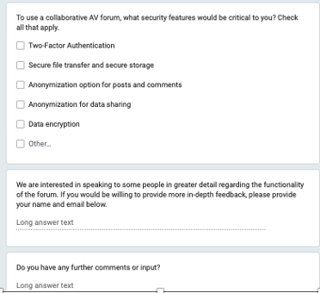

Appendix 2: Key Survey Findings

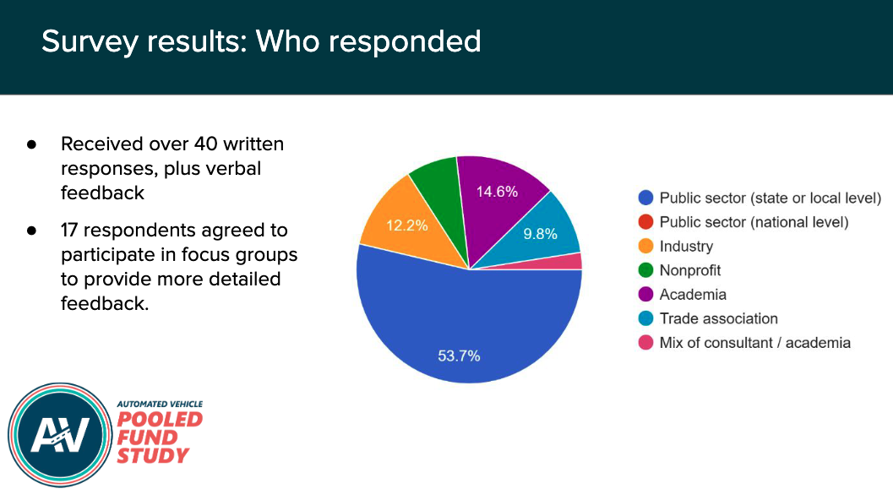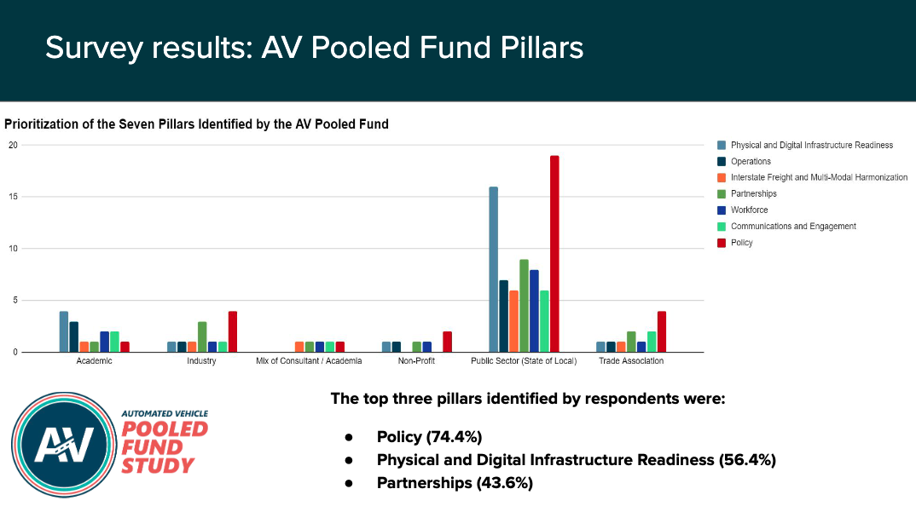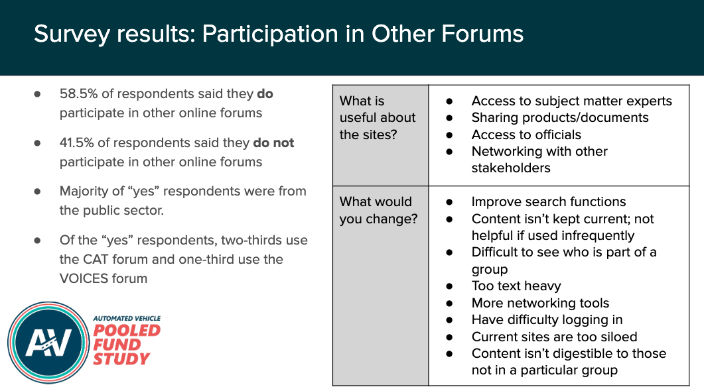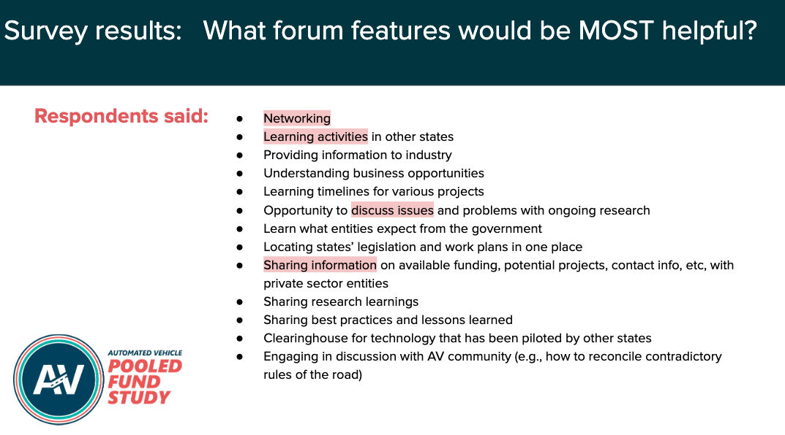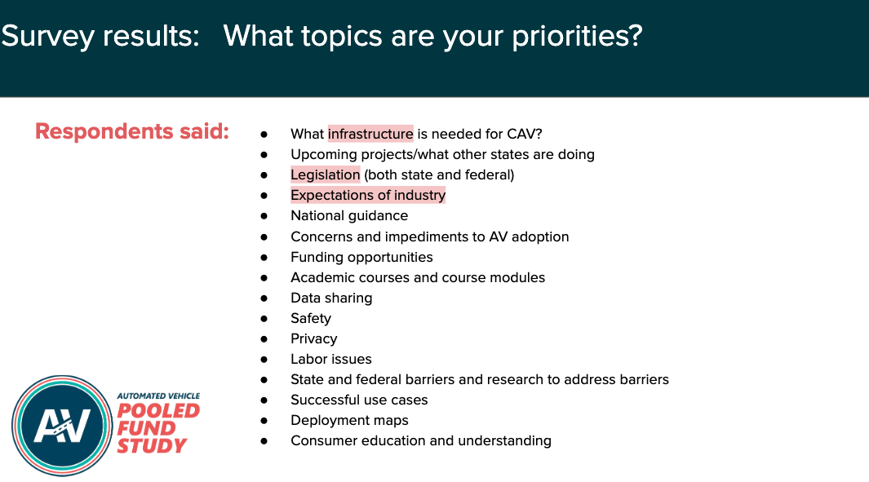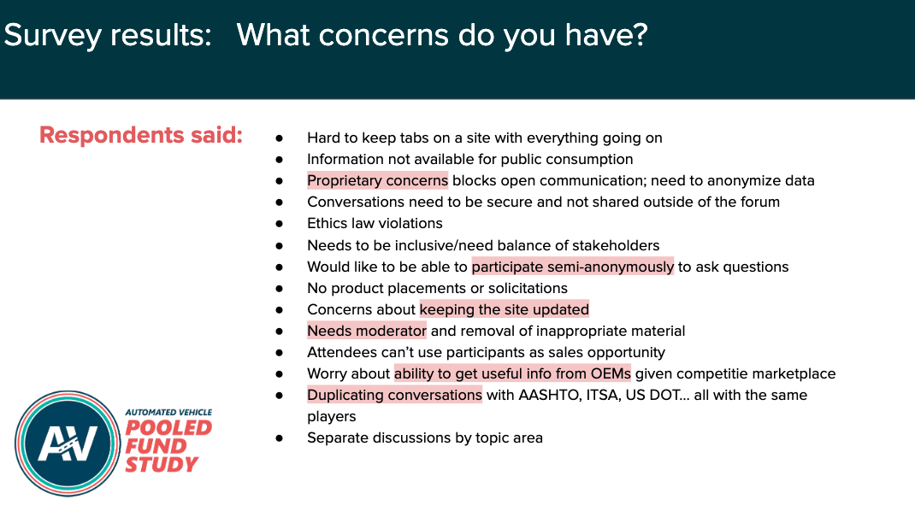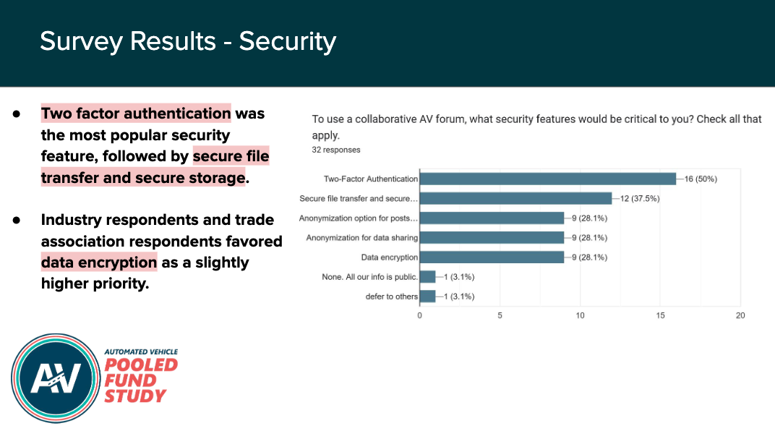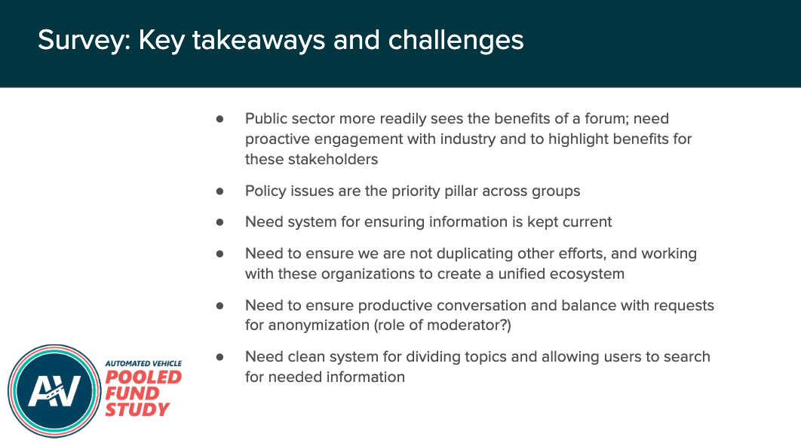

Appendix 3: Focus Group Feedback

AccelerateAV.org
Focus Group Report
December 13, 2022

Question: What information about forum participants should be collected and shared?
- Consensus from group: similar to linkedin. OK to share name, employer, title and location. Do not share contact information. Provide ability to send direct messages on this site, and people can share contact info if desired.

Question: What is the role of the moderator? How much moderation should occur?
- Comment from group: Moderation is needed. Concern that forum could otherwise turn into an advertising space.
- Comment: users need a way to flag inappropriate comments or personal attacks.

Question: Should the “news” section of the site include news from forum users? Or media stories?
- Comment: “news” from members should be vetted. It is not for advertisements.
- Comment: There should be rules. If there is a negative story about a forum user, we don’t want to pit users against each other.
- Comment: It could be a place for members to discuss media stories

Question: What should be included in the events section? Events from forum users? Or just major industry events?
- Consensus form group: Any event that is open to the public should be allowed.

Question: What rules/guidelines should exist regarding forum tags (hashtags?)
- Comment: Not sure hashtags are helpful? Participant is already responding to a thread, right?
- Comment: hashtags are a way to filter your search results when looking for specific threads/content.
- Comment: hashtags are useful/helpful with the search function (rather than needing to have the exact term or phrase that was used in a thread you are trying to retrieve)
- Comment: Perhaps a “standardized” library of hashtags would be helpful

Question: What should the initial “groups” be?
- Comment: Concerned about “mobility” as a topic. What does that even mean? (Different things to different people as it turns out)
- Comment: could we break topics down by type of vehicle or use case at the top level, then have all the same line item topics underneath each? E.g., Personal Vehicles, People Carrier Vehicles, Freight/Trucks (several people agreed)
- Comment: start with use cases up front then everything falls under that.
- Comment: add Insurance as a topic

Question: How can we encourage industry engagement and participation?
- Comment: Many companies’ legal departments limit what they can say and share.
- Comment: Let commercial companies share what they are doing but we don’t want it to become self-promotional
- Comment: would love to have a place to foster conversation between industry & government. Would like some feature to get the conversation started - i.e., “ice breaking” on a recurring basis.
- Comment: Perhaps include a way to schedule in-person meet ups?

Question: Are there other stakeholders we should engage?
- Comments:
  - AHSTO
  - AAMVA
  - NACTO
  - TX AV Task Force

Appendix 4: Communications Plan

AccelerateAV.org

Communications Plan

Mission, Purpose and Objectives

MISSION

The mission of the AccelerateAV.org forum is to facilitate collaboration on automated vehicle technology efforts between the public and private sectors.

To achieve this mission, organizers will actively promote the site, encouraging participation from both industry and public sector entities.

PROBLEM STATEMENT

The AV industry is growing rapidly and, at the same time, IOOs are working to rebuild, update, and modernize transportation infrastructure to meet the needs of these new technologies. Successful AV implementation efforts will rely on collaboration and communication between parties across the AV ecosystem.

Recognizing the need for this collaboration, the Automated Vehicle Pooled Fund Study (AV PFS) commissioned the development of the IOO Strategic Roadmap for Accelerated Adoption of AVs. The roadmap identified seven program pillars, which are focus areas where IOOs can have the greatest influence in the AV ecosystem. The program pillars are: physical and digital infrastructure readiness, operations, interstate freight and multi-modal harmonization, partnerships, workforce, communications and engagement, and policy.

In conjunction with the roadmap development, the AV Pooled Fund members initiated establishment of an IOO-industry forum for collaboration across the AV ecosystem. The forum, AccelerateAV.org, will facilitate idea sharing, networking, communication, and problem solving between AV stakeholders.

In order for the forum to be successful and adopted as the “go-to” site for collaboration, its launch needs to be communicated broadly to users, it needs to be user friendly, it needs to be kept up-to-date, and it needs to meet the needs of all parties.

This communications plan outlines the steps to position AccelerateAV.org for success.

PURPOSE

The communications strategy for AccelerateAV.org seeks to increase stakeholder awareness of the site, position the site as the go-to hub for collaboration, encourage use of the site, and underscore the proactive role of the AV PFS in supporting a successful AV ecosystem.

COMMUNICATIONS GOALS

External
- Promote the launch of AccelerateAV.org to inform AV stakeholders of its existence and functionality;
- Differentiate the IOO-AV Industry forum from pre-existing AV collaboration efforts;
- Encourage stakeholder registration on AccelerateAV.org;
- Highlight the value of AcclerateAV.org to prospective users; and
- Generate earned media highlighting the forum and the proactive leadership role of the AV Pooled Fund in encouraging collaboration among stakeholders.

Internal
- Identify internal standard operating procedures and points of contact for the management of the site;
- Encourage engagement on the forum to increase utilization and forum activity;
- Highlight pathways for feedback and demonstrate responsiveness to user feedback;
- Keep content fresh and current to promote regular engagement of forum users;
- Encourage networking between participants to incentivize returning to the forum.

Assumptions and Challenges

OPERATING ASSUMPTIONS

- PAVE surveyed many AV stakeholders from the public, private, non-profit, and academic sectors. The results from the IOO-AV stakeholder survey provided valuable information that informed communications planning, including:

  - AV stakeholders currently use some digital forums, including the Cooperative Automated Transportation Coalition (CAT) IOO-OEM Forum and the Virtual Open Innovation Collaborative Environment for Safety (VOICES) Platform. Stakeholders who use these forums report some changes they would make to optimize the effectiveness of the platforms.
  - A focus on AV policy is the pillar of greatest interest to stakeholders.
  - User perceptions regarding the management and functionality of the forum will be important for retaining usership and engagement.

- PAVE has experience communicating with many AV stakeholders and is recognized as a trusted organization within the wider AV community.

- Establishing a strong value proposition for potential forum users is essential to encourage forum use.

- Registration to the forum will require an affiliation within the AV ecosystem, and users must use their real name and email for admission.

CHALLENGES

- There are numerous efforts to promote collaboration in the AV space. AccelerateAV.org must work in tandem with other AV collaboration efforts while striving to maintain a strong self-identity.

- Prospective users may question the time-value proposition of the project. Communication efforts must highlight that the forum will be well-managed, up-to-date, and easy to use.

- Potential users, particularly in the private sector, expressed concerns about confidentiality, antitrust concerns, and trade secrets. Some potential users also raised questions about forum moderation and community standards. We need to clearly communicate the security and administration policies of the forum.

- The forum will only be available to registered users. A strong public-facing landing page and other public informational materials will be important.

Objectives, Strategies, Tactics, and Tools

Planned communications tools:
- Forum Fact Sheet
- Forum One-pager
- Forum Infographics
- Branded package of social media graphics, social media copy, and a posting schedule
- Promotional Introductory Video
- Press Release

Objective 1.
Inform public and private sector AV stakeholders about the development of AccelerateAV.org, including its mission, functionality, and timeline.
- Strategy 1. Inform stakeholders and the general public about the launch of the forum and the forum’s features, mission, and goals. PAVE will lead all communications activities and coordinate with the AV Pooled Fund representatives to engage in parallel efforts.
  - Tactics:
    - Press release announcing forum, to be delivered on newswire, via email, and on social media.
    - Social media campaign regarding forum launch. PAVE will share content and will encourage AV Pooled fund members to share on their channels
    - PAVE Virtual Panel/Podcast highlighting launch of forum
    - Speeches/panels/conference appearances: We will encourage AV Pooled Fund members and PAVE staff to share information about the forum and registration at any upcoming appearances.
    - Stakeholder outreach: we will request promotion of the forum on key stakeholders’ websites, in their membership newsletters, and on their social media channels. Example organizations include:
      - The Autonomous Vehicle Industry Association (AVIA)
      - The Association for Uncrewed Vehicle Systems International (AUVSI)
      - Intelligent Transportation Society of America (ITS America)
      - The Alliance for Automotive Innovation
      - American Association of State Highway and Transportation Officials (AASHTO)
      - American Public Works Association (APWA)

- Strategy 2. Engage in earned and owned media outreach to spread the word about AccelerateAV.org

  - Tactics:
    - Develop boilerplate one-pager for media distribution.
    - Email and phone pitches to targeted reporters and media outlets.
    - Pitch stories to AV industry blogs, podcasts, and newsletters. Examples:
      - Podcast - http://www.autonocast.com/
      - Podcast - https://www.autonomousvehiclespodcast.com/
      - Podcast: Self-Driving Cars: Podcast Series by Dr. Lance Eliot
https://podcasts.apple.com/us/podcast/self-driving-cars-podcast-series-by-dr-lance-eliot/id1330558096
      - Blog - https://www.2025ad.com/
      - Blog - https://www.here.com/company/blog
      - Blog - https://intellias.com/
      - Publication - Automotive News
https://www.autonews.com/
      - Publication - Automotive World
https://www.automotiveworld.com/
      - Industry Newsletter - AASHTO Journal
https://aashtojournal.org/
      - Industry Newsletter - APWA Reporter
https://www.apwa.net/MYAPWA/Resources/The_Reporter_Magazine/MyApwa/Apwa_Public/Resources/APWA_Reporter_Magazine.aspx

Objective 2.
Generate interest in the IOO-AV Industry Digital Forum among AV stakeholders to increase user registration. This is a motivational objective aimed at increasing user registration and engagement among prospective stakeholders.

- Strategy 1. Leverage relationships with partner organizations to promote the forum and disseminate detailed marketing materials to be shared by partner organizations.

  - Tactics:
    - Create digital marketing materials promoting the forum and directly distribute these materials to AV industry organizations, academic partners, public sector partners, consumer and safety groups, etc.

    - Share social media content with partner organizations highlighting the purpose and functions of the forum.

- Strategy 2. Publish persuasive articles, interviews, and blog posts to selected publications or outlets aimed at stakeholder audiences. Articles will focus on the value proposition of the forum, the functionality of the platform, the mission of both the forum and the AV Pooled fund, and the AV Pooled Fund seven pillars.

  - Tactic:
    - Earned media pitches: seek persuasive stories encouraging stakeholders to register and use the forum to AV industry publications, blogs, podcasts, and newsletters. These story pitches will be distinct from the announcement pitches, focusing on the functionality of the forum, the advantages of collaboration within the forum, and other persuasive topics.

- Strategy 3. Engage in preview marketing to increase word-of-mouth publicity and user buy-in prior to the public launch of the forum.

  - Tactics:
    - Beta test the forum website with focus group members and incorporate their feedback wherever possible.
    - Schedule a series of promoted, live demonstrations of the forum to elevate the profile of the platform and preview the platform’s functionality with stakeholder audiences. Provide representatives to answer questions and record feedback.
    - Create a call for “kickoff content” with AV leaders in the public, private, academic, and non-profit sectors so the forum will be pre-populated with content upon launch.

Objective 3.
Differentiate the IOO-AV Industry Digital Forum from other AV forums.

- Strategy 1. As early as possible, launch a public-facing site that clearly describes AccelerateAV.org’s focus and mission.

  - Tactic:
    - Launch a public-facing landing page and FAQ section to provide clear details on the forum, the unique functionality of the forum, the target audience, and the mission of the project.

- Strategy 2. Ensure that the IOO-AV Industry Forum is recognizable and unique to potential users.

  - Tactic:
    - Develop a branded logo, name, and style guide for the forum that will be used in all marketing and outreach materials. Co-branding will occur with the AV Pooled Fund Study.

- Strategy 3. Gain trust of potential that AccelerateAV.org is distinct and provides value
  - Tactic:
    - Develop content that features early user testimonials and positive stakeholder reviews about the value of forum’s mission and functionality. Content examples include promotional videos, blog posts, and social media quote cards.

Timeline

Phase | Action Items | Deadline
Pre-Launch | Branding and Style Guide Development | Sept 2022
 | Landing page and FAQ Development | Jan 2023
 | Boilerplate One-Pager | Jan 2023
 | Focus group meetings | Feb 2023
 | Beta-Testing | Feb-Mar 2023
 | Preview Demos | Apr-May 2023
Launch | Embargoed press release sent to target organizations and individuals. | May 2023
 | Earned Media Pitches | May- June 2023
 | Pre-Launch Social | May 2023
 | Stakeholder Outreach | June 2023
 | Press release distribution | June 2023
 | Social media announcements | June 2023
Post-Launch | Distribute persuasive resource materials | June - Aug 2023
 | Persuasive Social | June - Aug 2023
 | User Testimonial Marketing | June - Aug 2023
 | Persuasive earned media pitches | June - Aug 2023

Target Audiences

AccelerateAV.org is a forum for AV stakeholders. Specific organizations listed below are examples of an audience category; this list is not intended to be exhaustive.

- Public Sector
  - Infrastructure Owners and Operators (IOOs)
  - AV Pooled Fund Members
  - State Transportation Agencies
  - USDOT
  - Federal, State, and Local Policymakers
- Media
  - AV/Transportation Media. For example: Trade publications, magazines, newsletters, blogs, podcasts, broadcasts.
  - General Public Media
- Private Sector AV Industry
  - Original Equipment Manufacturers (OEMs)
  - AV Developers
  - AV Component Manufacturers
  - Software/AI
  - AV insurers
- Non-Profit
  - Industry groups
    - The Autonomous Vehicle Industry Association (AVIA)
    - The Association for Uncrewed Vehicle Systems International (AUVSI)
    - Intelligent Transportation Society of America (ITS America)
    - The Alliance for Automotive Innovation
  - Issue-Based Stakeholder Groups
    - Motorist groups
    - Underserved/Marginalized populations
    - Business/Economic Development
    - Consumer groups
    - Vulnerable Road Users
    - Safety groups
    - Mobility advocates
    - Environmental Organizations
    - Law Enforcement
  - Public
    - American Association of State Highway and Transportation Officials (AASHTO)
    - American Public Works Association (APWA)
    - Governors Highway Safety Association (GHSA)
  - Geographic/Location Based
    - Urban/Rural Mobility
    - Local, State, Regional Development & Advocacy Organizations in the Technology or transportation sectors
    - Regional Economic Development Organizations
- Academic
  - Research Groups and Organizations
  - Think Tanks
  - Individual Researchers

Key Messages

- Positioning Statement:
AccelerateAV.org is a collaborative ecosystem established by the AV Pooled Fund Study where industry, government, and other AV stakeholders can network, cooperate, and share information, to their mutual benefit. The forum will allow AV stakeholders to provide input and share perspectives with public sector partners so that all parties can align their approaches and needs.
- Value Proposition:

  - On AccelerateAV.org, users learn from the expertise and perspectives of a diverse group of AV stakeholders. The forum is a multi-functional platform with secure features allowing for user networking, collaboration, consultation, and resource sharing.
  - AccelerateAV.org is the go-to collaboration venue for the widest cross section of AV stakeholders in the United States. Users span disciplines within the AV sector from a broad range of public sector, private sector, non-profit, and academic institutions.
  - AccelerateAV.org is the best place to learn, gain support, and discover new information about subjects related to the interaction between the evolving AV industry and national infrastructure development.

Evaluation and Assessment

PAVE will evaluate the campaign to measure its effectiveness and use these evaluations as a tool to sharpen messaging and distribution channels, and to recommend changes to keep the forum current.

FORUM SITE EVALUATION
To track and monitor the continued growth and utilization of AccelerateAV.org, PAVE will develop performance metrics and feedback collection tools. PAVE will collect and report these data regularly to the AV Pooled Fund. PAVE will also produce an annual report with future recommendations.
Monthly Reporting Frequency
- Monthly active users
- New users vs user attrition/stagnation
Quarterly Reporting Frequency
- Quarterly Survey on user satisfaction and feedback (quantitative/qualitative)
- Quarterly Engagement Metrics
  - Page views: A breakdown of page views, highlighting subject popularity
  - Time on page/Bounce Rate: Review of whether users are reading content
  - Review of discussions: Report on categories, topics, and tags with greatest popularity
  - Number of comments: Quantifies the engagement of the users within a discussion
  - New registrations
  - Number of returning users
  - Posts per session: Identifies top contributors and discussion leaders
  - Pageviews/category: Determines the popularity of specific categories.
  - Site questions, issues, support tickets, user feedback
Annual Reporting Frequency
- Annual review of all data collected during the year. The report will cross-reference and analyze all information on topic areas with the AV Pooled Fund Roadmap’s seven pillars. Site administrators will summarize recommendations for the next reporting year.

SOCIAL MEDIA EVALUATION
Evaluation and assessment of social media campaigns will be reported on a quarterly basis.

LinkedIn Metrics
- Views
- Engagement
- Positive reactions per post
- Negative Reactions per post
- Shares
- Source tracking/link clicks to forum site
- Comments

Twitter Metrics
- Views
- Positive reactions per post
- Negative Reactions per post
- Shares
- Source tracking/link clicks to forum site
- Comments

EARNED MEDIA EVALUATION
Evaluation and assessment of earned media will be reported on a quarterly basis.

Publication Metrics
- Number of stories
- Potential Reach of stories
- Comments if applicable to the outlet

Communications Planning Matrix

ACTIVITY | TARGET AUDIENCE | MESSAGE TYPE | DELIVERY METHOD | SCHEDULE
Branding & Style Guide Development | General | Informational | Digital Landing Page/Email | Sept 2022 / Ongoing
Landing page and FAQ Development | General | Informational | Digital Landing Page/Email | Jan 2023 / Ongoing
Boilerplate Descriptive Resource One-Pager | General | Informational | Digital Landing Page/Email | Jan 2023 / Ongoing
Focus groups convene | Public/Private AV Main Site Users | Informational | Zoom | Feb 2023
Beta-Testing | Public/Private AV Main Site Users | Informational | Beta-Site | Feb-Mar 2023
Preview Demos | General | Informational | Zoom & Demo Site | Apr-May 2023
Embargoed press release sent to target organizations and individuals. | Public/Private AV Main Site Users | Informational | Email | May 2023
Pre-Launch Social | Site users | Informational | LinkedIn/  Twitter | May 2023
Stakeholder Outreach | All target audiences | Informational | Digital | June 2023
Press release sent | Earned media: All target audiences | Informational | Newswire, email, social media | June 2023
Social media announcements | Prospective site users | Informational | LinkedIn/  Twitter | June 2023
Earned Media Pitches | Earned media: All target audiences | Informational | Media Outlets/Blogs/Podcasts/Newsletters/ | June-July 2023
Distribute persuasive resource materials | All target audiences | Persuasive | Email | June - Aug 2023
Persuasive Social | Prospective site users | Persuasive | LinkedIn/  Twitter | June - Aug 2023
User Testimonial Marketing | Prospective site users | Persuasive | LinkedIn/  Twitter/YouTube | June - Aug 2023

