11th Quarterly Progress Report to the

FEDERAL HIGHWAY ADMINISTRATION

(FHWA)

On the Project

THE IMPACT OF WIDE-BASE TIRES ON PAVEMENT DAMAGE

DTFH61-11-C-00025

For the Period

October 1 to December 31, 2013

Submitted by

Illinois Center for Transportation

University of Illinois at Urbana-Champaign



**QUARTERLY PROGRESS REPORT**

**QUARTER 10**

**The Impact of Wide-Base Tires on Pavement Damage – A National Study**

1. **Work performed**

The following tasks were accomplished in this quarter:

* Data was extracted from existing data sources. Data extraction included filtering and obtaining peaks/valleys of sensor readings from previous data. Data sources consist of past test runs from Florida, Ohio SPS8, and UC-Davis sections.
* New data from Florida and Ohio was stored in SQL. The data will be used in the online user interface being designed.
* The online user interface for Florida, Ohio, and UC-Davis new sections was completed. Documents, reports, and other minor information related to each test site need to be added to the interface.
* The test specimens for DCT and SCB tests for Florida and UC-Davis sections were prepared in accordance with proper dimensions. The gage points required for mounting strain gages during testing have been placed.
* The SCB test was conducted and completed for Florida and UC-Davis sections. DCT specimens were prepared, and testing will be completed in the next quarter.
* The research team at the University of Illinois at Urbana-Champaign received the instrumented response reports from Florida DOT and UC-Davis.
* Sixty-five percent of finite element analysis of pavement structures was completed (See Appendix A for details).
* A procedure was established to determine the pulse duration of the considered pavement structures. The methodology will facilitate computation of the elastic modulus required by transfer functions such as fatigue cracking (See Appendix B for details).
* An Extension Request was submitted to the Research Panel for consideration.

1. **Work to be accomplished next quarter**

* Data will be extracted for existing data sources.
* New data will be stored in SQL.
* User-interface design will be finalized for new and existing data.
* DCT will be run for Florida and UC-Davis specimens.
* Finite element analyses of pavement structures will continue.

1. **Problems Encountered**

* The computational resources used by the research team to perform the finite element analysis were not fully available. This was due to maintenance and technical issues experienced by XSEDE on some of their super-computers.

1. **Current and Cumulative Expenditures**

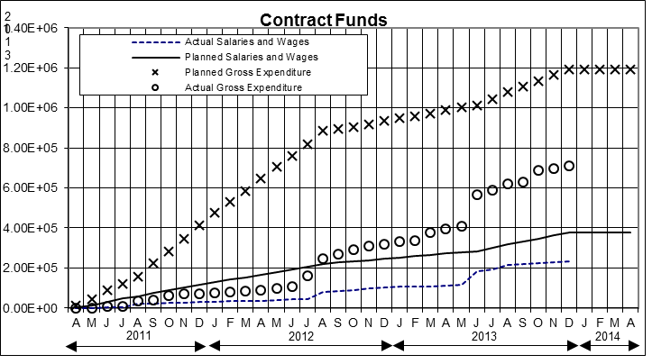

Figure 1. Project’s expenditure.

1. **Planned, Actual, and Cumulative Percentage of Effort**

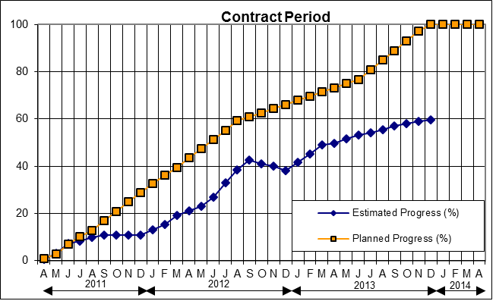

Figure 2. Project’s progress.

**APPENDIX A**

**FINITE ELEMENT ANALYSIS**

The status of the finite element modeling of thick and thin pavement cases is shown in Table A-1 and Table A-2. The green- and yellow-highlighted cells indicate completed and ran (but not post-processed) cases, respectively. The first column lists different pavement structures considered in factorial with 12 loading cases (L1-L12).

Table A-1. FEM Status for Thick Pavements

|  |  |  |  |  |  |  |  |  |  |  |  |  |
| --- | --- | --- | --- | --- | --- | --- | --- | --- | --- | --- | --- | --- |
| **Thick** | **LOAD CASE** | | | | | | | | | | | |
| **WBT** | | | | | **DTA** | | | | | | |
| **L1** | **L2** | **L3** | **L4** | **L11** | **L5** | **L6** | **L7** | **L8** | **L9** | **L10** | **L12** |
| **AC125W_B150W** | 3 | 3 | 3 | 3 | 3 | 3 | 3 | 3 | 3 | 3 | 3 | 3 |
| **AC125W_B150S** | 3 | 3 | 3 | 3 | 3 | 3 | 3 | 3 | 3 | 3 | 3 | 3 |
| **AC125S_B150W** | 3 | 3 | 3 | 3 | 3 | 3 | 3 | 3 | 3 | 3 | 3 | 3 |
| **AC125S_B150S** | 3 | 3 | 3 | 3 | 3 | 3 | 3 | 3 | 3 | 3 | 3 | 3 |
| **AC125W_B600W** | 3 | 3 | 3 | 3 | 3 | 3 | 3 | 3 | 3 | 3 | 3 | 3 |
| **AC125W_B600S** | 3 | 3 |  | 3 |  | 3 | 3 |  | 3 | 3 |  |  |
| **AC125S_B600W** |  |  |  |  |  |  |  |  |  |  |  |  |
| **AC125S_B600S** | 3 | 3 | 3 | 3 | 3 | 3 | 3 | 3 | 3 | 3 | 3 | 3 |
| **AC412W_B150W** | 3 | 3 | 3 | 3 | 3 | 3 | 3 | 3 | 3 | 3 | 3 | 3 |
| **AC412W_B150S** |  |  |  |  |  |  |  |  |  |  |  |  |
| **AC412S_B150W** |  |  |  |  |  |  |  |  |  |  |  |  |
| **AC412S_B150S** | 3 | 3 | 3 | 3 | 3 | 3 | 3 | 3 | 3 | 3 | 3 | 3 |
| **AC412W_B600W** |  |  |  |  |  |  |  |  |  |  |  |  |
| **AC412W_B600S** |  |  |  |  |  |  |  |  |  |  |  |  |
| **AC412S_B600W** |  |  |  |  |  |  |  |  |  |  |  |  |
| **AC412S_B600S** | 3 | 3 |  | 3 |  |  |  |  |  |  |  |  |

Table A-2. FEM Status for Thick Pavements



**APPENDIX B**

**LOAD PULSE DURATION CALCULATION**

Recalling the fatigue cracking transfer function, the two input variables are the critical tensile strain and the material stiffness. The critical tensile strain can be obtained from the output database of the finite element model. To determine the material stiffness, the load pulse duration is needed. However, the load pulse duration cannot be directly determined from the load pulse data because the wheel path used is not long enough. A long wheel path would significantly increase the number of elements needed in the FE model as well as the computation times. Both long and reduced wheel path cases were analyzed and compared, and it was concluded that pavement responses were not greatly affected. Hence, an appropriate fitting function for load pulse duration is needed.

The variation of the vertical stress with time of the reduced wheel path was fitted to a specific function to obtain load pulse duration. Three functions were investigated: (1) bell; (2) haversine functions presented in a past study (Loulizi et. al, 2002); and (3) the “revised haversine” function (Fakhri et. al, 2013). The three equations are shown below:

(1)

(2)

(3)

where:

: Load pulse

: Loading time

: Pulse duration

: Standard duration that controls the curve shape

: Radial distance from the center of loading

and : Fitting constants

Several thin and thick pavements’ loading cases were investigated to determine the appropriate fitting function that represents the accurate pulse load duration at the critical tensile strain location (middle of wheel path and bottom of the asphalt concrete layer). The coefficient of determination, , and the resulting load durations, obtained by the three functions, were compared. It was observed that it is not possible to represent a complete waveform that asymptotically approaches to zero because of the size of the model (wheel path length).

Based on Loulizi et. al (2002), the load pulse duration could be calculated by considering only the rising part of the waveform. The time at which the normalized stress is equal to 0.01 would then be arbitrarily chosen as the start of the waveform. Because the expected waveform is symmetrical, the load pulse duration is calculated as twice the time the normalized stress needs to change from 0.01 to its peak. Based on this method, the current output databases would be sufficient for the research team and there will not be any need for data points generating a complete load pulse curve.

Comparing the three functions, it was observed that the bell and haversine functions could not capture the load pulse data in some cases. On the other hand, the “revised haversine” function was the most consistent and representative fit for all selected load cases. The “revised haversine” produced the highest and was the least sensitive to different load cases. An example of the fit for a thin pavement load case (L11_AC125W_B150W) is illustrated in Figure B-1.

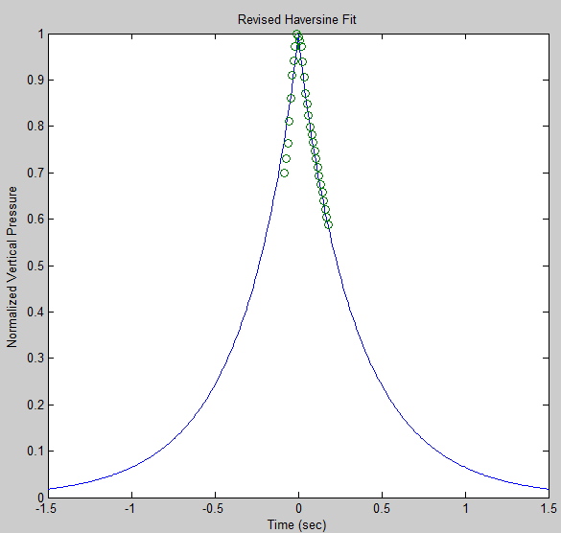

Figure B-1. Data points and fitted curve using the revised haversine equation.

For the given scenario, the fitting constants and were equal to 0.475 and 13.5, respectively, with an of 0.9552. The resulting load pulse duration was 3.46 seconds. Using the prepared Matlab script, the database of extracted stress pulses for all load cases could be used to estimate the load pulse duration and obtain the appropriate material stiffness to be used in the fatigue transfer function.

**References:**

Loulizi, A., I.L. Al-Qadi, S. Lahouar, and T.E. Freeman. 2002. “Measurement of Vertical Compressive Stress Pulse in Flexible Pavements.” *Transportation Research Record* 1816: 125-136.

Fakhri, M., and A.R. Ghanizadeh. 2013. “Modelling of 3D Response Pulse at the Bottom of Asphalt Layer Using a Novel function and Artificial Neural Network.” *International Journal of Pavement Engineering*. DOI: 10.1080/10298436.2013.851791.