Research Problem Statement

Research Problem Title:
Use of Signing for Safe Operation of Passenger Vehicles and Commercial Motor Vehicles in a Multilane Roundabout

Statement of Problem
Roundabouts have superior safety performance compared with signalized and two-way stop-controlled intersections (Rodergerdts et al., 2010, chapter 5). Serious injury and fatal crashes are rare at roundabouts because right-angle and head-on crash types are mitigated by design. Nevertheless, failures to yield at entry-circulating and exit-circulating conflicts are known to result in property damage only (PDO) crashes. Rates of such crashes exceed those for otherwise comparable signalized or two-way stop-controlled intersections. While the Manual on Uniform Traffic Control Devices (MUTCD) (2009) addresses traffic control devices within roundabouts, it does not address how to inform drivers about potential conflicts with commercial motor vehicles (CMVs) within roundabouts. CMVs have difficulty maneuvering through roundabouts due to the higher turning radius. As a result, CMVs will frequently require more space when turning than is provided by the marked lane within the roundabout. Passenger vehicle drivers driving within the marked lane can encroach on the space CMVs require to traverse the roundabout, thus, creating a conflict point (Chevuri, 2018).
The objective of this research is to evaluate signing to inform vehicles that CMVs need to use both lanes to navigate through a multilane roundabout.
Summary of Existing Literature
Little research on signing options for passenger vehicles traveling in multi-lane roundabouts with CMVs has been performed. Waddell et al., (2009) indicated that warning signs to alert motorists not to drive adjacent to trucks or pass trucks could be an effective countermeasure. They also indicated that signs are used in the British Columbia, Canada to warn drivers not to drive next to trucks in roundabouts.
The Joint Roundabout Truck Study by the Wisconsin Department of Transportation and the Minnesota Department of Transportation surveyed the trucking industry and found that truck drivers felt that roundabouts do not have adequate signing indicating if trucks must stay in their lane or may use both lanes. Several survey respondents recommended signs be added stating “Trucks Use Both Lanes” or “Do Not Pass Trucks in Roundabout.” Another survey response indicated “WIDE TURNING TRUCKS” signs had been added to a roundabout to warn drivers that trucks may leave their lane in the roundabout (Wisconsin Department of Transportation [WisDOT] et al., 2012). A later phase of the Joint Roundabout Truck Study provided signing recommendations for multi-lane roundabouts with high truck volumes. The recommended signs are intended to be supplemental to traditional roundabout signing and designers are encouraged to carefully consider if the potential benefits outweigh the risk of contributing to sign clutter. The figures below show the suggested optional signing and the intended purpose of the messaging (WisDOT et al., 2012).

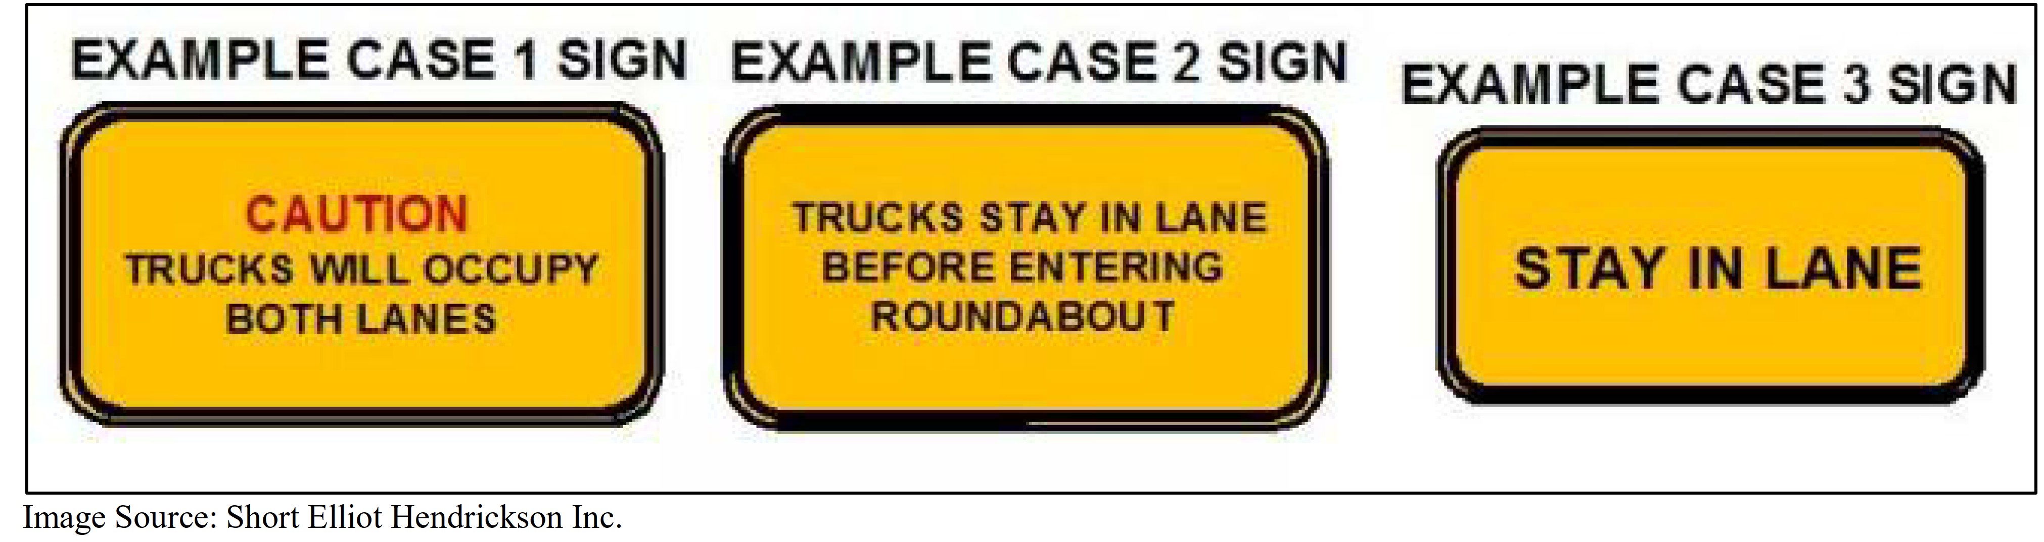
Figure 1: The Joint Roundabout Study - Suggested Optional Signs (WisDOT et al., 2012)

Table 1: The Joint Roundabout Study Suggested Sign Messages and Purposes (WisDOT et al, 2012)
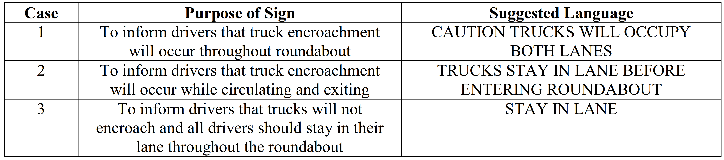

A 2012 Traffic Control Devices Pooled Fund Study by Katz, Dagnall, and Bertola evaluated the comprehension and legibility of symbol signs. Several of the signs evaluated (see the figure below) were intended to indicate that trucks may use multiple lanes in roundabouts (Katz et al., 2012).
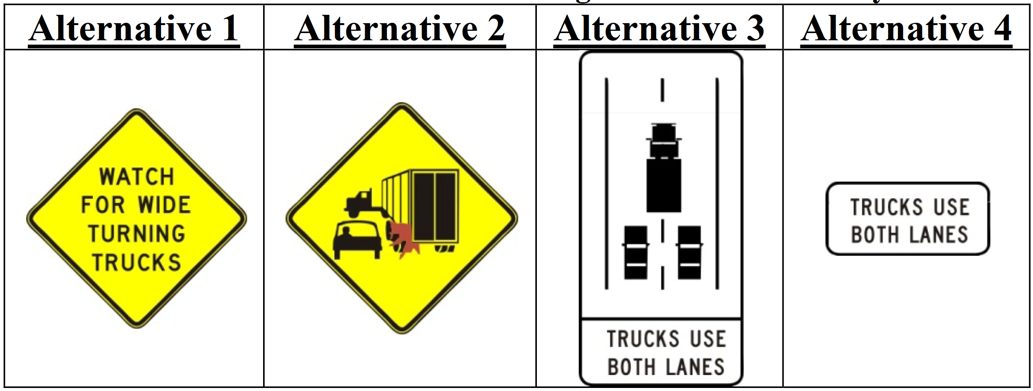
Figure 2: TCD PFS Trucks in Roundabouts Sign Alternatives (Katz et al., 2012)
Sign alternatives 1 and 3 had the highest comprehension. Alternatives 2 and 4 were considered to have low comprehension. Additionally, alternatives 1, 2, and 3 all had acceptable legibility. The study ultimately recommended the alternative 1 sign over the alternative 3 sign because it could be used in a variety of settings (not just multi-lane roundabouts) and because the Alternative 3 sign could be misconstrued as regulatory sign for trucks as opposed to a warning sign for all motorists (Katz et al., 2012).

Potential Research Approach
The general approach to the research has been identified as:
A driving simulator-based laboratory study in which two-lane, four-leg roundabouts with different signing are compared based on participants’ lane choice and driving performance parameters.

For the scope of the research, a four-legged two-lane roundabout is recommended. Adding more than two lanes or varying geometric designs (e.g., adding bicycle lanes) could marginalize the interaction between CMVs and passenger vehicle (i.e., interaction of passenger vehicles and heavy vehicles). It will, further reduce the likelihood of isolating the effects of sign as a treatment.

A driving simulator study can identify measurable differences in driving behavior of passenger vehicle drivers in response to signing options. A small-scale simulator can be used to record lane choice data to categorize the interaction of the passenger vehicles with other classification of vehicles i.e., CMVs. Using a simulated roundabout with ambient vehicles will provide the opportunity to record such interactions.

Task 1 – Kick-off Meeting and Project Management
Researchers would attend a kickoff meeting with FHWA and the TCD PFS panel.
Task 2 – Literature and State of the Practice Review
The research team will review and synthesize literature regarding research that has been performed on signing pertaining to trucks in multi-lane roundabouts. Additionally, current practices and sign designs for signing for trucks in multi-lane roundabouts will be gathered from the TCD PFS members, at a minimum, and summarized.

Task 3 – Research Plan Development
The research team will work with the TOCOR, TCD PFS, MUTCD team, and other stakeholders to select the sign designs that will be evaluated in the experiment and refine characteristics of a candidate roundabout that facilitates the interactions of interest between CMVs and passenger vehicles. Based on inputs from the kickoff meeting and stakeholder coordination, as well as findings of the literature review, the research team will develop and submit a research plan specifies the signs and methodology that will be used for conducting the study.

Task 4 – Comprehension Testing
The signs selected for evaluation based on TOCOR, TCD PFS, MUTCD team, and other stakeholder feedback as well as the literature review will be initially evaluated in comprehension lab testing. The research team will develop the needed stimuli for the study. Participants will view the signs and be asked questions to gauge their comprehension. Distractor signs will also be included to avoid participants recognizing patterns and learning the goal of the testing.

Task 5 – Simulation Development
Using 3D modeling tools, a dynamic environment with the desired roundabout design will be simulated. Signing treatments that performed well in the comprehension testing will be modeled and included in the dynamic environment. CMVs and passenger vehicles, based on the desired interactions, will be coded into the environment.
Task 6 – Data Collection & Analysis
The research team will collect and analyze data based on the approved, final research plan. This will include participants driving as a passenger vehicle in the simulation. The research team will track any behavior changes throughout the course of the simulation study by collecting driving performance and lane choice data, and potentially other data (e.g., eye tracking, driving stress level) as deemed fit. Appropriate data analyses will be performed.
Task 7 – Final Report and Presentation
The research team will develop a final report that describes the research approach and results and provides a discussion of the findings. The team will present their findings to the TCD PFS members.
Chance of Successful Evaluation
Medium – There is a high likelihood that comprehension testing results of this research will determine what sign messages and designs may be appropriate to communicate the intended behavior for passenger vehicles traveling in multi-lane roundabouts with CMVs.
Simulation testing may reveal some changes in behavior based on the signs being tested. However, actual behavior changes and safety benefits may differ somewhat from a simulation study and would require further evidence from a field study after a simulator study is completed.
References

Chevuri, P.K., (2018) Trucks at Roundabouts: A Synthesis Study. Journal of Transportation Technologies, 8, 65-74. https://doi.org/10.4236/jtts.2018.81004
Federal Highway Administration. Manual on Uniform Traffic Control Devices (MUTCD). U.S. Department of Transportation, Washington, D.C., 2009.
Katz, B., Dagnall, E., Bertola, M.A. (2012). Comprehension and Legibility of Selected Symbol Signs Phase III Final Report. https://www.pooledfund.org/Document/Download?id=3557
Rodergerdts, L., Bansen, J., Tiesler, C., Knudsen, J., Myers, E., Johnson, M., . . . O'Brien, A. (2010). Roundabouts: An Informational Guide (2nd ed.): Transportation Research Board.
Waddell E, Gingrich MA, S.R., Lenters M, P.E. Trucks in roundabouts: Pitfalls in design and operations. Institute of Transportation Engineers.ITE Journal. 2009;79(2):40-45.
Wisconsin Department of Transportation, Minnesota Department of Transportation, Short Elliott Hendrickson Incorporated, DLZ National, and Roundabouts & Traffic Engineering. (2012). Joint Roundabout Truck Study. http://www.terraroadalliance.org/research/factsheets/roundabouttrucks/documents/final.pdf

