Connected Vehicle Pooled Fund Study
TPF-5(206)

Transition Plan

May 2018

Background

The Research Program to Support the Research, Development, and Deployment of System Operations Applications of Vehicle Infrastructure Integration (VII), TPF-5(206), which is now known as the Connected Vehicle Pooled Fund Study (CV PFS), was initiated in 2009 and has been in place for nearly 10 years. During this time, the CV PFS program has been successful in its pursuit to aid transportation agencies and OEMs in justifying and promoting the large scale deployment of the connected vehicle environment and applications through modeling, development, engineering and planning activities. As of May 2018, eleven research projects have been completed and four additional projects are currently underway. For reference, a summary of completed research projects is shown in Table 1.

Successful and relevant research topics along with an increasing interest in the topic have resulted in the CV PFS experiencing continued membership growth over time. The group started with seven founding members and now has 22 current members with several additional new members expected in FY2018 and FY2019. The role of CV PFS remains relevant and will likely become more significant in the coming years, thus the CV PFS members would like to see the program extended beyond its currently anticipated program end time of June 2020.

As the CV PFS enters its 4th funding phase, administrative challenges are beginning to become apparent and the lead agency, Virginia Department of Transportation, believes it would be prudent to start a new CV PFS program for the next decade and to begin to transition the current CV PFS (TPF-5(206)) program into the new CV PFS program.

This document offers a proposed approach for this transition from the current CV PFS program to a new CV PFS program. It is anticipated that there will be an overlap of the two programs as projects from Phase 4 are completed and projects from Phase 5 begin.

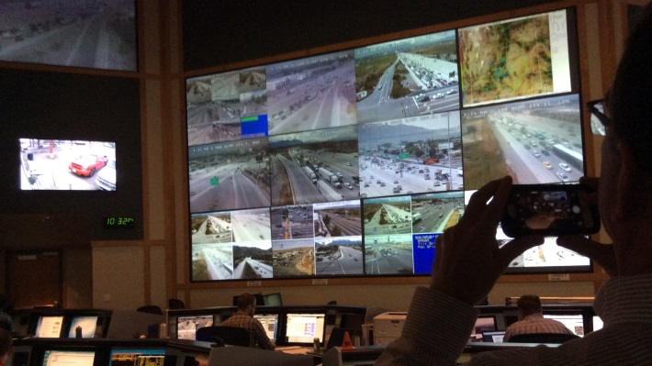
Proposed Approach

Project and Funding Phasing

The proposed approach for transitioning projects and funding is presented in Table 2. Detailed descriptions are provided below:

- Current CV PFS Program (TPF-5(206))
  - The current CV PFS Program (TPF-5(206)) is set to end on June 30, 2020.
  - Within the current CV PFS Program, we are accepting commitments for four federal fiscal years, i.e. FY 2017, FY 2018, FY 2019, and FY 2020.

- FY 2016 - CV PFS Program TPF-5(206)
  - Commitments received up to FY 2016 have been used up, for the current PFS Phase 3 and as 20% matches for the MMITSS Phase 3 and the CTCS projects.
  - All the commitments up to FY 2016 are accounted for and there are no (or very little) remaining funds.

- FY 2017 and FY 2018 – CV PFS Program TPF-5(206)
  - Commitments received for FY 2017 and FY 2018 will be used to establish PFS Phase 4 for the next two or so years so that it can end within the current CV PFS Program.
  - The total expected budget is $1,790,000 and approximately $1,350,000 can be used for projects. The remainder is budgeted for program management fees and travel expenses.
  - The number, length, and budget of projects can remain flexible and to be determined.
  - All funds for TPF-5(206) should be committed by the end of FY 2018. Invoices will continue to be received and paid until the projects are complete and closed out. Efforts will be made to complete all TPF-5(206) projects by Summer 2020; however outstanding invoices may still be paid beyond that date if needed.

- FY 2019 and FY 2020 – NEW CV PFS Program TPF-X(XXX)
  - Commitments made for FY 2019 and FY 2020 may not be used up by the end of the current CV PFS Program (June 30, 2020). As such, it is recommended to reallocate these commitments to the NEW CV PFS Program.
  - Action Items
    - A NEW CV PFS Program will start in July 2019, which will allow a one-year overlap with the current CV PFS Program.
    - Once a NEW PFS Program is initiated, the members will be asked to reallocate their commitments in FY 2019 and FY 2020 to the NEW PFS number.
    - Then a new research contract (either CY 2020 or Phase 5) will be established from the NEW CV PFS Program.

Membership Approval

The proposed approach for transitioning to the new CV PFS program will require member buy in and approval. The transition plan will be discussed and reviewed at the face to face meeting in May 2018. The plan will be revised, reviewed, and agreed upon by the current CV PFS members. Detailed guidance will be prepared and shared on the website to direct current members to the new program for FY 2019 and beyond.
CV PFS Leadership and Program Management

The proposed approach for transitioning to the new CV PFS program will assume that the new CV PFS program will continue to be led by Virginia Department of Transportation.

Establishing a New CV PFS Program

The CV PFS Lead Agency will work FHWA to set up the new CV PFS Program in summer 2018 and will work with the Program Manager to share this information to the members. The CV PFS Charter and scope, including name, will be revised and posted to the FHWA Pooled Fund site. Funding levels will be evaluated to review what levels are required to meet the goals of the new program given the current membership levels; efforts will be made to make the commitment levels uniform among members. Members will be given instructions to update their commitments and transfer funds to the new program beginning in FY2019.

Table 1: Summary of CV PFS Research Projects Completed

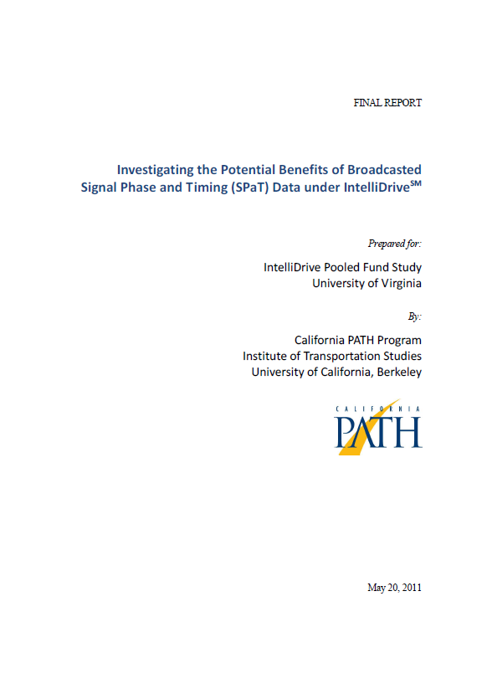 | 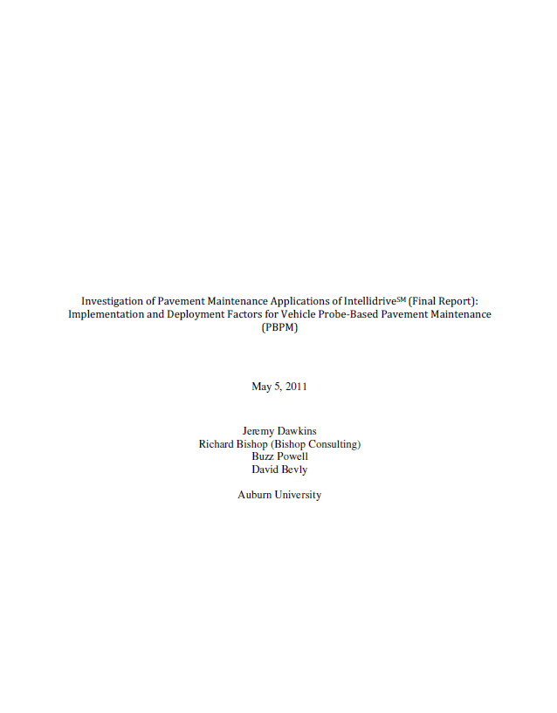 | 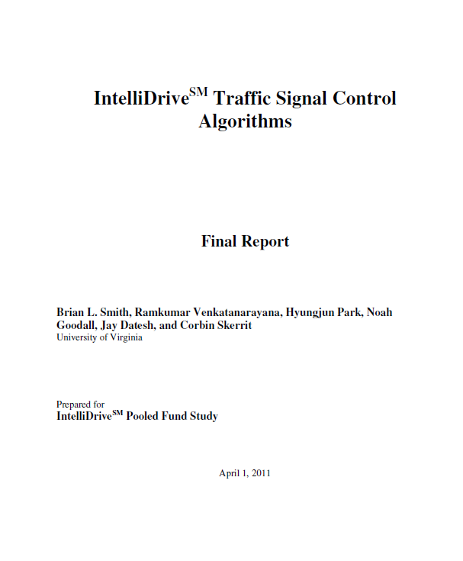 | 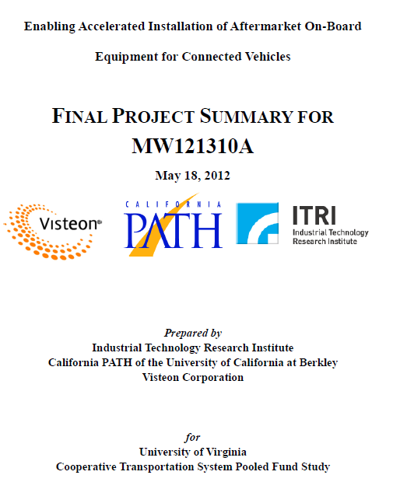 | 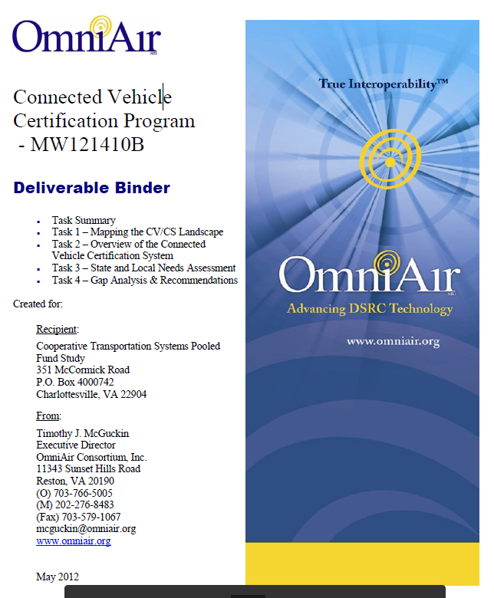
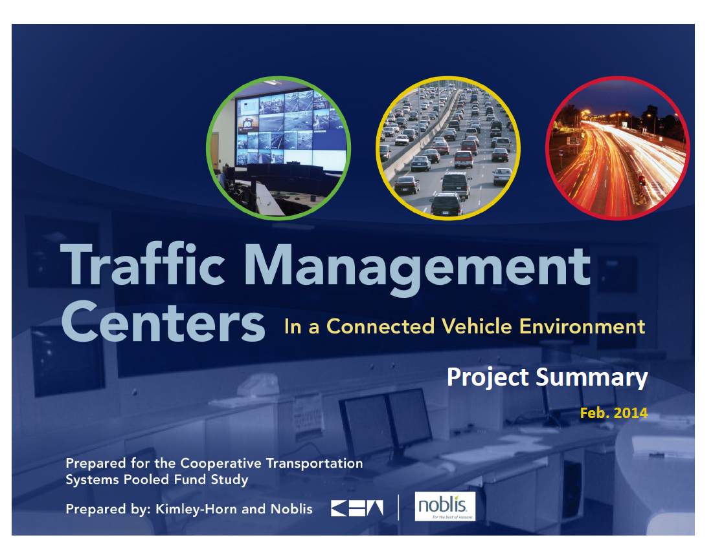 | 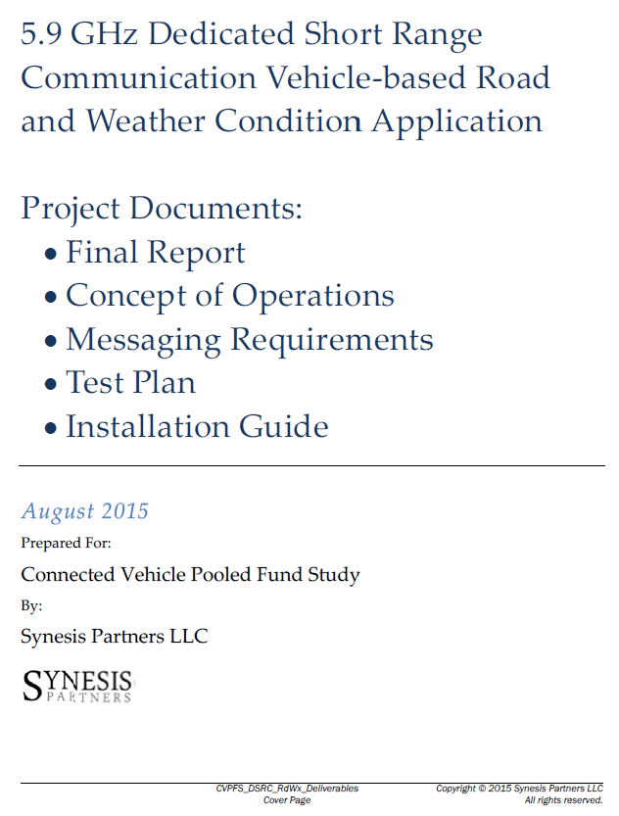 | 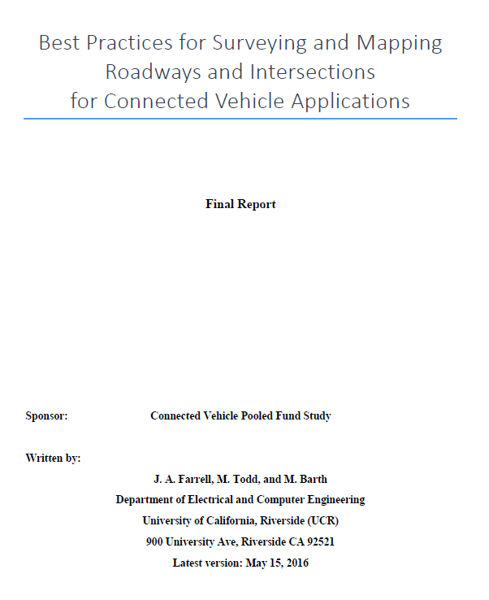 | 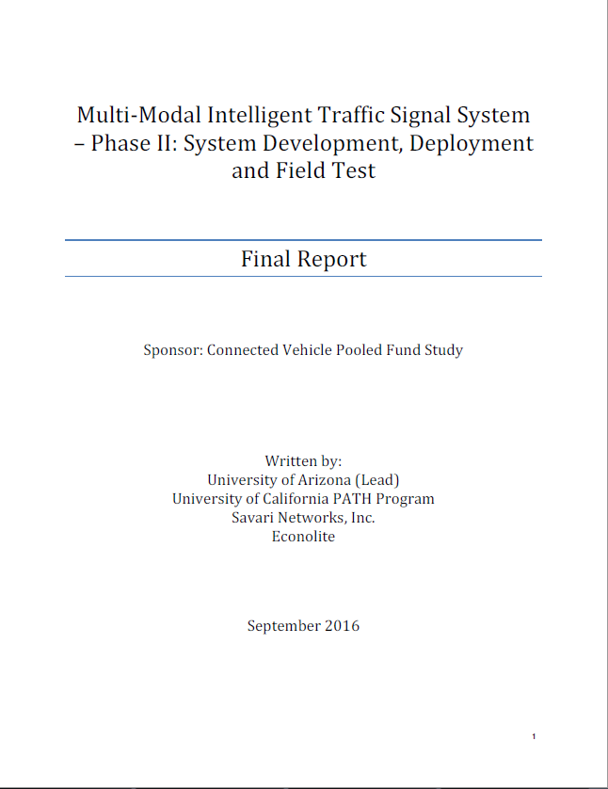 | 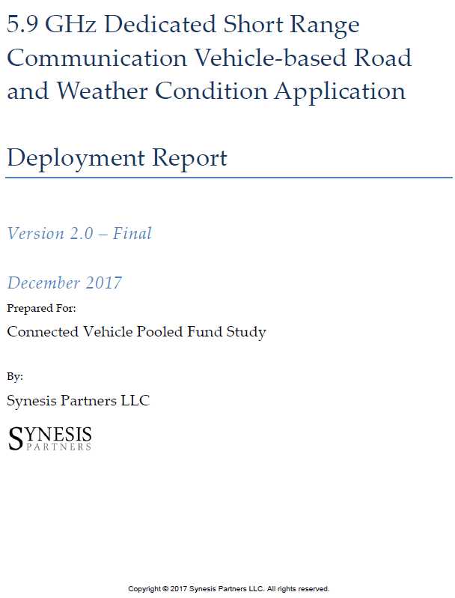

Table 2: Proposed Approach for CV PFS Transition

CY 2016 |  | CY 2017 |  |  |  | CY 2018 |  |  |  | CY 2019 |  |  |  | CY 2020 |  |  |  | CY2021
Q3 | Q4 | Q1 | Q2 | Q3 | Q4 | Q1 | Q2 | Q3 | Q4 | Q1 | Q2 | Q3 | Q4 | Q1 | Q2 | Q3 | Q4 | Q1 | Q2
Current CV PFS Program (TPF-5(206)) ending in June 2020
 | FY17 Commitment |  |  |  |  |  |  |  | FY19 Commitment
FY16 |  |  |  |  | FY18 Commitment |  |  |  |  |  |  |  | D) FY20 Commitment
FY16
PFS Phase 3
DSRC Rd/Wx
 | BIM
 |  |  |  |  | MMITSS Phase 3
 |  |  |  |  | CTCS
 |  |  |  |  |  | PFS Phase 4
 |  |  |  |  |  |  | V2I Queue Warning
 |  |  |  |  |  |  | Using 3rd Parties to Deliver V2I
 |  |  |  |  |  |  |  |  |  |  | TBD Future Project
 |  |  |  |  |  |  |  |  | NEW CV PFS (TPF-X(XXX) Initiated
 |  |  |  |  |  |  |  |  | FY19 Commitment
 |  |  |  |  |  |  |  |  |  |  |  |  | FY20 Commitment
 |  |  |  |  |  |  |  |  |  |  |  |  |  | PFS Phase 5 or CY2020
 |  |  |  |  |  |  |  |  |  |  |  |  |  |  | Project #1
 |  |  |  |  |  |  |  |  |  |  |  |  |  |  | Project #...

