Title: Gravel-Bed River Assessment Tool for Improved Resiliency of Engineering Design
Lead: Washington State Department of Transportation (WSDOT) in collaboration with US Fish and Wildlife Service Region 1, Lacey, WA
Partners: FHWA, USFS, Caltrans, Oregon DOT
Request: $248,000 FHWA Resilience and Durability Pilot Funds

Project Description
In response to FHWA’s request to partner with state DOTs and others to improve the resilience and durability of the nation’s transportation systems, WSDOT proposes to develop a gravel-bed river assessment tool. This tool will support the advanced-level riverine hydraulic analysis needed when designing resilient infrastructure along and near gravel-bed rivers and streams. Currently, there is a critical gap in the existing tools available because those tools are based on sand-bed rivers. This pilot project seeks to close the gap in current tools and methodology by creating a gravel-bed river assessment tool that better informs culvert replacement, bridge design, maintenance strategies, and road repairs along gravel-bed rivers and streams, and will have application to DOTs across the United States.
- Purpose/goal of the project and a detailed description of the effort
The world’s rivers and streams are adjusting to changes in climate. In Washington State, stream channels are becoming more dynamic – especially in the vicinity of gravel-bed rivers. Federal, state, tribal and private roads are increasingly compromised or destroyed due to progressively more dynamic channel processes. A river’s bedload (sediment transported along the channel bed) drives how rivers move into – or away from – road infrastructure. In order to design durable roads and bridges, we need high quality information on how the natural material in the river system will move and deposit in the vicinity of road infrastructure.
Widely available methods for assessing channel dynamics and hazards are based on sand-bed rivers, like the Mississippi River, that do not apply to gravel-bed rivers found throughout the United States. We need a gravel-bed river assessment tool that accounts for changes in gravel-bed rivers from glacial melt and extreme flooding associated with projected future climate change.
In this pilot, WSDOT proposes to develop practical guidance and methods for assessing bedload transport in gravel-bed rivers for more resilient road infrastructure. This guidance will inform engineering design, hazard assessment, and maintenance strategies of roads along or near gravel-bed rivers. Other federal and state agencies support the pilot, and are willing to assist in the development and review process. WSDOT anticipates that US Forest Service, US Fish and Wildlife Service, Oregon DOT, Caltrans and other public works agencies will use the gravel-bed assessment tool developed by this pilot project.
This pilot will consist of three parts: 1) a technical workshop to define the framework, goals, and criteria for developing the guidance and case studies; 2) data collection and case study development; and 3) the guidance write-up and finalization. WSDOT will bring together with experts and stakeholders in a one-day technical workshop to establish the assumptions, key resources, goals and identify the data gaps. This will assist WSDOT in directing the data collection and other work of the consultants and staff within an established framework.
WSDOT will test the sediment transport modeling capabilities of the Sedimentation and River Hydraulics – Two-Dimensional model (SRH-2D), now the preferred hydraulic modeling software by FHWA, and compare the results obtained from current FHWA Guidance HEC-18. The pilot study will also consider future extreme weather conditions using the methods described in HEC-17.
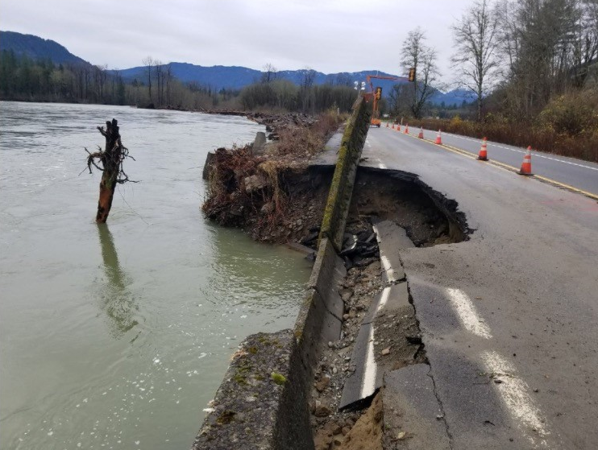
The pilot will closely examine the state-of-art technology for collecting direct and indirect measurements of bedload (e.g., passive and active hydroacoustic, Acoustic Doppler Profiler (ADP), Apparent Bedload Velocity (ABV), photosieving, accelerometers, Passive Integrated Transponder (PIT) tags, remote sensing and GIS). WSDOT’s hydraulics staff have experienced many challenges in collecting physical bedload samples: it is often dangerous and untenable. Advancements in data collection techniques offer opportunities for indirect measurement of bedload while ensuring safety of DOT staff and contractors. These data could greatly improve the calibration – and therefore the results – of sediment transport models within acceptable limits of accuracy. Physical sampling of bedload (for calibrating sediment transport models) will be compared to data obtained from modern tools in data collection in three case studies. The outcomes will be applied towards guidance development. The goal is to identify data collection techniques that refine inputs into sediment transport models within acceptable limits of accuracy when field-based site calibration is unsafe or untenable.
The pilot will conduct three case studies in order to develop the guidance and test methods with a focus on:
- Stream Simulation culvert design for fish passage and geomorphic stability, particularly in dynamic settings such as alluvial fans and transitions of channel slope or confinement.
- Design criteria for bridge and roadway projects at risk from channel migration and spatially-extensive bed scour or gravel accumulation.
Photo: Bank erosion of Washington State Route 20 along the Skagit River after flooding that occurred November 23, 2017. Deposition of the Skagit River’s gravel bedload caused the river to overtop the highway and destroy one lane of the highway.
- Design of bank stabilization projects in a manner that maintains integrity of habitat and adjacent streambanks.
- Maintenance strategies for DOT infrastructure in rivers and streams, such as reconfiguring culverts on small creeks to prevent blockage from heavy aggradation that requires annual dredging.
Following the completion of the three case studies, WSDOT will prepare the guidance document. This final stage will include a third party review by independent experts, as well as review by partners and stakeholders who have been engaged in earlier stages of the pilot.
The final product of the pilot study will be the publication of WSDOT’s guidance and methods. These will be applicable to state DOTs and other highway asset managers across the nation wherever gravel-bed rivers are found.
- Description of past or ongoing resilience and durability efforts and how the proposed effort fits with other agency activities
WSDOT has a strong commitment to considering climate change and extreme weather vulnerability in our plans, projects and programs. We have incorporated climate into our environmental review for a decade. More recently, we have integrated climate and extreme weather risk into our corridor planning process and our guidance for design of water crossings for fish passage. We continue to work on incorporating resilience for all hazards into our asset management planning and related agency programs.
Thanks to FHWA’s funding, we successfully completed two pilot studies, and we are in the middle of a third. In 2011, WSDOT completed a statewide assessment of climate vulnerability of state-owned transportation assets. WSDOT’s planners and project teams actively use the results of the vulnerability assessment. WSDOT has also made its results available to local agencies and the public via WSDOT’s Community Planning Portal. In 2015, WSDOT applied FHWA’s framework for adaptation planning and decision making in the Skagit River basin. We created a process to help transportation planners better connect information across sectors (using hydraulic data from the Skagit River General Investigation Study). WSDOT’s Skagit Pilot report emphasized the need to coordinate long-term solutions and to leverage the information found in flood studies led by the US Army Corps of Engineers. Currently, we are very fortunate to be part of an international collaboration with FHWA and the Netherlands. WSDOT’s SR 167 pilot project team and a Dutch highway project are testing climate risk assessment tools, precipitation models, and demonstrating nature-based solutions, including innovative storm water techniques.
Correcting Barriers to Fish Passage
WSDOT is heavily invested in improving roads that cross rivers and streams. WSDOT is very active in culvert replacement and fish passage barrier correction. As of June 2017, WSDOT has documented 978 barrier culverts under state highways that are subject to the federal Culvert Injunction of March 2013. Culverts are corrected through transportation improvements and stand-alone corrections. Each barrier needs to be replaced by a bridge or a new culvert large enough to fully span the channel and simulate natural stream flow, gradient and bed configuration.
WSDOT is working to remove fish barrier culverts under all state highways. This has the dual benefit of reducing upstream flood risk and facilitating the migration of ESA-listed salmon. As of June 2017, WSDOT completed 319 fish passage correction projects statewide, improving more than 1,032 miles of upstream habitat and benefitting flood resiliency. This pilot will help inform the design of new fish passable, durable and resilient bridges and culverts.
Addressing Chronic Streambank Problems
WSDOT’s Chronic Environmental Deficiency (CED) program addresses areas of repeated maintenance repairs that have adverse impacts to streams, and includes them in the Transportation Asset Management Plan. CED projects are those where maintenance has been conducted on the site at least 3 times in the past 10 years. This frequent repair causes impacts to the fish habitat. Repair may be needed due to frequent flooding and streambank erosion. The funded CED projects are designed to reduce impacts to fish habitat by using nature-based solutions that are resilient to climate hazards. For each site, WSDOT conducts either a reach assessment that evaluates and identifies the hydrologic mechanisms for failure and develops a conceptual design solution. By the end of FY 2017, 39 projects were completed, and seven are funded for design and/or construction (through CED or other funding program). A total of 154 sites (or groups of sites) have been nominated for CED analysis over the life of the program. Some CED projects are funded under emergency situations. The majority of CED projects are in gravel-bed systems.
Reducing Bridge Scour
Scour is the leading cause of bridge failures in Washington State and nationwide. Of the 70 documented bridge failures in Washington State history, 43 were due to scour. The goal of WSDOT’s Bridge Scour Mitigation Program effort is to address the risk of future bridge foundation undermining due to scour during flooding events. Scour is the removal of soil from around and under bridge piers and abutments. Flowing water transports soils from around bridge piers and abutments and moves it down stream, leaving the bridge foundations exposed and in some cases undermined. Undermined bridge foundations can compromise the integrity of the structure and in some cases cause collapse. WSDOT has approximately 1,583 vehicular bridges and culverts over 20-feet in length that span over water. 262 of these bridges are considered “scour critical” which means there is potential for the bridge to be damaged by scour. WSDOT’s efforts to ensure that these bridges are safe and haven’t been damage by scour fall in to two categories, monitoring and response. Many of these bridges are on gravel-bed rivers.
The proposed pilot will contribute to WSDOT’s current efforts to improve resilience as we are heavily investing in statewide transportation improvement projects today. WSDOT must have better information to address these dynamic systems – and assure that our corrections allow for bed material that will provide habitat and withstand extreme flows. The proposed pilot will create much needed guidance for our hydraulic analysis – which is essential to culvert replacement, bridge design, and road repairs along streams and rivers.
- Geographic focus of the pilot project (e.g. statewide, metropolitan area, DOT maintenance district, floodplain, etc.)
The geographic focus is statewide with an emphasis in the foothills of the Cascade and Olympic Ranges. Approximately 1,600 miles of road infrastructure in Washington State cross or lie adjacent to streams and rivers.
Figure 1. Washington State roads adjacent or crossing rivers and streams
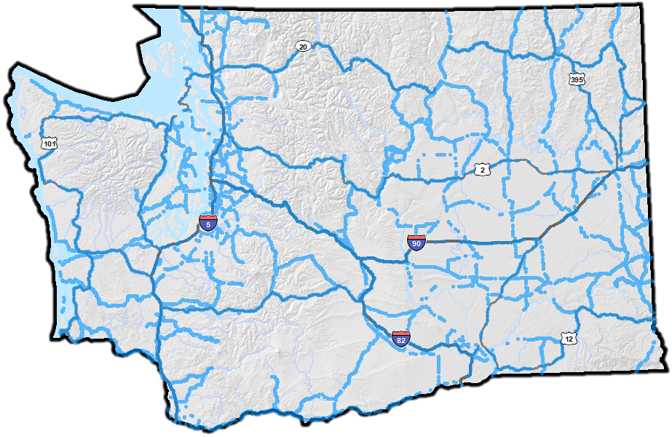
- Types of extreme weather effects and future conditions to be addressed
Warming, already observable in Washington and the rest of the Pacific Northwest, is likely due in part to rising greenhouse gas concentrations caused by human activities. Future warming depends on how much global greenhouse gas emissions rise. Under continued increasing greenhouse gas emissions, Washington’s climate is expected to continue to warm throughout this century and beyond. In general, Washington and the rest of the Pacific Northwest can expect warmer temperatures year round with greater warming during the summer. A modest increase in annual precipitation is expected along with shift in precipitation patterns to dryer summers and wetter winters, springs, and falls. Precipitation projections are more uncertain than temperature projections. Extreme precipitation events in the Pacific Northwest are governed both by atmospheric circulation and interaction with complex topography. Atmospheric rivers carry large amounts of water vapor from the tropics to mid-latitudes generally result in extreme precipitation events west of the Cascades.
Temperature is the key climate driver which changes the patterns of precipitation, accumulation and melting of snow and glacial melt and retreat. Warming temperatures, changes in precipitation, and decreasing snowpack are already having, and will continue to have, significant impacts on hydrology. Changes in winter flood risk are expected under a future warmer climate. These hydrologic impacts will vary across watersheds, depending largely on whether the watershed receives precipitation mostly as rain or snow, or a combination of both.
As the climate warms, precipitation will fall more as rain and less as snow. By midcentury under the high emissions pathway (RCP 8.5), 30% of the area of the western United States normally conducive to snowfall (4,000 ft and above) is projected to become part of the rain-snow transition zone, including the Cascade Range. Likewise, areas presently in the rain-snow transition zone (1,500 ft to 4,000 ft) are projected to become largely rain-dominated. These projected changes in precipitation type represent a fundamental hydrologic regime shift that will result in a geomorphic response in rivers and streams. In the Western US, glacier retreat is exposing large stores of sediment previously trapped beneath ice.
Glacier retreat combined with precipitation increasingly falling as rain instead of snow results in the long-term introduction of large quantities of sediment to the river network that previously was locked beneath ice. Larger, more frequent floods carrying larger quantities of sediment result in more destructive, unstable channel dynamics that directly impact DOT road infrastructure. Increased flows in addition to increased sediment inputs from rock falls, slope failures, and glacier retreat will lead to increased flooding, and more dramatic river channel migration, scour, and aggradation.
Figure 2, below, indicate current and future watershed classifications, based on the proportion of winter precipitation stored in peak annual snowpack.

Figure 2. Changing hydrology with warming
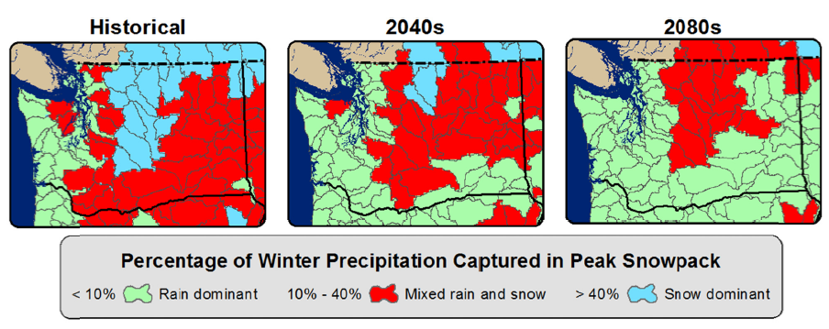
The UW Hydro/Computational Hydrology research group at the University of Washington and the Oregon Climate Change Research Institute at Oregon State University have developed streamflow time series for 396 locations that represent an assortment of future climate projection scenarios. The proposed study area, the foothills of the Olympics and Cascade Ranges, is in the heart of the rain-snow transition area and is expected to experience the most dramatic changes with continued warming.
The time series data in conjunction with future climate regression equations developed for the National Flood Insurance Program will provide the project team an informed estimate of how the hydrology will change at the pilot test sites. Following the FHWA HEC-17: Highways in the River Environment-Floodplains, Extreme Events, Risk and Resilience analysis framework, the pilot will allow us to develop recommendations for our WSDOT and partner practitioners as to the level of analysis needed to maximize resilience and minimize risk at similar sites.

- Lead agency and partners that will be involved in the pilot project
WSDOT will be the lead agency for the pilot. Partners will include: USFWS (Region 1), Oregon DOT, Caltrans, USFS. We remain open to acquiring additional partners to strengthen the effectiveness of the pilot.
Total estimated costs of the pilot are $310, 000. We are seeking $248,000 (80%) from FHWA.
WSDOT proposes to meet the 20% match requirement with staff time and funds from our state DOT partners. Caltrans has offered to contribute $25,000 toward the effort, if the pilot is funded and pending their approval of the work plan.
Without funding from FHWA, WSDOT would not be able to lead or participate in this work. WSDOT’s Hydrology Program provides direct technical support to funded projects. Project budgets do not have funds for experimental techniques. While WSDOT has a research program, it’s funding is very limited. External funds are essential for the success of this pilot project.

Staffing and Resources

WSDOT will serve as the lead agency for this project. The proposed work will be completed by employees of WSDOT and USFWS. WSDOT anticipates contracting services for specialized data collection.

Project Team:
Contract Manager: Lu Saechao, WSDOT Research Office
Technical Lead: Cygnia Rapp, WSDOT Hydraulics
Contributing Scientist: Paul Bakke, USFWS Lacey Office
Other Contributors: Experts from other WSDOT Offices
Consultants: TBD

Cygnia F. Rapp, LG, LHG is a Geomorphologist of 20 years and lead author of state guidelines for assessing channel migration. She works in the Hydrology Group within the Hydraulics Section of WSDOT and leads reach assessments for recommending treatment alternatives for Chronic Environmental Deficiency sites. Cygnia also evaluates the effects of changes to watershed inputs on channel morphology, sediment transport characteristics, hydrology, and habitat forming processes for design of fish passage projects.

Paul Bakke, LG, PH has 16 years of experience as a Hydrologist and Geomorphologist with the U.S. Fish and Wildlife Service in Lacey, Washington. In this role, he is involved with all things having to do with the physical aspects of aquatic habitat, such as quantity and quality of water, sediment dynamics, the shape, condition and evolution of river channels, streambeds, shorelines, and the way groundwater interacts with surface water. He provides key technical assistance to the projects funded by Service's restoration programs, including the Puget Sound Coastal program, Partners for Fish and Wildlife, the Chehalis Fisheries Restoration Program and National Fish Passage Program. Paul is an expert in sediment transport analysis and modeling, especially the development of site-calibrated models, and has taught numerous workshops in sediment dynamics and modeling. He is a co-author of the Stream Habitat Restoration Guidelines for Washington State, and an instructor at Guidelines workshops. Paul has also instructed River Science and Management at the U.S. Fish and Wildlife Service's National Conservation Training Center.

Lu Saechao, PE currently serves as the Research Engineer/Manager in WSDOT’s research office managing and overseeing research-related activities in the areas of water resources and hydraulics, design, bridge and structures, pavements, and geotechnical. He has successfully secured and managed several federal grants for WSDOT, including four STIC grants ($300K total), four SHRP2 grants ($400K total), and two Fast Act, HRD funds ($200K total). In addition, Lu coordinated and led WSDOT’s application efforts for a $1 Million FHWA AID grant request, which is pending a decision by FHWA.

Draft Work Plan
Within the first two months of funding, WSDOT and USFWS staff (the WSDOT project team) will conduct a 1-day technical workshop with independent experts, State DOT and federal partners to develop a framework for the methods and guidance materials that will guide case study development. The workshop will be used to outline content that ensures the practicality of guidance, critically review state-of-art technology for data collection techniques, and develop criteria for selecting case studies.

Based on the direction provided in Task 1, the WSDOT project team will draft a short list of case study candidates, and choose three for in-depth study. The WSDOT project team will create the work plan for the first case study and begin research in the second and third quarters of 2018. Outcomes from the first case study will be used for revising the guidance framework and work plans of the second and third case studies. Research and report writing for the second and third case studies will be completed during the 2019 calendar year. Following the completion of all case studies, the WSDOT team will capture the methods, results, and conclusions in guidance development. A draft gravel-bed assessment tool will be completed by the end of the first quarter 2020. After collaborating with stakeholders and partners, the gravel-bed assessment tool will be completed and published online by the end of 2020. In addition, WSDOT will submit a pilot report to FHWA detailing the work performed, lessons learned, and recommendations for improving the FHWA resources used.

Key Tasks | Q2  2018 | Q3 | Q4 | Q1  2019 | Q2 | Q3 | Q4 | Q1  2020 | Q2 | Q3 | Q4
Task 1: Conduct 1-day technical retreat for developing guidance framework, methods, and criteria for case studies.
Task 2: Identify and prioritize case study opportunities.
Task 3: Develop and execute work plan for first case study. Apply outcomes to revise work plan for additional case studies.
Task 4: Develop and execute work plan for second and third case studies.
Task 5: Write technical report and share with state and federal partners.
Task 6. Present guidance, methods, and case studies to state and federal partners. Solicit feedback.
Task 7. Complete draft and final pilot report for FHWA
Task 8. Finalize WSDOT guidance and publish online.

Letters of Support and State DOT Partners
The proposed pilot will fill an information need which is essential to culvert replacement, bridge design, and road repairs along streams and rivers. WSDOT has confirmed interest from two state DOT partners (Oregon DOT and CalTrans). Paul Bakke of the US Fish and Wildlife Service has agreed to join the project team. We anticipate that FHWA-WA Division will receive letters or emails of support from USFWS and US Forest Service before February 15, 2018.

Many public agencies and communities are interested in finding long-lasting, environmentally sound solutions to the hazards that threaten our infrastructure. This pilot will assist FHWA and WSDOT in creating practical guidance for resilient project design.

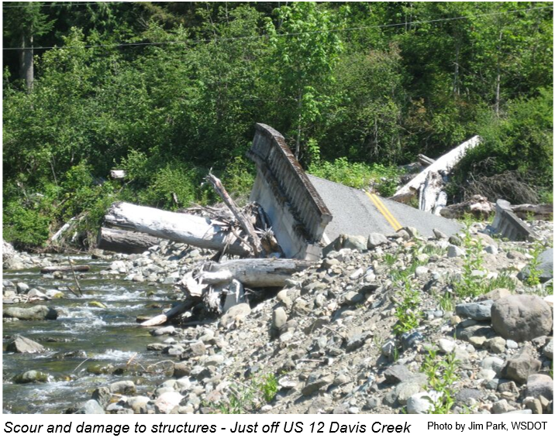

Snover, A.K, G.S. Mauger, L.C. Whitely Binder, M. Krosby, and I. Tohver. 2013. Climate Change Impacts and Adaptation in Washington State: Technical Summaries for Decision Makers. State of Knowledge Report prepared for the Washington State Department of Ecology. Climate Impacts Group, University of Washington, Seattle.
Hamlet, A.F. et al., 2013. An overview of the Columbia Basin Climate Change Scenarios Project: Approach, methods, and summary of key results. Atmosphere-Ocean 51(4): 392-415. doi: 10.1080/07055900.2013.819555

